

Certificate of Higher Education in Employability Skills
LEVEL 4
Managing Enterprise - BMSW4011

Student name: Florina Dinitica
Student number: 2321857
Date: 29th November 2024
Word count:1559

Contents
Business Plan 2
Introduction 2
Description of Service 2
Structure and Rationale 2
Mission Statement, Aim and Objectives 2
Location and Physical Resources 3
Human Resources 3
Marketing Strategy 4
Market Research 5
Financial Resources and Cash Flow Forecast 5
Risk Assessment and Mitigation 7
Individual Reflection 7
Knowledge and Skill Acquisition 7
Evaluating of Entrepreneurial Strengths 8
Challenges in implementation 8
References 9

Business Plan

Introduction
Pure Eco Cleaners will be a residential cleaning company based out of the United Kingdom located in Cwmtillery Industrial Estate. The focus of the business will be upon delivering cleaning solutions that are ecofriendly by prioritising environmentally responsible activities and it will also cater to health-conscious residents and households with pets and children. Increase in demand for ecofriendly cleaning services has been increasing steadily across the United Kingdom with respect to increasing awareness of consumers towards sustainability (Williams, 2022).

Description of Service
Pure Eco Cleaners will specialise in biodegradable nontoxic cleaning services which will offer regular maintenance as well as deep cleaning and even seasonal cleaning services that will be specifically designed for households that prioritise environmental safety along with health. The proposed solutions will be different from traditional cleaners due to exclusive use of ecofriendly products that set these services apart in a business environment within which green alternatives are very inadequate.

Structure and Rationale
Pure Eco Cleaners will be operating as a Limited Liability Company or known as LLC. The choice will be made in this context due to it limiting individual liability as well as supporting constant growth. Such a choice can also help in gaining tax advantages as well as have flexibility in managing operations while making it suitable for a small-scale firm (Whittington et al., 2023).

Mission Statement, Aim and Objectives
Mission – “To deliver ecofriendly as well as superior residential cleaning solutions that helps in prioritising environmental sustainability as well as health and assist in creating a cleaner as well as greener future along with securing customer satisfaction for one home at a time.”
Aim - To promote ecofriendly as well as sustainable cleaning solutions while also achieving high rates of customer satisfaction and making a positive impact on the community
Objectives -
- Securing 50 repeat clients within the first year of operation
- Achieving 90% retention rate of clientele through consistent and high-quality service
- Increasing yearly revenue by 15% through expanded service and reference
- Definition environmental impact through eco responsible model of business
USP – Eco-Friendly Exelance with a personal touch for evry home and evry needs.
Pure Eco Cleaners will offer exclusive green certified cleaning solutions which will provide satisfaction to clients who are seeking an environmentally responsible and healthier alternative.

Location and Physical Resources
Pure Eco Cleaners will be operating from Cwmtillery Industrial Estate which is in the United Kingdom and available storage spaces in the estate that are affordable and can be used for storing equipment as well as cleaning supplies. The main office of the business will be based at the resident of the owner for minimising costs of overhead and in this regard a storage unit of 20 square metres will be considered for rent and storing the ecofriendly supplies which ill ome at a cost of 100 pounds per month. 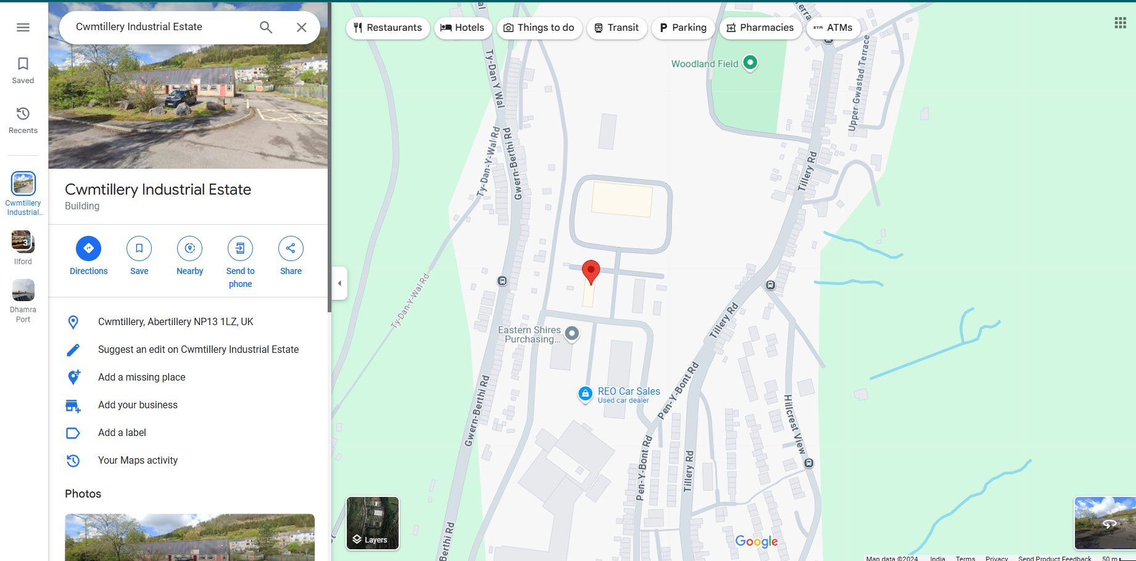

Human Resources
The proposed business will be employing eco conscious and small team while the ancient recruitment process will include two part time cleaners .
The staff will be receiving training in regards to ecofriendly cleaning as well as techniques as well as customer service processes. Competitive wage as well as performance bonuses will be provided for retaining human resources and professional development programmes on environmental sustainability will also be provided (Barringer & Ireland, 2022).

Marketing Strategy
The marketing strategy in this context will be threefold and it will include both communities based as well as digital strategies for attracting and retaining clientele.
- Social media - Instagram and Facebook pages of the proposed business will showcase its impact through ecofriendly cleaning solutions and will also include visuals and testimonials (Pakura and Rudeloff, 2023).
- Community Engagement - Flyers will be considered as distributable items across local events and eco focused presentations will also be organised in raising awareness (Rodríguez-Zurita et al., 2024).
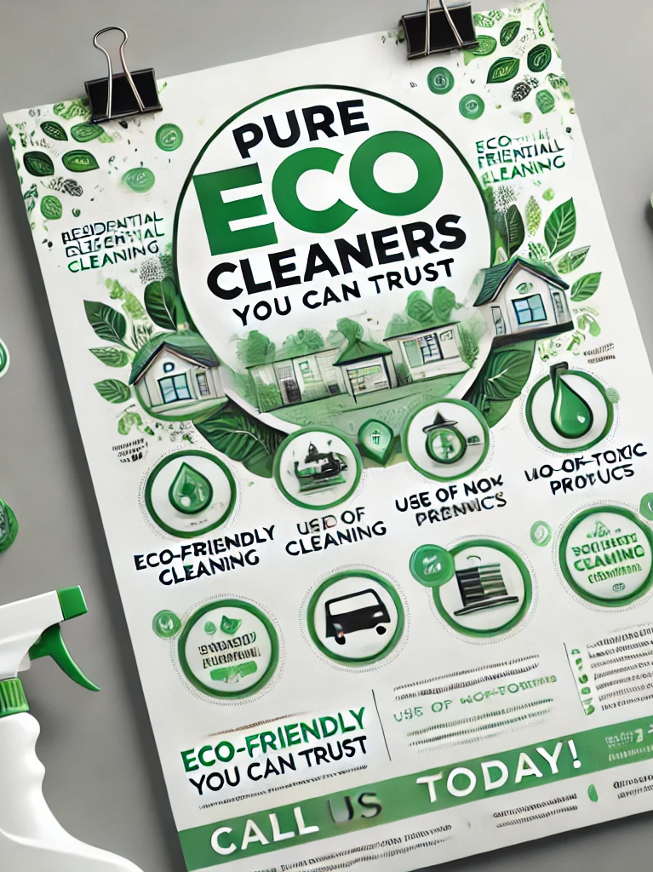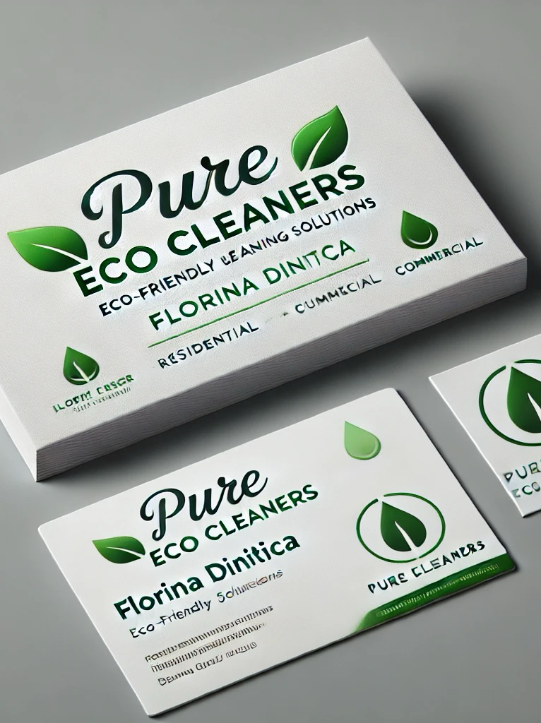

- Eco-Certification - Certified green products will be exclusively used for establishing credibility and recent studies are indicative that consumers in the UK are becoming more and more interested in sustainability as a concept (Hooley et al., 2020).
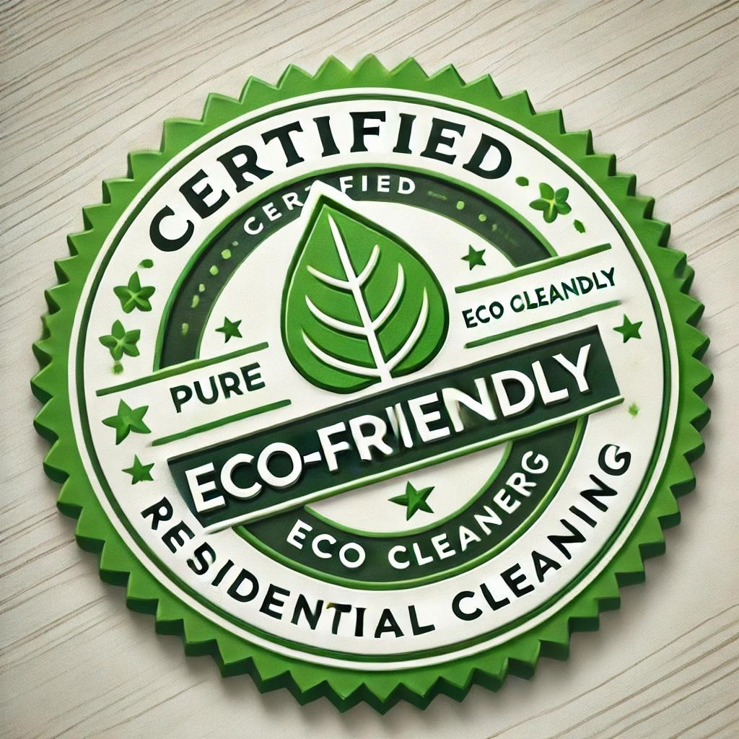

The combination of offline and online marketing can be helpful in creating brand recognition and also establish the proposed business solution as a trusted provider of ecofriendly cleanliness solutions.

Market Research
Recent data is indicative of that ecofriendly cleaning services resulted demand increasing in the United Kingdom at a per annum rate of 8% that is being consistently driven by environmental and health benefits seek to buy customers through sustainable products (MarketLine, 2023). Local surveys also indicate that 65% respondents prefer cleaning services that are ecofriendly. The research in this context was considered for influence decision making in regards to targeting health conscious and environmentally aware customers in the residential market.

Financial Resources and Cash Flow Forecast
An initial investment of £20,000 will be required and from this £5000 will come from personal savings whereas £15,000 will be raised through loans or government grants. Funding will be applied for via the UK Startup Loan Scheme that will be considered for providing no interest small business loans (Williams, 2022). Kickstarter will be considered as an example of a crowdfunding platform that will be considered for generating funds for initial growth.
The following information will highlight a cash flow forecast that demonstrates the financial viability and it will include operating costs in the form of supplies as well as wages including insurance along with storage.

 | Jan £ | Feb £ | Mar £ | Apr £ | May £ | June £ | July £ | Aug £ | Sept £ | Oct £ | Nov £ | Dec £
Income
Sales | 10000 | 10000 | 15000 | 15000 | 20000 | 20000 | 25000 | 25000 | 30000 | 30000 | 35000 | 35000
Govt. Grant | 15000
Own Capital | 5000
Total Income | 30000 | 15000 | 15000 | 15000 | 20000 | 20000 | 25000 | 25000 | 30000 | 30000 | 35000 | 35000
Expenditures
Direct Costs
Employee Salaries | 2500 | 3890 | 4500 | 5600 | 9580 | 3250 | 5980 | 6150 | 9520 | 12000 | 13600 | 15560
Employee Payroll Taxes and Benefits | 60 | 55 | 46 | 90 | 75 | 66 | 70 | 115 | 125 | 90 | 70 | 80
Supplies | 2500 | 2750 | 1860 | 2160 | 1840 | 1649 | 1458 | 1267 | 1076 | 885 | 1694 | 1503
Total Direct Costs | 5060 | 6695 | 6406 | 7850 | 11495 | 4965 | 7508 | 7532 | 10721 | 12975 | 15364 | 17143
Rent/Lease Payments | 1100 | 1100 | 1100 | 1100 | 1100 | 1100 | 1100 | 1100 | 1100 | 1100 | 1100 | 1100
Advertising/Promotion/Web Site | 500 | 500 | 500 | 500 | 500 | 500 | 500 | 500 | 500 | 500 | 500 | 500
Postage/Shipping | 750 | 750 | 750 | 750 | 750 | 750 | 750 | 750 | 750 | 750 | 750 | 750
Communication/Telephone | 260 | 260 | 260 | 260 | 260 | 260 | 260 | 260 | 260 | 260 | 260 | 260
Utilities | 350 | 350 | 350 | 350 | 350 | 350 | 350 | 350 | 350 | 350 | 350 | 350
Other Taxes | 110 | 110 | 110 | 110 | 110 | 110 | 110 | 110 | 110 | 110 | 110 | 110
Insurance | 50 | 50 | 50 | 50 | 50 | 50 | 50 | 50 | 50 | 50 | 50 | 50
Interest Expense | 50 | 50 | 50 | 50 | 50 | 50 | 50 | 50 | 50 | 50 | 50 | 50
Bank Service Charges | 100 | 100 | 100 | 100 | 100 | 100 | 100 | 100 | 100 | 100 | 100 | 100
Repairs & Maintenance | 1250 | 1250 | 1250 | 1250 | 1250 | 1250 | 1250 | 1250 | 1250 | 1250 | 1250 | 1250
Professional Services - Legal, Accounting | 200 | 200 | 200 | 200 | 200 | 200 | 200 | 200 | 200 | 200 | 200 | 200
Travel & Entertainment | 500 | 500 | 500 | 500 | 500 | 500 | 500 | 500 | 500 | 500 | 500 | 500
Miscellaneous | 360 | 360 | 360 | 360 | 360 | 360 | 360 | 360 | 360 | 360 | 360 | 360
Purchase Equipment | 3860 |  |  |  | 2500 |  |  |  | 3580
Total Fixed Cost | 9440 | 5580 | 5580 | 5580 | 8080 | 5580 | 5580 | 5580 | 9160 | 5580 | 5580 | 5580
Total Payments | 14500 | 12275 | 11986 | 13430 | 19575 | 10545 | 13088 | 13112 | 19881 | 18555 | 20944 | 22723
Opening Balance | 15500 | 15500 | 18225 | 21239 | 22809 | 23234 | 32689 | 44601 | 56489 | 66608 | 78053 | 57109
Closing Balance | 15500 | 18225 | 21239 | 22809 | 23234 | 32689 | 44601 | 56489 | 66608 | 78053 | 57109 | 69386

Feasibility Analysis - The cash inflow and outflow forecasted in this case is able to show that the business is sustainable financially and it will be able to achieve its target of 50 repeat customers within first year of operation. The aimed profit margin will be around 25 to 30%.

Risk Assessment and Mitigation
The main risk to the proposed business is embedded in terms of its abilities in client retention particularly in a very competitive environment that features non ecofriendly cleaning services which comes at low prices. For addressing the risk, the proposed business will be focused upon educating clientele on the benefits of ecofriendly products and cleaning processes on health and environmental impact. The feedback system will also be considered for continuous improvement as far as service quality and client satisfaction is concerned.

Individual Reflection

Knowledge and Skill Acquisition
The process of developing the business plan help me in gaining a range of different insights into the integration of managing a new business. The process of creating the cash flow required for me to have a careful estimation in regards to initial costs of operation and have an idea about projected revenues and understanding the feasibility of a new business. The process of analysing market trends and understanding customer requirements also helps me in gaining practical skills that can be helpful in research and analysing the industry and creating differentiation in a business context. In addition to this I am also grateful for being able to plan a sustainable business model which helped me in understanding the importance of environmental and financial goals as a concept in a business which can be particularly valuable as green business-related consumer demands grow (Rodrigues et al., 2021). In terms of knowledge, I think I also understood about how communication is very important in order to facilitate client needs as well as communicate business capabilities towards the external environment. As a result, I think developing and understanding about how business communication should be executed in order to establish a bridge between internal processes and target audiences is necessary (Lacarcel and Huete, 2023).

Evaluating of Entrepreneurial Strengths
The process of developing the USP was helpful for me to develop abilities in identifying market caps and create a brand image that can be identifiable as far as customer needs are concerned (Fitsilis et al., 2016). The process of creating a community focused brand can require creativity which is an area where I was feeling confident and especially in the process of designing the marketing campaigns and the social media approach towards promotion. However, I will admit that my adaptability was somewhat tested in regards to the stage of financial planning where the projected revenue as well as the sources of funding needed to be aligned with the realistic expectations as far as financials are concerned (Beaudry et al., 2016). My strategic skills were also tested as I was able to define marketing strategies and business objectives carefully.

Challenges in implementation
Initially I am very optimistic in regards to the success of the business while also understanding that there can be some implementation related issues on the way. High levels of customer satisfaction through consistent quality of service and consistent engagement can be very critical due to these cleaning services coming at somewhat premium pricing (Hora, 2019). I will address this through implementing mechanisms of feedback as well as introduction of loyalty programmes within the second year of operation.
In summary it can be said that the development of the business plan was helpful for me in developing my business acumen in regards to having an idea about market positioning as well as management of other variables that can lead to long term business success. The experience in this context has refined my strengths in relation to being a potential entrepreneur but has also prepared me to be confident in mitigating any potential issues of implementation within the business while valuing customer demand as well as my own values (Burns and Sinfield, 2022).

References
Barringer, B.R. & Ireland, R.D. (2022) Entrepreneurship: Successfully Launching New Ventures, 6th edn. Harlow: Pearson.
Beaudry, P., Green, D.A. and Sand, B.M., 2016. The great reversal in the demand for skill and cognitive tasks. Journal of Labor Economics, 34(S1), pp.S199-S247.
Burns, T. and Sinfield, S., 2022. Essential study skills: The complete guide to success at university.
Fitsilis, P., Tsoutsa, P. and Gerogiannis, V., 2018. Industry 4.0: Required personnel competences. Industry 4.0, 3(3), pp.130-133.
Hooley, G., Nicoulaud, B., Rudd, J.M. & Lee, N. (2020) Marketing Strategy and Competitive Positioning, 7th edn. Harlow: Pearson.
Hora, M.T., 2019. Beyond the skills gap: Preparing college students for life and work. Harvard Education Press.
Lacarcel, F.J. and Huete, R., 2023. Digital communication strategies used by private companies, entrepreneurs, and public entities to attract long-stay tourists: a review. International Entrepreneurship and Management Journal, 19(2), pp.691-708.
MarketLine (2023) Eco-Friendly Cleaning Services Market Report. Available at: https://www.marketline.com/ (Accessed: 5 November 2024).
Pakura, S. and Rudeloff, C., 2023. How entrepreneurs build brands and reputation with social media PR: empirical insights from start-ups in Germany. Journal of Small Business & Entrepreneurship, 35(2), pp.153-180.
Rodrigues, M., Fernández-Macías, E. and Sostero, M., 2021. A unified conceptual framework of tasks, skills and competences (No. 2021/02). JRC Working Papers Series on Labour, education and Technology.
Rodríguez-Zurita, D., Jaya-Montalvo, M., Moreira-Arboleda, J., Raya-Diez, E. and Carrión-Mero, P., 2024. Sustainable development through service learning and community engagement in higher education: a systematic literature review. International Journal of Sustainability in Higher Education.
Whittington, R., Regnér, P., Angwin, D., Johnson, G. & Scholes, K. (2023) Exploring Strategy: Text and Cases, 13th edn. Harlow: Pearson.
Williams, S. (2022) The Financial Times Guide to Business Start Up 2021/2023, 32nd edn. Harlow: Pearson.
Williams, S. (2022) The Financial Times Guide to Business Start Up 2021/2023, 32nd edn. Harlow: Pearson.
Young, P. (2021) Business Plan. Global Media Publications.

