

BA (Hons) Leadership and Management Skills for the Workplace
Module: Leading and Implementing Change (LCLM6003)
Assignment Title:
A Strategic Change Plan
Student Name: Suleha Begum Azad
Student ID: 2325115
Lecturer(s): Dr Eric Osei
Submission Date: 20/07/2026
Word Count: 4618

Executive Summary

This report critically evaluates Jaguar Land Rover's (JLR) Reimagine Strategy, which seeks to reposition the organisation as a sustainable modern luxury automotive manufacturer through electrification, digital transformation and environmental sustainability. Strategic analysis using PESTLE, Porter's Five Forces and SWOT demonstrates that while the strategy is well aligned with external market trends, its successful implementation will depend on effective organisational change, leadership and employee engagement.
The report critically examines contemporary change management models, including Lewin's Three-Step Model, Kotter's Eight-Step Model and the ADKAR Model, together with the influence of leadership and organisational culture on strategic transformation. Based on this evaluation, a Strategic Change Management Plan is proposed, incorporating stakeholder analysis, communication strategies, implementation phases, performance measures and risk management to support the successful delivery of the Reimagine Strategy.
The report concludes that although JLR's strategic direction is appropriate for responding to technological, competitive and regulatory change, achieving sustainable competitive advantage will depend on embedding organisational change alongside technological innovation. Consequently, Lewin's Three-Step Model is recommended as the most appropriate framework because it provides a practical and structured approach to preparing the organisation for change, implementing transformation and embedding new behaviours to support the long-term success of the Reimagine Strategy.

Table of Contents
Executive Summary 2
1.0 Purpose of the Report 4
1.1 Introduction 4
2.0 Strategic Drivers of Organisational Change 5
2.1 PESTLE Analysis 7
2.2 Industry Analysis: Porter's Five Forces 7
2.3 Internal Analysis: SWOT Analysis 9
2.4 Triggers for Organisational Change 10
2.5 Chapter Summary 10
3.0 Critical Evaluation of the Reimagine Strategy 10
3.1 Strategic Objectives of the Reimagine Strategy 10
3.2 Critical Evaluation of the Reimagine Strategy 12
3.3 Implementation Challenges 12
3.4 Chapter Summary 13
4.0 Evaluation and Selection of Change Management Models 13
4.1 Evaluation of Lewin's Three-Step Model 13
4.2 Comparison with Kotter's Eight-Step Model and the ADKAR Model 14
4.3 Justification for Selecting Lewin's Three-Step Model 14
4.4 Chapter Summary 15
5.0 Leadership, Organisational Culture and Stakeholder Engagement 15
5.1 Leadership Styles and Their Impact on Organisational Change 15
5.2 Organisational Culture and Its Impact on Organisational Change 16
5.3 Stakeholder Engagement and Its Impact on Organisational Change 17
5.4 Chapter Summary 18
6.0 Strategic Change Management Plan 18
6.1 Stakeholder Analysis 18
6.2 Implementation Framework 19
6.3 Communication Plan 20
6.4 Financial and Resource Plan 22
6.5 Risk Management and Mitigation Plan 23
6.6 Performance Evaluation and Key Performance Indicators (KPIs) 24
6.7 Chapter Summary 25
7.0 Discussion and Critical Reflection 25
8.0 Conclusion 25
References 27

1.0 Purpose of the Report
This report critically evaluates the strategic drivers influencing organisational change at Jaguar Land Rover (JLR) and assesses whether the Reimagine Strategy provides an effective response to the transformation of the premium automotive industry. It analyses the external and internal factors shaping strategic change, evaluates alternative change management models and proposes a Strategic Change Management Plan to support implementation. The report also examines the contribution of leadership, organisational culture and stakeholder engagement in sustaining organisational change (Burnes, 2020; Hayes, 2022).

1.1 Introduction
The automotive industry is undergoing significant transformation driven by electrification, digital technologies, artificial intelligence (AI), changing consumer expectations and increasingly stringent environmental regulation. These developments are reshaping competition and requiring manufacturers to develop new organisational capabilities alongside technological innovation (Johnson et al., 2023; Verhoef et al., 2021).
Jaguar Land Rover (JLR) provides an appropriate case study because its Reimagine Strategy seeks to reposition the organisation as a sustainable modern luxury manufacturer through investment in battery electric vehicles, software-defined technologies and sustainable operations (Jaguar Land Rover, 2021). Although the strategy aligns with major industry trends, successful delivery depends on effective organisational change rather than strategic intent alone.
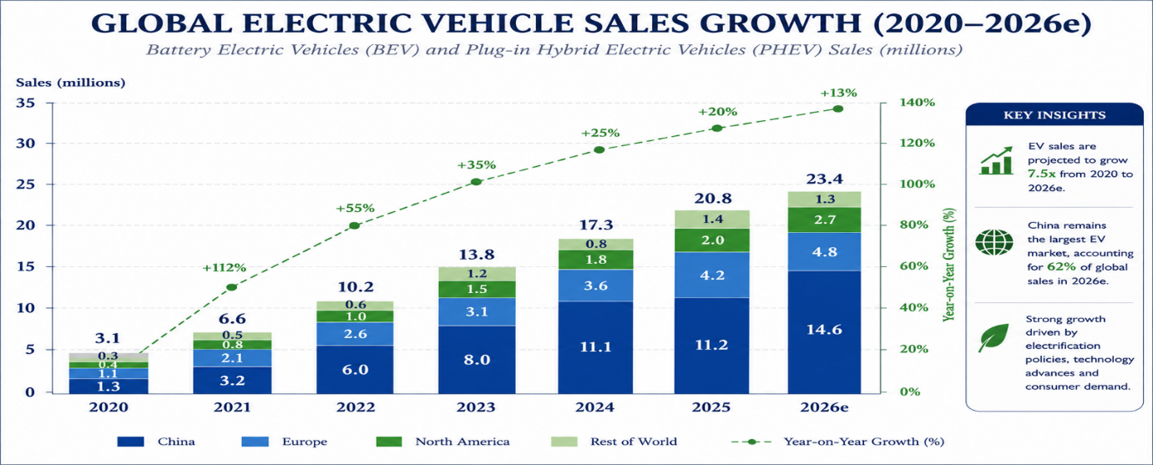
Figure 1: Global Electric Vehicle Sales Growth (2020–2026)
Source: Author's own figure, adapted from International Energy Agency (2026) Global EV Outlook 2026.
Figure 1 illustrates the continued expansion of the global electric vehicle market, reinforcing the strategic importance of electrification and digital innovation within the automotive sector (International Energy Agency, 2026).
The report begins by analysing the strategic drivers influencing JLR's operating environment before critically evaluating the Reimagine Strategy and comparing alternative change management models. It then examines the role of leadership, organisational culture and stakeholder engagement before presenting a Strategic Change Management Plan for implementing organisational change.

2.0 Strategic Drivers of Organisational Change
Jaguar Land Rover (JLR) operates within a rapidly evolving automotive industry characterised by technological innovation, environmental regulation and changing customer expectations. These interconnected drivers are reshaping competitive conditions and requiring manufacturers to adapt their business models, organisational capabilities and operational processes to remain competitive. Figure 2 summarises the principal strategic drivers influencing JLR's Reimagine Strategy. This chapter applies PESTLE analysis, Porter's Five Forces and SWOT analysis to evaluate JLR's external and internal environment before identifying the principal triggers for organisational change.
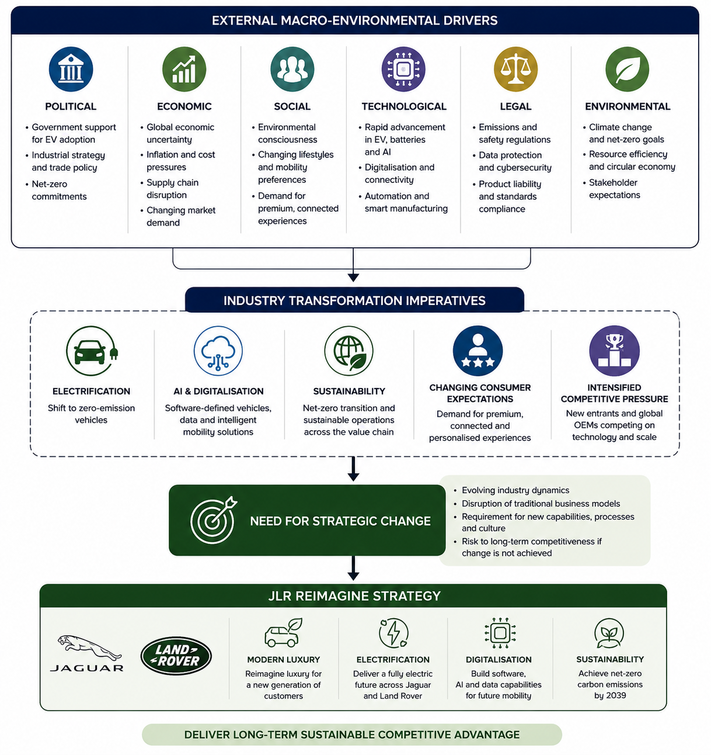
Figure 2: Strategic Drivers Influencing Jaguar Land Rover's Reimagine Strategy
Source: Author's own illustration, informed by Johnson et al., (2023), Porter (2008), Department for Transport (2025), Deloitte (2025) and Jaguar Land Rover (2021).

2.1 PESTLE Analysis
Table 1: PESTLE Analysis of Jaguar Land Rover (JLR)
Factor | Key Strategic Issues | Implications for JLR
Political | Net-zero policies and government support for zero-emission vehicles | Accelerates investment in electrification.
Economic | Inflation, supply chain disruption and global market uncertainty | Requires operational resilience and cost management.
Social | Demand for sustainable, connected and personalised mobility | Increases demand for premium electric vehicles.
Technological | AI, connectivity, software-defined vehicles and automation | Drives digital transformation and capability development.
Legal | Emissions regulation, safety standards and data protection | Requires ongoing compliance and investment.
Environmental | Carbon reduction targets and sustainability expectations | Supports JLR's net-zero strategy and sustainable manufacturing.

Source: Author's own analysis based on Johnson et al. (2023), Department for Transport (2025), Deloitte (2025) and Jaguar Land Rover (n.d.).
Political and environmental policies continue to accelerate the transition towards zero-emission mobility, whilst economic uncertainty and supply chain disruption require manufacturers to improve operational resilience. However, technological advances in artificial intelligence (AI), connectivity and software-defined vehicles represent the most significant driver of change because they are fundamentally reshaping product development, manufacturing and customer experience (Verhoef et al., 2021). Collectively, these factors demonstrate that JLR's transformation is driven by long-term structural change rather than short-term market fluctuations.

2.2 Industry Analysis: Porter's Five Forces
Porter's Five Forces framework indicates that Jaguar Land Rover (JLR) operates within an increasingly competitive premium automotive market, where sustaining competitive advantage depends on continuous innovation rather than brand heritage alone (Porter, 2008).
Table 2: Porter's Five Forces Analysis of Jaguar Land Rover (JLR)
Competitive Force | Impact on JLR
Competitive rivalry | High competition from premium manufacturers, including BMW, Mercedes-Benz, Audi, Tesla and emerging Chinese electric vehicle manufacturers such as BYD.
Threat of new entrants | Moderate. Significant capital investment creates barriers to entry; however, advances in digital technologies have enabled new competitors to enter the electric vehicle market.
Buyer power | High. Customers have greater access to information and increasing expectations regarding technology, sustainability and product quality.
Supplier power | Moderate to high due to dependence on semiconductor manufacturers, battery suppliers and specialist technology providers.
Threat of substitutes | Moderate, with changing mobility preferences, public transport, mobility-as-a-service and shared transport offering alternative transport solutions.

Source: Author's own analysis based on Porter (2008), Johnson et al. (2023) and Deloitte (2025).
The analysis indicates that competitive rivalry represents the strongest force influencing JLR because established automotive manufacturers and emerging electric vehicle producers continue investing heavily in electrification, digital technologies and product innovation. As technological capabilities become increasingly similar across competitors, maintaining competitive advantage requires differentiation through innovation, customer experience and premium brand positioning rather than traditional manufacturing strengths alone (Johnson et al., 2023).
Buyer power has also increased as customers have greater access to product information and a wider choice of premium electric vehicles, encouraging manufacturers to improve quality, sustainability and digital connectivity. At the same time, supplier power has strengthened because of the automotive industry's dependence on semiconductor manufacturers, battery suppliers and advanced technology providers. This dependence increases supply chain risk and highlights the strategic importance of developing resilient supplier relationships (Deloitte, 2025).
Overall, Porter's Five Forces demonstrates that JLR operates within a highly competitive environment characterised by technological disruption and evolving customer expectations. These industry pressures reinforce the need for continuous innovation and support the strategic rationale underpinning the Reimagine Strategy.

2.3 Internal Analysis: SWOT Analysis
The SWOT analysis demonstrates that JLR possesses significant strategic strengths, including a globally recognised premium brand, established engineering expertise and a clear strategic commitment to electrification. These capabilities provide a strong foundation for implementing the Reimagine Strategy.
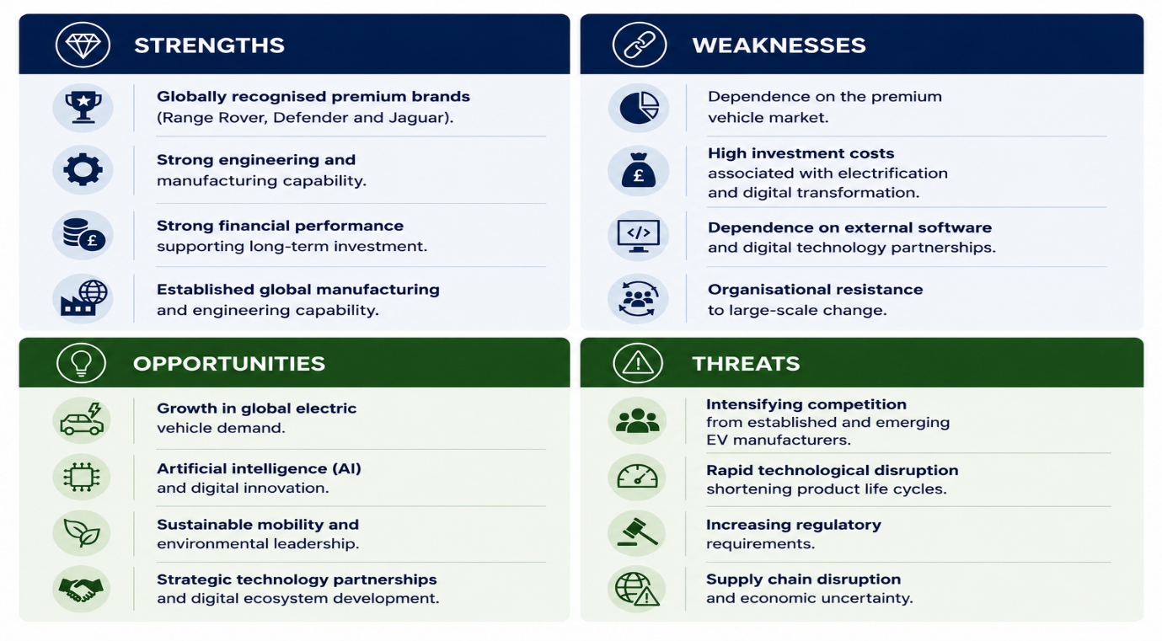
Figure 3: SWOT Analysis of Jaguar Land Rover (JLR)
Source: Author's own analysis based on Johnson et al. (2023), Jaguar Land Rover (2025a) and Deloitte (2025).
Despite these strengths, JLR faces important challenges, including high investment requirements, increasing competitive pressure and dependence on global supply chains. Successfully addressing these issues will require continued investment in organisational capability, operational flexibility and technological innovation (Jaguar Land Rover, 2025a; Deloitte, 2025).

2.4 Triggers for Organisational Change
The environmental and organisational analyses demonstrate that JLR's transformation is driven by several interconnected triggers for change. Technological disruption is the most significant, as advances in artificial intelligence (AI), software-defined vehicles and connected technologies are reshaping vehicle development, manufacturing and customer expectations (Verhoef et al., 2021). At the same time, increasingly stringent environmental regulation and growing demand for sustainable mobility have accelerated investment in electrification and reinforced the strategic importance of the Reimagine Strategy (Department for Transport, 2025; Jaguar Land Rover, 2021).
Competitive pressure further intensifies the need for change as established manufacturers and emerging electric vehicle producers continue investing heavily in digital technologies and battery electric vehicles (Porter, 2008). Collectively, these technological, regulatory and competitive pressures create a compelling case for organisational transformation and justify the implementation of JLR's Reimagine Strategy.

2.5 Chapter Summary
The strategic analysis demonstrates that JLR operates within an environment characterised by rapid technological advancement, increasing regulatory pressure and intensifying competition. Whilst the organisation possesses significant strategic strengths, maintaining competitiveness will depend on its ability to respond effectively to the key triggers for organisational change identified in this chapter. These findings provide the strategic context for the critical evaluation of the Reimagine Strategy presented in Chapter 3.

3.0 Critical Evaluation of the Reimagine Strategy
Jaguar Land Rover's (JLR) Reimagine Strategy represents a long-term response to the structural changes reshaping the premium automotive industry. Introduced in 2021, the strategy aims to reposition JLR as a sustainable modern luxury manufacturer through electrification, digital innovation and environmental sustainability (Jaguar Land Rover, 2021). This chapter critically evaluates whether the strategy effectively addresses the external and internal challenges identified in Chapter 2, while recognising the opportunities and limitations that may influence its successful delivery.

3.1 Strategic Objectives of the Reimagine Strategy
Jaguar Land Rover's (JLR) Reimagine Strategy aims to reposition the organisation as a sustainable modern luxury manufacturer by integrating electrification, digital innovation and environmental sustainability into its long-term business strategy (Jaguar Land Rover, 2021). Its principal strategic priorities include expanding the battery electric vehicle (BEV) portfolio, developing software-defined and connected vehicle technologies, strengthening manufacturing capability and achieving net-zero carbon emissions by 2039 (Jaguar Land Rover, n.d.). Collectively, these objectives demonstrate JLR's commitment to responding proactively to changing customer expectations, technological innovation and increasingly stringent environmental regulation.
Table 4: Strategic Objectives of the Reimagine Strategy
Strategic Objective | Purpose | Expected Outcome
Electrification | Expand the battery electric vehicle portfolio | Enhanced competitiveness within the premium electric vehicle market
Digital transformation | Develop software-defined and connected vehicle technologies | Improved customer experience and digital capability
Sustainability | Achieve net-zero carbon emissions by 2039 | Greater environmental sustainability and regulatory compliance
Modern luxury | Strengthen premium brand positioning | Increased market differentiation and long-term competitive advantage

Source: Author's own table, adapted from Jaguar Land Rover (2021; 2025a).
The strategic objectives demonstrate strong alignment with the external drivers identified in Chapter 2, particularly the increasing demand for electrification, digital transformation and sustainable mobility. However, the successful delivery of these objectives depends not only on strategic intent but also on JLR's ability to secure significant financial investment, develop workforce capability and implement organisational change effectively. Furthermore, competitors are pursuing similar strategic priorities, reducing opportunities for differentiation through technology alone. Consequently, sustained competitive advantage will depend on JLR's ability to combine technological innovation with operational excellence, organisational agility and the consistent delivery of customer value (Johnson et al., 2023; Verhoef et al., 2021).

3.2 Critical Evaluation of the Reimagine Strategy
The Reimagine Strategy responds effectively to the strategic drivers identified in Chapter 2 by prioritising electrification, digital capability and sustainability. Investment in battery electric vehicles and software-defined technologies positions JLR to respond to evolving customer expectations and regulatory requirements (Jaguar Land Rover, 2021).
However, the strategy's effectiveness depends on successful execution rather than strategic intent alone. Nevertheless, implementation requires significant investment, organisational adaptability and continuous innovation. Furthermore, competitors are pursuing similar strategic priorities, reducing opportunities for differentiation through electrification alone. Consequently, JLR's competitive position will increasingly depend on its ability to integrate technological innovation with operational excellence and customer value (Verhoef et al., 2021).
Overall, the Reimagine Strategy provides a coherent framework for future growth, but its long-term effectiveness will depend on the organisation's ability to translate strategic ambition into measurable business performance.

3.3 Implementation Challenges
Successful implementation of the Reimagine Strategy requires JLR to address several organisational and operational challenges. Investment in electrification, digital infrastructure and workforce capability places considerable pressure on financial resources, while dependence on advanced technologies and global supply chains increases operational complexity and potential disruption (Jaguar Land Rover, 2025a).
Organisational readiness is equally important. Employees must acquire new technical capabilities and adapt to revised ways of working, requiring effective leadership, workforce development and clear communication to encourage engagement and minimise resistance (Hayes, 2022). In addition, the rapid pace of technological change requires JLR to remain agile, continuously reviewing its capabilities and responding proactively to evolving market conditions.
Collectively, these challenges demonstrate that strategic success depends not only on the quality of the Reimagine Strategy but also on JLR's ability to translate strategic ambition into effective organisational delivery. Addressing these challenges requires an appropriate change management approach capable of supporting organisational adaptation, employee engagement and sustained behavioural change. The following chapter therefore evaluates alternative change management models to identify the most appropriate framework for implementing the Reimagine Strategy.

3.4 Chapter Summary
The Reimagine Strategy provides a well-defined response to the strategic drivers identified in Chapter 2 by prioritising electrification, digital innovation and sustainability. However, its effectiveness will depend on JLR's ability to overcome organisational challenges, develop workforce capability and successfully embed change across the business. These findings demonstrate the need for an appropriate change management approach to support implementation. The following chapter therefore evaluates alternative change management models to determine the most suitable framework for delivering the Reimagine Strategy.

4.0 Evaluation and Selection of Change Management Models
Successful organisational transformation depends not only on a clear strategic direction but also on the selection of an appropriate change management approach. As discussed in Chapter 3, implementing JLR's Reimagine Strategy requires more than technological investment; it also demands organisational readiness, employee engagement and the successful integration of new ways of working. This chapter critically evaluates Lewin's Three-Step Model, Kotter's Eight-Step Model and the ADKAR Model to determine the most appropriate framework for supporting JLR's transformation.

4.1 Evaluation of Lewin's Three-Step Model
Lewin's Three-Step Model provides a structured framework for managing organisational change through the sequential stages of Unfreeze, Change and Refreeze (Lewin, 1947). Its emphasis on preparing employees for change, supporting behavioural adaptation and reinforcing new organisational practices makes it particularly relevant to JLR's transition towards electrification and digital transformation (Burnes, 2020).
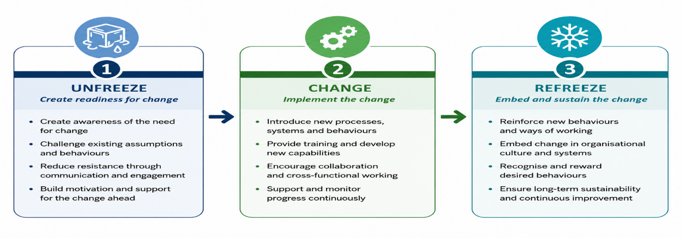
Figure 4. Application of Lewin's Three-Step Model to the Reimagine Strategy
Source: Adapted from Lewin (1947), Burnes (2020) and Hayes (2022).
A key strength of Lewin's model is its focus on organisational readiness before implementation and the reinforcement of new behaviours once change has been introduced. This aligns with JLR's need to develop workforce capability alongside technological investment. However, the model has been criticised for presenting change as a linear process, whereas organisations increasingly operate in environments characterised by continuous adaptation (Hayes, 2022). Nevertheless, when applied iteratively rather than as a one-off process, Lewin's framework provides a practical and flexible approach for embedding strategic change across the organisation.

4.2 Comparison with Kotter's Eight-Step Model and the ADKAR Model
Whilst Lewin's Three-Step Model provides the principal framework for this report, Kotter's Eight-Step Model and the ADKAR Model offer valuable perspectives on organisational change. Kotter (1996) places greater emphasis on leadership, vision and sustaining momentum through a structured eight-stage process. Its focus on building urgency and creating organisational commitment makes it particularly effective for large-scale transformational change. However, the model can be resource-intensive and less flexible, particularly where organisations must respond quickly to evolving market conditions.
The ADKAR Model adopts a different perspective by focusing on individual behavioural change through five sequential stages: Awareness, Desire, Knowledge, Ability and Reinforcement (Hiatt, 2006). Its strength lies in supporting employee engagement and identifying individual barriers to change, making it particularly useful where workforce adoption is critical. However, because the model concentrates primarily on individual change, it provides less strategic guidance for managing organisation-wide transformation.
Both models offer valuable principles that complement JLR's transformation. Kotter highlights the importance of leadership and strategic vision, whilst ADKAR reinforces employee engagement and capability development. Nevertheless, neither provides the same balance between organisational readiness, behavioural change and long-term reinforcement as Lewin's Three-Step Model, which more closely aligns with the objectives of the Reimagine Strategy.

4.3 Justification for Selecting Lewin's Three-Step Model
Based on the comparative evaluation, Lewin's Three-Step Model provides the most appropriate framework for supporting the implementation of JLR's Reimagine Strategy. Unlike Kotter's Eight-Step Model, which places greater emphasis on leadership activities and sequential implementation, Lewin offers a more adaptable framework that focuses on organisational readiness, behavioural change and the reinforcement of new working practices (Burnes, 2020). These characteristics closely reflect JLR's requirement to integrate technological innovation with workforce capability and organisational adaptation.
Although the ADKAR Model strengthens employee engagement by addressing individual behavioural change, it provides less strategic guidance for managing organisation-wide transformation (Hiatt, 2006). In contrast, Lewin's model balances organisational and behavioural perspectives, enabling JLR to prepare employees for change, implement new technologies and embed revised practices within everyday operations.
Consequently, Lewin's Three-Step Model offers the strongest foundation for implementing the Reimagine Strategy because it aligns strategic objectives with practical organisational change. Its emphasis on preparation, implementation and reinforcement provides a coherent framework for supporting sustainable transformation across the organisation.

4.4 Chapter Summary
The evaluation demonstrates that each change management model offers valuable perspectives on organisational transformation. However, Lewin's Three-Step Model provides the strongest strategic fit for JLR because it combines organisational readiness, behavioural change and long-term reinforcement within a practical framework for managing change. Consequently, Lewin's model provides the most appropriate foundation for supporting the implementation of the Reimagine Strategy (Burnes, 2020; Hayes, 2022).

5.0 Leadership, Organisational Culture and Stakeholder Engagement
Successful organisational change depends not only on selecting an appropriate change management model but also on the people responsible for implementing and sustaining change. Leadership, organisational culture and stakeholder engagement influence organisational readiness, employee commitment and the successful adoption of new ways of working. This chapter critically evaluates these organisational factors and their contribution to the successful implementation of JLR's Reimagine Strategy (Hayes, 2022; Schein and Schein, 2021).

5.1 Leadership Styles and Their Impact on Organisational Change
Effective leadership is fundamental to organisational transformation because it influences employee commitment, organisational readiness and the successful adoption of change (Northouse, 2022). Different leadership styles offer distinct approaches to managing organisational change, with their effectiveness depending upon the strategic context.
Transformational leadership is particularly appropriate for JLR's Reimagine Strategy because it encourages innovation, communicates a shared vision and motivates employees to embrace organisational change. As JLR transitions towards electrification and digital transformation, leaders must foster collaboration, continuous learning and adaptability to support new technologies and revised ways of working (Bass and Riggio, 2006).
In contrast, transactional leadership focuses on performance management, clearly defined responsibilities and reward systems. Whilst this approach strengthens operational control and accountability, it is less effective in promoting innovation because it emphasises maintaining established performance rather than encouraging organisational transformation (Northouse, 2022).
Situational leadership recognises that leadership approaches should vary according to employee capability and organisational circumstances. During large-scale transformation, leaders may need to adopt more directive or supportive behaviours depending on workforce readiness, making this approach particularly valuable during different stages of implementation (Hersey, Blanchard and Johnson, 2013).
Overall, transformational leadership provides the strongest strategic fit for JLR because it supports innovation, employee engagement and organisational learning. However, combining transformational leadership with situational flexibility and transactional controls would enable JLR to balance strategic vision with effective operational delivery throughout the implementation of the Reimagine Strategy.

5.2 Organisational Culture and Its Impact on Organisational Change
Organisational culture influences how employees perceive, accept and sustain organisational change. A culture that promotes innovation, collaboration and continuous learning strengthens organisational adaptability and supports the successful implementation of strategic transformation (Schein and Schein, 2021; Burnes, 2020).
Several models provide different perspectives on organisational culture. Schein's model explains culture through three interconnected levels: artefacts, espoused values and underlying assumptions. This framework is particularly valuable because it demonstrates that successful organisational change requires behavioural change alongside changes in organisational values and beliefs (Schein and Schein, 2021). Burnes (2020) similarly argues that sustainable organisational change is difficult to achieve unless cultural values and employee behaviours support the strategic direction of the organisation.
In contrast, Hofstede's cultural dimensions focus primarily on national culture and how cultural differences influence organisational behaviour across countries (Hofstede, Hofstede and Minkov, 2010). Whilst valuable for multinational organisations such as JLR, the model provides less guidance for managing internal organisational transformation.
Similarly, Handy's cultural typology categorises organisations according to power, role, task and person cultures, offering useful insights into organisational structure and decision-making (Handy, 1993). However, it is less effective in explaining how organisational culture evolves during large-scale change.
Overall, Schein's model provides the strongest framework for JLR because it emphasises aligning organisational values, behaviours and underlying assumptions with strategic objectives. Developing a culture that encourages innovation, collaboration and continuous learning will strengthen employee engagement and improve the long-term sustainability of the Reimagine Strategy (Schein and Schein, 2021; Burnes, 2020).

5.3 Stakeholder Engagement and Its Impact on Organisational Change
Stakeholder engagement is a critical factor in the successful delivery of organisational change because it builds trust, reduces resistance and encourages shared ownership of strategic initiatives. Large-scale transformation affects multiple stakeholder groups, including employees, suppliers, customers, investors and regulatory bodies, each of whom can influence organisational performance and the successful implementation of change (Hayes, 2022).
For JLR, effective stakeholder engagement is particularly important because the Reimagine Strategy requires collaboration across the organisation and throughout its supply chain. Early consultation and regular engagement enable concerns to be identified, improve decision-making and strengthen stakeholder commitment to strategic objectives. Engaging stakeholders throughout the change process also supports organisational learning by encouraging feedback and continuous improvement.
Although stakeholder engagement cannot eliminate all resistance to change, it improves transparency, strengthens relationships and increases the likelihood of successful implementation. Consequently, meaningful stakeholder engagement should be regarded as a strategic capability that supports the long-term sustainability of JLR's organisational transformation.

5.4 Chapter Summary
Leadership, organisational culture and stakeholder engagement collectively influence the successful implementation and long-term sustainability of organisational change. The comparative evaluation of leadership styles and organisational culture models indicates that transformational leadership and Schein's organisational culture framework provide the strongest strategic fit for supporting JLR's Reimagine Strategy. These people-centred factors provide the foundation for the Strategic Change Management Plan presented in the following chapter (Hayes, 2022; Schein and Schein, 2021).

6.0 Strategic Change Management Plan
The successful delivery of JLR's Reimagine Strategy requires a structured implementation approach that translates strategic objectives into practical organisational actions. Building on the evaluation of Lewin's Three-Step Model in Chapter 4 and the people-centred considerations discussed in Chapter 5, this chapter presents a Strategic Change Management Plan to support the implementation, monitoring and long-term sustainability of organisational change. The plan incorporates an implementation framework, communication strategy, performance measures and risk management to support effective organisational transformation.
The Strategic Change Management Plan translates the findings of Chapters 2–5 into a structured implementation programme designed to support the successful delivery of JLR's Reimagine Strategy.

6.1 Stakeholder Analysis
Successful implementation of the Reimagine Strategy requires JLR to understand the interests and influence of key stakeholders throughout the change process. Stakeholder analysis enables the organisation to prioritise engagement activities, allocate resources effectively and reduce potential resistance to change. Identifying stakeholder expectations at an early stage also supports informed decision-making and strengthens organisational commitment to the transformation programme (Hayes, 2022).
Table 5: Stakeholder Analysis for the Reimagine Strategy
Stakeholder | Interest in Change | Level of Influence | Engagement Strategy
Employees | Job security, skills development and career opportunities | High | Continuous consultation, training and involvement in decision-making
Senior Leadership Team | Strategic performance and successful implementation | High | Regular progress reviews and strategic oversight
Suppliers | Supply chain continuity and long-term partnerships | Medium–High | Collaborative planning and regular communication
Customers | Sustainable, innovative and high-quality products | Medium | Product updates, marketing communications and customer feedback
Investors | Financial performance and long-term business growth | High | Performance reporting and investor briefings
Regulators | Compliance with environmental and safety legislation | High | Ongoing compliance monitoring and regulatory reporting

Source: Author's own table, informed by Hayes (2022), Johnson et al. (2023) and Lock (2003).
The stakeholder analysis demonstrates that different stakeholder groups require different engagement approaches according to their level of influence and interest in the transformation. Prioritising high-influence stakeholders, whilst maintaining effective communication with all stakeholder groups, will strengthen organisational support and improve the successful delivery of the Reimagine Strategy.

6.2 Implementation Framework
Following the stakeholder analysis, the implementation framework applies Lewin's Three-Step Model to guide the delivery of JLR's Reimagine Strategy. Whilst Chapter 4 established Lewin's suitability as the preferred change management approach, this section demonstrates how each stage can be applied to support organisational readiness, implementation and the long-term integration of change. Integrating Lewin's behavioural framework with structured project management principles strengthens coordination, accountability and performance monitoring throughout the transformation process (Burnes, 2020; Lock, 2003).
Table 6: Implementation Framework Based on Lewin's Three-Step Model
Lewin's Stage | Key Implementation Activities | Expected Outcome
Unfreeze | Communicate the strategic vision, engage stakeholders, identify capability gaps and deliver employee training. | Organisational readiness and reduced resistance to change.
Change | Implement electrification initiatives, digital technologies, revised operational processes and workforce development programmes. | Successful adoption of new ways of working and strategic initiatives.
Refreeze | Reinforce change through performance management, continuous learning, recognition and regular performance reviews. | Sustainable organisational change embedded within everyday operations.

Source: Author's own table, adapted from Lewin (1947), Burnes (2020), Hayes (2022) and Lock (2003).
The implementation framework provides a structured approach for translating strategic objectives into practical organisational actions. Applying Lewin's Three-Step Model alongside project management principles enables JLR to coordinate implementation activities, monitor progress and reinforce new behaviours across the organisation. This integrated approach supports the long-term sustainability of the Reimagine Strategy by aligning behavioural change with effective project delivery.

6.3 Communication Plan
Effective communication is essential for supporting organisational change by reducing uncertainty, strengthening stakeholder confidence and encouraging employee commitment throughout implementation. A structured communication plan ensures that key stakeholders receive consistent, timely and relevant information, supporting organisational readiness during the Unfreeze stage and maintaining engagement throughout the transformation process (Hayes, 2022).
Table 7: Communication Plan for the Reimagine Strategy
Stakeholder | Communication Objective | Method | Frequency | Responsibility
Employees | Communicate the purpose of the Reimagine Strategy and organisational changes | Town hall meetings, team briefings and intranet updates | Monthly | Senior Leadership Team
Line Managers | Provide implementation updates and coordinate departmental activities | Management meetings and progress reports | Fortnightly | Project Manager
Suppliers | Communicate operational requirements and implementation timelines | Supplier meetings and email updates | Monthly | Procurement Manager
Customers | Promote sustainability initiatives and new product developments | Website, social media and marketing campaigns | Quarterly | Marketing Department
Investors | Report implementation progress and organisational performance | Investor briefings and annual reports | Quarterly | Executive Leadership Team

Source: Author's own table, informed by Hayes (2022) and Lock (2003).
The communication plan promotes transparency, strengthens stakeholder engagement and supports effective coordination throughout the implementation process. Clearly defining communication responsibilities, methods and reporting frequencies enables JLR to maintain stakeholder confidence and reinforce organisational commitment to the successful delivery of the Reimagine Strategy.

6.4 Financial and Resource Plan
The successful implementation of the Reimagine Strategy requires adequate financial investment and the effective allocation of organisational resources. Beyond technological investment, JLR must ensure that sufficient resources are available to support workforce development, project management and stakeholder engagement throughout the transformation process. Aligning financial and human resources with strategic priorities strengthens implementation capability and supports the long-term sustainability of organisational change (Lock, 2003; Hayes, 2022).
Table 8: Financial and Resource Plan
Resource Area | Investment Priority | Purpose
Workforce training | Technical skills development | Equip employees with the capabilities required for electrification, AI and digital technologies.
Digital infrastructure | Software, AI and connected vehicle technologies | Support innovation, operational efficiency and digital transformation.
Project management | Implementation teams and project coordination | Ensure effective planning, monitoring and delivery of change initiatives.
Communication and engagement | Employee and stakeholder communication activities | Maintain stakeholder commitment and reduce resistance throughout implementation.
Performance monitoring | KPI systems and performance reviews | Evaluate implementation progress and support continuous organisational improvement.

Source: Author's own table, adapted from Lock (2003), Hayes (2022) and Jaguar Land Rover (2021).
Effective resource allocation enables JLR to coordinate organisational, financial and technological investments in support of the Reimagine Strategy. Regular reviews of resource utilisation will help ensure that implementation remains aligned with strategic priorities, enabling the organisation to respond effectively to emerging challenges while maintaining operational performance.

6.5 Risk Management and Mitigation Plan
Effective risk management is essential to minimise disruption and support the successful implementation of JLR's Reimagine Strategy. Identifying potential risks and implementing appropriate mitigation strategies enables the organisation to maintain implementation progress, strengthen organisational resilience and respond proactively to emerging challenges (Lock, 2003; Hayes, 2022).
Table 9: Risk Management and Mitigation Plan
Risk | Potential Impact | Mitigation Strategy | Responsibility
Employee resistance to change | Delays in implementation and reduced employee engagement | Deliver leadership support, employee training and continuous communication | Senior Leadership Team
Supply chain disruption | Production delays and increased operational costs | Diversify suppliers and strengthen supplier relationships | Procurement Manager
Skills shortages | Reduced capability to support electrification and digital technologies | Invest in workforce development and targeted technical training | Human Resources
Technology implementation delays | Slower deployment of digital systems and operational disruption | Phase implementation, monitor milestones and allocate contingency resources | Project Manager
Regulatory changes | Increased compliance requirements and implementation delays | Monitor legislative developments and conduct regular compliance reviews | Compliance Manager

Source: Author's own table, adapted from Lock (2003), Hayes (2022) and Jaguar Land Rover (2025a).
Regular monitoring and review of implementation risks enable JLR to respond proactively to changing organisational and external conditions. Clearly defined responsibilities and mitigation strategies strengthen accountability, minimise disruption and support the successful delivery of the Reimagine Strategy.

6.6 Performance Evaluation and Key Performance Indicators (KPIs)
Monitoring organisational performance is essential to evaluate the successful implementation of the Reimagine Strategy. Establishing clear Key Performance Indicators (KPIs) enables JLR to measure progress against strategic objectives, strengthen accountability and identify areas requiring corrective action throughout the implementation process (Lock, 2003; Hayes, 2022).
Table 10: Performance Evaluation Framework
Strategic Objective | Key Performance Indicator (KPI) | Target | Review Frequency
Expand battery electric vehicle (BEV) portfolio | Percentage of BEV sales | Increase annually in line with the Reimagine Strategy | Quarterly
Strengthen digital transformation | Percentage of new vehicles using software-defined technology | Full implementation across new platforms by 2028 | Quarterly
Develop workforce capability | Percentage of employees completing technical training | 100% of targeted employees within 24 months | Six-monthly
Improve sustainability performance | Reduction in operational carbon emissions | Achieve net-zero operational emissions by 2039 | Annually
Enhance customer satisfaction | Customer satisfaction index and brand perception | Year-on-year improvement | Quarterly

Source: Author's own table, adapted from Jaguar Land Rover (2021; 2025a), Lock (2003) and Hayes (2022).
Regular performance reviews enable JLR to assess implementation progress, evaluate organisational performance and respond promptly to emerging issues. Using measurable KPIs supports evidence-based decision-making and helps ensure that the Reimagine Strategy remains aligned with its strategic objectives throughout the transformation process.

6.7 Chapter Summary
The Strategic Change Management Plan provides a structured approach for implementing JLR's Reimagine Strategy through stakeholder analysis, Lewin's Three-Step Model and practical management tools, including communication planning, resource allocation, performance evaluation and risk management. Collectively, these elements strengthen organisational readiness, support effective implementation and enhance the long-term sustainability of organisational change (Burnes, 2020; Hayes, 2022).

7.0 Discussion and Critical Reflection
The proposed Strategic Change Management Plan provides a structured framework for implementing Jaguar Land Rover's (JLR) Reimagine Strategy by integrating stakeholder analysis, Lewin's Three-Step Model, communication planning, performance evaluation and risk management (Burnes, 2020; Hayes, 2022). By combining strategic planning with behavioural change principles, the plan supports organisational readiness and the effective implementation of change.
A key strength of the plan is its alignment of strategic objectives with practical implementation activities. It recognises that successful transformation depends not only on technological innovation but also on leadership, employee engagement and organisational culture (Schein and Schein, 2021). However, the analysis is based on publicly available information and therefore does not reflect confidential organisational data or internal operational challenges. Furthermore, although Lewin's Three-Step Model provides a practical framework for managing change, organisations operating in rapidly evolving industries may require greater flexibility and continuous adaptation (Burnes, 2020).
Overall, the proposed plan provides a practical foundation for supporting JLR's transformation. Its long-term success will depend on effective implementation, continuous performance monitoring and the organisation's ability to adapt to changing market conditions while maintaining stakeholder commitment and organisational learning.

8.0 Conclusion
This report has demonstrated that Jaguar Land Rover's (JLR) Reimagine Strategy provides a coherent response to the technological, competitive and environmental challenges reshaping the premium automotive industry. The strategic analysis confirmed that electrification, digital transformation, artificial intelligence (AI) and increasing sustainability expectations are key drivers of organisational change, reinforcing the need for a structured approach to transformation (Johnson et al., 2023; Verhoef et al., 2021).
Following the evaluation of established change management models, Lewin's Three-Step Model was identified as the most appropriate framework for supporting JLR's organisational transformation because of its emphasis on organisational readiness, behavioural change and long-term reinforcement (Burnes, 2020). The proposed Strategic Change Management Plan further demonstrated how stakeholder engagement, effective communication, resource allocation, performance evaluation and risk management can support successful implementation.
Overall, JLR has a clear strategic direction for future growth. However, achieving sustainable competitive advantage will depend on the organisation's ability to implement change effectively, develop organisational capability and adapt to future technological and market developments (Hayes, 2022).

References

Bass, B.M. and Riggio, R.E. (2006) Transformational leadership. 2nd edn. Mahwah, NJ: Lawrence Erlbaum Associates.
Burnes, B. (2020) Managing change. 8th edn. Harlow: Pearson.
Deloitte (2025) 2025 global automotive consumer study. London: Deloitte Insights. Available at: https://www.deloitte.com (Accessed: 26 June 2026).
Department for Transport (2025) The transition to zero emission vehicles: Progress report. London: Department for Transport.
Handy, C. (1993) Understanding organizations. 4th edn. London: Penguin Books.
Hayes, J. (2022) The theory and practice of change management. 6th edn. London: Bloomsbury Publishing.
Hersey, P., Blanchard, K.H. and Johnson, D.E. (2013) Management of organizational behavior: Leading human resources. 10th edn. Harlow: Pearson.
Hiatt, J. (2006) ADKAR: A model for change in business, government and our community. Loveland, CO: Prosci Learning Centre Publications.
Hofstede, G., Hofstede, G.J. and Minkov, M. (2010) Cultures and organizations: Software of the mind. 3rd edn. New York: McGraw-Hill.
International Energy Agency (2026) Global EV outlook 2026. Paris: International Energy Agency. Available at: https://www.iea.org/reports/global-ev-outlook-2026 (Accessed: 26 June 2026).
Jaguar Land Rover (2021) Reimagine: A strategy for modern luxury. Available at: https://media.jaguarlandrover.com/news/2021/02/reimagine-strategy-modern-luxury (Accessed: 26 June 2026).
Jaguar Land Rover (2022) Jaguar Land Rover partners with NVIDIA to develop next-generation software-defined vehicles. Available at: https://media.jaguarlandrover.com/news/2022/02/jaguar-land-rover-partners-nvidia (Accessed: 26 June 2026).
Jaguar Land Rover (2023) JLR announces £15 billion investment to accelerate modern luxury strategy. Available at: https://media.jaguarlandrover.com/news/2023/04/jlr-accelerates-modern-luxury-strategy (Accessed: 26 June 2026).
Jaguar Land Rover (2025a) Annual report 2024/25. Coventry: Jaguar Land Rover. Available at: https://www.jaguarlandrover.com/investors (Accessed: 26 June 2026).
Jaguar Land Rover (n.d.) Sustainability. Available at: https://www.jaguarlandrover.com/sustainability (Accessed: 26 June 2026).
Johnson, G., Scholes, K., Whittington, R. and Angwin, D. (2023) Exploring strategy: Text and cases. 13th edn. Harlow: Pearson.
Kotter, J.P. (1996) Leading change. Boston, MA: Harvard Business School Press.
Lewin, K. (1947) Frontiers in group dynamics. Human Relations, 1(1), pp. 5–41.
Lock, D. (2003) Project management. 8th edn. Aldershot: Gower Publishing.
Northouse, P.G. (2022) Leadership: Theory and practice. 9th edn. Thousand Oaks, CA: Sage.
Porter, M.E. (2008) The five competitive forces that shape strategy. Harvard Business Review, 86(1), pp. 78–93.
Schein, E.H. and Schein, P.A. (2021) Organizational culture and leadership. 6th edn. Hoboken, NJ: John Wiley & Sons.
Verhoef, P.C., Broekhuizen, T., Bart, Y., Bhattacharya, A., Dong, J.Q., Fabian, N. and Haenlein, M. (2021) Digital transformation: A multidisciplinary reflection and research agenda. Journal of Business Research, 122, pp. 889–901.
Vial, G. (2019) Understanding digital transformation: A review and a research agenda. The Journal of Strategic Information Systems, 28(2), pp. 118–144.

