Exercises for lists in Python (2)

2a. Using float

Create an empty list to hold some temperatures.

temps = []

2b. Allow the user to enter 6 temperature readings into your list. Use .append() and preferably a for loop!

Sample output:

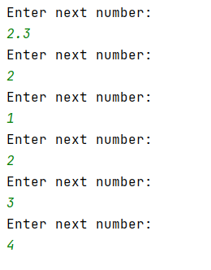

2c. Print out the numbers entered by the user.

Sample output:

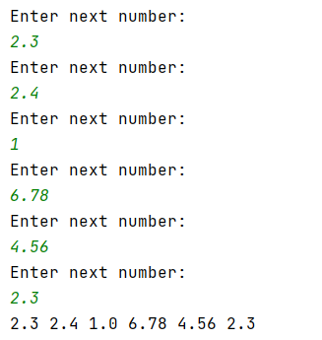

2d. Allow the user to select which element they would like to see.

Sample output:

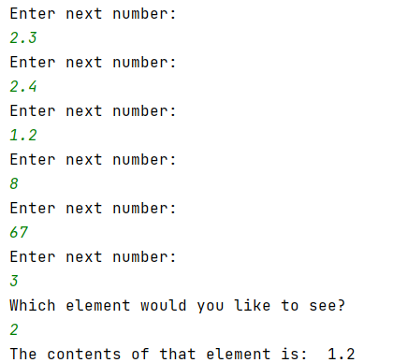

3a Create a program with the following list:

theNumbers = [2, 4, 3, 7, 3, 1, 3, 8, 9]

3b Multiply every list item by 2 and print the result on the screen:

Sample output:

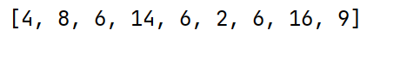

3c (Harder) – Find the average of the following list (ie add the contents of the list – preferably using a loop – and then divide by the number of entries in the list)

theNumbers = [2, 4, 3, 7, 3, 1, 3, 8, 9]

Sample output:

4a. Create 2 lists, one of strings and one of integers with 8 entries. The string list will hold names, the integer list will hold telephone extension numbers eg. 4234, 6545

4b. Print the lists on the screen as shown in the sample output below, using a for loop.

Sample output:

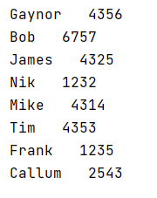

4c (Harder) Allow the user to enter a name. Look through the list and find the name. When you find it, print out the number associated with that name.

Sample output:



