

Postgraduate/Distance Learning
Assignment coversheet & feedback form

THIS SHEET MUST BE THE FIRST PAGE OF THE ASSIGNMENT YOU ARE SUBMITTING (DO NOT SEND AS A SEPARATE FILE)

For completion by the student:
Student Name:
Maya Galimidi
Student University Email: 2014078@student.uwtsd.ac.uk
Module code:  HPCA7019  Module title: Sacred Skies | Student ID number:  2014078 |  |  | Educational support needs:  Yes/No  I do have Dysgraphia and Dyslexia
Assignment title: Comparing and contrasting artworks of Rain Room, CLOUD and Your waste of time

Assignment due date:14.05.2021
This assignment is for the 1st 2nd 3rd 4th 5th 6th module of the degree
Second assignment
I confirm that this is my original work and that I have adhered to the University policy on plagiarism.
Signed: M. Galimidi ………………………………………………………
Email submission: If you are submitting this form via email, please tick this box x□
(as a substitute for your signature) to confirm that you agree to the above declaration.
Assignment Mark
1st Marker's Provisional mark
2nd Marker's/Moderator's provisional mark
External Examiner's mark (if relevant)
Final Mark

NB. All marks are provisional until confirmed by the Final Examination Board.

For completion by Marker 1:
Comments:

Marker's signature: |  |  | Date:
For completion by Marker 2/Moderator:

Comments:

Marker's Signature: |  | Date:
External Examiner's comments (if relevant)

External Examiner's Signature: |  | Date:

Comparing and contrasting artworks of Rain Room, CLOUD and Your waste of time
Word Count: 5096
Introduction
This essay will compare Rain Room, an art piece by Hannes Koch and Florian Ortkrass of Random International, 2013, Your waste of time art piece of Olafur Eliasson, 2006 and CLOUD, an art sculpture by Caitlind r.c. Brown and Wayne Garrett, 2012. Rain Room is an art installation experiential artwork exhibited in various places, mainly in New York MoMa and at the Barbican Centre in London, England. Both Koch and Ortkrass are German artists. The artwork was created in 2013. Your waste of time is an art piece by Olafur Eliasson created in 2006. It is made from several ice blocks from Vatnajökull, the largest glacier in Iceland, placed in monumental city centres or inside famous art exhibitions. Your waste of time was created in Iceland as Eliasson is from Iceland. CLOUDis an art sculpture by Caitlind r.c. Brown and Wayne Garrett at the Garage Center for Contemporary Cultures in Moscow, Russia. It was created in 2012 by Canadian artists.
Comparing and contrasting the three artworks regarding different weather conditions will mainly concentrate on the connection between humans and the sky through weather interaction. Firstly, the three main concepts that emerge are that the artworks are by artists that make people participate, experience and understand the skies using their senses. This participation transforms the skies from something intangible to something tangible and directly experienced with the senses. Secondly, throughout civilisations, people's cultural concepts and urge to control the weather will be examined according to the cultural context of the skies. Thirdly, the essay will consider how the artworks represent climate change, waste and time through the materials they use or the time people spend with them.
When people participate in the artwork, they suddenly appreciate that one can understand the abstract through their senses. Artworks with their cultural and political representation also communicate to humanity by stating that every individual has an impact.
Introducing work of arts
Rain Room by Hannes Koch and Florian Ortkrass of Random International

Random International: Rain Room, MOMA, (2013), https://www.moma.org/calendar/exhibitions/1352 [accessed 27 April 2021]
Rain Room is a room ‘composed of a 5,000 square-foot field of falling water; the Rain Room offers visitors the experience of controlling the rain’. In the Rain Room, where ‘rain is falling according to the visitor's body movements. It shows the connection between human and nature. Rain Room offers visitors the experience of controlling the rain—its carefully choreographed downpour pauses and creates a dry path wherever a human body is detected. Therefore the visitors walk through a room of heavy rain without getting wet.
Klaus Biesenbach, director of MoMA PS1, expresses that the ‘Rain Room makes you feel the forces of nature.’ I visited the Rain Room exhibition in Barbican in 2013; my phenomenological experience was long lines outside, every one of us waiting to enter. I have felt the force of nature, as Biesenbach expressed. One could hear the intense sound of pouring rain, the smell of rain and almost frightened to go under the rain. Once I was inside the room after a long wait, I had the senses of seeing, smelling, and sound other than the touch. I wanted to touch, but it feels like the raindrops run away from me. On the other hand, walking through the rain and not getting wet felt like I was protected because the sound and smell and sight of rain were sensed strongly, and nothing was touching my body.
Your waste of time by Olafur Eliasson 2006,
The artwork Your waste of time is created from ‘six tons of glacial ice was collected from Jökulsárlón – the largest glacier lagoon in Iceland’. Jökulsárlón is a significant referred place about climate change and ice melting.
From Jökulsárlón, ‘these glacial fragments were transported in a refrigerated container and travelled approximately 2,250 km to Neugerriemschneider art gallery in Berlin, Germany’.. ‘the ice was displayed inside a room kept below freezing and accessible. The Vatnajökull glacial ice collected from Jökulsárlón became art and was titled Your waste of time. Looking through the photos of the exhibition, one can see that visitors are entering a room that is freezing and feeling the cold of Iceland.
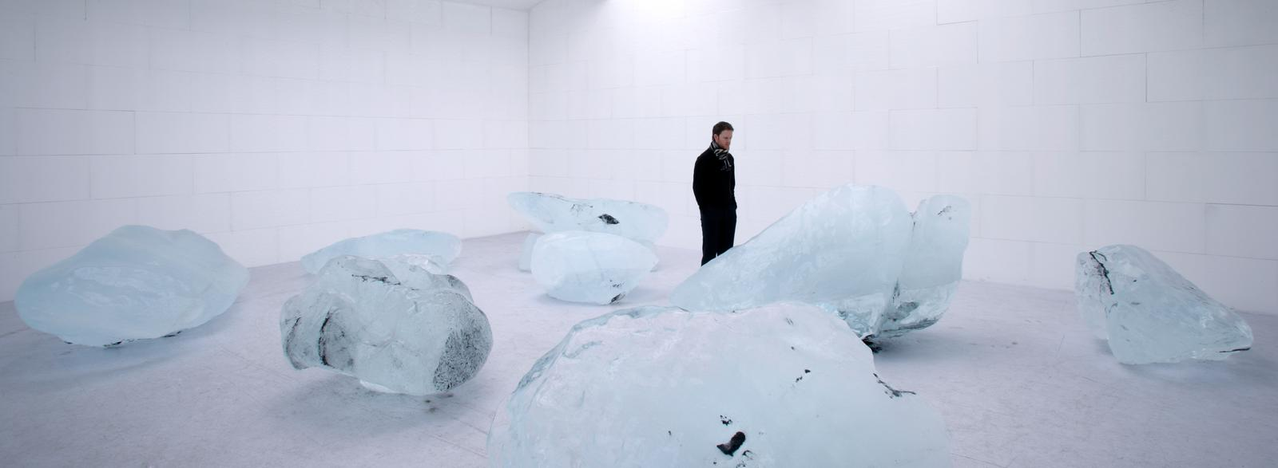
Jens Ziehe,(photographer) Your waste of time, Olafur Eliasson, neugerriemschneider, Berlin, (2006) https://olafureliasson.net/archive/artwork/WEK100564/your-waste-of-time [accessed 24 April 2021]
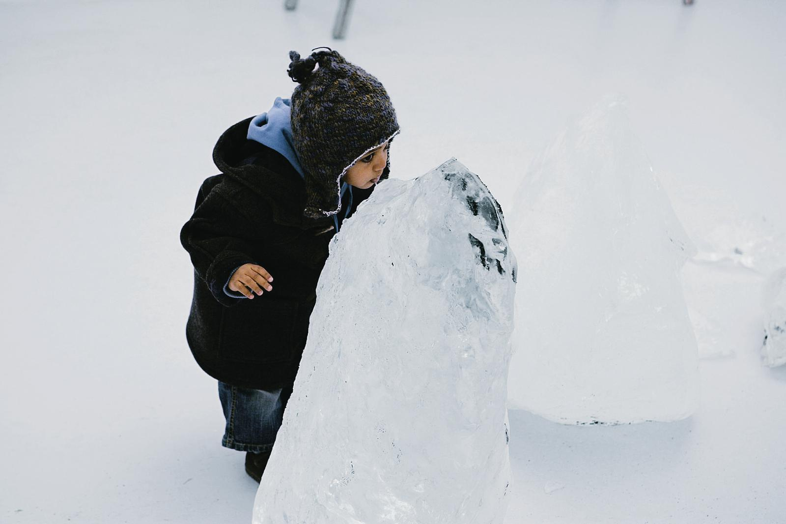
Olafur Eliasson,(photographer and artist) Your waste of time, neugerriemschneider,Berlin, (2006) https://olafureliasson.net/archive/artwork/WEK100564/your-waste-of-time [accessed 24 April 2021]

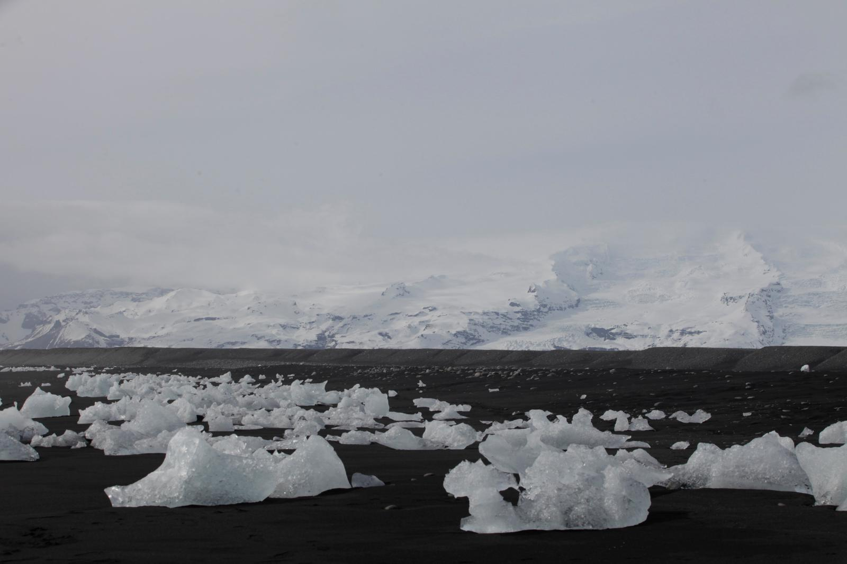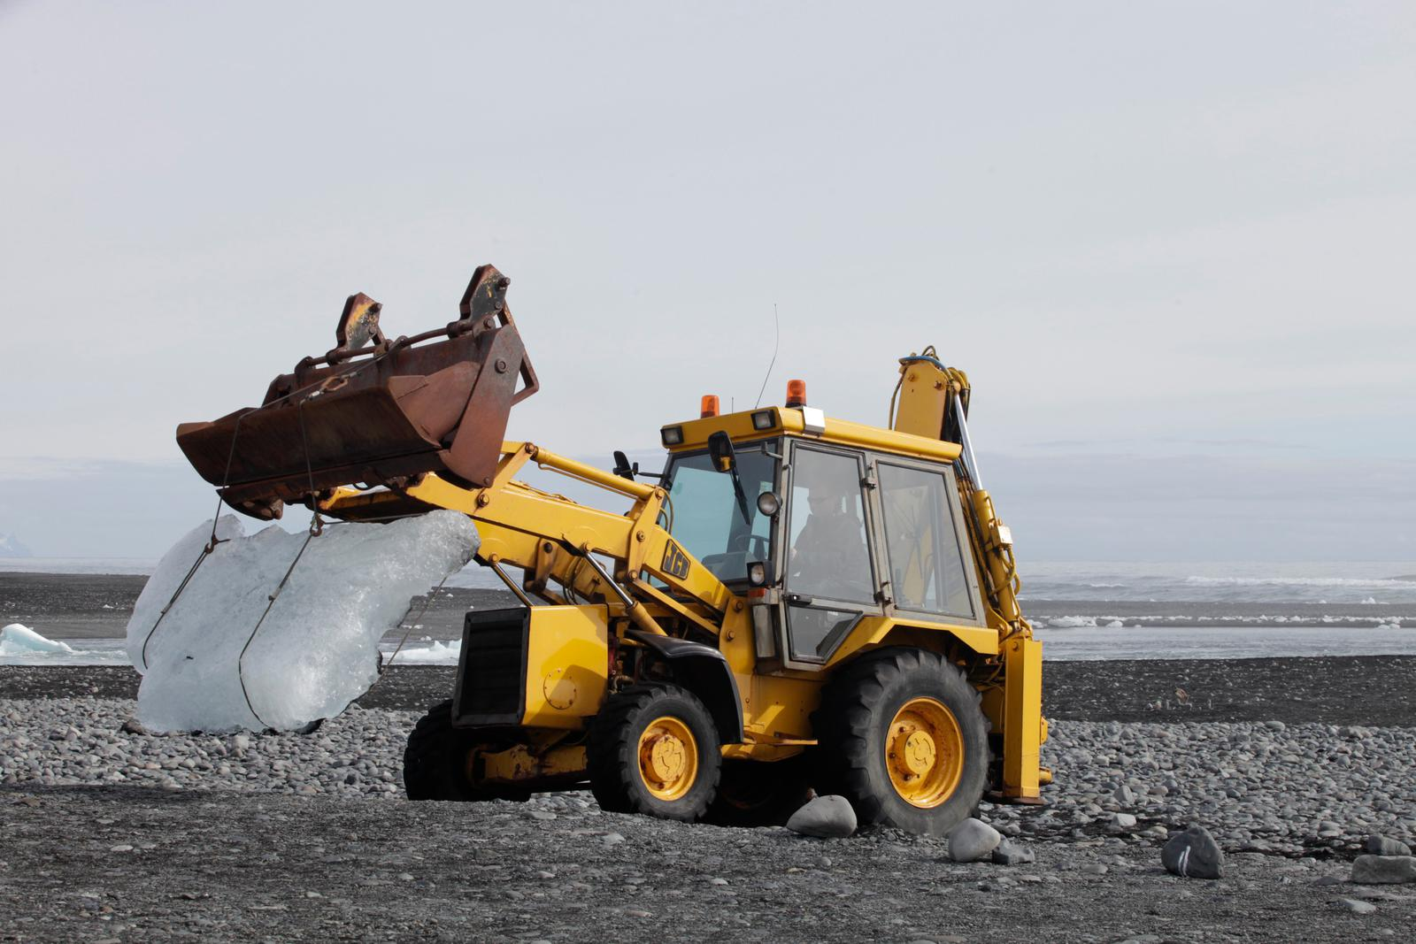
Ingvar Högni Ragnarsson, (photographer) Ice harvest in Iceland for Your waste of time, for the exhibition Expo 1: New York, (2006), photo (2013)

Ingvar Högni Ragnarsson, (photographer) Ice harvest in Iceland for Your waste of time, for the exhibition Expo 1: New York, (2006), photo (2013)

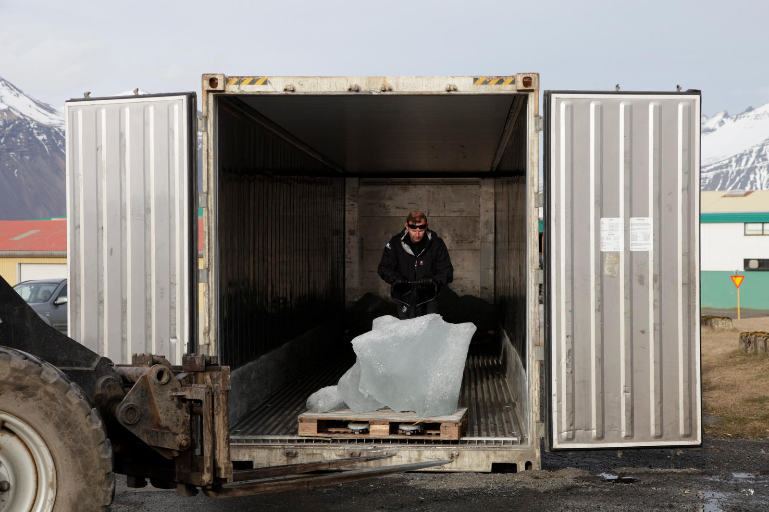CLOUD by Caitlind r.c. Brown and Wayne Garrett
Ingvar Högni Ragnarsson, (photographer) Ice harvest in Iceland for Your waste of time, for the exhibition Expo 1: New York, (2006), photo (2013)
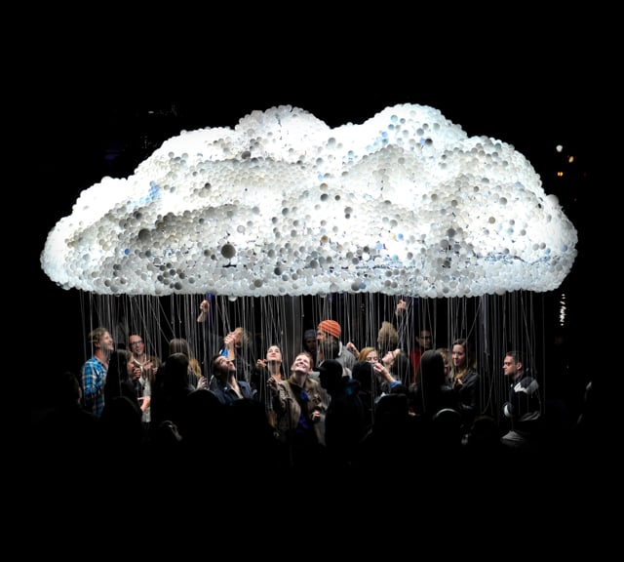
Caitlind r.c. Brown, (photographer) CLOUD: An Interactive Sculpture Made from 6,000 Light Bulbs, Nuit Blanche Calgary (Canada),2012, https://vimeo.com/49748983 [Accessed: 24 April 2021]
CLOUD features 6,000 new and burnt-out light bulbs collected from local households, businesses, museums and eco-stations. The sculpture is rear-lit by 250 compact fluorescent bulbs, each attached to a pull-string, allowing viewers to control the structure's illumination–like lighting in the CLOUD.
From the videos and photos, one can observe that viewers interact with CLOUD during the exhibition through the cooperative movement of people, pulling the chain switches of the light bulbs to animate the lighting. The artwork shows the tangibility, touching, movement and animation of the lights.
Literature review
Phenomenology Weather and Skies
Phenomenology makes us experience and understands nature. As Maurice Merleau-Ponty sees ‘phenomenology as the essential contact point between consciousness and environment’. The more one mindfully observes nature, the more our consciousness changes. Regarding human connection with skies, the weather is the bridge between us to sense the skies. As Immanuel Kant states about the phenomenological experience of the environment, ‘we can never experience it directly, always mediated by the senses, cognitive categories, etc.’ Sensing nature and skies is the medium to comprehend and have a consciousness about the experience.
Merleau‐Ponty's phenomenology argued that ‘in the open-world persons and things relate not as closed forms but by virtue of their common immersion in the generative fluxes of the medium – in wind and weather’. Therefore, according to Ponty, understanding the meaning of skies and sensing skies comes from the medium of wind and weather. However, James J. Gibson suggests that the medium to understand skies is ‘movement and perception’. Gibson explains that we see the movement of the skies by the movement of the stars, sun, moon and clouds, and this is our understanding of the skies. As Nicholas Campion states, ‘sight is the most important sense for our experience of the sky’. Phenomenological experiences of the sky come from sight and the movement of skies through the wind. Tim Ingold expresses his views on sight that ‘all visual perception is necessarily indirect’. However, according to Ingold's statement, sight is not enough to directly connect and sense the skies.
Ingold expresses his views about touch; ‘the isolation of both of things as objects of touch and the perceiver as a subject who touches. Thus we could not touch unless we first could feel.’ Moreover, Ingold mentions, ‘As we touch in the wind, so we see in the sky.’ Therefore, for Ingold to understand the environment, touch is the primary sense, and for him, if one does not, touch does not feel or connect.
There is one last issue that Ingold suggests that ‘because we generally think and write indoors, the world we describe in our writing is one that has been imaginatively remodelled as if it were already set up within an enclosed, interior space.’ As the skies are open and have no end, no limit, Ingold believes one could not express the skies without living in the openness. As people are living indoors, human expression of the sky comes from how we see it indoors.
Cultural representation of weather
Geographical locations bring weather characteristics which in turn affect the cultural context of those experiencing it. As Darrelyn Gunzburg states, ‘we locate ourselves externally and internally, physically and symbolically, by the sky, and humanity uses it to judge its time and set its courses geographically and culturally.’ The cultural context of skies comes from the weather, movement of skies and historical, spiritual beliefs. As Eliasson states, ‘Attempts to control or modify the weather had has a chequered history.’ Humanity could not control the weather; however, by predicting the weather, doing rituals, believing in weather Gods and believing if the Gods are happy so the weather will be as they want is peoples belief of being able to control the weather.
Each location has its weather condition, and how people have understood the sky and its role within their culture has made them try to control it. As Malcome Miles states, ‘geographical investigations of art, culture, and urban life have developed grounded and politicized approaches.’ Looking through the artworks from their geographical context, the Rain Room artists Koch and Ortkrass are from Germany; however, the art company Random International is based in London. Both Germany and England are famous for being places where it rains most of the year. Rain Room is a dark room, so the rain is in a dark, gloomy place like in England and Germany. As Michael Govan, the Director of Los Angeles County Museum of Art, states, experience about Rain Room ‘in Los Angles, people do not see rain much often, and the weather is sunny, so it was a different experience to and experience rain in a dark room.’ The same weather conditions under different skies have a different cultural context. English weather requires the need to defend from rain; however, it is common to have rain prayers in arid places. As Franklin Fenenga et al., wrote in their research, ‘Native control of the weather was quite generally practised throughout the arid portions weather shaman's success, of the western United States.’ Fenenga, also researched different practices people undertake in Native American culture to control rain, as weather shamans specialise in techniques such as ‘three different rain machines; one for snow, one for rain, and one to make waterspouts. He could stop the rain, too.’ Therefore, there were different beliefs throughout history to stop or make rainfall according to geographical and cultural contexts.
Olafur Eliasson, the artist of Your waste of time, is from Iceland. As Eliasson states, ‘the weather has been utilised for both hostile and utopian purposes throughout history. Entire civilisation had collapsed prospered depending on the ability to predict and adapt to climate change.’ As Iceland is in the front line of the places to be affected by climate change, Eliasson puts his views on the danger of ice melting. Alexandra Harris explains the melting of ice and describes the icebergs sound as a ‘witching menace and terrible laughter (whole soundscape of ice)’ as the sound of ice cracks as the ice melts.
Concerning Vikings beliefs, Harris explains
There was ice on one of the sides of the universe and fire and other and a place in between called Gunningagap where ice comes into contact with warmth and begins to melt. As it thaws, the ice forms strange beings: the great frost giant Ymir and the holy cow Audumla. With its large tongue, the cowlicks out a shape from the ice. The shape comes to life. This new beginning born from the interaction of cold and heath is a human.
This myth also explains the human and ice connection for the Nordic cultures.
CLOUD is an artwork created by Canadian artists where Canada is famous for its thunderstorms. As Eugene S. McCartney states, ‘the ancients were interested not only in averting the thunderbolt but also in drawing it down for their own benefit.’ There was always a cultural context of trying to control the weather. Canadian indigenous cultures have a spiritual Thunderbird figure. According to Edward J. Lenik ‘In the legends of Native Algonkian and Iroquoian peoples of the Northeast region, the thunderbird is an extremely powerful spirit in the form of a giant eagle-like bird with the ability to change into a human.’ Also, as Lenik explained, ‘The thunderbird, a spirit of the sky, protects Indian people against the Great Horned Serpent of the underworld.’ Thunder in Canadian culture has a profound cultural and spiritual context other than just being a weather phenomenon.
Climate change
Art has a leading role in expressing the issues of humanity. One of these issues is climate change and has recently become the subject of many art pieces. Malcolm Miles expresses his views on art and climate change, stating ‘how art creates a new consciousness of climate change or acts as a catalyst to action on it; but the material discussed offers a few insights into how assumptions and values are either affirmed or ruptured; by contemporary art.’ Art is a representative, changing perspective, but it is questionable whether it would be enough to make people shift their behaviour and become more environmentally friendly. Miles, quoting from David Buckland, argues ‘for personal experience as a means to shift consciousness’. Therefore, participatory experiences can change the way people think, and the three artworks considered within this essay are experiential. By experiencing, sensing skies and weather conditions, Eliasson states, ‘perception is generally regarded as the reflex detection of truth or reality, an assimilation of pre-existing and new information in order to make sense of once physical surroundings.’ Through the artworks, participants could sense the skies and connect with climate change issues.
Theme 1: The tangibility of weather and sensing
Within the sensory and experiential nature of the art, it encourages participatory engagement. The artworks make people use their bodies in weather conditions: rain, cloud, thunder, and ice. As skies are usually experienced outdoors, artists have created an experience and made this more tangible by presenting them indoors. Participants are allowed to interact with the weather in a way they would typically not be able to. As Ingoldmentioned, as we live indoors, we write about skies from an imaginative indoor perspective; therefore, it is questionable how representative the artwork is about the weather and skies. Malcolm Miles states, ‘art may contribute to a shift in attitudes, but wonders whether intervention-as-art is in its way another form of representation, and whether art inevitably distances whatever problems it addresses.’The artworks are made to shift our views and attitudes about the weather, skies and sense them in different ways than we are used to sensing them. As Immanuel Kant stated about the phenomenological experience, people are always mediated by the senses. Sensing things in different ways than we are used to; therefore, not touching the rain, touching the thunder or standing in a room with ice changes our experience and consciousness; this way, art shifts the perception. As Campion mentioned, ‘sight is the most important sense for our experience of the sky’. In these artworks, they all go beyond the aspect of sight and try to make the skies and weather tangible. In the CLOUD, strings are pulled to make thunder. In the Rain Room, hearing the sound of heavy rain, the smell of rain, and not touch the rain. Your waste of time makes people sense the ice by touching, being in the same room and bodies matching the ice temperature degree to experience.
The Rain Room reacts to every person's movement without raining on them, ensuring visitors leave dry. It is a sense of human movement controlling the weather condition. As Gibson suggests, the medium to understand skies is ‘movement and perception’ . The movement of the visitor switches places making the skies work according to their movements. Participants experience the rain in a dark room in an indoor environment. Ingold states that our representation of skies are as objects in nature as we live indoors. Ingold further explains the role of weather; ‘the relation between land and weather does not cut across an impermeable interface between earth and sky but is rather one between the binding and unbinding.’ Rain Room is a fantastic example of this statement of being indoors and also can be seen as an amplified representation of our environment. The concept of phenomenology in Rain Room, as Koch and Ortkrass explain, ‘swift to human presence prevents the rain from falling, creating a unique atmosphere and exploring how human relationships to each other and to nature are increasingly mediated through technology.’ Technology becomes the central controller, not the skies or weather; everything else is in the relationship of technical algorithms creating an experience.
Your waste of time has ice cubes exhibited in a refrigerated room. As Simone Hancox explains, this creates an environment for the visitors to experience the ice caps. ‘the glacial ice, via representation (i.e., its display in the art gallery) is converted into a fetishized (art) object that is placed within the cultural discourses and practices of the human.’ Ice usually is external, kept in the open, and bringing it into the house can be seen as a piece of furniture or an in-house object, as Ingold refers to.
Ice cubes were exhibited in the Berlin gallery at a freezing temperature for the ice not to melt. As Hancox puts it, ‘human and ice, therefore, are brought into being through this particular set of ‘intra-actions’.’ In general, the human body would not be in the coldness of the freezing and ice cubes would not be in the warmth of a closed room. In this exhibition, Hancox explains that ‘human and ice are revealed to have both distinct and shared materiality within the enclosed refrigeration room, and so while the differential boundary between them is destabilized, it does not dissolve completely.’ Human and ice intra-action shows how much our body is a medium to sense nature. Also, as seen in the pictures, people touch the ice and feel a touch of connection. Hancox points to, ‘the ice transforms: from solid to liquid to gas, from order to disorder, from rigidity to movement, from form to formlessness.’ There is a very different form of movement in this piece as the ice does not changes form; instead, the movement is fixed by human technology.
Comparable to Rain Room is CLOUD, where collective movement rather than individual movement is crucial. Brown and Garrett express CLOUD as ‘working as a collective to animate “lightning” on the surface of the sculpture’ As Gibson suggested, movement becomes the medium and again, as in Rain Room, it is the movement of people, not skies. Brown and Garrett express the movement in their artwork as ‘reveal breaks the illusion of delicacy and lightness characterized by the outside aesthetic of the artwork.’ The illusion of CLOUD as independently making lightning is broken, as participants generate the lightning through their collective movement and pulling the strings of the light bulbs. As Ingold states, touching is the primary sense. Therefore, it gives people a sense of touch in CLOUD that one cannot usually experience as they can never touch the clouds or thunder. In the Rain Room and in CLOUD objects that people use in their everyday life, such as light bulbs, they transfer the outside, external phenomenon to an inside.

Merleau‐Ponty's states that phenomenology is ‘in the open-world persons and things relate[s] not as closed forms’. However, in this case, and with the three artworks, visitors experience weather in closed forms and sense it contrary to ordinary experience in external weather conditions. It is almost like artists changing the relationship between humans and the sky, trying to make the skies more tangible and sensed in different forms than daily life or the openness, which alters the perception of connecting with the skies.

Theme 2: Controlling the weather
Weather controls human actions, dress code, habitats and materials they use. Human beings tried to predict the weather throughout history, pray for the weather to be harmless for them, and try to make the weather gods happy to have weather conditions according to their needs. Three of the artworks play with the concept of a human trying to shape the weather condition according to human want, being in the form of human captivity through being indoors, controlled by technology.

Hannes Koch expresses the tangibility of rain in their Rain Room artwork as; ‘it connects people to something that is hard to grasp; it puts you in this place that you can never control; you cannot control the environment and the weather.’ Although humans cannot usually control the weather despite their beliefs, these artworks provide the ability to do just that. Koch further explains people’s experience as ‘a feeling of empowerment – the whole space reacts to me – it is a physical reaction at an architectural scale to only you. It becomes very personal.’ Rain Room has exhibited in Europe, as the artist lived in these places, which often have dark, heavy rains. However, once it has exhibited in Los Angles and arid parts of the world, so it has, as Koch explains, ‘this fusion of very personal and very cross-cultural memory to rain, and I think that is some of the appeal.’ In arid areas, it is a known custom to have rain prayers to ask the skies for rain. A great example of people believing in controlling the weather or skies through belief is from the Shamans from Native Americans. According to the research of Fenenga et al., Shamans were also referred to as rain doctors, and it was believed that they have rain machines where they could make rain, snow or stop the rain, and these are usually done by praying and using the unique stones in the area they have. Belief and rituals introduce the concept of humans controlling the weather or humans having special powers or stones that could control the weather. In the Rain Room, it is a way of human and technology trying to control the weather.

Thunderbird

Canadian artists Brown and Garrett, with their artwork CLOUD, also connects to the Canadian culture. As Canada is famous for lightening in Indigenous culture, Thunderbird is a spiritual protector. As Lenik explained, Thunderbird protects people from thunder and the underworld. It is seen in various cultures that Thunder is a strong spirit. In Ancient Greek and Roman cultures, Zeus, with his thunderbolts, is the God of gods and God of Thunder. As Eugene S. McCartney explains as ‘Thessalian enchantresses who by their voices alone could bring down clouds and rains, and even thunder, without the permission of Zeus’. The belief of controlling thunder is always there, therefore, through believing Zeus, Thunderbird. As Brown and Garrett explain, the CLOUD ‘Subsequently the “inner” and “outer” spheres of the artwork pose different dynamics, inviting both participation and contemplation, spectacle and speculation, collective and subjective, harmony and chaos’. As thunder being the harmony of nature and also could create chaos for humanity.

Ice Myths from Vikings
Ellison from Iceland is the artist of Your waste of time who used ice cubes to exhibit in the Berlin gallery. Iceland is known for its harsh weather conditions and ice. In Viking mythology, as Harris states, men are created from the ice where fire and ice came together. Therefore, according to myth and Viking belief, the source of humans comes from the ice. The other myth that Harris explains is that the sound of melting ice is like a ‘witching menace and terrible laughter.’ As ice is melted, it cracks and makes the sound of witch laughter. Sound is also the other way of humans sensing ice and not controlling ice. Eliasson states, ‘since the beginning of time, human beings have had to negotiate the primary conditions of temperature, humidity and seasonal climate.’ Humanity negotiates it with prayers and rituals, but in the context of Your waste of time, as Hancox points out, ‘ice is dependent upon human intervention (i.e. artificial cooling) to maintain its state/status as ice/art.’ Your waste of time is exhibited in springtime in Berlin, which is not a natural season for ice. The ice is stopped from melting with technology and human control of nature.
As Vannini et al. express, ‘to weather means to subject oneself to the elements, to undergo exposure to challenges, to somehow adapt, .... Dwelling with weather is a skilful practice.’. Humans plan and shape their day according to the weather and the temperature. However, in the artworks, the movement, controlling, feeling, and sense of weather connectedness is not the same as in ordinary life. Therefore, artworks all change how we comprehend weather and skies and try to control the weather in a small room; however, they try to make us comprehend skies from different perspectives.
Climate Change, Waste and Time
The artworks show the importance of an individual’s impact on climate change. Malcolm Miles pointed out that art could change people’s perspective to act on climate change. Through the usage of the senses and the movement of people, the weather and the artworks are changed. However, each artwork discussed in this essay also stands by itself and refers to climate change issues.
As Javier Pes reported, ‘Rain Room will remain at Los Angeles County Museum of Art and that the continuous downpour of around 528 gallons of recycled water will resume.’ In some way, it also shows how many times water could be recycled and how important it is not to wastewater. Gary Friedman, the chairman and chief executive of Restoration Hardware, says: ‘to us, Rain Room is a reflection of creative courage, trust and a belief that all of us have the ability to affect any environment we choose to step into.’ The artwork tries to put it to the individual how personal movement also affects the climate.
According to Brown and Garrett, LED bulbs are used in CLOUD ‘As incandescent bulbs are phased out in the European Union and various countries around the world.’ This artwork also tries to express the waste of energy and how technology creates more environmentally friendly lightbulbs. By pulling strings or switching unnecessary lights on and off, the individual could help with climate change.
Your waste of time is created to be a political statement to climate change. In the last couple of decades, ‘the Jökulsárlón lagoon has received attention in the context of climate change as it provides a visible indicator of rising earth surface temperatures.’ ‘The first installation was in Copenhagen, 2014 mark the UN IPCC's Fifth Assessment Report on Climate Change. The second installation took place in Paris, 2015, at the UN Climate Conference COP21.’. The fact that ice is melting and will create floods is the essential point of climate change. The artwork, in which ice cubs from Iceland are transported and exhibited in an art gallery in a freezing room, shows how much humanity wastes time and energy to transport things globally. In other exhibitions than Berlin, the artwork is exhibited outdoors, where the ice left to melt, which also emphasized that passing and nature is not waiting.
Eliasson connects the sense of touching and climate change or individuals’ impact on climate change by saying that ‘by touching it, I embody my knowledge by establishing physical contact. Suddenly, we understand that we do have the capacity to understand the abstract with our senses. Touching time is touching abstraction.’ Tangibility and seeing that the environment reacts to a person or personal movements change the environment and affect how people look at nature and climate change. Buckland states, ‘we intend to communicate through artworks our understanding of the changing climate on a human scale so that our individual lives can have meaning in what is a global problem.’ Climate change is a vast and global issue for an individual to solve; however, each artwork shows how an individual can impact.
Conclusion
Rain Room, CLOUD and Your waste of time are specific artworks that connect people with skies through the weather conditions. Three of the artworks are participatory artworks where the visitors have to experience the weather conditions created by artists through technology inside a gallery. As Pontey states, phenomenology is about experiencing the environment and by that experience, something changes in our consciousness. Art also tries to point out climate change and weather connectedness and shift people's perspectives. Visitors come to experience a condition through their senses and movements in an indoor environment. In nature, the environment is out of our control; the weather is out of our control. However, in these art galleries, everything is controlled by the artist and through technology.
Going into the Rain Room, where the rain reacts to the personal movement, is almost how nature reacts to our carbon footprints. The CLOUD compares to the Rain Room and emphasises more a collective way of making an impact by bringing the concept of togetherness and community to create things. Culturally, thunder is very chaotic, and balancing the nature concept and the artwork with its unique experience creates the idea that as a collective movement, we could impact climate change by the collective usage of environmentally friendly LED lightbulbs, which reduces energy waste.
Compared to Rain Room and CLOUD, Your waste of time creates an environment where ice cubs can stay and make visitors visit in the conditions of an ice cube. Of course, for the ice to be able to last, it needs a refrigerated room. So again, technology and artist are creating a nature-like condition. On the other hand, instead of making nature work for humanity, humanity works according to the condition of the ice. The artwork makes people be in the temperature of nature in a room. It also tries to show that humanity needs to adapt to nature. As Eliasson expresses with the name of the artwork, it is a waste of time to transport things, use technology to sustain the goods and waste energy and nature. Eliasson is trying to push in his work the connection of melting ice in the central city centres and make people connect, touch and comprehend the experience. He tries to make people care about climate change. Similarly, the CLOUD and Rain Room try to control the weather condition in a room through technology.
Three of the artworks try to control the weather conditions in a room and change the senses and experiences by showing these artworks in various parts worldwide with each different culture associations about the concept of skies and weather but still connect people. The artworks impact humanity with technology but could only control the weather or skies only in a small room through technology. With the movements of humans, nature reacts and creates things like in the lightening; it could be chaos or balance. Weather and skies constantly move, and humanity tries to find solutions according to the movements of the weather conditions. On the other hand, through the movement of humans, the conditions of nature and natural resources change. Therefore, movements of humans affect nature and nature’s movements affect humans. Therefore, the artworks discussed in this essay show individual and collective movements; one can help to use the resources less and not waste the resources or time. Therefore, one can control one’s actions and understand how the actions could impact skies and climate change.
Bibliography
Brown , Caitlind r.c. and Wayne Garrett, CLOUD, (2013) https://incandescentcloud.com/about-the-artist-2/ [accessed 25 March 2021].

Campion, Nickholas, (ed.), Heavenly Discourses, (Bristol: Spohia Center Press, 2011 ), Kindle edition, p.22.

Eliasson, Olafur, The weather project, ed. by Susan May (London: Tate Publishing, 2003), p.19.

Eliasson, Olafur, Your waste of Time,(2006) https://www.olafureliasson.net/ [accessed 20 March 2021].

Fenenga, Franklin ,Francis A. Riddell, Jerry N. Hopkins, Gerrit L. Fenenga, Alan P. Garfinkel, Samantha Riding-Red-Horse and Donna Miranda-Begay ,‘A Weather Shaman's Rain-Making Bundle from the Tübatulabal and its Relationship to the History of Weather Control in South-Central California’, Journal of California and Great Basin Anthropology, Vol.2, (2012), p. 109. www.jstor.org/stable/24644372 [accessed 27 March 2021].
Gibson, James J., The ecological approach to visual perception, (Boston: Houghton Mifflin, 1979) cited in Tim Ingold , ‘Earth, Sky, Wind, and Weather.’ The Journal of the Royal Anthropological Institute, vol. 13, 2007, pp. S19–S38. JSTOR, www.jstor.org/stable/4623118. [Accessed 29 Apr. 2021].
Gunzburg , Darrelyn , (ed), The Imagined Sky Cultural Perspective, (Sheffield, Bristol: Equinox Publishing Ltd,2016) p. ix.

Hancox, Simone , The Performativity of Ice and Global Ecologies, Performance Research,Vol.6 (2013),p.54 https://www.tandfonline.com/doi/abs/10.1080/13528165.2013.908057 [accessed 20 March 2021].

Harris, Alexandra, Weatherland Writers and Artists Under English Skies, (Thames&Hudson, 2015) Kindle Edition), p.33.

Identity and Autonomy in 'Rain Room' and Beyond | Brilliant Ideas [video], Ep. 44, (2017) https://www.youtube.com/watch?v=3Vv0E-NCmGw [accessed 03 May 2021].

Ingold, Tim, ‘Earth, Sky, Wind, and Weather.’ The Journal of the Royal Anthropological Institute, vol. 13, 2007, pp.29. JSTOR, www.jstor.org/stable/4623118. [Accessed 29 April 2021].
Ingold, Tim, ‘Research for the Stars! Light, Vision and The Atmosphere’ in The Imagined Sky Cultural Perspective, ed. by Darrelyn Gunzburg, (Sheffield, Bristol: Equinox Publishing Ltd,2016), p. 217.

Kant, Immanuel, Theoretical Philosophy, trans. and ed. by David Walford (Cambridge: Cambridge University Press, 1992 [1755–1770]), p. 237.

Lenik, Edward J. ‘The thunder motif in Northeastern Indian’ Archaeology of Eastern North America, vol. 40, (2012), p. 163. JSTOR, www.jstor.org/stable/23265141.[accessed 29 Apr. 2021].
McCartney, Eugene S., ‘Classical Weather Lore of Thunder and Lightning (Concluded).’ The Classical Weekly, vol. 25, no. 25, (1932), pp. 212. JSTOR, www.jstor.org/stable/4339106. [accessed 26 Apr. 2021].

Merleau-Ponty, Maurice, The Phenomenology of Perception, trans. by Colin Smith (London, New York: Routledge & Kegan Paul , 1962) p. 73.

Miles, Malcolm, ‘Representing nature: art and climate change’, Cultural Geography, Vol.17, (2010) p.20. https://www.jstor.org/stable/i40178162 [accessed 25 March 2021]

Pes, Javier, ‘Let it pour: Rain Room to stay in Los Angeles’, The Art Newspaper, 27 January 2017, https://www.theartnewspaper.com/news/let-it-pour-rain-room-to-stay-in-los-angeles/ [acessed 07 May 2021].
Random International, Rain Room, (2005) https://www.random-international.com/biography [accessed 25 March 2021].

Valera, Stephanie, Astounding Weather-Inspired Art Installations, (2015) https://weather.com/travel/news/uk-weather-inspired-art-20130426 [accessed 25 March 2021].
Vannini,Phillip.,Dennis Waskul,Simon Gottschalk,and T.Ellis-Newstead, ‘Making sense of the weather: Dwelling and weathering on Canada’s rain coast’. Space Cult., Vol. 15, (2012), pp. 361–380, doi:10.1177/ 1206331211412269. cited in Eliza De Vet, Experiencing and Responding to Everyday Weather in Darwin, Australia, Weather, Climate, and Society, Vol. 2, (2017), pp. 141-154
https://www.jstor.org/stable/26388203?seq=1 [accesed 25 March 2021].

Random International, Rain Room, (2005) https://www.random-international.com/biography [accessed 25 March 2021].
Olafur Eliasson, Your waste of Time,(2006) https://www.olafureliasson.net/ [accessed 20 March 2021].
Caitlind r.c. Brown and Wayne Garrett, CLOUD, (2013) https://incandescentcloud.com/about-the-artist-2/ [accessed 25 March 2021].
Stephanie Valera, Astounding Weather-Inspired Art Installations, (2015) https://weather.com/travel/news/uk-weather-inspired-art-20130426 [accessed 25 March 2021].
Valera, 2015.
Valera, 2015.
Simone Hancox, The Performativity of Ice and Global Ecologies, Performance Research,Vol.6 (2013),p.54 https://www.tandfonline.com/doi/abs/10.1080/13528165.2013.908057 [accessed 20 March 2021].
Hancox, ‘Ice and Global Ecologies’, p.54.
Hancox, ‘Ice and Global Ecologies’, p.54.
Brown and Garrett, (2013).
Maurice Merleau-Ponty, The Phenomenology of Perception, trans. by Colin Smith (London, New York: Routledge & Kegan Paul , 1962) p. 73.
Immanuel Kant, Theoretical Philosophy, trans. and ed. by David Walford (Cambridge: Cambridge University Press, 1992 [1755–1770]), p. 237.
Ponty, The Phenomenology of Perception, p. 159.
James J. Gibson, The ecological approach to visual perception, (Boston: Houghton Mifflin, 1979) cited in Tim Ingold , ‘Earth, Sky, Wind, and Weather.’ The Journal of the Royal Anthropological Institute, vol. 13, 2007, pp. S19–S38. JSTOR, www.jstor.org/stable/4623118. [Accessed 29 Apr. 2021].
Nickholas Campion (ed.), Heavenly Discourses, (Bristol: Spohia Center Press, 2011 ), Kindle edition, p.22.
Tim Ingold, ‘Research for the Stars! Light, Vision and The Atmosphere’ in The Imagined Sky Cultural Perspective, ed. by Darrelyn Gunzburg, (Sheffield, Bristol: Equinox Publishing Ltd,2016), p. 217.
Tim Ingold,’Earth, Sky, Wind, and Weather.’ The Journal of the Royal Anthropological Institute, vol. 13, 2007, pp.29. JSTOR, www.jstor.org/stable/4623118. [Accessed 29 Apr. 2021].
Ingold, ‘Earth, Sky, Wind, and Weather.’, p.29.
Ingold, ‘Earth, Sky, Wind, and Weather.’, p.32.
Darrelyn Gunzburg (ed), The Imagined Sky Cultural Perspective, (Sheffield, Bristol: Equinox Publishing Ltd,2016) p. ix.
Olafur Eliasson, The weather project, ed. by Susan May (London: Tate Publishing, 2003), p.19.
Malcolm Miles, ‘Representing nature: art and climate change’, Cultural Geography, Vol.17, (2010) p.20. https://www.jstor.org/stable/i40178162 [accessed 25 March 2021].
Identity and Autonomy in 'Rain Room' and Beyond | Brilliant Ideas [video], Ep. 44, (2017) https://www.youtube.com/watch?v=3Vv0E-NCmGw [accessed 03 May 2021].
Franklin Fenenga et al., ‘A Weather Shaman's Rain-Making Bundle from the Tübatulabal and its Relationship to the History of Weather Control in South-Central California’, Journal of California and Great Basin Anthropology, Vol.2, (2012), p. 109. www.jstor.org/stable/24644372 [accessed 27 March 2021].
Fenenga , ‘A Weather Shaman’, p. 110.
Eliasson, The weather project, p.20.
Alexandra Harris, Weatherland Writers and Artists Under English Skies, (Thames&Hudson, 2015) Kindle Edition), p.33.
Harris, Weatherland, p.48.
Eugene S. McCartney, ‘Classical Weather Lore of Thunder and Lightning (Concluded).’ The Classical Weekly, vol. 25, no. 25, (1932), pp. 212. JSTOR, www.jstor.org/stable/4339106. [accessed 26 Apr. 2021].
Edward J. Lenik, ‘The thunder motif in Northeastern Indian’ Archaeology of Eastern North America, vol. 40, (2012), p. 163. JSTOR, www.jstor.org/stable/23265141.[accessed 29 Apr. 2021].
Lenik, ‘The thunder’, p. 164.
Miles, ‘Representing nature’, p.20.
Miles, ‘Representing nature’, p.31.
Eliasson, The weather project, p.20.
Ingold, ‘Earth, Sky, Wind, and Weather.’, p.32.
Miles, ‘Representing nature’, p.20.
Kant, Theoretical Philosophy, p. 237.
Campion , Heavenly Discourses, p.22.
James J. Gibson, The ecological approach to visual perception, (Boston: Houghton Mifflin, 1979) cited in Tim Ingold , ‘Earth, Sky, Wind, and Weather.’ The Journal of the Royal Anthropological Institute, vol. 13, 2007, pp. S19–S38. JSTOR, www.jstor.org/stable/4623118. [Accessed 29 Apr. 2021].
Tim Ingold,’Earth, Sky, Wind, and Weather.’, p.29.
Ingold,’Earth, Sky, Wind, and Weather.’, p.33.
Random International, (2005).
Hancox, ‘Ice and Global Ecologies’, p.54.
Hancox, ‘Ice and Global Ecologies’, p.54.
Hancox, ‘Ice and Global Ecologies’, p.54.
Hancox, ‘Ice and Global Ecologies’, p.59.
Hancox, ‘Ice and Global Ecologies’, p.59.
Brown and Garrett, (2013).
Gibson, p. 28.
. Brown and Garrett, (2013).
Ingold, ‘Earth, Sky, Wind, and Weather.’, p.29.
Ponty, The Phenomenology of Perception, p. 189.
Random International, Rain Room, (2005).
Random International, Rain Room, (2005).
Random International, Rain Room, (2005).
Fenenga , ‘A Weather Shaman’, p. 110.
Lenik, ‘The thunder ‘, p. 163.
McCartney, ‘Classical Weather’, p. 212.
Brown and Garrett, (2013).
Eliasson, Your waste of Time,(2006).
Harris, Weatherland ,p.33.
Harris, Weatherland ,p.48.
Eliasson, The weather project, p.132.
Hancox, ‘The Performativity of Ice’ (2013), p.57.
Phillip Vannini,and others , ‘Making sense of the weather: Dwelling and weathering on Canada’s rain coast’. Space Cult., Vol. 15, (2012), pp. 361–380, doi:10.1177/ 1206331211412269. cited in Eliza De Vet, Experiencing and Responding to Everyday Weather in Darwin, Australia, Weather, Climate, and Society, Vol. 2, (2017), pp. 141-154 https://www.jstor.org/stable/26388203?seq=1 [accesed 25 March 2021].
Miles, ‘Representing nature’, p.20.
Javier Pes, ‘Let it pour: Rain Room to stay in Los Angeles’, The Art Newspaper, 27 January 2017, https://www.theartnewspaper.com/news/let-it-pour-rain-room-to-stay-in-los-angeles/ [acessed 07 May 2021].
Pes, ‘Let it pour’ 2017.
Brown and Garrett, (2013).
Hancox, ‘Ice and Global Ecologies’,p.55.
Eliasson, (2006).
Eliasson, (2006).
David Bucland cited in Malcolm Miles, Representing nature: art and climate change, Cultural Geography, Vol.17, p.30.
Merleau-Ponty, The Phenomenology of Perception, p. 73.

