HOW DO INDIVIDUALS DIFFER?
Our sense of self is shaped by our inherited characteristics and by influences in our social environment. The process of growing up – such as the impact of our early family life and the country in which we live – has a significant part to play in our identity. Most social scientists would agree that both inherited and environmental factors are important in our development, and it is the way in which these factors interact which is the key to our adult personality. However, scientists differ with regard to the weight they place on these factors – some believing that our personality is heavily influenced by our inherited characteristics and will never change, others believing the reverse. But first, what are the differences among individuals? These include:
■ ethnic origin
■ physique
■ gender
■ early family experiences
■ social and cultural factors
■ national culture
■ motivation
■ attitudes
■ personality traits and types
■ intelligence and abilities
■ perception.
Some of these characteristics are shared with others, for example individuals who are from the same ethnic group or who have the same ability levels or who share similar physical attributes such as short-sightedness. But our uniqueness stems from the dynamic ways in which these inherited and environmental factors combine and interact. The ways in which it is possible to differentiate between individuals include an understanding of personality, the heart of individual differences and the importance and functions of attitudes. The process of perception and communications is examined in Chapter 6. All contribute to a greater understanding of self and others.

Personality may be viewed as consisting of stable characteristics that explain why a person behaves in a particular way. So, for instance, independence, conscientiousness, agreeableness and self-control would be examples of these personality characteristics. However, it is only when we see/hear/observe a person that we can gain an understanding of their personality. For example, a person who is independent may show that characteristic by displaying a strong sense of self-sufficiency. We would expect him or her to take the initiative and not to depend on other people. Furthermore, if the characteristic is ‘stable’ we can rely on this being a consistent part of the person’s behaviour. We would be surprised if the person one day demonstrated autonomy and initiative and the next withdrew and delayed any decisions. We anticipate that individuals are generally consistent in the way in which they respond to situations. There are times when we might be surprised by somebody’s behaviour and we may feel they are ‘acting out of character’. Of course this would be known only if we had an understanding of their ‘typical behaviour’ in the first place. Individuals may exaggerate or suppress certain personality traits, for example if they are under stress or influenced by drink/drugs. It is self-evident that managers need to learn the art of ‘reading’ people’s behaviour in order to manage relationships effectively.

NOMOTHETIC AND IDIOGRAPHIC APPROACHES
Broadly speaking, personality studies can be divided into two main approaches, labelled as nomothetic and idiographic. The nomothetic approach is a measurable and specific perspective that looks at the identification of traits and personality as a collection of characteristics. These characteristics are ones that can be described, identified and measured and therefore can be subjected to observation and tests. This perspective is especially helpful for managers when they are involved in the selection, training and development of individuals. Nomothetic approaches tend to view environmental and social influences as minimal and view personality as consistent, largely inherited and resistant to change. Although they would not diminish the difficulties that measuring personality brings, nomothetic approaches would claim that it is possible to measure and predict the ways in which personality types would behave given certain circumstances.

Nomothetic researchers closely align themselves to studies that are ‘scientific’ in a positivistic sense. (The term positivism refers to the branch of science that is exclusively based on the objective collection of observable data – data that are beyond question.) Such an approach transfers methods used in natural sciences to the social world. Some psychologists are interested in describing and measuring characteristics and comparing individuals’ scores. Does this person exhibit more or less than ‘average’ of this particular trait? Being able to predict behaviour is a major aim and outcome of this approach.

The idiographic approach is a holistic and dynamic perspective which insists that managers take into account a ‘whole’ understanding of the individual at work. This may also require going beyond the study of pure psychology to an understanding of the societal context in which the person lives. These are called idiographic approaches and are particularly pertinent in understanding motivation, career development and team relationships.

Idiographic approaches are concerned with understanding the uniqueness of individuals and the development of the self-concept. They regard personality development as a process that is open to change. They regard individuals as responding to the environment and people around them and see the dynamics of the interactions as playing a critical part in shaping personality. The measurement of traits is seen as largely inappropriate in that one person’s responses may not be comparable to another’s. They suggest that personality assessment is not a valid method of understanding the unique ways in which a person understands and responds to the world. The depth and richness of a person’s personality cannot be revealed in superficial paper-and-pencil questionnaires. Furthermore, the categories defined by psychologists are too narrow in scope and depth.4

NOMOTHETIC PERSONALITY THEORIES
The big five
The identification of personality traits has been a dominant subject of research in the UK and the USA. There is now a body of evidence which suggests that five dimensions capture distinct differences between people. These clusters of traits (not personality types) are known as the Big Five2 and sometimes expressed in the acronym OCEAN:
■ Openness/closed-mindedness
■ Conscientiousness/heedlessness
■ Extraversion/introversion
■ Agreeableness/hostility
■ Neuroticism/stability
The big five form the basis of standard personality questionnaires that determine positive or negative scores for each dimension. Results from a wide number of studies have shown that these factors can be identified as being significant in measuring the variation between people.3 Of these, conscientiousness has the highest positive link with high levels of job knowledge and performance across a range of occupations.4 However, some researchers are critical of the descriptors used.5 Bentall suggests they are ‘tainted by the investigators’ values’ and continues: ‘I suspect that most people will have a pretty clear idea of where they would like to find themselves on the dimensions of neuroticism, extraversion, openness, agreeableness and conscientiousness.’ He questions the ethical and political
nature of the scales.6 The relationship between personality and work performance is also questioned by Robertson who suggests that the only two of the five dimensions linked consistently with high levels of performance are conscientiousness and emotional stability.7

Despite these reservations, the strength and value of the Big Five model has been extolled in a review by Lord and Rust. They conclude that:

Indeed, the five factor model has become the linchpin that holds personality assessment together, at least within the work context. Without it, how would we generalize with confidence from the validity of one work-based instrument to that of another? Furthermore, the model links the study of assessment instruments within the HR field to research in personality and related areas
carried out within clinical and mainstream psychology fields in which the Big Five have also become dominant.

Eysenck
Hans Eysenck believed that personality was largely inherited and that we are born with differing physiological tendencies. He identified two major individual differences Eysenck’s approach was influenced by the positivistic tradition with his research findings grounded in robust research. His aim was to produce objective evidence of personality differences using large samples of the population. The two dimensions define four distinct personality types:

■ stable extraverts (sanguine) with traits such as being talkative, responsive, easygoing, lively, carefree;
■ unstable extraverts (choleric) with traits such as being impulsive, changeable, excitable, restless;
■ stable introverts (phlegmatic) with traits such as being calm, even-tempered, peaceful, thoughtful;
■ unstable introverts (melancholic) with traits such as being anxious, moody, reserved, pessimistic.

Individuals in Eysenck’s theory could, therefore, be one of four main personality types. The type would lead to a predisposition of traits that would, itself, lead to the likelihood of certain behaviours. For instance, a person typed as an extravert would predictably talk over things with someone to help them think it through, while an introvert would prefer to mull it over before talking about the issue. Eysenck developed an instrument to measure personality type called EPQ (Eysenck’s Personality Questionnaire).

IDIOGRAPHIC THEORETICAL APPROACHES
Idiographic approaches emphasise the development of the individual and of individuals’ views of themselves – their self-concept. Supporters of idiographic approaches are critical of the nomothetic approach that attempts to categorise individuals on the basis of group data. They argue that the techniques used to collate the group data are questionable and the outcome inappropriate to an understanding of personality. For the idiographic researchers, personality is expressed through the experiences and development of the individual. It cannot be understood outside a social context and has to be studied in the light of individuals’ own perceptions of their world. Idiographic researchers would always take into account the social circumstances of the person and in particular the relationships with others, family life and social conditions. In early childhood strong personal relationships and unconditional love are essential for later fulfilment and psychological growth. Carl Rogers’ theory claims that personality is embedded within personal relationships. The process of becoming an adult requires the ability to give and receive unconditional regard – the warmth and respect for the person, who they are, regardless of how they behave. The phrase ‘the looking-glass self’ was first discussed by Cooley – by this he meant that we come to know ourselves through our relationship with others and their reactions to us.
Gurus in idiographic approaches
Erikson
Erik Erikson’s theory is a good example of the idiographic approach. He viewed personality development as continuing throughout life. He was interested in the effect of experiences on the development of the self-concept and how different individuals resolved personal conflicts.15 He recognised the importance of early childhood in establishing certain basic concepts of trust, autonomy and initiative, but also claimed that all stages of life produce different tensions and conflicts.

For Erikson, there are eight distinct stages of life, each of which produces different tensions and conflicts that have to be resolved (see Table 4.4). Successful resolution of these conflicts produces a healthy personality, whereas difficulties in earlier stages may produce problems later on. Erikson’s theory not only makes considerable sense in terms of face validity (i.e. the ‘it feels right’ factor), it also links with other research indicating that managers’ motivations and goals change with age (see Hunt, who identified nine different career/life stages).

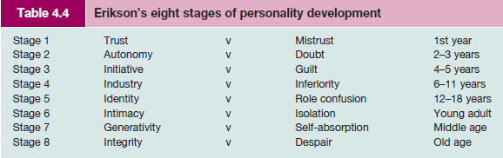

The Myers–Briggs Type Indicator® (MBTI®)
Jung is probably best known for his constructs that form the foundation for the MBTI personality indicator. The Myers–Briggs Type Indicator (MBTI) assessment tool was designed by Isabel Briggs Myers and Katherine Briggs who applied the rigours of systematic testing to Jung’s personality functions and attitudes.18 Jung identified differences between individuals in terms of their libidinal energy that could flow outwards to the external world (extravert) or inwards
to their inner world (introvert). Personality differences would also be manifest through differing cognitive functions of thinking, feeling, sensation and intuition. The Myers–Briggs assessment added a further dimension of style of living. The personality types are shown in Figure 4.3.

The MBTI tool has promoted considerable research interest, particularly with regard to the correlation between personality type, occupations and management style – see Table 4.5. The Myers–Briggs assessment asserts that people tend to be attracted to and have the most satisfaction in work that allows them to express and use their psychological type preferences. Such a match enables them to handle their tasks more effectively and generates more energy. Confidence is a likely outcome of this process. The Myers–Briggs instrument is an affirmatory tool
and knowledge gained through using the MBTI assessment can lead to recognition and respect for differences between people and appreciation for the value such differences brings.
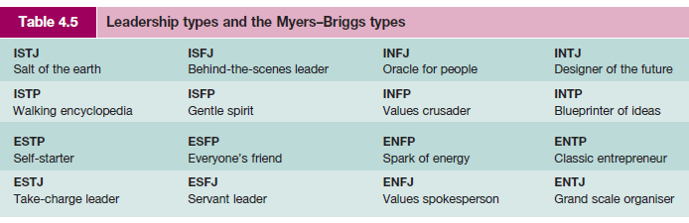

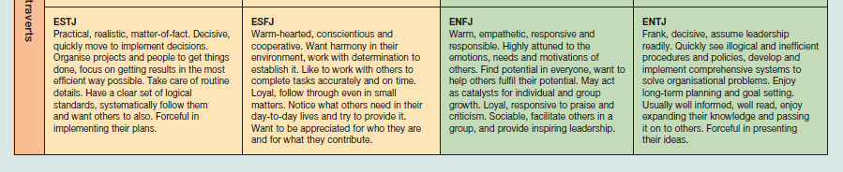
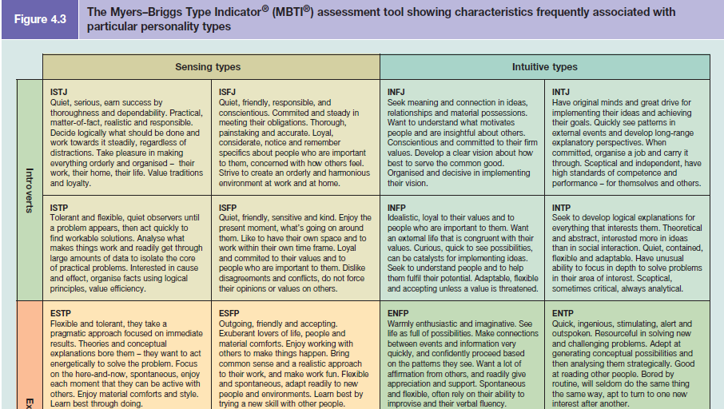

APPLICATIONS WITHIN THE WORK ORGANISATION
Recruitment and selection
It would be rare for organisations not to take the personality of a candidate into consideration at a selection interview. For some organisations, personality is a major criterion for selection or rejection. The hospitality industry, for example, is replete with research studies demonstrating the potency of personality.21 So, how do organisations assess a candidate’s personality?

The interview remains the most usual method of selection, but there is an increasing use of objective psychometric measures. Such growth in psychometric testing is significant and a number of studies have demonstrated its growing popularity.22 Concern has been expressed about the use and misuse of psychological instruments and there is a continuing debate within psychological circles with regard to the validity of these measures23 – that is, do they actually measure what they claim to measure? There are controversies and sensitivities surrounding the use of any psychological test, but tests of typical performance are especially problematic in certain circumstances.

Critics have accused consultants and practitioners of inappropriate use of personality assessments and claim low validity between non-work-related personality assessments and work performance.25 Goss suggests that the use of personality assessments not only is an infringement of the individual’s privacy but also leads to unfortunate organisational consequences, with ‘cloning’ as an outcome. Such techniques can be perceived as a form of social engineering and an insidious form of organisational control.26 Aware of these problems, the British Psychological Society has produced guidelines and codes of practice for users of psychometric tests. Furthermore, evidence is emerging to show that where personality questionnaires have been specifically designed and related to work characteristics, prediction and validity scores are much higher.27Critical reflection

Personal development and team working
Personality questionnaires can be particularly valuable if individuals complete them for their personal development or if they are used within team-building and development programmes. Here, they can initiate discussion about individual differences, the importance of diversity in team working and the strengths that each personality type can bring to the working situation. The notion of judgement is therefore out of the equation. Personality questionnaires can thus be a valuable diagnostic tool at the start of a coaching session or as a preliminary to a team-building process – an audit of strengths and weaknesses. At these times a discussion can be held to look at a balanced team with complementary personalities, skills and abilities. This could be followed by group training exercises designed to develop strengths and balance the weaknesses of the team. An effective team at work should be aware of the division of their strengths and weaknesses.

TYPE A AND TYPE B PERSONALITIES
Two polar sets of behaviour that link with personality and health have been identified by medical students Friedman and Rosenman, who identified recurring patterns of personality in patients suffering from premature heart disease.32 Individuals with a Type A personality are excessively competitive and thrive on hard work and long hours. They work under moderate to high levels of stress and exhibit characteristics such as:le 4.6
■ a high need for achievement;
■ extreme competitiveness;
■ impatience with obstacles to the completion of tasks;
■ aggressiveness;
■ a tendency to move and speak rapidly;
■ an aversion to idleness;
■ restlessness and urgency about time.

Individuals with a Type B personality are considered to exhibit the opposite characteristics from Type A. They may still have high levels of drive and ambition but are more relaxed, work at a steady pace and do not exhibit a sense of time urgency. According to Friedman and Rosenman, Type A personalities are far more vulnerable to heart attacks than Type B personalities. Individuals who have a personality classified as Type A are more likely to suffer from heart disease under severe stress than individuals with a Type B personality.33 Research also supports the link between stress and Type A personality.

Type A people and team performance
Gratton reports on what happens when Type A people, for whom time urgency is crucial, get to work together with less time-urgent people. Type A people are likely to pay a great deal of attention to the passage of time, constantly check the time remaining and see time as their enemy. Typically they will be very efficient in their use of time, and will use deadlines to prioritise tasks and increase their work pace. Type A people have the potential to keep things
moving and active but can have a detrimental impact.35 A study by Waller et al.36 found that where teams were responsible for completing creative tasks, Type A time-urgent people tended to impose strict, linear schedules on members and this reduced the innovative performance of the team.
Critical reflection
ABILITY
Individuals vary with regard to their mental abilities and the extent to which they apply them at work, and different occupations require different skills, competencies and abilities. The ‘happy’ scenario is one where a match occurs between the individual’s abilities and their occupation, but reality suggests that this is not always the case. The extremes include employees bored rigid with a simple task who become careless and make a succession of mistakes, and the employees who have been promoted beyond their capability. The result could be stress either for the individuals unable to cope or for their colleagues who are picking up the debris left behind. In a similar vein to the studies of personality, different schools of thought have emerged with regard to the study of abilities. Similar debates to the ones that surround the study of personality have also swirled around the research on intelligence.
Figure
ATTITUDES
There are no limits to the attitudes people hold. Attitudes are learned throughout life and are embodied within our socialisation process. Some attitudes (such as religious beliefs) may be central to us – a core construct – and may be highly resistant to any change, whereas other, more peripheral attitudes may change with new information or personal experiences. Specific events, particularly traumatic ones such as redundancy, may have a dramatic effect on our attitudes. So what are attitudes and how can they be distinguished from beliefs and values? Attitudes can be defined as providing a state of ‘readiness’ or tendency to respond in a particular way.51 Beliefs are concerned with what is known about the world; they centre on what ‘is’, on reality as it is understood. Values are concerned with what ‘should’ be and what is desirable. Gross suggests that ‘to convert a belief into an attitude, a “value” ingredient is needed which, by definition, is to do with an individual’s sense of what is desirable, good, valuable, worthwhile and so on’. Gross has suggested that whereas ‘adults may have thousands of beliefs, they may have only hundreds of attitudes and a few dozen values’.52 Hofstede defines values as a ‘broad tendency to prefer certain states of affairs over others’.

Employee attitude surveys
Attitude surveys or questionnaires are used by many organisations as a way of attempting to gauge the attitudinal climate of the organisation and monitor the views of members of staff.
The Chartered Management Institute defines an employee attitude survey as:
A planned procedure which enables an organisation to obtain the opinions of its employees on a particular issue or on the organisation itself, so as to take account of them in the planning process or make changes beneficial to the organisation and individuals alike.
Table 4.7
Surveys can encourage employee involvement, allow management to be more aware of employees’ opinions, and provide effective communications or a sounding board. However, surveys require significant time and costs to administer and evaluate, and may generate suspicion from staff about ‘hidden agendas’ of the survey. The frequency should be no more than every 18 months and it is important to report results of the survey and plans of action to all employees.61
The usual method of measurement is by adopting a five-point ‘Likert scale’ (as in the example shown in Table 4.7) that reflects the comparative strength of the attitude.62

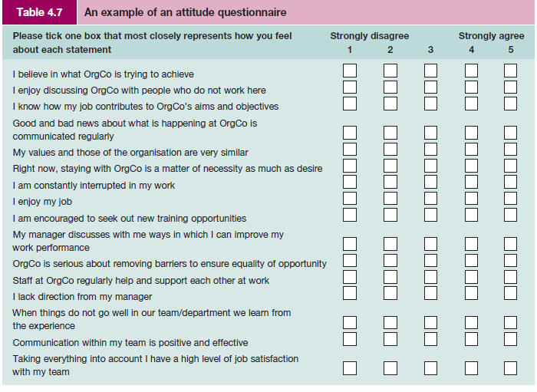
Critical reflection
TESTING AND ASSESSMENT
Much has been written about the value of selection tests and questionnaires and they are subject to a number of criticisms. It should be noted that the word ‘test’ is often taken to refer to measures of intelligence, achievement and developed abilities, and aptitude for particular tasks. Measures of interests, social attitudes, emotional stability or traits of personality are usually referred to as questionnaires or profiles, or similar. Answers are regarded as common or uncommon, typical or untypical, rather than right or wrong, good or bad. The word ‘test’ is therefore usually avoided in such measures, as in, for example, the Cattell 16PF Questionnaire.

The early tests of intelligence have evolved into a large psychological business. Most people will have taken a psychometric test of one kind or another by the time they are an adult in employment. Tests may be administered at school or college, or as part of the selection assessment process at work. The use of tests is widespread and growing. They are perceived to be useful as an objective discriminating tool, but they are not without controversies and
sensitivities.

Tests are divided broadly by the British Psychological Society into the following:
1 Tests of typical performance. These assess an individual’s typical responses to given situations. Answers are not right or wrong but identify choices, preferences and strength of feelings. Personality assessments and interest inventories are examples of such tests.
2 Tests of maximum performance. These assess an individual’s ability to perform effectively under standard conditions. Performance on these tests, which include ability and aptitude tests, can be judged as right or wrong. Ability tests come in many different forms and may test a general intellectual functioning or a specific ability (such as verbal reasoning, numerical reasoning, etc.).

Alice Heim (cited in Anastasia) developed a series of general ability tests – AH series – which is widely used to assess general ability. These test three key areas: verbal, numerical and diagrammatical reasoning. For example, an individual would be asked questions similar to the following:

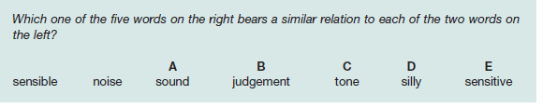

Modern Occupational Skills Tests are an example of specific ability tests and measure a range of clerical and administrative skills: verbal checking, technical checking, numerical estimation, etc. They claim to be an aid in the selection of administrative staff. Their tests are short and can be used singly or together as a battery of tests. The individual would be asked questions similar to the following:

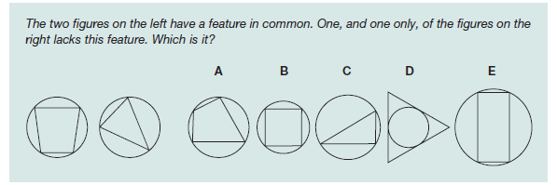
Some tests are designed to be given individually whereas others are suitable for administering within a group situation. However, there are certain minimum features and standards of conditions that distinguish psychological tests from other forms of informal assessments; tests are essentially ‘an objective and standardised measure of a sample of behaviour’.65

Features of psychometric tests
Psychometric tests have certain standard features:
1 Tests will comprise a standard task or a set of questions with a standard means of obtaining the score.
2 A technical manual will explain what the test is measuring, how it was constructed, and the procedures for administering, scoring and interpreting the test.
3 Details of the test’s validity (whether the test measures what it claims to measure) and reliability (the test’s ability to measure consistently) will also be shown in the manual along with the inferences that can be drawn from the data.

For a test to be considered as a psychological instrument it must be objective, standardised, reliable, valid and discriminating (but not discriminatory). The selection and choice of the test should be based on a number of other key features such as its acceptability, practicality,
time, costs and perceived and actual added value.

DIVERSITY MANAGEMENT
The concept of diversity
An integral and essential feature of individual differences is the concept of diversity. We have seen from the discussion above that people are not homogeneous. Diversity focuses on the multiplicity of differences among people – on the variety of people as heterogeneous groupings. Individual differences are the basis of diversity. For Kandola and Fullerton, diversity is defined as follows:
The basic concept of managing diversity accepts that the workforce consists of a diverse population of people. The diversity consists of visible and non-visible differences which will include sex, age, background, race, disability, personality and workstyle. It is founded on the premise that harnessing these differences will create a productive environment in which everybody feels valued, where their talents are being fully utilised, and in which organisational goals are met.68

Individual differences and diversity have long been recognised as important for effective team performance but in recent years greater attention has been given to the management of diversity. Reasons for this include:

■ demographic changes in the workforce;
■ wider customer base;
■ equal employment opportunities legislation;
■ a shortage of higher-level skills;
■ programmes of affirmative action and positive discrimination;
■ increasing number of women and part-time workers entering the workforce;
■ changing social attitudes;
■ a more global environment and increasing internationalisation.

However, valuing differences is easier said than done. It means relating and working with people who hold different perspectives and views, bringing different qualities to the workplace, having different aspirations and having different customs and traditions. Differences are challenging; they question people’s views, perceptions and attitudes and require individuals to see things from a different frame of reference. Managing diversity does not mean that managers champion their own values and try to shift other people’s values to conform and match their own! The Chartered Management Institute provides the following description of diversity:
The concept of diversity encompasses any sort of difference between individuals. These could be differences in ethnic origin, age, gender, disability, family status, education, social or cultural background, personality or attitudes – in fact, anything which may affect workplace relationships and achievements. The management of diversity involves the implementation of strategies through which a network of varied individuals are integrated into a dynamic workforce.69

In addition to the above it is possible to identify a number of ‘secondary’ learned characteristics that a person acquires and modifies throughout life and over which the individual has relatively more influence. These include:
■ religious beliefs
■ sexual orientation
■ work experience
■ personal style
■ income
■ geographical location.

From equal opportunities to managing diversity
Equal opportunities relates to legislation intended to outlaw discrimination. The government is committed to protect individuals at work against discrimination in employment on the basis of gender, disability, race, religion, sexual orientation or age. Encouraging a diverse workforce is high on the government’s agenda and the reluctant employer is having their hand forced by statutory obligations. Although diversity in the workplace relates to treating everyone equally, it complements and further develops initiatives on equal opportunities.
Future demographic patterns present new challenges for managers. Among those who believe that equal opportunities policies and training, though important, are not by themselves enough to secure the positive value of individual contributions is Guirdham. Only where an organisation has fully embraced diversity, trained its staff accordingly and inculcated its principles in every way will the barriers to good work communications between subgroups be lowered.

THE BUSINESS CASE FOR DIVERSITY
As businesses become increasingly global it is even more important for managers to have a sound understanding of diverse countries and workforces. According to ACAS, the business case for diversity – that a more diverse employee base will attract a more diverse customer base and increase sales, improve performance etc. – is a well-argued one.72 Organisations that embrace difference and diversity as opposed to those which are merely compliant will, it is claimed, succeed in a fiercely competitive climate. For example, as J. M. Barry Gibson, (then) Chief Executive of Littlewoods, has stated:

The fact is that if we effectively exclude women, ethnic minorities and disabled people we are fishing in a smaller pool for the best possible talent. As a service organisation, we ought to reflect the style, taste and opinions of our consumers, who of course represent sexes, all colours and creeds, all ages and disabilities. The main point is that cultural diversity will strengthen the quality of the company and will make us much more outward-looking.73

A joint report from the CBI and TUC, supported by the Equality and Human Rights Commission, suggests that promoting diversity in the workplace and employing people solely on the basis of their ability can bring many real business benefits. These include:
■ increasing employee satisfaction, which helps attract new staff and retain those already there, reduces recruitment costs, and can increase productivity;
■ understanding better how the company’s diverse customers think and what drives their spending habits, or how they access markets they have not previously been able to tap into so effectively;
■ finding enough workers to fill skills gaps in areas with tight labour markets, where there are not enough ‘obvious candidates’ for the vacancies they have.

The report also makes clear that diversity can be improved through positive action – such as encouraging applications from types of people who have not in the past applied for jobs, additional training, providing support networks or adapting work practices – but not positive discrimination.

Diversity and management recruitment
The Institute for Employment Studies, in conjunction with the Chartered Management Institute, emphasises the importance of diversity as a strategic priority for retaining and developing key people in an organisation. They draw attention to the different career ambitions of managers from under-represented groups and state that, if organisations want management talent at the top, recruitment approaches must recognise that managers from different ethnic groups are attracted by different benefits. For example, compared with other ethnic groups, black managers were more likely to cite good progression opportunities; Asian managers more likely to cite working for a good employer; managers from mixed background to cite challenging work; white managers and black managers more likely to mention better work/life balance.

Diversity action plans
Management of diversity requires an effective action checklist and plan. As an example, The Office for National Statistics (ONS) has produced a comprehensive and detailed Equality Scheme 2008–2011 which includes reference to ONS as an employer; equality impact assessments; and governance, monitoring, reporting and reviewing. Figure 4.
DIVERSITY TRAINING
More than ever, effective organisational performance demands an understanding of, and response to, diversity. This necessitates a work climate that respects individual differences and treats all members of staff with dignity and mutual respect. Diversity training will not be effective unless there is active support from the top and it is recognised as a company-wide initiative and part of the core value of the organisation.
Organisations need to manage diversity in a manner that benefits the well-being of all members of staff.

Training should involve:

■ increasing the awareness and value of diversity;
■ education in understanding the culture and values of members of a diverse workforce;
■ the ability to communicate effectively with all members of staff – and also customers and
suppliers;
■ developing the skills of effective diversity management;
■ addressing biases, prejudices and stereotypes.

Business in the Community (BITC) is one of the agencies that help businesses to embrace a culture of inclusiveness by helping them to look at the competitive case for diversity. Current activities focus on labour market discrimination, religious beliefs, sexual orientation, and general diversity and equality.79 As another example, ACAS draws attention to managing disability and to the importance of line managers’ contribution to organisational
culture and managing performance. Training managers in effective people management skills and developing a culture of inclusion are crucial.80 Attention to top management is also required. Arkin suggests that in company headquarters the chances are that the people will be overwhelmingly white, male, able-bodied and of a certain age. There is little joinedup thinking between activities under the diversity agenda and the nurturing of top talent. The effective management of diversity will also entail a review of organisational processes and the execution of work. For example, not everyone:

■ shares the same work ethic or seeks the same goals and objectives;
■ responds in the same way to working in a bureaucratic structure;
■ works better in a self-managed group or with a more participative style of management;
■ will fit the same psychometric profile;
■ is motivated in the same way; or
■ reacts the same way to different forms of control.

Diversity management requires time and effort and may well have a high financial cost. There is a general feeling that badly managed initiatives do more harm than good. Managing diversity requires a company-wide philosophy and commitment, a change to organisational culture and supportive systems of management and training.

Diversity and stereotyping
Diversity also challenges many traditional stereotypes. Stereotyping infers that people within a particular perceived category are assumed to share the same traits or characteristics. Stereotypes are a means of making simplified judgements of other people instead of coping with a range of individual stimuli. Stereotyping attributes to all individuals the characteristics or tendencies of the categorisation as a whole. An important feature of managing diversity is an awareness of, and training in, overcoming inaccurate stereotyped perceptions and attributions. A greater understanding of cultural differences in non-verbal communications and body language will help improve interpersonal relationships.

Managers’ attitudes, values and beliefs
If they are to be successful in managing diversity, managers need to have greater reserves of emotional intelligence (discussed earlier in this chapter). In turn this suggests that managers need to have an awareness of, and be able to get in touch with, their own attitudes, values and beliefs – what they are and where they come from. Clements and Jones recognise that the process can be uncomfortable:

A model of good diversity training will recognize that when people engage in an exploration of their attitudes, values, beliefs and prejudices, this may be an uncomfortable process. Some will find out things about themselves that will cause them emotional pain, and often the tension in learners will relate to how they should respond.

