Moynul Ali ~ 2205390 

Ludwig Mies van der Rohe

In 1886, Ludwig Mies van der Rohe was born in Aachen. Son of a stonemason, at which workshop the teenage boy spent many years working.
- He had the opportunity to collaborate with Max Fisher between 1903 and 1904, working on stucco decorations for him.
- He moved to Berlin between 1905 and 1907 where he worked for furniture designer Bruno Paul.
- He studied at the Hochschule für Bildende Künste and the Kunstgewerbeschule both art schools from 1906 to 1908. He then later worked for Peter Beherens, one of the most well-known architects of the day, where he remained until opening his own firm in 1912.
- Mies van der Rohe was appointed to lead the Bauhaus school from 1930 to 1933 in place of Walter Gropius.
- He was forced to relocate permanently to the United States because of the new totalitarian Nazi regime in Germany. In 1938 when he was appointed head of the Illinois Institute of Technology's architecture programme. In Illinois, he would stay until his death in 1969.
Barcelona Pavilion
One of Ludwig's most famous works is the German Pavilion, also known as the Barcelona Pavilion, which was constructed in 1929 and is close to the Montjuic hill. 1929 saw the Spanish city of Barcelona host the Exposition Universal, which Mies van der Rohe designed and built. Universal expositions are sizable exhibits where development was aimed and is intended to be promoted in the industrial and technological realms by showcasing the most spectacular inventions of the period (Neumann, 2020).
Every participant nation worked on building its own display pavilion while attempting to convey the concept and key characteristics of that country. Mies goal was to symbolically express the progressive, democratic, and peaceful nature of the new Weimar republic as well as the desire for rebirth in accordance with a socially sophisticated way of life in order to restore the reputation that had been damaged following the First World War (Dodds, 2005).

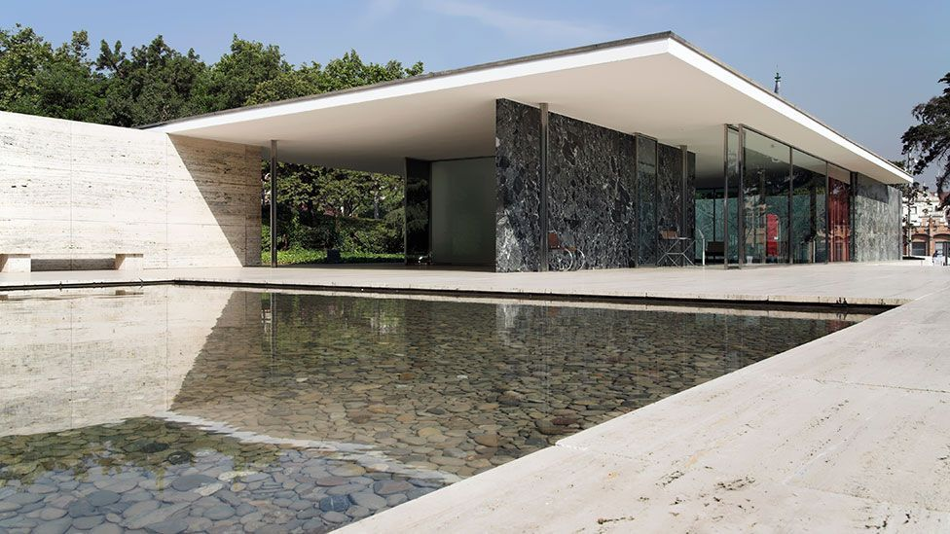
Fig. 1 Picture of the Barcelona pavilion (Llenas,2006)

Geometric purity
The Pavilion's architecture is based on a geometric purity with harmoniously blending connected rectangular elements. The building's foundation is a 242 cm module, and eight chromed columns support the flat roof made of travertine slabs. The walls are composed of glass that reflects light, turning them into mirrors that reflect the around vegetation (Dodds, 2005). A wide gap in the centre was ringed by six unique zones that were tastefully decorated with works of natural art. The Barcelona Pavilion's form consists of a rectangular form divided into three areas, one of which is an inner courtyard that illuminates the gallery that surrounds it. A welcome room and an exhibition hall are located in two small volumes that make up the remaining two areas. A sensation of equilibrium and order is produced by the use of basic geometric forms and the rotation of volumes. The building's section makes it clear how the use of resources like travertine, green marble, and chrome is combined into the design to produce a place that is both attractive and practical. A flat concrete slab that serves as the roof plane and is supported by steel wire columns allows natural light to enter the area and fill it . With no sensation of weight or load on the structure, the use of these light materials produces a breezy, open feeling (Josep Quetglas, Moneo and Der, 2001). The utilization of a few walls, which enables the area to flow organically from one area to another, is just another remarkable aspect of the section. Every area is divided and defined by the independent walls that have been constructed, and they emphasize the building's coherence by being made of the same materials as the rest of it. The roof structure is the additive component of the pavilion as a whole, whilst the reflecting ponds are the subtractive component that balances the additive components. This demonstrates another state of balance inside the pavilion. Due to the addition and role the roof plays in the construction, even with this balance, the pavilion feels more adding than subtractive.

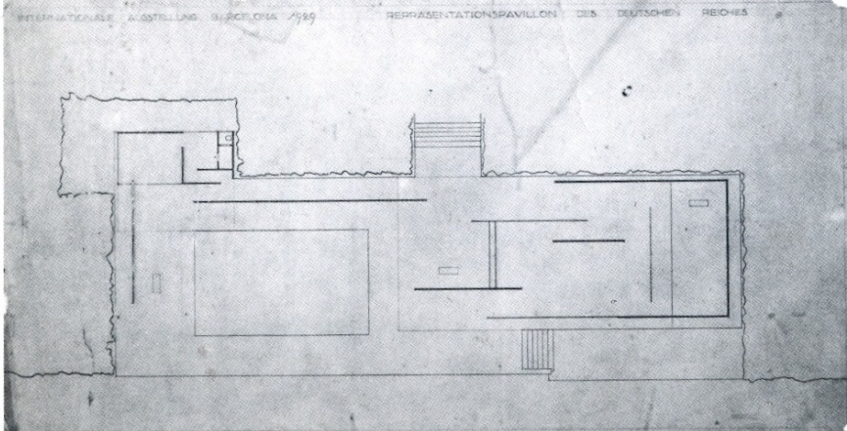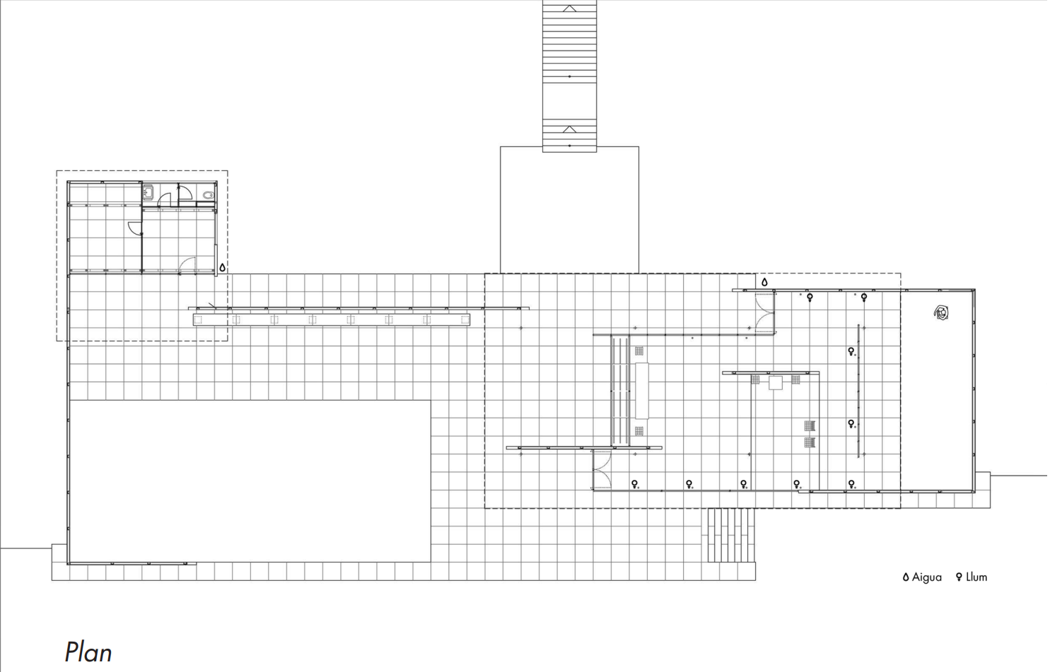
Fig. 2 First preliminary drawing (1928) Fig. 3 Plan on CAD (Manzoni, 2012)
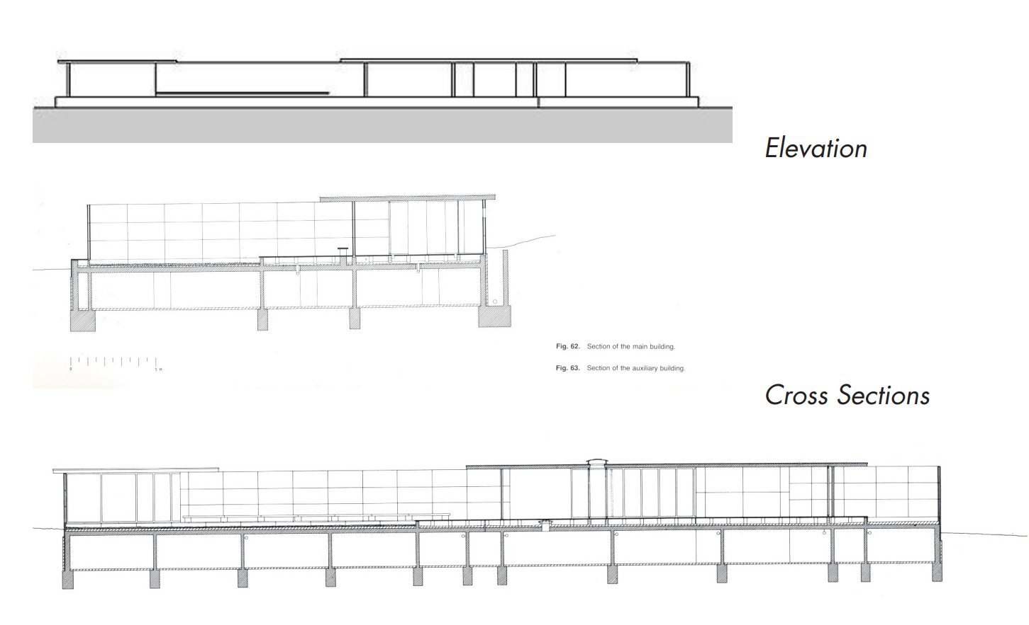
Fig. 4 Elevation on CAD (Manzoni,2012)
Fig. 5 Section on CAD (Manzoni, 2012)

Fig. 6 Cross section on CAD (Manzoni, 2012)

Elegance and Simplicity
A sense of great elegance pervades the space, enabling guests to savour the expensive materials used in every aspect. The minimalist furniture created by architect Mies van der Rohe features a range of natural and opulent finishes, as do the geometric architectural components. The Barcelona chair and the Brno chair were created by Mies, who was inspired by the purity of design and worked under the guiding philosophy that form follows function. In the former, the square cushions in the latter are formed from several tiny leather pieces and are covered with a stainless-steel frame. The leather is treated to get the most brilliant white colour imaginable. The seat and back of the Brno chair are covered in leather, while the frame is made of seamless tubular steel with a refined chrome finish.

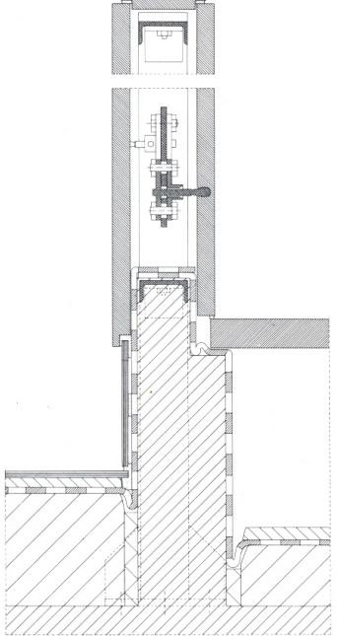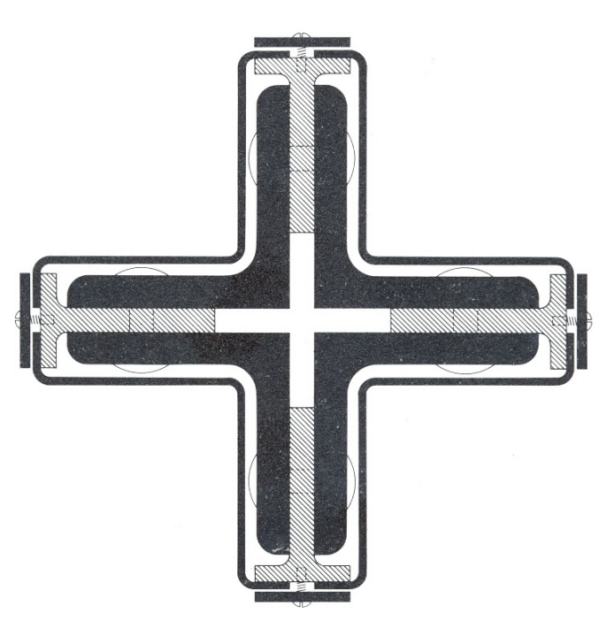
Fig. 7 Detail of travertine wall (Manzoni, 2012) Fig. 8 Detail of the steel column (Manzoni, 2012)

Light and Space
A consistent sense of harmony between the natural and artificial components is made possible by the Pavilion's distinctive, unbroken layout and high-quality materials. The glass walls' semi-reflective properties serve to increase the amount of natural light entering the room. Visitors’ movements are calmed by the effect of water on the floor created by the reflected pool at the entrance. Walls serve as spatial separators and "directors" of the area rather than just as a simple structural support (Josep Quetglas, Moneo and Der, 2001).

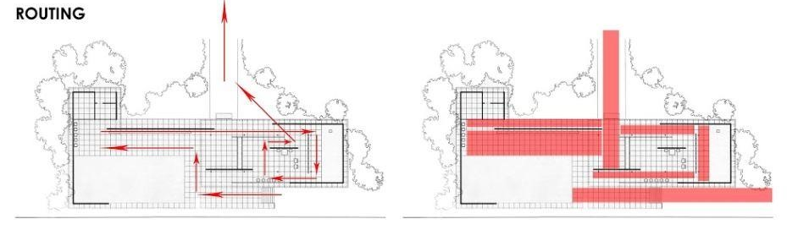
Fig. 9 Routing (Ntow-kummi,2014)
One of the key elements of the pavilion is the circulation, which is apparent in the left image. The visitor first ascends to enter the pavilion itself. The individual will need to follow the specified circulation loops almost instinctively once they are on the podium. The open layout and fluid spatial configurations are entirely responsible for this. The vertical components shift the visual axis of the individual in a different direction. On the left, people can see the route, and on the right, they can see the space system.

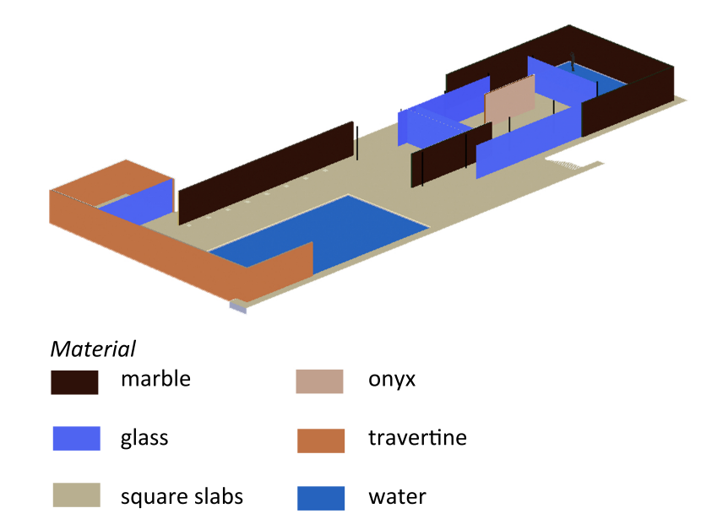
Fig. 10 Materials (Depardon, 2012)

Symmetry

In terms of its general design, the pavilion is nearly symmetrical. The seating area, which is an extra breakout of the structure (the positive), and the vacant space that leads the visitor up the steps to the pavilion combine to create symmetry in the middle of the design and highlight its rectangular shape (the negative). The pavilion would become unbalanced if one were to add more material or remove some of these components (Der et al., 2010). The positioning of the walls that divide up the pavilion's interior constitutes the only aspect of the structure that may be deemed asymmetrical.
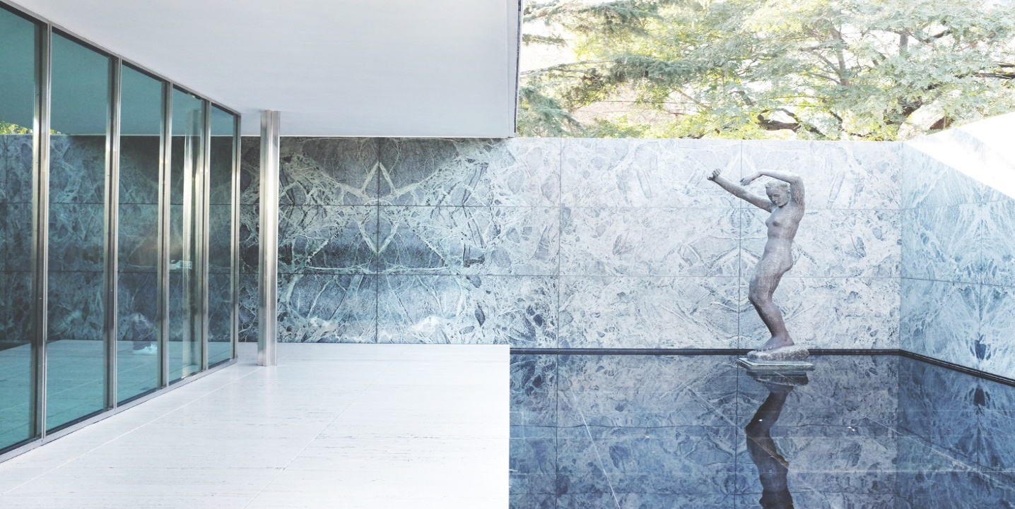
Fig. 11 Picture of the statue in symmetry (Merin, 2018)
Legacy and Significance
The construction of the Barcelona Pavilion represented the start of a new phase in architectural modernism. The pioneer of this movement in Europe, Mies, developed an important idea for architecture: the union of clarity, elegance, utility, and careful consideration of every detail. The key to this approach is aligned with the modern way of life, which is focused on the fundamental, was minimalism (Tafuri and Francesco Dal Co, 1986). Mies continued to have an impact on architecture and design after the Barcelona Pavilion when he was a professor at the Illinois Institute of Technology in Chicago.
Beyond Mies' influence, the Barcelona Pavilion has left a constructive impact. The Pavilion continues to be relevant in today's world and serves as an example for upcoming designers, artists, and architects. The crucial project for modern architecture serves as a model and a baseline for inspiring present-day and future dwelling solutions. Several modern constructions bear the significant influence of the Barcelona Pavilion, with a particular emphasis on the interiors transformation into rich, sumptuous rooms.

Water is a crucial component of the project. Mies integrates two water mirrors in the pavilion. The larger one, which is at the entrance, serves to mirror the pavilion and make it appear more lighter.
At the east side of the building, across from the living room, is the second, more quiet and private. It is entirely enclosed on three sides by walls made of antique green marble, is shallow, and German sculptor Kolbe sculpted a bronze statue of it called "Der Morgen," or "the morning," which features
a woman emerging from the water and lifting her arms up in the air (Kroll, 2011).

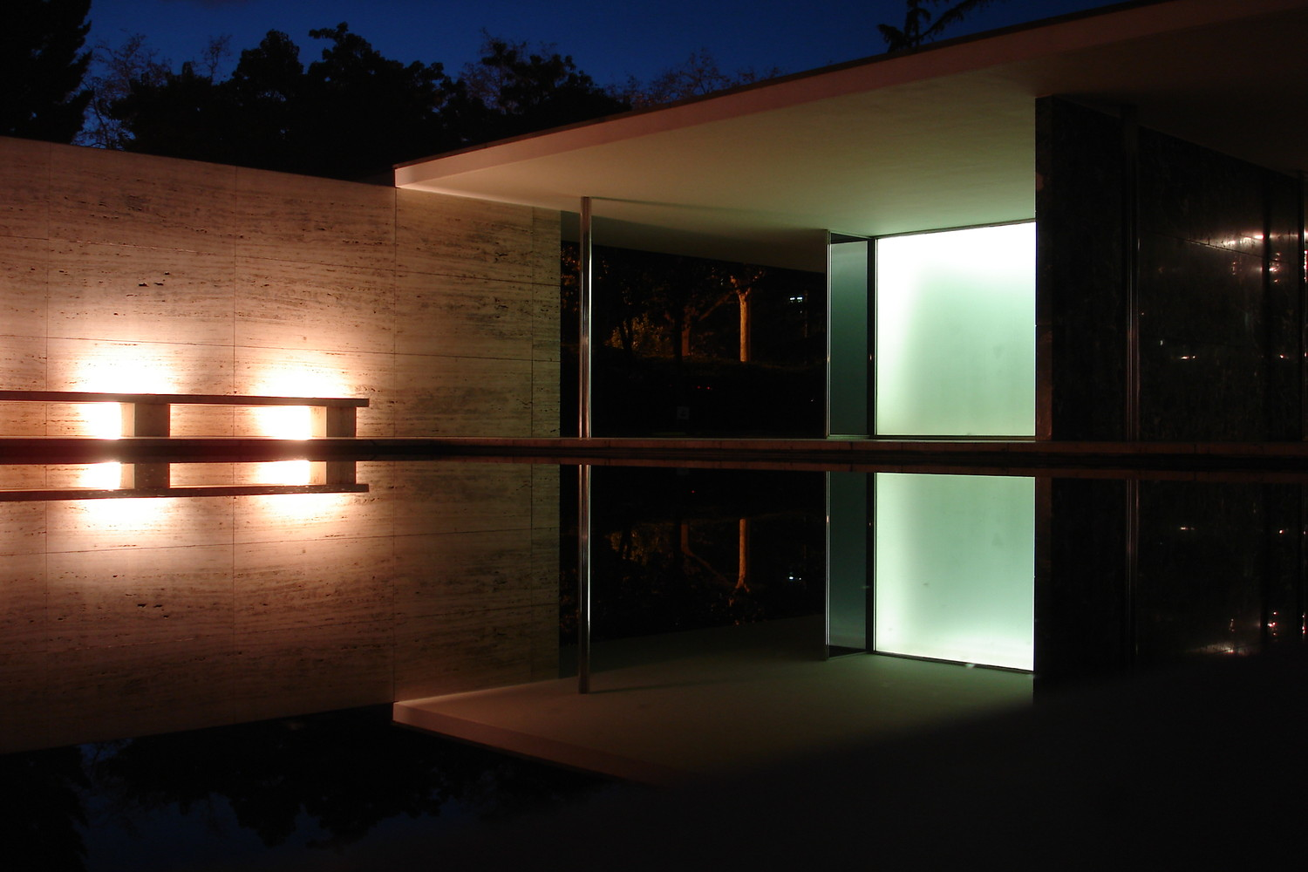
Fig. 12 Lighting at night (Kristo, 2019)
Conclusion
To summarise, the Barcelona Pavilion is a masterwork of modern design as well as an iconic emblem of the Modernist movement. Simple geometric designs, natural materials, and the interaction of light and space are highlighted in its minimalism architecture. The Pavilion's impact on later generations of architects and designers cannot be underestimated despite its comparatively short existence. Its lasting beauty and significance make it an essential location for everyone with an interest in architecture or design, and its history continues to inspire new generations of artists, engineers, and inventors across the world. The Barcelona Pavilion was created in the past, yet it continues to serve as a timeless demonstration of the value of innovation and the attractiveness of modernism.

References:

Depardon, D. (2012) Barcelona Pavilion: Mies Van der Rohe [CAD].
Der, V., Jean-Louis Cohen, Dachs, S., Patricia De Muga and Laura García Hintze (2010). Mies van der Rohe. Barcelona: Ediciones Polígrafa ; New York.
Dodds, G. (2005). Building desire : on the Barcelona Pavilion. London Routledge.
Josep Quetglas, Moneo, R. and Der, V. (2001). Fear of glass : Mies van der Rohe’s pavilion in Barcelona. Basel: Birkhäuser.
Kristo, G. (2019). Lighting at night. [Digital Photography] Available at: https://www.flickr.com/photos/_gk/ [Accessed 31 Mar. 2023].
Kroll, A. (2011). AD Classics: Barcelona Pavilion / Mies van der Rohe. [online] ArchDaily. Available at: https://www.archdaily.com/109135/ad-classics-barcelona-pavilion-mies-van-der-rohe [Accessed 31 Mar. 2023].
Llenas, Q. (2006) Picture of the Barcelona Pavilion, www.gettyimages.co.uk. Available at: https://www.bbc.com/culture/article/20130924-less-is-more-a-design-classic. [Accessed 31/03/2023]
Manzoni, R. (2012) Padiglione di Barcellona: planimetrie [CAD].
Merin, G. (2018). Picture of the statue in symmetry. [Digital Photography] Available at: https://www.archdaily.com/109135/ad-classics-barcelona-pavilion-mies-van-der-rohe/54c6a195e58eced670000007-mies4-jpg?next_project=no [Accessed 31 Mar. 2023].
Moffett, M., Fazio, M. and Wodehouse, L. (2005). A World History of Architecture. Laurence King Publishing.
Neumann, D. (2020). The Barcelona Pavilion by Mies van der Rohe One Hundred Texts since 1929. Basel/Berlin/Boston: Birkhäuser.
Ntow-kummi, B. (2014) Precedence study: Barcelona Pavilion [CAD].
Tafuri, M. and Francesco Dal Co (1986). Modern architecture. New York: Electa/Rizzoli.

‌

