

LCBB6014
Independent Project
Project Proposal

Evaluating the Impact of Social Media Marketing on Customer Acquisition in UK Start-Up Businesses

Student Name:Georgiana Piticas
Student ID:2315601
Supervisor Name:Shahrukh Irfan

Table of Contents
1. Introduction and Background 3
a. Background and Problem Statement 3
b. Research Aim 3
c. Research Objectives 3
d. Research Questions 3
2. Literature Review 3
3. Theoretical Framework 4
4. Research Methodology 5
a. Research Philosophy 5
b. Research Approach 5
c. Research Design 5
d. Population & Sampling 5
e. Data Collection 5
f. Data Analysis 6
g. Ethical Considerations 6
5. Expected Contribution 6
a. Theoretical Contribution 6
b. Practical Contribution 6
c. Policy Contribution 6
6. Limitations 6
7. Proposed Timeframe (Gantt chart) 7
8. Conclusion 7
9. References 9

1. Introduction and Background

a. Background and Problem Statement
The low cost and extensive reach have made social media marketing a crucial part of the UK start-ups. Social media platforms have become an important source of marketing and discovery channel with nearly 43% of consumers in the UK using social media platforms on a daily basis to find information (McNamee, 2025). The high adoption, however, presents a problem to many start-ups, which is the inability to translate internet activity into real customer acquisition. This brings out a very essential issue that even though visibility and interaction are on the rise, it is still unclear whether they can achieve a tangible business result (Usman and Sun, 2023). Subsequently, which are the particular social media factors contribute to the successful customer acquisition.

b. Research Aim
The study will aim at examining the influence of social media marketing (SMM) on consumer acquisition within the UK startup businesses.

c. Research Objectives
- To analyse the link between social media marketing activities and customer acquisition.
- To identify the most effective social media strategies used by UK start-ups.
- To examine the impact of engagement, content quality, and platform usage on customer acquisition.

d. Research Questions
Primary Research Question
1. What is the impact of social media marketing on the acquisition of customers in UK start-ups?
2. What are the best customer acquisition strategies in social media?
3. How much do engagement, content quality and platform use influence the acquisition outcomes?

2. Literature Review
Social media marketing is a strategic tool that has been widely recognised as having the potential to boost customer acquisition (Laradi et al., 2024). In the existing literature, although its efficiency is still disputed. According to Tian and Liu (2026), even though measures of engagement are commonly employed to measure success, researchers increasingly challenge the use of engagement measures as predictors of purchase, with many viewing them as indicators of shallow interaction and not purchase intentions. In the same way, Dwivedi et al. (2021) stated that despite the positive relationship between high-quality and personalised content and better consumer responses, the influence is limited by the algorithmic filtering and content saturation that reduce the visibility despite the high quality of the content.
Moreover, as per Olivieri and Testa (2024) platform-specific studies have pointed out different behaviour of users but lack comparative analysis to ascertain which platforms are most suitable for start-ups. One of the main weaknesses highlighted by Antonio et al. (2024) is that most of the literature is based on large organisations, thus not considering the specific constraints of start-ups, including limited resources and strategic skills. In addition to this, the current literature focuses on the study of variables separately without a comprehensive framework that could evaluate the effect of these variables on customer acquisition (Li, Lin and Zhang, 2023). Therefore, a more holistic and context-specific study remains evidently necessary in order to come up with meaningful and actionable insights.

3. Theoretical Framework
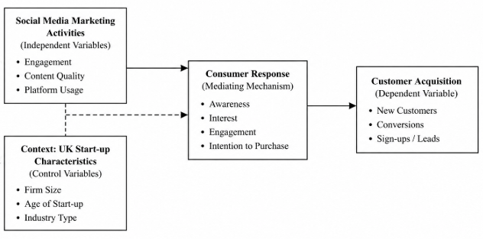
Figure 1: Theoretical Framework
(Source: By Author)
As illustrated in the above framework, the AIDA model and Relationship Marketing Theory are the foundations of this study, which explains how social media marketing leads to customer acquisition. The conceptualisation of the AIDA model is that marketing stimuli can capture attention, create interest, generate desire, and eventually result in action, which is why it is especially applicable to the digital world (Tristanto et al., 2021). On the other hand, the Relationship Marketing Theory also highlights the role of trust, engagement, and interaction as some major attributes that drive customer behavior (Morgan and Hunt, 1994).
Based on these theories, the model suggests that engagement, quality of content, and utilisation of platforms will impact customer acquisition and brand trust will improve the relationships. Combining the two approaches provides a more elaborate approach to observing the impact of marketing strategies in the social media environment. It can provide insights into turning audience engagement into business outcomes.

4. Research Methodology

a. Research Philosophy
The research uses a positivist philosophy, where it is aimed at measuring and analysing relationships on variables objectively (Saharan et al., 2024).

b. Research Approach
A deductive approach will be employed, whereby research questions have been developed from existing theories and tested using empirical evidence.

c. Research Design
The secondary research design will be quantitative, which allows the existing data and studies to be analysed, and patterns and relationships identified (Yuwono and Rachmawati, 2023).

d. Population & Sampling
The sample will include scholarly research and documents pertaining to social media marketing in start-ups. Recent, peer-reviewed sources pertinent to the UK context will be selected with a purposive sampling method.

e. Data Collection
Secondary sources will be used to gather data, such as academic journals, industry reports, and reliable databases, such as Google Scholar (Maida et al., 2022).

f. Data Analysis
The research will utilise the themes and comparative analysis in determining trends in the literature. Results will be generalised in order to address the questions using thematic analysis and discussion (Ghanad, 2023).

g. Ethical Considerations
Ethical principles will be upheld by ensuring that proper referencing has been made, plagiarism should be avoided, and credible and unbiased sources should be used (Hasan, 2023).

5. Expected Contribution

a. Theoretical Contribution
The significance of the study is the combination of several factors into one comprehensive framework and an increase in knowledge about the influence of SMM on customer acquisition.

b. Practical Contribution
The findings will help start-ups to develop more efficient marketing policies by focusing on the best practices of the marketing approach, such as engagement and high-quality content.

c. Policy Contribution
The study may influence the formation of digital marketing policy and contribute to the efforts to enhance the UK start-up environment.

6. Limitations
The research has a few limitations related to using secondary data, which can lead to a limitation of analysis. Also, the results can be affected by publication bias and might not be a perfect reflection of the dynamics of the market at a specific time. The emphasis on UK start-ups can also make it difficult to generalise to other settings (Taherdoost, 2022).

7. Proposed Timeframe (Gantt chart)

Figure 2: Activity Table

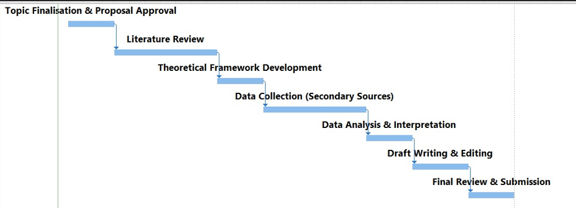
Figure 3: Gantt Chart

Figure 4: Network Diagram

8. Conclusion
This research proposal outlines the systematic study of the significance of social media marketing in customer acquisition among UK start-ups. With the objective of addressing the gaps in literature and applying the theoretical frameworks, the research will yield valuable outcomes.

9. References
Antonio, M., Terzidis, O., Lütz, P. and Heblich, B. (2024) Critical Decisions at the Early Stage of start-ups: a Systematic Literature Review. Journal of Innovation and Entrepreneurship, 13(1). doi:https://doi.org/10.1186/s13731-024-00438-9.
Dwivedi, Y.K., Ismagilova, E., Hughes, D.L. and Carlson, J. (2021) Setting the future of digital and social media marketing research: Perspectives and research propositions. International Journal of Information Management, [online] 59(1), pp.1–37. doi:https://doi.org/10.1016/j.ijinfomgt.2020.102168.
Ghanad, A. (2023) An Overview of Quantitative Research Methods. International Journal of Multidisciplinary Research and Analysis, 6(8), pp.3794–3803. doi:https://doi.org/10.47191/ijmra/v6-i8-52.
Hasan, A. (2023) Ethical Considerations in Mixed Methods Research Design. Routledge eBooks, pp.30–43. doi:https://doi.org/10.1201/9781003204046-3.
Laradi, S., Elfekair, A., Alrawad, M., Hashim, M. and Derouez, F. (2024) Leveraging capabilities of social media marketing for business success. Computers in Human Behavior Reports, 16, pp.100524–100524. doi:https://doi.org/10.1016/j.chbr.2024.100524.
Li, J., Lin, Z. and Zhang, X. (2023) The Study on the Effectiveness of Sustainable Customer Relationship Management: Evidence from the Online Shopping Industry. Sustainability, 15(7), p.5911. doi:https://doi.org/10.3390/su15075911.
Maida, C.A., Xiong, D., Marcus, M., Zhou, L., Huang, Y., Lyu, Y., Shen, J., Garcia, A.O. and Liu, H. (2022) Quantitative data collection approaches in subject-reported oral health research: a scoping review. BMC Oral Health, 22(1). doi:https://doi.org/10.1186/s12903-022-02399-5.
McNamee, S. (2025) Social media statistics in the UK: What businesses need to know in 2025, Sprout Social. Available at: https://sproutsocial.com/insights/social-media-statistics-uk/?
Morgan, R.M. and Hunt, S. (1994) The Commitment-Trust Theory of Relationship Marketing, ResearchGate. Available at: https://www.researchgate.net/publication/233894851_The_Commitment-Trust_Theory_of_Relationship_Marketing.
Olivieri, M. and Testa, G. (2024) Social media platforms use in startups’ international marketing strategies: A multiple case study. International Marketing Review, 41(5). doi:https://doi.org/10.1108/imr-09-2023-0222.
Saharan, V.A., Kulhari, H., Jadhav, H., Pooja, D., Banerjee, S. and Singh, A. (2024) Introduction to Research Methodology. CRC Press eBooks, pp.1–46. doi:https://doi.org/10.1201/9781003088226-1.
Taherdoost, H. (2022) What Are Different Research Approaches? Comprehensive Review of Qualitative, Quantitative, and Mixed Method Research, Their Applications, Types, and Limitations. Journal of Management Science & Engineering Research, 5(1), pp.53–63. Available at: https://hal.science/hal-03741840/document.
Tian, S. and Liu, J. (2026) Does social media engagement really build brand loyalty? Evidence of short-term null effects in emerging markets. Frontiers in Communication, 11. doi:https://doi.org/10.3389/fcomm.2026.1780347.
Tristanto, T.A., Hurriyati, R., Dirgantari, P.D. and Elyusufi, A.M. (2021) AIDA Model as a Marketing Strategy to Influence Consumer Buying Interest in the Digital Age. Budapest International Research and Critics Institute (BIRCI-Journal): Humanities and Social Sciences, 4(4), pp.12575–12586. doi:https://doi.org/10.33258/birci.v4i4.3319.
Usman, M.A. and Sun, X. (2023) The impact of digital platforms on new startup performance: Strategy as moderator. Heliyon, 9(12), pp.e22159–e22159. doi:https://doi.org/10.1016/j.heliyon.2023.e22159.
Yuwono, M.A. and Rachmawati, D. (2023) Combined Methods. Can This Solve The Differences Between Deductive and Inductive Methods in Qualitative Research? Moroccan Journal of Quantitative and Qualitative Research, 5(3). doi:https://doi.org/10.48379/IMIST.PRSM/mjqr-v5i3.45541.

