

ASSESSMENT COMPONENT 2

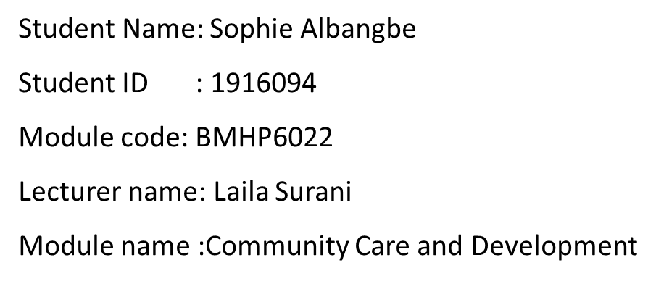
Executive summary
This report is based on the community development which includes issues in the community The demographic diversity along with the health issues of the community is highlights in this report. The health belief model is used to determine the heath approaches towards the Refugees community in the borough of Islington. This also discussed some of the measures that have been adopted by UK government for developed the community. This healthcare system includes free checkups and medical facilities by the NHS. This also states that according to UK governments it has been assumed that Tuberculosis screening has been carried out every six months, for the community health assessment.
Table of Contents
Introduction 4
Overview of the chosen community 4
Demography 4
Challenges faced within the community 5
Stakeholders in the community program 6
Theory used to approach community development 6
Legislation and policy 8
Social media techniques 8
Recommendations 9
Conclusion 9

References 12

Introduction
Community development is beneficial for people of all age groups bond together to support and empowerment. The community consists stakeholders and other agencies. They provide information about the care service of the community and arranges support services for the community(gov.au,2022). This report is based on the care given to Refugees community in the London borough of Islington and their health issues. The refugees living in the UK are facing several problems including health problems. There are many factors are affected their health including refugee camp conditions as well as the geographic origin and current atmosphere. Many of them face intestinal parasite and tuberculosis.

Overview of the chosen community
A large number of Refugee community living in the London borough of Islington, the community and the government focus, is to ensure that support are provide for the need of the refugee. There are many online platforms actively helping the Refugee community. This community faced several health issues due to many factors including mental fear and stress disorder. In addition, they are often detected with a high risk of mental health problems (Goodson et al. 2021). In the UK, at the end of 2015, approximately 123,000 refugees faced complex health issues. Implementing good healthcare policies for refugees can provide them with good healthcare services and help to get out of mental trauma. Living with poor sanitation increases the risks of tuberculosis and intestine parasite and increases the risk of transmitting communicable diseases to their population. Moreover, the poor socio-economic condition of refugees increases their health issues.

Demography
The UK government recently consulted for prohibits access for refugees and consider their issues for health inequalities. Iniquitous and unethical health policy creates health service issues in the UK. As per the recent report the refugee statistics in the UK in 2021, the number increased by 32.61% from 2020 and presently the number is 137,078.00 (Gov.uk, 2022). The report also stated that in 2021, there are over 200.000 living in the london borough of Islington from different nationalities of the world.
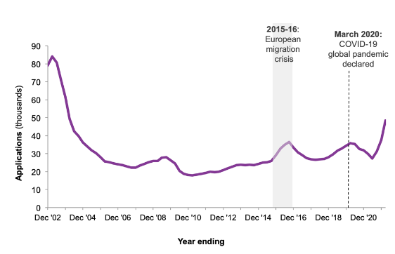
Figure 1: Number of refugee applications lodged in the UK
(Source: Gov.uk, 2022)
All the refugees were resettled in the UK in 2010 and most of them are from Syria. According to “United Nations High Commissioner for Refugees (UNHCR)” almost there are approximately 45,244 pending refugee cases present for resettlement. The UK government offer protection in the form of Humanitarian protection along with alternative resettlement to 14,734 people (Gov.uk, 2022). In addition, 6,134 children of refugees are currently living in the UK and granted entry to the UK by visa for a family reunion.

Challenges faced within the community
As per the consultation of refugee’s report, it is discovered that refugees are more actual to the wrong environment and cannot timely access quality health care service. Using poor contaminated water during their journey increases the risk of various infections and bacterial diseases among the refugee people. Refugee camp conditions and geographic origin led to health issues, intestinal parasite, and tuberculosis. (Ibragimova and Žužak, 2020). Moreover, these issues generate to anxiety and depression which are commonly reported among the refugee and they are linked to lengthy processes for poor socioeconomic conditions. Isolation and poor employment among refugees and are considered the main cause of mental stress disorder. This can lead to depression and anxiety among them. There are also some treatment challenges that occur among the refugee such as health screening programmers, clinical resources and access to health care services during the disaster. The arrival of Covid 19 pandemic disrupted the health care service putting refugee people in more vulnerable conditions and hampering their healthcare needs and responses to their care services. Therefore, intestinal parasite, and tuberculosis are common among refugees and various non-communicable diseases due to integration policy, migration experiences and exclusion (Goodson et al. 2021). Many of them feel sleeping difficulty, fatigue, and hopelessness. However, the health of refugees is potentially relevant to social determinants such as education, income, housing facility and employment.
Stakeholders in the community program
The Community Awareness and Development Plan was created to make sure that all project stakeholders, particularly the underprivileged and vulnerable groups, are effectively included in all projects. The economic plan's main goal is to allow these groups the chance to have their voices heard throughout all levels of judgment. Stakeholders were found via a preliminary study of stakeholder, and they were then invited to participate in the project design stage. Sustaining public support and resolving complaints depend heavily on substantive, pertinent, continuing interactions with various stakeholders and effective, prompt information dissemination (Kimberley, 2022). The partners must be promptly informed of all pertinent details on the project's purpose, design, timetable, effects, and overall advantages in a manner that is understandable to the target audiences.

Theory used to approach community development
The proper implication of the Health belief model is for the disease prevention programmed and guide to health promotion among refugees. This model has specifically focused on the health condition of the people and defines key objectives for health care influence to health behavior and positive benefits of the care action. This healthcare model is communication to the refugee community to be involved in recommended action for mental and physical well-being policy (Limbu et al. 2022). In addition, demonstrate the health care act that provides support to enhance the self-efficiency among refugee and successfully changes the behavior among the community. This model particularly focus on the perceived benefits from health service.
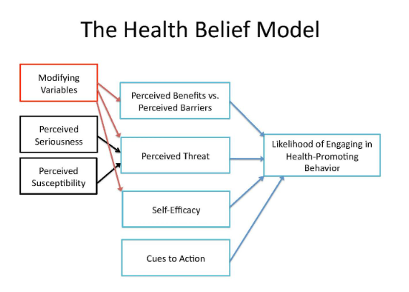
Figure 2: The health belief Model
(Source: Unizin.org, 2022)
The health belief model is appropriate to use in the combination development of the community and it can ensure the identification of two causes of the diseases. This model is appropriate to use for the target population and specific communities as it is able to prevent the disease's spread. Determining the risk of the community is the main focus of this model and targets the prevention steps involved in recommending action for diseases. Using the health beliefs model identifies the key decision-making points that include proper action of health care services (Sreelakshmi and Prathap, 2020). In addition, the long-term and short-term interventions determine the ability to understand the perceived severity among refugees. This model particularly uptake health care services towards people. Providing environmental support is also a major objective of the health belief model. The UK government takes some active steps for refugee protection for physical well-being.

This basically deals with different approaches that mainly focus on the health of the Refugees in the borough of Islington. This basically deals with a proper systems approach to healthcare improvement that can be used as benefits for Refugees.
Legislation and policy
Asylum Act 1999 helps refugees to receive support from the “Home Office under section 95” of the “Immigration. NHS Introduction to entitlements for migrants helps them by providing a way for addressing health delivery challenges that identify the multiplicity of elements interacting to impact an outcome for developing a new health care system for the refugee’s community (gov.uk,2022). Thus, this provided better scope and opportunity for employment. Human Right Act 1998 allowed protection for the refugees in the form of asylum; this includes humanitarian protection and also provides alternative forms of leave and resettlement. Nearly 15,684 people including dependents in the year ending June 2022 have been recorded as refugees (Mawson and Kasem, 2019). This can be derived from the fact that the UK government has taken measures to look after this community, especially in healthcare. This refugee is also allowed to get equal treatment, as normal UK citizens. From total UK cities, it has been noticed that “12,968 were granted refugee status following an asylum application ('asylum') 859 were granted humanitarian protection. The UK government has developed a proper healthcare system for refugees. This healthcare system includes free checkups and medical facilities by the NHS. This also states that according to UK governments it has been assumed that Tuberculosis screening has been carried out every six months, for the refugee's health assessment.

Social media techniques
In the long term, social media and digital technology help refugees to continue their education as well as connect with their family members easily through social media. It can be surmised that digital technology helps governments to connect with refugees and update them according to various needs, which can also be part of decimal success for the country. Digital technologies that capture and analyse educational data can also play an important role in improving the basic operational, controlling functions, and planning in education systems. According to the report of 2018, it can be said that UNESCO released a report in 2018 that highlighted mobile technologies and digital technology plays a key role in “ensuring refugees receive an education”. That helps them to understand the way of living as well as they are also able to interact with people in that country. Communications help the refugees to lead normal lives whereas it can be said that social media interactions and updates can help them to realize there is a brighter future ahead. Thus, this helps to make them feel free and update them with the outside world (Hatayama 2018). Thus, this provided better scope and opportunity for employment That helps to get access to updates themselves and learn new things which can help them to attract new opportunities and scope for employment. In these settings and the services available to them it can be noted that refugees also become a part of the economic and social success of a country. Thus, they feel that they are also an equivalent part of countries just like other normal citizens. thus social media and digital technologies plays an important role in order to meet their demands and needs. This also helps governments to deal with refugees.
Recommendations
Thus, to meet all these things digital technologies are playing an important role in terms of meeting this challenge. Moreover, it has been assumed that the refugees can learn more about the UK government and their policies. It also helps them to get an idea about different facilities that have been provided for them. Hence it can also be noted that websites and social media platforms help refugees to learn multiple languages which can help them to communicate with people (Phillimore, 2021). “UNHCR and its partners deliver important information to refugees that can be easily conveyed through social media about asylum applications, and their local policies. Digital technology also helps them to be unified with this country's habits and habitations. It is agreed on challenges in the 21st century. This is one of the major challenges. To overcome these challenges digital technology plays an important role in order to provide effective services to this community.

Conclusion
This research discussed the refugee community and its deals with nearly 133,083.00 people which are 5.03% of the UK's overall population. Thus, this research also analysed the effective measurements that have been taken by the UK government as an effective step to provide production services for them so that they can get every facility like normal citizens of the UK. They also get different job opportunities which can help them to run their lives and accommodations in the UK as well as also get an effective healthcare service which becomes a reason for developing healthcare services and the health of refugees is potentially relevant to social determinants such as education, income, housing facility and employment. These are some of the effective roles that have been overviewed over here.

References
Goodson, L., Darkal, H., Hassan, P., Taal, S., Altaweel, R. and Phillimore, J., 2021. Conceptualising Experiences of Sexual and Gender Based Violence across the Refugee Journey: The Experiences of Forced Migrants from the MENA Regionin the UK (No. 46). IRiS Working Paper Series.
Hatayama, M., 2018. ICTs and livelihood supports of refugees and IDPs.
Ibragimova, I. and Žužak, M., 2020. Refugee health in Europe: mapping review of research literature (2015–2019). International Journal of Health Governance.
Islington Centre for Refugees and Migrants. Available at: https://islingtoncentre.co .uk/ (Accessed: December 10, 2022).
Kirkwood, S., 2019. History in the service of politics: Constructing narratives of history during the European Refugee “Crisis”. Political Psychology, 40(2), pp.297-313.
Kirkwood, S., 2019. History in the service of politics: Constructing narratives of history during the European Refugee “Crisis”. Political Psychology, 40(2), pp.297-313.
Kimberley (2022) Community stakeholders: How to identify and engage for project success, Swift Digital. Available at: https://www.swiftdigital.com.au/blog/community-stakeholders/ (Accessed: November 22, 2022).
Limbu, Y.B., Gautam, R.K. and Pham, L., 2022. The Health Belief Model Applied to COVID-19 Vaccine Hesitancy: A Systematic Review. Vaccines, 10(6), p.973.
Mawson, S. and Kasem, L., 2019. Exploring the entrepreneurial intentions of Syrian refugees in the UK. International Journal of Entrepreneurial Behavior & Research.
Participation, E. (1998) Human rights act 1998, Legislation.gov.uk. Statute Law Database. Available at: https://www.legislation.gov.uk/ukpga/1998/42/contents (Accessed: November 22, 2022).
Phillimore, J., 2021. Refugee-integration-opportunity structures: shifting the focus from refugees to context. Journal of Refugee Studies, 34(2), pp.1946-1966.
Sreelakshmi, C.C. and Prathap, S.K., 2020. Continuance adoption of mobile-based payments in Covid-19 context: an integrated framework of health belief model and expectation confirmation model. International Journal of Pervasive Computing and Communications.
Stevens, A.J., 2020. How can we meet the health needs of child refugees, asylum seekers and undocumented migrants?. Archives of Disease in Childhood, 105(2), pp.191-196.
Gov.uk, 2022. How many people do we grant asylum or protection to? - GOV.UK Available at: https://www.gov.uk/government/statistics/immigration-statistics-year-ending-december-2021/how-many-people-do-we-grant-asylum-or-protection-to#:~:text=This%20section%20covers%20individuals%20granted,(including%20dependants)%20in%202021. [Accessed on: 09/11/2022]
Unizin.org, 2022. The Health Belief Model Available at: https://psu.pb.unizin.org/kines082/chapter/the-health-belief-model/ [Accessed on: 09/11/2022]
What is community development? (2019) AIFS. Available at: https://aifs.gov.au/resources/practice-guides/what-community-development (Accessed: November 22, 2022).

