Application Development (Games)
  - Lecture 1 Lab Tutorial Exercise

Perky Penguin Game Part I

Objectives
The aim of this lab exercise is to introduce you to game development in Unity. You will create a basic 2D Game, Perky Penguin, which is a Jetpack Joyride-based game.
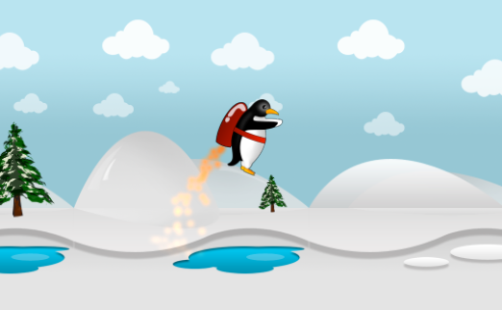

Getting Started
- Open up Unity and create a new 2D project for today’s exercise called Perky Penguin.
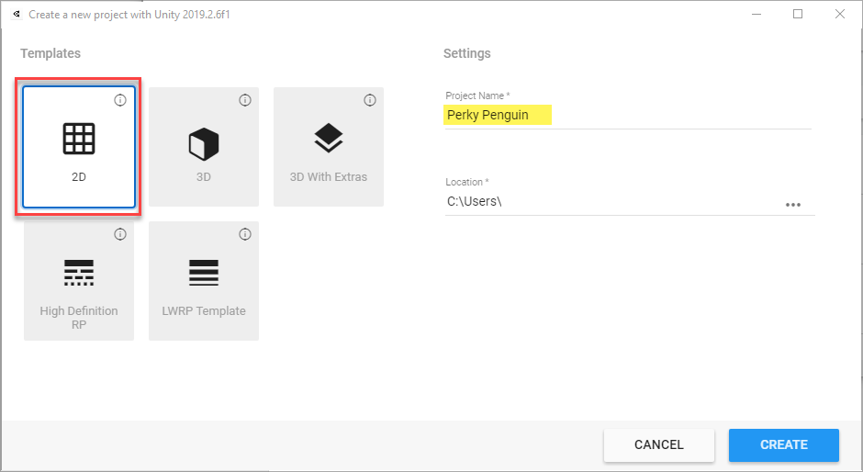
- Confirm that your project is setup for 2D from the menu option Edit Project Settings Editor.
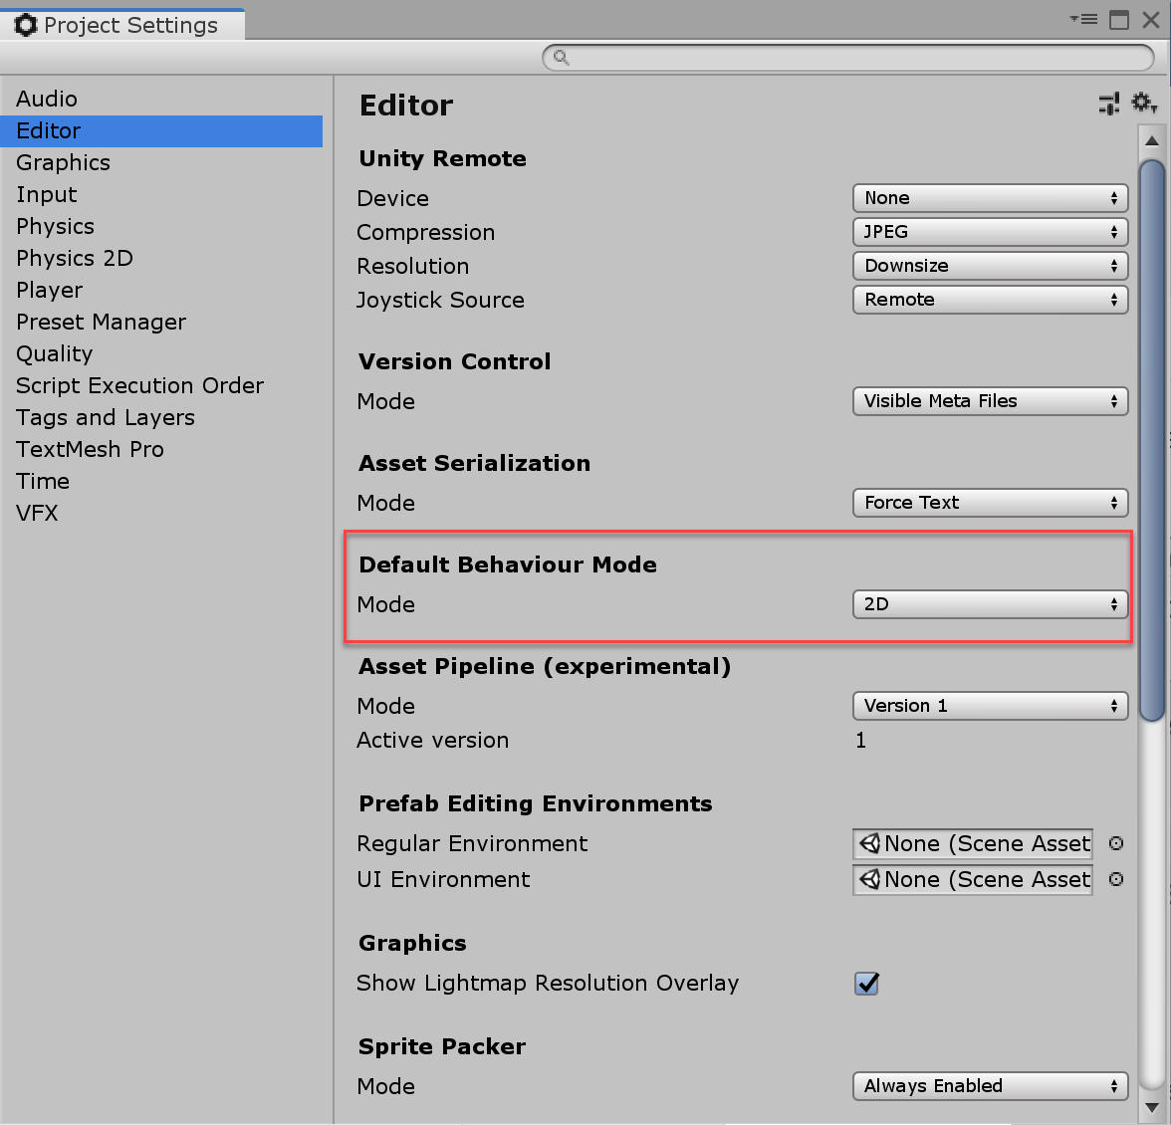
- Create a new folder in the Project Assets window called Scenes.
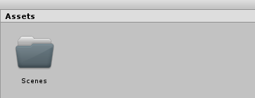
- Save your scene in this folder with a name of your choice by clicking File Save scene as….
- Select the camera from the hierarchy window and in the inspector confirm that your camera has the following two settings.
Note: It is a good practice to use orthographic projection mode for 2D in unity.
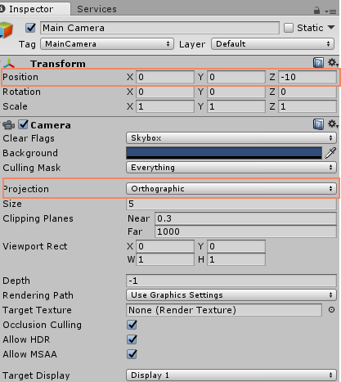

Configuring Build Settings
This section shows you how to configure the project for deployment to an Android device. It is optional.
- From the main menu, go to File Build Settings….
- Select Android from the Platform list and click the Switch Platform button.
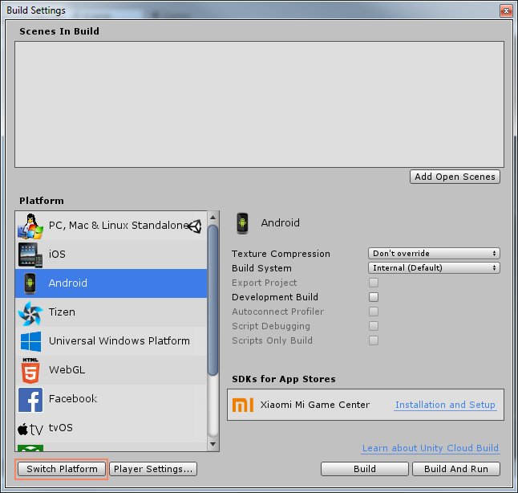
- Close the window and switch to Game view mode.
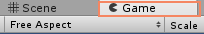
- To create a game that runs on all Android devices, you have to select a primary target size for viewport implementation. Expand the free aspect and change the primary target size for the viewport to 1280x800 or 1920x1080.
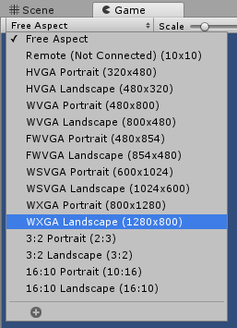
- You can always adjust the scale when testing, if you do not like the cropped view.
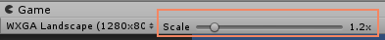

Adding Perky
- Create a new folder in the assets window called Graphics.
- Download the penguin image from Moodle. You can either:
  - Paste this directly to the Graphics folder you have created.
  - Right-click within the Graphics folder and select Import New Asset…
- Click on Perky and from the Inspector window, confirm that it has imported it as a Sprite image.
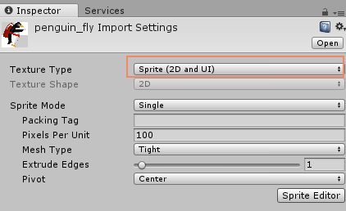

Making Perky a Game Object
- Drag the penguin_fly asset to the hierarchy window and rename it Perky or whatever you wish. You can also leave the default name.
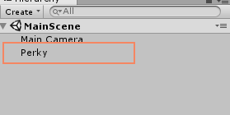
- From the Inspector window, change Perky’s position to 0, 0, 0.
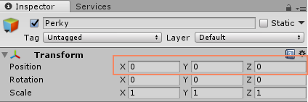

Collider Component
- Next you will add a collider to Perky. Collider components define the shape of an object for the purposes of physical collisions. Read more.
- Click the Add Component Button in the Inspector Window and select Physics 2D Circle Collider.
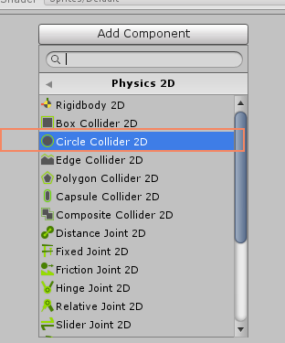
- You should see a new Circle Collider Component 2D in the Inspector window. Change the Radius as shown to 0.6
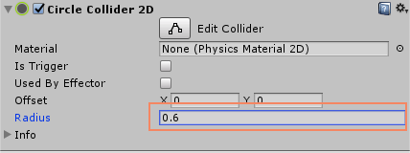

Rigid Body Component
- To make the penguin behave like a physical object and respond to gravity, you need to add a rigid body component to it. Unity’s physics system will act only on objects that have a Rigidbody component attached to them. Click Add Component Physics 2D Rigid Body 2D. Read more.
Note: Since a Rigidbody component takes over the movement of the GameObject it is attached to, you shouldn’t try to move it from a script by changing the Transform properties such as position and rotation. Instead, you should apply forces to push the GameObject and let the physics engine calculate the results. See more.
- To avoid the penguin being rotated while falling or jumping due to physics dynamics, expand the Constraints section and check Freeze Rotation on z-axis.
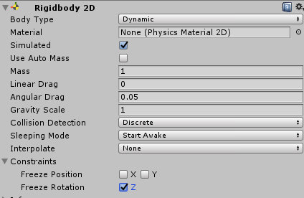

Particle Effect
Perky also has a rocket fire particle effect as shown below. See more
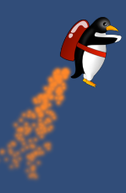
- Right-click on Perky in the hierarchy window and select Effects Particle System. This should add a child Particle System to perky. Rename to Rocket Fire or whatever you want.
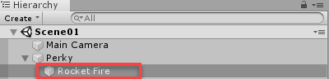
- Set the Transform properties as follows:
  - Position: (-0.62, -0.33, 0)
  - Rotation: (65, 270, 270)
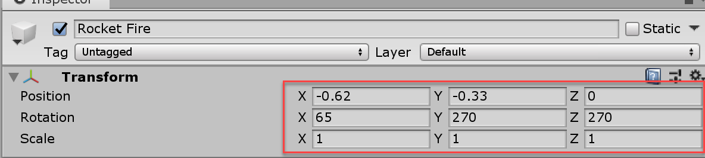
- Configure the following properties:
  - Start Lifetime: 0.5 (Start Lifetime is the total lifetime in seconds that particles will have when emitted)
  - Start Size: 0.3 (Start Size is the initial size of particles when emitted)
  - Start Colour: Orange (Hex: FF8728) or whatever you like. (Start Color is the initial colour of particles when emitted)
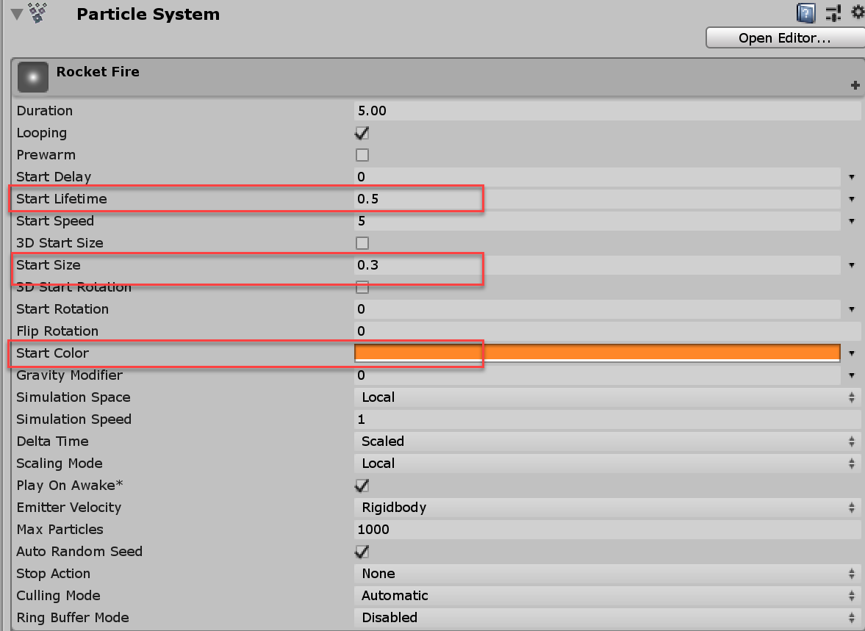
- Expand the Emission section and set Rate to 300 as shown below:
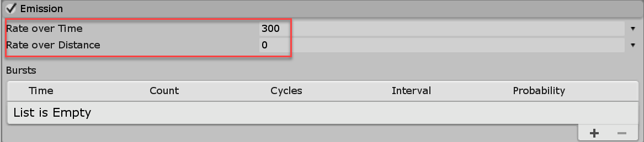
  - Expand the Shape section and configure as shown below: set Shape to Cone, Angle to 12 and Radius to 0.1
    - Shape is the shape of the emission volume. Options include sphere, hemisphere, cone, box, mesh, circle and edge.
    - Angle is the angle of the cone at its point (only available for cones)
    - Radius is the radius of the circular aspect of the shape
    - Set the Randomize Direction value to 1 to create randomness in fire particles. Setting to 1 means that the particles’ initial direction will be chosen randomly.
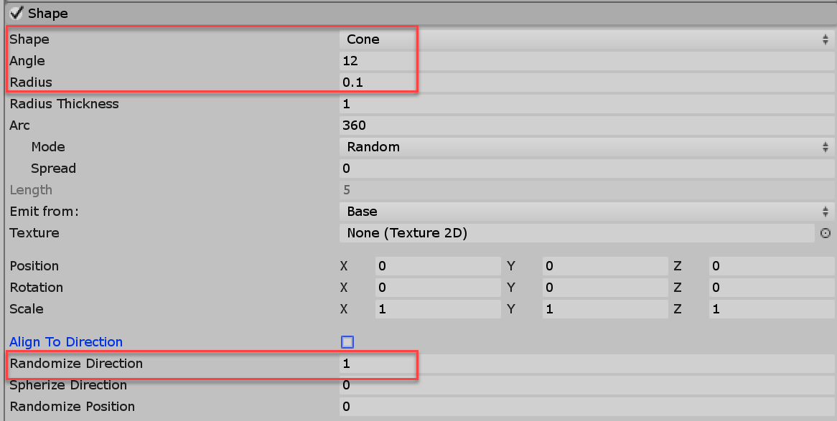
- Expand the Colour over Lifetime section and set the Color to a gradient. You need to adjust the rocket fire, so that the fire fades out over time, rather than ending abruptly.
  - Check the Colour over lifetime
  - Click the little drop down arrow beside the Color picker box.
  - Change the setting to Gradient.
  - Change the colour option, so it starts at white (RGB: 255, 255, 255) and ends as transparent.
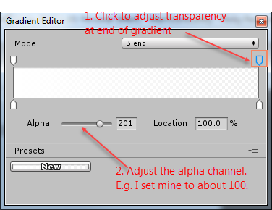
- Save your changes.
- If you hit play, you will see Perky fall out of the game world quite quickly. You will adjust the gravity settings now even though you will not really notice the effect till we do some coding.
- Go to Edit Project Settings Physics2D
- Set the Gravity to -15 as shown.
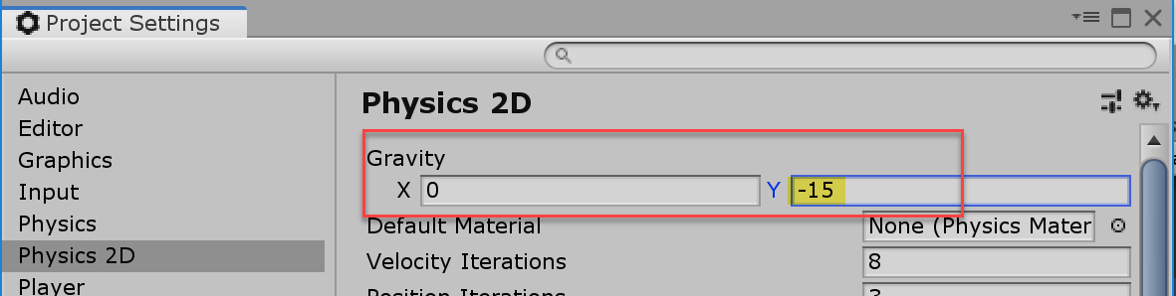
- Save your changes.

Adapted from: Mastering Android Game Development with Unity, Packt (2017), By Siddharth Shekar, Wajahat Karim.

