Submitted by :
Iulia Cosmina Barbu
Student ID: 2014826
Module code: BMSW 5104

BMSW5104: Managing Projects in the Organisation

Executive Summary
Eco-Bites is launching a new product, a new brand of fuzzy drinks variety. This project plan outlines how this project will be achieved. The project plan seeks to outline and develop the project plan tools that will ensure its success. This project plan outlines strategies that will ensure project success.

Table of Contents
Executive Summary 2
Introduction 4
Project Description 4
Project Scope 5
Work Breakdown Structure (WBS) 5
Quad Chart 7
Gantt chart 8
Stakeholder Involvement 9
Allocation of Resources 10
Risk Analysis 10
Conclusion 12
References 13

Introduction
This management plan is for a project that will be undertaken by a food and Beverage company, Eco-Bites, to introduce unique drink mixtures in the market. The project will be undertaken in the UK. Notably, the food and beverages industry is highly competitive and such a project should be undertaken systematically to ensure success. Eco-Bite’s previous effort to introduce a drink was not successful. The current project plan explains the scope of the project and outlines various tools that are used in managing a project. The tools that will be outlined in this plan include the work breakdown structure, the Gantt chart, and the quad chart. A project can be affected by various risks that need to be identified and mitigated. This project plan will determine risks that may affect the project by embarking on a risk analysis.

Project Description
The project will involve introducing a new beverage combination to the market that will be owned by Eco-Bites and assist the company in gaining market supremacy. The project was launched to correct the previous mistakes as the company tried to launch a new drink before but it did not achieve its launch objectives. This project will correct the mistakes that were done before and ensure success in launching the project. The project’s aim is to launch a new brand of fuzzy beverages in the UK food and beverages market. The key projective is to capture the attention of hotels, new customers, schools, hospitals, and retail stores in order to attract them to buy the new fuzzy brand (Arslan et al., 2021). If this succeeds, the project will ensure that the company dominates the highly competitive beverages market and help the company boost its profits (Arslan et al., 2021).
The project will undertake various activities including developing the new fuzzy drink, marketing it, and launching the drinks into the market. The project will also determine and manage several risks that can potentially affect the project and market success. Previous projects did not succeed and this could be due to risks that were not well mitigated. They ended up leading to the failure of the project. This project will be undertaken to correct the mistakes that made the previous project to fail. The project attract new customers and gain the attention of key product outlets such as hotels, retail stores, and schools. These will make them to avail the project to their customers. The purpose of the project is to draw lessons from previous launch mistakes and introduce a new fuzzy brand while avoiding the mistakes that were previously done. The project plan is made to ensure a successful launch of the project. Eco-Bites will achieve the purpose by using fundamental principles of innovation and customer satisfaction.
Project Management Methodology
The approach used in managing this project is important for its success. The industry is constantly presenting new needs that need to be adapted to the current market. This makes the agile project management process the most appropriate methodology to use in this project. This methodology provides agility and adaptability as changes can easily be made based on the transition presented by the market (Marnada et al., 2022). Moreover, this methodology will ensure that an iterative method is used so that the project team can implement modifications quickly to contain the views of customers. This will improve the success of the project launch.

Project Scope
Project scope refers to the definition of the set boundaries on the project that define the exact goals, deadlines, and deliverables that the project should achieve (Memon, 2023). The main goal of the project is to introduce Eco-Bites fuzzy drink in the UK market and be sold within the food and beverages industry. The target audience of this product are schools, retail stores, restaurants, and hotels. The entire project is estimated to cost £1.5 million. The project is set to be completed in nine months. The project will boost Eco-Bites market share, profitability, revenue, and customer satisfaction.

Work Breakdown Structure (WBS)
WBS refers to deliverable-oriented composition of the work that the project team will complete to achieve the project objectives (Amin et al., 2020). It plays a crucial roles of guiding the project team as the primary schedule of the project (Naufal et al., 2021). WBS arranges activities in various phases in hierarchical order and this ensures that activities are not left out when implementing the project. The work breakdown structure will divide the project into five phases. The WBS structure of this project is show below.
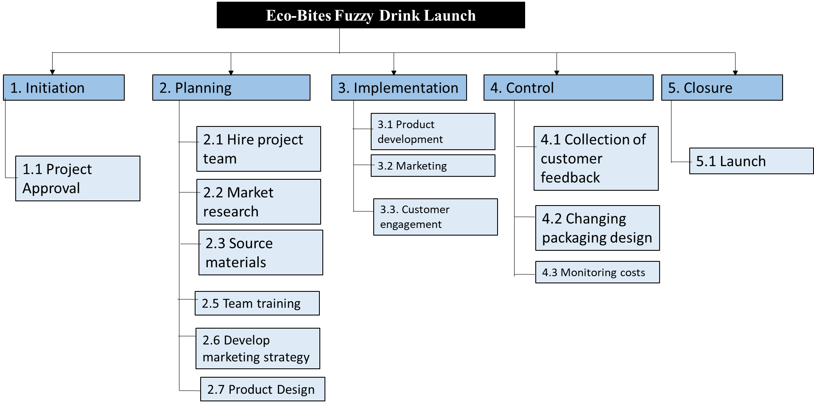

Figure 1: WBS
The first phase of the project will be the initiation phase. This is where senior management of Eco-Bite will approve the project. The Second phase of the project will be planning and it will involve seven key activities. This phase will ensure that key resources required are availed. It will hire the project team including product developers and marketers. This phase will also involve hiring and training the project team. Key resources including raw materials used for the new product development will be sourced at this phase. This phase will also include developing a computerised design of the packaging of the product. Marketing plan for the new product will also be developed at this phase. The third phase is the implementation phase. In this phase, the actual development of the product will be made based on the market research carried out in the planning phase. The market strategy will also be implemented in this phase. Various marketing channels and strategies will be used to create awareness of the new product and get the attention of key customers.
The fourth stage will be the control phase and it will involve mitigating various risks. One of the key activities will be getting feedback from customers to determine areas that need further development. The design may be changed and the costs will be monitored to ensure that the project is within the budget. The last phase will be closure. It will involve launching the project to the public.

Quad Chart
The quad chart is a graphical outline that is used to describe an innovation (Lai et al., 2022). The quad chart for this project has four quadrants based on the key objectives that the project seeks to achieve. The quad chart for this project is shown below.
Establish strong market Presence  Increase market share by 20%  High recognition  Competition analysis | Achieve Sales Targets  Raise revenue by £7 million  Achieve sales growth rate of 14%  ROI by 23%
Customer Engagement  Attain customer satisfaction 90%  Customer retention 75%  Repeat sales 50% | Sustainability  Eco-friendly packaging  Water reduction by 10%  Report sustainability

Figure 2: Quad Chart

Gantt chart
The Gantt chart is a graphical representation of the project activities based on their timeframe (Tereso et al., 20219). It will be used as the secondary schedule for the project (Ramachandran & Karthick, 2019). It shows the duration of each task and how activities follow each other. This helps to ensure activities are not left out. It will also be used to avoid delays in the project. The first activity will be approval of project and its budget. This will be done within one other. The Gantt chart for this project is show below.
 | Duration in Months
Task | 1 | 2 | 3 | 4 | 5 | 6 | 7 | 8 | 9
Launch
Hire project team
Market Research
Source material
Develop marketing plan
Product Design
Product development
Marketing
Customer engagement
Customer views
Changes on product
Monitor costs
Launch

Figure 3: Gantt chart
The project will be completed in nine months. The project team will have sub teams so that some activities can be carried out simultaneously. For instance, the marketing plan will be developed at the same time with the marketing plan by two different teams. This will shorten the project duration. Moreover, marketing will be done as views are collected from customers and customers are engaged.

Stakeholder Involvement
The project will involve various stakeholders that can be classified as either internal or external stakeholders (Lehtinen & Aaltonen, 2020). Internal stakeholders will involve the project manager, product development team, senior management, and marketers. External stakeholders will be raw suppliers, the community the government, customers, hotels, regulatory authorities, and schools. The project will consider effective stakeholder engagement to ensure that the needs of various stakeholders are fulfilled. Effective communication will be guaranteed to ensure that all stakeholders are involved in the project.
The senior management will play a crucial role of funding the project and availing other resources that are needed for the success of the project. The senior management of Eco-Bites will be required in the project from initiation to the last phase of project launch. In initiation phase, they will be required to approve the project and the budget. They will be required to provide the launch resources as the brand is handed over to them in the last project phase. The project team will undertake market research and develop the product according to the needs of customers. Suppliers and venders will supply raw materials required to manufacture the new product. Customers will play a role of giving insights into the qualities that they want the new product to have. Authorities will ensure that the new product is registered and approved as safe for human consumption. Although their level of interest is low, government authorities have high level of power as failure to approve the product will lead to product failure. Retail stores, schools, and hotels are crucial to the distribution of the product to consumers. They project team will need to attract their attention.
Communication strategy in every stakeholder will be different depending on how a stakeholder can be involved. The senior management of the company is a key strategy and will be involved through several communication strategies. Reports and face-to-face communication will be used to involve the senior management of the company. Marketing communications such as social media, TV ads, and feedback will be used to involve customers. Consumers will be engaged through social media and the company’s website. The website of the company will allow customers to give feedback and give their views on the new product. This will ensure that areas for further development on the product are known by the project team.
The government and authorities will be engaged by filling the required forms to register the drink and obtain patent to have production rights of the drink and avoid duplication by competitors. The project team will be involved through frequent one-on-one meetings with the project managers and the company’s management.

Allocation of Resources
The management team will allocate various resources to the project. One of the key resources that will be allocated will be human resources. The company will hire new employees to work in the project as the project team. The project team will use the funds allocated for the project as shown below.
Resource Allocation | Cost (£)
Market research | 100000
Hiring | 50000
Product development | 500,000
Marketing | 500,000
Changes to the product | 200,000
Mitigation | 150000
Total | 1500000
Table 1: Resource Allocation
The company will allocate £500,000 to market the product so that it can avoid the previous failures that made the product fail to penetrate the market. To mitigate unforeseen risks, the project team will allocate £150,000 to ensure that any risk that will require funds is well-mitigated.

Risk Analysis
This project may be challenged by various risks that will need to be mitigated. Various risks that may impact the project are outlined in table 2 below. Moreover, the risk mitigation strategy for each risk is outlined.
Risk | Impact | Mitigation Strategy
Lack of customer trust | The fuzzy drink introduced into the market may fail to get customer trust. This will make the product fail to penetrate the market. | This risk will be mitigated through increased marketing and promotional activities throughout the UK market (Rathore & Ilavarasan, 2020).
High cost | The project may cost higher than the budget. | Accurate estimates will be made based on market research to avoid cost overruns. There will be £150,000 set as mitigation funds in case the project exceeds the budget.
High competition | High competition from the products existing in the market may make it difficult for the product to penetrate the market and succeed. | The project team will make an innovative products whose health benefits exceed those of the rivals.
Unsustainable packaging | The product may entail packaging that would be considered to be unsustainable by consumers. This will make some consumers to avoid buying it (Ahlström et al., 2020). | The project team will innovate eco-friendly packaging from the product.
Delays | Some activities may delay leading to the delay of the project. | The project plan will include well-made Gant chart to ensure that the team avoids delays in each task
Injuries and sicknesses | Some of the project team members may get injuries and sicknesses. This will delay the project. | There will be safety measures and training to ensure the safety of team members.
Lack of approval by authorities | The project may fail to be approved by authorities because of lack of compliance. | The project team will include a legal adviser that will ensure that the project is compliance in all aspects.
Poor profitability | The new product may have low profit margins. | The project team will assess costs to allocate prices that will make the products economically sustainable and ensure high profitability. Various technologies will be used to lower production costs.

Conclusion
This plan summarises how various aspects of the project launch of a new fuzzy drink for Eco-Bites, and how it will be achieved. The project team will use agile methodology to implement the project in nine months. The aim of the project is to launch fresh drinks and allow the company to gain market supremacy, increase revenue, and boost profitability. Diverse risks have been identified and mitigating the risks identified will allow the company to avoid previous mistakes made by the company that made a different project fail.

References
Ahlström, R., Gärling, T., & Thøgersen, J. (2020). Affluence and unsustainable consumption levels: The role of consumer credit. Cleaner and Responsible Consumption, 1, 100003.
Amin, J. T., Sagita, L., & Latief, Y. (2020, September). Work breakdown structure (WBS) dictionary and checklist development of stadium architectural and interior works for safety planning. In IOP Conference Series: Materials Science and Engineering (Vol. 930, No. 1, p. 012006). IOP Publishing.
Arslan, A. N., Klibi, W., & Montreuil, B. (2021). Distribution network deployment for omnichannel retailing. European Journal of Operational Research, 294(3), 1042-1058.
Lai, S. T., Susanto, H., & Leu, F. Y. (2022). Project Management Mechanism Based on Burndown Chart to Reduce the Risk of Software Project Failure. In Advances on Broad-Band Wireless Computing, Communication and Applications: Proceedings of the 16th International Conference on Broad-Band Wireless Computing, Communication and Applications (BWCCA-2021) (pp. 197-205). Springer International Publishing.
Lehtinen, J., & Aaltonen, K. (2020). Organizing external stakeholder engagement in inter-organizational projects: Opening the black box. International Journal of Project Management, 38(2), 85-98.
Marnada, P., Raharjo, T., Hardian, B., & Prasetyo, A. (2022). Agile project management challenge in handling scope and change: A systematic literature review. Procedia Computer Science, 197, 290-300.
Memon, F. A. (2023). Stakeholder engagement in managing scope change during the execution phase of UK construction projects.
Naufal, A. M., Yufrizal, A. H., Latief, Y., & Machfudiyanto, R. A. (2021, November). Development Standard Operational Procedure of Safety Architecture Work in University of Indonesia Project Based on Work Breakdown Structure to Reduce Work Accidents. In Journal of International Conference Proceedings (Vol. 4, No. 2, pp. 254-263).
Ramachandran, K. K., & Karthick, K. K. (2019). Gantt chart: An important tool of management. Int. J. Innov. Technol. Explor. Eng, 8(7).
Rathore, A. K., & Ilavarasan, P. V. (2020). Pre-and post-launch emotions in new product development: Insights from twitter analytics of three products. International Journal of Information Management, 50, 111-127.
Tereso, A., Ribeiro, P., Fernandes, G., Loureiro, I., & Ferreira, M. (2019). Project management practices in private organizations. Project Management Journal, 50(1), 6-22.

