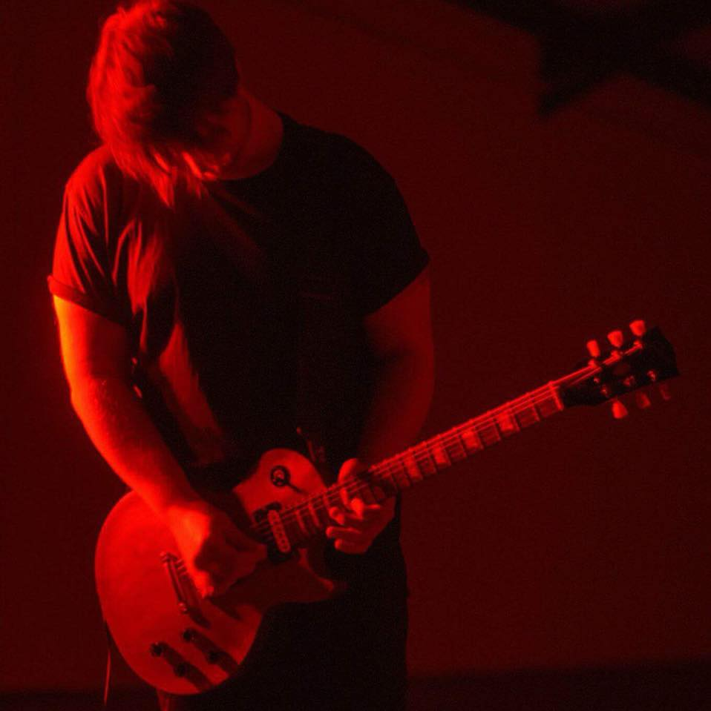YN  Personal statement:  I have worked in the music industry for over 6 years, and have experience in many areas within it, including performance, composition, live sound, recording as a musician and recording as a producer. This experience helps greatly when recording with artists, as it helps me to understand their thought process during recording, and how to make the process as smooth and stress free as possible, resulting in the best possible end recording.  I am hard working, enthusiastic and committed, and have a strong passion for all areas of music, and constantly aim to better myself in them. | music industry Experience & achievements:  - 6+ years working in various areas of the music industry  - Worked extensively in cover/function bands performing music of various genres  - Acted as manager of cover/function band, responsible for all aspects of running the band, including bookings, promotional material, advertisement, rehearsals etc  - Worked in Alternative Rock/Metal band, composing and performing original music  - Performed in several UK tours, ranging from 3-8 days in length  - Recorded on several studio recordings, ranging from independent releases, label-backed releases, and promotional audio for function bands  - Vast experience in live sound, from small clubs to large festival events, on both hired equipment and my own  - Produced studio recordings and live recordings for bands and artists of several genres, including recording, mixing and mastering the tracks, and offering creative input where needed  COntact  Address: 2 Ffordd Llyffant, Birchgrove Swansea, SA79NY  Phone: 07907546439  E-mail: danobrien1997@hotmail.co.uk  References available on request.
  DAn O’Brien – Musicproducer

