Dean’a Comrie 1906643
BSc Health and Social Care
BMHP5003_(BIRM)
Introduction to Physiology
Mumtaz Goolam

Task 1-Part 1 – Individual Academic Poster
Using up to 1000 words, students are required to produce a one-page academic poster (if printed would be A2). Within the poster, students must demonstrate their understanding of the relationship between body functioning and relevant detailed anatomy and physiology of one body system, within a health and social care context.
Students can select one from the following:

• Skeletal System
• Integumentary System
• Cardiovascular System
• Respiratory System
• Female Reproductive System
• Male Reproductive System
• Endocrine System
• Nervous System
• Digestive System
• Urinary System
• Lymphatic System

Contents Page
1. Introduction
2. Task 1 – Academic Poster
3. References

Introduction
This is an academic poster of the cardiovascular system demonstrating the understanding of the relationship between body functioning and relevant detailed anatomy and physiology of the cardiovascular system, within a health and social care describing how the information is developed the understanding of the cardiovascular system. Cardiovascular disease (CVD) is a general term for conditions affecting the heart or blood vessels. It's usually associated with a build-up of fatty deposits inside the arteries (atherosclerosis) and an increased risk of blood clots. It can also be associated with damage to arteries in organs such as the brain, heart, kidneys and eyes. In this academic poster you will aloe e what effect the heart and how to prevent diseases with diet, exercise and wellbeing.

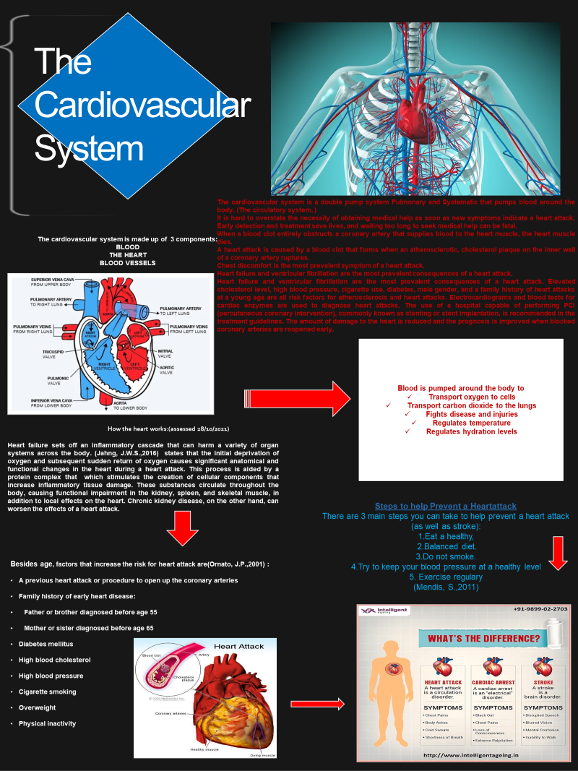
Task 1 – Academic Poster

References
(Jahng, J.W.S.,2016) Song, E. and Sweeney, G., 2016. Crosstalk between the heart and peripheral organs in heart failure. Experimental & Molecular Medicine, 48(3), pp. e217-e217.
Aaronson, P.I., Ward, J.P. and Connolly, M.J., 2020. The cardiovascular system at a glance. John Wiley & Sons.
Centres for Disease Control and Prevention (CDC, 2008. Disparities in adult awareness of heart attack warning signs and symptoms--14 states, 2005. MMWR. Morbidity and mortality weekly report, 57(7), pp.175-179.
Gaziano, T., Reddy, K.S., Paccaud, F., Horton, S. and Chaturvedi, V., 2006. Cardiovascular disease. Disease Control Priorities in Developing Countries. 2nd edition.
Helen Oxenham*, Norman Sharpe, Cardiovascular aging and heart failure, Department of Cardiology, Royal Infirmary of Edinburgh, Lauriston Place, Edinburgh, Scotland, EH3 9QW, UK, 2003 European Society of Cardiology. Published by Elsevier Science B.V.
htco.com/cardiovascular-system-373577 (assessed on 28/10/2021)
https://www.google.com/url?sa=i&url=https%3A%2F%2Fwww.medicinenet.com%2Fheart_attack%2Farticle.htm&psig=AOvVaw0YTZ9Ab4Eor8fkrTUMYFlF&ust=1637417766360000&source=images&cd=vfe&ved=0CAsQjRxqFwoTCOCn0tXO (accessed 18/11/2021)
Image: - How the Heart Works: Diagram, Anatomy, Blood Flow Visit Images may be subject to copyright, https://www.medicinenet.com/heart_how_the_heart_works/article.htm (assessed 28/10/2021)
Image: - The circulatory system. Getty Images/artpartner-images By Regina Bailey, https://www.thoug
Kroeker, C.G., 2018. Cardiovascular System: Anatomy and Physiology. Cardiovascular Mechanics, 2(5), p.1.
Mendis, S., Puska, P., Norrving, B. and World Health Organization, 2011. Global atlas on cardiovascular disease prevention and control. World Health Organization.
Ornato, J.P. and Hand, M.M., 2001. Warning signs of a heart attack. Circulation, 104(11), pp.1212-1213.
Tucka, J., Bennett, M. and Littlewood, T., 2012. Cell death and survival signalling in the cardiovascular system. Front Biosci, 17, pp.248-261.
Wald, N.J. and Law, M.R., 2003. A strategy to reduce cardiovascular disease by more than 80%. Bmj, 326(7404), p.1419.

