Introduction:
How do we define modern technology? Author Emmanuel Mesthene defined technology in 1970 as “the organization of knowledge for the achievement of practical purposes” Technology has been advancing at limitless levels, from “reading yell pages to the internet” technology has affected everyone differently. Major businesses have thrived due to technological advancements in our era, however not all business achieve success through technology.
Ways of how the use of technology has been very effective in the workplace:
Cloud storage: firstly, what does cloud storage mean? Cloud storage is a “cloud computing model” were organisations or people can store their data, in which they can access anytime online in the internet. Their data is secured, and it is stored in “remote servers”
Cloud storage has enabled small businesses and large businesses to store insane amounts of data at cheaper costs. Greg Schulz who is an author and has extensive background in this sector stated that one of the biggest challenge for businesses is to manage “exploding data growth along with associated managing tasks and constraints.” Such things include floor space, cooling, and capital. Using a storage network is far more efficient and maintainable. Especially if you run a large firm such as HSBC or JP MORGAN.
The importance of data and storage: it is said that “we live in a information-centric world” we have the need to create and store more data as we grow older. And this data needs to be accessible by the time we need it. Information can be kept in the same or even similar footprint than before. What this means is that it needs less power and cooling. (per GB, TB, PB AND OR PB)
Examples of cloud storage: there are many cloud storages that people can use within the workplace. This helps them keep track of data more easily at a cheaper costs then if you buy a hard drive or something of a similar product.
- Dropbox: is a personal cloud storage that allows people to store pictures, audio and documents at relatively cheap price. Dropbox also offers business cloud storage.
- iCloud: is owned by Apple and it is mainly used by apple iPhone and I mac users.
- Google drive- they are mainly used by android users to store data
- Amazon cloud storage- cloud storage can be used by business or personal use.
ADVANTAGES OF USING CLOUD STORAGE | DISAVANTAGES OF USING CLOUD STORAGE
It is much cheaper to use cloud storage than to buy servers or hard drives | Cyber security is a big issue when using cloud storage. Information can be exploited. For example (SONY HACK)
Cloud storage can be accessed anywhere as long as you have internet access. | Data is kept in a sever and there is no backup if data is lost by any cause.
Updates on cloud storage is made regularly and data is protected | People argue if data is safe on the cloud. And worry if it can be accessed without permission.

The use of emails; a way for businesses to communicate: Technology has helped us with the internet, businesses can now use emails to communicate. Emails are far more convenient and incredibly faster than the use of letters in the workplace. It is said that communication is “vital to business success” communicating in many ways has helped business drastically due to technology.
Fax machine: In the past the only way to send important documents was through sending documents. Due to technology businesses have been able to send documents directly through a machine. This way of sending info is far more simpler and faster. There is no worry of missing documents through the post.
Smartphones: smartphones have become better and better in time. Using smartphones has been very effective in the workplace and has changed the way we communicate. Using mobiles we can now call, email, and text right from our pockets.
Negatives of technological advancement: modern technology has helped many organisations run smoother to achieve one goal. “success” however not all businesses benefit from technology for example “retail stores” research shows that eight out of ten businesses fail (Forbes) part of the problem is technology. How is that? More and more retail businesses collapse because consumers would rather purchase products online as it is so much more convenient. “As technology grows people become more and more lazy” other reasons as to why technology is not helping some companies is because some businesses do not have the capital to buy technological products or services. Greg Schulz (author) stated that businesses gain “competitive advantage” as they improve on their technology. This means that small businesses would most likely fail as they do not have the funds to upgrade.
Social media as a tool for marketing;
Tracy L. Tuten and Michael R Solomon both have a background on marketing (PHD) they mentioned that the general population often use several platforms of social media at once while they are doing what they are supposed to be doing. The authors call those people “digital natives” And this is “why social media is important” for marketing. Most people use or know of companies such as Facebook, LinkedIn or twitter. They are all used worldwide by millions of people, therefore it is a valuable tool for marketing. So far there is about 3.77 billion internet users today. That’s nearly half of the worlds population. It is said that thirty seven percent of the earth’s population use at least one type of social media platforms. Businesses want to target marketing there.
What is social media? Social media is a communication platform where people worldwide can communicate with each other.
Examples of what a person could do when using social media:
- Watch a television program while talking about it on social media
- Locate the best restaurant based on some reviews from social media
- Create a page where you advertise your business
- Raise money for a charity
These are some of the ways of how businesses can benefit by marketing on social media.
Social community: This describes the channel of social media and what this means is that it focuses on what people do and how they react with their friends. The activities they participate in and share the same or similar interest. It is said that all “social media channels are built on network relationships” businesses will have the access to see who best suits their target market and pay the social media platform.
Social media marketing involves using social media to advertise a business and to persuade consumers that the companies products or services are worth buying. Lazer and Kelly’s (1973) definition of social marketing: as "concerned with the application of marketing knowledge, concepts, and methods to improve social also economic ends.
Social media allows businesses to:
- Share their expertise
- Get into their customers mind
- Customers helping customers
- Brand awareness and customer awareness
Social media as a tool for communication:
Research shows that the majority of businesses, involve in social networking and they promote what it is that they offer as a business. Most of the time, the major companies try to sustain a good relationship with their respected customers. It is known that most social networking sites are now seen as an advertising must. Social media is now used by businesses to communicate with their customers about their products and services. If they have new products or services they would communicate with their target market. It is a way of promoting what they have to offer. For example Kanye West an artist has his own Instagram profile and what he does is, he uploads his new clothes collection on Instagram and notifies his customers on where to buy his products and the amount of stock left. It is known that customers do not always go to a site to search for new items especially if they are customers of many businesses. Instead what they do is follow the business on social media, and if any product comes online it would show on their front page. Consumers can communicate without the hassle and fuss.

Furthermore businesses can market better and improve because social media platforms monetize chat conversations and history. Trades can analyse what their customers really want and what they do not. In addition nearly all major social media platforms which are available now are very “cost-effective” Advertising is very expensive if you take a different approach for example if you use online advertising.

One of the major benefits of communicating through social media is that businesses can “create communities” through posting or using tweets on twitter. And using this gives the business feedback or replies quite quickly. If you were to communicate through other means such as surveys it would take time and effort.

Usefulness of social media for communication: A table shows out of 60 people how useful social media. The table will be in one of the reference links at the end of page 4
The table showed that “52 people plays a role of an interactive medium” the table also showed that 38 people use “social media as a source of information”
To conclude on social media as a tool for communication; social media is very important to business as it is cheaper for them to advertise and interact with their customers more personally.

Social media as a tool for information gathering: social media can be used to gather information. What type of information? Businesses can find data on their subscribers, friends and followers. Sensitive data such as:
How old are their customers: most customers that subscribe to a business page tend to be loyal customers therefore businesses can determine what age group purchased most of their products. This is essential to a company because with that information they can focus on how to market their product perfectly.
Hobbies and interests: Accessing this information gives businesses an idea of what their customers like doing and are interested in. With that information they can produce new products or services that interest their customers based on what their consumers like. This makes everything more convenient.
Emails: This is very important to gather from a business perspective, for the reason that businesses can widen their advertising strategy. When a loyal customer follows a business, the business will then have the access to their emails. What they tend to do with the email is promote their services and products through email, thus increasing the chance of revenue. The disadvantages of advertising through social media is that there is so much that you can advertise on. On snapchat its only around one short five second video or page and on YouTube its maximum 30 seconds of advertisement. Through email it is more structured and detailed.
Name; the importance of getting the names of your consumers is high. The reason why is quite simple. Companies gather information from social media of their customers name is because they would want to make everything more personal. Greeting each customer with their name would be a “nice touch”
Phone number: Businesses have access to customers phone numbers however not all businesses have phone numbers written but most do. With the phone number, companies can call their customers if they wish to and speak about things such as their products and services. In addition businesses can text customers straight on to their phones via SMS to get a direct reach.
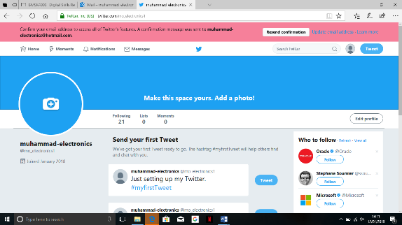
To evidence this research I have made twitter, LinkedIn and Facebook pages
My business is called Muhammad electronics

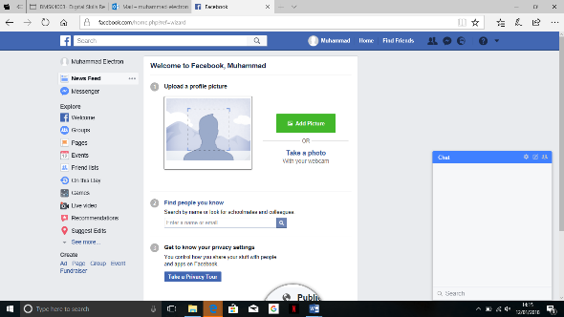
twitter

Facebook

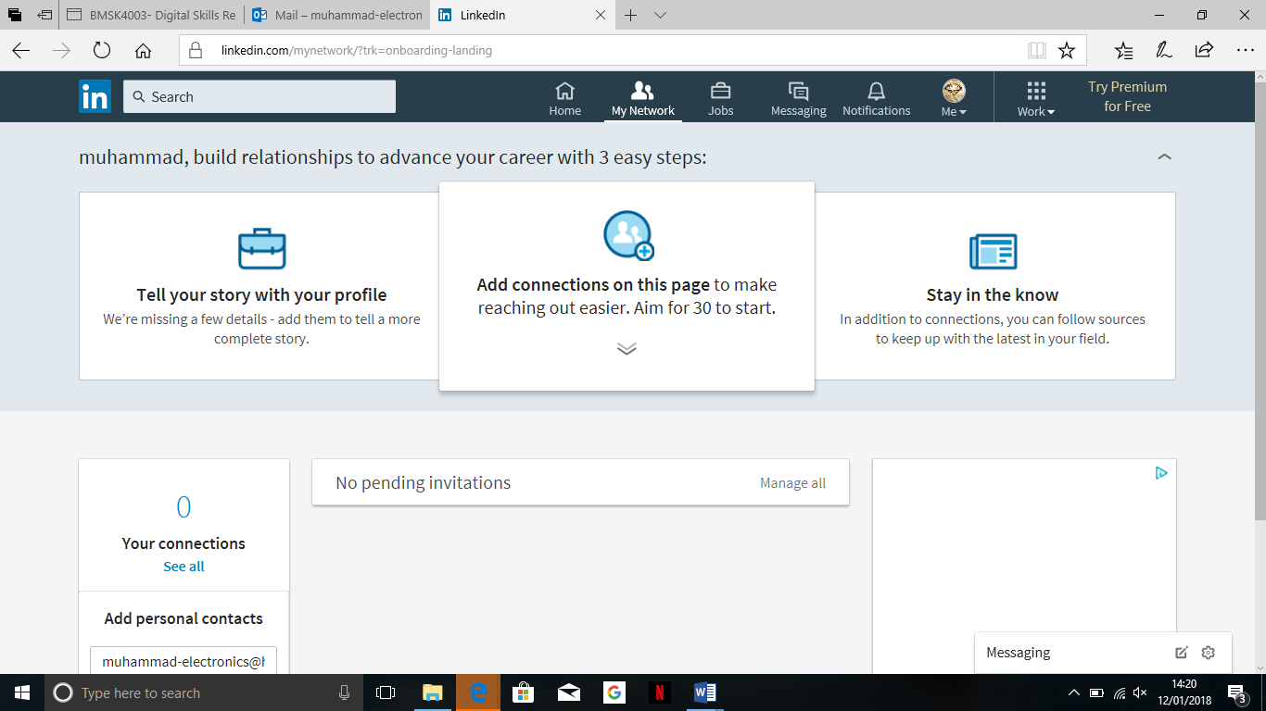LinkedIn
Reference links:
https://pdfs.semanticscholar.org/1013/ba91a504e085212ae4751ed61c3c0e1b6622.pdf
https://s3.amazonaws.com/academia.edu.documents/45712283/ijsrp-may-2012-24.pdf?AWSAccessKeyId=AKIAIWOWYYGZ2Y53UL3A&Expires=1515760501&Signature=GOTkaC7UhCna4pOddPrt44Nx5vM%3D&response-content-disposition=inline%3B%20filename%3DEffectiveness_of_Social_Media_as_a_tool.pdf
Social media marketing by Tracy L EBOOK
Greg Schulz cloud and data storage networking EBOOK

