Fundamentals in Construction Technology

module code: ACBA4001
Student number: 1802688
Lecture: Tom Duxbury

By Ed Jeanes

Contents page:

- Cover page pg1
- Contents page pg2
- Foundation and substructure details pg3
- Ground floor detail pg4
- First floor detailing pg5
- Eaves detailing and roof covering pg6
- Main roof structure pg7
- Roof structure advantages and disadvantages pg8
- Condensation and ventilation pg9 – pg14

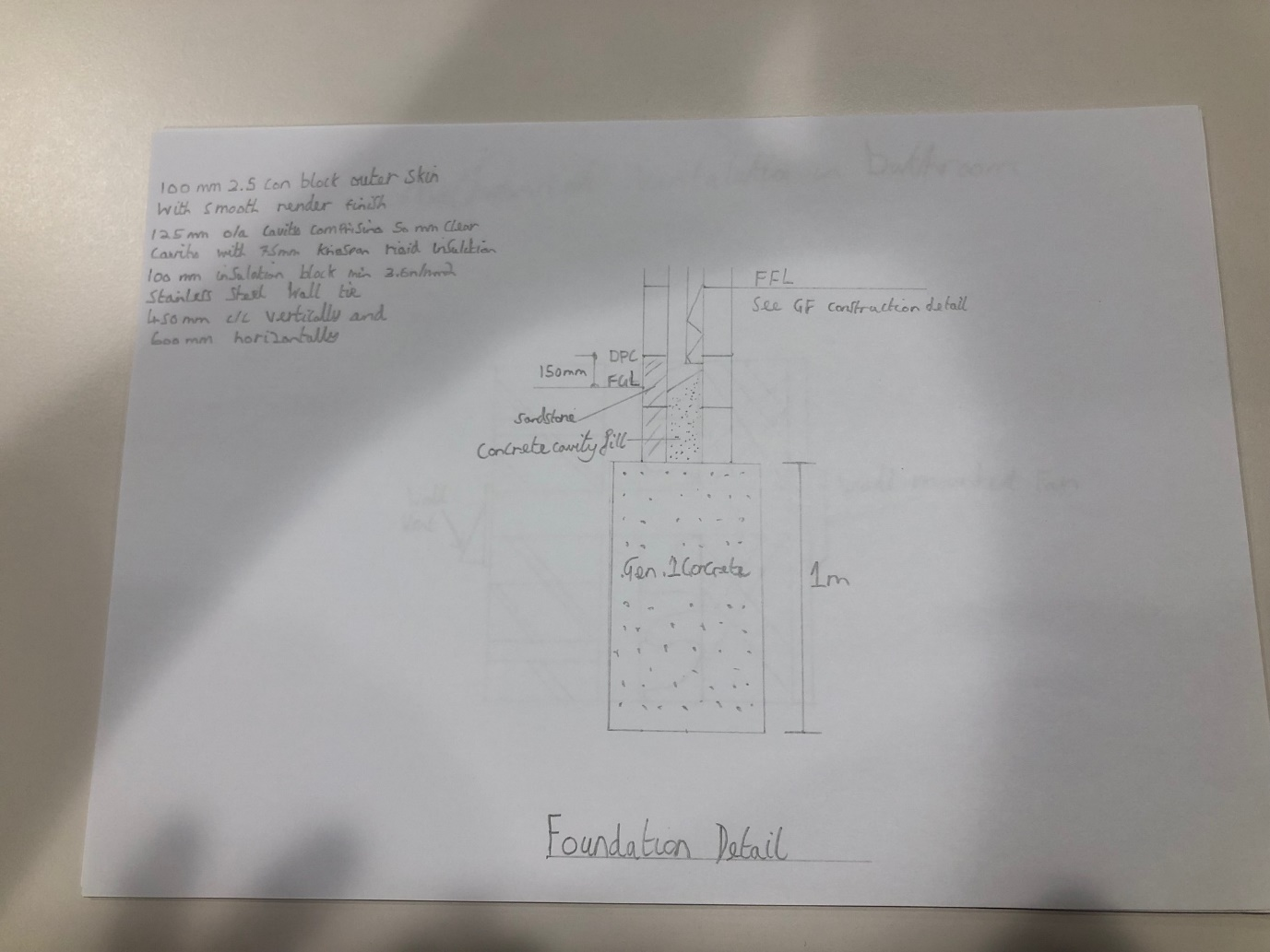

Foundation detail
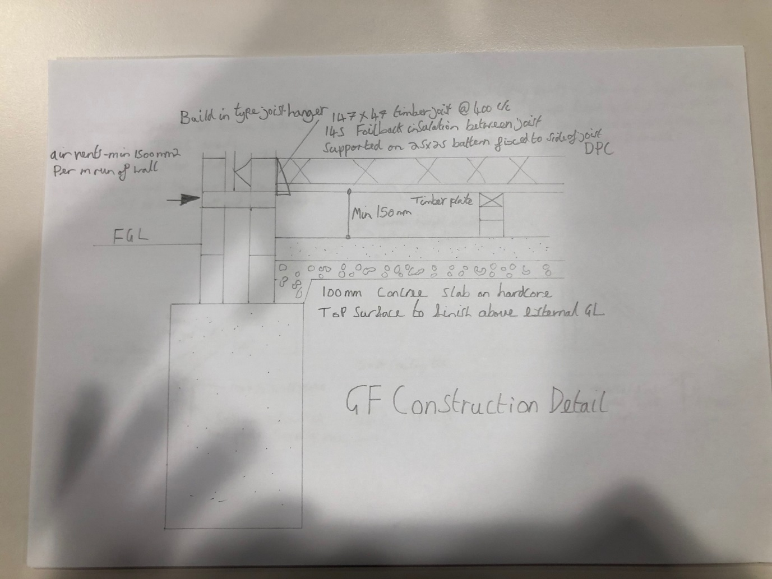

Ground floor construction detail

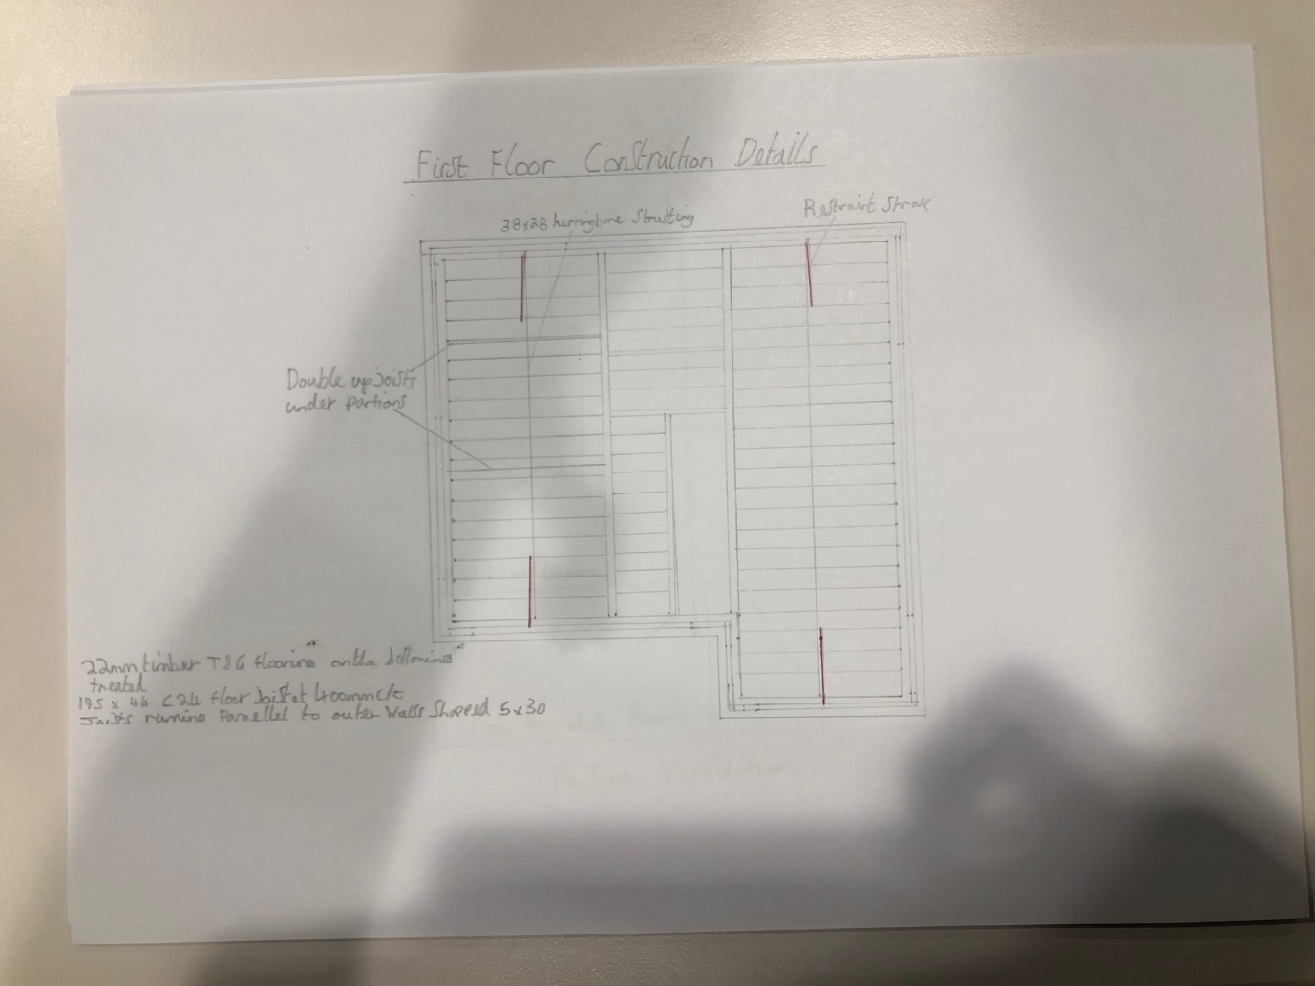

First floor construction detail

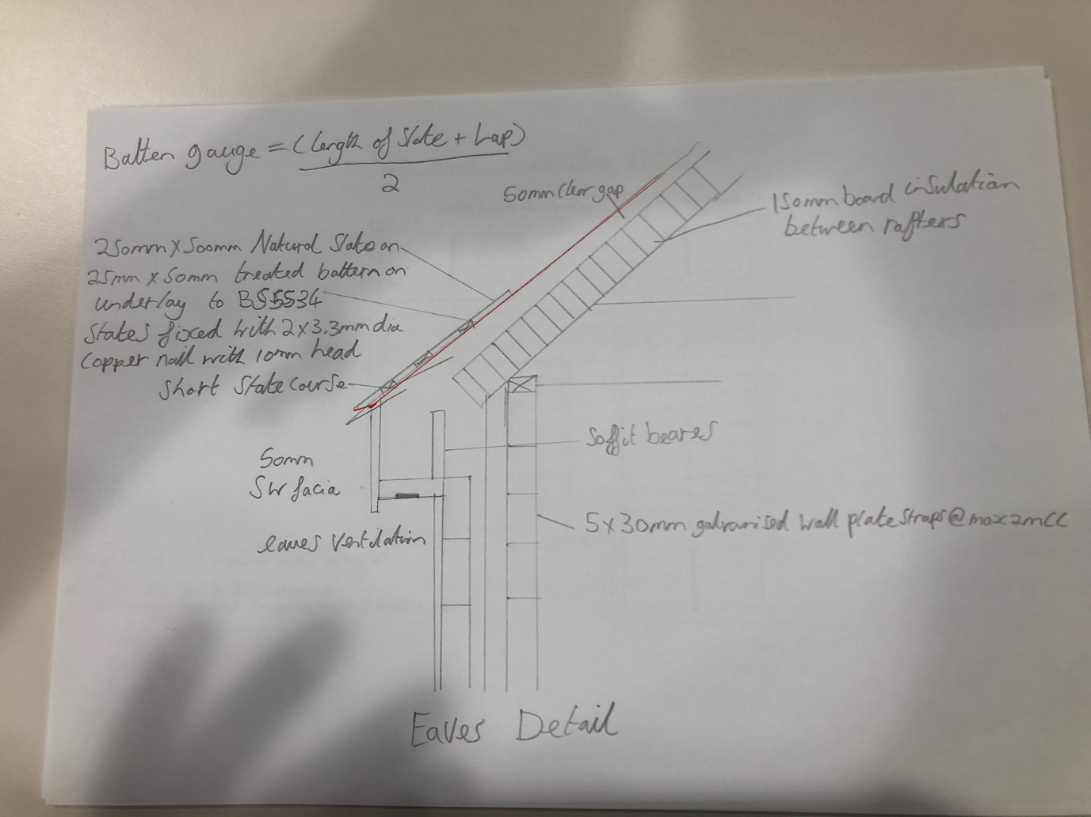

Eaves detail

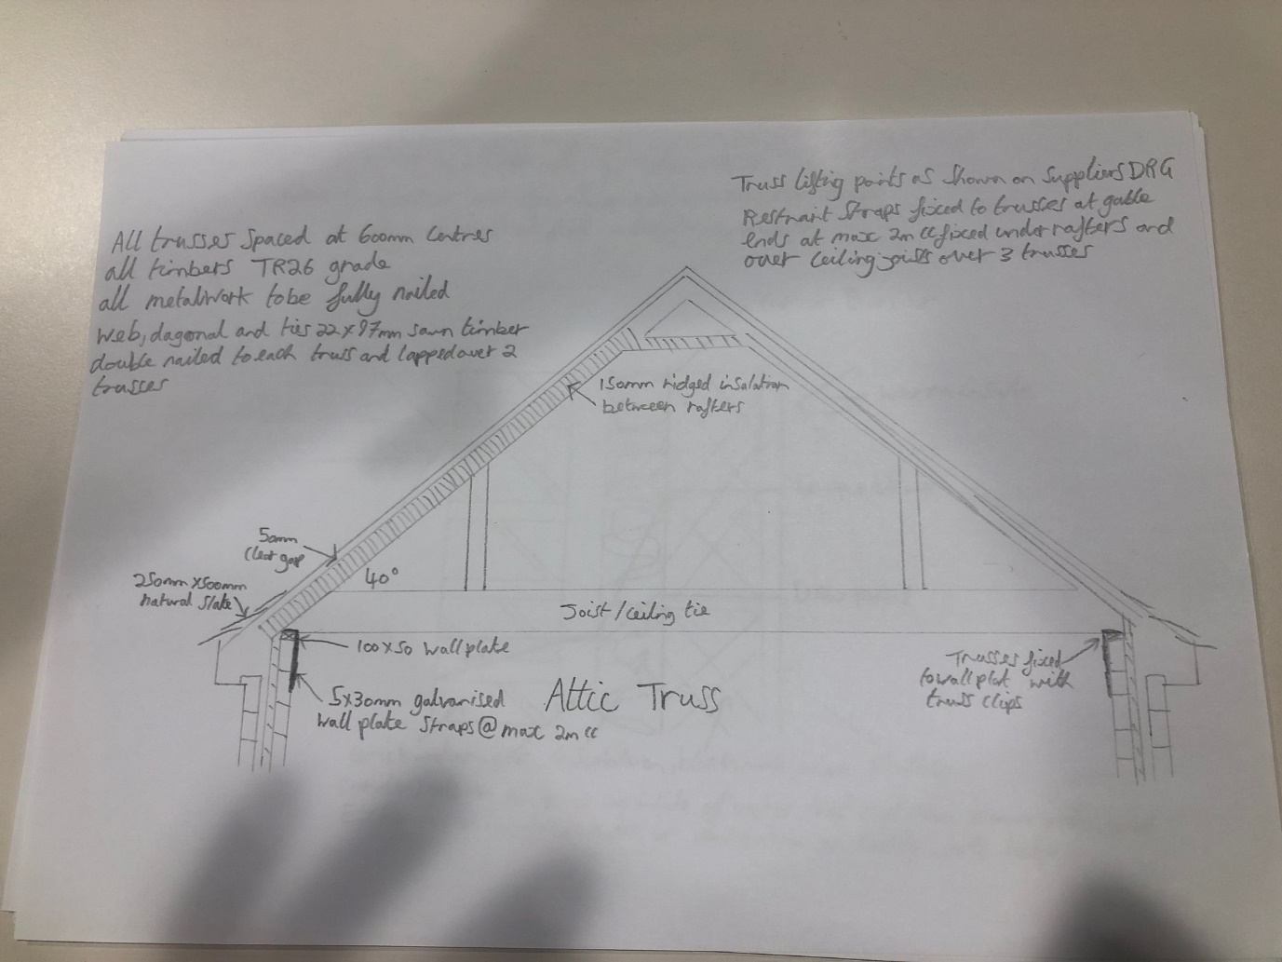

Attic truss detail

Roof-structure: question 3

Attic roof trusses:
I have chosen to use an attic roof truss. This is because attic roof trusses are designed to carry both the roof and floor loads of a house.
Advantages:
The attic truss is delivered to site in one solid component and designed by the supplier.
It reduces site labour time and costs.
Omits the requirement for purlins and pad stones and is factory assembled ensuring consistent quality.

Disadvantages:
Uses large timber sections which means that components are heavy requiring the use of a crane to erect them.
Requires good unrestricted site access

Timber I beams:
My alternative roof structure would be timber I beams which are used as joist, beams, purlins and rafters .
Advantages:
They are much lighter to handle than solid timber.
Their good where site access is restricted.

Disadvantages:
The roof is built on site so construction time is increased over the erection of attic trusses.
Requires engineers design.
Requires ridge support beams.
Needs additional bevelled wall plate and addition strapping.

References:
Books read – Roofconstruction and loft conversion by C.N. Mindham, Construction Technology by Eric Fleming

Condensation and ventilation: Question 4
https://www.diydata.com/problem/condensation/condensation.php
https://www.designingbuildings.co.uk/wiki/Condensation_in_buildings

1.
Condensation occurs when moist warm air comes into contact with cooler surfaces that are at or below the due point such as windows. Moisture in the air can come from many different sources in a house.
Causes:
- “ breathing (asleep) 0.3 kg
- breathing (awake) 0.85 kg
- cooking 3 kg
- personal washing 1.0 kg
- washing and drying clothes 5.5 kg
- heating - especially paraffin and flueless gas heaters. For every litre of paraffin burnt over one litre of moisture vaporises into air. Every carbon fuel produces some amount of water from combustion.
- (1 kg of water equates to about 1 litre)

Condensations affects on building fabrics:
The most common affect of condensations negative impact is mould which can grow onto walls and other surfaces in a house where condensation is present. Condensation can cause ‘Corrosion and decay of the building fabric’.
There are two types of condensation, surface condensation and interstitial condensation
Interstitial condensation:
This is when structural dampening occurs, this is when moist air infiltrates into a gap in a cavity wall, roof or wall. So the condensation has made its way through the layers of the houses envelope. This usually happens when air diffuses from the warm interior to the cooler exterior. WHY
Surface condensation:
This is when air cools then it can no longer hold the moisture in it then the water vapour density falls which then causes the relative humidity rises. When the air continues to cool this is when the moist begins to condense. So it’s the transfer of warm moist air to a cooler surfaces which causes surface condensation.

2.

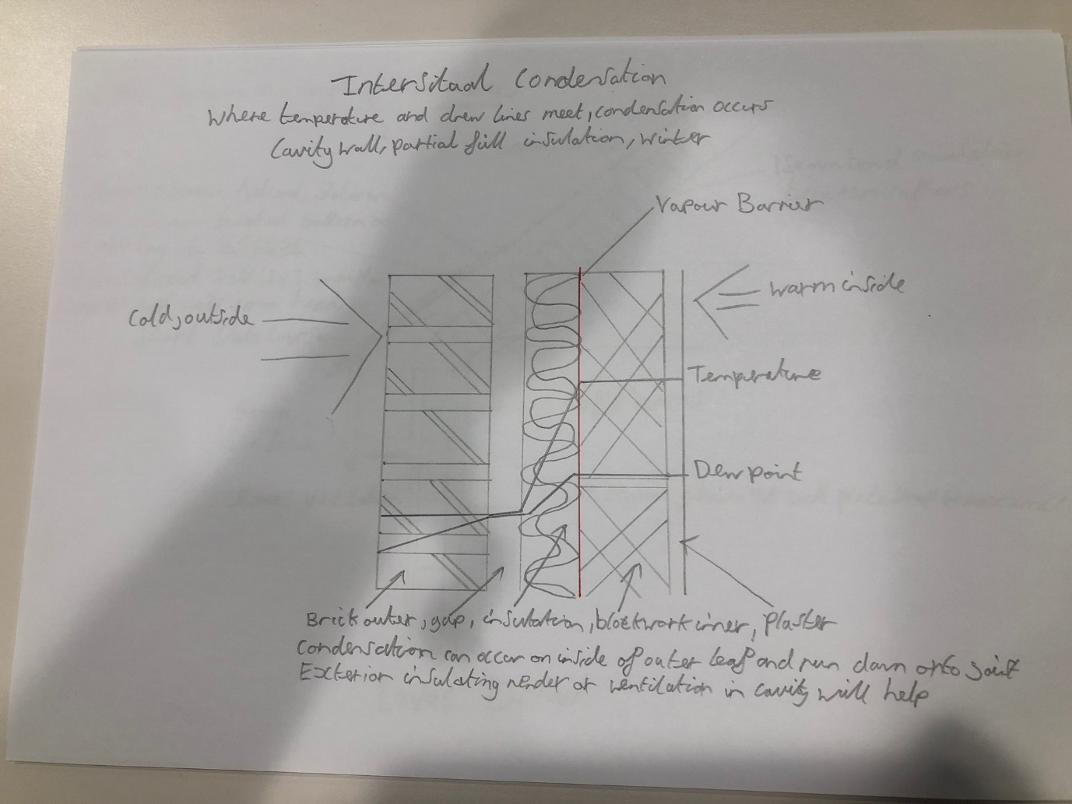

Interstitial condensation

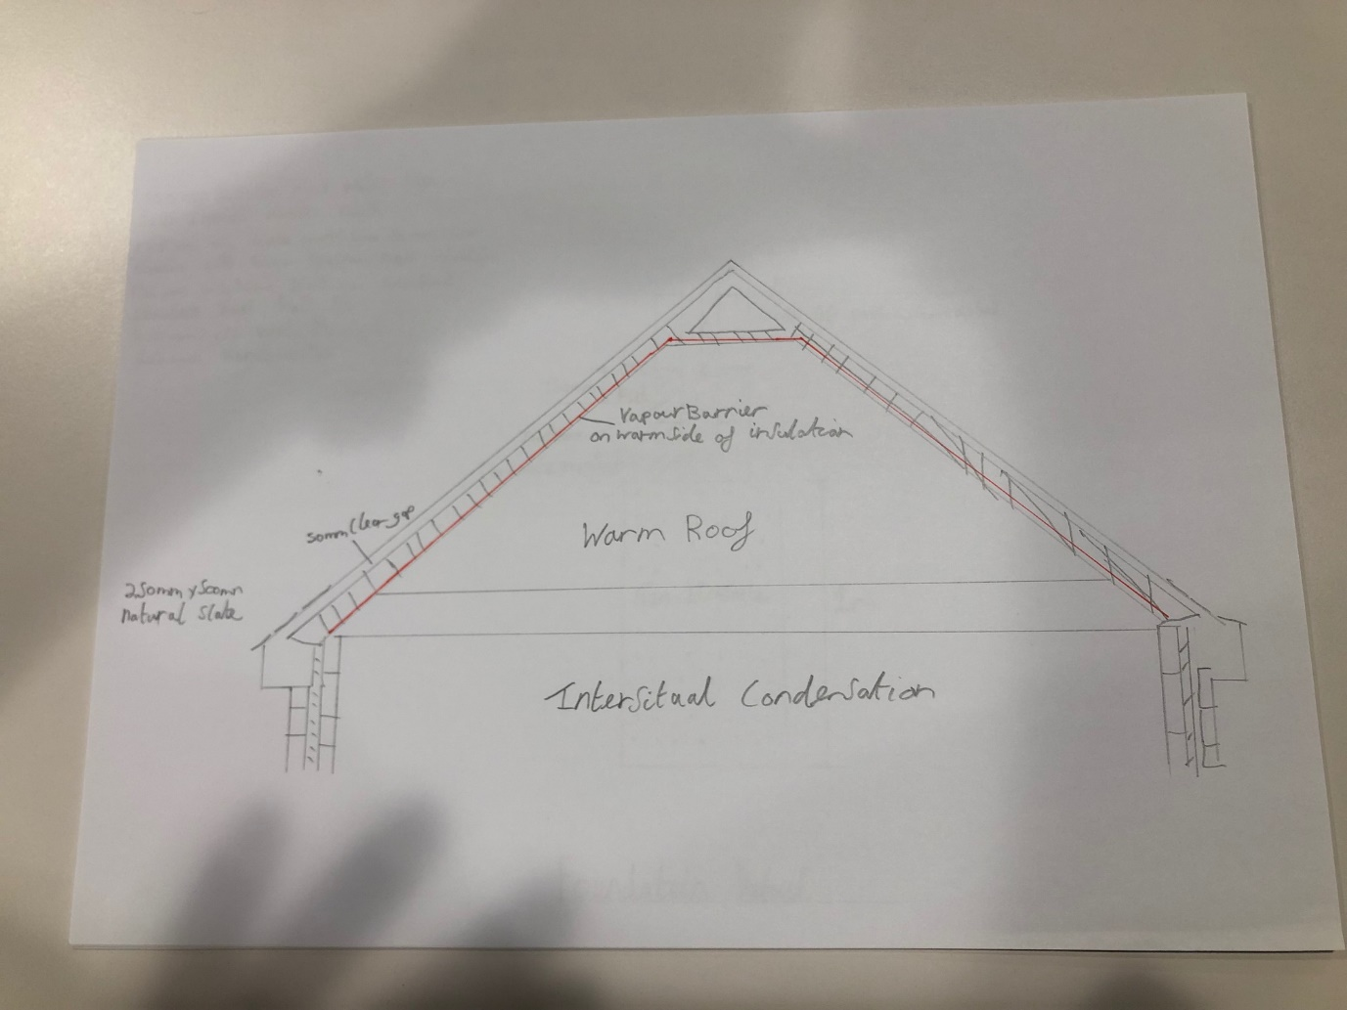

Interstitial condensation

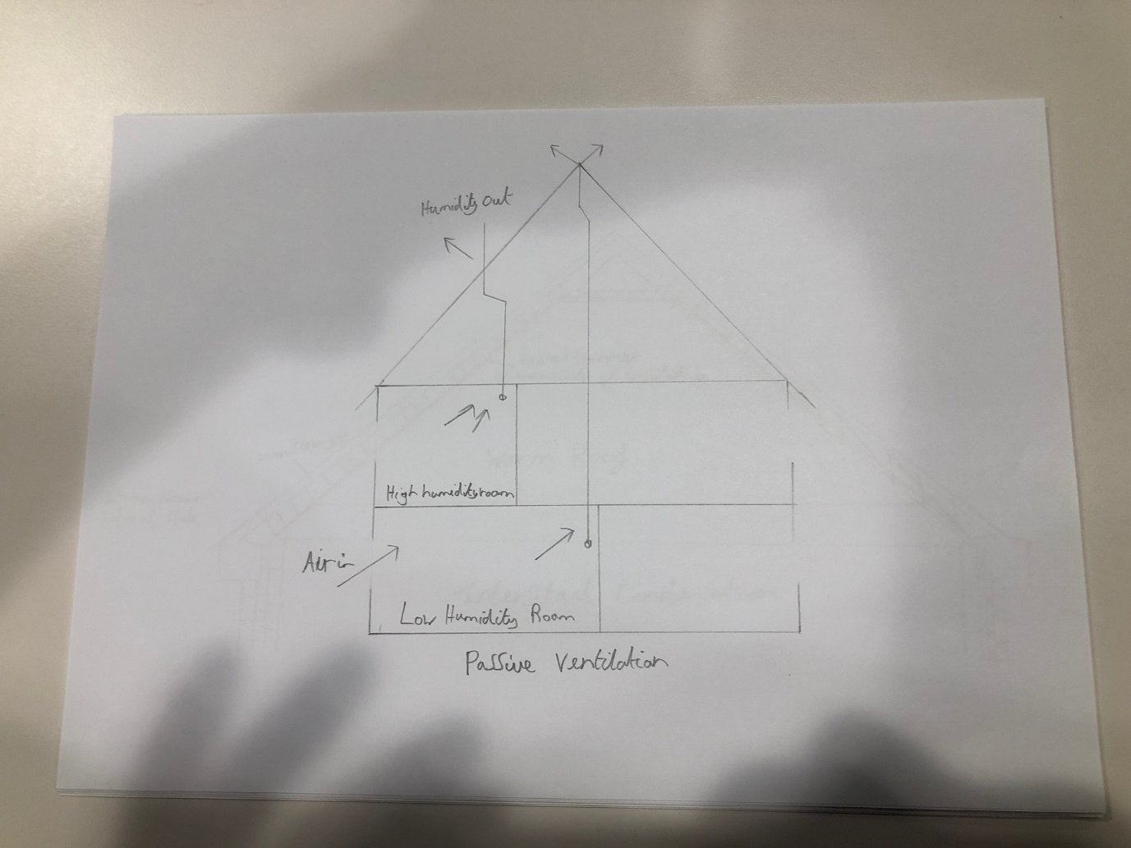

Passive ventilation

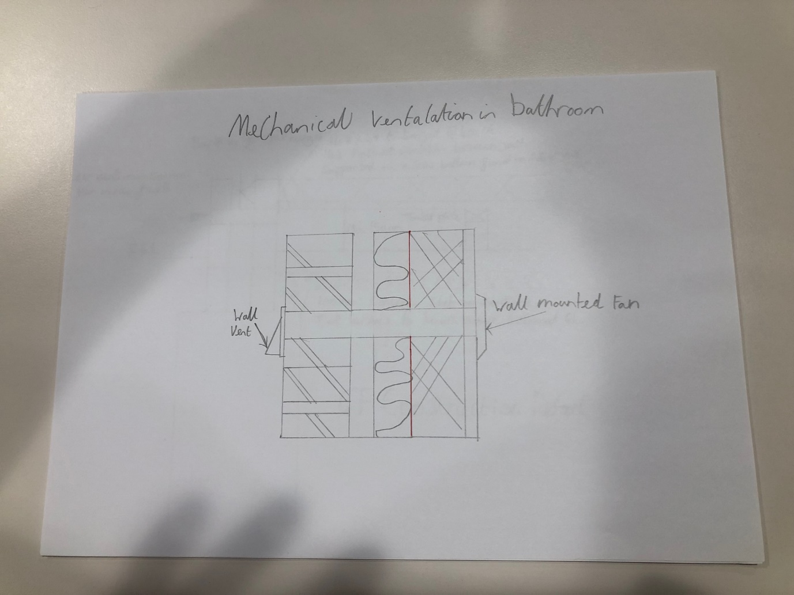

Mechanical ventilation in bathroom

3.
Measures to reduces condensation:
The common way of controlling the amount of surface condensation is to limit any source of moisture from any damp materials inside of the home. So making sure anything damp is controlled or stopped. Another method would be natural and mechanical ventilation which would get rid of any moist air that comes into the building. Natural ventilation is when the house is built in such a way that it ventilates all by its self, this could also be something such as having a window open in the house to let the moist air out. The other being mechanical ventilation which would be something such as a fan to take the most air out of the building straight from somewhere such as the bathroom where there’s lots of condensation due to people having showers/baths.
A way to reduce interstitial condensation in the house would be to avoid having any cold bridges, this is when there is no moisture barrier which stops moisture getting through the insulation which then cause moist to get into corners of the house and damp can occur.
Measures that can be taken to reduce condensation such as simple life style changes that generate less moisture.
- Place lids on pans when cooking
- Dry clothes outdoors
- Close kitchen and bathroom doors when in use
- Vent tumble drier to outside
- Ensure the loft is kept well ventilated
- Keep property warm to avoid cold surfaces including rooms not in use
- Lag cold pipes
- Leave trickle vents open when rooms are occupied to ventilate moisture away
- If mould occurs treat it straight away to stop it from spreading

Info from the NHBC

