Tesco’s influence on sustainable relationship, marketing policies and practices, and its impact on organisation performance.

November 29, 2024
Elena Ravelo Barreto (2240356)
University of Wales Trinity Saint David
Building a Sustainable Marketing Relationship (BMSW5007_CARD)

Executive Summary

Tesco maintains its leadership in the UK grocery market and thrives internationally, leading markets in Ireland, Hungary, and Thailand. While its U.S. expansion failed due to misaligned strategies, Tesco has excelled in other regions by leveraging data driven personalisation, robust loyalty programs, and competitive pricing to retain customers amidst growing competition from discount retailers. Its sustainability initiatives, including emission reductions and waste management, align with rising consumer demand for ethical practices, though opportunities remain to expand refillable packaging and budget options in smaller stores. With strong financial performance and a customer centric approach, Tesco continues to grow and solidify its global presence.

Contents

Executive Summary 1
1.0 Introduction 3
2.0 Findings 4
2.1 Background 4
2.1.1 Current Market Share 4
2.1.2 Growth or Decline 4
2.1.3 Current Financial Status 5
2.1.4 Tesco’s Mission Statement 5
2.2 Data Collection and Evaluation 6
2.2.1 Definitions 6
2.2.2 Application to Tesco’s Strategy 6
2.3 Segmentation, Pricing Strategies and Differentiation 8
2.3.1 Segmentation 8
2.3.2 Pricing Strategies 8
2.3.3 Differentiation 10
2.4 Ethics and Sustainability 11
3.0 Conclusions 13
4.0 Appendices 14
A 14
B 14
C 14
D 15
E 15
F 15
G 15
H 16
I 16
J 16
K 17
5.0 References 18
5.1 Pictures and Charts References 22

1.0 Introduction

This report has been requested by the Marketing Executive Officer of ‘Marketing Focus’ an online journal produced by Tesco.
This report aims to investigate the influence of Sustainable Relationship Marketing Policies and Practices, and the impact on Organisational Performance.
Elena Ravelo Barreto has compiled this report upon invitation to contribute to this research.
This report will summarise Tesco's background and current corporate and financial status while exploring key concepts such as data collection, market segmentation, pricing strategies, differentiation, ethics, and sustainability. It will also analyse how Tesco manages these concepts.
It has been identified the following problems:
- Difficulties entering and settling in the US Market
- Limited Budget Product Accessibility
- Sustainability Challenges

This report has been compiled using information and sources from online books, journals, blogs, articles and websites.

2.0 Findings

2.1 Background
Tesco was founded in 1919 by Jack Cohen, who began his venture by selling surplus groceries from a market stall in the East End of London (Hughes, 2023). The name "Tesco" was coined by combining the initials of Cohen's tea supplier, T.E. Stockwell, with his surname (Hoare, 2020). Over the decades, Tesco experienced significant growth, opening its first self service store in 1948 (Hughes, 2023) and introducing notable retail innovations, such as the Tesco Clubcard in 1995 (Shelper, 2024). In 1947, the company made its debut on the London Stock Exchange and continued to expand through strategic acquisitions and international ventures (London Stock Exchange, 2024).
Tesco currently operates in twelve countries, United Kingdom, Republic of Ireland, Slovakia, Czech Republic, Poland, Hungary, Turkey, India, Malaysia, Thailand, South Korea, and Japan, (Jobzmall, 2024). Tesco currently has 4950 stores and employs 33,751,8 people worldwide (Bedford, 2024).

2.1.1 Current Market Share
Tesco leads the markets in the United Kigndom, Republic of Ireland, Hungary and Thailand; and it is the third largest retailer in the world by gross revenues (World Economic Forum, 2024). According to Bedford (2024), Tesco holds a substantial 27% share of the UK grocery market in 2024. Despite the competitive pressure from discount retailers such as Aldi and Lidl, it has successfully maintained its status leading the supermarket sector in the United Kingdom.

2.1.2 Growth or Decline
In 2007, Tesco launched its Fresh & Easy brand in the U.S., reaching a peak of 208 stores. However, due to issues like small store sizes, poor customer research, and unsuitable locations, Tesco withdrew in 2013, selling its remaining stores and incurring losses of $1.6 billion.
Despite this, Tesco has experienced significant growth in recent years. The company's share price has risen by nearly 30% over the past 12 months, primarily fuelled by increased sales volume and market share gains (Boyrazian, 2024). Furthermore, Wise (2024) believes that the expansion of Tesco's premium Finest product range has notably contributed to this success.

2.1.3 Current Financial Status
In 2023/24, Tesco PLC led the UK grocery market with profits of 2,689 million, while Asda, Sainsbury’s, and Morrisons lost market share. Aldi surpassed Morrisons to become the fourth-largest grocery retailer, (Bedford, 2024).
* See Appendix A for further information.
Tesco has showcased impressive financial performance in recent times. For the fiscal year ending in February 2025, the company is anticipated to reach an adjusted operating profit of £2.9 billion. This success can be largely attributed to Tesco's steadfast focus on cost management, customer satisfaction, and ongoing innovation (Murray, 2024).

2.1.4 Tesco’s Mission Statement
‘’Serving our customers, communities and planet a little better every day’’ (Tesco PLC, 2024, para. 1). Prioritizing their customers, communities, and the environment in their daily operations reflects their commitment to placing customers at the centre of their activities, while concurrently acknowledging their obligations to the communities they serve, and to society at large (Tesco PLC, 2024).
* See Appendix B for further information.

2.2 Data Collection and Evaluation

2.2.1 Definitions
Buttle (2012), describes Customer Relationship Management (CRM) as a central business strategy that integrates internal processes and functions with external networks to create and deliver value to targeted customers while generating profit. This approach relies on high quality customer related data and is supported by information technology.
Customer data refers to the information gathered about a company's clients; it is utilised to tailor marketing efforts, pinpoint target demographics, and boost sales. Besides demographic details such as age, gender, and job title, it encompasses purchase history, online browsing behaviour, and individual preferences, (Tejeda, 2023). Customer data can be obtained through numerous methods in retail, such as gathering phone numbers or email addresses, enrolling customers in loyalty programs, acquiring data from point-of-sale transactions, and utilising analytics from mobile applications and e-commerce sites (Smith, 2021).
* See Appendix C for further information.
Customer Data can be categorised in different ways, based on the specific levels one decides to apply, (Griva et al,. 2018).
* See Appendix D for further information.
Integrating various forms of data can be advantageous for grocery retailers. By merging customer loyalty information, demographic insights, and geographic data, retailers can develop enhanced demand models that assist in managing inventory and labour expenses more effectively, (Grewal et al. 2018).

2.2.2 Application to Tesco’s Strategy
Tesco collects Customer Data through the Club Card, Shopping Patterns Online and in Store, the Tesco App, and various forms of communication including social media (Tesco, 2024). In November 2021, Tesco launched Tesco Media & Insight in partnership with Dunnhumby. This closed loop platform, supported by data from the Tesco Clubcard, which serves more than 20 million households in the UK and has nearly seven million regular app users, enables suppliers and agencies to engage more effectively with customers and better understand their evolving needs, as stated by Tesco (Nott, 2022).
* See Appendix E for further information.
Station 10 (2020), who conduct data analysis for Tesco, establishes that data analysis allows Tesco to adopt a more strategic approach to its inventory purchasing and planning, leading to enhanced revenue potential. In their analysis, Station 10 found that when it rains, the Average Order Value (AOV) increases by 2.1%, with shoppers gravitating towards more expensive items, especially indoor products like electrical appliances and technology. Male consumers are particularly inclined to spend more on electrical and entertainment goods during rainy weather. Additionally, they found that the temperature threshold for higher sales of 'warm weather' items decreases as customers’ locations shift north.
While there are advantages to data collection for retailer’s, it doesn’t not come without its limitations. In Smith’s (2021) article on BizTech Magazine, Christian Beckner, who serves as the vice president of retail technology and cybersecurity at the National Retail Federation said that gathering data presents various challenges, particularly regarding consumer privacy and data security issues. Neglecting these matters could lead to potential liabilities or regulatory complications for retailers.

2.3 Segmentation, Pricing Strategies and Differentiation

2.3.1 Segmentation
The idea of segmentation was originally introduced by Smith in 1957 and focuses on categorising consumers based on their traits, requirements, and behaviours, which can be targeted through marketing efforts. Market segmentation involves grouping potential customers into categories or segments based on demographics, location, behaviour, or psychographic characteristics to enhance understanding and marketing efforts towards them (Tarver, 2024).
* See Appendix F for further information.
Tesco categorises its customers using multiple segmentation strategies, including geographic segmentation, which divides customers by region within the United Kingdom and across 13 other countries, as well as by density, distinguishing between urban and rural areas. Demographic segmentation is based on factors such as age, gender, income, occupation, education, social status, and family size. They also use psychographic segmentation, focusing on lifestyle and personality traits, and behavioural segmentation, considering aspects like purchase frequency, benefit sought, user status, and customer attitudes (Dudovskiy, 2016).
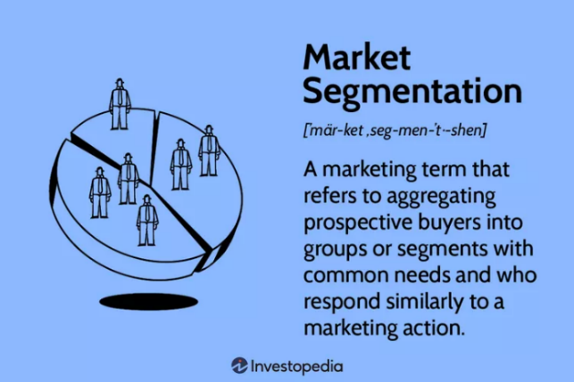
(Collins, 2024)

2.3.2 Pricing Strategies
Pricing strategy refers to the method a business employs to set the price for its products or services. It is an essential aspect of a company’s marketing strategy and can significantly affect its revenue, profitability, and overall success. This strategy takes into account various factors, including competitor pricing, the target market's willingness to pay, production costs, and the desired positioning of the product in the market. A thoughtfully crafted pricing strategy can enhance a company’s profits, attract and retain customers, and help achieve its marketing and business objectives, (The House of Marketing, 2024).
* See Appendix G for further information.

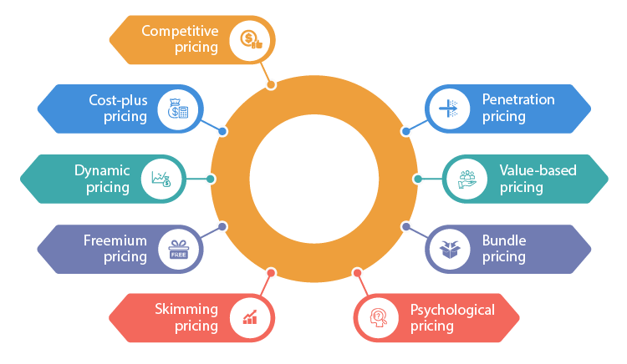
(Upmetrics, 2024).

Ongoing price optimisation is vital for a company's growth. Various factors affect the selection of a pricing strategy, such as economic trends, market demand levels, profit margin objectives, and the degree of competition. The most frequently utilised strategies include price skimming, penetration pricing, cost-plus pricing, premium pricing, value-based pricing, competitive pricing, economy pricing, and loss leader pricing. Additional strategies include dynamic pricing, psychological pricing, and freemium pricing (Indeed Editorial Team, 2024).
* See Appendix H for further information.
Tesco claims it is offering its best value ever, achieved through a "unique customer offer." This includes the Aldi Price Match initiative, exclusive discounts available through Clubcard Prices for members, and Low Everyday Prices that highlight value on various brands, (Carroll, 2024).
Tesco's pricing strategy comprises a complex mix of methods aimed at maintaining competitive prices and effectively positioning the brand within the market. This approach includes Competitive Pricing, Promotional Pricing, Psychological Pricing, and Private Label Pricing, all tailored to meet the needs of a varied customer base, (Bhasin, 2024).
* See Appendix I for further information.

2.3.3 Differentiation
A differentiation strategy is how a company can distinguish from similar competitors in the market. This typically involves emphasising a significant difference that sets them apart. According to renowned strategist Michael Porter, there are only two methods to achieve a sustainable competitive advantage: competing on price or differentiating business from others, (Frederiksen and Harr, 2024).

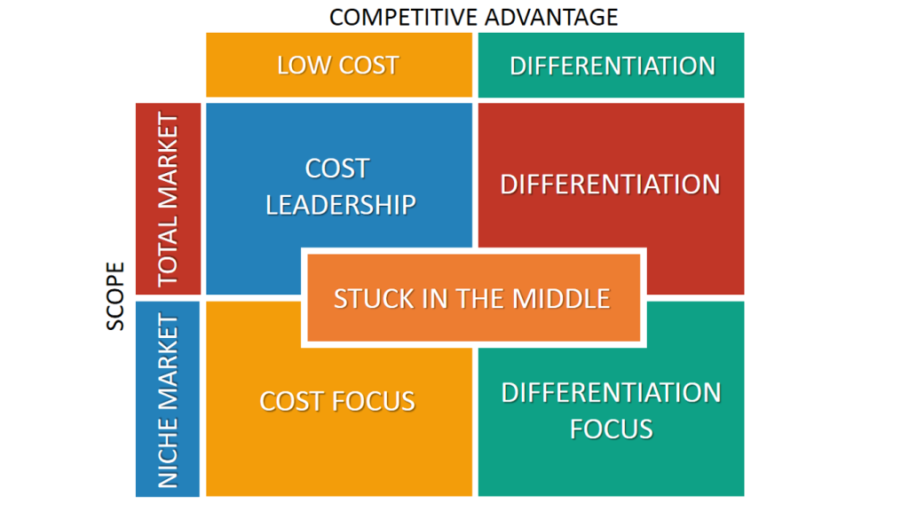
(De Bruin, 2021).

Kolb (2023) states that Porter’s competitive strategies—cost leadership, differentiation, and a focused approach—guide businesses in gaining market advantage. These strategies enable companies to leverage their strengths against competitors, focusing on pricing, product features, customer support, and market segmentation. It's important to avoid being "stuck in the middle" and to be aware of the risks associated with each strategy for sustained market success.

2.4 Ethics and Sustainability

‘’Business ethics is the application of ethical values to business behaviour. Business ethics is relevant both to the conduct of individuals and to the conduct of the organisation as a whole. It applies to any and all aspects of business conduct, from boardroom strategies and how companies treat their employees and suppliers to sales techniques and accounting practices’’, Institute of Business Ethics. (2024).

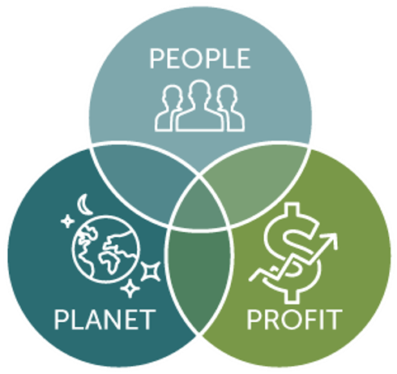

The triple bottom line is a business concept that encourages companies to evaluate their social and environmental impacts alongside financial outcomes, focusing on "profit, people, and the planet." By adopting sustainable practices within operations and supply chains, businesses can achieve profitability while enhancing societal and environmental well-being. Many companies have found that prioritising these aspects can actually lead to financial benefits, (Miller, 2020).

(EZ Office Products, .).

Sustainability has often been seen as optional for consumers, but that's changing. Our research reveals a significant shift in buying habits toward genuinely sustainable brands that fulfill their promises to people and the environment. We're approaching a time when sustainability will be a basic expectation for purchases, so companies should prepare accordingly, (Reichheld et al, 2023).
* See Appendix J for further information.
Tesco is dedicated to reducing the food system's impact on climate and nature by improving products, lowering emissions from logistics and stores, encouraging sustainable choices, minimising food waste and packaging, and protecting biodiversity, (Tesco PLC, 2024).
Supermarkets are vital in combating climate change, as they significantly contribute to greenhouse gas emissions, plastic waste, and food waste. Companies working with the Science-Based Targets initiative (SBTi) commit to measuring and reducing their emissions and have two years to validate their targets after making this commitment, (Howes, 2024).
* See Appendix K for further information.

Customer Centrality is paramount to Tesco’s success, and its foundation is directly influenced by its customer base. The organisation prioritises gaining insights into customer desires and preferences, enabling it to predict and react efficiently. This focus on customers is reflected in numerous aspects of its operations, including product choices and service delivery, (Gupta, 2024).

3.0 Conclusions

Tesco maintains a strong market position in the UK through innovative strategies, data driven marketing, and a focus on customer satisfaction. Although it faces competition from Aldi and Lidl, Tesco thrives with loyalty programs like Clubcard and dynamic pricing. Its emphasis on personalization, backed by customer data analysis, strengthens its competitive edge. Despite past challenges, such as its U.S. expansion failure, Tesco has shown resilience with recent financial growth. Its sustainability efforts, including carbon reduction and waste management, cater to the demand for ethical practices, though improvements are needed in areas like refillable packaging.
Recommendations:
1. Enhance Value Perception: Address pricing concerns by offering budget-friendly options, particularly in convenience stores, to improve customer value ratings.
2. Expand Sustainability Initiatives: Resume refillable packaging trials and intensify efforts in sustainable logistics and product sourcing to strengthen consumer trust.
3. Leverage Competitive Pricing: Continue initiatives like Aldi Price Match while promoting the benefits of Clubcard and Clubcard Plus to attract and retain customers.
4. International Focus: Consolidate success in high performing international markets while cautiously exploring new opportunities.

4.0 Appendices

A
During the financial year 2023/24, Tesco recorded annual revenues exceeding 62.8 billion British pounds across the United Kingdom and the Republic of Ireland (ROI). This represented an increase of more than 2.6 billion pounds when compared to the previous financial year.

B
According to Walsh and Simmonds (2024), Tesco ranks joint-second among online supermarkets in and has received positive feedback from in store customers. Online shoppers rated Tesco four stars for the availability of delivery slots, communication about services, customer service, stock availability, and product quality. However, Tesco received only three stars for value for money, falling short of Iceland's ratings. The supermarket angered some customers by raising the minimum spend for online grocery deliveries from £40 to £50. In-store, Tesco scored four stars in most areas except value for money. While Clubcard members enjoy lower prices, a Which? investigation in June 2023 revealed that the savings may not be as substantial as advertised. Furthermore, Tesco has not introduced budget range groceries in its smaller convenience stores, which has been requested by Which? for several months, resulting in Tesco not being a Which? recommended provider.
CRM (Customer Relationship Management) is a targeted and measurable strategy that engages audiences likely to respond to messages. CRM allows Tesco to connect with and reward loyal Clubcard customers through Direct Mailings, Reward Mailing Coupons, and Coupons at Till. These initiatives help deliver personalized marketing directly to customers.
Direct Mailings allows Tesco to send measurable marketing materials to customers' homes. As part of the reward mailing coupon strategy, Tesco offers personalised coupons to loyal Clubcard customers as incentives to shop, accessible via their online accounts and in-app. Tesco also offer coupons at the till, which provides specific customers and prospective shoppers with purchase incentives and measure their responses accurately (Dunnhumby, 2021).

C
A significant element of Tesco’s data-driven marketing strategy is its focus on personalisation. By utilizing data regarding customer behaviours and preferences, Tesco can craft tailored experiences that enhance customer engagement and boost loyalty. One illustration of this is the Tesco Online Grocery service. By examining customer data, Tesco can offer personalised suggestions for customers based on their previous shopping habits. This simplifies the process for customers to locate the products they require and motivates them to choose Tesco for future purchases (World Brand Affairs, 2023).

D
- Demographics, including details like gender, age, and marital status.
- Geographics, encompassing information such as a person's workplace location or home address.
- Attitudinal, which indicates a customer's preferences and feelings towards the provided products and services.
- Psychographics, covering aspects like values, beliefs, interests, and personality characteristics.
- Sales, including metrics such as sales quantity, visit frequency, total value, and timing of purchases.
- And Behavioural, that looks at how customers navigate through a physical store or an online site.

E
Retailers are able to track what customers buy using debit and credit card transactions, even if customers have not participated in loyalty programs. For cash payments, supermarkets can still recognise products that prompt cashiers to offer various incentives. The information gathered enables brands to acquire access to consumers who purchase competing products, allowing them to present tailored offers. This precise targeting leads to a significant increase in coupon redemption rates, rising from as low as 1% to more than 50%, which illustrates the substantial monetary value of customer information for supermarkets (Ferguson, 2013).

F
Aktas and Meng (2017), state that customer information can assist in dividing customers into smaller segments and facilitate decisions regarding product assortment optimisation, as well as in implementing dynamic pricing if digital price tags are utilised. This customer information may include not only purchase history but also lifestyle related data. Segmentation allows marketers to divide their customer base into smaller, more defined groups. These groups are formed based on factors such as demographic and psychographic details, along with purchasing behaviour and preferences (Tejeda, 2023).

G
An effective pricing strategy delivers important benefits. It reflects value, with lower prices potentially signalling poor quality, while higher prices are typically associated with better value. It also helps attract customers, as setting the right price is crucial; too high and it risks losing buyers. Furthermore, it builds trust, since prices that are too low can create doubts about the product’s quality (GoCardless, 2022).

H
Tesco has announced plans to categorise its 20 million Clubcard users into distinct groups when they access the company's website. This categorisation will be based on their past purchasing behaviours, with a primary focus on whether the customer has frequently purchased a significant number of Tesco Finest-branded products – the supermarket's upscale food line. This initiative is reportedly aimed at providing shoppers with promotions tailored to their specific preferences, with wealth and age being important factors (Internet Retailing, 2012).

I
Tesco’s pricing strategy also comprises of its Loyalty Pricing Program: Clubcard and Clubcard Plus. This includes:
- Exclusive Member Prices
Having a Tesco Clubcard allows customers to access Clubcard Prices on select products, potentially saving around 7% on their shopping.
- Points System - customers earn one point for every £1 spent and one point for every two litres of fuel. Each point is worth 1p, equating to £1.50 for 150 points. If redeemed with Clubcard partners, points are worth double.
- Additional Benefits - Clubcard app users receive personalised coupons every two weeks, while those receiving vouchers by post get them about eight times a year. Customers can also earn points through Tesco Bank and Tesco Mobile.
- Clubcard Plus, at £7.99 a month, offers a 10% discount on two big shops and selected Tesco brands, plus double data on Tesco Mobile (Simmonds, 2024).

J
The recent change in consumer behaviour towards sustainability has emerged as a crucial element in buying choices. Companies that commit to authentic sustainable practices are experiencing an increase in customer loyalty. Organisations are more frequently acknowledging the significance of incorporating sustainability to gain the trust and loyalty of their clientele, spurred by an increasing awareness of environmental and social concerns, (Agusiegbe, 2024).

To build loyalty, it's important to connect emotionally with customers. Emotional engagement is vital for a positive experience, and sustainability addresses key issues that modern consumers care about. Shared values and supporting sustainable choices enhance customer experience, leading 72% of customers to share positive experiences with others. Thus, incorporating sustainability boosts the likelihood of customers becoming brand advocates and strengthens their loyalty, (Veldwijk, 2020).

K
Tesco's sustainability goals include:
- Net zero emissions for own operations by 2035 and for value/supply chain by 2050 (both SBTi validated).
- Largest UK supermarket by revenue, with the highest emissions, accounting for over 25% market share.
- Emission reductions through 100% renewable energy and improved refrigeration; plans for a fully electric delivery fleet by 2030.
- 98% of carbon footprint from Scope 3 emissions; 70% of suppliers have set net zero targets.
- Committed to 39% reduction in FLAG emissions by 2032 and 72% by 2050, including zero deforestation by 2025.
- Targeting 65% sales from healthier products by 2025 and has halted HFSS promotions.
- Trialled refillable products with Loop, but the trial ended in 2022 and hasn’t resumed, (Howes, 2024).

5.0 References

Agusiegbe, O. (2024). The Rise of Consumer Loyalty Through Sustainable Practices. [Online]. Environ Buzz Magazine. Last Updated: 19th April 2024. Available at: https://environbuzz.com/the-rise-of-consumer-loyalty-through-sustainable-practices/ [Accessed 25 November 2024].
Aktas, E. and Meng, Y. 2017. ‘An exploration of big data practices in retail sector’, Logistics, 1(2), p.12. Available at: 10.3390/logistics1020012
Bhasin, H. (2024). Marketing Mix of Tesco and 7Ps (Updated 2024). [Online]. Marketing91. Last Updated: 19th February 2024. Available at: https://www.marketing91.com/marketing-mix-tesco/ [Accessed 17 November 2024].
Bedford, E. (2024). Annual revenue of Tesco Group in the United Kingdom (UK) and the Republic of Ireland from financial year 2015 to 2024. [Online]. Statista. Last Updated: 10th June 2024. Available at: https://www.statista.com/statistics/490931/tesco-group-finance-revenue-united-kingdom-uk/#:~:text=In [Accessed 18 November 2024].
Bedford, E. (2024). Tesco PLC - statistics & facts. [Online]. Statista. Last Updated: 14 June 2024. Available at: https://www.statista.com/topics/3807/tesco-plc/ (Accessed 11 November 2024).
Boyrazian, Z. (2024). Where might the Tesco share price go in the next 12 months? Here’s what experts think. Available at: https://www.fool.co.uk/2024/11/11/where-might-the-tesco-share-price-go-in-the-next-12-months-heres-w (Accessed: 11 November 2024).
Buttle, F. (2012). Customer relationship management : concepts and technolgies (2nd ed.). Routledge.
Castus. (2022). International Expansion: Why Tesco Missed the Mark in the U.S. Market. [Online]. castusglobal.com. Last Updated: 12th September 2022. Available at: https://www.castusglobal.com/insights/international-expansion-why-tesco-missed-the-mark-in-the-u-s-m [Accessed 17 November 2024].
Dudovskiy, J. (2016). Tesco Segmentation, Targeting and Positioning. [Online]. Business Research Methodology. Last Updated: 15th May 2016. Available at: https://research-methodology.net/tesco-segmentation-targeting-and-positioning-2/ [Accessed 18 November 2024].
Dunnhumby.. (2021). Tesco Media Insight Platform - CRM. [Online]. Dunnhumby for Tesco. Available at https://www.dunnhumby.com/wp-content/uploads/2021/11/Tesco-Media-Insight-CRM-OnePager.pdf. [Accessed 17 November 2024].
Ferguson, D. (2013). How supermarkets get your data – and what they do with it. The Guardian. [Online]. 8 Jun 2013. Available at https://www.theguardian.com/money/2013/jun/08/supermarkets-get-your-data [Accessed 17th November 2024].
Frederiksen, L and Harr, E. (2024). Mastering Differentiation Strategy for Professional Services Firms. [Online]. Hinge. Last Updated: 25th June 2024. Available at: https://hingemarketing.com/blog/story/expertise-as-a-differentiation-strategy#:~:text=A%20differenti [Accessed 17 November 2024].
Grewal, D., Motyka, S. and Levy, M. 2018. The evolution and future of retailing and retailing education. Journal of Marketing Education, 40(1), pp.85-93.
Griva, A., Bardaki, C., Pramatari, K. and Papakiriakopoulos, D. 2018. Retail business analytics: customer visit segmentation using market basket data. Expert Systems with Applications, 100, pp.1-16.
GoCardless. (2022). Importance of a Pricing Strategy. [Online]. GoCardless. Available at: https://gocardless.com/en-au/guides/posts/importance-of-a-pricing-strategy/ [Accessed 17 November 2024].
Gupta, S. (2024). Tesco: The Pillars of Success and Market Leadership. [Online]. Grocery Doppio. Last Updated: 30th July 2024. Available at: https://www.grocerydoppio.com/articles/tesco-the-pillars-of-success-and-market-leadership#:~:text=Te [Accessed 27 November 2024].
Hoare, C. (2020). Tesco secret: Founder Jack Cohen's unique inspiration behind company name reveal. Express. [Online]. 6 July 2020. Available at https://www.express.co.uk/life-style/life/1305890/tesco-secret-jack-cohen-company-name-online-shopping-supermarket-price [Accessed 11 November 2024].
Howes, O. (2024). Supermarkets and the environment. [Online]. Which?. Last Updated: 24th July 2024. Available at: https://www.which.co.uk/reviews/shopping-sustainably/article/supermarkets-and-the-environment-ahzAC2 [Accessed 25 November 2024].
Hughes, M. (2023). Huge range of North East roles at Tesco stores available Now. The Northen Echo. [Online]. 25th March 2023. Available at https://www.thenorthernecho.co.uk/news/23407843.huge-range-north-east-roles-tesco-stores-available-now/ [Accessed 11 November 2024].
Hughes, N. (2023). How England’s First Self-Service Store Heralded the Birth of the Modern Supermarket. [Online]. The Historic England Blog. Last Updated: 12 January 2023. Available at: https://heritagecalling.com/2023/01/12/how-englands-first-self-service-store-heralded-the-birth-of-t [Accessed 11 November 2024].
Institute of Business Ethics. (2024). What is business ethics?. [Online]. IBE. Available at: https://www.ibe.org.uk/knowledge-hub/what-is-business-ethics.html [Accessed 25 November 2024].
Indeed Editorial Team. (2024). Pricing strategies: what are they and their importance. [Online]. Indeed. Last Updated: 5th August 2024. Available at: https://uk.indeed.com/career-advice/career-development/pricing-strategies [Accessed 17 November 2024].
Internet Retailing. (2012). Tesco plans targeted approach with Clubcard data. [Online]. Internet Retailing. Last Updated: 29th June 2012. Available at: https://internetretailing.net/tesco-plans-targeted-approach-with-clubcard-data-9328/ [Accessed 18 November 2024].
Jobzmall. (2024). In which countries does Tesco operate?. [Online]. jobzmall.com. Available at: https://www.jobzmall.com/tesco/faqs/in-which-countries-does-tesco-operate [Accessed 14 November 2024].
Kolb, D. (2023). An Overview of Porter’s Generic Competitive Strategies. [Online]. Medium. Last Updated: 17th July 2023. Available at: https://medium.com/@kolbeuk/an-overview-of-porters-generic-competitive-strategies-453342d1a6ae [Accessed 17 November 2024].
Carroll, N. (2024). Tesco CEO claims retailer ‘more competitive than ever’ on value. [Online]. Marketing Week. Last Updated: 10th April 2024. Available at: https://www.marketingweek.com/tesco-ceo-more-competitive-value/ [Accessed 17 November 2024].
Miller, C. (2020). The Triple Bottom Line: What It Is & Why It’s Important. [Online]. Harvard Business School Online. Last Updated: 8th December 2020. Available at: https://online.hbs.edu/blog/post/what-is-the-triple-bottom-line [Accessed 25 November 2024].
Murray, A. (2024). UK's leading grocer Tesco revises profit guidance upwards after strong half-year performance. [Online]. Business Live. Last Updated: 3 OCT 2024. Available at: https://www.business-live.co.uk/retail-consumer/uks-leading-grocer-tesco-revises-30060808 [Accessed 11 November 2024].
Nott, G. (2022). Tesco gives brands full access to planogram data with new tool. [Online]. The Grocer. Last Updated: 27 July 2022. Available at: https://www.thegrocer.co.uk/news/tesco-gives-brands-full-access-to-planogram-data-with-new-tool/6698 [Accessed 14 November 2024].
https://www.thegrocer.co.uk/news/tesco-gives-brands-full-access-to-planogram-data-with-new-tool/669854.article
London Stock Exchange. (2024). Tesco PLC. [Online]. London Stock Exchange. Available at: https://www.londonstockexchange.com/stock/TSCO/tesco-plc/our-story [Accessed 11 November 2024].
Reichheld, A; Peto, J and Ritthaler, C. (2023). Research: Consumers’ Sustainability Demands Are Rising. [Online]. Harvard Business Review. Last Updated: 18th September 2023. Available at: https://hbr.org/2023/09/research-consumers-sustainability-demands-are-rising [Accessed 25 November 2024].
Shelper, P. (2024). Do Loyalty Programs Work? Just ask Tesco. [Online]. Loyalty & Reward Co. Last Updated: 9 October 2024. Available at: https://loyaltyrewardco.com/do-loyalty-programs-work-just-ask-tesco/ [Accessed 11 November 2024].
Sherman, R. 2015. Business intelligence guidebook: from data integration to analytics. 1st ed. Morgan Kaufmann.
Simmonds, E. (2024). Loyalty schemes compared. [Online]. which. Last Updated: 2nd October 2024. Available at: https://www.which.co.uk/reviews/supermarkets/article/loyalty-schemes-compared-a4ERY9a5NFJd#loyalty-p [Accessed 17 November 2024].
Smith, E. (2021). The 4 Types of Consumer Data That Matter to Retailers. [Online]. BizTech. Last Updated: 29 September 2021. Available at: https://biztechmagazine.com/article/2021/09/4-types-consumer-data-matter-retailers-perfcon#:~:text=C [Accessed 16 November 2024].
Smith, W.R., 1956. Product differentiation and market segmentation as alternative marketing strategies. Journal of marketing, 21(1), pp.3-8.
Station 10. (2020). Tesco: Using Data Analysis to Make Better Business Decisions. [Online]. Station10.co.uk. Available at: https://station10.co.uk/case-studies/tesco-using-data-analysis-to-make-better-business-decisions/ [Accessed 18 November 2024].
Tarver, E. (2024). Market Segmentation: Definition, Example, Types, Benefits. [Online]. Investopedia. Last Updated: 27th June 2024. Available at: https://www.investopedia.com/terms/m/marketsegmentation.asp [Accessed 16 November 2024].
Tesco PLC (2024) 2024 Annual Report. Available at: https://www.tescoplc.com/media/zgvhd0dn/tescos_ar24.pdf (Accessed: 13 November 2024).
Tesco. (2024). Your Data Journey. [Online]. Tesco.com. Available at: https://www.tesco.com/zones/your-data-journey [Accessed 16 November 2024].
Tesco PLC. (2024). Core Purpose and Values. [Online]. tescoplc.com. Available at: https://www.tescoplc.com/about/how-we-do-business/core-purpose-and-values#:~:text=Serving%20our%20cu [Accessed 11 November 2024].
Tejeda, V. (2023). Customer Data: Strategies for Sales and Marketing Teams (2024). [Online]. Shopify. Last Updated: 13 February 2023. Available at: https://www.shopify.com/uk/retail/customer-data [Accessed 16 November 2024].
The House of Marketing. (2024). Pricing Strategy 101: What is Pricing Strategy and why should you look into it?. [Online]. Thom.eu. Available at: https://thom.eu/resources/article/pricing-strategy-101-what-is-pricing-strategy-and-why-should-you-l [Accessed 17 November 2024].
Veldwijk, J. (2020). The Role of Sustainability in Customer Loyalty. [Online]. Customer Think. Last Updated: 12th October 2020. Available at: https://customerthink.com/the-role-of-sustainability-in-customer-loyalty/ [Accessed 25 November 2024].
Walsh, H and Simmonds, E. (2024). Supermarkets reviewed: compare the best and worst. [Online]. Which. Last Updated: 26th February 2024. Available at: https://www.which.co.uk/reviews/supermarkets/article/best-supermarkets-aOJjN2J0A10N [Accessed 18 November 2024].
World Brand Affairs. (2023). How Tesco Uses Data-Driven Marketing To Increase Customer Loyalty. [Online]. World Brand Affairs. Last Updated: 25th August 2023. Available at: https://worldbrandaffairs.com/how-tesco-uses-data-driven-marketing-to-increase-customer-loyalty/#:~: [Accessed 18 November 2024].
World Economic Forum. (2024). Tesco. [Online]. WEForum. Available at: https://www.weforum.org/organizations/tesco/ [Accessed 14 November 2024].

5.1 Pictures and Charts References

Collins, M.. (2024). Market Segmentation. [Online]. Investopedia. Available at https://www.investopedia.com/terms/m/marketsegmentation.asp. [Accessed 16 November 2024].
De Bruin, L.. (2021). Porter’s Generic Strategies: Differentiation, Cost Leadership and Focus. [Online]. Business-to-you. Available at https://www.business-to-you.com/porter-generic-strategies-differentiation-cost-leadership-focus/. [Accessed 17 November 2024].
EZ Office Products.. (.). 9 Benefits of the Triple Bottom Line. [Online]. EZ Office Products. Available at https://ezop.com/blog/water-cooler-talk/benefits-of-triple-bottom-line-madison-wisconsin/. [Accessed 25 November 2024].
Tesco PLC.. (2022). Tesco to lock over a thousand everyday products at low prices until 2023. [Online]. Tesco PLC. Available at https://www.tescoplc.com/tesco-to-lock-over-a-thousand-everyday-products-at-low-prices-until-2023/. [Accessed 17 November 2024].
Upmetrics.. (2024). How to Write Pricing Strategy for Your Business Plan. [Online]. Upmetrics. Available at https://upmetrics.co/blog/everything-you-need-to-know-about-pricing-strategy. [Accessed 17 November 2024].

