Geraint Jones (1908119)
1908119@student.uwtsd.ac.uk

HTML & CSS Web Development

Name of the author – Geraint Jones
Course – Introduction to Web and Database Concepts
The Faculty name – School of applied computing
The date of submission – 20/04/2021

Declaration

The work of this report is completed under the supervision of Gareth Jones. I declare that this report is the product of my own work and is not being submitted for any other degree etc.

Acknowledgement

I would like to thank my family for giving me the additional time to undertake a degree, my employer for sponsoring the degree and the many lecturers for giving their time and knowledge to arm me with the necessary to complete the tasks at hand.

Abstract

This report is a specification document on the production of a website for a small Floristry business. It will leverage skills learnt from the introductory module to web concepts. The report will cover the following requirements, implementation and evaluation as well as offering an introduction and conclusion to the said task, as well as evidencing the studies via the appendices.

Keywords include html, css, wireframe, wcag, perceivable, operable, understandable, robust

Contents page
Declaration 1
Acknowledgement 1
Abstract 1
Contents page 2
Main chapters 3
Introduction 3
1. Requirements 3
1.1 Purpose 3
1.2 Subject matter 3
1.3 Target audience 5
1.4 Relevance 5
2. Implementation 5
2.1 Wireframe 6
2.2 Screenshots 7
2.3 Example and fixes of errors 9
2.4 Validation 12
3. Evaluation 14
3.1 Website usability 14
3.2 Accessibility 14
3.3 Search Engine Optimisation 16
4. Conclusion 18
5.1 Future work 18
References 19
Supporting material 21

Main chapters

Introduction

This report outlines the considerations weigh when designing a html website for a Floristry business, for one Mrs H Jones, although most of the concepts could be considered for any website. It will cover a range of topics such as the requirements, research, testing and best practice which goes into the finished product.

1. Requirements

Purpose

Mrs H Jones uses social media to promote her small business, Florabunda Carmarthen, which she currently runs as more of a hobby than a business around major events which require Floristry, like Mothering Sunday. Having a website would allow her to increase the businesses web presence, as well as have a station for ecommerce. Ideally the website would be “modern, fresh, and easy to maintain”.

1.2 Subject matter

As discussed, the subject matter of the website is flower sales, specifically around dates such as Weddings, Funerals, and holiday events which have traditionally involved flowers like Easter weekend[1].
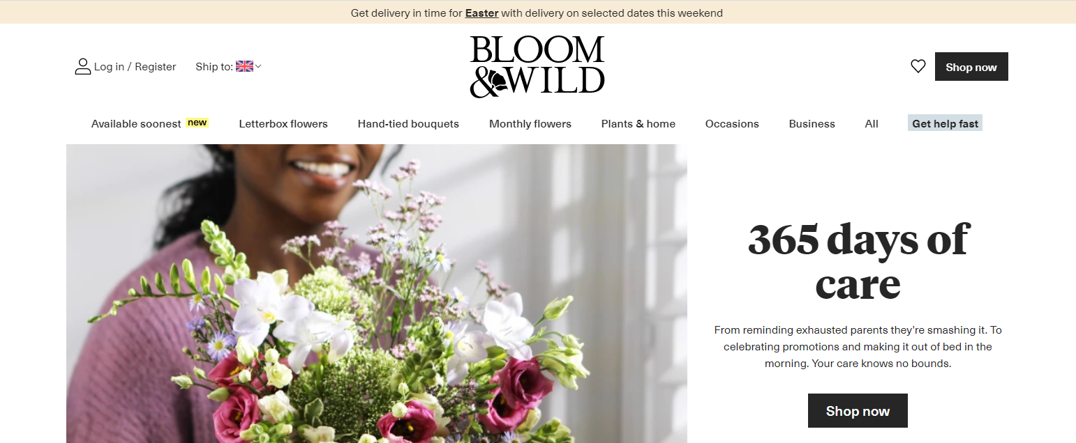
Figure 1[2]
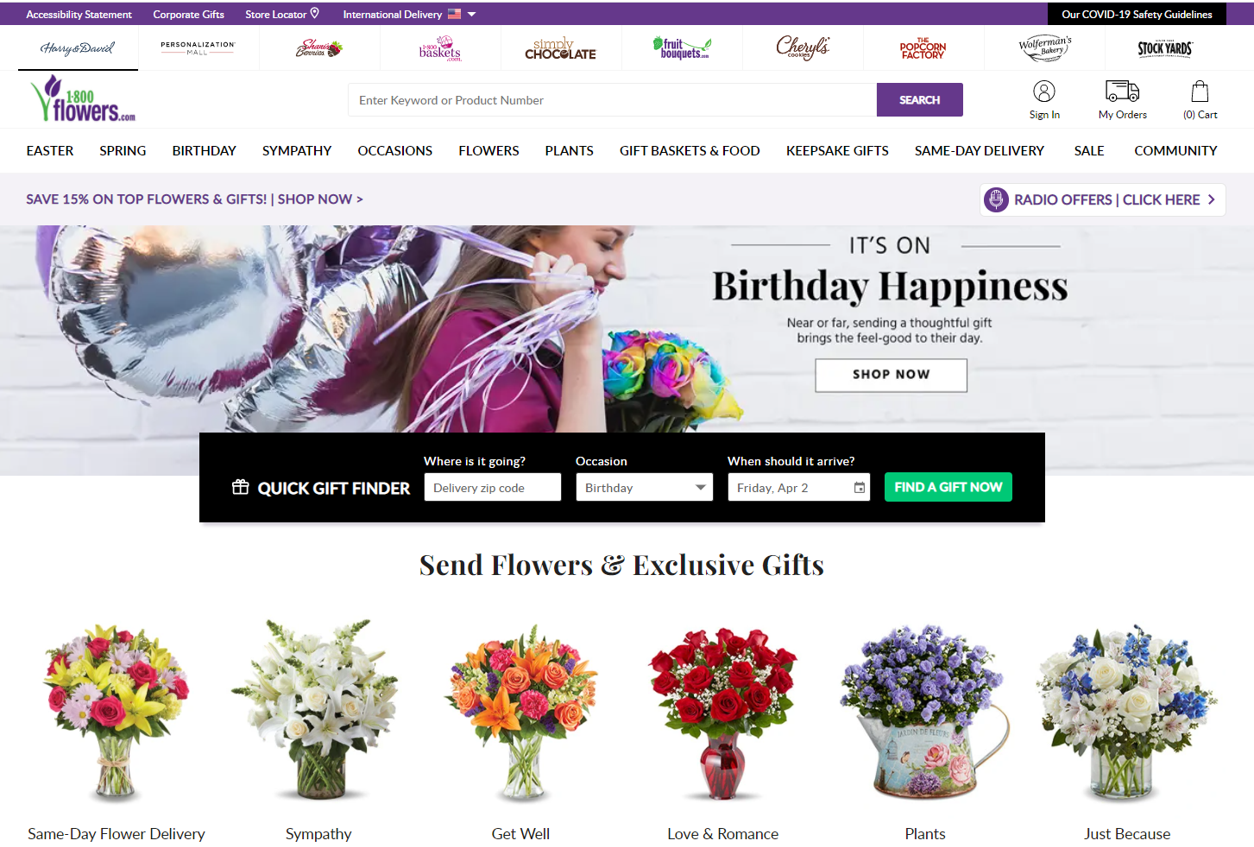
Figure 2[3]

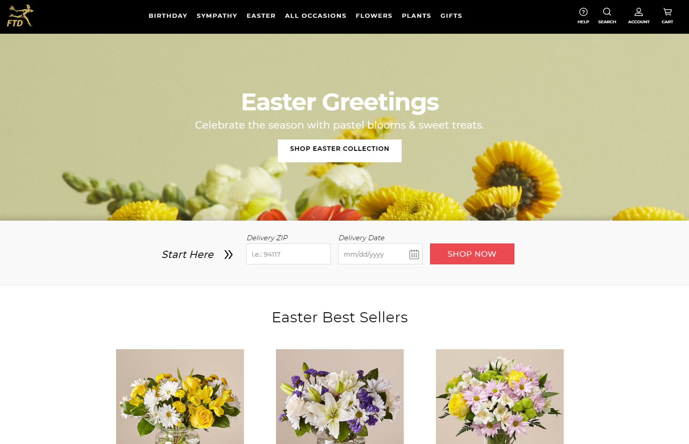
Figure 3[4]
Figure 1 to 3 show typical websites from major UK suppliers of flowers. They are similar in their design and the following can be taken away from them for Florabunda’s design
- Feature a hero image or graphic[5]
- All contain images of flowers, the product
- They follow a common website template (like Amazon shown in Figure 4)
  - Navigation bar at the top
  - Hero image in centre
  - Shop now middle right
  - Search, basket and or other top left or right
- Have corporate branding
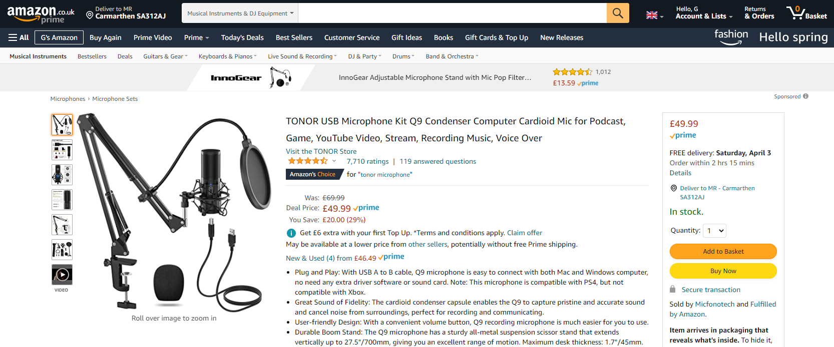
Figure 4

1.3 Target audience

Broadly speaking women are more likely to purchase flowers than men, with 65 percent of transactions conducted by them.
Up to eighty percent of transactions are for gifts, although supermarket have disrupted this for the traditional Florist.
Demographically, florist shoppers fit into three groups, “Baby Boomers (1946-1964)”, “Generation X (1965-1980)” and “Generation Y (1981-1994)”. Generation X are the most likely to buy flowers through a website as a gift, but a mixture of demographics will buy for events such as Weddings[6].

1.4 Relevance

As Generation X are the main target audience, it is important to understand the bearing of their situation on the website. Although not true for all, in the main they are the squashed middle, which leads to them having to make the rightly informed decision quickly, as they manage the peak of their career and family lives with dependants formed from both children and parents[7].
They will spend time reading condensed, relevant information which will reassure them when making a purchase. They are not looking for uniqueness in website design, and usability should be a priority with tests being conducted early and often. As such leveraging tried and tested designs as noted in subject matter, where this work will have been undertaken would be preferable[8].

2. Implementation

With the above research considered, a conversation was held with Mrs H Jones to create a site diagram to capture the structure of the website. This was translated into a Visio diagram shown in figure 5. The Wedding Page would not have any add to basket features, as it would require a conversation between business and customer, although there was still a requirement to navigate to other sections from this page.
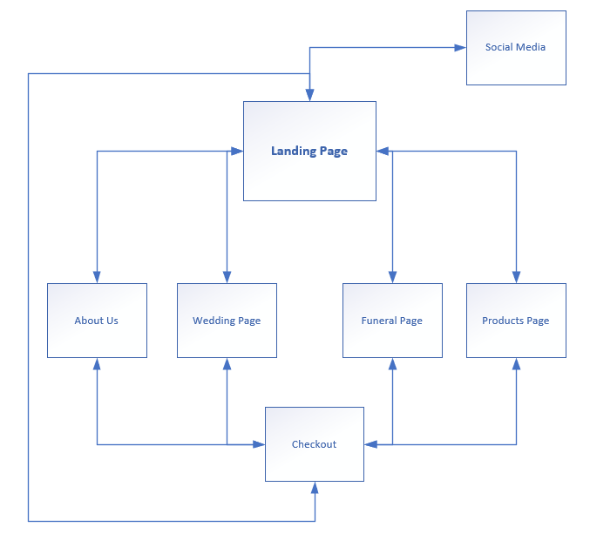
Figure 5

2.1 Wireframe

With the structure in place wireframe diagrams were made of the individual pages. This is a technique which uses simple diagramming to express what each page will contain to a customer, including site navigation, content that appears on pages, interactive components, dynamic functionality etc[9].
The following free tool was used to accomplish this https://wireframe.cc/xnriJw for Mrs H Jones. The landing page diagram is shown in figure 6.
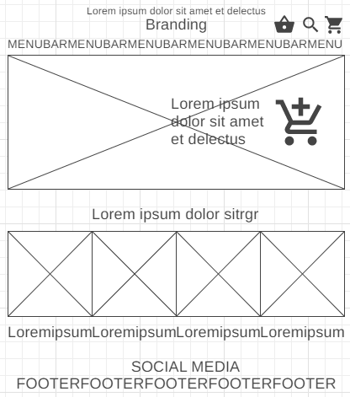
Figure 6

2.2 Screenshots

2.2.1 index.html
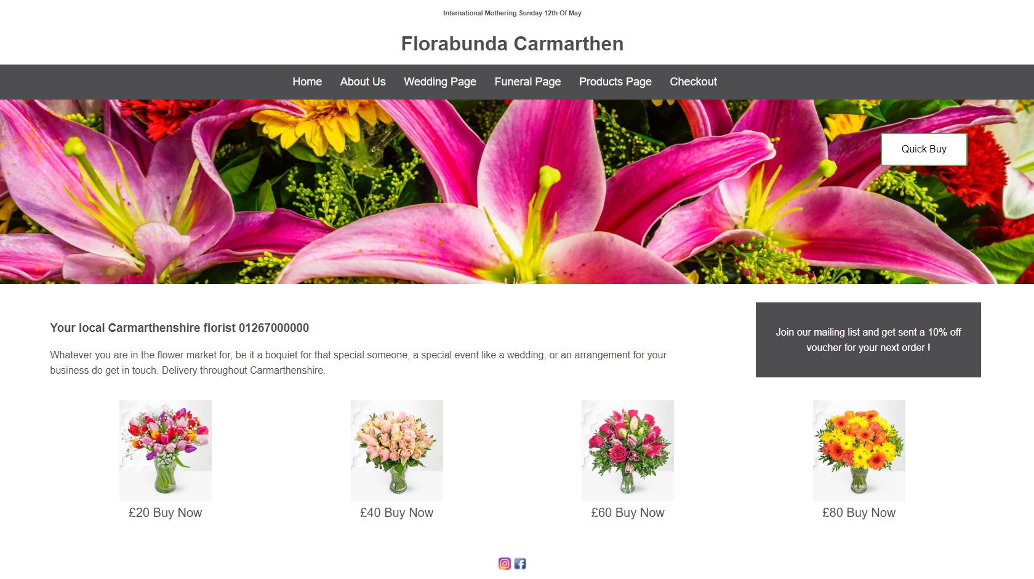
Figure 7

2.2.2 about.html
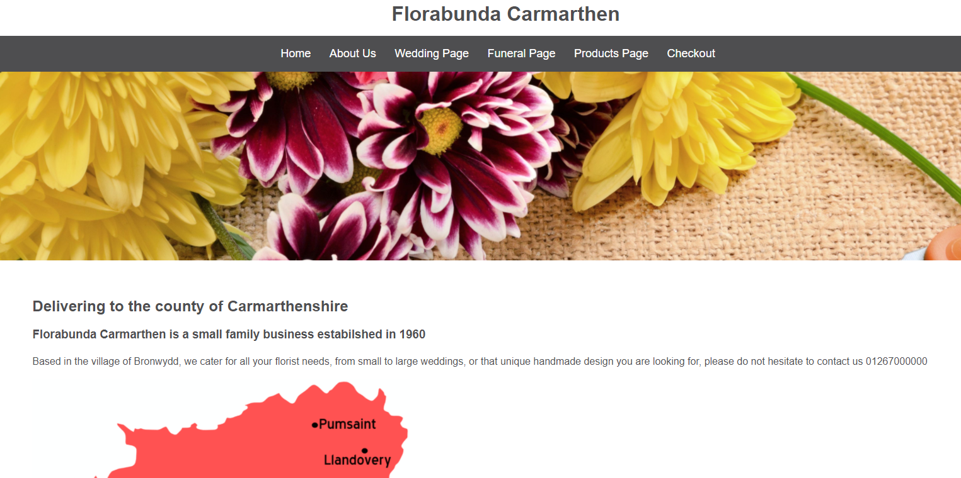
Figure 8

2.2.3 wedding.html
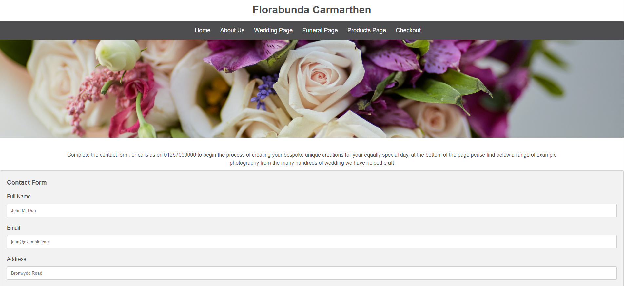
Figure 9

2.2.4 Funeral/product.html
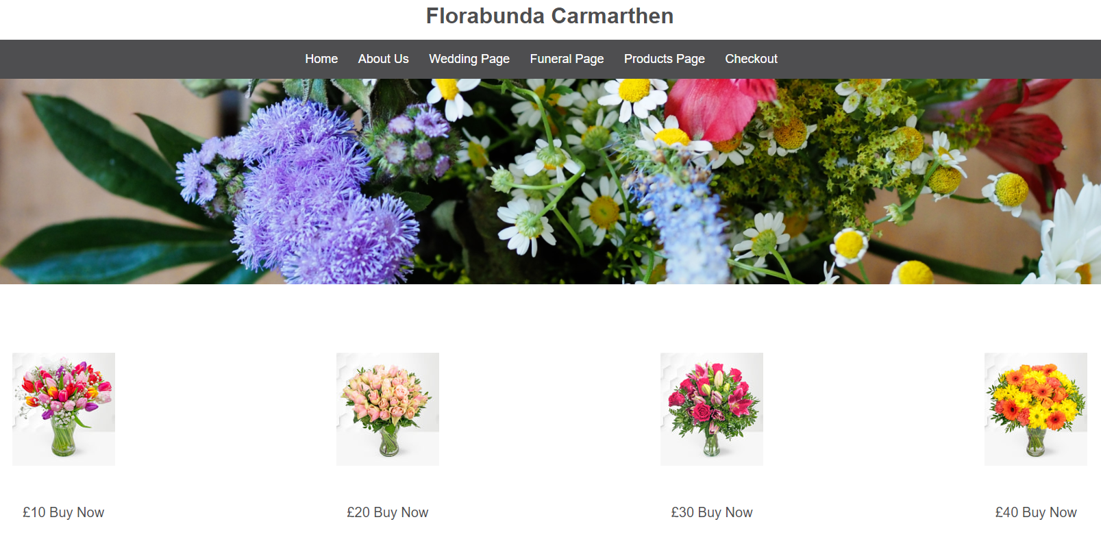
Figure 10

2.2.5 checkout.html
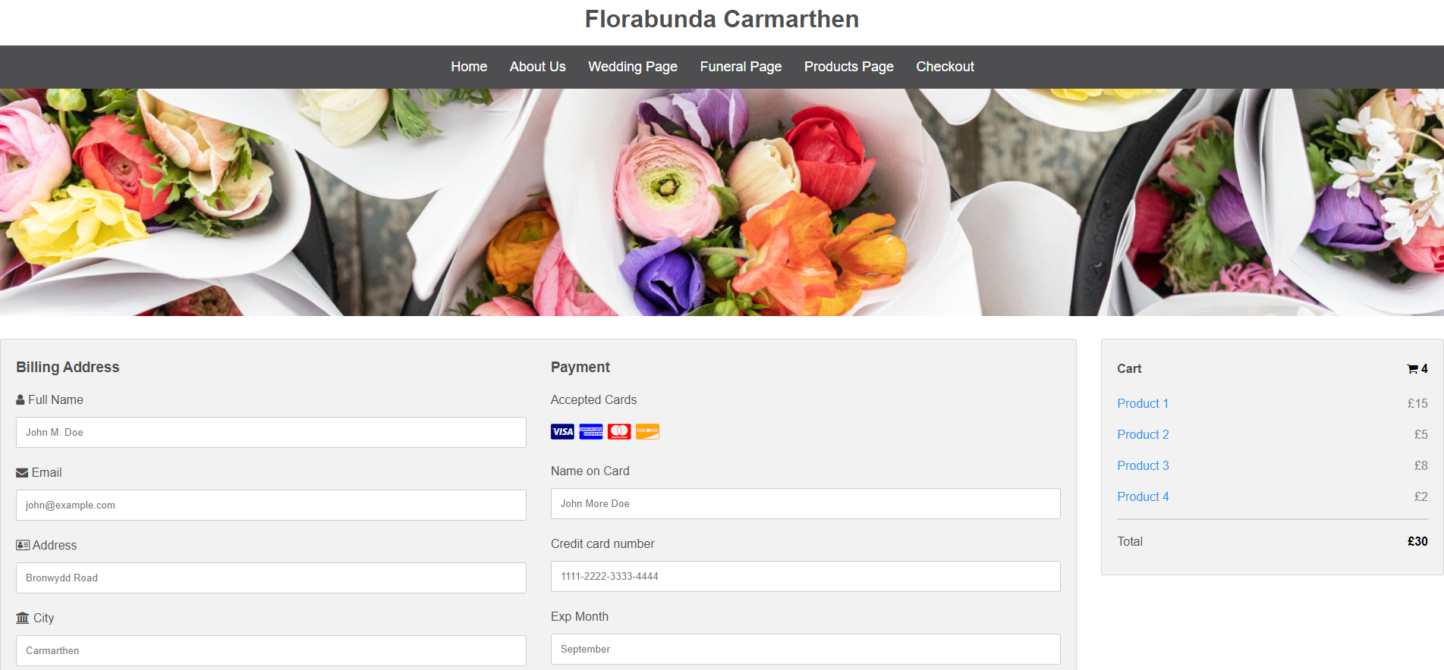
Figure 11

2.2.6 Images

For the purpose of generating images for the site, the various hero images and product pictures were taken from either Prestige Hampers[10] or Unsplash.com[11].
Some images were edited, for example using the software Gimp[12] to crop and sharpen images where it was appropriate to do so, to give a better visual experience when dynamically changing the website.

2.3 Example and fixes of errors

The following is a list of example errors and their fixes, it does not include all the errors seen when building the site.

2.3.1 Text not showing on banner

Figure 12

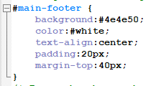
Figure 13

Need to remove the # before white

2.3.2 Text not centring

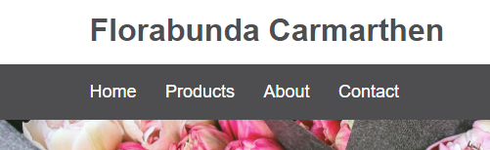
Figure 14

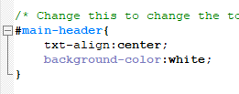
Figure 15
Need to watch out for correct command spelling, text instead of txt

2.3.3 Bar not going to edge


Figure 16

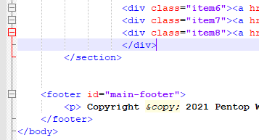
Figure 17

Missing a </div>

2.3.4 Image changing text layout
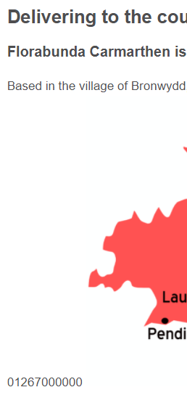
Figure 18

Figure 19

Adding <p> line break resolved

2.4 Validation

The full results of the validation tools are pasted into the appendix

2.4.1 http://validator.w3.org

2.4.1.1 alt not allowed on element button
Figure 20
The “alt” value is for use with images and is not intended for using with buttons. An alternative for buttons is the “title” tag which may be used by some screen readers to aid the visually impaired[13].

2.4.1.2
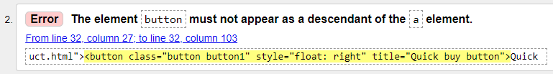
Figure 21

Although the button was working, this appears to be bad practice. Wrapping the button in a <form> and applying the style, title and action elements resolves it[14].

2.4.1.3
Figure 22
This is a standards error which was attempted to be corrected in HTML five, by introducing the <style scoped> statement. This would allow style to be used outside of the <head> tag.
There is an open incident with the validator team on this, as should be flagged as a warning.
https://github.com/validator/validator/issues/489
However, when inspecting this part of my code, I found I hadn’t closed my <div> correctly, which I amended accordingly[15].

2.4.1.4
Figure 23
In html the backslash key should not be used for separators, instead the / should be used. Changing this in the code suppressed the error[16].

2.4.2 http://jigsaw.w3.org/css-validator
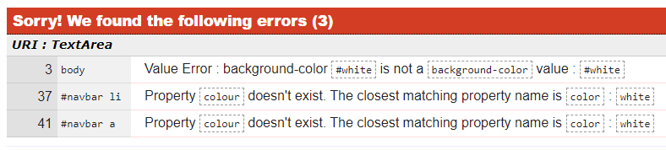
Figure 24
Thankfully these were straight forward errors, with # being removed from white, and u from colour.

3. Evaluation

3.1 Website usability

Website usability is a broad set of principles, which focus on the presentation of a website, for the purpose of making user friendly. This generally means making the most important information readily available to the user in the shortest amount of time, thus giving them the best user experience[17]. This should lead to increased customer loyalty, positive word of mouth and sale conversion rate[18].
The website quicksprout.com top tips for achieving this are
- Follow WCAG standards
- Stick to common design elements
- Create a visual hierarchy
- Simplify the navigation
- Establish credibility
- Make sure your content is legible
- Be consistent[19]
It also involves the study of human being psychology, such as attraction to certain colour, or eye movements etc[20]. Amongst journal articles read, one interesting one which would be relevant to the target audience of Florabunda, Generation X, was “Age-related differences in eye tracking”[21]. The study shows different generations look at different aspects of a website, with generation X spending more time focused on the centre of a website for the information they require, with other groups looking at the periphery. Consideration was giving to this in the design, with the placement of quick by buttons and the phone number on the home page.

3.2 Accessibility

Accessibility is about making your content/design clear and simple, so that most people can use it without the need of adaptation while supporting those who require it[22].
This includes people suffering from impaired vision, motor difficulties, cognitive impairments/disabilities or deafness/impaired hearing.
From a business perspective it is important to understand that one in five people in the UK suffer with a long-term illness, impairment or disability, which is around 13.5 million people. Supporting these customers, to support your business is common sense[23].

3.2.1 Web Content Accessibility Guidelines 2.1 (WCAG 2.1)

WCAG 2.1 are recommendation guidelines for achieving accessibility. They include four main principles, being
Perceivable – Information must not be invisible to the end user; it should be perceivable to one of their sense. An example in this website being the use of Alt tag to describe pictures.
Operable – The interface cannot require an interaction a user cannot perform. An example being no keyboard traps when navigating using the tab key.
Understandable – Content or operation must not be beyond the users understanding. An example being use of the html language tag to inform screen readers of the language used.
Robust – Content should cater for a broad range of assistive technologies. For example by ensuring that a website is not just Operable[24][25][26].

3.2.1 aXe : The accessibility engine

The aXe chrome plugin, will scan a website to determine any issues around accessibility. Using this to investigate the index.html, ten issues were found as demonstrated in figure 25.
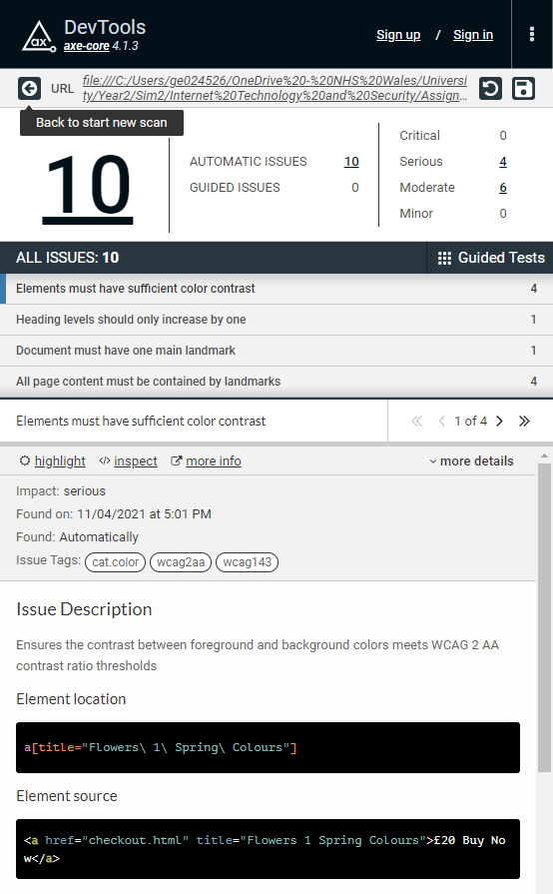
Figure 25
Using the four serious errors as an example as shown in figure 26
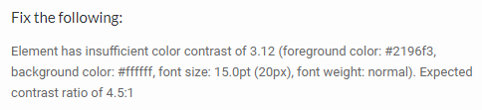
Figure 26
The colour of the grid-container a links was changed to grey theme, which then corrected the contrast mismatch.

3.3 Search Engine Optimisation (SEO)

Search engines strive to offer their users the most relevant results to their queries. By doing so, they offer value to the customer, and retain loyalty, which they can then leverage to create a business model to sell ads etc. To create relevance, they create custom algorithms which index public facing websites, storing their information in their databases, which is then filtered and returned to the user when they query the search engine.
SEO is about making sure your website is tagged by search engines in a specific way to improve the chances customers will find it. As search engines are the main way internet users navigate the internet this will increase site visitors and ultimately sales[27].
As recognised by both the US government, to the point of filing antitrust lawsuits against the company, and private sector advice on optimising, Google algorithm should be the main cause of concern due to market dominance as shown in figure 27.

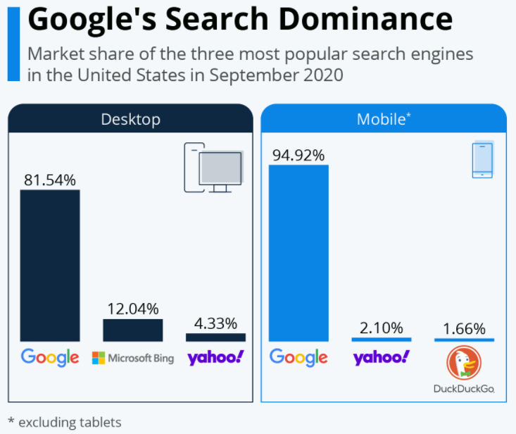
Figure 27 [28]
Due to services that Google run to make money, for example pay per click[29], how searches are ranked is not an exact science, and therefore there are many suggestions on how to improve a sites rankings. One methodology to follow is shown in Figure 28
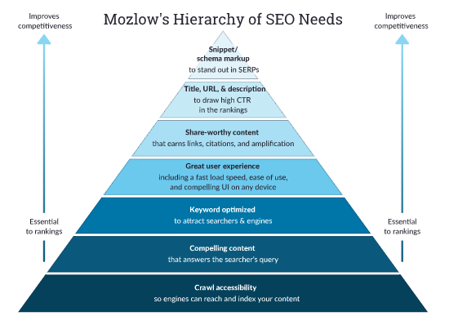
Figure 28 [27]

3.3.1 Keywords

One aspect from figure 28 is keywords. Simply put this is a list of words which would be associated with your business, which would match a user’s query on a search engine. Taking Florbunda as an example, “Carmarthen” and “Weddings” would be two keywords searched for, that the business would like its website presented for. Keywords can be placed in many areas of the website as shown in Figure 29
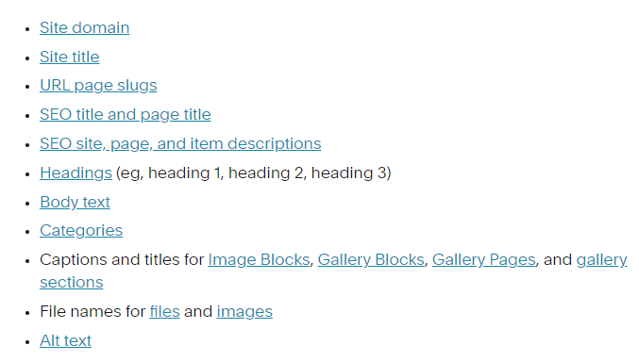
Figure 29 [30]
Taking “Bloom & Wild” from figure 1 as an example, and inspecting the source of their website, we can note steps they have taken, as shown in Figure 30
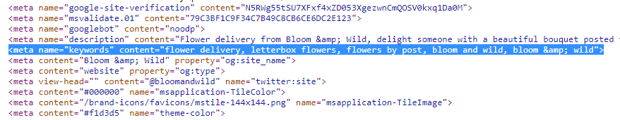
Figure 30 [31]
A brain stormed list specific to the keywords for the business will be added to the index.html following the example from figure 30.

4. Conclusion

More than any other assignment to date, I have found this assignment has been a labour of love. It has proved a challenge as there is always that one more thing which could be done, tweaked or improved upon, which has led to the opening of many cans of worms.
It is intriguing the variety of considerations which are required, outside of the core set of skills in the html and css language needed to build the site. Specifically, consideration that need to be given around human phycology at the design stage, on-going developments for generating traffic, adhering to accessibility and graphic design. This is without beginning the work on the intended purpose of the site being the business hub for ecommerce and the questions that would bring some of which are outlined in future work.

5.1 Future work

Complete the website sections such as contact and check out, through separate learning of PHP.
Look into leveraging cookies, and the agreements that go along with them, such as General Data Protection Regulation[32] for example with the mailing list referred to on the homepage. Understand how this could benefit the business.
Add the corporate logo image to top left hand corner of each page in the banner bar.
Look at hosting the website and testing it on mobile phone platforms.
Where appropriate split out the .css files into separate files for the different .html files. Document the process of updating these for any significant colour scheme change etc. This would make the management of various aspects easier around grids and forms.
Replace the stock photos with bespoke examples from the Florabunda catalogue. Edit them appropriately with photo editing software, building upon funeral and product pages. Confirm best file format is selected.
Add other elements to the website, search, basket top right.

References

[1] “Special Dates in the UK and Worldwide | The Real Flower Company blog.” https://www.realflowers.co.uk/blog/special-dates-in-the-uk-and-worldwide/ (accessed Apr. 01, 2021).
[2] “Send Bloom & Wild Flowers by Post | Flowers Delivery.” https://www.bloomandwild.com/?trackingCode=AWBRND&campaignid=327248655&adgroupid=22223356575&term=bloom and wild&gclid=CjwKCAjw3pWDBhB3EiwAV1c5rM6korlJ3odhGHUUg9--Sj2qgSTHQapJ1gcigdZqH9wtFsoD8pcBfRoCW7IQAvD_BwE (accessed Apr. 01, 2021).
[3] “Flowers | Flower Delivery | Fresh Flowers Online | 1-800-Flowers.com.” https://www.1800flowers.com/ (accessed Apr. 01, 2021).
[4] “Flowers: Send Flowers & Fresh Floral Arrangements Online | FTD.” https://www.ftd.com/ (accessed Apr. 01, 2021).
[5] “Hero Images in Web Design: When, Why, and How to Use - Design4Users.” https://design4users.com/hero-images-in-web-design/ (accessed Apr. 13, 2021).
[6] “Customer insights: Demographics, purpose of purchase important factors in floral transactions | Produce News.” https://theproducenews.com/customer-insights-demographics-purpose-purchase-important-factors-floral-transactions (accessed Apr. 01, 2021).
[7] “How to Design a Website for Generation X Customers - Spark My Site.” https://sparkmysite.com/website-design/generation-x-customers/ (accessed Apr. 06, 2021).
[8] “Web design across different generations | Econsultancy.” https://econsultancy.com/web-design-across-different-generations/ (accessed Apr. 06, 2021).
[9] “- VleReader.” https://r1.vlereader.com/Reader?ean=9781118404133 (accessed Apr. 06, 2021).
[10] “Tulip Supreme » Next Day Flowers - £19.99 at Prestige Hampers.” https://www.prestigehampers.co.uk/next-day-flowers/spring-supreme (accessed Apr. 13, 2021).
[11] “Free Stock Photos & Images.” https://unsplash.com/images/stock (accessed Apr. 13, 2021).
[12] “GIMP - GNU Image Manipulation Program.” https://www.gimp.org/ (accessed Apr. 13, 2021).
[13] “html - W3C Validation: Attribute alt not allowed on element a at this point - Stack Overflow.” https://stackoverflow.com/questions/30420710/w3c-validation-attribute-alt-not-allowed-on-element-a-at-this-point (accessed Apr. 10, 2021).
[14] “html - The element button must not appear as a descendant of the a element - Stack Overflow.” https://stackoverflow.com/questions/24837102/the-element-button-must-not-appear-as-a-descendant-of-the-a-element (accessed Apr. 10, 2021).
[15] “css - What is the current state of the ‘scoped’ attribute for the style element in HTML5? - Stack Overflow.” https://stackoverflow.com/questions/28633038/what-is-the-current-state-of-the-scoped-attribute-for-the-style-element-in-htm/45692033#45692033 (accessed Apr. 10, 2021).
[16] “HTML Homework that doesnt pass validation on image tag - Stack Overflow.” https://stackoverflow.com/questions/45837855/html-homework-that-doesnt-pass-validation-on-image-tag (accessed Apr. 10, 2021).
[17] M. Matera, F. Rizzo, and G. T. Carughi, “Web usability: Principles and evaluation methods,” in Web Engineering, Springer Berlin Heidelberg, 2006, pp. 143–180.
[18] Q. X. Qu, F. Guo, and V. G. Duffy, “Effective use of human physiological metrics to evaluate website usability: An empirical investigation from China,” Aslib J. Inf. Manag., vol. 69, no. 4, pp. 370–388, 2017, doi: 10.1108/AJIM-09-2016-0155.
[19] “A Simple Guide to Website Usability – 2021 Best Practices.” https://www.quicksprout.com/website-usability/ (accessed Apr. 11, 2021).
[20] “How Does Eye Tracking For Usability Work? | Adobe XD Ideas.” https://xd.adobe.com/ideas/process/user-research/eye-tracking-and-usability/ (accessed Apr. 11, 2021).
[21] J. C. Romano Bergstrom, E. L. Olmsted-Hawala, and M. E. Jans, “Age-Related Differences in Eye Tracking and Usability Performance: Website Usability for Older Adults,” Int. J. Hum. Comput. Interact., vol. 29, no. 8, pp. 541–548, Aug. 2013, doi: 10.1080/10447318.2012.728493.
[22] “Understanding accessibility requirements for public sector bodies - GOV.UK.” https://www.gov.uk/guidance/accessibility-requirements-for-public-sector-websites-and-apps (accessed Apr. 11, 2021).
[23] “Overview of the UK population - Office for National Statistics.” https://www.ons.gov.uk/peoplepopulationandcommunity/populationandmigration/populationestimates/articles/overviewoftheukpopulation/january2021 (accessed Apr. 11, 2021).
[24] “Introduction to Understanding WCAG 2.1.” https://www.w3.org/WAI/WCAG21/Understanding/intro#understanding-the-four-principles-of-accessibility (accessed Apr. 12, 2021).
[25] “Web Content Accessibility Guidelines (WCAG) 2.1.” https://www.w3.org/TR/WCAG21/ (accessed Apr. 12, 2021).
[26] “How to Meet WCAG (Quickref Reference).” https://www.w3.org/WAI/WCAG21/quickref/?showtechniques=311#principle4 (accessed Apr. 12, 2021).
[27] “How Search Engines Work: Crawling, Indexing, and Ranking | Beginner’s Guide to SEO - Moz.” https://moz.com/beginners-guide-to-seo/how-search-engines-operate (accessed Apr. 13, 2021).
[28] “• Chart: Google’s Search Dominance | Statista.” https://www.statista.com/chart/23250/search-market-share-in-the-united-states/ (accessed Apr. 13, 2021).
[29] “Pay Per Click vs. Search Engine Optimization - Google Ads.” https://ads.google.com/home/resources/seo-vs-ppc/ (accessed Apr. 13, 2021).
[30] “Adding keywords for SEO – Squarespace Help.” https://support.squarespace.com/hc/en-us/articles/360001997648-Adding-keywords-for-SEO (accessed Apr. 13, 2021).
[31] “Send Bloom & Wild Flowers by Post | Flowers Delivery.” https://www.bloomandwild.com/ (accessed Apr. 13, 2021).
[32] “General Data Protection Regulation (GDPR) – Official Legal Text.” https://gdpr-info.eu/ (accessed Apr. 20, 2021).

Supporting material

“
Html validation
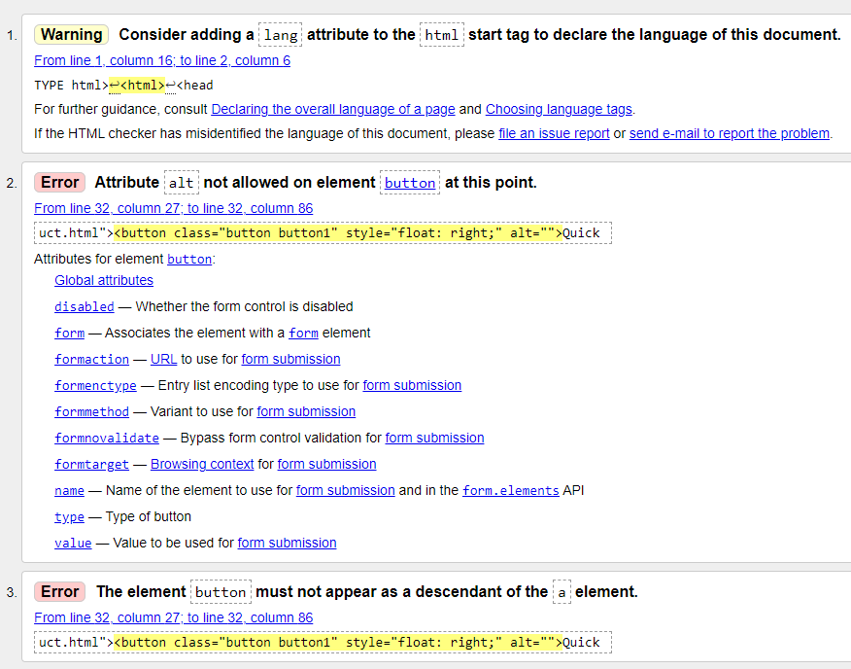
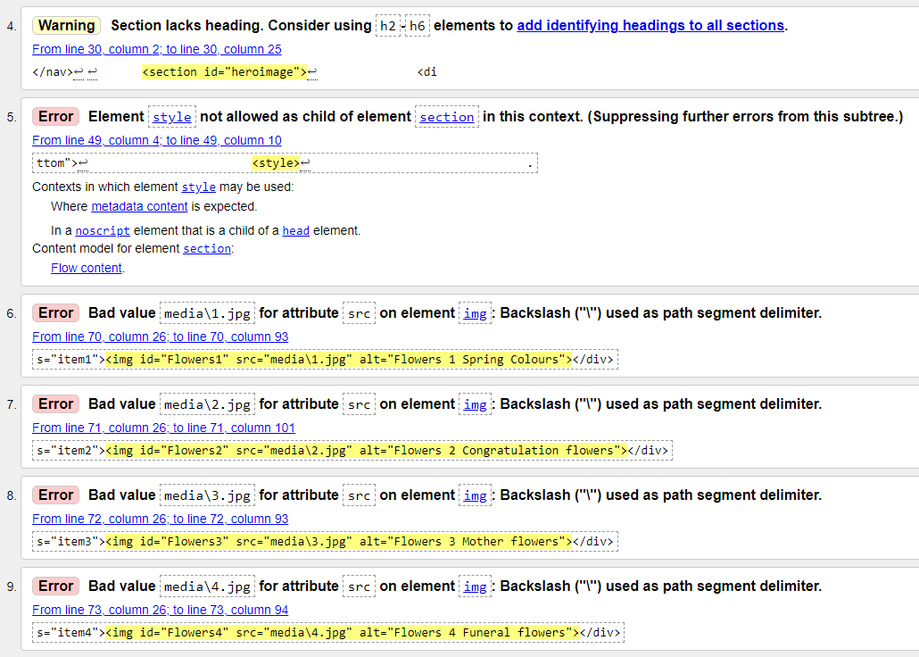
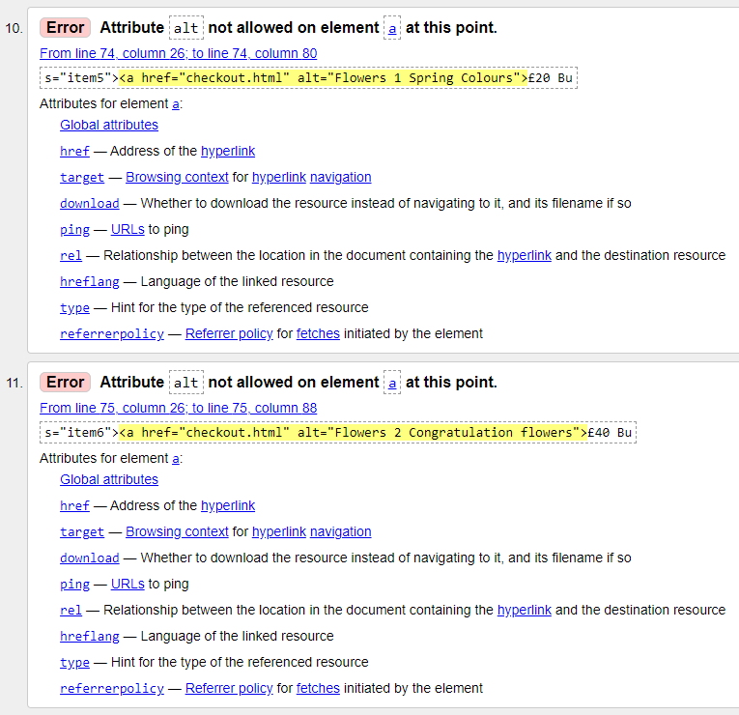
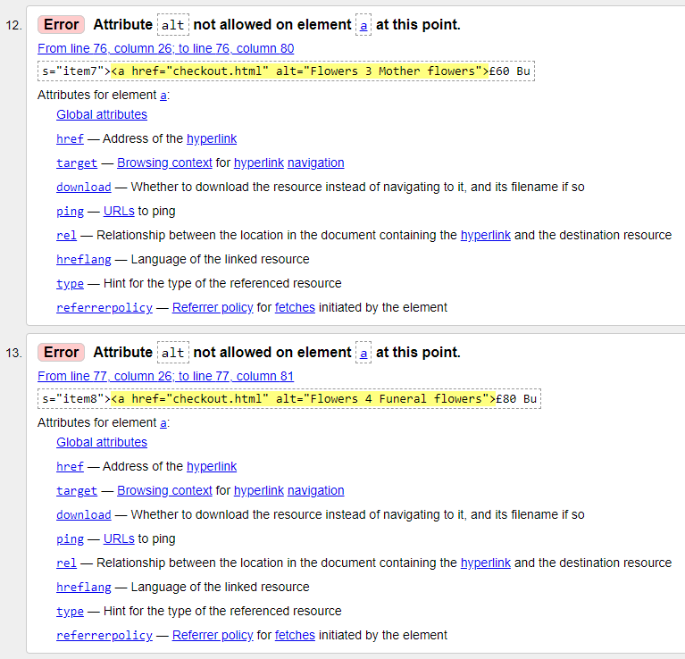
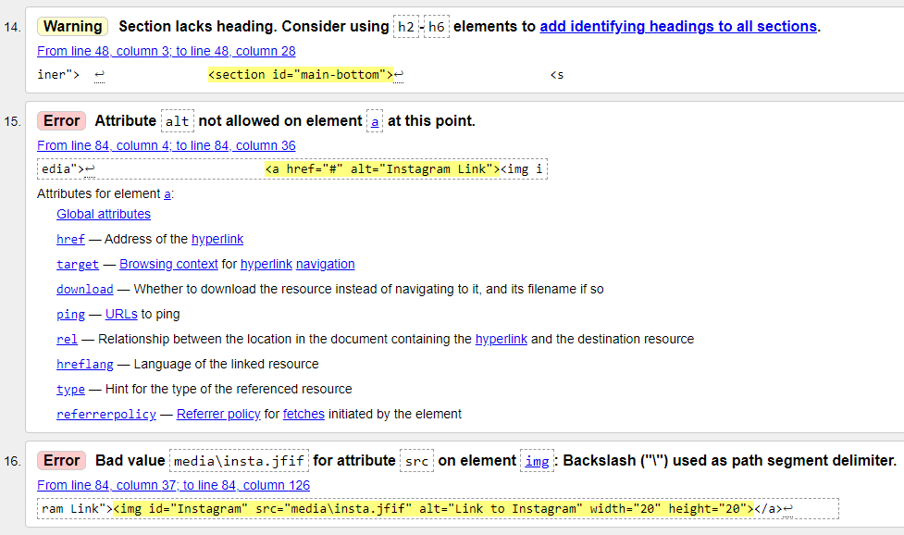
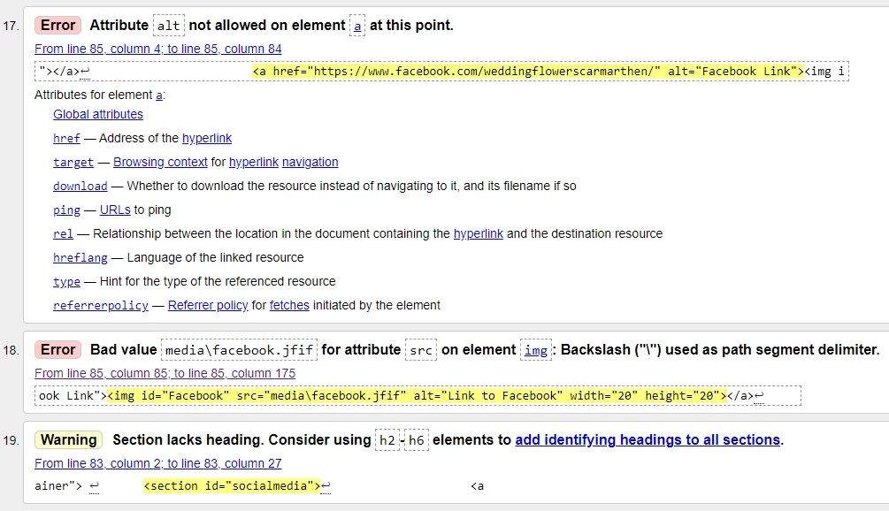
“
“
CSS Validator
“
Css.css
“
body{
/* Change this to change the background colour */
background-color:white;
/* Change this to change the default text colour */
color:#4e4e50;
font-family:Arial, Helvetica, san-serif;
font-size:16px;
line-height:1.6em;
margin:0;
}

.container{
width:80%;
margin:auto;
overflow:hidden;
}

/* Change this to change the top banner box which contains business name */
#main-header{
text-align:center;
background-color:white;
}

/* Change this to change the nav bar */
#navbar{
background-color:#4e4e50;
text-align:center;
}

#navbar ul{
padding:0;
list-style:none;
}

#navbar li{
display:inline;
color: white;
}

#navbar a{
color: white;
font-size:18px;
padding-right:25px;
}

#navbar a{
color: white;
text-decoration: none;
}

#navbar a:hover{
color:red;
}

/* Change this to change the centre left text area */
#main{
float:left;
width:70%;
text-align:left;
padding:10px;
box-sizing: border-box;
}

/* Change this to change the centre left text area */
#weddingmain{
float:left;
width:100%;
text-align:center;
padding:10px;
box-sizing: border-box;
}

/* Change this to change the centre left text area */
#aboutmain{
float:left;
width:100%;
text-align:left;
padding:10px;
box-sizing: border-box;
}

/* Change this to change the main bottom of the page */
#main-bottom {
text-align:center;
padding: 20px;
font-size: 20px;
grid-gap: 10px;
background-color: white;
padding: 10px;
}

/* Change this to change the main bottom buy now links*/
#grid-container a{
font-size:18px;
}

a{
color:#4e4e50;
text-decoration: none;
}

a:hover{
color:red;
}

/* Change this to change the centre right text area */
#sidebar{
float:right;
text-align:center;
width:24%;
background-color:#4e4e50;
color:white;
padding:20px;
box-sizing:border-box;
}

/* Change this to change the heroimage */
#heroimage{
background-image:url("media/flowers5.jpg");
height: 300px;
background-size: cover;
opacity:1.0;
background-position:center;
margin-bottom:30px;
padding: 50px 25px;
object-fit: cover;
}

/* Change this to change the aboutheroimage */
#aboutheroimage{
background-image:url("media/about.jpg");
height: 300px;
background-size: cover;
opacity:1.0;
background-position:center;
margin-bottom:30px;
padding: 50px 25px;
object-fit: cover;
}

/* Change this to change the weddingheroimage */
#weddingheroimage{
background-image:url("media/wedding.jpg");
height: 300px;
background-size: cover;
opacity:1.0;
background-position:center;
margin-bottom:30px;
padding: 50px 25px;
object-fit: cover;
}

/* Change this to change the funeralheroimage */
#funeralheroimage{
background-image:url("media/funeral.jpg");
height: 300px;
background-size: cover;
opacity:1.0;
background-position:center;
margin-bottom:30px;
padding: 50px 25px;
object-fit: cover;
}

/* Change this to change the productheroimage */
#productheroimage{
background-image:url("media/product.jpg");
height: 300px;
background-size: cover;
opacity:1.0;
background-position:center;
margin-bottom:30px;
padding: 50px 25px;
object-fit: cover;
}

/* Change this to change the checoutheroimage */
#checkoutheroimage{
background-image:url("media/checkout.jpg");
height: 300px;
background-size: cover;
opacity:1.0;
background-position:center;
margin-bottom:30px;
padding: 50px 25px;
object-fit: cover;
}

/* Change this to change the social media bar at the bottom of the page */
#socialmedia {
text-align:center;
padding:20px;
margin-top:30px;
}

/* Change this to change the footer at the bottom of the page */
#main-footer {
background:#4e4e50;
color:white;
text-align:center;
padding:20px;
margin-top:30px;
}

/* Change this to change the button */
.button {
border: none;
color: white;
padding: 16px 32px;
text-align: center;
text-decoration: none;
display: inline-block;
font-size: 16px;
margin: 4px 2px;
transition-duration: 0.4s;
cursor: pointer;
}

.button1 {
background-color: white;
color: black;
border: 2px solid #4CAF50;
}

.button1:hover {
background-color: #4CAF50;
color: white;
}

/* The following will change the nav bar if the browser is smaller */
@media(max-width:600px){
#main{
width:100%;
float:none;
}

#sidebar{
width:100%;
float:none;
}

#navbar li{
display:block;
}

}

/* The following will change the checkout */

* {
box-sizing: border-box;
}

.row {
display: -ms-flexbox; /* IE10 */
display: flex;
-ms-flex-wrap: wrap; /* IE10 */
flex-wrap: wrap;
margin: 0 -16px;
}

.col-25 {
-ms-flex: 25%; /* IE10 */
flex: 25%;
}

.col-50 {
-ms-flex: 50%; /* IE10 */
flex: 50%;
}

.col-75 {
-ms-flex: 75%; /* IE10 */
flex: 75%;
}

.col-25,
.col-50,
.col-75 {
padding: 0 16px;
}

.contactcontainer {
background-color: #f2f2f2;
padding: 5px 20px 15px 20px;
border: 1px solid lightgrey;
border-radius: 3px;
}

input[type=text] {
width: 100%;
margin-bottom: 20px;
padding: 12px;
border: 1px solid #ccc;
border-radius: 3px;
}

label {
margin-bottom: 10px;
display: block;
}

.icon-container {
margin-bottom: 20px;
padding: 7px 0;
font-size: 24px;
}

.btn {
background-color: #4CAF50;
color: white;
padding: 12px;
margin: 10px 0;
border: none;
width: 100%;
border-radius: 3px;
cursor: pointer;
font-size: 17px;
}

.btn:hover {
background-color: #45a049;
}

hr {
border: 1px solid lightgrey;
}

span.price {
float: right;
color: grey;
}

/* Responsive layout for the checkout - when the screen is less than 800px wide, make the two columns stack on top of each other instead of next to each other (also change the direction - make the "cart" column go on top) */
@media (max-width: 800px) {
.row {
flex-direction: column-reverse;
}
.col-25 {
margin-bottom: 20px;
}
}

/* The following will change the weddingcontactcontainer */

.weddingcontactcontainer {
background-color: #f2f2f2;
padding: 5px 20px 15px 20px;
border: 1px solid lightgrey;
border-radius: 3px;
}
“
Index.html
“
<!DOCTYPE html>
<html>
<head>
<meta charset="utf-8" />
<meta name="keywords" content="florabunda, flower delivery, carmarthen, llanelli, flowers, wedding, funeral">
<html lang="en">
<title>Florabunda Carmarthen</title>
<link rel="stylesheet" type="text/css"
href="css.css">
</head>
<body>
<header id="main-header">
<div class="container">
<h6>International Mothering Sunday 12th Of May</h6>
<h1>Florabunda Carmarthen</h1>
</div>
</header>

<nav id="navbar">
<div class="container">
<ul>
<li><a href="index.html">Home</a></li>
<li><a href="about.html">About Us</a></li>
<li><a href="wedding.html">Wedding Page</a></li>
<li><a href="funeral.html">Funeral Page</a></li>
<li><a href="product.html">Products Page</a></li>
<li><a href="checkout.html">Checkout</a></li>
</ul>
</div>
</nav>

<section id="heroimage">
<div class="container">
<form style="float: right" action="product.html" method="get" title="Quick buy button">
<button class="button button1">Quick Buy</button>
</form>
</div>
</section>

<div class="container">
<section id="main">
<h3>Your local Carmarthenshire florist 01267000000</h3>
<p>Whatever you are in the flower market for, be it a boquiet for that special someone, a special event like a wedding, or an arrangement for your business do get in touch. Delivery throughout Carmarthenshire.</p>
</section>

<aside id="sidebar">
<p>Join our mailing list and get sent a 10% off voucher for your next order !</p>
</aside>
</div>

<div class="container">
<section id="main-bottom">
<style>
<div
.item1 { grid-area: one; }
.item2 { grid-area: two; }
.item3 { grid-area: three; }
.item4 { grid-area: four; }
.item5 { grid-area: five; }
.item6 { grid-area: six; }
.item7 { grid-area: seven; }
.item8 { grid-area: eight; }

.grid-container {
display: grid;
grid-template-areas:
'one two three four'
'five six seven eight';
}

.grid-container >
</div>
</style>
<div class="grid-container">
<div class="item1"><img id="Flowers1" src="media/1.jpg" alt="Flowers 1 Spring Colours"></div>
<div class="item2"><img id="Flowers2" src="media/2.jpg" alt="Flowers 2 Congratulation flowers"></div>
<div class="item3"><img id="Flowers3" src="media/3.jpg" alt="Flowers 3 Mother flowers"></div>
<div class="item4"><img id="Flowers4" src="media/4.jpg" alt="Flowers 4 Funeral flowers"></div>
<div class="item5"><a href="checkout.html" title="Flowers 1 Spring Colours">£20 Buy Now</a></div>
<div class="item6"><a href="checkout.html" title="Flowers 2 Congratulation flowers">£40 Buy Now</a></div>
<div class="item7"><a href="checkout.html" title="Flowers 3 Mother flowers">£60 Buy Now</a></div>
<div class="item8"><a href="checkout.html" title="Flowers 4 Funeral flowers">£80 Buy Now</a></div>
</div>
</section>
</div>

<div class="container">
<section id="socialmedia">
<a href="#" title="Instagram Link"><img id="Instagram" alt="Link to Instagram" src="media/insta.jfif" width="20" height="20"></a>
<a href="https://www.facebook.com/weddingflowerscarmarthen/" title="Facebook Link"><img id="Facebook" alt="Link to Facebook" src="media/facebook.jfif" width="20" height="20"></a>
</section>
</div>

<footer id="main-footer">
<p> Copyright &copy; 2021 GJ Web Designs</p>
</footer>
</body>
</html>
“
About.html
“
<!DOCTYPE html>
<html>
<head>
<meta charset="utf-8" />
<title>Florabunda Carmarthen</title>
<link rel="stylesheet" type="text/css"
href="css.css">
</head>
<body>
<header id="main-header">
<div class="container">
<h1>Florabunda Carmarthen</h1>
</div>
</header>

<nav id="navbar">
<div class="container">
<ul>
<li><a href="index.html">Home</a></li>
<li><a href="about.html">About Us</a></li>
<li><a href="wedding.html">Wedding Page</a></li>
<li><a href="funeral.html">Funeral Page</a></li>
<li><a href="product.html">Products Page</a></li>
<li><a href="checkout.html">Checkout</a></li>
</ul>
</div>
</nav>

<section id="aboutheroimage">
<div class="container">
</div>
</section>

<div class="container">
<section id="aboutmain">
<h1>Delivering to the county of Carmarthenshire</h1>

<h3>Florabunda Carmarthen is a small family business estabilshed in 1960</h3>

Based in the village of Bronwydd, we cater for all your florist needs, from small to large weddings, or that unique handmade design you are looking for, please do not hesitate to contact us 01267000000<p>

<img id="carmarthenshiremap" src="media\Carmarthenshire_map.png" alt="Map Of Carmarthenshire" class="center" width="600" height="400">
</section>
</div>

<footer id="main-footer">
<p> Copyright &copy; 2021 GJ Web Designs</p>
</footer>
</body>
</html>
“
Wedding.html
“
<!DOCTYPE html>
<html>
<head>
<meta charset="utf-8" />
<title>Florabunda Carmarthen</title>
<link rel="stylesheet" type="text/css"
href="css.css">
</head>
<body>
<header id="main-header">
<div class="container">
<h1>Florabunda Carmarthen</h1>
</div>
</header>

<nav id="navbar">
<div class="container">
<ul>
<li><a href="index.html">Home</a></li>
<li><a href="about.html">About Us</a></li>
<li><a href="wedding.html">Wedding Page</a></li>
<li><a href="funeral.html">Funeral Page</a></li>
<li><a href="product.html">Products Page</a></li>
<li><a href="checkout.html">Checkout</a></li>
</ul>
</div>
</nav>

<section id="weddingheroimage">
<div class="container">
</div>
</section>

<div class="container">
<section id="weddingmain">
Complete the contact form, or calls us on 01267000000 to begin the process of creating your bespoke unique creations for your equally special day, at the bottom of the page pease find below a range of example photography from the many hundreds of wedding we have helped craft
</section>
</div>

<div class="row">
<div class="col-75">
<div class="weddingcontactcontainer">
<form action="/action_page.php">

<div class="row">
<div class="col-50">
<h3>Contact Form</h3>
<label for="fname"><i class="fa fa-user"></i> Full Name</label>
<input type="text" id="fname" name="firstname" placeholder="John M. Doe">
<label for="email"><i class="fa fa-envelope"></i> Email</label>
<input type="text" id="email" name="email" placeholder="john@example.com">
<label for="adr"><i class="fa fa-address-card-o"></i> Address</label>
<input type="text" id="adr" name="address" placeholder="Bronwydd Road">
<label for="city"><i class="fa fa-institution"></i> City</label>
<input type="text" id="city" name="city" placeholder="Carmarthen">

<div class="row">
<div class="col-50">
<label for="state">County</label>
<input type="text" id="County" name="County" placeholder="Carmarthenshire">
</div>
<div class="col-50">
<label for="Postcode">Postcode</label>
<input type="text" id="Postcode" name="Postcode" placeholder="SA312AF">
</div>
<div class="col-50">
<label for="phone">Phone Number</label>
<input type="text" id="phone" name="phone" placeholder="01267000000">
</div>
<input type="submit" value="Submit form" class="btn">
</div>
</div>
</div>
</form>
</div>
</div>
</div>

<div class="container">
<section id="main-bottom">
<style>
.item1 { grid-area: one; }
.item2 { grid-area: two; }
.item3 { grid-area: three; }
.item4 { grid-area: four; }
.item5 { grid-area: five; }
.item6 { grid-area: six; }
.item7 { grid-area: seven; }
.item8 { grid-area: eight; }

.grid-container {
display: grid;
grid-template-areas:
'one two three four'
'five six seven eight';
grid-gap: 10px;
background-color: white;
padding: 10px;
}

.grid-container > div {
background-color: rgba(255, 255, 255, 0.8);
text-align: center;
padding: 20px 0;
font-size: 20px;
}
</style>
</section>
</div>

<div class="grid-container">
<div class="item1"><img id="Flowers1" src="media\1.jpg" alt="Wedding Flowers 1"></div>
<div class="item2"><img id="Flowers2" src="media\2.jpg" alt="Wedding Flowers 2"></div>
<div class="item3"><img id="Flowers3" src="media\3.jpg" alt="Wedding Flowers 3"></div>
<div class="item4"><img id="Flowers4" src="media\4.jpg" alt="Wedding Flowers 4"></div>
<div class="item5"><img id="Flowers5" src="media\1.jpg" alt="Wedding Flowers 5"></div>
<div class="item6"><img id="Flowers6" src="media\2.jpg" alt="Wedding Flowers 6"></div>
<div class="item7"><img id="Flowers7" src="media\3.jpg" alt="Wedding Flowers 7"></div>
<div class="item8"><img id="Flowers8" src="media\4.jpg" alt="Wedding Flowers 8"></div>
</div>

<footer id="main-footer">
<p> Copyright &copy; 2021 GJ Web Designs</p>
</footer>
</body>
</html>
“
Funeral.html
“
<!DOCTYPE html>
<html>
<head>
<meta charset="utf-8" />
<title>Florabunda Carmarthen</title>
<link rel="stylesheet" type="text/css"
href="css.css">
</head>
<body>
<header id="main-header">
<div class="container">
<h1>Florabunda Carmarthen</h1>
</div>
</header>

<nav id="navbar">
<div class="container">
<ul>
<li><a href="index.html">Home</a></li>
<li><a href="about.html">About Us</a></li>
<li><a href="wedding.html">Wedding Page</a></li>
<li><a href="funeral.html">Funeral Page</a></li>
<li><a href="product.html">Products Page</a></li>
<li><a href="checkout.html">Checkout</a></li>
</ul>
</div>
</nav>

<section id="funeralheroimage">
<div class="container">
</div>
</section>

<div class="container">
<section id="main">
</section>
</div>

<div class="container">
<section id="main-bottom">
<style>
.item1 { grid-area: one; }
.item2 { grid-area: two; }
.item3 { grid-area: three; }
.item4 { grid-area: four; }
.item5 { grid-area: five; }
.item6 { grid-area: six; }
.item7 { grid-area: seven; }
.item8 { grid-area: eight; }
.item9 { grid-area: nine; }
.item10 { grid-area: ten; }
.item11 { grid-area: eleven; }
.item12 { grid-area: twelve; }
.item13 { grid-area: thirteen; }
.item14 { grid-area: fourteen; }
.item15 { grid-area: fifteen; }
.item16 { grid-area: sixteen; }

.grid-container {
display: grid;
grid-template-areas:
'one two three four'
'five six seven eight'
'nine ten eleven twelve'
'thirteen fourteen fifteen sixteen';
grid-gap: 10px;
background-color: white;
padding: 10px;
}

.grid-container > div {
background-color: rgba(255, 255, 255, 0.8);
text-align: center;
padding: 20px 0;
font-size: 20px;
}
</style>
</section>
</div>

<div class="grid-container">
<div class="item1"><img id="Flowers1" src="media\1.jpg" alt="Flowers 1 Spring Colours"></div>
<div class="item2"><img id="Flowers2" src="media\2.jpg" alt="Flowers 2 Congratulation flowers"></div>
<div class="item3"><img id="Flowers3" src="media\3.jpg" alt="Flowers 3 Mother flowers"></div>
<div class="item4"><img id="Flowers4" src="media\4.jpg" alt="Flowers 4 Funeral flowers"></div>
<div class="item5"><a href="#" alt="Flowers 1 Spring Colours">Buy Now</a></div>
<div class="item6"><a href="#" alt="Flowers 2 Congratulation flowers">Buy Now</a></div>
<div class="item7"><a href="#" alt="Flowers 3 Mother flowers">Buy Now</a></div>
<div class="item8"><a href="#" alt="Flowers 4 Funeral flowers">Buy Now</a></div>
<div class="item9"><img id="Flowers5" src="media\1.jpg" alt="Flowers 1 Spring Colours"></div>
<div class="item10"><img id="Flowers6" src="media\2.jpg" alt="Flowers 2 Congratulation flowers"></div>
<div class="item11"><img id="Flowers7" src="media\3.jpg" alt="Flowers 3 Mother flowers"></div>
<div class="item12"><img id="Flowers8" src="media\4.jpg" alt="Flowers 4 Funeral flowers"></div>
<div class="item13"><a href="#" alt="Flowers 1 Spring Colours">Buy Now</a></div>
<div class="item14"><a href="#" alt="Flowers 2 Congratulation flowers">Buy Now</a></div>
<div class="item15"><a href="#" alt="Flowers 3 Mother flowers">Buy Now</a></div>
<div class="item16"><a href="#" alt="Flowers 4 Funeral flowers">Buy Now</a></div>
</div>

<footer id="main-footer">
<p> Copyright &copy; 2021 GJ Web Designs</p>
</footer>
</body>
</html>
“
Product.html
“
<!DOCTYPE html>
<html>
<head>
<meta charset="utf-8" />
<title>Florabunda Carmarthen</title>
<link rel="stylesheet" type="text/css"
href="css.css">
</head>
<body>
<header id="main-header">
<div class="container">
<h1>Florabunda Carmarthen</h1>
</div>
</header>

<nav id="navbar">
<div class="container">
<ul>
<li><a href="index.html">Home</a></li>
<li><a href="about.html">About Us</a></li>
<li><a href="wedding.html">Wedding Page</a></li>
<li><a href="funeral.html">Funeral Page</a></li>
<li><a href="product.html">Products Page</a></li>
<li><a href="checkout.html">Checkout</a></li>
</ul>
</div>
</nav>

<section id="productheroimage">
<div class="container">
</div>
</section>

<div class="container">
<section id="main">
</section>
</div>

<div class="container">
<section id="main-bottom">
<style>
.item1 { grid-area: one; }
.item2 { grid-area: two; }
.item3 { grid-area: three; }
.item4 { grid-area: four; }
.item5 { grid-area: five; }
.item6 { grid-area: six; }
.item7 { grid-area: seven; }
.item8 { grid-area: eight; }
.item9 { grid-area: nine; }
.item10 { grid-area: ten; }
.item11 { grid-area: eleven; }
.item12 { grid-area: twelve; }
.item13 { grid-area: thirteen; }
.item14 { grid-area: fourteen; }
.item15 { grid-area: fifteen; }
.item16 { grid-area: sixteen; }

.grid-container {
display: grid;
grid-template-areas:
'one two three four'
'five six seven eight'
'nine ten eleven twelve'
'thirteen fourteen fifteen sixteen';
grid-gap: 10px;
background-color: white;
padding: 10px;
}

.grid-container > div {
background-color: rgba(255, 255, 255, 0.8);
text-align: center;
padding: 20px 0;
font-size: 20px;
}
</style>
</section>
</div>

<div class="grid-container">
<div class="item1"><img id="Flowers1" src="media\1.jpg" alt="Flowers 1 Spring Colours"></div>
<div class="item2"><img id="Flowers2" src="media\2.jpg" alt="Flowers 2 Congratulation flowers"></div>
<div class="item3"><img id="Flowers3" src="media\3.jpg" alt="Flowers 3 Mother flowers"></div>
<div class="item4"><img id="Flowers4" src="media\4.jpg" alt="Flowers 4 Funeral flowers"></div>
<div class="item5"><a href="#" alt="Flowers 1 Spring Colours">£10 Buy Now</a></div>
<div class="item6"><a href="#" alt="Flowers 2 Congratulation flowers">£20 Buy Now</a></div>
<div class="item7"><a href="#" alt="Flowers 3 Mother flowers">£30 Buy Now</a></div>
<div class="item8"><a href="#" alt="Flowers 4 Funeral flowers">£40 Buy Now</a></div>
<div class="item9"><img id="Flowers5" src="media\1.jpg" alt="Flowers 1 Spring Colours"></div>
<div class="item10"><img id="Flowers6" src="media\2.jpg" alt="Flowers 2 Congratulation flowers"></div>
<div class="item11"><img id="Flowers7" src="media\3.jpg" alt="Flowers 3 Mother flowers"></div>
<div class="item12"><img id="Flowers8" src="media\4.jpg" alt="Flowers 4 Funeral flowers"></div>
<div class="item13"><a href="#" alt="Flowers 1 Spring Colours">£50 Buy Now</a></div>
<div class="item14"><a href="#" alt="Flowers 2 Congratulation flowers">£60 Buy Now</a></div>
<div class="item15"><a href="#" alt="Flowers 3 Mother flowers">£70 Buy Now</a></div>
<div class="item16"><a href="#" alt="Flowers 4 Funeral flowers">£80 Buy Now</a></div>
</div>

<footer id="main-footer">
<p> Copyright &copy; 2021 GJ Web Designs</p>
</footer>
</body>
</html>
“
Checkout.html
“
<!DOCTYPE html>
<html>
<head>
<meta name="viewport" content="width=device-width, initial-scale=1">
<link rel="stylesheet" href="https://cdnjs.cloudflare.com/ajax/libs/font-awesome/4.7.0/css/font-awesome.min.css">
<meta charset="utf-8" />
<title>Florabunda Carmarthen</title>
<link rel="stylesheet" type="text/css"
href="css.css">
</head>
<body>
<header id="main-header">
<div class="container">
<h1>Florabunda Carmarthen</h1>
</div>
</header>

<nav id="navbar">
<div class="container">
<ul>
<li><a href="index.html">Home</a></li>
<li><a href="about.html">About Us</a></li>
<li><a href="wedding.html">Wedding Page</a></li>
<li><a href="funeral.html">Funeral Page</a></li>
<li><a href="product.html">Products Page</a></li>
<li><a href="checkout.html">Checkout</a></li>
</ul>
</div>
</nav>

<section id="checkoutheroimage">
<div class="container">
</div>
</section>

<div class="row">
<div class="col-75">
<div class="contactcontainer">
<form action="/action_page.php">

<div class="row">
<div class="col-50">
<h3>Billing Address</h3>
<label for="fname"><i class="fa fa-user"></i> Full Name</label>
<input type="text" id="fname" name="firstname" placeholder="John M. Doe">
<label for="email"><i class="fa fa-envelope"></i> Email</label>
<input type="text" id="email" name="email" placeholder="john@example.com">
<label for="adr"><i class="fa fa-address-card-o"></i> Address</label>
<input type="text" id="adr" name="address" placeholder="Bronwydd Road">
<label for="city"><i class="fa fa-institution"></i> City</label>
<input type="text" id="city" name="city" placeholder="Carmarthen">

<div class="row">
<div class="col-50">
<label for="state">County</label>
<input type="text" id="County" name="County" placeholder="Carmarthenshire">
</div>
<div class="col-50">
<label for="Postcode">Postcode</label>
<input type="text" id="Postcode" name="Postcode" placeholder="SA312AF">
</div>
</div>
</div>

<div class="col-50">
<h3>Payment</h3>
<label for="fname">Accepted Cards</label>
<div class="icon-container">
<i class="fa fa-cc-visa" style="color:navy;"></i>
<i class="fa fa-cc-amex" style="color:blue;"></i>
<i class="fa fa-cc-mastercard" style="color:red;"></i>
<i class="fa fa-cc-discover" style="color:orange;"></i>
</div>
<label for="cname">Name on Card</label>
<input type="text" id="cname" name="cardname" placeholder="John More Doe">
<label for="ccnum">Credit card number</label>
<input type="text" id="ccnum" name="cardnumber" placeholder="1111-2222-3333-4444">
<label for="expmonth">Exp Month</label>
<input type="text" id="expmonth" name="expmonth" placeholder="September">
<div class="row">
<div class="col-50">
<label for="expyear">Exp Year</label>
<input type="text" id="expyear" name="expyear" placeholder="2018">
</div>
<div class="col-50">
<label for="cvv">CVV</label>
<input type="text" id="cvv" name="cvv" placeholder="352">
</div>
</div>
</div>

</div>
<label>
<input type="checkbox" checked="checked" name="sameadr"> Delivery address same as billing
</label>
<div class="col-50">
<label for="cvv">Alternate address</label>
<input type="text" id="altadd" name="altadd" placeholder="Alternative delivery address">
</div>
<input type="submit" value="Continue to checkout" class="btn">
</form>
</div>
</div>
<div class="col-25">
<div class="contactcontainer">
<h4>Cart <span class="price" style="color:black"><i class="fa fa-shopping-cart"></i> <b>4</b></span></h4>
<p><a href="#">Product 1</a> <span class="price">£15</span></p>
<p><a href="#">Product 2</a> <span class="price">£5</span></p>
<p><a href="#">Product 3</a> <span class="price">£8</span></p>
<p><a href="#">Product 4</a> <span class="price">£2</span></p>
<hr>
<p>Total <span class="price" style="color:black"><b>£30</b></span></p>
</div>
</div>
</div>

<footer id="main-footer">
<p> Copyright &copy; 2021 GJ Web Designs</p>
</footer>
</body>
</html>
“

