Written Reflection

Module: Coaching and Mentoring Skills for the Workplace
Module code: BMSW6105
Lecturer name: Dennis Pepple
Student name: Vasilka Sarandalieva
Student number:2113113

Contents
Introduction 3
Definition of Coaching and Mentoring 3
Critical Evaluation of the Purpose of Coaching and Mentoring within a Workplace 5
Purposes of Coaching in the Workplace 5
Purposes of Mentoring in the Workplace 7
Critical Analyse of RAW model of coaching 9
Critical Analyse of Johari Window Model 10
Reflection 10
Reflection on coaching session 11
Reflection on mentoring session 12
Conclusion 14
Reference 16

Figure 1 Comparison of Coaching and Mentoring 4
Figure 2 Key skills of an effective coach 4
Figure 3 Benefits of professional coaching 7
Figure 4 Benefits of mentoring 8
Figure 5 Kolb's reflective model 11
Figure 6 Demonstration of decrease in hidden area 13

Introduction

Coaching and mentoring are indispensable components of professional development, playing pivotal roles in fostering individual growth and organizational success. Defined by distinct yet complementary methodologies, coaching involves targeted interventions aimed at achieving specific goals through structured dialogue and feedback, while mentoring nurtures long-term relationships to facilitate personal and professional advancement through guidance and support. This report explores the nuances between coaching and mentoring, highlighting their unique attributes, shared objectives, and critical theoretical underpinnings. Drawing on practical experiences and theoretical frameworks, this examination employs Kolb’s' Reflective Model to analyse the efficacy of coaching and mentoring in enhancing professional competencies and overcoming developmental challenges. By interpreting these developmental processes, this report aims to underscore their significance in cultivating a culture of continuous improvement and achieving strategic organizational objectives.

Definition of Coaching and Mentoring

Coaching is a developmental methodology wherein a coach collaborates with an individual (coachee) to facilitate the achievement of specific personal or professional objectives. This approach incorporates guided conversations, structured feedback, and strategic interventions aimed at promoting self-discovery and skill enhancement. According to the International Coach Federation (ICF), coaching involves "partnering with clients in a thought-provoking and creative process that inspires them to maximize their personal and professional potential" (ICF, 2021).
Mentoring, on the other hand, is a relationship-based process in which a more experienced individual (mentor) provides guidance, support, and advice to a less experienced individual (mentee). The primary aim of this relationship is the long-term development and career advancement of the mentee. The European Mentoring and Coaching Council (EMCC) defines mentoring as "the practice of developing a long-term relationship between a more experienced or knowledgeable mentor and a less experienced or knowledgeable mentee to facilitate personal and professional growth" (EMCC, 2021). Figure 1 demonstrate similarities and differences of coaching and mentoring.
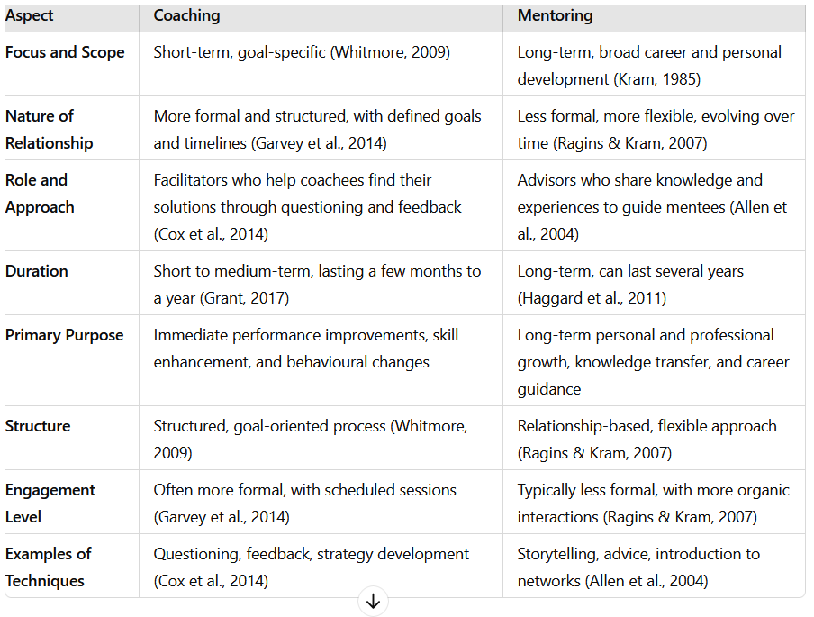
Figure 1 Comparison of Coaching and Mentoring

Figure 2 illustrates the essential competencies of a proficient coach.
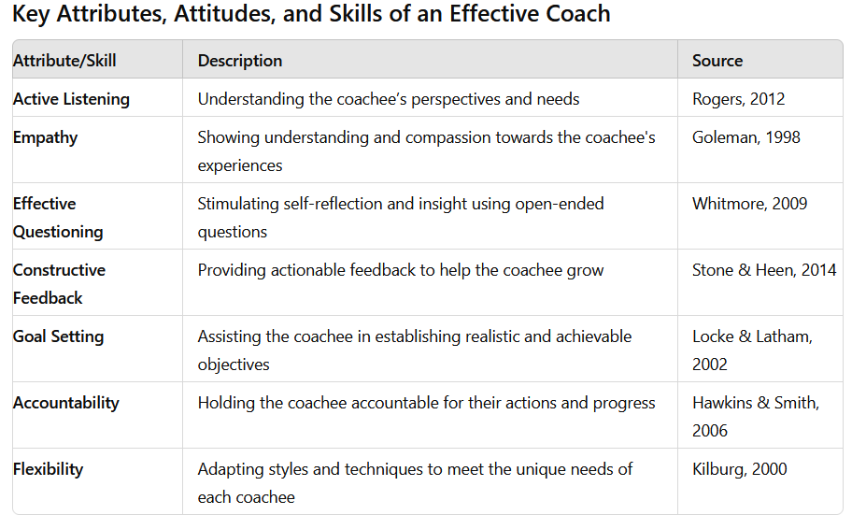
Figure 2 Key skills of an effective coach
Key Theories and Models in Coaching
Several theories and models underpin effective coaching practices. The GROW model, developed by John Whitmore, provides a structured framework for coaching conversations, focusing on Goal, Reality, Options, and Will (Whitmore, 2009). Transformational coaching aims to facilitate profound personal change and development, drawing on principles of transformational leadership and psychology (Bass & Riggio, 2006). Cognitive-Behavioural Coaching (CBC) integrates principles from cognitive-behavioural therapy (CBT) to help coachees identify and change limiting beliefs and behaviours (Neenan & Dryden, 2013).

Critical Evaluation of the Purpose of Coaching and Mentoring within a Workplace

Coaching and mentoring are vital developmental tools in the workplace, aimed at enhancing individual and organizational performance. Both processes, though distinct, play crucial roles in professional growth and career advancement. This evaluation examines the purposes of coaching and mentoring, compares and contrasts their views, and supports points with relevant literature.

Purposes of Coaching in the Workplace
Coaching is primarily goal-oriented, focusing on improving specific skills, behaviours, and performance outcomes. It serves several key purposes that contribute to both individual and organizational success. One primary function of coaching is performance enhancement, where it boosts employee performance by identifying strengths and addressing weaknesses, helping employees achieve their full potential (Grant, 2017). A critical evaluation of this purpose reveals that while performance enhancement is a primary goal of coaching, it can sometimes lead to an overemphasis on short-term results rather than sustainable, long-term development. This focus can create pressure on employees to quickly demonstrate improvement, potentially leading to burnout or reduced job satisfaction.
Additionally, coaching is vital for leadership development, as it aids in developing leadership skills and preparing individuals for higher responsibilities and leadership roles, particularly nurturing high-potential employees (Ely et al., 2010). However, effective leadership development through coaching requires a commitment of time and resources that organizations may not always be willing or able to provide. Furthermore, coaching high-potential employees can inadvertently lead to neglecting the development needs of other employees, potentially creating disparities within the organization.
Coaching also supports career development by helping individuals set and achieve career goals, providing clarity on career paths, and helping overcome barriers to advancement (Smither, 2011). Despite its benefits, coaching for career development may not always align with organizational objectives. Employees might pursue career paths that lead them away from the organization, resulting in a loss of talent. Additionally, the benefits of coaching in career development may not be uniformly accessible to all employees, depending on organizational policies and culture.
Furthermore, coaching facilitates necessary behavioural changes for personal and professional growth, using structured feedback and reflection to alter behaviours and improve interpersonal skills (Boyatzis, 2006). Although behavioural change through coaching is effective, it requires a high level of self-awareness and willingness to change from the coachee. Resistance to change, lack of motivation, or inadequate support from the organization can impede the effectiveness of coaching in this area.
Coaching assists employees in adapting to organizational changes such as new roles, technologies, or processes, supporting smooth transitions and enhancing resilience (Joo, 2005). While coaching can be instrumental in facilitating adaptation to change, it might not be sufficient in isolation. Organizational change often requires comprehensive strategies that include training, communication, and cultural shifts. Relying solely on coaching might not address all the complexities and challenges associated with significant organizational transformations.
In addition, coaching plays a crucial role in enhancing performance, developing leadership, supporting career growth, facilitating behavioural change, and aiding adaptation to change. However, its effectiveness can be influenced by various factors, including organizational culture, resource allocation, and the readiness of individuals to engage in the coaching process. For coaching to achieve its intended purposes, it must be part of a broader, integrated approach to employee development and organizational change. Figure 3 display some of the benefits of professional coaching.

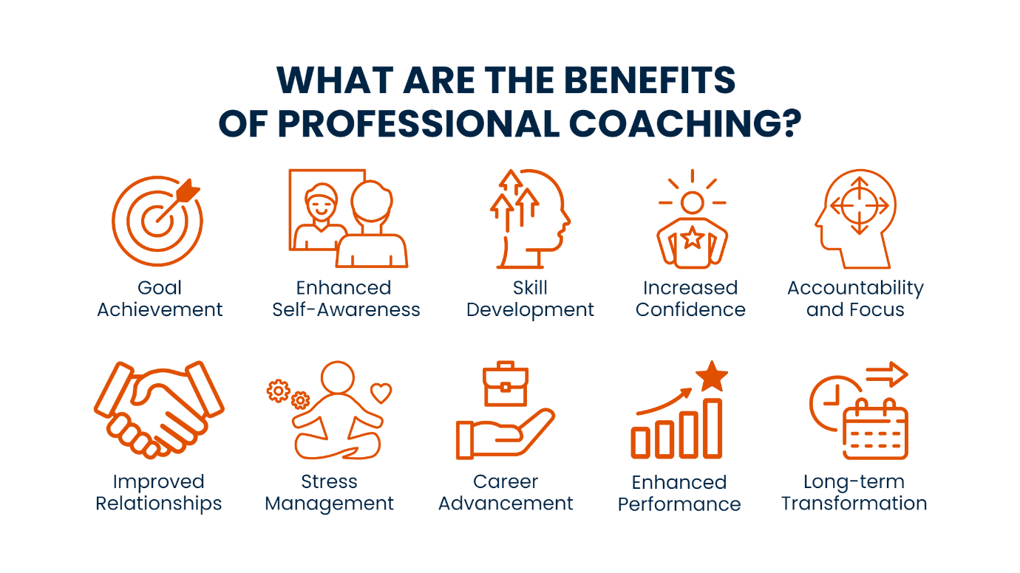
Figure 3 Benefits of professional coaching
Source: https://www.leadershipcoachgroup.com/blog/professional-coaching

Purposes of Mentoring in the Workplace
Mentoring focuses on long-term personal and professional development through a relationship-based approach. One of its key purposes is knowledge transfer, where mentoring facilitates the transfer of knowledge and expertise from experienced professionals to less experienced employees, helping preserve organizational knowledge (Haggard et al., 2011). Additionally, mentoring provides career guidance and advice, assisting mentees in navigating their career paths and making informed decisions about career progression and professional development (Kram, 1985). Mentoring also offers emotional support and encouragement, fostering a sense of belonging and confidence in mentees, which is particularly beneficial for new employees or those facing challenges (Ragins & Kram, 2007). Furthermore, mentors aid in the development of critical skills and competencies needed for career success, including technical skills, soft skills, and leadership abilities (Allen et al., 2004). Lastly, mentoring expands mentees' professional networks by introducing them to valuable contacts and opportunities, enhancing career opportunities and professional growth (Higgins & Kram, 2001).
However, a critical evaluation of mentoring reveals some limitations and challenges. While mentoring can be highly beneficial, its effectiveness is contingent on the quality of the mentor-mentee relationship. Poorly matched pairs or insufficient commitment from either party can hinder the mentoring process (Eby et al., 2013). Additionally, the informal nature of many mentoring relationships can lead to variability in the quality and consistency of the guidance provided. Unlike formal training programs, mentoring does not always follow a structured curriculum, which can result in gaps in knowledge transfer and skill development (Noe et al., 2002).
Another potential drawback is the time commitment required for effective mentoring. Both mentors and mentees must invest significant time and effort to build a productive relationship, which can be challenging in fast-paced or resource-constrained environments. Moreover, mentors may inadvertently project their biases and preferences onto mentees, influencing their career choices and development in ways that may not align with the mentees' true interests and goals (Ragins & Verbos, 2007). Finally, mentoring relationships can sometimes foster dependency, where mentees rely too heavily on their mentors for guidance, potentially stifling their independence and self-reliance (Allen et al., 2004).
In conclusion, while mentoring offers substantial benefits in terms of knowledge transfer, career guidance, emotional support, skill development, and network expansion, it is not without its challenges. Ensuring effective mentor-mentee matching, maintaining a balanced and structured approach, and fostering independence in mentees are critical to maximizing the positive impact of mentoring programs. Figure 4 illustrate the benefits of mentoring.
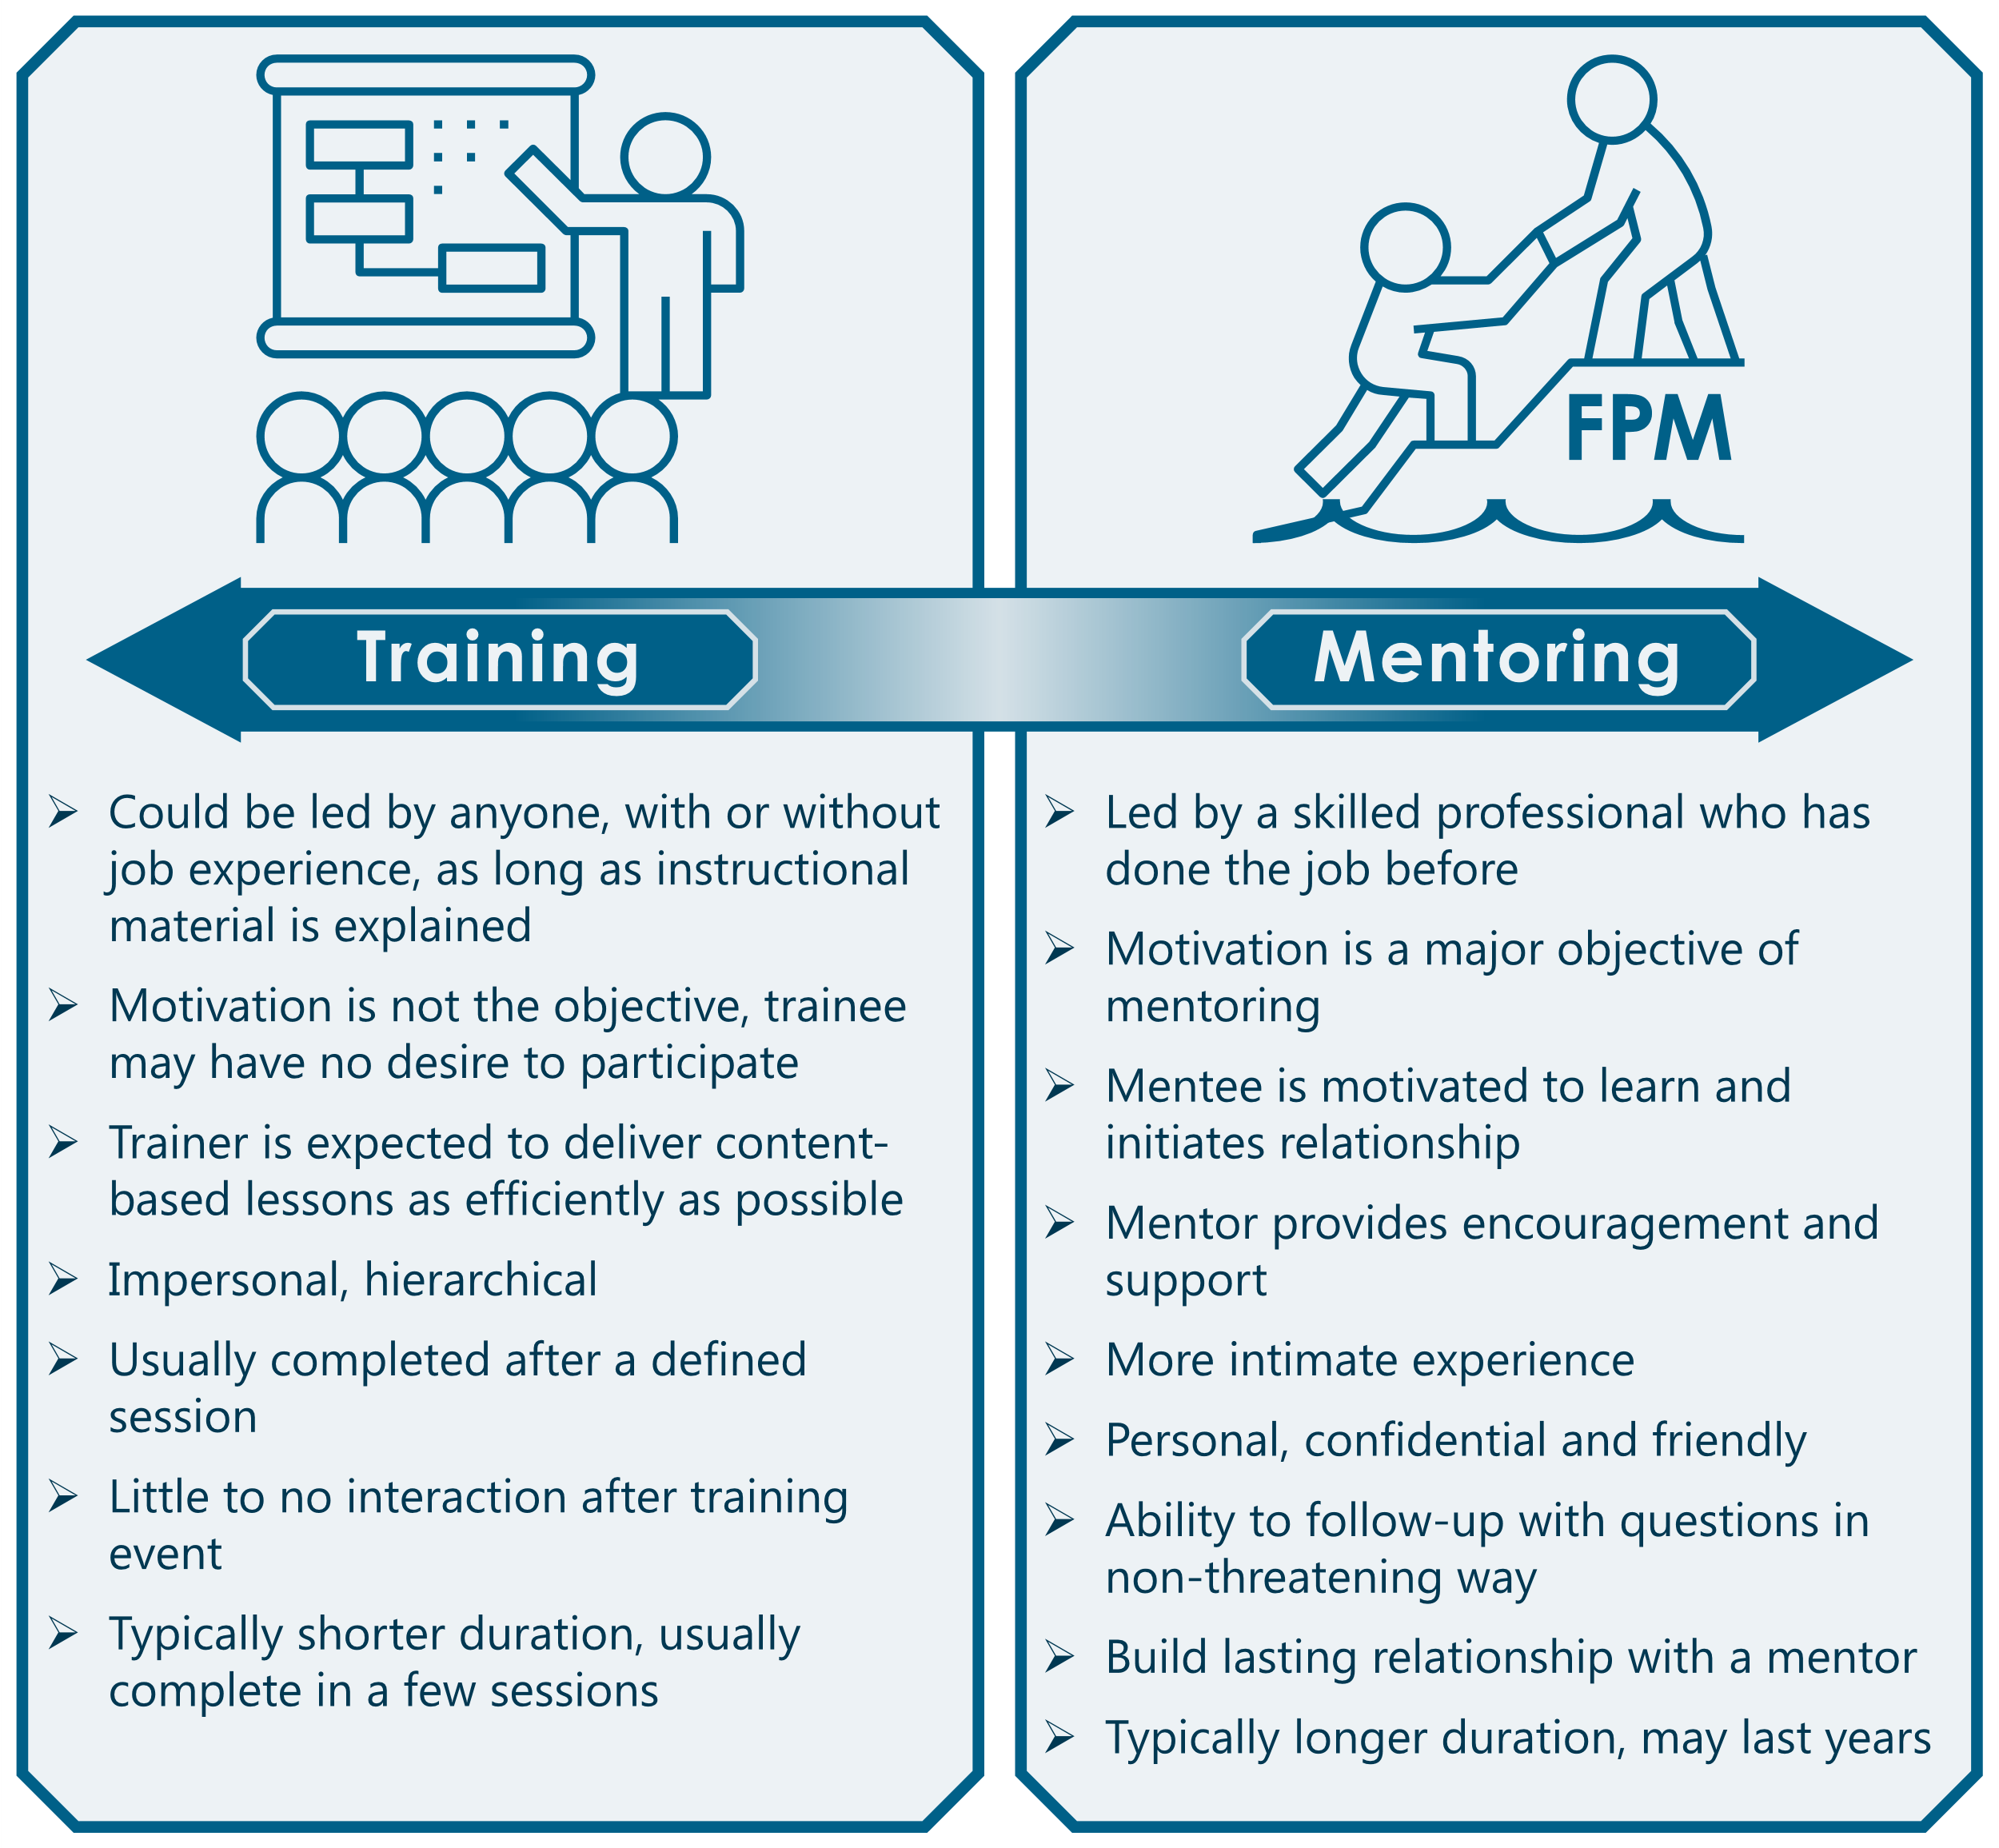
Figure 4 Benefits of mentoring
Source: https://floodsciencecenter.org/products/state-mentoring-program/what-is-mentoring/

Critical Analyse of RAW model of coaching

The RAW (Realistic, Achievable, Worthwhile) model of coaching provides several advantages in goal-setting. One significant benefit is its focus on realism. By ensuring goals are realistic, the model helps prevent the frustration and demotivation that can result from setting unattainable objectives, thereby fostering a sense of confidence and feasibility (Whitmore, 2009). Another advantage is the emphasis on achievability, which ensures that the coachee experiences regular successes. This can build motion and enhance self-efficacy, contributing to sustained motivation and progress (Bandura, 1997). Additionally, by highlighting the worthwhileness of goals, the model ensures that the effort invested aligns with the coachee's values and long-term objectives. This alignment can increase commitment and satisfaction as individuals work towards goals that truly matter to them (Deci & Ryan, 2000).
However, the RAW model also has its disadvantages. Determining what is "worthwhile" can be highly subjective and vary greatly between individuals, making the process challenging as it requires a deep understanding of the coachee's values and long-term aspirations. This can be complex and multifaceted. Furthermore, the emphasis on realism and achievability might lead to setting overly conservative goals, potentially stifling ambition and creativity. This cautious approach could result in missed opportunities for growth that might come from striving towards more challenging objectives. Additionally, the initial stages of thoroughly evaluating and aligning goals to ensure they are realistic, achievable, and worthwhile can be time-consuming. This phase demands significant effort from both the coach and the coachee, which might be a constraint in fast-paced environments.
The RAW model is particularly useful in situations where individuals or teams need to establish a clear, actionable, and motivational framework for their goals. In corporate settings, for example, employees looking to set career development goals can benefit from the RAW model as it ensures these goals are practical and aligned with both personal values and organizational objectives. In educational settings, students can also benefit from the RAW model when setting academic and personal development goals. Ensuring that their goals are realistic and achievable helps maintain motivation and prevent burnout, while the worthwhileness ensures that their efforts are aligned with their long-term aspirations.
In addition, the RAW model of coaching offers a balanced approach to goal-setting by emphasizing the importance of realism, achievability, and intrinsic value. While it has clear advantages in fostering practical and meaningful progress, it also poses challenges such as the subjectivity of worthwhileness and the potential for overly cautious goal-setting. Despite these challenges, the model can be highly effective in various contexts where sustainable and value-aligned growth is the objective.

Critical Analyse of Johari Window Model

The Johari Window model, introduced by Luft and Ingham (1955), is a framework designed to enhance self-awareness and interpersonal communication by categorizing information into four quadrants: Open, Blind, Hidden, and Unknown (Luft & Ingham, 1955). It encourages individuals to disclose information about themselves (Open quadrant) and receive feedback on aspects unknown to them (Blind quadrant), fostering personal growth and mutual understanding (Luft & Ingham, 1955). Moreover, by reducing hidden aspects (Hidden quadrant), the model promotes transparency and clearer communication (Luft & Ingham, 1955). However, the model's subjectivity and susceptibility to biases, along with cultural influences, can impact its effectiveness (Luft & Ingham, 1955). The Unknown quadrant signifies unexplored aspects that require ongoing exploration for comprehensive self-awareness (Luft & Ingham, 1955). Practical application of the Johari Window necessitates time, commitment, and skilled facilitation to build trust and foster effective communication (Luft & Ingham, 1955). By navigating its strengths and limitations, organizations and individuals can utilize the Johari Window to cultivate trust, enhance teamwork, and support personal development effectively (Luft & Ingham, 1955).

Reflection

In this section, I will reflect on two key professional development sessions: Part 1 focuses on my experience with coaching, while Part 2 delves into my experience with mentoring. Utilizing Kolb's model of reflection, I will analyse and evaluate both sessions to gain insights and improve my approach. By systematically reflecting on these experiences, I aim to understand the effectiveness of the methods used, identify areas for improvement, and enhance my skills in both coaching and mentoring. This reflective process will not only help me grow as a professional but also ensure that I provide the best support to those I coach and mentor in the future. Figure 3 illustrate Kolb’s reflective model.
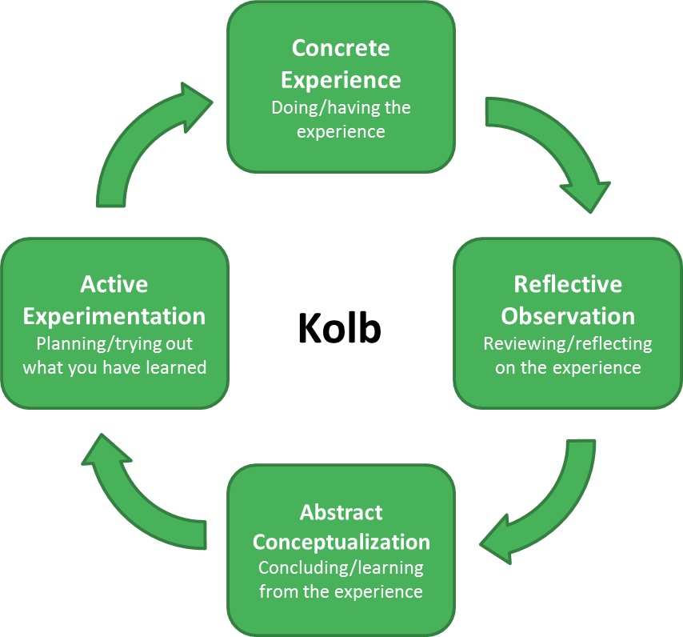
Figure 5 Kolb's reflective model
Source: https://www.cambridge-community.org.uk/professional-development/gswrp/index.html

Reflection on coaching session
Concrete Experience
The initial coaching session involved David, who is seeking a promotion to the position of marketing manager within the next six months. During our conversation, we used the RAW (Realistic, Achievable, Worthwhile) approach to break down his goal. We discussed his current role, the specific promotion he is aiming for, the steps needed to achieve it, and the importance of this promotion to his long-term career goals.
Reflective Observation
Reflecting on the session, I noticed that David was very motivated and had a clear vision of what he wanted to achieve. He articulated his goals well and understood the steps he needed to take. However, I observed that he might face challenges in allocating time for his training and finding a mentor, which could hinder his progress. The RAW approach was effective in structuring our conversation and ensuring that we covered all aspects of his goal setting.
Abstract Conceptualization
From this experience, I learned the importance of a structured approach like RAW in goal setting and coaching. It helps in breaking down complex goals into manageable steps and ensures that all relevant aspects are considered. The session highlighted the need for clear communication and the importance of understanding the coachee's motivations and challenges. Additionally, I realized the value of setting specific, achievable tasks for the coachee to focus on before the next session.
Active Experimentation
In future coaching sessions, I will maintain the use of the RAW approach while enhancing my focus on recognizing potential challenges and crafting tailored strategies to surmount them. I will also ensure that the coachee has a clear action plan for each step, with specific deadlines and required resources. Furthermore, I will follow up more frequently to monitor progress and provide support, ensuring that the coachee remains on track towards achieving their goals.
Conclusion
The feedback from the lecturer was very positive and satisfactory, indicating that the approach and execution of the coaching session were effective. Moving forward, I will build on this experience to refine my coaching techniques, ensuring that I provide the best possible support to my coachees in achieving their professional goals.

Reflection on mentoring session
In this mentoring session with David, we delved into his apprehensions about applying for a promotion despite completing his training. Using Kolb's model of reflection, I will analyse this experience to gain insights and improve my mentoring approach.
Concrete Experience
The session began with a casual check-in, then shifted focus to David's training program. Despite completing the training, David expressed reluctance to apply for the promotion due to fear of failure. To address this, we used the Johari Window model to explore his hidden fears and enhance self-awareness. David shared a past success where he overcame uncertainty, which we used to draw parallels to his current situation. We discussed his fears, the feedback from his manager and colleagues, and devised a plan to boost his confidence and preparedness.
Reflective Observation
Reflecting on the session, I observed that David's fear of failure was a significant barrier to his progress. His past success story was a powerful tool in highlighting his capabilities, yet he struggled to internalize this confidence. The Johari Window model proved effective in bringing hidden fears to the surface, allowing us to address them directly. The reduction of the hidden area and the expansion of the open quadrant in the Johari Window proved to be effective. David's openness and willingness to engage in the process were encouraging, and it became clear that a structured plan was necessary to build his confidence further. Figure 4 demonstrate reduction of hidden quadrant.
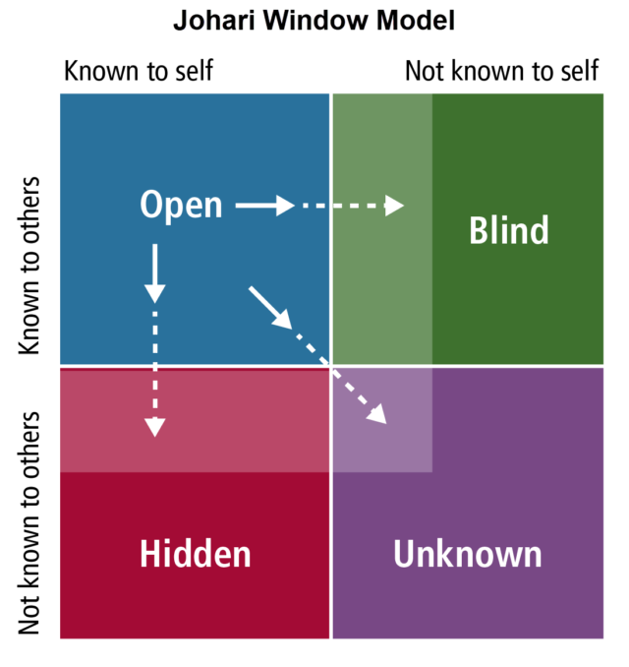
Figure 6 Demonstration of decrease in hidden area
Source: https://resources.managementconcepts.com/download/leadership-management/the-johari-window-model-a-tool-for-federal-agency-teams/
Abstract Conceptualization
From this mentoring experience, I learned the importance of addressing emotional barriers such as fear of failure, which can significantly impact professional growth. The Johari Window model was instrumental in facilitating self-reflection and identifying areas for improvement. This session reinforced the need for a supportive and structured approach in mentoring, ensuring that mentees feel understood and empowered to take on challenges. Additionally, linking personal motivations, such as being a role model for his children, provided David with a compelling reason to overcome his fears.
Active Experimentation
In future mentoring sessions, I will keep utilizing various models, tailoring them to fit the specific needs and circumstances of each mentee. I will ensure that we create detailed, actionable plans to tackle specific areas of concern, reinforcing their confidence through past successes and positive feedback from peers and supervisors. Additionally, I will emphasize personal motivations and the broader impact of their professional growth, helping them see the value in taking risks and embracing opportunities.
Conclusion
The received feedback was very positive, emphasizing the success of the approach used. Reflecting on this session has given me significant insights into the mentoring process, particularly the necessity of addressing emotional barriers and developing structured plans to assist mentees. In the future, I will leverage this experience to refine my mentoring skills, ensuring I offer optimal guidance and support to those I mentor.

Conclusion

In conclusion, coaching and mentoring emerge as indispensable tools in cultivating talent, enhancing performance, and nurturing leadership potential within organizational settings. While coaching focuses on immediate skill enhancement and performance optimization through structured interventions, mentoring fosters long-term development by imparting wisdom, providing career guidance, and fostering emotional support. The critical evaluation of coaching and mentoring practices reveals their multifaceted impacts on individuals and organizations, balancing short-term objectives with sustained growth initiatives. Moving forward, the integration of robust theoretical models and reflective practices will be essential in refining coaching and mentoring approaches, ensuring they remain responsive to evolving professional needs and organizational dynamics. By harnessing the synergies between coaching and mentoring, organizations can cultivate resilient leaders, foster innovation, and sustain a competitive edge in an increasingly complex global landscape.

Reference

Allen, T. D., Eby, L. T., Poteet, M. L., Lentz, E. & Lima, L., (2004). Career benefits associated with mentoring for protégés: A meta-analysis. Journal of Applied Psychology, 89(1), pp.127-136.
Bandura, A., (1997). Self-efficacy: The exercise of control. W.H. Freeman and Company.
Bass, B. M. & Riggio, R. E., (2006). Transformational leadership. Psychology Press.
Boyatzis, R. E., (2006). Using tipping points of emotional intelligence and cognitive competencies to predict financial performance of leaders. Psicothema, 18(Suppl.), pp.124-131.
Boyatzis, R. E., (2006). An overview of intentional change from a complexity perspective. Journal of Management Development, 25(7), pp.607-623.
Cox, E., Bachkirova, T. & Clutterbuck, D., (2014). The complete handbook of coaching. 2nd ed. London: Sage Publications.
Deci, E. L. & Ryan, R. M.,(2000). The "what" and "why" of goal pursuits: Human needs and the self-determination of behaviour. Psychological Inquiry, 11(4), pp.227-268.
Eby, L. T., Allen, T. D., Hoffman, B. J., Baranik, L. E., Sauer, J. B., Baldwin, S., Morrison, M. A., Kinkade, K. M., Maher, C. P., Curtis, S., & Evans, S. C., (2013). An interdisciplinary meta-analysis of the potential antecedents, correlates, and consequences of protege perceptions of mentoring. Psychological Bulletin, 139(2), pp.441-476.
Ely, K., Boyce, L. A., Nelson, J. K., Zaccaro, S. J., Hernez-Broome, G. & Whyman, W., (2010). Evaluating leadership coaching: A review and integrated framework. The Leadership Quarterly, 21(4), pp.585-599.
European Mentoring and Coaching Council (EMCC), (2021). Mentoring definitions. Available at: https://www.emccouncil.org/what-is-mentoring/ [Accessed 16 July 2024].
Garvey, B., Stokes, P. & Megginson, D., (2014). Coaching and mentoring: Theory and practice. 2nd ed. London: Sage Publications.
Grant, A. M., (2017). The third 'generation' of workplace coaching: Creating a culture of quality conversations. International Coaching Psychology Review, 12(2), pp.76-88.
Grant, A. M., (2017). The third ‘generation’ of workplace coaching: Creating a culture of quality conversations. Coaching: An International Journal of Theory, Research and Practice, 10(1), pp.37-53.
Haggard, D. L., Dougherty, T. W., Turban, D. B. & Wilbanks, J. E., (2011). Who is a mentor? A review of evolving definitions and implications for research. Journal of Management, 37(1), pp.280-304.
Higgins, M. C. & Kram, K. E., (2001). Reconceptualizing mentoring at work: A developmental network perspective. Academy of Management Review, 26(2), pp.264-288.
International Coach Federation (ICF), (2021). What is coaching? Available at: https://coachfederation.org/about [Accessed 16 July 2024].
Joo, B. K., (2005). The relationship between culture, leadership behaviour, and perceived leadership effectiveness: The case of Korean business organizations. Leadership Quarterly, 16(1), pp.79-102.
Joo, B. K., (2005). Executive Coaching: A Conceptual Framework From an Integrative Review of Practice and Research. Human Resource Development Review, 4(4), pp.462-488.
Kram, K. E., (1985). Mentoring at work: Developmental relationships in organizational life. Glenview, IL: Scott, Foresman, and Company.
Luft, J., & Ingham, H., (1955). The Johari window: A graphic model for interpersonal relations. University of California, Western Training Lab.
Neenan, M., & Dryden, W., (2013). Cognitive-behavioural coaching in practice: An evidence-based approach. Routledge.
Noe, R. A., Clarke, A. D., & Klein, H. J., (2002). Learning in the twenty-first-century workplace. Journal of Employee Relations, 24(4), pp.260-282.
Noe, R. A., Greenberger, D. B. & Wang, S., (2002). Mentoring: What we know and where we might go. Research in Personnel and Human Resources Management, 21, pp.129-173.
Ragins, B. R. & Kram, K. E., (2007). The roots and meaning of mentoring. In: The handbook of mentoring at work: Theory, research, and practice. Thousand Oaks, CA: Sage Publications, pp.3-15.
Ragins, B. R. & Verbos, A. K., (2007). Positive relationships in action: Relational mentoring and mentoring schemas in the workplace. In: J. E. Dutton and B. R. Ragins, eds. Exploring positive relationships at work: Building a theoretical and research foundation. Mahwah, NJ: Lawrence Erlbaum Associates, pp.91-116.
Ragins, B. R., & Kram, K. E., (2007). The handbook of mentoring at work: Theory, research, and practice. Sage Publications.
Ragins, B. R., & Verbos, A. K., (2007). Positive relationships in action: Relational mentoring and mentoring schemas in the workplace. In D. L. Nelson & C. L. Cooper (Eds.), Positive organizational behaviour (pp. 183-198). Sage Publications.
Smither, J. W., (2011). Executive development: The potential of 360-degree feedback for executive coaching. Journal of Management Development, 30(6), pp.546-560.
Smither, J. W., (2011). Can working with an executive coach improve multisource feedback ratings over time? A quasi-experimental field study. Personnel Psychology, 64(1), pp.175-206.
Whitmore, J., (2009). Coaching for performance: Growing human potential and purpose. 4th ed. London: Nicholas Brealey Publishing.

