
APPENDIX GA36c

LEVEL 6 ASSESSMENT SPECIFICATION

Student name: | Tomos Morris | Student ID number: | 1807844
Programme: | Sport and Exercise Science
Module: | Advanced Training Methods
Module code: | SHSS6089 | Contribution to Overall Module Assessment (%): | 50%
Lecturer: | Geraint Forster | Internal Verifier: | David Gardner
Assignment Title: | Review Article | Word count (or equivalent): | 2,500 words
Submission deadline: | 3PM 19/03/2021 | Return date of provisional marks & written feedback: | 16/04/2021
Submission method: | All written assessments, where practical and possible, must be submitted via Turnitin unless otherwise instructed by the Lecturer. (Please DO NOT put this assessment specification into Turnitin or it will match many similarities with other students’ submissions.)  Alternative submission method (if applicable):  Late submission of the assessment will result in a late penalty mark. Penalties for late submission: Up to one week late, maximum mark of 40%. Over one week late, 0%. Only the Extenuating Circumstances Panel may approve a change to submission dates.
Academic honesty / referencing: | Academic honesty is required. In the main body of your submission you must give credit to authors on whose research and ideas your work is based. Append to your submission a reference list that indicates the books, articles, etc. that you have used, cited or quoted in order to complete this assessment.

Module Learning Outcomes
(from module syllabus)
- Critically evaluate the effectiveness of a range of recent advanced training methods.

- Integrate advanced training methods effectively into a training programme.

- Use technology effectively to enhance training outcomes and monitoring.

Student FEEDBACK FORM

This section details the extent to which the assessment criteria are demonstrated by you, which in turn determines your mark. The marks available for each category of skill are shown. Lecturers will use the space provided to comment on the achievement of the task(s), including those areas in which you have performed well and areas that would benefit from development/improvement.

Generic Assessment Criteria | Marks available | Marks  awarded
1. Engagement with Literature Skills  . | 25
2. Knowledge and Understanding Skills | 25
3. Cognitive and Intellectual Skills | 20
4. Practical Application Skills | 20
5. Transferable Skills for Life and Professional Practice | 10

Assessment Mark (Assessment marks are subject to ratification at the Exam Board. These comments and marks are to give feedback on module work and are for guidance only until they are confirmed. ) | Late Submission Penalties (tick if appropriate) |  | %
 | Up to 1 week late (40% Max) |  | %
 | Over 1 week late (0%) |  | %

The effects of High Intensity Interval Training hill sprinting (Sprint Interval Training) on distance running time.

Client Profile

The client is a 20 year old male who is a full time university student studying Sport and Exercise Science, he is employed on a full-time basis as a lifeguard with previous experience of distance running.

The Client’s ’s main sporting interests are running and skiing. He currently caries out a weight training programme during which he completes 3 workouts a week with his running taking place between those workouts. His weekly schedule allocates Wednesday as a rest day. His current exercise routine is dependent on his work and university schedule. He has previously completed 4 half marathons with a best time of 1 hour and 49 minutes. His training schedule is aimed at enabling him to repeat this achievement. The Client also takes part in other recreational sports including mountain biking every couple of weeks and he also takes part in football and rugby. His main focus however is to improve his running times.

The Client aims to run a weekly average of 30km varying in distance from 5km to 12km on different terrain and under different weather conditions resulting in varying elevation gains. The Client s wishes to improve his overall time in the 5km and 10 km distances aiming to get under 22 minutes and 48 minutes respectively. Prior to any testing, the client’s best 5km and 10 km times were 24.23 minutes and 51.39 minutes. The Client currently suffers from sports induced asthma, but it is well-controlled. He always carries an inhaler, and his asthma has not affected his performances at these distances. In recent years he has twice suffered a dislocated shoulder, the most recent one a year ago. He has broken his thumb once as well as being concussed on two occasions. Watson et al (2016) suggests that in relation to recovery from a shoulder dislocation “clinical recommendations in this regard are based on individual anecdotal experience instead of clear guidelines” which would indicate that recovery is dependant whether the individual himself feels that he has fully recovered from the dislocation.

Before any training commenced the Client completed a few tests to establish his understand the individuals current ability. The client weighs 63.5kg; is 167cm tall with a Body Mass index (BMI) of 22.7. Such BMI is regarded as healthy according to NHS UK.

The Client also underwent a test to measure his time running 1-mile 5km and 10km. He was asked to complete these tests running at his absolute limit. The three tests were completed 2 days apart to allow for sufficient rest to recover. The times recorded were 7.55 minutes for the 1-mile run; 24.30 minutes for 5km and 50.43 minutes for 10km. These were assessed using the app Strava (2021) alongside a Garmin (2021) GPS wrist-based watch to provide the final times, splits and effort. A Polar Electro (2021) heart rate monitor was worn to record the Client’s heart rate during these runs.

Rationale

The purpose of this study is to identify the effects of High Intensity Interval sprint training on distance running time. Consistent endurance training helps to improve physical fitness and recovery rate (Haskell et al., 2017) with the American College of Sports medicine (2009) recommending 150 minutes of moderate activity or 75 minutes of vigorous intensity per week for adults aged 18 - 65.

High Intensity Interval Training (HIIT) is a “type of training which involves repeated bouts of high intensity effort followed by varied recovery times.” (ACSM, 2014) HIIT has been used as a “time-efficient programme to improve physical fitness, physiological functions, and cardiovascular disease risk factors” (Petersen et al., 2016). According to Ito (2019). HIIT has been identified as an alternative and more efficient form of training when compared with moderate-intensity continuous training which is currently the most popular form of exercise. HIIT has been shown to increase VO2 max peak more than that produced by moderate intensity exercise.

For this study the Client will be doing a Sprint Interval training regime which is a sub-category of High Intensity Interval Training and characterised by Weston et al. (2014) as brief intermittent “all out” intense exercise separated by periods of low-intensity exercise for recovery between sets. Helgerud et al (2007) suggested that VO2 max is one of the most important factors in determining success in aerobic endurance sport. Research by Milanovich suggests that both HIIT and regular endurance activities showed improvements in an individual’s VO2 and also found that the gains in VO2 max were greater following a HIIT training session than from moderate endurance activity.

Training programmes that consist of long, continuous exercise at a moderate intensity have been shown to improve VO2 max in an individual (Eddy et al., 1977) but further research has shown that repeated short intervals of high intensity exercise can be an effective alternative to improve the VO2 max of an individual (Cocks et al., 2013). Xie et al. (2016) claims that an increase in the peak VO2 can improve “aerobic capacity and promote cardiac rehabilitation.” Research by Conraads et al. (2016) and Loennechen et al. (2007) found there to be no difference in peak heart rate produced by either interval training or continuous training.

Sprint Interval training as a form of HIIT has been shown to improve cardiorespiratory fitness, with Gillen et al. (2016) suggesting that following three 20 second “all out” sprints within a 10-minute training session three times a week over a six-week programme there was an improvement in cardiorespiratory fitness. It has also been suggested by Gibala et al (2006), that Sprint Interval Training (SIT) can produce greater improvements in aerobic power and metabolic function achieved biregular endurance training.

Research by Sloth et al. (2013) found that the use of SIT as a form of HIIT could induce increases in VO2 max and an improved maximal aerobic performance. This would therefore be vital for individuals attempting to improve their distance running times as an increased VO2 max can contribute substantially to successful performance in an aerobic endurance event. (University of California, 2019). SIT as stated by Burgomaster et al. (2005) has contributed towards an improvement in both the anaerobic/glycolytic system as well as the aerobic/oxidative system of the individual undertaking exercising. Gibala et al. (2005) found that in Sprint Interval Training in cyclist time trials at distances of 2 to 40km in cyclist time aerobic performance was improved by 3.5% to 10.1% This would indicate that the use of SIT for a runner should improve their overall times.

Training Programme

The training programme prescribed for the Client followed that which was proposed by Buchheit and Laursen (2020). They suggested that sprint interval training in which the individual performed at maximum intensity (“all-out”) for up to 20s with a passive recovery of up to 2 minutes maximum of recovery between each repetition, with 6-10 repetitions per set would be putting greater stress on the anaerobic system. When prescribing the training programme, the Client’s current training regime was taken into account. The general structure of the HIIT session was Sprint Interval Hill sprints with 10 repetitions of 20s of maximum effort with 40s of passive recovery, walking/slow jog back to the start point, followed by 10 repetitions of 10s of maximum effort with 20s of passive recovery. Following this structure, the training programme prescribed for the Client is as follows, with the training programme being the same over the 6 weeks:

Table 1: Showing the Training programme for the client
Day | Monday | Tuesday | Wednesday | Thursday | Friday | Saturday | Sunday
X6 weeks | Weight training | HIIT session: Hill sprints- 10x20s:40s  10x 10s:20s | Rest day/ 5/10k run | Weight training | HIIT session: Hill sprints- 10x20s:40s  10x 10s:20s | Weight training | 5/10k run

The prescribed programme as seen in Table 1 shows 2 HIIT training sessions per week to fit in with the Client’s current training regime. The HIIT sessions will be Sprint Interval sessions performed at maximum intensity. The training programme was designed to be observed over a 6-week period with progress being monitored, at 3 weeks the individual would be required to undertake a 5km run at the start of the week and a 10km run at the end of the week Overall time, average kilometre splits and average heart rate over the run would be recorded. Before the start of each HIIT session the participant will warm up by running 1km at a slow pace in the aerobic zone and that session will be followed by a 1km cool down at a slow pace. Following the completion of the programme the client will then complete two runs of 5km and 10km distances to establish whether or not there has been any improvement in overall time, heart rate, time spent in heart rate zones and split times.

Technology Used

The technology used during the sessions and testing was the Strava app, a Garmin wrist-based watch with the use of Garmin connect (to analyse runs alongside the Strava app), together w with a polar electro heart rate monitor. Strava (2021) was used to analyse the Client’s data when he was running and for analysing the data, pace, split times and heart rate as seen in figures 1,2 and 3 below. Strava was also used to analyse the heart rate zones alongside the Polar Electro (2021) chest heart rate monitor as seen in figure 4, 5 and 6. The Garmin (2021) wrist-based watch was used by the Client to track the distances covered during his run and to provide immediate and current details on their heart rate, pace and split times.
Figure 1 – showing the data of 10km and 5km runs before HIIT session

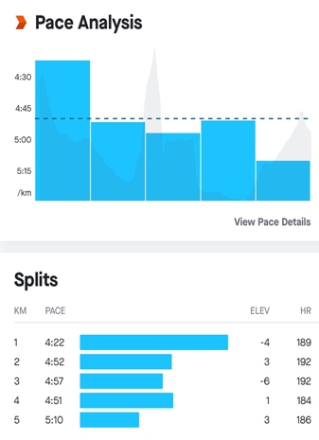
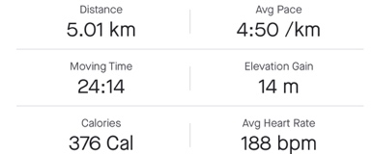
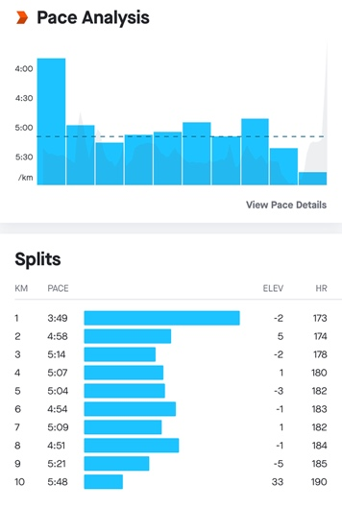
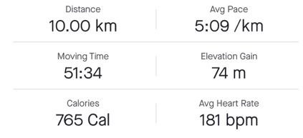

Figure 2 – showing the data of 10km and 5km runs 3weeks into the HIIT programme

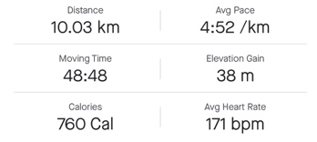
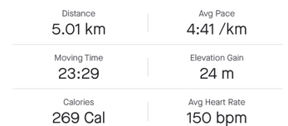
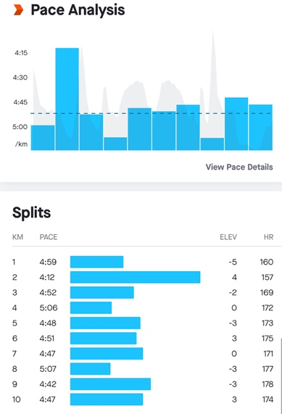
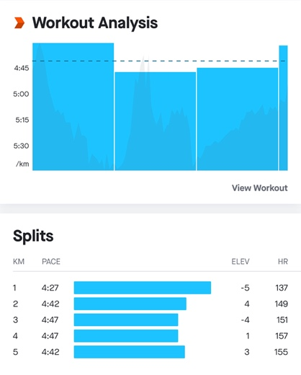

Figure 3 – showing the data of 10km and 5km runs following completion of the HIIT programme

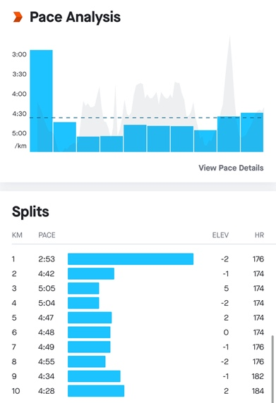
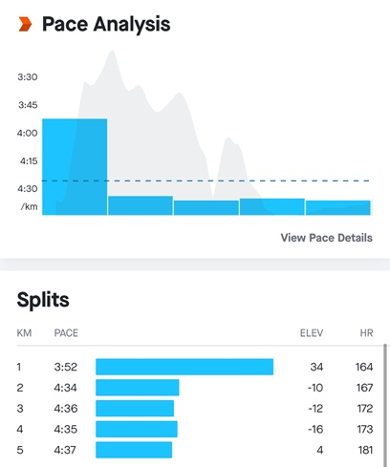
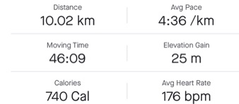
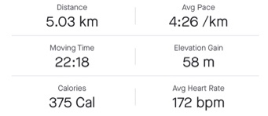

Figure 4 – Data showing the heart rate zones and heart rate during 10km and 5km runs before HIIT session
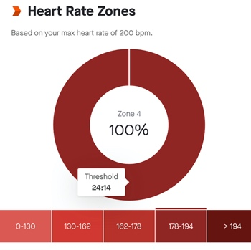
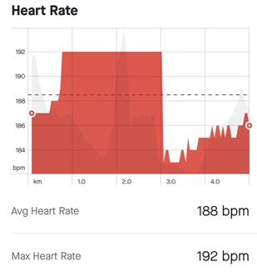
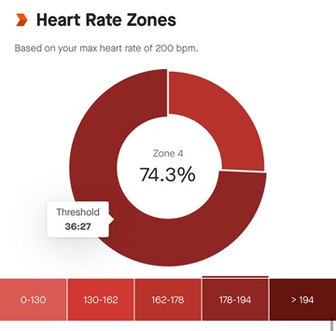
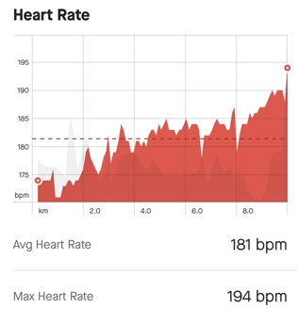

Figure 5 – Data showing the heart rate zones and heart rate during 10km and 5km runs 3 weeks into HIIT training sessions
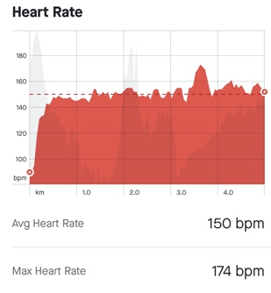
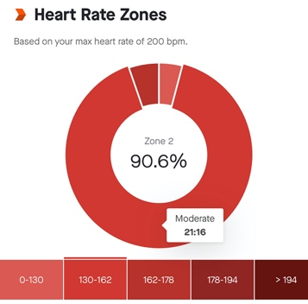
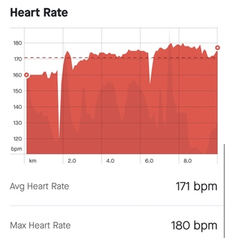
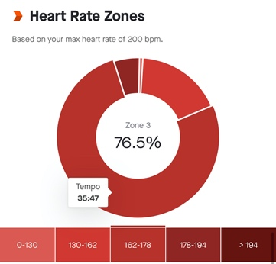
Figure 6 – Data showing the heart rate zones and heart rate during 10km and 5km runs following the completion of the HIIT training sessions

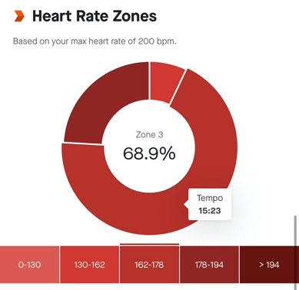
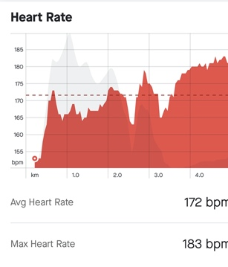
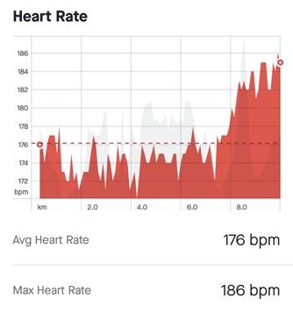
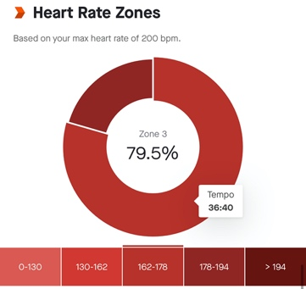

Critical Analysis

By looking at figures 1,2 and 3 there is a clear difference in the Client’s 5km run time and 10km run time; with a 10% decrease in overall time in the 10km from 51.34 minutes to 46.09 minutes following the completion of the 6-week Sprint Interval Training (SIT) sessions and a very similar decrease in overall 5km time of 8%; the time decreasing from 24.14 minutes pre-SIT sessions to 22.18 following the 6 weeks of training.

It is also clear to see that there was change after only 3 weeks of the SIT sessions with a 3.5% decrease in the Client’s 5km time and a 5.5% decrease in his time for 10km. The average split per km also changed drastically following the 6-week training programme. The split time decreased from 5.09/km to 4.36/km in the 10km distance and decreasing from 4.50/km to 4.26/km for the 5km distance.
This information supports the point made up by Sloth et al. (2013) that the use of SIT as a form of HIIT can induce increases in VO2 max and provide improved maximal aerobic performance which is clear to see in the data produced by the Client upon completion of his 6 weeks SIT training program. The development shown by the Client is quite significant and also quite very surprising considering how little he was required to do during the training programme over a relatively short period of time. The Client did however state that he struggled to maintain the motivation to complete the training programme due to the high intensity of the sessions, stating he “felt awful” after completion and felt like he needed to throw up afterwards.

This reaction is quite common in individuals doing HIIT, as the high intensity of the session can often put them off continuing with the programme. Research by Foster et al. (2015) showed that the enjoyment of HIIT decreased over an 8-week training period in untrained adults. Little research seems to have been undertaken on the continuation of a HIIT training programme and this could well be a topic to be investigated further.

By looking at figures 1,2 and 3 it is clear to see that the average heart rate of the Client decreases over the period of the training programme. This is not significant in the 10km run, with the average heart going from 181bpm pre HIIT intervention to 172bpm 3 weeks into the training programme and then rising back up to 178bpm after the 6 weeks of training. However, the data from the 5km run showed that the average heart rate fluctuated massively. The average heart rate pre HIIT intervention being at 188bpm and after 3 weeks of training had reduced to 150bpm and then went back up to 172bpm There is very clearly a difference between the average heart rate of the Client at the start of the sessions in both the 5km and 10km distances and at the successful completion of the training programme. These results contradict the research by Conraads et al. (2016) and Loennechen et al. (2007) where they found that there was no difference in peak heart rate in both interval training and continuous training. This could be due to technological error or it may be due to the limitations of the study due to COVID. In the present circumstances it is very difficult to retest or produce a comparison.

An examination of the data from figures 4,5 and 6 shows that there is also a clear difference in the heart rate zones of the Client at the start of the training sessions and at the end. In the 5km run the Client spent 90% in zone 4 pre intervention and 68% in heart rate zone 3 at the end of the sessions. In the 10 km run and there was also a similar difference with the Client spending 74% in zone 4 pre intervention and 79% spent in zone 3 following the training session.

To conclude: the use of Sprint Interval Training as a form of High Intensity Interval Training appears to have a great effect on the individual’s overall distance times showing a 10% decrease in 10km time and an 8% decrease in 5km time. There is also a difference in average heart rate and time spent in heart rate zones following a 6 week SIT training programme. There are however limitations to this study Due to the current restrictions imposed as a result of COVID-19 it was only possible to analyse one individual’s data. Without such a limitation if there were more participants taking part there could be a greater variety of results.

It was also found within this study that the Client did not enjoy HIIT and stated that he would not continue the training programme weekly due to the intensity of the sessions but would only do the sessions once every 3 weeks ass there were clear improvements in his times following the completion of the 6-week training programme.

Finally, it is clear from the results of this research that SIT makes a massive difference to an individual’s times in runs of both 5kmand 10 km. Quite obviously these exercises would be valuable tools to use in an individual’s training programme but due to the lack of enjoyment of the sessions these training methods are unlikely to be generally accepted by individuals and consequently unlikely to be recommended widely and frequently.

Word Count – 2568

References
ACSM, 2009. ACSM’s Guidelines for Exercise Testing and Prescription, 7th Edition. Medicine & Science in Sports & Exercise,.
Buchheit, M. and Laursen, P., 2020. High-Intensity Interval Training: The key strategy to maintain fitness during periods of reduced activity. HIIT Science, [online] Available at: <https://hiitscience.com/high-intensity-interval-training-the-key-strategy-to-maintain-fitness-during-periods-of-reduced-activity/> [Accessed 12 March 2021].
Burgomaster, K., Hughes, S., Heigenhauser, G., Bradwell, S. and Gibala, M., 2005. Six sessions of sprint interval training increases muscle oxidative potential and cycle endurance capacity in humans. Journal of Applied Physiology, 98(6), pp.1985-1990.
Cocks, M., Shaw, C., Shepherd, S., Fisher, J., Ranasinghe, A., Barker, T., Tipton, K. and Wagenmakers, A., 2013. Sprint interval and endurance training are equally effective in increasing muscle microvascular density and eNOS content in sedentary males. The Journal of Physiology, 591(3), pp.641-656.
Conraads, V., Pattyn, N., De Maeyer, C., Beckers, P., Coeckelberghs, E., Cornelissen, V., Denollet, J., Frederix, G., Goetschalckx, K., Hoymans, V., Possemiers, N., Schepers, D., Shivalkar, B., Voigt, J., Van Craenenbroeck, E. and Vanhees, L., 2015. Aerobic interval training and continuous training equally improve aerobic exercise capacity in patients with coronary artery disease: The SAINTEX-CAD study. International Journal of Cardiology, 179, pp.203-210.
Eddy, D., Sparks, K. and Adelizi, D., 1977. The effects of continuous and interval training in women and men. European Journal of Applied Physiology and Occupational Physiology, 37(2), pp.83-92.
Farland, C., Schuette, J., Foster, C., Porcari, J., Doberstein, S., Harbin, M., Guidotti, F., Roberts, B. and Tuuri, A., 2015. The Effects of High Intensity Interval Training versus Steady State Training on Aerobic and Anaerobic Capacity. Medicine & Science in Sports & Exercise, 47(5S), p.133.
Garmin.com. 2021. Garmin | United Kingdom | Home. [online] Available at: <https://www.garmin.com/en-GB/> [Accessed 13 March 2021].
Gibala, M., Little, J., Van Essen, M., Wilkin, G., Burgomaster, K., Safdar, A., Raha, S. and Tarnopolsky, M., 2006. Short-term sprint intervalversustraditional endurance training: similar initial adaptations in human skeletal muscle and exercise performance. The Journal of Physiology, 575(3), pp.901-911.
Gillen, J., Martin, B., MacInnis, M., Skelly, L., Tarnopolsky, M. and Gibala, M., 2016. Twelve Weeks of Sprint Interval Training Improves Indices of Cardiometabolic Health Similar to Traditional Endurance Training despite a Five-Fold Lower Exercise Volume and Time Commitment. PLOS ONE, 11(4), p.e0154075.
HASKELL, W., LEE, I., PATE, R., POWELL, K., BLAIR, S., FRANKLIN, B., MACERA, C., HEATH, G., THOMPSON, P. and BAUMAN, A., 2007. Physical Activity and Public Health. Medicine & Science in Sports & Exercise, 39(8), pp.1423-1434.
HELGERUD, J., HØYDAL, K., WANG, E., KARLSEN, T., BERG, P., BJERKAAS, M., SIMONSEN, T., HELGESEN, C., HJORTH, N., BACH, R. and HOFF, J., 2007. Aerobic High-Intensity Intervals Improve V˙O2max More Than Moderate Training. Medicine & Science in Sports & Exercise, 39(4), pp.665-671.
Ito, S., 2019. High-intensity interval training for health benefits and care of cardiac diseases - The key to an efficient exercise protocol. World Journal of Cardiology, 11(7), pp.171-188.
Kravitz, L., 2014. AMERICAN COLLEGE OF SPORTS MEDICINE. Medicine & Science in Sports & Exercise,.
nhs.uk. 2021. BMI calculator | Check your BMI. [online] Available at: <https://www.nhs.uk/live-well/healthy-weight/bmi-calculator/> [Accessed 13 March 2021].
Petersen, B., Hastings, B. and Gottschall, J., 2016. High intensity interval cycling improves physical fitness in trained adults. J. Fitness Res, 5, pp.39-49.
Sloth, M., Sloth, D., Overgaard, K. and Dalgas, U., 2013. Effects of sprint interval training on VO2maxand aerobic exercise performance: A systematic review and meta-analysis. Scandinavian Journal of Medicine & Science in Sports, 23(6), pp.e341-e352.
Strava.com. 2021. Strava. [online] Available at: <https://www.strava.com/dashboard> [Accessed 13 March 2021].
UC Davis Health, S., 2021. VO2max and Oxygen Consumption | UC Davis Sports Medicine. [online] Health.ucdavis.edu. Available at: <https://health.ucdavis.edu/sportsmedicine/resources/vo2description.html> [Accessed 13 March 2021].
UK, P., 2021. Heart rate monitors, activity trackers and bike computers. [online] Polar UK. Available at: <https://www.polar.com/uk-en> [Accessed 13 March 2021].
Watson, S., Allen, B. and Grant, J., 2016. A Clinical Review of Return-to-Play Considerations After Anterior Shoulder Dislocation. Sports Health: A Multidisciplinary Approach, 8(4), pp.336-341.
Weston, K., Wisløff, U. and Coombes, J., 2014. High-intensity interval training in patients with lifestyle-induced cardiometabolic disease: a systematic review and meta-analysis. British Journal of Sports Medicine, 48(16), pp.1227-1234.
Wisløff, U., Støylen, A., Loennechen, J., Bruvold, M., Rognmo, Ø., Haram, P., Tjønna, A., Helgerud, J., Slørdahl, S., Lee, S., Videm, V., Bye, A., Smith, G., Najjar, S., Ellingsen, Ø. and Skjærpe, T., 2007. Superior Cardiovascular Effect of Aerobic Interval Training Versus Moderate Continuous Training in Heart Failure Patients. Circulation, 115(24), pp.3086-3094.
Xie, B., Yan, X., Cai, X. and Li, J., 2017. Effects of High-Intensity Interval Training on Aerobic Capacity in Cardiac Patients: A Systematic Review with Meta-Analysis. BioMed Research International, 2017, pp.1-16.

