

MODULE CODE: Digital Skills for Personal Development and Business Growth BMSW4008

ASSESSMENT COMPONENT: PORTFOLIO

STUDENT NAME: Mario Adamache

STUDENT NUMBER: 2528756

LECTURER: Manjit Biant

DATE:12/03/2026
Contents
Task 1 3
Assessment of Digital Skills 3
References 6
Task 2 7
LinkedIn Learning Certificates for Office365 7
Task 3 11
Essay on Relevance of Excel in professional and personal life. 11
References 15
Task 4 15
7 Minute Reflective Presentation 15
References 15

Task 1

Assessment of Digital Skills
Portfolio Example
Image 1
Screen shot of your JISC report
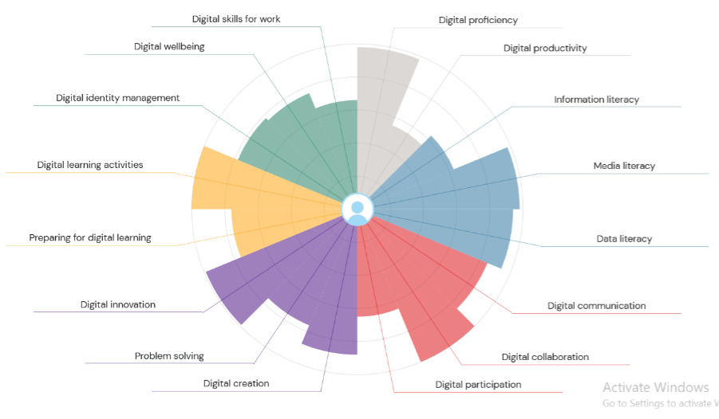

700 words on your assesment of digital skills Plus recommendations and badges you have completed because of this report

The JISC report has been used by multiple universities across the UK to evaluate student’s experience within the digital environment, and to thus give feedback to their pupils regarding their possible improvements in the digital era (JISC, n.d). As shown above, I have completed this report, and it subsequently shows a contrast: my digital capabilities strong points and weaker points. It visually shows the skills which I need to improve, and the ones that I need to strengthen. Thus, I will divide the digital capabilities shown, into two subdivisions: strong points and weak points.
My stronger points that I will first mention are “Information Literacy”, “Media Literacy” and “Data Literacy”. Although these digital capabilities differ, they are hovered over one main subject, which is Digital Literacy. As Paul Gilster suggests, he described digital literacy as “the ability to understand and use information in multiple formats from a wide range of sources when it is presented via computers” (Gilster, 1997, p.1). This simply shows that Digital Literacy is as important in the digital world as the ability to read a book. Firstly, the digital skill of Information Literacy refers to “to finding, evaluating and managing information” (Digital Literacy Unpacked, 2017, p.7). Although the report shows that I can still improve it, it shows that I have a decent ability of Information Literacy. Furthermore, while Media Literacy refers to “the ability to critically engage with digital content across formats like text, video, audio, websites, games, and simulations”, Data Literacy refers to how someone handles the data as a special form of information. (JISC, 2026), The graph shows that I excelled in these subjects, although it encourages me to improve them.
Moreover, within my “forte” points are also “Digital Collaboration”, which evaluates the way someone collaborates with others digitally, “Digital Participation”, which refer to how much someone is involved non-verbally in digital projects and work, and “Digital Communication”, which overall scales the quality of one’s communication through digital environments (JISC, 2026).
Furthermore, I showed an overall decent ability for digital creativity, which involves problem solving and digital innovation. As it is mentioned, the book “Digital Entrepreneurship” shows that collaboration is up-most important in digital creativity (Soltanifar et al, n.d). The figure below also shows the Digital Creativity Model, portrayed by Julian Sefton Green.
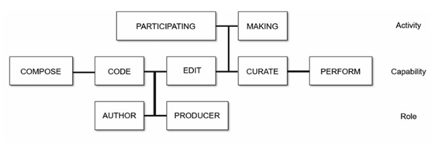

To continue, the digital skills of digital preparing activities and preparing for digital learning have also been evidenced that they had a large impact on my digital expertise. As the official site says, “Preparing for digital learning means being ready to use digital opportunities to support your learning. Preparing for digital learning might involve setting up your digital environment (devices, apps, resources and web services) to suit your learning needs”, whilst the digital skill of digital learning activities “are the different ways you learn in digital spaces and with digital media.” (JISC, 2026). As this includes participating online, using a wide range of digital media, recording and showcasing your learning, and producing digital outcomes for assessment, this shows that I have experience in these digital skills.
Lastly, my generally recognized strong point shown in the graph is “digital proficiency”, which refers to the ability and capability of using “digital devices, networks, applications, software and services.” (JISC, 2026). A study shows that this digital skill is imperative in lecturing for teachers, signifying that it is nevertheless for students too (Exploring the relationship between teachers’ competencies in AI-TPACK and digital proficiency, 2024). Thus, although most people (especially students) have already integrated technology into their daily lives, having this skill in educational atmosphere is advantageous.

Weak Digital Skill Points
The skills below are the digital skills that (mentioned in the graph) are areas which I can improve. Firstly, there’s Digital Productivity. It refers to how effectively we use digital tools and resources to enhance our output, whether in our personal or professional lives (Anderson, 2024). Digital Productivity is a counterpart in many post-modern businesses, educational institutions and personal usage atmosphere, and improving it will up-rise my other digital skills automatically.
Lastly, there are these three skills on which I also need improvement: Digital wellbeing, Digital skills for work and Digital identity management. Each of these generally refer to the impact technology and the digital skills have on the person itself: Digital Wellbeing “is about creating an intentional, healthy relationship with technology that supports rather than undermines your mental health” (Frenker, 2025), Digital skills for work refer to how well these skills influences someone in deciding their job, while Digital identity management “involves the processes and technologies that ensure the secure creation, maintenance, and deletion of digital identities, allowing users to control their online presence while safeguarding sensitive information” (What is Digital Identity Management, 2025). Because these Digital Skills have been highlighted as weak points, this creates the perfect opportunity and environment to discipline myself on improving each digital skill.

What is Digital Identity Management?

What Is Digital Well-Being and Why Is It Important? - OpenUp

What is digital productivity? – Focuskeeper Glossary
Sefton-Green, J. (2018). Is there such a thing as digital creativity? https://clalliance.org/blog/is there-such-a-thing-as-digital-creativity/.
Digital Entrepreneurship: Impact on Business and Society | Springer Nature Link

Digital Literacy Unpacked, edited by Katharine Reedy, and Jo Parker, Facet Publishing, 2017. ProQuest Ebook Central, http://ebookcentral.proquest.com/lib/trinity/detail.action?docID=5490897.
Created from trinity on 2026-03-09 18:58:50.
Digital learning activities” and “Digital innovation”

My stronger points
(5 references)

References
Digital Literacy Unpacked, edited by Katharine Reedy, and Jo Parker, Facet Publishing, 2017. ProQuest Ebook Central, http://ebookcentral.proquest.com/lib/trinity/detail.action?docID=5490897.
Created from trinity on 2026-03-09 18:58:50.
Our service | Building digital capability
Digital literacy : Gilster, Paul, 1949- : Free Download, Borrow, and Streaming : Internet Archive

Task 2

LinkedIn Learning Certificates for Office365
Add all the certificates from LinkedIn learning here

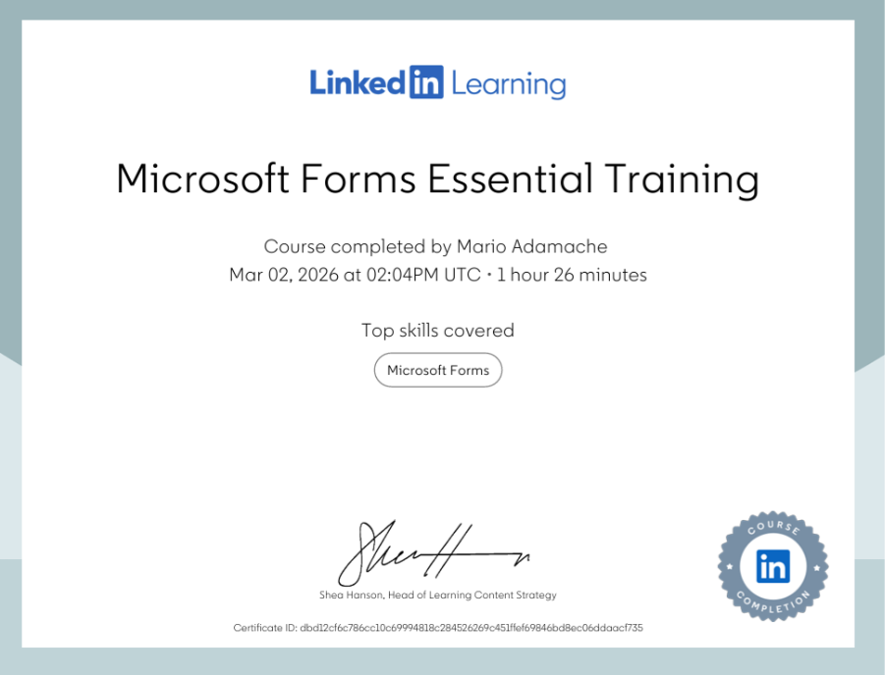

Task 3

Essay on Relevance of Excel in professional and personal life.

Microsoft Excel was created with the intention to make a dual-usage, user-friendly spreadsheet application, that could be used by businesses and individuals at the same time (SoftKeys, n.d). Thus, this application’s relevance firstly has an expanded relevance because of its large, targeted audience, used in various contexts and by different people over the whole globe. Without question, it is necessary to explain why its popularity has positively impacted businesses and individuals simultaneously and enumerate its factors orderly. Hence, this report will be divided into two sections, the first section explaining the relevance of Microsoft Excel in professional institutions, and the second section, explaining its relevance in personal usage context, by enumerating the characteristics of Excel which are appropriate for each context.
Microsoft Excel has multiple characteristics that attract businesses globally and are appropriate for professional context. Firstly, because multiple businesses, smaller or larger, use spreadsheets as a form of organizing and using their data in a neat pursuit, Microsoft Excel is one of the best options that they have, because of its accessibility and relevance regarding spreadsheet formulas (Ţarcă and Popa, 2014). A study regarding the use of Microsoft Excel tools in businesses show that small businesses embrace it, because of its efficiency: “Tools for analysis, aggregation and data modelling offered by Microsoft Excel software are used more or less in different companies. For example, in small companies, Microsoft Excel software is primarily used for recording data as spreadsheets by using simple formulas, common functions, sorting, filtering.” (Ţarcă and Popa, 2014).
Excel’s graphical design is also a major factor in businesses choosing and embracing it. As a study from Cornell University shows, “Information visualization plays a key role in business intelligence analytics.” (Lavalle, 2024). Its user interface does not contain hundreds of complicated instructions, buttons or labels, meaning that this may be another reason why it is relevant for professionals (Hermans et al, 2012).
Furthermore, another major factor that makes hundreds of businesses gravitate around Excel is its multiple digital tools that enhance data visualization, data processing, data security and data productivity. A study in Romania has shown that Excel offers correlation tools, a Solver tool, and pivot tables which allows users to organise and analyse large datasets efficiently. (Ţarcă and Popa, 2014). These tools help organisations transform raw data into meaningful insights. For example, pivot tables allow users to summarise large amounts of information quickly, while the solver tool can be used to optimise business decisions such as cost reduction or resource allocation. Excel’s analytical and visualisation tools make it a valuable resource for organisations that need to process data efficiently and support informed decision making.
Another advantage of Excel is that it allows to convert datasets into visual representations such as bar charts, pie charts, and dashboard for both personal and business environments. Data visualisation is essential to a number of individuals and businesses to help organise and communication information clearly which also support decision making. This can be proven by research which suggests that visual data representation improves understanding and allows stakeholders to interpret information clearly (Few, 2023). For instance, an example could be the opportunity given to managers to present sales trends or financial performance using charts and highlight patterns overtime. As a result, Excel plays a significant role in transforming raw data into meaningful insights.
Moreover, a well-known relevance of Microsoft Excel is that it is commonly used for inventory management, particularly in small and medium sized businesses. This is a strength of Excel as it is reliable and relevant for any sized businesses. Companies can track stock levels, monitor product sales and identify when items need to be recorded. Research shows developing spreadsheet and data analysis skills is increasingly important for employability because many modern jobs require workers to analyse digital data and interpret information for decision-making (World Economic Forum, 2023). By using formulas and conditional formatting, businesses can automatically highlight low stock levels and prevent shortages.
Another factor that highlights the continued relevance of Excel is its ability to adapt to areas that are rapidly developing due to technological innovation and digital transformation. According to a source, digital tools such as spreadsheet software remain essential for analysing data, managing information and supporting digital decision making across modern industries (European Commission, 2022). For example, as organisations increasingly rely on data driven strategies, Excel continues to evolve by integrating with modern technologies such as cloud computing, business intelligence platforms and automation systems. This is demonstrated by the fact that Excel can now connect with tools like Power BI, and cloud-based storage systems, allowing organisations to work collaboratively and analyse data in real time. Microsoft Excel’s Relevance in Personal Usage is characterized by multiple factors, one of which being it’s attractive and user-friendly User Interface. These capabilities enable businesses to transform raw information into interactive dashboards and visual reports that support strategic planning and operational efficiency. In addition, Excel’s automated features, such as macros and advanced formulas, reduce manual tasks and increase productivity. As digital innovation continues to shape modern workplaces, the ability to analyse and interpret data using spreadsheet tools remains an essential digital competency for professionals in fields such as finance, marketing, healthcare and logistics. As a result, Excel’s ability to evolve alongside technological advancements ensures that it remains relevant in emerging digital environments where data analysis, automation and innovation play a central role.
Furthermore, another factor that increased the relevance of Excel is the rapid growth in digital technology use following the COVID-19 pandemic. A source states that the pandemic accelerated digital transformation across organisations, increasing reliance on digital tools for communication, data management and remote collaboration (OECD, 2021). During periods remote working and online learning, spreadsheets such as Excel were widely used to track financial performance, analyse data and organise information. Consequently, the increased dependence on digital technologies strengthened the importance of spreadsheet skills in modern educational environments.
In conclusion, Microsoft Excel is a spreadsheet application that has expanded relevance over multiple contexts, in professional atmosphere and individual usage that nevertheless are specific in their effectiveness and characteristics. Considering the motives and factors above, its relevance not only efficiently impacts the global business life, but also each individual’s day to day life, which are represented in simple, intended and regular tasks overall. Hence, Microsoft Excel’s relevance has been thoroughly explained and evidenced in both contexts in an organized and organic method.
References
European Commission, 2022. DigComp 2.2: The Digital Competence Framework for Citizens. Luxembourg: Publications Office of the European Union.
Few, S., 2023. Data Visualisation for business intelligence. 2nd ed. Burlingame: Analytics.
Hermans, F., Pinzger, M, and van Deursen, A. (2012) Measuring spreadsheet formula understandability. Available at: https://arxiv.org/abs/1209.3517 (Accessed: 10 March 2026).
Lavalle A., Mate, A., Trujillo, J. and Rizzi S. (2024) Visualization Requirements for Business Intelligence Analytics: A Goal-Based, Iterative Framework. Available at: [2402.09491] Visualization Requirements for Business Intelligence Analytics: A Goal-Based, Iterative Framework (Accessed: 10 March 2026).
Naiana, Ţ. and Adela, P. (2014) ‘Study Regarding the Use of the Tools Offered by Microsoft Excel Software in the Activity of the Bihor County Companies’, Annals of the University of Oradea, Economic Science Series, 23(1), pp. 1075–1081. Available at: https://research-ebsco-com.uwtsd.idm.oclc.org/linkprocessor/plink?id=ba592c6c-2542-3add-bbb5-33a047cc9c53 (Accessed: 10 March 2026).
OECD, 2021. The Digital Transformation of SMEs. Paris: OECD Publishing. Available at: The Digital Transformation of SMEs | OECD (Accessed: 10 March 2026).
Softkeys (n.d.) Who created Excel? Available at: Who Created Excel? (Accessed: 10 March 2026).
The Future of Jobs Report, 2023. Geneva: World Economic Forum. Available at: The Future of Jobs Report 2023 | World Economic Forum (Accessed: 10 March 2026).

Use the following information create an Excel spread sheet, looking at income and expenditure of a typical family of 4 over the course of a year. Use formulars to achieve answers and add headings and highlight the different aspects of the finances, be realistic with the monetary amounts used for each area.
Income | Amount per month £££ | Expenditure | Amount per month £££
Wage 1 |  | Rent/Mortgage
Wage 2 |  | Council tax
Trust Funds |  | Electric
Stocks/Share payouts |  | Gas
Universal credit |  | Water rates
Student Finance |  | Food
Other |  | Car insurance
 |  | Car Tax
 |  | Fuel
 |  | Child Care Costs
 |  | Loans/credit cards
 |  | Other eg Birthdays/savings/holidays

Embed your excel here

References

Task 4

7 Minute Reflective Presentation
Create a PowerPoint presentation using techniques learned in class, reflecting on the module and what you have learned.
Maximum of 15 slides Minimum 7
You will reference your work where appropriate.
Embed PowerPoint here

References

