

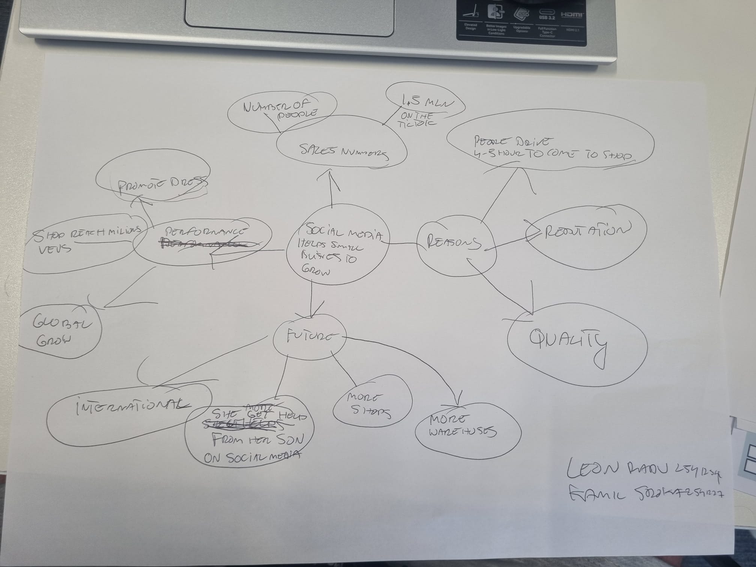

The Main idea is that social media can help you how to boost your business to grow and get more customers and good reviews.
-First point is that social media can help you create good reputation and promotes your products.
-By digital helps you can reach a mass audience and grow your profits.
-An important part of marketing is that well managed social media help in running a company and developing it so that sales and profit are large and quick
-I was not sure about How promotion through social media can affect the development and future of a company
-My group helped me by sharing ideas, discussing about topic and explaining some points
-For me the hardest part was find the most important information from the text and add them It into my own words, so that all this would make sense and be understandable.

