Dzhuliano Alenov Stefanov (2027630)

Data analysis & viusalisation
Module: ACCB4002 Lecturer: Suneth Fandaro

Deaths In England and Wales

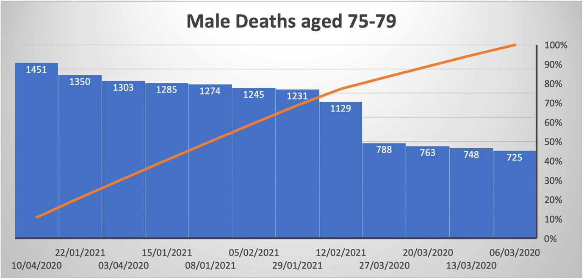

The total deaths for Men aged 75 – 79 for the time period of week 10 to week 15 in 2020 are 5,778, however next year (2021) for the same age group and sex, and same time frame (week 10 to week 15)
The deaths are 7,514
We can conclude that there is a 30% increase of death amongst males for that age group.

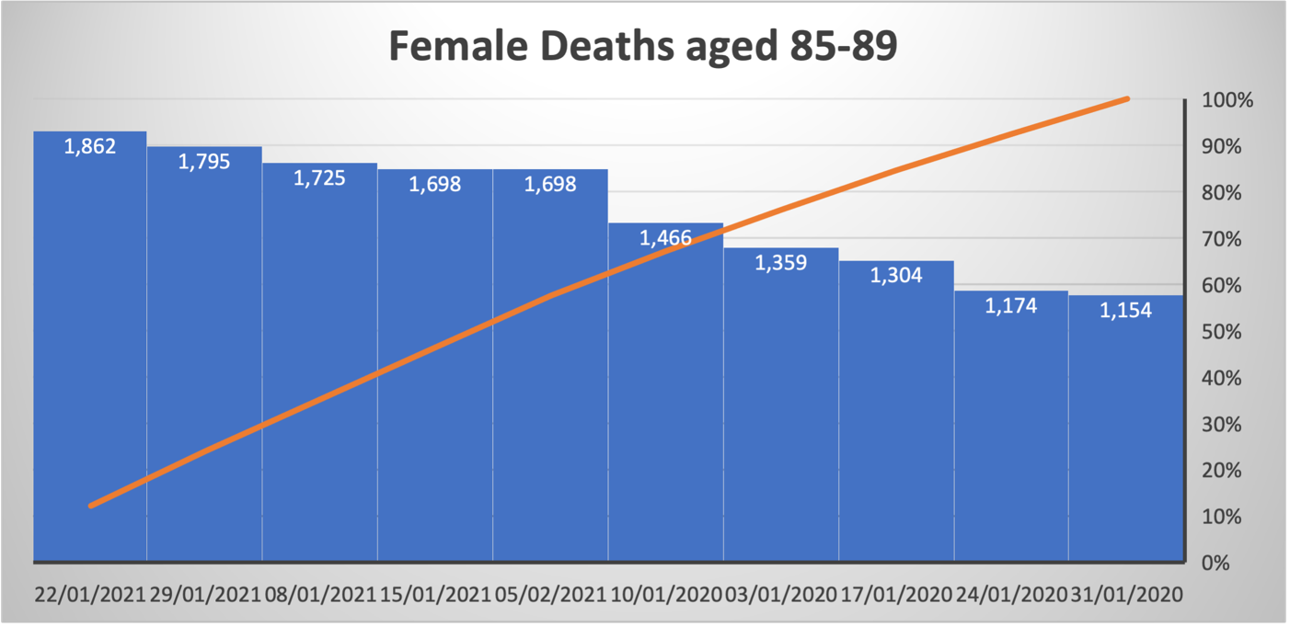

The number of deaths for females aged 85-89 and the time frame of week 1 to week 5 in 2020 are: 6,457,
But next year (2021) for the same age group and sex between week 1 and 5 there is a 30% increase of deaths (8,778).

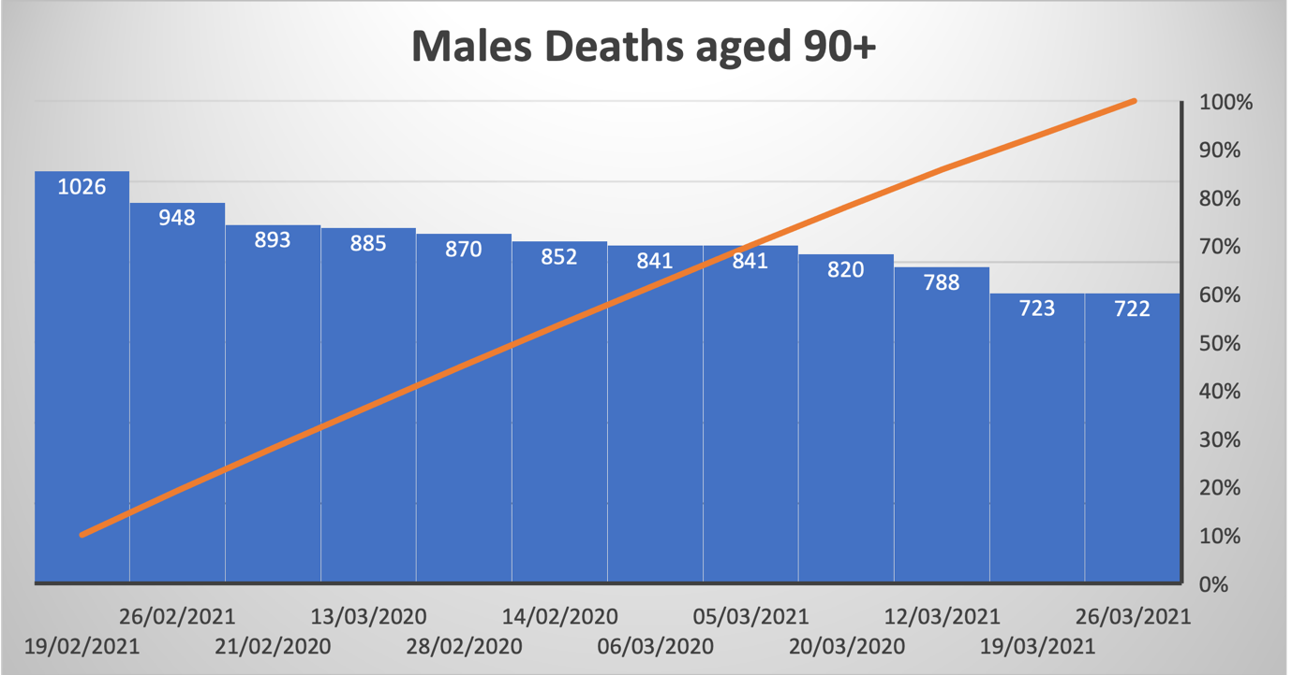

The number of deaths in Men aged 90 +,
and the time frame of week 7 to week 12 in 2020 are: 5,131
But next year (2021) for the same age group and sex between week 7 and 5 there is a 1.6% decrease of deaths (5,048).

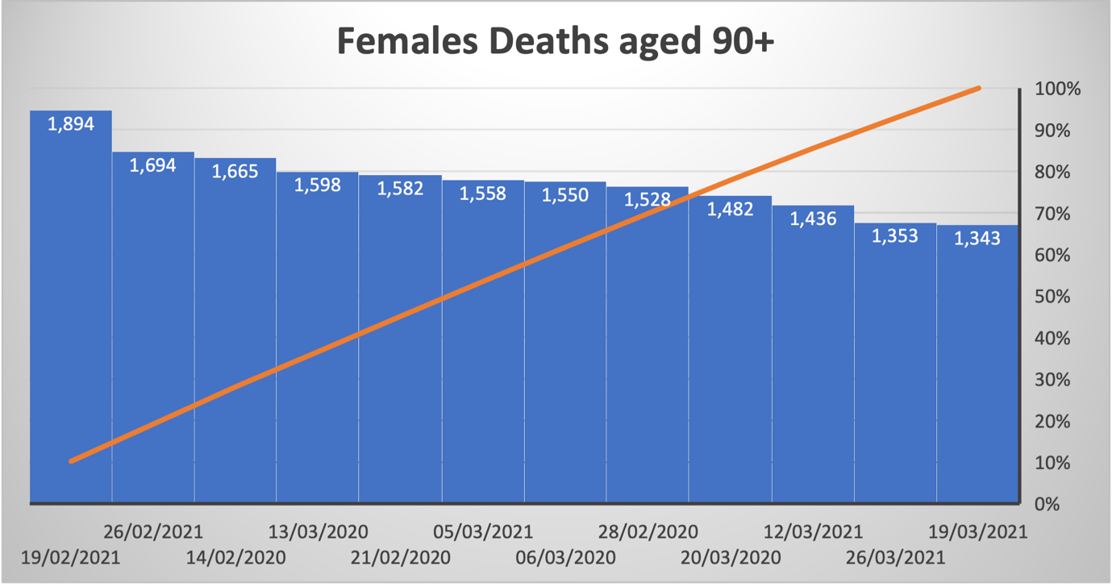

The number of deaths for females aged 90 + and the time frame of week 7 to week 12 in 2020 are: 9,405,
But next year (2021) for the same age group and sex between week 7 and 12 there is a 1.3% decrease of deaths (9278).

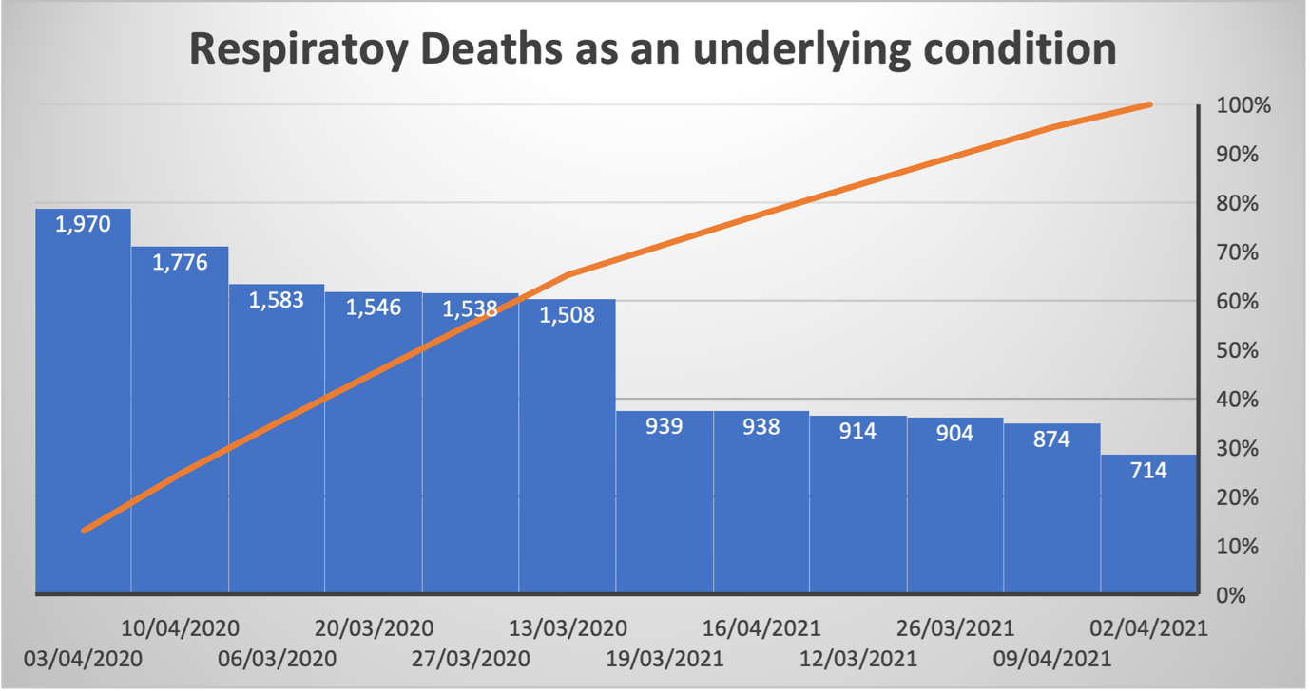

In 2020 week 10 to week 15 there are 9,921 deaths involving respiratory disease mentioned on the death certificate due to COVID-19.
However next year (2021) between week 10-15 there are only recorded 5,283 deaths that’s a 46% decrease compared to last year and my conclusion is that there is a steady decreasing in cases.

