Learning Log report – Blaenafon
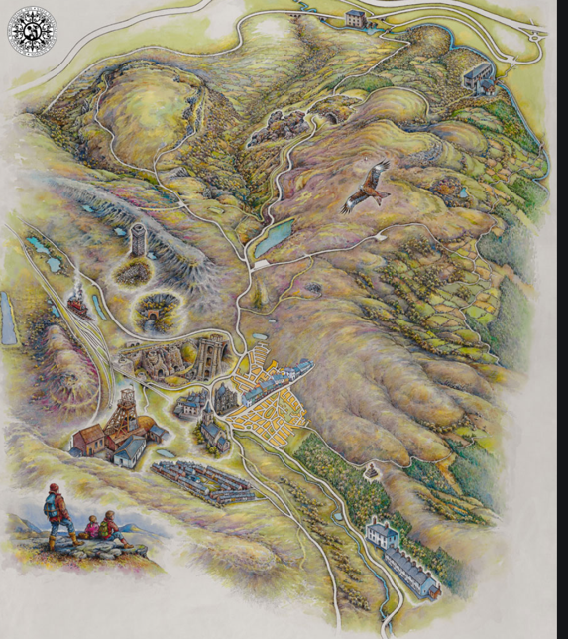
In 1787, Ironmasters Thomas Hill, Thomas Hopkins and Benjamin Pratt leased 12,000 acres of land from the Hanbury Family who leased the rights of use of timber and minerals from land between Blaenafon and Pontypool which was known as ‘Lord Abergavenny’s Hills’. They employed woodcutters to collect the timber from forests to fuel Pontypool furnaces which means they didn’t waste any productions and helped the furnace company in Pontypool. These were the main players in creating the Blaenafon Ironworks, then in 1789 Blaenafon Ironworks starts producing iron. In 1796, the Ironworks were producing 5,400 tons of iron a year. The Blaenafon Ironworks built houses alongside the ironworks for key workers.
( https://www.visitblaenavon.co.uk/en/Publications/Education/The-Blaenavon-Townscape-Story.pdf)

They also built a small network of railways to carry raw materials and products to markets, this allowed the Ironworks company to create business in the rest of wales, the Midlands, Ireland and Scotland. Railways and Canals were the main focus of transport during the industrial revolution, Blaenafon ironworks was supplied with raw materials and its products were conveyed to the coast. The port in Newport and the Monmouthshire canal was one of the reasons Thomas Hill, Thomas Hopkins and Benjamin Pratt built the Blaenafon Ironworks where it is because of how cheap it is to transport materials and products. (http://www.ggat.org.uk/cadw/historic_landscape/blaenavon/english/Blaenavon_Features.htm)

Alongside the Blaenafon Ironworks they created the ‘Company shop’ which people of blaenafon depended on for buying good for example, bread, meat, butter, cheese, footwear, clothing and general groceries. The Company shop was very popular and faced high demand especially by women, some would have to queue for up to nine hours.

Blaenafon did change the ecomony and you could say the world, the hills on the edge of the Brecon beacons were filled with coal, limestone and iron ore which was the fuel of the industrial revolution. This did help put Wales on the map a century after 1789 Sidney Gilchrist Thomas transformed the world’s steel industry by inventing a method to remove phosphorus from iron ore. (https://cadw.gov.wales/visit/places-to-visit/blaenavon-ironworks)

The Blaenafon Ironworks created a community for this area, if they didn’t have the ironworks in Blaenafon people wouldn’t have moved to the area, most people would move there for work. Blaenafon Ironworks turned Blaenafon into a thriving area for example, it created jobs, made shops e.g. the co-operative, the main shopping street broad street, made a lot of chapels. It also created a new commercial street in the ‘market field’. In 1798 the Blaenafon Ironworks employed approximately 350 people and around 1,000 people were living in the area, by 1841 Blaenafon Iron and Coal Company employed 2,000 people and over 6,000 people were living in the area. In 1848 there were many businesses created in Blaenafon, the main streets in Blaenafon for businesses were near Prince street and at the top of King Street and Queen Street area.

As you can see in this graph below, The Blaenafon population increased when the Blaenafon Ironworks was built during the industrial revolution however in 1849 the Cholera epidemic killed around 4,500 people in Wales which explains a slight decrease between 1841 to 1851 then after the first world war and especially after the second world war the population in in Blaenafon decreased rapidly.
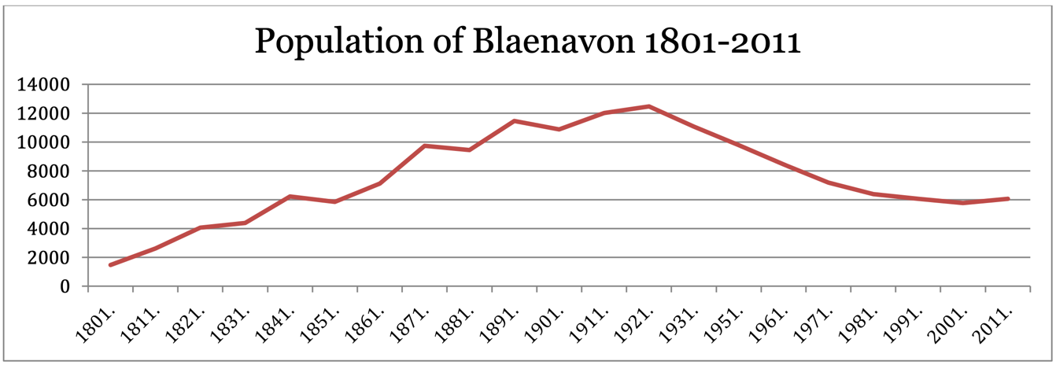
Blaenafon’s environment has lower levels of air concentrations and emissions and there is potential for energy generation from mine water and hydro. There are a few things that are bad for the environment in Blaenafon for example their peat bogs are being degraded, the number of active graziers are declining, upland fires and illegal off-road activity and parts of Blaenafon are high risk flood zones.
(http://www.torfaenpublicservicesboard.co.uk/en/Documents/Assessment-of-Well-being/Part-2-Well-being-of-Blaenavon-and-its-communities.pdf)
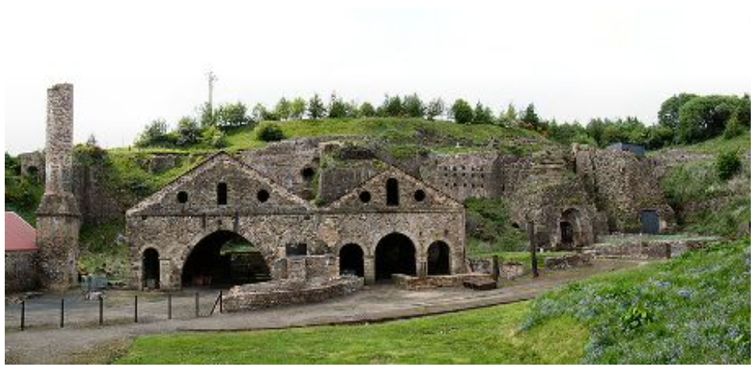
The Blaenafon Ironworks did close in the 1960’s but was saved in 1978 for the nation however the Big Pit did close in 1980 and re-opened in 1983 as a mining museum. This did cause a decrease in the population and caused a lot of residents to lose their jobs but 499 people living in Blaenafon also work in Blaenafon which means they don’t travel far for work which helps the environment. Blaenafon does have affordable housing and two thirds of households are owned outright or with a mortgage. The bad thing about Blaenafon socially is residents have a lower life expectancy, higher proportion of low birth- weight babies and a higher proportion of residents with limiting long-term illness. A positive impact of the Big Pit opening as a museum is that the World Heritage site attracts over half a million visitors a year which creates business for businesses in Blaenafon.
(http://www.essentialtravelguide.com/attractions-guides/world-heritage-sites/blaenavon-industrial-landscape/)

Another disadvantage of Blaenafon Ironworks would have been the working conditions for their employees, they suffered from many illnesses and health conditions from the coal mines. Blaenafon would push their work force to improve their profits so that the business could expand. Working in a coal mine was rough and the owners of coal mines would produce coal as cheaply as possible, a miner was paid according to how much coal he produced, not by how many hours he worked, some people would take their whole family down the mine to produce as much coal as possible to earn more money for each of their families. (www.ncm.org.uk)

Blaenafon Ironworks did help build the local economy for example nearly a fifth of working residents are employed in manufacturing and there is a higher level of full-time employment residents. However, I think there are more disadvantages Blaenafon has caused for the economy for example, higher levels of unemployed residents between the age of 16-24 or residents in long-term unemployment and lower educational attainment and 18 – 19-year olds entering higher education.

Blaenafon in the early 20th century was in high demand for quality coal for steam power generation and in 1904 iron production ceased at Blaenafon. During both world wars Blaenafon supplied shell steel for armaments and then produced aluminium magnesium alloys for the ministry of Aircraft. Sadly in 1947 the coal industry was nationalised, and people lost an interest in coal mining in Blaenafon.

Words Count: 1,003

References

https://www.visitblaenavon.co.uk/en/Publications/Education/The-Blaenavon-Townscape-Story.pdf

http://www.ggat.org.uk/cadw/historic_landscape/blaenavon/english/Blaenavon_Features.htm

https://cadw.gov.wales/visit/places-to-visit/blaenavon-ironworks

http://www.torfaenpublicservicesboard.co.uk/en/Documents/Assessment-of-Well-being/Part-2-Well-being-of-Blaenavon-and-its-communities.pdf

http://www.essentialtravelguide.com/attractions-guides/world-heritage-sites/blaenavon-industrial-landscape/

www.ncm.org.uk

