

Module Code: LCHS4009
Module Title: Professional Development within Health and Social Care

Assignment Title: LCHS4009-component 2
Module Lecturer: Anika Tahsin

Student Name: Zubeda Sembagare Umurerwa
Student ID: 2423193

Word count: 2100 words

Table of Contents
Introduction 3
Task 1 - Personal Action Plan 4
Key skills already have 4
Skills Gap and PDP Plan 5
Preparations for the Interview 7
Task 2 - Academic Report 9
Introduction 9
Problem-solving – Specification in Nursing 9
Significance of Problem-solving in Nursing Practice 9
Theoretical Implications 10
Practical Implications 10
Improvement strategies 11
Conclusion 11
Task 3 - Critical Reflection 12
Specification of the Model 12
Experience 12
Reflection 13
Action 14
Conclusion 15
Reference list 16

Introduction
In this professional portfolio, a reflective approach to emphasise the skills and knowledge required for the role of a Nurse is applied in the context of health and social care. Primarily, an action plan will be developed to determine the key skills required of a nurse and to identify improvement strategies. Next, an academic report will be prepared to emphasise a particular skill for the role essential in health and social care. Finally, a critical reflection will be performed on the presentation assessment developed in the first component.

Task 1 - Personal Action Plan

Key skills already have
The nursing role demands mixed clinical expertise, followed by interpersonal sensitivity as well as professional resilience. Amid this understanding, key skills are identified, which indeed show the importance as a nurse.
Skill | Description
Strong Communication & Interpersonal Ability | This is one of the most crucial roles when prioritising a nursing role. As explained by Babaii et al., (2021) nurses communicate with multiple individuals, including patients, doctors and patient families, as well as other multidisciplinary teams. I have strong communication skills with the necessary interpersonal abilities crucial to work in health & social care.
Empathy | Wu (2021), mention that nurse-patient interaction is pivotal to provide professional care. Research identifies that empathetic communication should be in line of patient needs. Hence my strong empathy has strengthened my listening capacity with proper verbal communication.
Adaptability | This is another important skill that I acquired. Evidence suggest that adaptability enable nurses to adequately respond to unpredicted situations, which is common in healthcare (Sovereignnursing, 2025).
Teamwork & Collaboration | Over the period of employment, the nursing role is inherent to collaboration to ensure patient-centred care (Baek et al., 2023). With continuous involvement in academic projects and group discussions, I honed the ability to interact with diverse teams, conflicts resolution and make constructive contributions in activities.
Ethical Awareness | In health and social care, adherence to ethical & safeguarding protocols is mandatory. This ensures professional integrity, accountability, confidentiality and making ethical decisions (Iomh, 2025). While I have no prior experience with this skill, I developed knowledge through my modules regarding the “Safeguarding & the Care Act”. This helps me to gather foundational insights into ethical practices.
Table 1: Potential Skills I have
(Source: Author)

Skills Gap and PDP Plan
Indeed, I acquired some potential skills through my past experiences. However, a skills gap exists.
Skill | Description
Time Management | I occasionally experience a dilemma in managing prioritised tasks, especially under immense pressure. This led to ineffective time management.
Lack of Leadership Experience | With limited experience as a team leader, I failed to make effective decisions, especially under high-stakes situations.
Poor Confidence | Although I have strong communication skill, I lack confidence when making complex decisions.
Digital Record-Keeping | In the modern digital landscape, digital record-keeping is an important ability in healthcare organisations (Huda, 2022). However, I have limited hands-on experience regarding clinical documentation, for example, SystmOne.
Data Analysis | Another gap identified is the limited ability of data interpretation based on data trends and audit outcomes.
Table 2: Key Skills Gap
(Source: Author)
Upon identifying the potential skills gap, a “Personal Development Plan” (PDP) has been developed. Ebsco (2025), explained that the PDP refers to a “structured document” which outlines personal goals upon identifying both strengths & weaknesses. This helps in setting actionable steps, thus helping in achieving key objectives relevant to personal as well as professional growth.
Goal | Action | Support/resources needed | Target date | Review Date
Improvement of task prioritisation | Using digital tools, for example, NHS e-Roster for task planning daily.  Applying techniques like the “Eisenhower Matrix”, effective in distinguishing urgent tasks from important and least important tasks. | eRooster, Eisenhower Matrix | 10.12.2025 | 7.12.2025
Building leadership ability | Volunteering group performance in leadership roles during project planning and peer mentoring  Completing online leadership management courses in Linked Learning. | Mentorship, Online courses | 05.12.2025 | 02.12.2025
Improving decision-making ability | Seeking mentorship by engaging with supervisors and senior nurses to gain feedback.  Enhancing critical thinking ability through inquiry. | Mentorship, Feedback loops | 15.12.2025 | 10.12.2025
Gaining familiarity with various types of record-keeping systems, such as EHR, besides understanding documentation standards | Reviewing NHS-based documentation protocols.  Practising mock entries through clinical case studies.  Attending online sessions for digital literacy specific to using healthcare software. | NHS protocols | 18.12.2025 | 16.12.2025
Development of analytical skills in clinical decision-making | Effectively using MS Excel to perform basic analysis of data & visualisation  Studying example files on patient audits from nursing journals. | MS Excel, EHR files | 20.12.2025 | 18.12.2025
Table 3: A Personal Development Plan
(Source: Author)

Preparations for the Interview
Question 1 | Explain in a few words why you want to be a nursing professional.
Response | As a nurse, I wanted to make a real difference in patients’ lives. With my academic background in Health & Social Care, the course has heavily impacted my focus on compassionate and skilled nursing.
Question 2 | Describe a particular event when you worked under high pressure and handled it.
Response | When I performed a presentation as my academic coursework, I experienced technical difficulties in the system. While the situation was challenging, I gradually adapted to understand the backup format while maintaining composure. The experience helped me to handle difficult situations, increase flexibility and remain composed under pressure.
Question 3 | Explain in 1-2 sentences how you handle high-risk patients and difficult families.
Response | With my strong empathetic and active listening skills, I positively acknowledge concerns and remain composed under stressful situations. This de-escalates tension, thus helping me to approach with clear information sharing & reassurance.
Table 4: Interview transcript
(Source: Author)

Task 2 - Academic Report

Introduction
In a dynamic & high-pressure environment like health and social care, nursing professionals play a vital role in making rapid patient-centric decisions, prioritising tasks and managing multiple responsibilities at the same time. Amid this focus, problem-solving skills is pivotal for a nurse. According to the information provided by Papathanasiou et al., (2020) problem-solving underpins a safe and effective, as well as compassionate nursing care for patients. As such, nurses often experience critical challenges during care provision on a regular basis. Hence, clinical decision-making for resource allocation, followed communication gaps requires adequacy in identifying the problem, critical analysis and introducing solutions aligned with patient safety and enhanced care quality. Hence, this report is phenomenal for understanding the significance of problem-solving skills in nursing.

Problem-solving – Specification in Nursing
In nursing, problem-solving skills is fundamental to identify, scan and address recurrent issues within patient care. The ability helps nurses to adopt critical thinking and reasoning, which is important for clinical decision-making (Perry et al., 2024). When applied in health and social care, problem-solving can be further disseminated to address the psychosocial needs, protection of vulnerable people, and multidisciplinary coordination.

Significance of Problem-solving in Nursing Practice
- Patient Safety - Nurses need to take prompt action to address clinical disparities like abnormal vital signs by examining the root cause and implementing suitable measures to address these changes Perry et al., 2024).
- Quality of Care - Appropriate focus on problem-solving leads to continuity of care, minimises errors, and promotes evidence-based practice (Levenson, 2021).
- Flexibility - In a health and social care setting, a dynamism is frequently observed. Hence, nurses need to adjust to shifting patient conditions, technology and healthcare policies.
- Professional Development - Problem-solving leads to reflective practice, since it allows nursing professionals to learn and retain more promising performance in the future (Horton-Deutsch and Sherwood, 2023).

Theoretical Implications
The critical thinking models and reflective frameworks are closely related to problem-solving in nursing. As stated by Bayih et al., (2021) the nursing process (assessment, diagnosis, planning, implementation, evaluation) offers a framework for solving problems in a systematic way. Correspondingly, reflective frameworks, for example, the Gibbs cycle or the ERA model, enable nurses to review their actions and improve future strategies for mitigating issues.

Practical Implications
- Clinical Decision-Making - A significant application identifies the nurse's contribution in addressing a sudden drop in oxygen saturation level (VO2). Notably, problem-solving is the appraisal of the patient, identifying potential causes (e.g., airway obstruction, infection) and presenting immediate interventions.
- Communication Problems - The lack of communication among the team members leads to ineffective care (Babaii et al., 2021). Hence, problem-solving enables nurses to provide information accurately, settle disputes and facilitate cooperation.
- Ethical Dilemmas - Iomh (2025), states that in healthcare, adherence to ethics is mandatory to support patients' autonomy and prevent conflict when offering health advice. Herein, problem-solving skills ensure adherence to ethical principles and collaborative decision-making.
Implementation Barriers to Problem-solving Skills in Nursing
- Limited time – It is evident that extreme job pressure reduces the ability to adequately analyse information gathered through specific observations in nursing (Goudarzian et al., 2024).
- Limited Opportunities - In a dynamic healthcare environment, resource constraint is a potential concern, which limits staffing and solution development.
- Emotional Stress - Nurses working in a high-pressure situation, for example, end-of-life care or patients with serious conditions after surgery, often struggle in expressing their thoughts critically (Alodhialah et al., 2024).

Improvement strategies
- Continuous Development Initiatives – As stated by Yu et al., (2022) a link between career progression and development of necessary skills is pivotal to improve nurses’ ability of problem-solving in the care environment.
- Teamwork - The multidisciplinary approach to work encourages the sharing of viewpoints and new ideas. This is essential to explore self-thoughts and overcoming shyness.
- Evidence-Based Practice (EBP) - Exploring the existing research and guidelines helps in reflecting best practices.

Conclusion
In conclusion, problem-solving has been identified as an essential skill for nursing professionals to ensure safe and patient-centred care. This report has provided critical insights into critical thinking and clinical reasoning as potential priorities of a nurse when navigating clinical complexities in the healthcare environment. This helps in standard clinical practices with adequate meeting of patient needs, while equally maintaining own well-being.

Task 3 - Critical Reflection

Specification of the Model
In this reflective practice, a comprehensive review of Component 1- Presentation will be critically reflected on. In this regard, the “Experience, Reflection and Action” (ERA) model will be used to reflect on the SWOT analysis performed in the previous component to develop an understanding of the personal strengths and areas for further improvement. The ERA model, as explained by Hull.ac.uk (2025), is a structured tool that focuses on three significant stages - experiencing, reflecting and action planning, thus fostering a self-improvement approach based on past experiences.
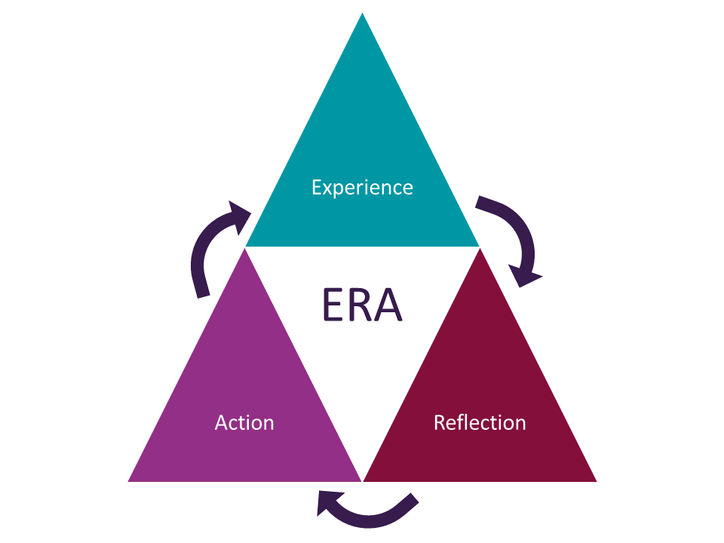
Figure 1: The ERA Model of Reflection
(Source: Hull.ac.uk, 2025)

Experience
During my preparation of the Component 1 presentation under the LCHS4009 module, I performed a personal SWOT analysis using the framework, thus reflecting my professional development. This provides insights into my ability for career growth in health & social care. Considerably, the presentation offers an array of information on my “strengths”, “weaknesses”, “opportunities” and “threats” that demonstrates my ability and career planning as a nursing staff.
Primarily, when I was preparing the presentation, I felt excited and confident regarding the content development, where I explored my potential strengths, including empathetic communication and adaptability. For better evaluation, I applied academic sources, for example, Sanmas et al., (2023) and Nightingale et al., (2023), for a better understanding of my findings. Despite the focus, I faced a dilemma with time management as well as digital formatting, thus impacted the presentation consistency.
On the presentation day, I clearly articulated my ideas while positively engaging with my audience. Herein, I applied visual tools that reinforce keypoints on every slide while adhering to the stipulated time limit. While this is true, I hesitated when emphasising my improvement areas since time management, leadership competency, and digital abilities need attention. Moreover, I experience technical glitches when changing slides. This disrupted my presentation flow.

Reflection
A critical reflection on my presentation has demonstrated my performance, which highlights both strengths and improvement areas. During the presentation, I was enthusiastic to communicate my thoughts on complex ideas through clarity & empathy. At the time, I explained ethical awareness while focusing on adaptability as a well-established concept in the current dynamic environment.
While this is true, I also experienced difficulties when presenting my insights into relative weaknesses. With limitations in my leadership experience and ineffective time management ability, I felt vulnerable and exposed with a sense of discomfort before the public. In this particular context, I understood that I need to pay attention to presenting sensitive attention skillfully to avoid awkwardness.
Overall, the feedback provided to me verbally by my lecturer highlighted my ability of presenting a well-structured presentation, which is academically grounded. However, it was also mentioned that I need improvement to maintain focus during slide transitions and keep pace. Hence, the feedback has helped me to understand how reflection plays a vital role in determining both strengths and flaws, while using the latter as a growth catalyst.

Action
Indicating the improvement areas from the reflective focus, I considered specific actions to address the areas:
- Effective Time Management - To develop this skill, I will leverage digital tools for planning and scheduling, for example, Pomodoro Timers. This will help in structuring the preparation as well a rehearsal sessions in an effective manner.
- Building Leadership Competence and Confidence - Through the reflective focus on my leadership ability and the empirical evidence gathered from the nursing scenario, I understand that an empathetic leadership trait is pivotal in patient care. Hence, I will voluntarily perform leadership roles during the group project to enhance my skills. At the same time, I will seek mentorship based on University programs.
- Refinement of Presentation Skills - With identifiable gaps in communicating the presentation, I will aim for rehearsing transitions through recorded practices in sessions. Further, I will gain peer feedback for further improvement.

Conclusion
Overall, this portfolio provides a comprehensive understanding of professional skills and knowledge essential in the health and social care practice. With the information established from all three tasks and self-accountability of the skills typically explored through the SWOT analysis in Component 1, it can be concluded that the information has showcased the learner’s readiness to dive into the nursing career and the commitment toward continuous learning, which is critical for evidence-based clinical practices & professional accountability.

Reference list
Alodhialah, A.M., Almutairi, A.A. and Almutairi, M. (2024) ‘Exploring nurses’ emotional resilience and coping strategies in palliative and End-of-Life care settings in Saudi Arabia: A qualitative study.’ In Healthcare (Vol. 12, No. 16, p. 1647). MDPI Available at: https://doi.org/10.3390/healthcare12161647
Babaii, A., Mohammadi, E. and Sadooghiasl, A. (2021) ‘The meaning of the empathetic nurse–patient communication: A qualitative study.’ Journal of patient experience, 8, p.23743735211056432. Available at: https://doi.org/10.1177/23743735211056432
Baek, H., Han, K., Cho, H. and Ju, J. (2023) ‘Nursing teamwork is essential in promoting patient-centered care: a cross-sectional study.’ BMC nursing, 22(1), p.433. Available at: https://bmcnurs.biomedcentral.com/articles/10.1186/s12912-023-01592-3 [Accessed 4 November 2025]
Bayih, W.A., Ayalew, M.Y., Belay, D.M., Alemu, A.Y., Birihane, B.M., Asnakew, S., Endalamaw, A., Demis, A., Kebede, S.D., Abate, B.B. and Baih, S.Z. (2021) ‘The implementation of nursing process during patient care in Ethiopia: A systematic review and meta-analysis.’ Heliyon, 7(5). Available at: https://www.cell.com/heliyon/fulltext/S2405-8440(21)01036-7 [Accessed 15 November 2025]
Ebsco, (2025) Personal Development Planning. Available at: https://www.ebsco.com/research-starters/psychology/personal-development-planning [Accessed 4 November 2025]
Goudarzian, A.H., Nikbakht Nasrabadi, A., Sharif-Nia, H., Farhadi, B. and Navab, E. (2024) ‘Exploring the concept and management strategies of caring stress among clinical nurses: a scoping review.’ Frontiers in psychiatry, 15, p.1337938. Available at: https://doi.org/10.3389/fpsyt.2024.1337938
Horton-Deutsch, S. and Sherwood, G. (2023) Reflective practice: reimagining ourselves, reimagining nursing. Sigma Theta Tau.
Huda, M. (2022) ‘Empowering professional and ethical balance in digital record management.’ Organizational Cybersecurity Journal: Practice, Process and People, 2(1), pp.60-73. Available at: https://doi.org/10.1108/OCJ-06-2021-0016
Hull.ac.uk, (2025) Reflective Writing – ERA. Available at: https://libguides.hull.ac.uk/reflectivewriting/era [Accessed 7 November 2025]
Iomh, (2025) What Is Safeguarding in Health and Social Care? Key Principles and Best Practices. Available at: https://iomh.co.uk/what-is-safeguarding-in-health-and-social-care-key-principles-and-best-practices/ [Accessed 4 November 2025]
Levenson, S.A. (2021) ‘The basis for improving and reforming long-term care, part 2: clinical problem solving and evidence-based care.’ Journal of the American Medical Directors Association, 10(8), pp.520-529. Available at: https://doi.org/10.1016/j.jamda.2009.05.002
Nightingale, J., Sevens, T., Appleyard, R., Campbell, S. and Burton, M. (2023) ‘Retention of radiographers in the NHS: Influencing factors across the career trajectory’, Radiography, 29(1), pp. 76–83. Available at: https://doi.org/10.1016/j.radi.2022.10.003
Papathanasiou, I.V., Kleisiaris, C.F., Fradelos, E.C., Kakou, K. and Kourkouta, L. (2020) ‘Critical thinking: the development of an essential skill for nursing students.’ Acta Informatica Medica, 22(4), p.283. Available at: https://doi.org/10.5455/aim.2014.22.283-286
Perry, A.G., Potter, P.A., Ostendorf, W.R. and Laplante, N. (2024) Clinical Nursing Skills and Techniques-E-Book: Clinical Nursing Skills and Techniques-E-Book. Elsevier Health Sciences.
Sanmas, M., Qadir, A., Nahria, N. and Laili, I. (2023) ‘The Role of Interpersonal Communication in Enhancing Teamwork Effectiveness in the Digital Era’, LITERATUS, 5(2). Available at: https://doi.org/10.37010/lit.v5i2.1503.
Sovereignnursing, (2025) The Importance of Continuous Learning and Adaptability in Nursing. Available at: https://sovereignnursing.com/the-importance-of-continuous-learning-and-adaptability-in-nursing/ [Accessed 7 November 2025]
Wu, Y. (2021) ‘Empathy in nurse-patient interaction: a conversation analysis.’ BMC nursing, 20(1), p.18. Available at: https://bmcnurs.biomedcentral.com/articles/10.1186/s12912-021-00535-0
Yu, X., Huang, Y. and Liu, Y. (2022) ‘Nurses’ perceptions of continuing professional development: a qualitative study.’ BMC nursing, 21(1), p.162. Available at: https://link.springer.com/article/10.1186/s12912-022-00940-z [Accessed 15 November 2025]

