Daniel Thomas (2003824)
BA Animation & VFX / BA Computer Games Design
Changemakers: Creativity and Value Creation
ACCA5033
Assignment 1: Innovation & Research

Contents
Task A- Mind Map 2
Task B - Moodboards 2
Bug Characters 3
Flower Characters 3
Robot Characters 4
Task C - Initial Designs 4
Task D - Written Summary 7
References 8

Task A- Mind Map
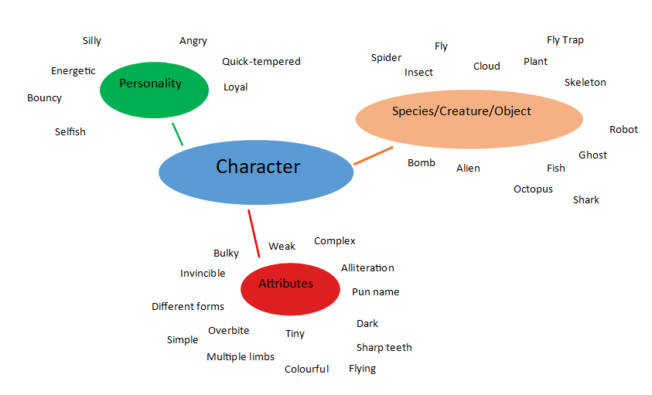

Task B - Moodboards

Bug Characters
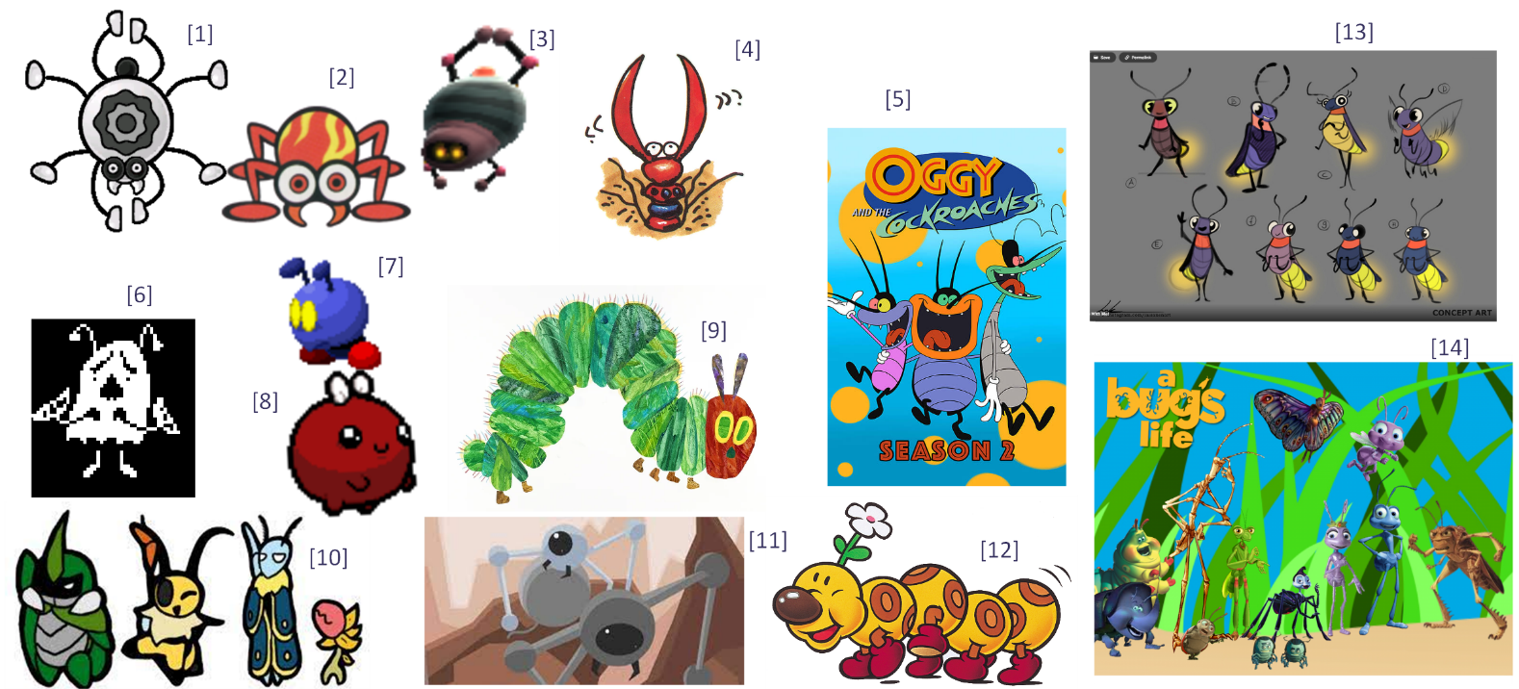

Flower Characters
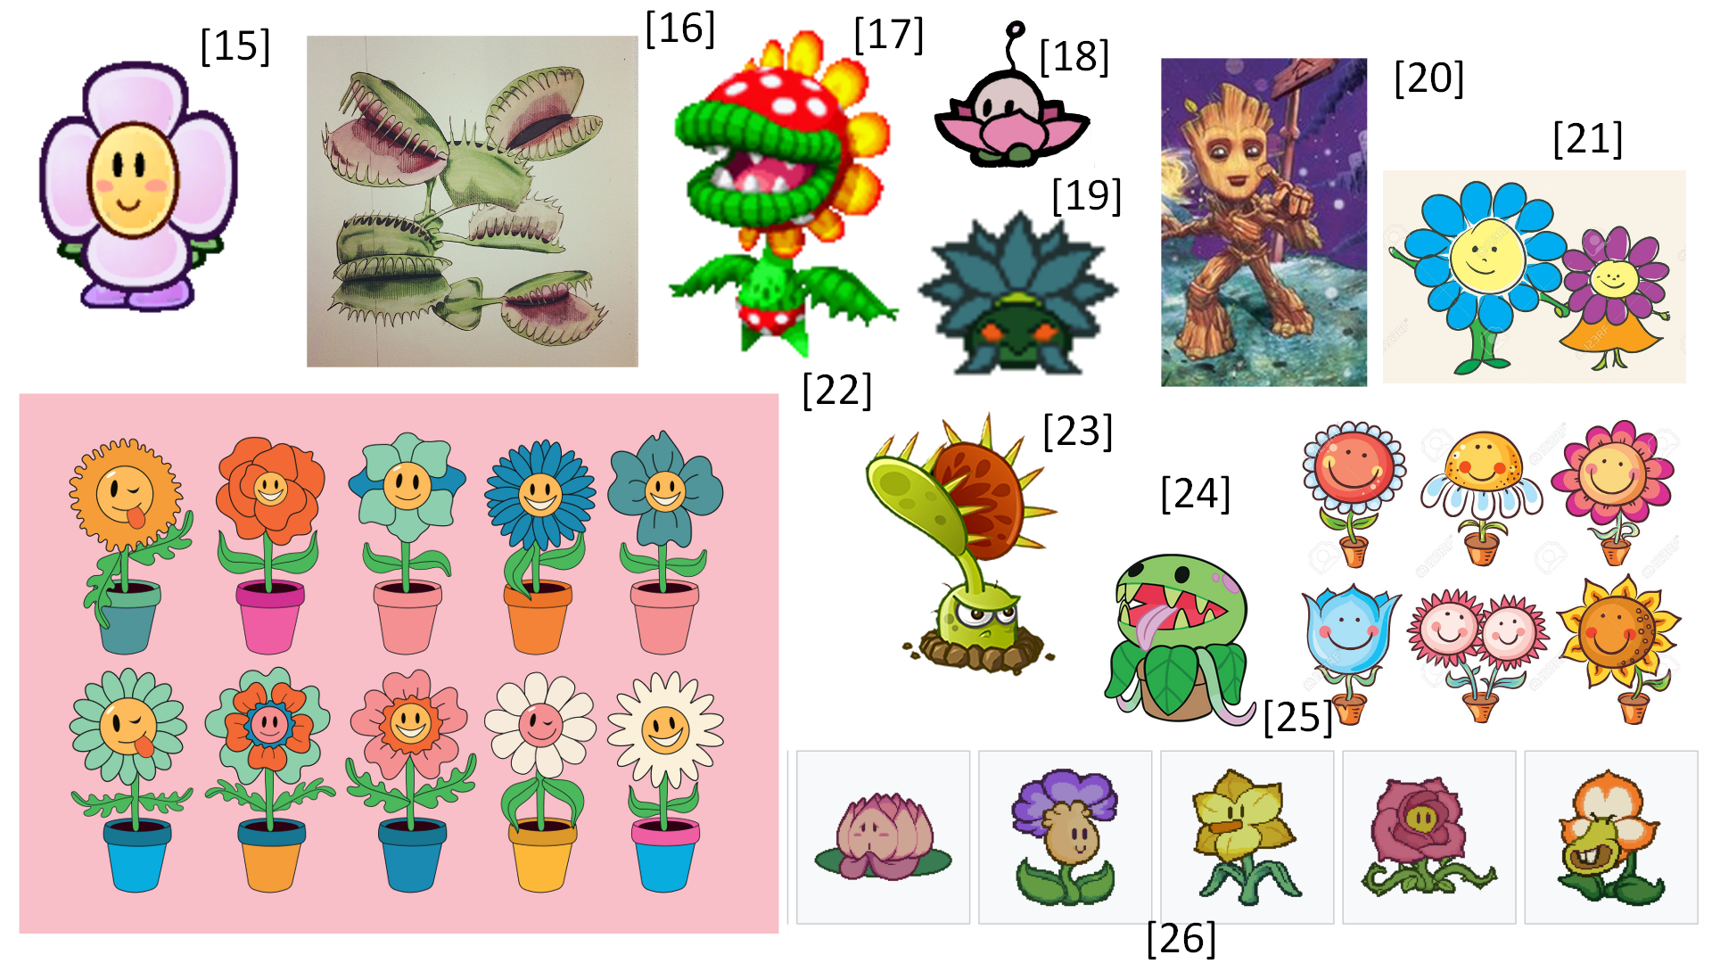

Robot Characters
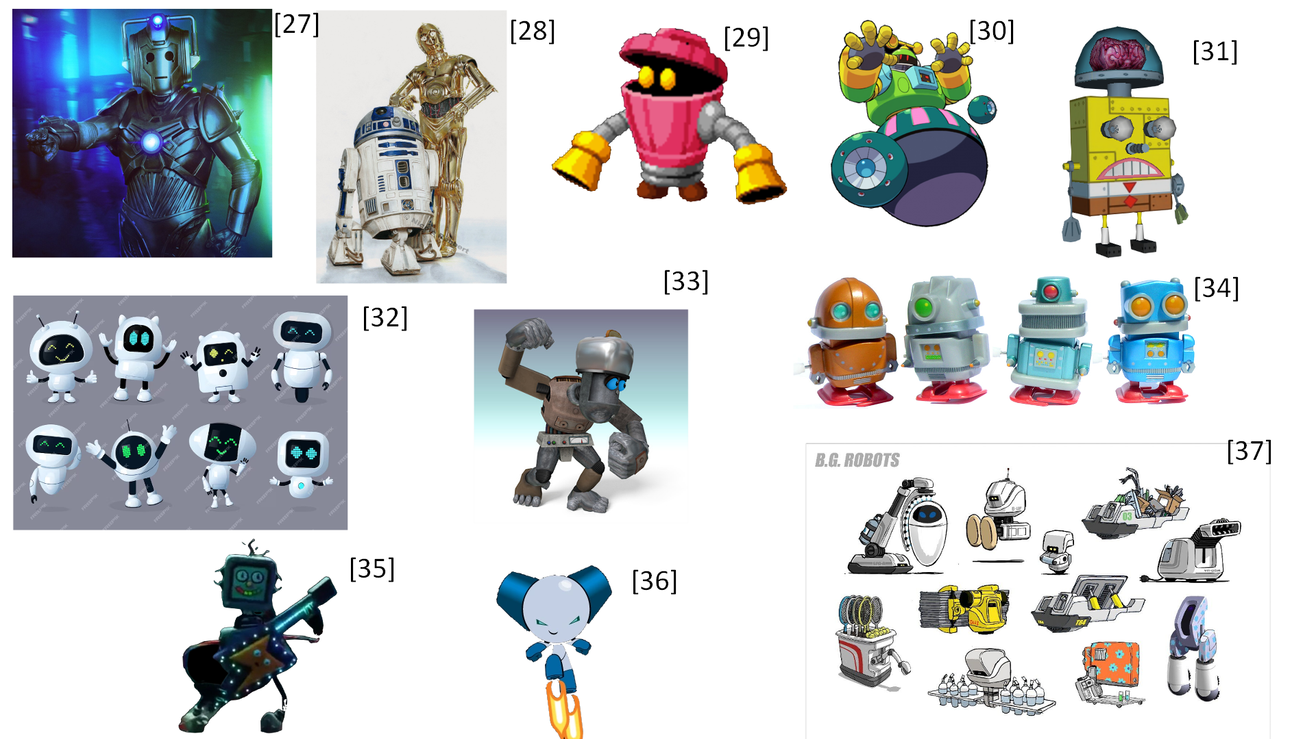

Task C - Initial Designs
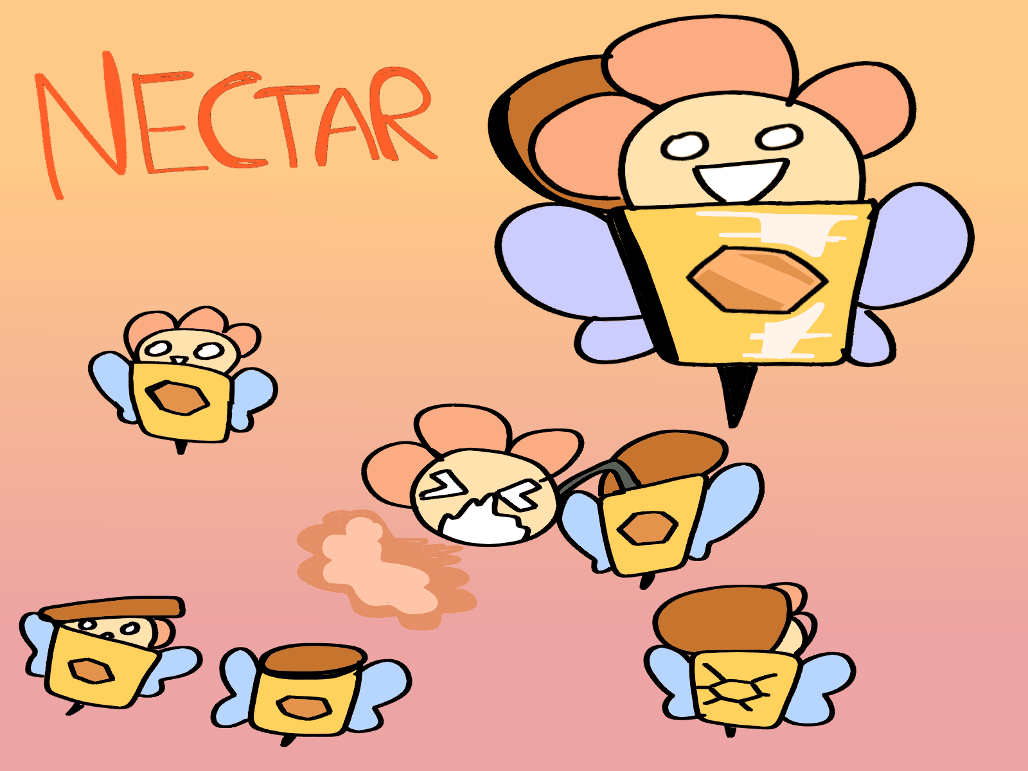
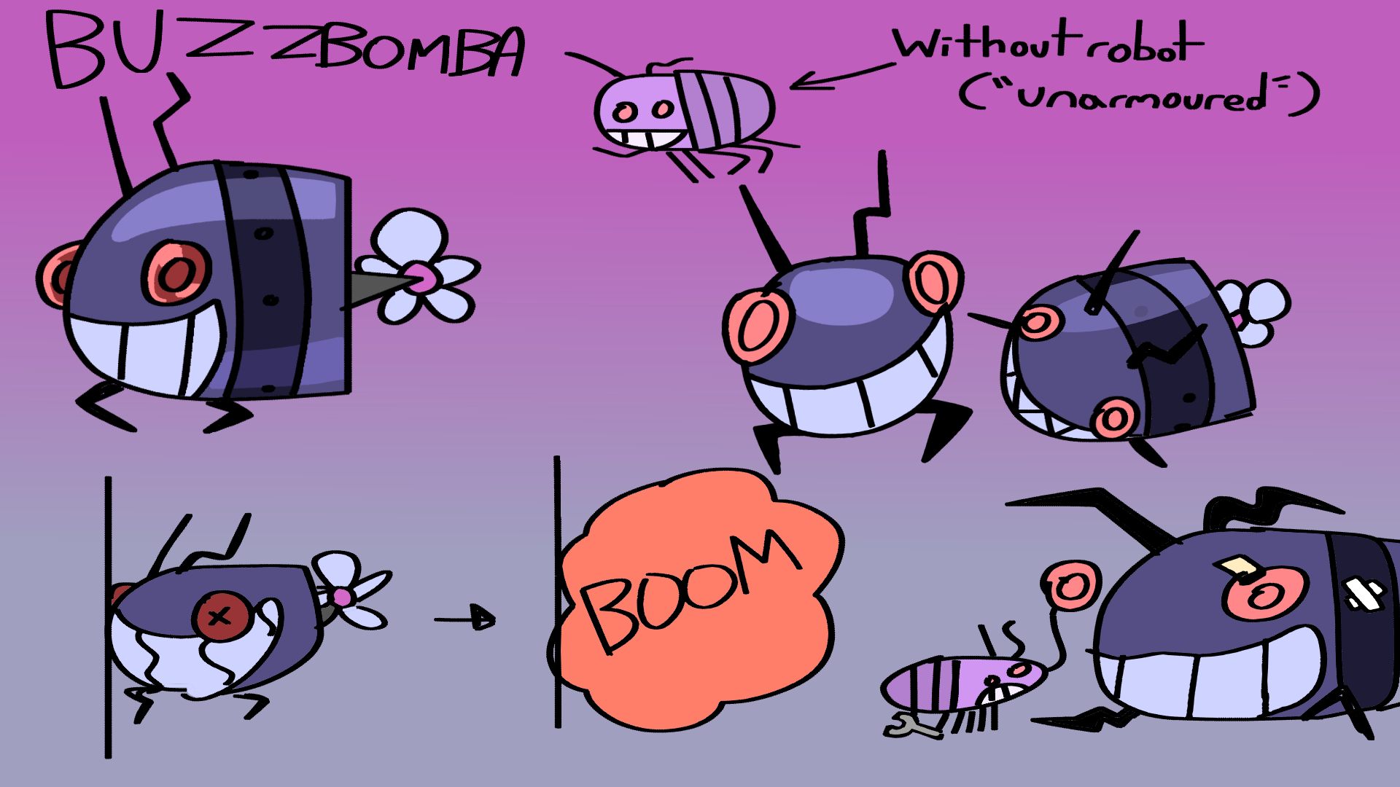
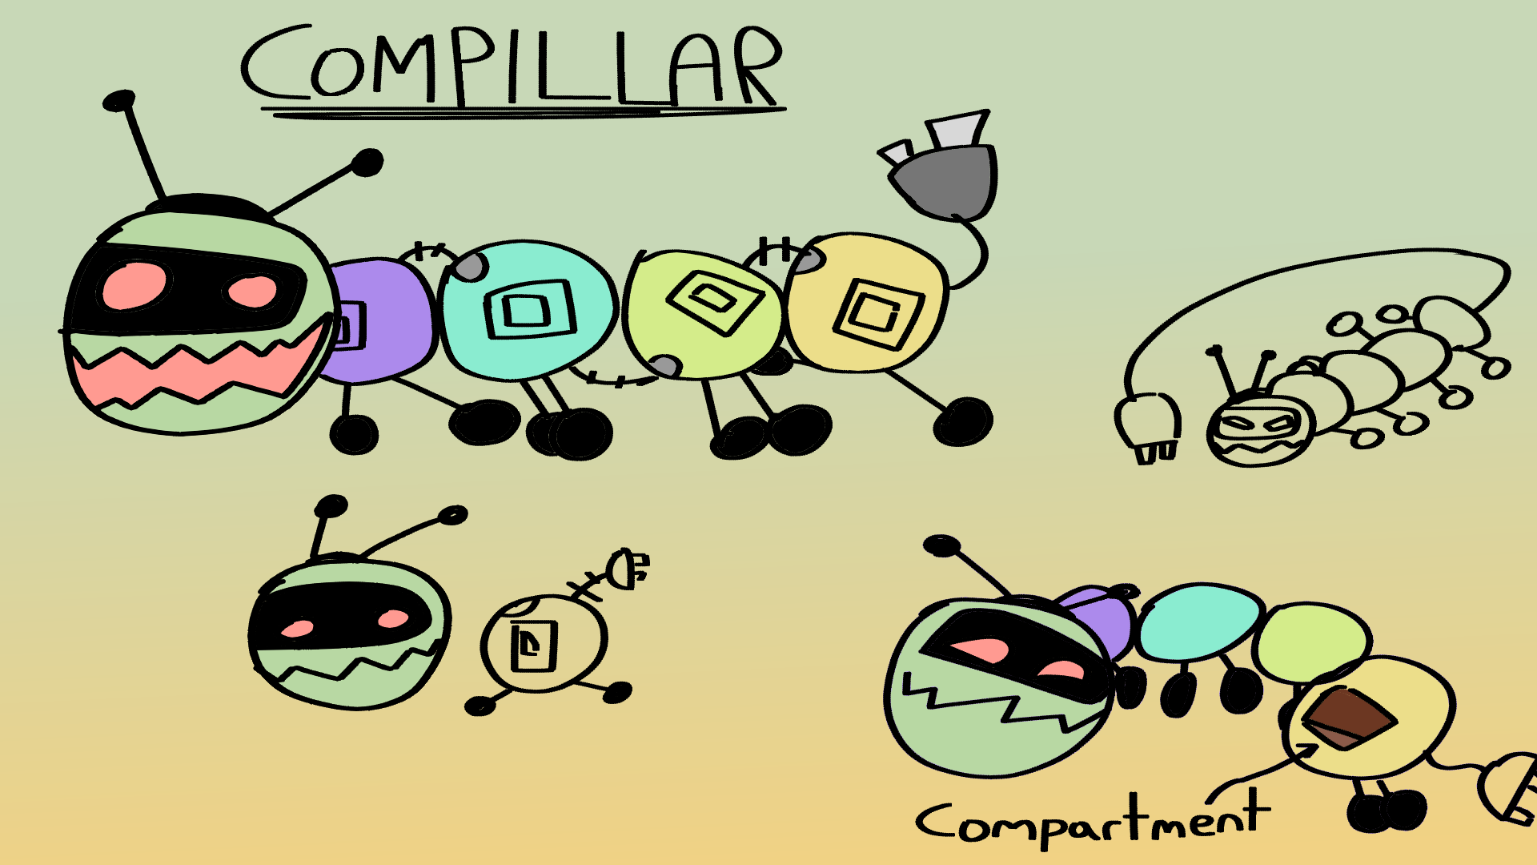
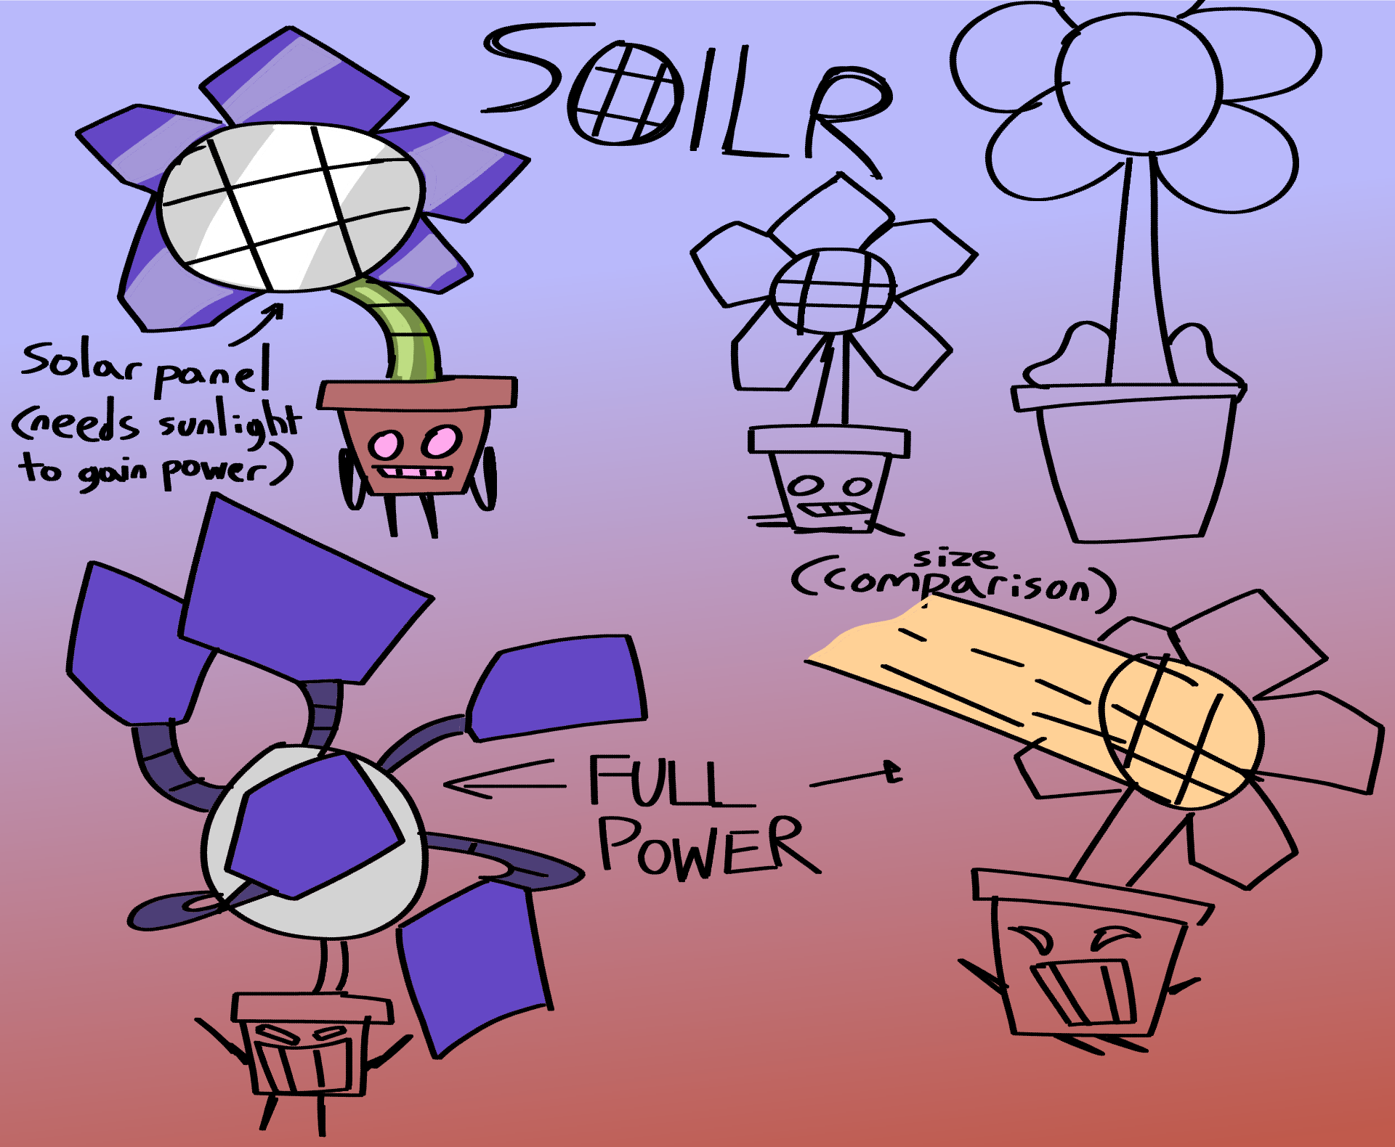
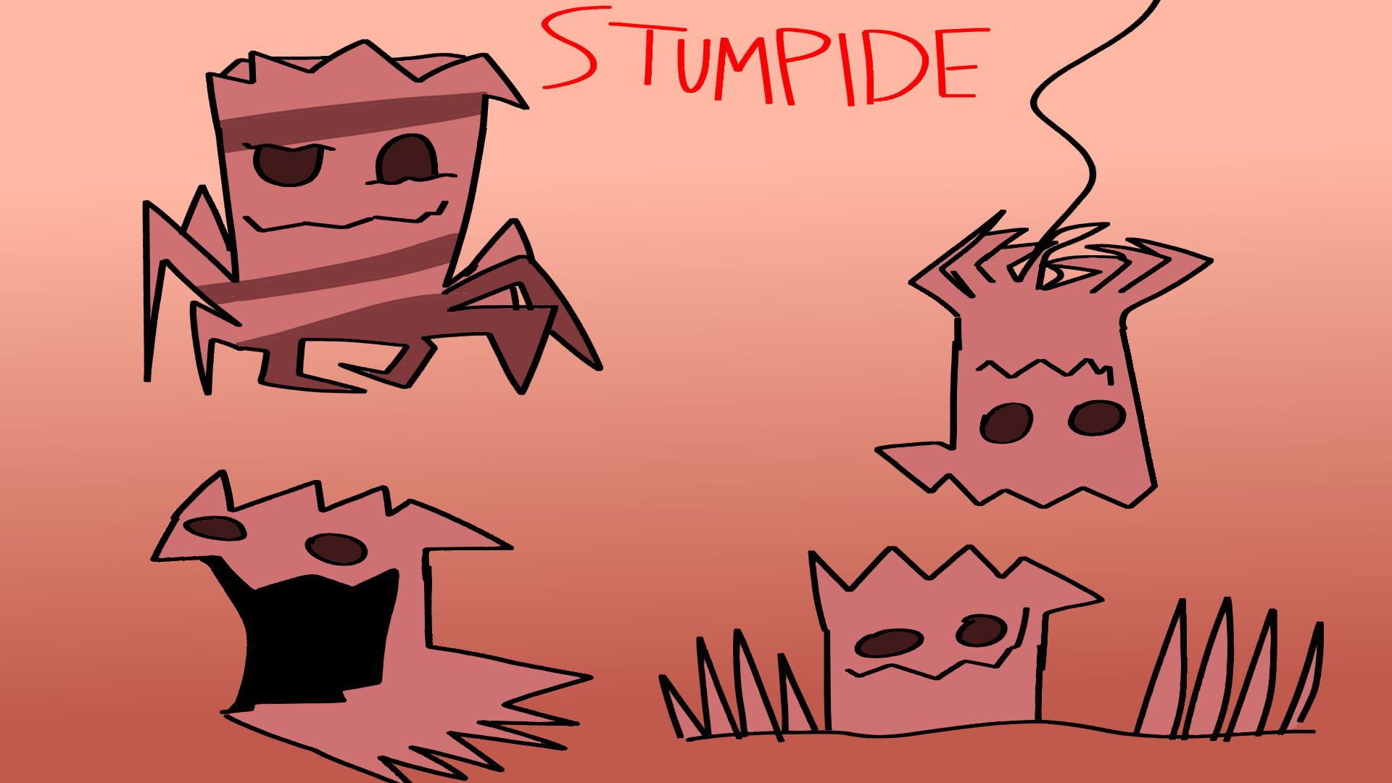

Task D - Written Summary
When trying to mix the three themes I researched in Task B, that being plants, bugs and robots, I ended up with multiple designs reflecting the general theme of nature being mutated or roboticized. The one best combining the three themes is the first design I drew called Nectar. It has a mechanical design based on a pot, even having a lid to close itself in, wings and a stinger at the bottom like a bee, and a head like a flower which even has a neck resembling a stem. There is also a honeycomb to further its bee theme. The idea of the name being “Nectar” is to allude to both the flower and bee like design of the creature, as well as it somewhat sounding like a robot name. This robot’s purpose is similar to a bee too, getting nectar from flowers and storing it to make honey. It’s designed to be somewhat evasive, with its wings and lid keeping it out of distance, and it can also shoot out pollen for self defence.
The second design is something I named Buzzbomba, originally designed to just be the robot but later changed to be more of a mech with an actual bug controlling it. As the alliterative name suggests, the robot is more of a bomb, designed after a bug. I took inspiration from some of the more “toothier” designed robots from the moodboard in Task B and applied a big grin to this robot. I also still tried to include a flower motif, and so added a flower-like propeller at the end. The “pilot” is a more generic bug design, slightly resembling the robot, namely with the grin, and having stripes resembling a few of the bugs in the bug moodboard. As the robot is designed to explode, the bug always has to rebuild the robot. While subtle, there’s a hint of personality given it the bug’s label, being quoted as “unarmoured” as a way of it coming off as a bigger threat as it actually is, also explaining why the names of the two entities are the same. The fact that the robot itself is an explosive device also implies some aggression with the bug.
For Compillar, the design is based on a caterpillar’s segmented body, with each segment being connected by plugs. The name itself plays off this, being a combination of “compile” and “caterpillar”. The design of Compillar also uses other elements of the robots shown on Task B’s moodboard, such as the wheels and black visor & eyes. The antennae is also a TV antennae compared to usual bug’s. It also has a jagged mouth, which was actually leaning more to the idea of a venus fly trap. Each segment Compillar has contains a compartment where things could be put in, so it gives the robot a purpose of transporting things from one place to the other. If Compillar was big enough, it could even be considered a vehicle.
Soilr is a robot based on a potted flower and the idea of solar power, hence the name “Soilr” sounding like “solar”. The solar panel is found in the centre of the mechanical flower itself, and the more power it has, the more abilities the flower can use, mostly involving the “petals” which function as extra limbs. It can also fire a beam at full power. The pot is also very loosely based on some of the bug characters from before, having stubby limbs and being smaller than an actual plant pot.
The final design and least mechanical design I made was Stumpide, a tree stump resembling a spider, having 8 roots like a spider has 8 legs. The jagged mouth it has is based on the occasional roughness of a tree. Similarly, the stripes added on one of the drawings both reference the “lines” of a tree and some of the bugs’ stripes. Stumpide acts a basic spider, albeit a very large one as it would still be the size of a tree stump. It can also plant itself in the ground and spread its roots across the ground to pop up elsewhere. Out of the five designs, this would be the most deadly one despite it’s happy expressions.

References
[1] “Pider,” Super Mario Wiki, January 8, 2024 (Online) Accessed: Feb 23 2024, Available: https://www.mariowiki.com/Pider
[2] “Scuttlebug”, Super Mario Wiki, February 8, 2024 (Online) Accessed: Feb 23, 2024, Available: https://www.mariowiki.com/Scuttlebug
[3] “Sprangler”, Super Mario Wiki, January 11, 2024 (Online) Accessed: Feb 23, 2024, Available: https://www.mariowiki.com/Sprangler
[4] “Pit Master”, Sonic Wiki Zone (Online) Accessed: Feb 23, 2024, Available: https://sonic.fandom.com/wiki/Pit_Master
[5] “Oggy and the Cockroaches (1999)” TMBD, (Online) Accessed: Feb 23, 2024, Available: https://www.themoviedb.org/tv/2777-oggy-and-the-cockroaches/seasons
[6] “Whimsun”, Undertale Wiki (Online) Accessed: Feb 23, 2024, Available: https://undertale.fandom.com/wiki/Whimsun
[7] “Ant Trooper”, Super Mario Wiki, January 8, 2024 (Online) Accessed: Feb 23, 2024, Available: https://www.mariowiki.com/Ant_Trooper
[8] “Baby Plum”. The Spriters Resource (Online) Accessed: Feb 23, 2024 Available: https://www.spriters-resource.com/pc_computer/bindingofisaacrebirth/sheet/153545/
[9] “Illustration from “The Very Hungry Caterpillar”, 1969 and 1987”, Eric Carle, Artsy, 2016 (Online) Accessed: Feb 23, 2024, Available: https://www.artsy.net/artwork/eric-carle-illustration-from-the-very-hungry-caterpillar
[10] “Team Snakemouth”, Bug Fables Wiki (Online) Accessed: Feb 23, 2024, Available: https://bugfables.fandom.com/wiki/Team_Snakemouth
[11] “Tri-Achnid”, by Florian Himsl and Edmund McMillen, Crazy Games, November 2020 (Online) Accessed: Feb 23, 2024, Available: https://www.crazygames.com/game/tri-achnid
[12] “Gallery: Wiggler”, Super Mario Wiki, January 28, 2024 (Online) Accessed: Feb 23, 2024, Available: https://www.mariowiki.com/Gallery:Wiggler
[13] “Character Design - Come With Me!”, Liisa Kareranta, Behance, November 16 2019 (Online) Accessed: Feb 23 2024, Available: https://www.behance.net/gallery/88233763/Character-Design-Come-With-Me
[14] “A Bug’s Life Characters Quiz,” Mr. Minion, PurposeGames March 25, 2022 (Online) Accessed: Feb 23 2024, Available: https://www.purposegames.com/game/RSa2qfLZLY3
[15] “Crazee Dayzee”, Super Mario Wiki, January 27, 2024 (Online) Accessed: Feb 23, 2024, Available: https://www.mariowiki.com/Crazee_Dayzee
[16] “#124 Venus fly trap”, Biology Notes for A level, 17 June 2016 (Online), Accessed: Feb 23, 2024, Available: http://biology4alevel.blogspot.com/2016/06/126-venus-fly-trap.html
[17] “Gallery: Petey Piranha”, Super Mario Wiki, December 11, 2023 (Online) Accessed: Feb 23, 2024, Available: https://www.mariowiki.com/Gallery:Petey_Piranha
[18] “Flowerling”, Bug Fables Wiki (Online) Accessed: Feb 23, 2024, Available: https://bugfables.fandom.com/wiki/Flowerling
[19] “M. Bush”, Super Mario Wiki, November 13, 2023 (Online) Accessed: Feb 23, 2024, Available: https://www.mariowiki.com/M._Bush
[20] “Groot”, Wikipedia, 19 February 2024 (Online) Accessed: Feb 23, 2024, Available: https://en.wikipedia.org/wiki/Groot
[21] “Little boy and girl smiling flowers cartoon image”, azgek, 123RF (Online) Accessed: Feb 23, 2024, Available: https://www.123rf.com/photo_15419616_little-boy-and-girl-smiling-flowers-cartoon-image.html
[22] “Collection of flower pots”, Art ydacha7, Vecteezy (Online) Accessed: Feb 23, 2024, Available: https://www.vecteezy.com/vector-art/21392100-collection-of-flower-pots-various-shapes-and-colors-abstract-cartoon-characters-with-faces-vector-illustration-botanical-pot-cute-home-indoor-plants-isolated-elements
[23] “Venus Flytrap”, Plants vs Zombie Wiki (Online) Accessed: Feb 23, 2024, Available: https://plantsvszombies.fandom.com/wiki/Venus_Flytrap
[24] “Squishable: The Mysterious Doctor Plague” (Online) Accessed: Feb 23, 2024, Available: https://www.squishable.com/mm5/merchant.mvc?Screen=CHAR
[25] “Flowers in pots as happy cartoon characters with faces” katedev 123RF (Online) Accessed: Feb 23, 2024, Available: https://www.123rf.com/photo_46791614_flowers-in-pots-as-happy-cartoon-characters-with-faces.html
[26] “Flower Spirit”, Super Mario Wiki, April 20, 2022 (Online) Accessed: Feb 23, 2024, Available: https://www.mariowiki.com/Flower_Spirit
[27] “Cyberman”, Doctor Who (Online) Accessed: Feb 23, 2024, Available: https://www.doctorwho.tv/characters/cybermen
[28] “R2D2 and C3PO (drawing)”, Quelchii, Deviantart, November 1, 2015 (Online) Accessed: Feb 23, 2024 Available: https://www.deviantart.com/quelchii/art/R2D2-and-C3PO-drawing-569659327
[29] “Junker”, Super Mario Wiki, February 17, 2024 (Online) Accessed: Feb 23, 2024, Available: https://www.mariowiki.com/Junker
[30] “Astro Man”, MegaManMaker Wiki, 2 February 2024 (Online) Accessed: Feb 23, 2024, Available: https://wiki.megamanmaker.com/index.php/Astro_Man
[31] “Robot SpongeBob”, The Models Resource (Online) Accessed: Feb 23, 2024, Available: https://www.models-resource.com/pc_computer/thespongebobsquarepantsmovie/model/22977/
[32] “Robots character vector set design robotic characters isolated for robot cyborg digital ai”, ZeinousStudio (Online) Accessed: Feb 23, 2024, Available: https://www.freepik.com/premium-vector/robots-character-vector-set-design-robotic-characters-isolated-robot-cyborg-digital-ai_40077363.htm
“Metal-head Donkey Kong” Peardian, Tumblr, September 28, 2015 (Online) Accessed: Feb 28, 2024 Available: https://peardian.tumblr.com/post/130099065513/metal-head-dk
“WIND UP ROBOT”, Protocol (Online) Accessed: Feb 23, 2024, Available: https://www.webprotocol.com/en/main-menu/products/wind-up/1257-wind-up-robot
“Electracey”, Don’t Hug Me I’m Scared Wiki (Online) Accessed: Feb 24, 2024, Available: https://donthugme.fandom.com/wiki/Electracey
“Robotboy” Robotboy Wiki (Online), Accessed: Feb 23, 2024, Available: https://robotboy.fandom.com/wiki/Robotboy_(character)
“JASON DEAMER INTERVIEW”, Randall Sly, Blogspot, July 28, 2010 (Online) Accessed: Feb 23, 2024, Available: http://jason-deamer-interview.blogspot.com/

