UWTSD
BMHR7010: Resourcing and Talent Management, Level 7

The New Talent Economy – A Challenging Climate



Author: Rachel Parfitt (2005681)
Date: February 2022
Word Count: 4,749

“Adapting employees’ skills and roles to the post-pandemic ways of working will be crucial to building operating-model resilience”
(Agrawal, S. et al., 2020, COVID-19 and reskilling the workforce | McKinsey)

“The future of the workforce is project-based, flexible workers and the winners will be those companies that engage people how they want to be engaged”
(Bridgland, J., 2018, Flex or Break - How to Engage the New Talent Economy (slideshare.net))

Glossary of Terms

BEIS Department for Business, Energy and Industrial Strategy
CIPD Chartered Institute of Personnel Development
ONS Office of National Statistics
PESTLE Political, Economic, Sociological, Technological, Legal and Environmental
RTM Resourcing and Talent Management
VCL Viscose Closures Limited
VUCA Volatility, Uncertainty, Complexity, Ambiguity
WHO World Health Organisation

Executive Summary

The following report evaluates internal and external factors that are creating a challenging climate for Viscose Closures Limited (VCL).
A critical analysis of the current HR systems, processes, and practices at VCL to address these factors is presented and their suitability for the future of work is assessed.
Recommendations for improvements to the talent management approach at VCL to address the changes in the way we work will be presented for review by the CEO and Finance Director. These recommendations will also include any cost implications for VCL.

Table of Contents
Glossary of Terms 3
Executive Summary 4
Table of Contents 5
Table of Figures 6
1. Introduction 7
2. Evaluation of Internal and External Factors creating a challenging environment for VCL 8
2.1 Internal factors 8
2.1.1 Increase in workload 8
2.1.2 New CEO 8
2.1.3 Employee Relations 8
2.1.4 Culture 9
2.2 External factors (PESTLE Analysis) 9
2.2.1 Political 9
2.2.2 Economic 10
2.2.3 Social 10
2.2.4 Technology 11
2.2.5 Legal 11
2.2.6 Environmental 11
3. Critical Analysis of HR systems, processes and practices currently in place at VCL 12
3.1 Resourcing Strategy at VCL 12
3.1.1 Alternative views of the HR-business strategy link 13
3.1.2 The GIG / Open Talent Economy 14
3.1.3 Flexible / Hybrid working 15
3.2 Talent Management Strategy at VCL 16
3.3 Recruitment Strategy 17
3.4 Workforce Planning at VCL 19
3.5 Retention Strategies at VCL 21
4. Conclusions 23
5. Recommendations 25
5.1 Focus on multi-skilling the Production-based workforce 25
5.2 Consider Apprenticeships to improve skills 25
5.3 Continuous improvement of policies and procedures 26
5.4 Consider in house vs outsourcing recruitment 27
5.5 Timeframe and Costs 27
References 28
Appendix 1 – PESTLE Analysis for VCL 39
Appendix 2 - Action Plan 43

Table of Figures
Figure 1 - Higgs Model (Higgs, 2004) 13
Figure 2 - Flexible Firm (Atkinson, 1984) 15
Figure 3 - The Full Cycle of Recruitment (Mishra, 2021) 17
Figure 4 - Workforce Planning (CIPD, 2021b) 19
Figure 5- Maslow's Hierarchy of Needs, Macloed, 2020 20

1. Introduction
Viscose Closures Limited (VCL) is a manufacturing company based in Swansea, UK. VCL has been manufacturing for more than 100 years and is regarded as one of the leading UK players in the caps, closures, seals and sleeving markets. VCL is also an importer of plastic and metal closures from Europe which are sold globally and predominantly to drink manufacturers. VCL’s unique selling propositions are manufacturing expertise and exceptional customer service. VCL has 50 employees and is a unionised organisation.
As a result of the pandemic and like most organisations VCL has been forced to adapt to the changing working conditions (Worley and Claudy, 2020) – i.e. the workforce has been split between homeworkers and those unable to work from home so have still been required to come to the site.
For VCL to achieve the ambitious targets set for 2022 of aggressive sales growth using existing staff and resources, the importance of retaining and engaging the workforce should not be underestimated (Armstrong, 2017).
For the purpose of this report a challenging climate refers to the ongoing uncertainty around the continued impact of the pandemic and VCL’s ability to continue with business critical operations despite employee shortages or reductions (CIPD,2020a).

Evaluation of Internal and External Factors creating a challenging environment for VCL

2.1 Internal factors

2.1.1 Increase in workload
The workforce at VCL has seen an increase in workload due to the pandemic as it supplies the food and beverage industry, the NHS and other pharmaceutical industries. Whilst this has been beneficial to the overall success of the business it has negatively impacted the ability to continue with multi-skilling of the workforce due to time restraints. Staff are operating machinery and equipment around the clock to meet customer demand and are therefore unable to be released from their current activities to learn new tasks.
This could harm retention as employees may feel underutilised and become bored at work (Hassan, et al., 2013).

2.1.2 New CEO
A new CEO joined VCL in February 2020. Since then, there has been a positive change in culture with employees becoming more engaged and happier. The management style has also transitioned from autocratic to a more laissez-faire approach (Lewin, 1939). Senior Managers are now enabled, empowered and authorised to make their own decisions. However, this has not been entirely positive with one member of the senior team leaving the business in December 2021 due to conflicting beliefs over management style (Lipman, 2015).

2.1.3 Employee Relations
Viscose is a unionised organisation with 22 out of the 50 members of staff belonging to the Union. The relationship between VCL and Union is good and is maintained on a basis of mutual trust (Pardey, 2010).

2.1.4 Culture
A divide between homeworkers and those not able to work from home has also been created resulting in relationship breakdowns due to feelings of resentment and a resulting increase in the level of conflict between teams (Baska, 2020 and Dixon, 2020).

2.2 External factors (PESTLE Analysis)
The role and impact of external factors can be analysed using a PESTLE analysis (CIPD, 2020). COVID-19 is a macro factor that has had an impact on all PESTLE components. A full PESTLE analysis for VCL can be found in Appendix 1. The key findings relevant to VCL will be evaluated in the next sections.

2.2.1 Political
Government policy on Covid restrictions, lockdowns etc. along with pay freezes, redundancies etc. remain after almost 2 years of the pandemic which creates nervousness among employees. Those who may be considering leaving may think otherwise due to uncertainty around a new employer for example (Barnard-Bahn, 2021).
Lockdowns and forced business closures also impact VCL as this reduces the customer base due to many clients in the hospitality sector. This sector has been greatly impacted by the pandemic (ONS, 2021c).
Brexit also continues to impact challenges for VCL because of astronomical price increases in shipping container prices and lack of availability (Barns-Graham, 2021) making it difficult to deliver products to customers at an acceptable price.

2.2.2 Economic
The current tight labour market in the UK is making recruitment very difficult as demand exceeds supply (KPMG, 2021). There is currently a record number of job vacancies with the ONS reporting 1,102,000 job vacancies from July to September – up by 318,000 from pre-pandemic January to March 2020 (ONS, 2021).
Inflation is at its highest rate in 30 years at 5.4% (ONS, 2022. and BBC, 2021a.) meaning increased prices on raw materials for VCL.
Economic instability leads to a reduced ability inability to accurately forecast customer demand, thus making production and resource (including people) extremely challenging (Anderson, 2004).
The introduction of the increase in National Insurance contribution from April 2022 (Gov.uk, no date) will cost VCL an additional £50,000 for the year.

2.2.3 Social
Work-life balance has been impacted by the pandemic and the enforcement of working from home. Working from home has been positive for some due to less travel time, easier to manage childcare and fewer interruptions (Spiggle, 2020) but others felt that their lifestyle had deteriorated due to difficulty switching off, feeling lonely and missing time spent with coworkers (Richmond, 2020).

2.2.4 Technology
There is a clear need for an increased amount of IT equipment required when employees are working from home. This is especially the case when working under a hybrid working agreement as the employee is likely to require a full IT set up at home as well as in the office – for example, 2 monitors at work and home as it would not be reasonable to expect staff to transport monitors between the 2 locations (ACAS, no date).

2.2.5 Legal
The continued requirements for covid-19 safeguarding measures create sustained financial pressure on the business (OECD, 2020).

2.2.6 Environmental
The introduction of the Plastics Tax in April 2022 (Gov.uk, 2021) is estimated to have an impact of approx. £30k-£40k in additional costs to VCL in 2022.

Critical Analysis of HR systems, processes and practices currently in place at VCL

Based on the above it would be a fair judgement to make that 2022 and beyond will be challenging for VCL based on the financial impact expected from external factors. The increase in inflationary pressures will have an impact on the availability of funds for all aspects of the business including recruitment, attraction, development of existing employees and retention. The next section of this report will critically analyse HR systems, processes and practices in place at VCL and determine their suitability for the ever-changing VUCA environment (Bennett and Lemoine, 2014).

3.1 Resourcing Strategy at VCL
At VCL currently, the resourcing focus is very reactive and focused on short term goals rather than long-term workforce planning. An exception to this is in the Cellulose department where the Company is adding to the workforce in anticipation of the ageing workforce retiring (CIPD, 2020b) or requesting flexible working/reduction in hours.
Resourcing strategies are usually organisation-wide, and they aim to increase the likelihood that major staffing objectives will be met. (Bach and Edwards (eds.), 2013). Millmore (2003) and Lawler (2017:27-9) found there is a strong tendency for managers to make decisions based on what they feel is right rather than making evidence-based decisions. Millmore’s work is considered particularly useful as he developed a measure of calculating whether an organisation is strategic or not in their recruitment and selection of staff.
Exceptions aside, most resourcing practice is not aligned with overall organisational strategy and is focused on short term objectives (Taylor, 2018).

3.1.1 Alternative views of the HR-business strategy link
There are two major alternative views regarding the link between HR policy and practice and organisational strategy. These are “best practice” schools and “resource-based” schools (Armstrong, 2017). Perhaps the model most relevant to consider for VCL at the time of writing, in the tight labour market and the likely continuation of this due to the pandemic, is the Higgs Model from 2004 (Higgs, 2004). His model suggests four basic strategic choices with two variables – the amount of cash available and culture (i.e. the way employees are treated). This is shown in the figure below:
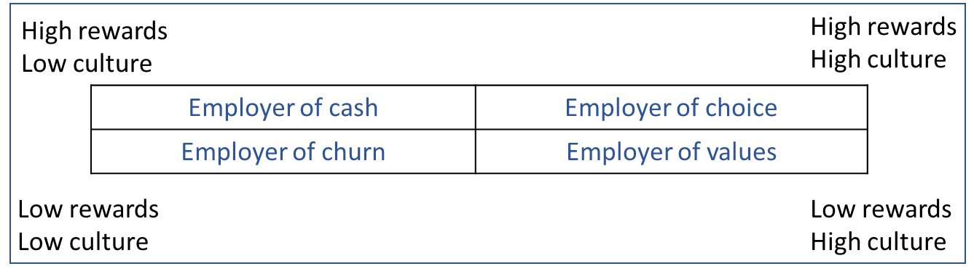
Figure 1 - Higgs Model (Higgs, 2004)
VCL could currently be considered as an employer of choice as rates of pay are good and employees are treated positively. This was confirmed in a recent employee survey whereby 90% of those employees who completed the survey stated they were satisfied or extremely satisfied when asked how satisfied they were overall with working at VCL (Parfitt, 2021, p.36)
There is always work to be done to maintain this and throughout 2021 VCL has introduced several new policies focussing on the cultural aspect of the Higgs model. Such policies include Wellbeing Policy, Menopause Policy, Covid-19 Vaccination Policy, Hybrid working Policy. In an environment with extreme financial pressures, initiatives such as these, which have small financial costs attached to them will become even more important for the future of work. Their impact on employee morale, wellbeing and overall satisfaction should not be underestimated. This in turn is likely to have a positive impact on performance and employee retention (Weakliem and Frenkel, 2006; Coates and Howe, 2019).

3.1.2 The GIG / Open Talent Economy
The gig economy is not a new concept. For many, it was created by the global financial crisis of 2008-09 where individuals were forced to take short term work to replace income lost from more stable employment which had been lost. (Taylor and Perkins, 2021). The pandemic has highlighted that the concept of work, as well as the treatment of workers, must continue to evolve (Gaskell, 2021).
In extreme cases, the precarious nature of gig working could lead to the exploitation of more vulnerable groups (Standing, 2011). This was recently demonstrated by the widely publicised case against Uber. The supreme court ruled that they are workers, not self-employed, meaning they are entitled to more employment rights (BBC, 2021).
In 2021 VCL employed its first production-based employees under temporary contracts to assist with a project for an initial duration of six months. The use of gig workers could be considered as a measure to keep employment costs down and may be attractive to some potential employees. However, it may be less attractive to individuals on a long-term basis due to its precarity (Department for Business, Energy and Industrial Strategy (BEIS), 2018).

3.1.3 Flexible / Hybrid working
The flexible firm model (Atkinson, 1984) is based on the composition of the workforce of an organisation comprising of 3 basic groups of employees: core, peripheral and subcontractors and two types of flexibility – functional and numerical.
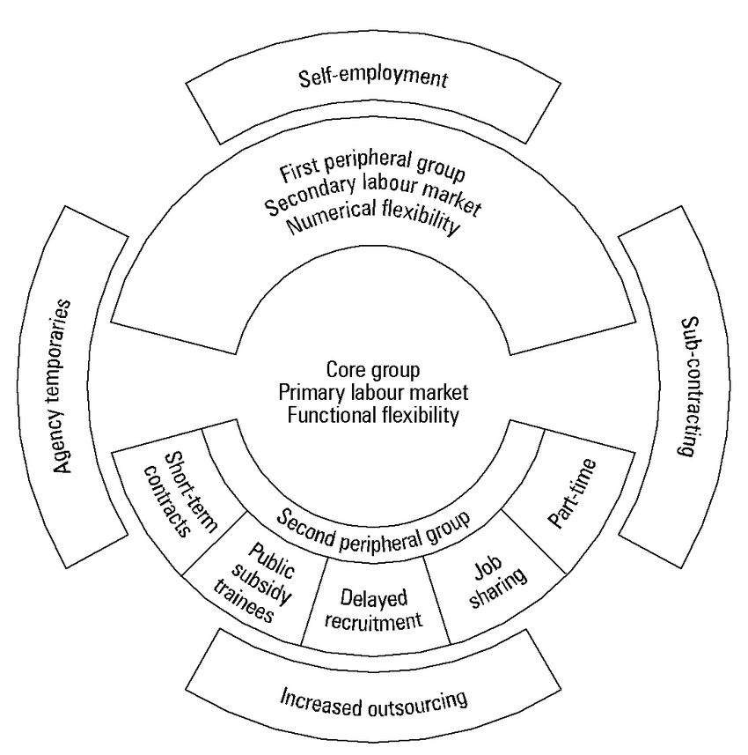
Figure 2 - Flexible Firm (Atkinson, 1984)
Historically, the core group were the largest in most organisations. This has shifted in more recent years due to the rise of "gig working" (CIPD, 2017). There are advantages to having a flexible organisation and a flexible workforce, but this is not always achievable in practice.
Talent management strategy should also be considered under the flexible firm approach. Organisations should decide whether to adopt an inclusive (offer opportunity to all) exclusive (target core group only) or blended approach to talent management. A blended approach works to develop and engage all employees ensuring the organisation benefits from the widest possible pool (CIPD, 2021).
At VCL the majority of the workforce are core group workers with a very small number of periphery workers. This is due to the skill level and training time required for many of the production-related tasks making it very difficult to open these roles to agency workers for example (Cappelli, 2019). Within the past 12 months, VCL has also taken on employees on zero-hours contracts for the first time. This allowed temporal flexibility to achieve short term customer hike in demand.
VCL has introduced flexible working (for those who can effectively work from home) and implemented a hybrid working policy because of the success of home working during the pandemic. This allows employees a better work-life balance which is becoming increasingly important for the modern workforce (Fatania, 2020). This could also help with morale and staff retention (CIPD, 2021a). A survey carried out by Price Waterhouse Coopers revealed that 77% of UK employees want a mix of face-to-face and remote working (PWC, 2021).
However, it is evident that hybrid working is not for everyone and may eventually be rejected by workers. This could be due to the difficulty some face when setting up a workspace in the home, fatigue from video calls, feelings of isolation at home, feeling that they are less likely to be promoted when working from home etc. (Lufkin, 2021).

3.2 Talent Management Strategy at VCL
In contrast to the organisation-wide resourcing strategy, talent management strategy is usually focused on a small proportion of the workforce (Mupepi, 2017). Whilst there is danger in focusing only on the very best performers there is a clear business case for focussing on a group of conscientious employees who have greater potential. (Clutterbuck, 2012). Other employees may have no interest in progressing in the company by learning new skills for example. This is the case at VCL where some production operators who have been with the Company for many years still carry out the same 3 or 4 tasks during their working day. They have been approached with training opportunities and they are not interested.
Netflix has taken the talent management approach whereby they “seek excellence”. At Netflix mediocrity is rewarded by a handsome severance package (Hastings, 2009).

3.3 Recruitment Strategy
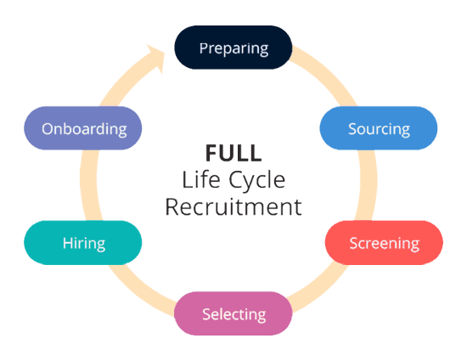
Figure 3 - The Full Cycle of Recruitment (Mishra, 2021)

At VCL the six-stage model for the recruitment life cycle is followed.
Part of stage 1 includes preparing or updating a job description (JD) and person specification for the role. At this stage it is also important to consider the location for the role and whether it can be remote, flexible, hybrid etc.
Stage 2 requires a decision on whether recruitment will be internal, external and how the vacancy will be advertised. At VCL, all permanent recruitment is outsourced to recruitment companies. The cost of doing this can be considerable and in house recruitment could be a more cost-effective option to consider.
Stage 3 – screening will be carried out by the recruiter initially then the relevant line manager to create a shortlist for the next stage.
Stage 4 – selection. This stage usually involves the "classic trio" (Cook, 2016). That is what most people expect when they apply for a job - application form submission, one interview, then a job offer.
However, advances in technology and artificial intelligence (AI) have meant that some screening and selection is carried out by computers, not people. There are several arguments for and against this practice including the benefit of time not being spent sifting large numbers of CVs when a computer program can do versus the ethical /legal and professional dilemma of allowing a computer to screen / select potential employees based on algorithms (Schettler, 2019). There is clear cause for concern here and the need to proceed with caution. Some companies may see AI as a time saving, money-saving way of at least carrying out some of the recruitment life cycle. However, it would be advisable to proceed with caution as some companies have been forced to pay large settlement amounts to potential candidates based on the AI recruitment process being proven to be discriminatory. An example of this is the case of ‘British Telecommunications PLC v Meier’ (2019). The initial stage of the recruitment process was a situational judgement test and they were at a disadvantage as they had Asperger’s syndrome. They were refused an interview when they failed the test. The court held that this was a failure to make reasonable adjustments.
Stage 5 – hiring involves making an offer and negotiating over salary, benefits etc.
Stage 6 – onboarding. It is critical to get this right. Make the new employee feel welcome and try not to focus solely on paperwork (Zojceska, 2018). One company that start the onboarding before the employee has officially joined is Essity. They use technology to grant access to their web-based platform to new recruits (Essity, no date).

3.4 Workforce Planning at VCL
Workforce planning (WP) is the process of ensuring an organisation has the right number of people with the right skills, in the right place and at the right time. This process should be linked to the overall strategy of the organisation and is an important part of the strategic business planning process (CIPD, 2021b).
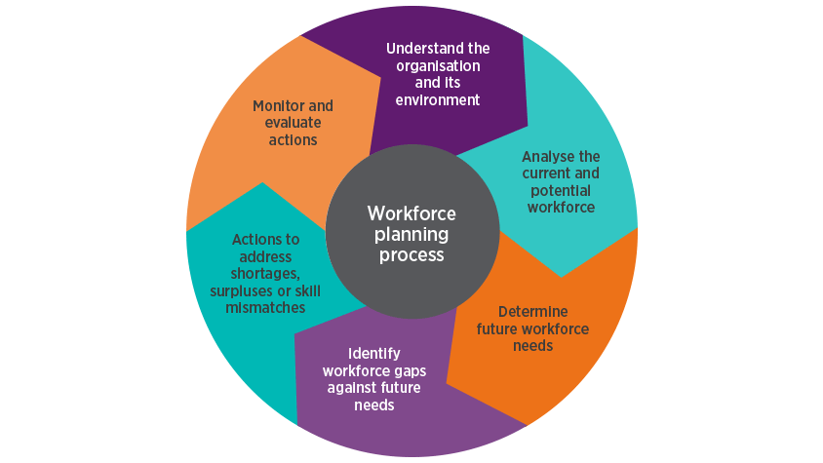
Figure 4 - Workforce Planning (CIPD, 2021b)
The objectives of WP include several areas which have been made even more critical to organisations since the pandemic began. Some of those which are most relevant to VCL and are highlighted in section 2 above are:
- Anticipating problems of potential surplus/deficit of people.
- The development of a multi-skilled, flexible workforce allows organisations to adapt to a VUCA environment.
- Reduce dependence on external recruitment by formulating retention and development strategies (Armstrong, 2018).
Considering item 1 above – this has been increasingly difficult at VCL since the pandemic began due to the unpredictability of who would catch the virus and how long they would need to be away from the workforce depending on the severity of the illness (ONS, 2021d). For example, most employees who have contracted the virus have only needed to be away for the duration of the isolation period (14 or 10 days). However, a small proportion has taken up to 3 months to return to work fully. This cannot be predicted (ACAS, no date a.).
Item 2 relates to a multi-skilled workforce. This has also been much more challenging since March 2020. Per Maslow's hierarchy of needs (figure 5 below) before an individual can achieve anything over and above basic functions the minimum safety needs must be satisfied (Macleod, 2020).
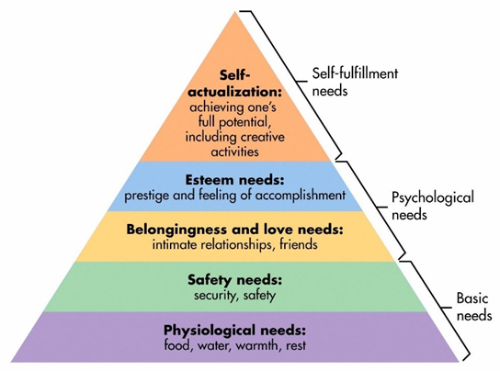
Figure 5- Maslow's Hierarchy of Needs, Macloed, 2020
This is also true in the workplace. The basic needs of an employee must be met before they can feel a sense of belonging, accomplishment and can achieve their full potential. At VCL the basic health and safety needs were quickly met following the immediate introduction of Covid-19 safeguarding measures such as social distancing, face masks etc. in line with government and HSE advice (HSE, no date). From a job security perspective, in a recent VCL employee survey (carried out in August 2021) 100% of respondents stated they feel that VCL offers job security (Parfitt, 2021, p.50). However, the continued uncertainty and anxiety around the pandemic may still have an impact on employees fulfilling their full potential (Godinic, et al., 2020).
Item 3 refers to reducing the dependence on external recruitment by formulating retention and development strategies. This is covered in the next section of the report.

3.5 Retention Strategies at VCL
In the CIPD 2020 Resourcing and Talent Planning Survey 32% of respondents stated they had reduced their recruitment activity (CIPD, 2020a). The CIPD 2021 Resourcing and Talent Planning Survey revealed 26% had not attempted to fill any short term or permanent positions in the last 12 months. 54% of SMEs have not attempted to recruit (CIPD, 2021c). The ONS reported a new record number of job vacancies from September to November 2021 of 1,219,000. This is an increase of 434,500 since January to March 2020 (before the pandemic) (ONS, 2021a). At VCL there has been minimal recruitment throughout the pandemic with 2 permanent positions being filled in November 2021 along with some zero-hour contracts.
There are several reasons for an employee leaving, not all of which are in the control of the company (Taylor, 2018). The attraction of potential employment elsewhere and unavoidable turnover due to illness for example is outside of the company's control. However, push factors (such as something perceived to be wrong with the Company) and involuntary turnover (dismissal, redundancy) are within the Company's control (Croner, 2016). Exit interviews can be used to try and keep track of reasons for leaving. Another option would be to ask current employees the reason(s) for joining an organisation.
Griffith and Hom (2001) identify 9 areas for employers to focus on for reducing turnover including job enrichment, workplace characteristics, reward practices etc.
In an environment where it may not always be possible to retain staff using remuneration, which may be the case at VCL, there are other options to consider (SHRM, no date). These include effective line management (e.g., no favouritism, acting quickly and fairly if problems arise and talking to everyone in the team regularly), employee engagement, training and development opportunities (Castrillon, 2021).
The redundancy rate between August and October 2021 was 3.5 per 1,000 employees. This is the lowest rate since May 2019. Redundancies peaked in September-November 2020 at 14.5 per 1,000 employees (ONS, 2021b). Redundancy should be avoided as far as possible and should be a last resort. However, if redundancy is required the process must be carried out in a fair manner (Bennett, et al., 2020). This is vital for the affected employees as well as remaining employees. Even the fairest, most comprehensive redundancy process can have a lasting impact on the remaining employees. This is known as survivor syndrome which encompasses several feelings employees can feel because of redundancy. These symptoms include feelings of guilt for the colleagues who have left the business, feelings of bitterness as they may have to take on extra work, fear for their own job, loss of trust in leadership to name a few (Williamson, 2020). These symptoms can be detrimental to employee morale and could lead to employees looking for alternative employment. Minimising the impact of survivor syndrome on employees and employee retention could be achieved by conducting open and honest discussions with employees and offering further assistance such as counselling if necessary. No redundancies have been required at VCL because of the pandemic and job security is a top priority for the CEO and management team.

4. Conclusions

With the ongoing uncertainty regarding the continued impact of Covid-19 and the potential emergence of new variants, organisations must ensure they have the skills required and are agile enough to keep business-critical operations going during staff shortages (CIPD, 2020a). This is especially relevant at VCL due to the nature of operations and the requirement for 24-hour operation of the cellulose department. Any shortage of staff in this area could impact the business severely and ultimately result in customer demand not being met. The biggest threat to this is absence due to sickness, whether covid or not. A critical countermeasure to this would be the multi-skilling of the workforce allowing operators to move to other roles as required. This is however easier said than done. Barriers to multiskilling must first be identified and considerations made as to how they could be potentially surmounted (Adamu, et al. 2012). The main barrier at VCL is a financial one. The workforce is willing to learn, however for them to train in other areas their current machines must be operated meaning backfilling using temporary labour for example as there is no excess labour at VCL. Having a multi-skilled workforce would increase productivity and cost-effectiveness eventually as disruption to production schedules would be minimised due to greater employee flexibility. The business would also be more flexible in meeting customer demands with the potential reduction in lead times. This could ultimately make VCL more competitive and lead to the generation of more new business opportunities. Moreover, a positive effect on employee morale, wellbeing and engagement could occur as employees feel more fulfilled and valued (Truss, et al.,2013).
When it comes to resourcing and talent management strategies it can be concluded that one of the key factors to consider is the ways of working and how these are changing. VCL has introduced flexible and hybrid working since the pandemic began and is continuing to look for ways of improving the “culture” measure of the Higgs model (Higgs, 2004). Offering flexibility is key to retaining and attracting new staff (Downing, 2021).
Recruitment policy and strategy should be considered in line with workforce planning. Forecasting the labour requirements based on future demand will potentially require the addition of new staff. Currently, VCL outsources all recruitment to agencies at a substantial cost to the business (Forbes, 2017). VCL has spent more than £9k in 2021 on the external recruitment of 2 employees (VCL, 2021).
Given the difficulties of recruitment, retention at VCL is more critical than ever in the current tight labour market situation (Hunt and Rasmussen, 2007). Attracting new employees in this environment where demand for labour exceeds supply is very challenging (Sanandaji, et al., 2021). Focussing on retaining employees and minimising leavers will lessen potential disruption to production schedules and ultimately customer deliveries. Creating an environment where employees want to stay should be a priority (Ravichandran, 2019).

5. Recommendations
The following recommendations are suggested to improve resourcing and talent management activities at VCL.

5.1 Focus on multi-skilling the Production-based workforce
“We cannot expect to recruit every skill we need” (Cheese, 2021, p.5). Skills need to be developed to meet the changing requirements of the business.
This is critical to the future success of the business and should be prioritised (Agrawal, et al., 2020). This will ensure business continuity as more employees will be trained to do more tasks (Ahmed and Barry, 2018). VCL will have the ability to arrange the workforce to meet the needs of the business (i.e. customer demand) (Afshar-Nadjafi, 2020).
There will be a financial impact on the business to allow for training, but this is likely to be considerably less than the potential cost of not being able to continue operating for some time due to sickness for example, particularly in the cellulose department.
A case study at British Steel in Scunthorpe revealed that multiskilling increased H&S incidents (Horbury and Wright, 2001). VCL should be aware of this, however, the safety culture at VCL should prevent a similar situation from happening there.

5.2 Consider Apprenticeships to improve skills
Given the inflationary pressures VCL is facing a cost-effective way of improving skills in the workforce could be to take on apprentices (Artur, et al., 2016).
It is recognised this may not be an appropriate solution for all roles at VCL but some are well-suited to this approach, e.g. engineers. (Gov.uk, no date a.).
Unicef has highlighted benefitting from the introduction of an apprenticeship programme due to the wider audience such a programme can attract as well as the important role it plays in developing the future talent for the organisation (Weakley, 2021).

5.3 Continuous improvement of policies and procedures
Following on from the Higgs model (Higgs, 2004) and the aspect of measuring an organisation on the way it treats its employees is a key measure employees and potential employees will consider in future (Achor, et al., 2018). VCL should therefore be continuously improving policies, procedures and implementing new ones as the ways of work evolve to ensure it remains an employer of choice (Jacobs, 2021) and therefore increasing employee retention.
Practices that have historically been in place at Amazon such as the “3 strike system” should be avoided as these negatively impact the workforce (Panorama, 2014). Examples of companies displaying positive cultures include Salesforce, McKinsey and Company and Adobe and were all rated very highly for culture in the employee’s choice awards for best places to work in the UK in 2022 in a recent Glassdoor survey (Glassdoor, 2021).

5.4 Consider in house vs outsourcing recruitment
Turnover at VCL is low with many employees having more than 15 years of service (VCL, 2021). However, VCL should consider in house recruitment to reduce costs when required (Reucroft, no date). Widely used online platforms such as Indeed (Indeed, no date) are free/low cost to employers. VCL is also launching a new website in February 2022 which could be used for advertising vacancies as well as social media platforms. One way of attracting the right candidates could be to create videos of what it is like to be a production operator at VCL for example and share them on the website. This has been a successful approach at The Longhurst Group (Hogarth, 2021). If in house recruitment is unsuccessful, VCL could then consider outsourcing.

5.5 Timeframe and Costs

For the recommendations to be carried out a financial outlay from VCL will be required. There is also the cost of the time of those involved to prepare, deliver and launch the recommendations as well as the opportunity cost of each person involved. The recommendation requiring the most planning from both a time and financial perspective is the multiskilling of the workforce. A detailed action plan is included in Appendix 2.

References
- ACAS (no date) Working from home and hybrid working. Available at: Working from home and hybrid working | Acas (Accessed: 20 January 2022).
- ACAS (no date a.) Long covid – advice for employers and employees. Available at: Sickness and absence because of long COVID: Long COVID – advice for employers and employees - Acas (Accessed: 21 January 2022).
- Achor, S. et atl. (2018) 9 out of 10 people are willing to earn less money to do more meaningful work. Available at: 9 Out of 10 People Are Willing to Earn Less Money to Do More-Meaningful Work (hbr.org) (Accessed: 20 January 2022).
- Adamu, N. et al (2012) ‘multi-skilling barriers in the construction industry in northwestern Nigeria’, Proceedings of the WABER 2021 Conference (Vol.1). Available at: WABER_Procs_2012_-_Vol_1.v3-with-cover-page-v2.pdf (d1wqtxts1xzle7.cloudfront.net) (Accessed: 30 December 2021).
- Afshar-Nadjafi, B. (2020) ‘Multi-skilling in scheduling problems@ a review on models, methods and applications’. Computers and Industrial Engineering. 151 (2) pp.1-26. Available at: Multi-skilling in scheduling problems: A review on models, methods and applications - ScienceDirect (Accessed: 20 January 2022).
- Agrawal, S. et al. (2020) To emerge stronger from the COVID-19 crisis, companies should start reskilling their workforces now. Available at: COVID-19 and reskilling the workforce | McKinsey (Accessed: 26 December 2021).
- Ahmed, N. and Barry, A. (2018) Significance of Multi-skilled employees in an organization. Available at: (14) Significance of Multi-skilled employees in an organization | LinkedIn (Accessed: 20 January 2022).
- Anderson, M. (2004) ‘The Metrics of Workforce Planning’, Public Personnel Management, 33(4), pp. 363-378. DOI: 10.1177/009102600403300402
- Armstrong, M. (2017) Armstrong’s handbook of human resource management practice. 14th ed. London: Kogan Page.
- Artur, A., et al. (2016) The cost-effectiveness of apprenticeship schemes. Available at: Employers_Final-Report-on-Apprenticeships-May-2016.pdf (erc-online.eu) (Accessed: 21 January 2022).
- Atkinson, J. (1984) Manpower strategies for the flexible organisation. Personnel Management. August. pp.28-31.
- Bach, S. and Edwards, M.R. (eds.) (2013) Managing human resources. 5th ed. Chichester: Wiley.
- Barnard-Bahn, A. (2021) 5 reasons not to quit your job (yet). Available at: 5 Reasons Not to Quit Your Job (Yet) (hbr.org) (Accessed: 20 January 2022).
- Barns-Graham, W. (2021) Is the UK being disproportionately impacted by soaring freight prices due to Brexit?
- Baska, M. (2020) Return to work and redundancy worries affect more than half of workers, survey finds. Available at: Return to work and redundancy worries affect more than half of workers, survey finds (peoplemanagement.co.uk) (Accessed: 20 January 2022).
- BBC (2021) Uber drivers are workers not self-employed, supreme court rules. Available at: Uber drivers are workers not self-employed, Supreme Court rules - BBC News (Accessed: 26 December 2021).
- BBC (2021a) What is the UK's inflation rate and why is the cost of living going up? Available at: What is the UK's inflation rate and why is the cost of living going up? - BBC News (Accessed: 20 January 2022)
- Bennett, N. and Lemoine, G. (2014) What VUCA really means for you. Available at: What VUCA Really Means for You (hbr.org) (Accessed: 26 December 2021).
- Bennett, et al. (2020) Managing Employment Relations. 7th ed. London: Kogan Page.
- Bridgland, J. (2018) Flex or break – how to engage the new talent economy. Available at: Flex or Break - How to Engage the New Talent Economy (slideshare.net) (Accessed: 26 December 2021).
- ‘British Telecommunications PLC v Meier’ (2019) Her Majesty's Court of Appeal in Northern Ireland, case 43. Available at: British Telecommunications Plc v Meier [2019] NICA 43 (29 July 2019) (bailii.org) (Accessed: 28 December 2021).
- Cappelli, P. (2019) ‘Your approach to hiring is all wrong’, Harvard Business Review, May-June 2019, pp.48-58.
- Castrillon, C. (2021) 5 Strategies to improve employee retention. Available at: 5 Strategies To Improve Employee Retention (forbes.com) (Accessed: 28 December 2021).
- Cheese, P. (2021) ‘Another uncertain year ahead’, People Management, December 2021/January 2022, p. 5.
- CIPD (2017) The growing gig economy. Available at: The growing gig economy | CIPD Voice (Accessed: 26 December 2021).
- CIPD (2020) Factsheet – PESTLE Analysis. Available at: https://www.cipd.co.uk/knowledge/strategy/organisational-development/pestle-analysis (Accessed: 26 December 2021).
- CIPD (2020a) Resourcing and talent planning survey 2020. Available at: Resourcing and talent planning survey 2020 (cipd.co.uk) (Accessed: 28 December 2021).
- CIPD (2020b) Succession planning. Available at: Succession Planning | Factsheets | CIPD (Accessed: 30 January 2022).
- CIPD (2021) Talent Management. Available at: Talent Management | Factsheets | CIPD (Accessed: 26 December 2021).
- CIPD (2021a) Planning for hybrid working. Available at: Planning for hybrid working | CIPD (Accessed: 28 December 2021).
- CIPD (2021b) Workforce planning. Available at: Workforce Planning | Factsheets | CIPD (Accessed: 28 December 2021).
- CIPD (2021c) Resourcing and Talent Management Survey 2021. Available at: Resourcing and talent planning survey 2021 (cipd.co.uk) (Accessed: 28 December 2021).
- Clutterbuck, D. (2012) The Talent Wave. London: Kogan Page.
- Coates, D. and Howe, D. (2019) ‘Combatting staff burnout in mental health: Key managerial and leadership tasks that are fundamental to staff wellbeing and retention, Asia Pacific Journal of Health Management, 10(2), pp. 24-32. Available at: Combatting staff burnout in mental health: Key managerial and leadership tasks that are fundamental to staff wellbeing and retention | Asia Pacific Journal of Health Management (informit.org) (Accessed: 28 December 2021).
- Cook, M. (2016) Personnel selection: adding value through people – a changing picture. 6th ed. Chichester: John Wiley.
- Croner (2016) Push-pull factors in employment. Available at: Push-pull factors in employment | Croner-i (croneri.co.uk) (Accessed: 28 December 2021).
- Department for Business, Energy and Industrial Strategy (2018), The experience of individuals in the gig economy. Available at: 171107_The_experiences_of_those_in_the_gig_economy.pdf (publishing.service.gov.uk) (Accessed: 26 December 2021).
- Dixon, H. (2020) Workers who have to go to the office resent those staying at home. Available at: Workers who have to go to the office resent those staying at home, experts say (telegraph.co.uk) (Accessed: 20 January 2022).
- Downing, N. (2021) Why the battle for talent will be won or lost over hybrid working. Available at: Why the battle for talent will be won or lost over hybrid working (peoplemanagement.co.uk) (Accessed: 30 December 2021).
- Essity (no date) What our recruitment process is like. Available at: What our recruitment process is like (essity.com) (Accessed: 28 December 2021).
- Fatania, T. (2020) Working in the new normal: The future is here and there is no going back. Available at: Working in the new normal: The future is here and there is no going back - CMI (managers.org.uk) (Accessed: 30 January 2022).
- Forbes (2017) 4 truths about working with recruiters. Available at: 4 Truths About Working With Recruiters (That They'll Never Tell You) (forbes.com) (Accessed: 30 December 2021).
- Gaskell, A. (2021) Gig platforms failing to provide fair work (still). Available at: Gig Platforms Failing To Provide Fair Work (Still) (forbes.com) (Accessed: 26 December 2021).
- Glassdoor (2021) Best places to work 2022. Available at: Best Places to Work UK | Glassdoor (Accessed: 20 January 2022).
- Godinic, D., et al. (2020) ‘Effects of Economic Uncertainty on Mental Health in the COVID-19 Pandemic Context: Social Identity Disturbance, Job Uncertainty and Psychological Well-Being Model’, International Journal of Innovation and Economic Development, 6(1), pp. 61-74. Available at: Effects-of-Economic-Uncertainty-on-Mental-Health-in-the-COVID-19-Pandemic-Context-Social-Identity-Disturbance-Job-Uncertainty-and-Psychological-Well-Being-Model.pdf (researchgate.net) (Accessed: 30 January 2022).
- Gov.uk (2021) Plastic Packaging Tax: steps to take. Available at: Plastic Packaging Tax: steps to take - GOV.UK (www.gov.uk) (Accessed: 20 January 2022).
- Gov.uk (no date) National Insurance. Available at: National Insurance: How much you pay - GOV.UK (www.gov.uk) (Accessed: 20 January 2022).
- Gov.uk (no date a.) Find an apprenticeship. Available at: Find an apprenticeship - GOV.UK (www.gov.uk) (Accessed: 21 January 2022).
- Griffith, R.W and Hom, P.W. (2001) Retaining valued employees. California: Sage.
- Hassan, W. et al. (2013) ‘The effect of training on employee retention’, Global Journal of Management and Business Research Administration and Management, 13(6), pp. 17-20. Available at: The Effect of Training on Employee Retention (psu.edu) (Accessed: 26 December 2021).
- Hastings, R (2009) Freedom and responsibility Culture (Version 1). Available at: Culture (Original 2009 version) (slideshare.net) (Accessed: 28 December 2021).
- Higgs, M. (2004) Future trends in HRM, in D. Rees and R. Mc.Bain (eds) People Management: challenges and opportunities. Basingstoke: Palgrave Macmillan
- Hogarth, A. (2021) Resourcing and talent planning 2021: case studies. London: Chartered Institute of Personnel Development.
- Horbury, C. Dr., and Wright, M. (2001) Development of a multiskilling lifecycle model. Norwich: Health and Safety Executive.
- HSE (no date) Employer’s Responsibilities. Available at: https://www.hse.gov.uk/workers/employers.htm (Accessed: 28 December 2021).
- Hunt, V. and Rasmussen, E. (2007) ‘Turnover and retention in a tight labour market: reflecting on New Zealand research’, New Zealand Journal of Employment Relations, 32(1), pp.45-58. Available at: Turnover and Retention in a Tight Labour Market: Reflecting on New Zealand Research - ProQuest (Accessed: 30 December 2021).
- Indeed (no date) Hire your next candidate fast. Available at: Post a job | Indeed.com (Accessed: 30 December 2021).
- Jacobs, K. (2021) How to be an employer of choice. Available at: How to be an employer of choice (peoplemanagement.co.uk) (Accessed: 20 January 2022).
- KPMG (2021) KPMG and REC UK report on jobs. Available at: KPMG and REC UK Report on Jobs - KPMG United Kingdom (home.kpmg) (Accessed: 20 January 2022).
- Lawler, E. (2017) Reinventing talent management: principles and practices for the new world of work. Oakland, California: Berrett-Koehler.
- Lewin, K. (1939). Lewin’s Leadership Styles. Available at: http://changingminds.org/disciplines/leadership/styles/lewin_style.htm (Accessed: 26 December 2021).
- Lipman, V. (2015) People leave managers, no companies. Available at: People Leave Managers, Not Companies (forbes.com) (Accessed: 20 January 2022).
- Lufkin, B. (2021) Why workers might eventually reject hybrid work. Available at: Why workers might eventually reject hybrid work - BBC Worklife (Accessed: 28 December 2021).
- MacLeod, S. (2020). Maslow's Hierarchy of Needs. Available at: Maslow's Hierarchy of Needs | Simply Psychology (Accessed: 28 December 2021).
- Millmore, M. (2003) ‘Just how extensive is the practice of strategic recruitment and selection?’ Irish Journal of Management. 24(1), pp. 87-108.
- Mishra, A. (2021) 6 Stages of recruitment life cycle. Available at: 6 Stages of Recruitment Life Cycle | Recruitment Process Steps | Oorwin (Accessed: 28 December 2021).
- Mupepi, M. (2017) Effective talent management strategies for organizational success. Michigan: IGI Global.
- OECD (2020) Coronavirus (COVID-19): SME policy responses. Available at: Coronavirus (COVID-19): SME policy responses (oecd.org) (Accessed: 20 January 2022).
- ONS (2021) Labour Market Overview. Available at: Labour market overview, UK - Office for National Statistics (ons.gov.uk) (Accessed: 26 December 2021)
- ONS (2021a) Labour Market Overview, UK : December 2021. Available at: Labour market overview, UK - Office for National Statistics (ons.gov.uk) (Accessed: 1 January 2022).
- ONS (2021b) LFS: ILO redundancy rate: UK: ALL: SA. Available at: LFS: ILO redundancy rate: UK: All: SA - Office for National Statistics (ons.gov.uk) (Accessed: 1 January 2022).
- ONS (2021c) Coronavirus and its impact on UK hospitality: January 2020 to June 2021. Available at: Coronavirus and its impact on UK hospitality - Office for National Statistics (ons.gov.uk) (Accessed: 20 January 2022).
- ONS (2021d) Sickness absence in the UK labour market: 2020. Available at: Sickness absence in the UK labour market - Office for National Statistics (ons.gov.uk) (Accessed: 21 January 2022).
- ONS (2022) Consumer price inflation, UK: December 2021. Available at: Consumer price inflation, UK - Office for National Statistics (Accessed: 20 January 2022).
- Panorama (2014) Amazon: the truth behind the click documentary [video]. Available at: BBC Panorama Amazon The Truth Behind the Click BBC documenta - YouTube (Accessed: 20 January 2022).
- Pardey, D. (2010) The changing relationship between trade unions and management. Available at: HR Magazine - The changing relationship between trades unions and management (Accessed: 20 January 2022).
- Parfitt, R. (2021) An analysis of employee voice: a case study at VCL. Unpublished PG Dip Research Report. UWTSD.
- PWC (2021) Hopes and Fears 2021. Available at: Upskilling Hopes and Fears 2021: PwC (Accessed: 28 December 2021).
- Ravichandran, S. (2019) 10 reasons why employees want to stay in an organization. Available at: (51) 10 Reasons why employees want to stay in an organization | LinkedIn (Accessed: 30 December 2021).
- Reucroft, G (no date) How in house recruiting can save 200k on agency fees. Available at: How In-House Recruiting Can Save You 200k on Agency Fees (theundercoverrecruiter.com) (Accessed: 20 January 2022).
- Richmond, S. (2020) Coronavirus: remote working worsens work-life balance, poll finds. Available at: Coronavirus: Remote working worsens work-life balance, poll finds | The Independent | The Independent (Accessed: 20 January 2022).
- Sanandaji, T., et al. (2021) Attracting talent during a worker shortage. Available at: Attracting Talent During a Worker Shortage (hbr.org) (Accessed: 30 December 2021).
- Schettler, L. (2019) The legal and ethical implications of using AI in hiring. Available at: The Legal and Ethical Implications of Using AI in Hiring (hbr.org) (Accessed: 28 December 2021).
- SHRM (no date) Managing for Employee Retention. Available at: Managing for Employee Retention (shrm.org) (Accessed: 28 December 2021).
- Spiggle, T. (2020) Coronavirus silver lining: a better work-life balance? Available at: Coronavirus Silver Lining: A Better Work-Life Balance? (forbes.com) (Accessed: 20 January 2022).
- Standing, G (2011) The precariat: the new dangerous class. London: Bloomsbury Academic.
- Taylor, S. (2018) Resourcing and talent management. 7th ed. London: Chartered Institute of Personnel Development.
- Taylor. S. and Perkins, G. (2021) Work and employment in a changing business environment. London: Kogan Page.
- Truss, C. et al. (2013) ‘Employee Engagement, organisational performance and individual wellbeing: exploring the evidence, developing the theory’, International Journal of Human Resource Management, 24 (14), pp. 2657-2659.
- VCL (2021) VHL Board Pack. Unpublished Internal VCL Report.
- Weakley, K. (2021) Take on more apprentices to improve diversity, urges Bond, Available at: Take on more apprentices to improve diversity, urges Bond (civilsociety.co.uk) (Accessed: 21 January 2022).
- Weakliem, D. and Frenkel, S. (2006) ‘Moral and workplace performance’, Sage Journals, 33(3), pp. 335-361. Available at: Morale and Workplace Performance - David L. Weakliem, Stephen J. Frenkel, 2006 (sagepub.com) (Accessed: 28 December 2021).
- Williamson, H. (2020). What is Survivor Syndrome & How Do I Combat It?. Available at: What is Survivor Syndrome & How Do I Combat It? | Croner Group (Accessed: 1 January 2022)
- Worley, C. G. & Claudy, J. (2020) COVID-19’s Uncomfortable Revelations About Agile and Sustainable Organizations in a VUCA World. The Journal of Applied Behavioural Science, 16 June, 56(3), pp. 279-283.
- Zojceska, A. (2018) Everything you need to know about full life cycle recruiting. Available at: Everything You Need to Know About Full Life Cycle Recruiting | TalentLyft (Accessed: 28 December 2021).

Appendix 1 – PESTLE Analysis for VCL
 | External Factors | Effect on VCL | Importance
Political | Government policy on lockdowns/restrictions,  Brexit  Global trade agreements and or restrictions  Increase in NI contributions from April 2022 | Reduced customer base as many are in the hospitality sector  Affects import/export customers and the supply chain. Trade deal still not reached  Uncertainty of tariffs and potential restriction on movement of goods within Europe  Increased payroll costs of 1.25% | Critical
Economic | Tight labour market  Economic decline  Cost base increase  Economic instability  Pay freezes/redundancy  Consumer spending habits  Energy price increases | Difficulty in recruiting new staff, increased cost to the business as all recruitment is outsourced to agencies.  The shrinking hospitality sector has resulted in a decrease in demand for some products  Increase costs of raw materials, increase in transport costs  Difficult to forecast business performance with any accuracy due to pandemic  Zero redundancies and no pay freeze. 3% pay increase agreed during annual collective pay negotiations in December 2021.  Less money being spent in restaurants/bars more products purchased at supermarkets (positive for VCL)  The huge rise in the cost of energy will impact VCL from October 2022 – currently in contract until then. | Critical (some positive)
Social | Lifestyle factors / work-life balance  Career attitudes/team | A large number of workers now working from home due to the pandemic. Whilst this has suited some it has not suited all – wellbeing issues. As the pandemic continues focus on mental health must be a priority.  Positive focus and dedication showed from all employees. The workforce pulled together almost as a family unit supporting each other. This will be tested in the coming weeks/months as the workforce is re-integrated back to the workplace | Critical
Technology | Automation / IT  Upgrades  Security | Increased need for IT provision due to pandemic for homeworkers  Training and learning time required to adapt to new platforms such as MST, Zoom  The large, unexpected cost of provision of equipment required for those to work from home effectively  The review was undertaken and investment was needed to improve system security (2 stage verification etc) | Medium
Legal | Employment law – EU Workers after Brexit 1 Jan 2021  Health and safety regulations | 2 affected employees at VCL have already achieved settled status. No imminent plans for recruitment so the impact is low.  Review regularly for any updates relating to COVID-19 safeguarding measures | Medium  High
Environmental | Plastics Tax (from April 2022)  Waste reduction  Environmentally friendly | Single-use plastic to be eradicated  Pressure to reduce waste and energy consumption  Push towards more eco-friendly products and promote cellulose product | High

Appendix 2 - Action Plan
Activity | Sub activity | Justification | Person(s) responsible | Completion date | Location | Method | Costs
1. Multi skilling the workforce | a) Identify critical areas to be addressed and priority order. | Focus on business continuity. | Head of Operations | 28 February 2022 | Onsite at VCL – no external support required. | Review skills and rank in order of risk to the business. Identify any key person dependencies and single points of failure. | Minimal financial cost as will use software already available. (MS Excel).  Head of Operations time to - estimated time requirement 15 hours.
1. Multi skilling the workforce | b) Identify staff who would like the opportunity to upskill. | Not everyone is interested in upskilling and some are very keen. | Head of Operations | 28 February 2022 | Onsite at VCL – no external support required. | This can run in parallel with the above. Ask for volunteers from the workforce via word of mouth, noticeboards, briefings.  A list should be drawn up to proceed to the next stage. | Head of Operations time – 4 hours.
1. Multi skilling the workforce | c) Create a training plan for each skill and individual. | Set clear expectations for the business and the individual. | Head of Operations and Head of HR | 31 March 2022 | Onsite at VCL – no external support required. | Matching the individuals to the skills required using Excel and setting a timeline for completion of each task. Completion of a task leads to sign off on the skills matrix meaning an individual is competent in that skill.  Review with each individual before proceeding. | Head of Operations and Head of HR time to prepare matrix – 15 hours.
1. Multi skilling the workforce | d) Arrange temporary labour to backfill for trainees. | To allow meaningful and consistent training, low skilled jobs should be backfilled by temporary labour / zero hours labour. | Head of Operations and Head of HR | 31 March 2022 | External support from recruitment companies is potentially required. | Advertising, screening and interviewing candidates. | Head of Ops and Head of HR time  Cost of recruitment – approx. 15 % of annual salary (minimum wage).
 | e) Launch training plan and review regularly. | Ensure individuals are happy and progressing to ensure maximum benefit. | Head of Operations / Assistant Head of Operations | At regular intervals throughout the training programme. Duration will vary depending on the skill. | Onsite at VCL – no external support required. | 1-1 meetings with individuals to review progress against training matrix. | Head of Operations / Assistant head of Operations time and operator time – approx. 2-4 hours depending on the skill being trained.
2) Consider apprenticeships | Review suitability of roles for possible apprenticeship, starting with engineers. | A cost-effective way of increasing skill and developing future talent for the business. | Head of HR and Head of Operations | 31 March 2022 | Onsite at VCL | Meeting, review of job descriptions. | Head of HR and Head of Ops Time
2) Consider apprenticeships | Meet with local colleges to discuss the potential to offer an apprenticeship is determined. | As above | Head of HR and Head of operations | 29 April 2022 | Onsite / at College premises | Meeting | Head of HR and Head of Ops Time
3) Continuous improvement in policies and procedures | Reviewing, amending, updating and creating policies and procedures. | Ensuring VCL remains an Employer of Choice. | Head of HR | Continuous | Onsite at VCL, various online events. | Website reviews, employment law updates, seminars, CIPD webinars etc. | Head of HR time, a small cost to attend Employment law updates – budget of £200 for 2022.
4) In-house recruitment | Create job advertisement / Job description and person specification | Required for recruitment. | Head of HR and relevant Head of Department | As required – no immediate plans for recruitment | On-site at VCL – no external support required | Prepare documents and meetings to discuss with the relevant department head. | Head of HR and relevant Head of department time.
4) In-house recruitment | Create videos around what it’s like to work at Viscose. Minimum 2 required – 1 production and 1 office. | Allows candidates to determine whether they may like working at VCL. Reduces time spent on applications for candidates and VCL if the business is not a good fit for them. | Head of Sales and Marketing and Head of HR. | 31 March 2022 – despite no immediate plans to recruit these can be ready should the need arise. | External support is required from the design company used by VCL for video/photography. | Videos to be created. | Cost of creating and editing short videos and uploading to the website – approx. £1,000. Head of Sales and Marketing and Head of HR time to oversee the activity – 8 hours.

