YMESTYN FEL FI

IOGA DRWY GYFRWNG Y GYMRAEG
  - Business Plan

TABLE OF CONTENTS

1. Introduction 3
2. Company Overview………………………….4
3.Business Overview…….…………………….5
4. Our Vision…………………………………….7
5.Children with additional needs………………8
6.Challenges…………………………………….9
7.One last thought…………………………….10
8. SWOT analysis …………………………….11

introduction
According to the Oxford dictionary (2019) yoga is a Hindu spiritual and ascetic discipline, a part of which, including breath control, simple meditation, and the adoption of specific bodily postures, is widely practised for health and relaxation. The word ‘yoga’ originates from the Sanskrit word meaning ‘union’.
Life is full of stresses little and large, this is no exception for children and they are not immune to the daily pressures that face us each day. Adults are able to take the time to relax and rejuvenate and yoga is becoming an increasing popular way of doing this in the recent years according to Moss (2018).
So why not give our young children the same opportunity?
The Welsh Governments National mission is to work towards having a million people able to enjoy and use the Welsh language by 2050. (Welsh Government, 2017).
Education is a vital part of this mission and ensuring young children are educated in the Welsh language and are proud to use the Welsh language.
Not only is this Welsh Government vision but the Welsh language also has an official status. In recent years legislation now provides the rights for Welsh speakers to receive Welsh language services.
The Well-being of Future Generations Act (Wales) 2015 that covers the whole of Wales states that public bodies in Wales must be working towards the seven well-being goals. One of these goals is ‘A Wales of vibrant culture and thriving Welsh language’.

Company Overview

Ymestyn fel fi aims to provide yoga sessions through the medium of Welsh for children aged 2-3 years old.
These sessions can be offered at pre-school settings such as pre-nurseries, or as classes for parents and toddlers at local community settings.
I am a qualified early years practitioner with a Level 5 Diploma in Leadership for Children's Care, Learning and Development. I have managed an early year’s settings providing a Welsh language for provision for children aged 2-3 years old. In this time, I have seen the positive impact yoga has on young children such as managing stress through breathing (Williams 2010).
I have experienced yoga sessions at my current nursery in previous years, however they were not provided through the medium of Welsh.
The Yoga sessions provided by Ymestyn fel fi can be offered solely through the Welsh language or bilingually. Professionals in the early years sector will have the opportunity to book these sessions as a standalone sitting or as blocks of 5 or 10 sessions. These sessions will be available to book via telephone or email.
There are other yoga sessions for children available on the current market, however they are unable to provide a bilingual service or welsh service.

Business Description
The Welsh language is becoming increasingly popular in Wales and the demand for Welsh speaking pre-schools is at an all-time high. (BBC, 2019).
The welsh language is one of Wales’s national treasures and is an important part of what defines us as Welsh nationals. (Welsh Government, 2015).
It is important that early years settings providing a welsh provision can provide the same opportunities to children that attend an English provision setting.
Yoga sessions are currently available for children in the early years and health visitors are also providing baby yoga.
These yoga sessions offer children the opportunity to develop body awareness and learn how their bodies work and ways in which they can use them in healthy ways. Using yoga supports children in using all parts of their body from the tips of their nose to their tiny little toes. Children can learn to manage stress through breathing exercises, meditation and healthy movements. By participating and achieving simple movements, they gain a sense of self-accomplishment thus improving confidence and a positive self-image.
The sessions will be done in groups therefor improving their social development skills and building relationships with peers.
Young children are full of enthusiasm and energy and yoga gives them a way of focusing their mind bodies allowing them to focus their energy on something positive. This in turn building on their concentration skills. Children thoroughly enjoy yoga and can concentrate for longer periods of time, even the busiest of children will sit and participate for 30-minute sessions.
Many children have commented on how much they enjoy yoga sessions and have said
“It helps me calm down”
“Lets me at peace with my own little body”
“It helps me stretch my body”.
Recent research has stated that 47% of children experience at least one ACE during their childhood this could then lead to mental health issues later in life. According to the Mental Health Foundation (2019), mental health problems affect around 1 in 10 children, this including depression and anxiety. Therefore, it is vitally important that we not only teach the next generation of children how to read and write but also the crucial ways in which to deal with daily stress and the skills to manage their emotions.
Yoga also provides an alternative to tuning out through constant attachment to an electronic device. With the progression of technology increasing at an extraordinary rate and the amount of time children spend on digital technology growing it is imperative that we offer children the ways and means in which to relax through other methods. This coincides with recent research that children under the age of 3 should only be subjected to and hour and a half of screen time each day, allowing their brains time to process information and thoughts. (NHS, 2019).
Providing yoga sessions in education through the medium of Welsh also supports the Welsh Governments action plan, ‘Welsh in education: action plan 2017–21’.
This action plan sets out direction for the development of compulsory Welsh-medium and Welsh language education.
The plan also supports the Welsh Governments aim of having a million Welsh speaker by 2050. Recognising the importance of early years in the development of children’s Welsh language skills.
A recent review of Wales’ education curriculum Successful Futures published in 2015 highlighted that the Welsh language should remain compulsory until the age of 16 and focus on the Welsh language being used primarily as a means of communication.

Our Vision

Our idea is delivering yoga sessions through the medium of welsh using guiding imagery and other relaxation techniques.
Images and props will help guide children through each movement and linking them with Welsh stories and nursery rhymes.
We have the vision of making yoga interesting and exciting for children, we want to do this by telling traditional tales and stories that all the children know and incorporating famous yoga moves into the story session as we move along each stage of the story.
Examples of these would be Lindysyn bach llwglyd which is the ‘Hungry caterpillar’ we can then incorporate moves such as curling up like a ball like the caterpillar egg, laying down straight on the floor like a cocoon or bending our bodies like a caterpillar or even stretching out wide like a butterfly.
Another example is Jigsaw mwnci which is the Monkey puzzle book we could imitate the elephants in the story stretching out big and wide. We could slither along the floor like the snakes or even bending down and then jumping up like the frogs in the story.
In addition to stories we can move our bodies to favourite nursery rhymes such as Dringodd y pry copyn which is Incy Winsy Spider, stretching up and wiggling our finger we can imitate the rain falling, stretching out wide with our arms and legs spread we can be the big bright sun or even moving our arms and legs like a spider.
By making this activity fun and exciting we can encourage the welsh language to be a life choice. Education and training alone cannot guarantee that speakers become fluent in Welsh or choose to use the language in their everyday lives.

children with additional needs

Being hands on myself as a manager of an early years setting, I had an incite to the positive outcome’s yoga can have on our children even after one session.
Some of the children I have cared for have come from deprived areas and disadvantaged backgrounds. This could be a huge opportunity for these children to express themselves as well as have a fun, calm and inviting environment.
This is true for children with additional needs. Adapting these activities and incorporating fun yoga games and activities for children across the spectrum.
Practising yoga can support children with additional needs especially those with Autistic Spectrum Disorder which can help them regulate their own emotions. (Goldberg, 2013).

Challenges

In order for staff to attend training for this opportunity I would have to ensure ratio is covered at the setting to meet national minimum standards in line with CIW 2016 requirements.
Another challenge would be that all staff involved in this business opportunity would have to be fluent Welsh speakers. Being a manager of a Welsh early years setting, I know how difficult it can be to find childcare practitioners that are fluent in the Welsh language.
Funding is always challenging; however, I have been granted funding from the Early Years Pupil Deprivation Grant which will allow us to begin our business venture. However, it is important that we maintain financial support to further expand the business across other settings in Wales allowing more children to access this fantastic opportunity, further promoting out national Welsh policies and the literacy and numeracy framework. (Foundation Phase, 2016).

one last thought
Sir Ken Robinson (YouTube, 07/01/2007) said Creativity is now as important for children’s education as literacy, therefore we should treat it with the same status.
Myself and my passionate team are all excited about this new adventure and are eager to get the ball rolling.

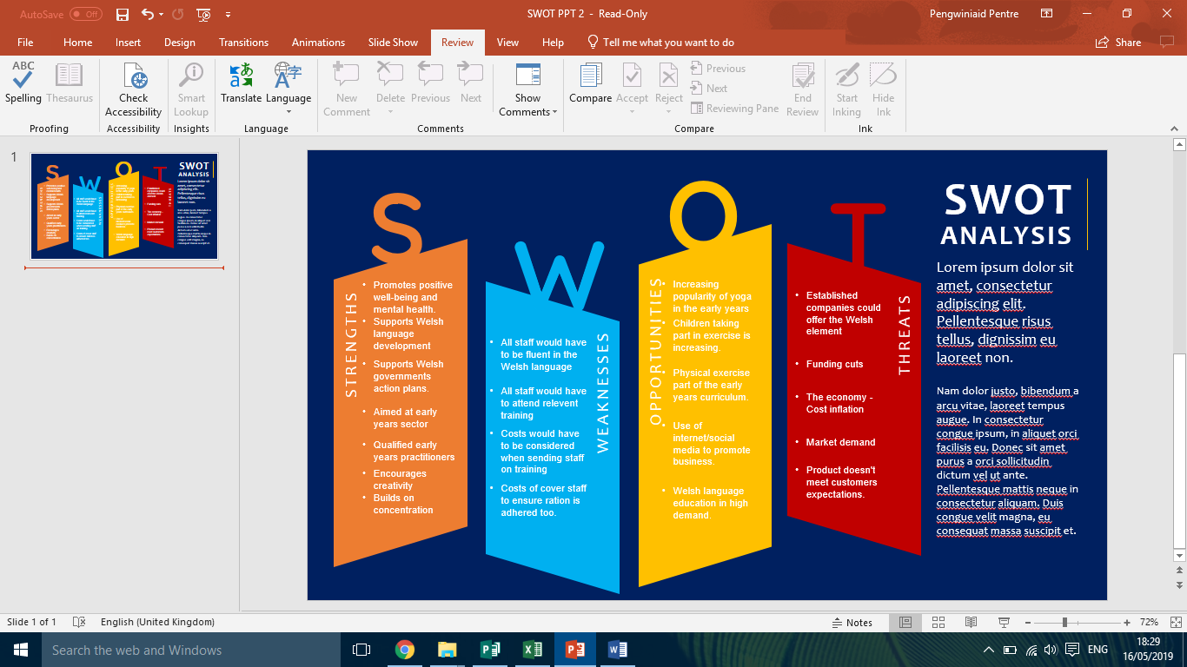
SWOT analysis

This paper is a critical analysis of the potential impact of a yoga session through the medium of Welsh on the development of young children. Including a critical reflection compared with what is currently available or accessible to young children.
The proposed business plan is yoga sessions aimed at children in the early years that is implemented through the medium of Welsh. These sessions will have several positive impacts on young children. According to Novotney (2009) yoga can be used as a psychotherapy tool as it provides many positive benefits. Yoga also improves mood, behaviour, and mindfulness in children and can also have a positive effect on staff and practitioners improving workplace wellbeing and resilience. (Hartfield et al, 2010). This research shows that these sessions would not only benefits the young children that will be participating but also the staff involved.
The Mental Health Foundation (2019), inform us that mental health problems affect around one in ten children, this includes depression and anxiety. With mental health at an all-time high, Welsh Government introduced ‘Together for Children and Young People’ (T4CYP) in 2015. Launched by the Minister of health and social services to refocus emotional and mental health services provided for young children in Wales. Public health Wales (2016) tells us that 47% of adults in Wales have experienced at least one ACE during their childhood. Studies have shown that 14% of adults have suffered four or more ACEs. Research has stated that ACEs are linked to mental health issues later in life.
The suggested yoga session would benefit children by giving them the opportunity to manage stress through breathing, awareness, meditation and healthy movement in a fun and creative way. Children are not immune to the stresses of daily life (Lite, 2014) and yoga encourages children to connect with their bodies and souls (Hoffman, 2018), allowing them the time to relax and reflect on their emotions and process their feelings. Children are full of energy, and these sessions gives them a way of focusing their minds and bodies, concentrating their energy on something positive.
Yoga also promotes children’s gross motor skills whilst being enjoyable, developing body awareness supporting children to learn the ways in which they can move their bodies (Shardlow, 2018). The National Center for Complementary and Alternative Medicine (2018) advises us that yoga is usually safe however, serious injuries can occur such as nerve damage and on rare occasions strokes, they further state that certain moves can potentially affect those with high blood pressure. Even if you’re healthy some muscle damage can occur if difficult poses are attempted too quickly injuring leg muscle, shoulders and wrists could lead to pain and discomfort. Children as young as two will sit and participate in yoga session for long periods of time as they are a fun and engaging way of partaking in physical activities, not only is this promoting a physical and healthy way of learning but can also build concentration skills. Taking part in these group sessions improves social interactions with peers, increasing confidence and a positive self-image by receiving praise for participation. A sense of self-worth is achieved when completing yoga movements. Yoga gives children an alternative to tuning out through constant attachment to electronic devices. This coincides with recent research undertaken that suggests that children under the age of three should only be subjected to an hour and half of screen time each day (Associated press, 2019). This then allowing children’s brains time to rest and recharge. (Dunckley, 2015).
To deliver these sessions effectively, staff will have to attend different nursery settings and provide sessions to children through the medium of Welsh. The Welsh language is one of Wales’s national treasures and is an important part of what makes us Welsh nationals. (Welsh Government, 2015). With the active offer being implemented across Wales, education through the medium of welsh will provide the next generation with increased opportunities. The Welsh language is becoming progressively popular in Wales and the demand for fluent Welsh provision in early years settings is growing. It is vital that early years settings can offer the same opportunities to all children in both English and Welsh.
By providing Welsh yoga sessions we are supporting the Welsh governments national which is Cymraeg 2050: a million welsh speakers, this mission aims to have a million people able to enjoy and use the Welsh language by 2050. Education plays a vital part of this mission, ensuring young children are educated through the medium of Welsh and are proud to use it in their everyday lives. Education and training alone cannot guarantee that speaker become fluent in Welsh or choose to use the language in their everyday lives, therefore it is important that we make learning fun and exciting. (Welsh Government, 2012). The Welsh language is not only Welsh Governments vision but also has an official status. In recent years legislation now provides the right for Welsh speaker to receive services through the Welsh language. (Welsh Language Commissioner, 2019). The Well-being of Future Generations Act (Wales) 2015 that covers the whole of Wales states that public bodies in Wales must be working towards the seven well-being goals. One of these goals is ‘A Wales of vibrant culture and thriving Welsh language’.
Another Welsh Government aim is the Welsh in Education: action plan 2017–21, this sets out the direction for the development of compulsory Welsh-medium and Welsh language education. The action plan is another way of supporting the Welsh Governments aim of having a million Welsh speakers by 2050. These government plans recognise the importance of early years in the development of children’s Welsh language skills. A recent review of Wales’ education curriculum Successful Futures published in 2015 highlighted that the Welsh language should remain compulsory until the age of sixteen and focus on the Welsh language being used primarily as a means of communication.
After completing a SWOT analysis which is the Strengths, Weaknesses, Opportunities and Threats strategy analysis and strategy development framework (Sarby, 2016), it is identified that there would be challenges to this business idea one of these being that all staff providing the sessions would have to be fluent in the Welsh language. According to the Welsh Language Commissioner (2018), Wales faced a shortage of Welsh-speaking employees. This is an ongoing problem across the early years sector (Mudiad meithrin, 2019).
Funding is available through different grants such as the Early Years Pupil Deprivation Grant, however costs must be taken into account when sending staff on training, not only the initial cost of training but also the additional cost of arranging cover for those staff in an early years setting to ensure ratio is being adhered in line with Care Inspectorate Wales’ national minimum standards (2016).
There are other yoga sessions available on the market designed for children in the early years, but they do not provide this service through the medium of Welsh, making this business and unique idea. Consideration must also be taken to further expand the business venture to more settings across Wales to reach demand, this would then allow more children to access the opportunity further promoting national Welsh policies and the Literacy and Numeracy Framework (Foundation Phase Profile, 2016).

