
Financial Management for the hotel industry
[Document subtitle]
Student name - Laxshan Rajagopalasingam
Student number – 2017474
Tutor – Dale Clarke


Executive Summary
The main goal of this assignment is to assess Hilton Worldwide Holding Inc.'s overall performance. The study indicates the company's success over the past two years, which shows a substantial result of the performance of the business. There is a ratio analysis for this corporation as well as a horizontal evaluation of the company that shows the performance over the previous two years. A brief proposal for the Horizontal Analysis and the Performance Analysis is included in the study.
The compensation of CEOs and other top executives has recently generated debate. The CEO's compensation has a greater effect on the company's profitability and the contentment of workers who put in extra effort to fulfill deadlines. Over the past few decades, there have been large pay disparities in a number of American businesses. A CEO now earns significantly more money than the ordinary worker.

Industry experts take a number of approaches to this important problem. According to some, CEOs have a moral and ethical duty to leave a sizable portion of their wealth to their staff. Mr. Banoff issues a warning that problems could develop if the CEO's pay increases more quickly than that of the average employee. The company's compensation committee must therefore pay close attention to this situation. It is essential that the CEO and his or her staff have a remuneration agreement. True, publicly traded companies inform the public of the justifications for the higher salaries of their CEOs. CEOs typically make more money when their compensation is performance-based.

“Zacks Equity Research reports that Hilton's (HLT) third-quarter earnings and revenues beat expectations and rose year over year”.

- HLT +0.93%
- CROX -2.15%
- H +1.91%

Table of Contents
Executive Summary 1
Introduction 3
“Financial Analysis” 3
Financial Analysis Trends 4
A) Calculation of Horizontal Ratios for 2019 and 2020 4
Discussion On the Trends in These Ratios Analysis 5
Gross Profit Ratio 5
Operating Profit Ratio 6
Net Profit Ratio 7
Interest Coverage Ratio 7
Current Ratio 8
Debt to Assets Ratio 8
B) “The Importance of Using Ratio Analysis for Decision-Making” 9
The Limitation of Ratio Analysis 10
“An Understanding of Ratios and Their Fluctuations Is Essential for Hotel Management” 10
“Conclusion” 10
References 14

Introduction
Overall examination of financial ratios and their significance in any business may be found throughout the entire paper. Following that discussion, the ratio of Hilton Worldwide Holding Inc. is examined for the years 2019 to 2020. At that time, the company's overall performance is discussed, and the ratio analysis essentially covers the entire structure with all of its activities. If the ratios do not fluctuate, the various kinds of issues might the company be experiencing in other words, both positive and negative aspects are discussed below, but those are only the benefits of financial ratios; the downsides are also covered.

“Financial Analysis”
“Horizontal Analysis”
Hilton Worldwide Holding Inc
Income Statement | 2020 | 2019 | Change | % Change
Fiscal Year Ends | 31-12-2021 | 31-12-2020
Sales | 43,07,000 | 94,52,000 | -51,45,000 | -54%
Cost of goods sold | 37,24,000 | 70,17,000 | -32,93,000 | -47%
Gross profit | 5,83,000 | 24,35,000 | -18,52,000 | -76%
Operating Expenses | 7,02,000 | 8,59,000 | -1,57,000 | -18%
Operating income | -1,19,000 | 15,76,000 | -16,95,000 | -108%
Interest Expense | 4,29,000 | 4,14,000 | 15,000 | 4%
Total Other income/ expenses net | -3,76,000 | 82,000 | -4,58,000 | -559%
Income before taxes | -9,24,000 | 12,44,000 | -21,68,000 | -174%
Net income | -7,15,000 | 8,81,000 | -15,96,000 | -181%

Horizontal Analysis
Hilton Worldwide Holding Inc
Balance Sheet | 2020 | 2019 | Change | % Change
Current Asset | 42,02,000 | 20,93,000 | 21,09,000 | 101%
Non-Current Asset | 1,58,10,000 | 1,25,58,000 | 32,52,000 | 26%
Total Asset | 1,67,55,000 | 1,49,57,000 | 17,98,000 | 12%
Current Liabilities | 24,31,000 | 28,71,000 | -4,40,000 | -15%
Non-current Liabilities | 1,58,10,000 | 1,25,58,000 | 32,52,000 | 26%
Total Liabilities | 1,82,41,000 | 1,54,29,000 | 28,12,000 | 18%
Common Stock | 3,000 | 3,000 | 0 | 0%
Retained Earnings | -67,32,000 | -59,65,000 | -7,67,000 | 13%
Total Stockholders' Equity | -14,90,000 | -4,82,000 | -10,08,000 | 209%
Total Liabilities and Stockholder | 1,67,55,000 | 1,49,57,000 | 17,98,000 | 12%

Financial Analysis Trends

A) Calculation of Horizontal Ratios for 2019 and 2020
Horizontal Analysis
Hilton Worldwide Holding Inc
Income Statement | 2020 | 2019 | Change | % Change
Fiscal Year Ends | 31-12-2021 | 31-12-2020
Sales | 43,07,000 | 94,52,000 | -51,45,000 | -54%
Cost of goods sold | 37,24,000 | 70,17,000 | -32,93,000 | -47%
Gross profit | 5,83,000 | 24,35,000 | -18,52,000 | -76%
Operating Expenses | 7,02,000 | 8,59,000 | -1,57,000 | -18%
Operating income | -1,19,000 | 15,76,000 | -16,95,000 | -108%
Interest Expense | 4,29,000 | 4,14,000 | 15,000 | 4%
Total Other income/ expenses net | -3,76,000 | 82,000 | -4,58,000 | -559%
Income before taxes | -9,24,000 | 12,44,000 | -21,68,000 | -174%
Net income | -7,15,000 | 8,81,000 | -15,96,000 | -181%
Ratios | 2020 | 2019 | Change | % Change
Gross Profit Ratio | 0.14 | 0.26 | -0.12 | -47%
Operating Profit Ratio | -0.03 | 0.17 | -0.19 | -117%
Net Profit Ratio | -0.17 | 0.09 | -0.26 | -278%
Interest Coverage Ratio | -0.28 | 3.81 | -4.08 | -107%

Horizontal Analysis
Hilton Worldwide Holding Inc
Balance Sheet | 2020 | 2019 | Change | % Change
Current Asset | 42,02,000 | 20,93,000 | 21,09,000 | 101%
Non-Current Asset | 1,58,10,000 | 1,25,58,000 | 32,52,000 | 26%
Total Asset | 1,67,55,000 | 1,49,57,000 | 17,98,000 | 12%
Current Liabilities | 24,31,000 | 28,71,000 | -4,40,000 | -15%
Non-current Liabilities | 1,58,10,000 | 1,25,58,000 | 32,52,000 | 26%
Total Liabilities | 1,82,41,000 | 1,54,29,000 | 28,12,000 | 18%
Common Stock | 3,000 | 3,000 | 0 | 0%
Retained Earnings | -67,32,000 | -59,65,000 | -7,67,000 | 13%
Total Stockholders' Equity | -14,90,000 | -4,82,000 | -10,08,000 | 209%
Total Liabilities and Stockholder | 1,67,55,000 | 1,49,57,000 | 17,98,000 | 12%
Ratios | 2020 | 2019 | Change | % Change
Current Ratio | 1.73 | 0.73 | 1.00 | 137%
Debt To Assets Ratio | 1.09 | 1.03 | 0.06 | 6%

Discussion On the Trends in These Ratios Analysis

The company's horizontal analysis, which includes a ratio of Hilton Worldwide Holding Inc., has been discussed (Islami and Rio, 2019). The type of analysis that aids in determining a company's performance is picture of ratio analysis. The ratio analysis is one of the measures that the organisation uses most frequently. In this study, additional types of ratio analysis that reflect the success of the organisation Hilton Worldwide Holding Inc. are calculated and are listed below:

Gross Profit Ratio
Popular financial indicators like "gross profit ratio" are used to assess a company's performance. An important factor in determining a company's productivity is the gross profit ratio (Islami and Rio, 2019). The gross profit ratio illustrates a company's profitability. In the case of Hilton Worldwide Holding Inc., the gross profit ratio in the year 2020 was 0.14, while in the year 2019, it was 0.26.
Despite a little change of roughly 47%, the gross profit ratio shows a significant decrease in the cost of the gross profit ratio. The primary justification for the change in the importance of the gross profit ratio was that Hilton Worldwide Holding Inc.'s 2020 gross profit would be lower than its 2019 gross profit, and as a result, 2020's value would be lower. The corporation wants to increase sales in order to elevate the importance of the gross profit ratio. In order to ascertain the significance of the gross profit ratio that can be raised for Hilton Worldwide Holding Inc., the company must develop its cost management techniques.
Zacks Equity Research reports that Hilton's (HLT) third-quarter earnings and revenues beat expectations and rose year over year.

- HLT +0.93%
- CROX -2.15%
- H +1.91%

For the third quarter of 2022, Hilton Worldwide Holdings Inc. HLT reported strong earnings and revenues, both of which beat the Zacks Consensus Estimate and increased from the same quarter the previous year. For the fourth straight quarter, both the bottom line and the top line performed better than anticipated.

The following comment was made by Christopher J. Nassetta, Hilton's president and CEO "Our adjusted EBITDA exceeded our expectations, as did our adjusted diluted earnings per share. The continuous growth of the leisure travel sector and the rebound in demand from transient businesses and group travellers were the main factors in the improved performance. These promising developments are expected to hold into the fourth quarter, resulting in a higher-than-anticipated gain in RevPAR."

Hilton's adjusted earnings per share for the third quarter came in at $1.31, exceeding the $1.25 Zacks Consensus Estimate. The business generated adjusted earnings of 78 cents per share during the same quarter of the previous fiscal year.

Operating Profit Ratio
One of the most important ratios for assessing a company's performance and profitability is the operational profit ratio, which is one of the most important financial indicators used to quantify a company's performance (Nugraha, Puspitasari and Amalia, 2020). By dividing operating profit by sales, the operating ratio is determined, and the result is the operating profit ratio's value. In this instance, Hilton Worldwide Holding Inc. has undergone a ratio study, and in 2019 and 2020, the company's operating ratio was 0.17 and 0.17, respectively.
The value has dropped to -0.03 during the year 2020, a change of almost 117%, making it a significant decline. The primary cause of this change is the company's operating loss, which causes the annual profit ratio to turn negative. The corporation must increase sales and reduce expenses in order to enhance the operational profit ratio, which illustrates the company's success.
“Price, Earnings Per Share, and Consensus Surprises for Hilton Worldwide Holdings, Inc”.

Hilton Worldwide Holdings Inc.'s share price, consensus, and profitability all exceeded forecasts. The Hilton Worldwide Holdings Inc. Price, Consensus, and EPS that Unexpectedly Increased Hilton Worldwide Inc.

The $2.36 billion in quarterly revenues exceeded the $2.36 billion market expectation by a significant amount. In addition, when compared to the same quarter last year, the top line increased by 35.4%.

Over the course of the review period, comparable system-wide occupancy levels and average daily rates grew. As a result, currency-neutral comparable system-wide revenue per available room (RevPAR) climbed by 29.9% from the previous year (ADR). Additionally, RevPAR grew 5% from 2019 to 2020.

The most recent quarter saw a 33% yearly increase in fee revenue. EBITDA, or earnings before interest, taxes, depreciation, and amortization, reached $732 million in the third quarter, up from $519 million in the corresponding period of the previous year.

Net Profit Ratio
The key financial measurements used to gauge a company’s performance are the net profit ratio. One of the key metrics used to assess a company's profitability is its net profit ratio (Nugraha, Puspitasari and Amalia, 2020). The Hilton Worldwide Holding Inc.'s net profit ratio was 0.09 in the year 2019; however, it changed to -0.17 in the next year, a 27.8% shift.
The company's Net Profit Ratio paints a poor picture of the business. The company suffered a net loss in 2020, which caused the value of the net profit ratio to decline that year. This is the main cause of the change in the net profit ratio's value. In order to increase the net profit ratio's value, the business must reduce costs and increase sales. This will help the business's net profit ratio in the long run.
Financial Report
At the end of the third quarter of 2022, the amount of cash and cash equivalents (including restricted cash) increased from $1,252 million to $1,362 million. Long-term debt for the corporation has consistently been reported around $8.8 billion. This represents an average weighted interest rate, exclusive of discounts and deferred financing charges, of approximately 4.29 percent.

The company repurchased almost 4 million shares of common stock during that time for close to $497 million.

The corporation has paid its shareholders 15 cents per share in dividends on a quarterly basis. The dividend payment will be delivered on or before December 30, 2022, to stockholders whose ownership was recorded on November 10, 2022.

Interest Coverage Ratio
One of the key financial metrics used to assess a company's performance is the interest coverage ratio, which demonstrates how much of the company's earnings are used to cover its interest costs. This ratio must be calculated in order to more accurately depict the company's performance (Otekunrinet al.,2018). The Hilton Worldwide Holding Inc.'s interest coverage ratio changed by 107% between the years 2020 and 2019, from -0.28 to 3.81.
The business's interest coverage ratio in 2020 reduces its operating profit and converts it into a loss for the company, is the main cause of the value changes. As a result, the interest coverage ratio's value changes from positive to negative. To boost the price of interest coverage ratio, which will be beneficial for the company in the long run, the company must increase sales and operational profit.
Business Developments
80 brand-new Hilton hotels will start accepting guests in the third quarter of 2022. Around 12,100 additional hotel rooms were also added. The company introduced the Curio Collection by Hilton brand during the quarter, which also saw the opening of the 600th Hilton Hotels & Resorts location. The company also disclosed the addition of Kuwait's Waldorf Astoria to its network of upscale accommodations.

As of September 30, 2022, Hilton had more over 416,000 rooms spread across 2,810 locations in 112 different countries and territories. The firm did not yet run hotels in 29 of these countries and territories. In addition, 204,200 rooms were being built in countries other than the United States, and 242,600 more were in the planning stage. In 2022, the company projects net unit growth of above 5%.

Current Ratio
The most popular financial statistic for assessing a company's performance is the current ratio (Otekunrinet al.,2018). One of the key tools for assessing a company's liquidity is the current ratio, which assesses a company's capacity to meet short-term obligations. By dividing current assets by current liabilities, the current ratio is determined. Hilton Worldwide Holding Inc.'s current ratio was 1.73 in the year 2020 and was 137% lower in the year 2019; as a result, the company's current ratio value has increased and is now better. The business must further raise the current ratio's value in order for the value can be enhanced.

Debt to Assets Ratio
The debt to assets ratio is a financial indicator used to assess a firm's performance, but this ratio ultimately establishes how much debt a company has in relation to its assets (Dance and Imade, 2019). By dividing the company's debts by its assets, the ratio of debt to assets is determined. The ratio of debt of possessions of Hilton Worldwide Holding Inc. was 1.09 in 2020 compared to 1.03 the year before, a gain of 6%. The employer requires continuing to improve its debt-to-assets ratio and in order to do that, it must maintain its debt and asset levels.
Outlook
The corporation estimates a net income of between $295 and 316 million dollars for the last three months of 2022. The estimated range for adjusted EBITDA is $641 million to $671 million. The company projects that adjusted diluted earnings per share for the fourth quarter would fall between $1.15 and $1.23.

According to the company, system-wide RevPAR would increase by 19 to 23% in the fourth quarter compared to the same time last year. In addition, it is expected that the metric will rise by 2-6% in 2020 compared to levels in 2019.

The company's net income is expected to be between $1,219 and $1,240 million in 2022, up from the prior prediction of between $1,146 and $1,216 million. The expected range for adjusted EBITDA has increased from $2,400 million to $2,500 million to $2,500 million to $2,530 million. From the previous estimate of $400 to $420 million, the increased estimate for general and administrative costs in 2022 is between $380 and $400 million.

The company's EPS prediction for 2022 has changed from the prior range of $4.21 to $4.46 to $4.46 to $4.54. This is more expensive than the prior price range of $4.21 to $4.46. The estimated range of the annual capital return is $1.5 billion to $1.9 billion.

The business has raised its forecast for system-wide RevPAR growth for 2022 from its previous projection of 37-43% growth to a rise of 40-43% year over year. But it's projected that the metric would fall by 1% to 3% from 2019 levels.

B) “The Importance of Using Ratio Analysis for Decision-Making”
As it gauges a company's success, the ratio analysis is one of the key instruments for performance management. One of the primary financial indicators used to assess a company's performance is the ratio analysis (Bozkurt et al., 2019). The ratio analysis is what provides the view of a company's performance and aids in comparing the company's performance to other companies. Ratio analysis provides a more comprehensive perspective of corporate performance, which assists decision-makers in formulating plans for the company's improvement. The ratio analysis reveals a firm's true performance; if the performance is poor, the company's decision-makers may quickly identify the issues the company is facing and can then quickly establish new plans for the company's growth.

Top Picks of the Week and the Zacks Rank
Hilton is currently placed third, per Zacks (Hold). The stocks with the current Zacks #1 Rank (Strong Buy) are listed in the table below.

One of the top-ranked stocks in the Zacks Consumer Discretionary industry is Crocs, Inc. Other top-ranked companies include Hyatt Hotels Corporation H and Live Nation Entertainment, Inc.

The company with the highest Zacks Rank right now is Crocs (Strong Buy). Long-term earnings should climb by 15%, according to CROX. A share of Crocs stock has lost 48.5% of its value in the last year.

The Zacks Consensus predicts that CROX's revenues will climb by 49.7% in 2022 and its earnings per share will rise by 20%.

Hyatt currently has the top Zacks Rank. H's earnings outperformed forecasts for the previous four quarters by 798%. The stock's price has increased by 8% during the past year.

In comparison to last year's levels, Zacks anticipates that H's current fiscal year revenues and earnings per share will rise by 89.1% and 113%, respectively.

Live Nation is the market leader, according to Zacks. Over the previous four quarters, LYV's average earnings surprise was 70.7%. Over the past year, the stock's price has dropped 19.2%.

The current fiscal year's sales and earnings per share for LYV are anticipated to rise by 130.8% and 117.2%, respectively, over the levels of the prior fiscal year, according to the consensus estimate provided by Zacks.

The Limitation of Ratio Analysis
Ratio analysis has some other drawbacks as well. For example, one of the biggest drawbacks of ratio analysis is that it is not standardised and cannot be used to determine a company's performance using a single ratio; rather, it requires a set of ratios to do so (Caesar et al., 2019).

“An Understanding of Ratios and Their Fluctuations Is Essential for Hotel Management”
The main financial indicator used to assess a company's performance is the ratio analysis (Meiling, 2019). Every organisation needs ratio analysis in order to see how the companies are performing. Every business, even hotel management, needs to perform ratio analyses. The operation of the firm Hilton Worldwide Holding Inc. is shown in the ratio analysis above, and there is a performance issue that the company is dealing with. When this happens, the ratios' values fluctuate as well, revealing the company's performance. By observing this, the decision-makers may then enhance the business operations, which is very beneficial for the company's expansion.

“Conclusion”
The worth of the financial ratio was covered throughout the entire paper. Because the corporation always identifies its difficulties it will find a remedy with the aid of the ratio. Furthermore, the ratios demonstrate how Hilton Worldwide Holding Inc.'s business is assisted in defining how it performs as well as how it resolves problems. The overall balance does, however, have some restrictions, which were mentioned in this article's general content. If the ratio is positive, the company is performing well; if it is negative, it needs to improve o how it is conducting business.
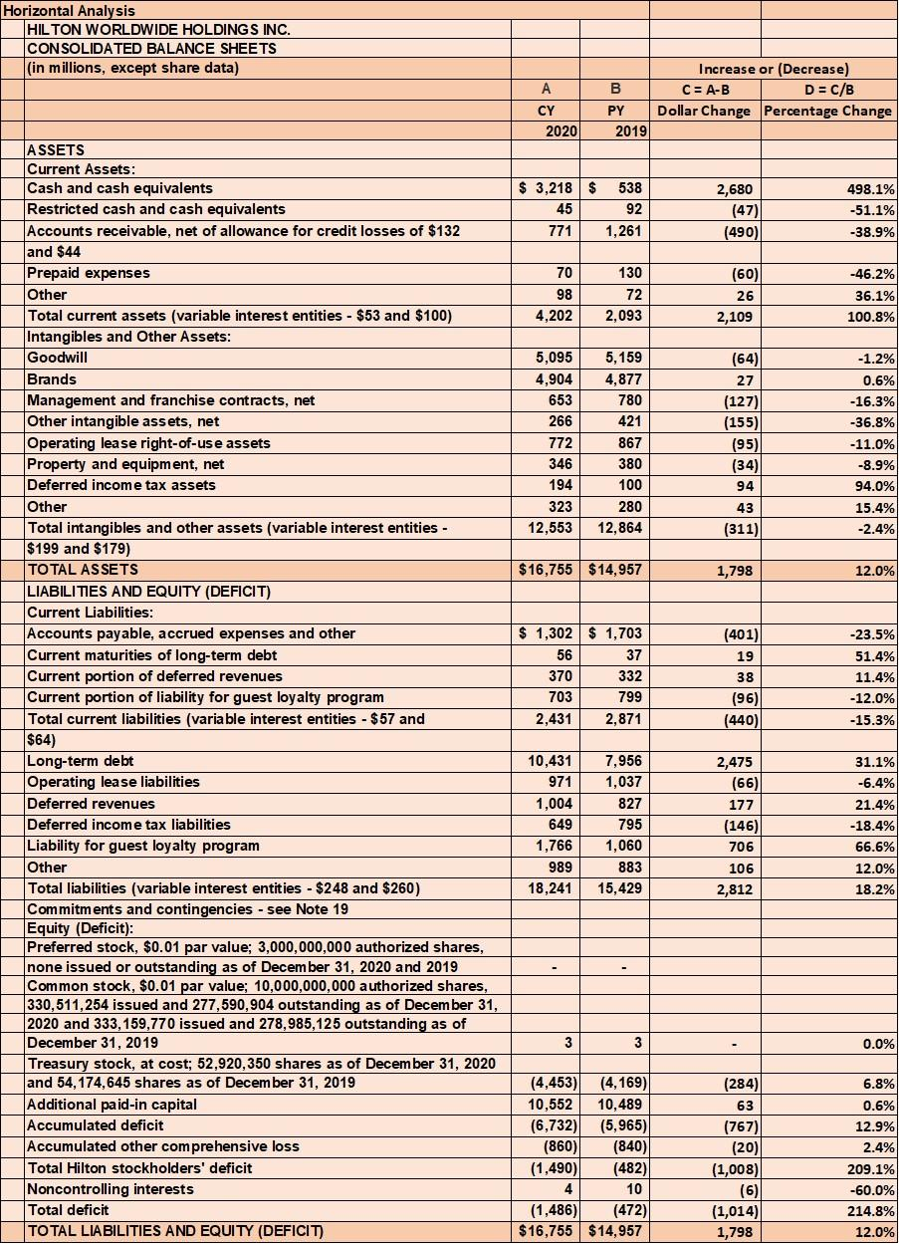

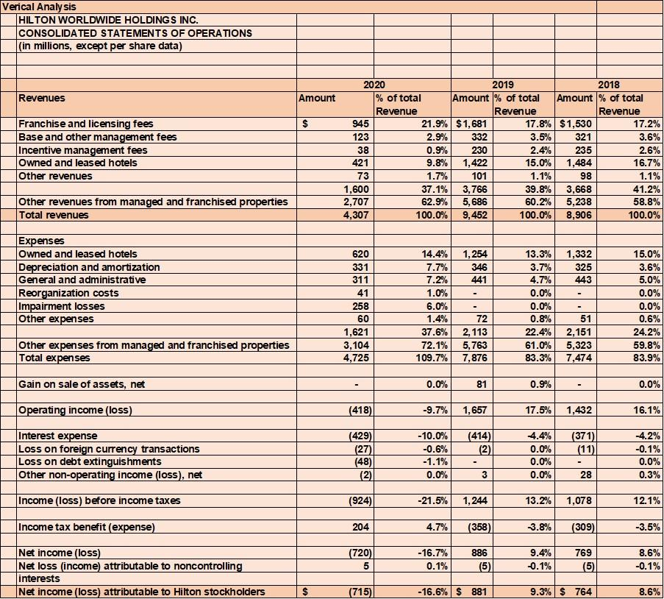

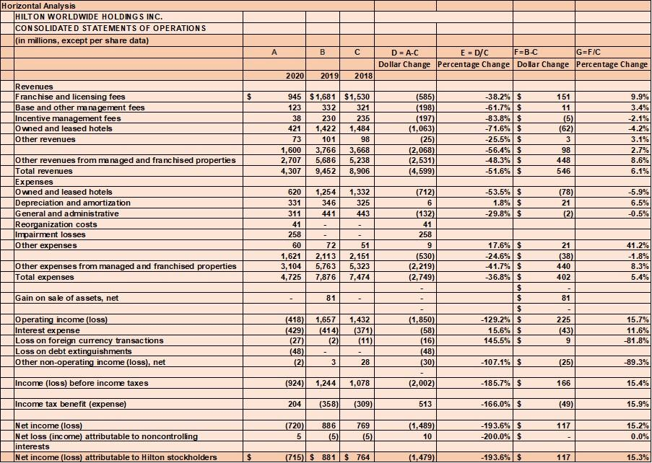

References
Bozkurt, H.H., Tokgöz, M.A., Yapar, A. and Atik, O.Ş., 2019. What is the importance of canal-to-diaphysis ratio on osteoporosis-related hip fractures?. EklemHastaliklariveCerrahisi= Joint Diseases & Related Surgery, 30(3), pp.296-300.
Caesar, L.K., Kellogg, J.J., Kvalheim, O.M. and Cech, N.B., 2019. Opportunities and limitations for untargeted mass spectrometry metabolomics to identify biologically active constituents in complex natural product mixtures. Journal of natural products, 82(3), pp.469-484.
Dance, M. and Imade, S., 2019. Financial ratio analysis in predicting financial conditions distress in indonesia stock exchange. Russian Journal of Agricultural and Socio-Economic Sciences, 86(2).
Islami, I.N. and Rio, W., 2019. Financial ratio analysis to predict financial distress on property and real estate company listed in indonesia stock exchange. JAAF (Journal of Applied Accounting and Finance), 2(2), pp.125-137.
Meiling, H., 2019, December. Research on Bank–Enterprise Relationship and SMEs Financing. In International Conference on Economic Management and Cultural Industry. Shenzhen, China (pp. 239-242).
Nugraha, N.M., Puspitasari, D.M. and Amalia, S., 2020. The effect of financial ratio factors on the percentage of income increasing of automotive companies in Indonesia. International Journal of Psychosocial Rehabilitation, 24(1), pp.2539-2545.
Otekunrin, A.O., Nwanji, T.I., Olowookere, J.K., Egbide, B.C., Fakile, S.A., Lawal, A.I., Ajayi, S.A., Falaye, A.J. and Eluyela, F.D., 2018. Financial ratio analysis and market price of share of selected quoted agriculture and agro-allied firms in Nigeria afteradoption of international financial reporting standard. The Journal of Social Sciences Research, 4(12), pp.736-744.

