
University of Wales Trinity Saint David

M4X02196

Electronic Ignition & Fuel Injection Systems

2020

Ethan Johnson

Contents

Contents 2
Abstract 4
Introduction 5
Background Research 6
Ignition Systems 6
Contact breaker type ignition 6
Transistored Type Ignition System 6
Distributor-less Ignition System (DIS) Wasted Spark Type 7
Amplifier 7
Sensors & Actuators 7
Throttle Potentiometer 7
Negative Temperature Coefficient Thermistor 7
Lambda Sensor 8
Coolant Thermostat 8
Crank Position Sensor 8
Methodology 9
Health and Safety legislation 9
Motronic system testing 9
Static Testing 9
Dynamic Testing 10
Jetronic/LE3 System testing 10
Static Testing 10
Dynamic testing 11
Results 12
Motronic 12
Static Test Results 12
Dynamic Test Results 15
Dynamic Test Oscilloscope Pattern 15
Jetronic/LE3 21
Static Results 21
Dynamic Test Results 22
Analysis 25
Jetronic/LE3 Ignition Analysis 25
Primary Ignition 25
Primary Current 26
Jetronic/LE3 Injection analysis 27
Engine Warm-Up 27
Acceleration 28
Deceleration 28
Idle Speed 28
LE3 Other Analysis 29
Crank Position Sensor 29
Motronic Ignition Analysis 29
Secondary Wave Pattern 29
Primary Current 30
Motronic Injection Analysis 30
Ignition ON Only 30
Engine Warm Up 30
Acceleration 31
Deceleration 33
Idle Speed 34
Motronic Other Analysis 35
Crank Position Sensor 35
Lambda Sensor 35
Differences between Motronic & Jetronic/LE3 36
Differences 36
Theoretical enhancements to the systems 38
Choice of Testing Equipment 38
Multimeter 38
Bosch oscilloscope unit 38
Review 40
Throttle & Air Potentiometers 40
A modern engine for comparison 40
Implementation of the theorized enhancements 40
The Motronic and Jetronic/LE3 systems 41
First Emissions Laws 41
Electrical Noise 41
Bibliography 42

Table of Figures
Figure 1 : Pins 1-20, Static Testing Results 13
Figure 2 : Pins 21-40, Static Test Results 14
Figure 3 : Pins 41-55, Static Test Results 14
Figure 4 : Motronic Component Static Testing 15
Figure 5 : Motronic Component Dynamic Testing 16
Figure 6 : Pin 1 Ignition Coil Primary 16
Figure 7 : Idle Valve %ON time 17
Figure 8 : Pin 7, Pin 53 17
Figure 9 : Pin 16, Injectors under acceleration 18
Figure 10 : Pin 16, Injectors under de-acceleration 18
Figure 11 : Injector Pulse 19
Figure 12 : Pin 16&17, Both banks of Injectors 19
Figure 13 : Pin 2&27, Ignition Supply with ECU Earth 20
Figure 14 : Pin 28, Lambda Sensor 20
Figure 15 : Pin 49, Crank Posistion Sensor 21
Figure 16 : Secondary wave pattern 21
Figure 17 : Amplifier Static Test 22
Figure 18 : Primary & Sencondary Resistance 22
Figure 19 : LE3 Component Dynamic Testing 22
Figure 20 : LE3 Component Dynamic Testing 23
Figure 21 : Pin 1&4, Amplifier Primary and Spark advance 23
Figure 22 : Pin 2&3 Amplifier Supply and Earth 23
Figure 23 : Pin 3, Fuel ECU Idle 24
Figure 24 : Pin 3, Fuel ECU Acceleration 24
Figure 25 : Pin 3, Fuel ECU De-acceleration 24
Figure 26 : Pin 12, Crank Sensor Signal 25
Figure 27 : Stages of Ingition 26
Figure 28 : Ignition & Coil Waveform Differences 27
Figure 29 : Nominal Primary Current Waveform 27
Figure 30 : LE3 NTC2 Resistance vs Temperature 28
Figure 31 : LE3 Injector Pulse 28
Figure 32 : Injector Waveform 30
Figure 33 : Nominal Crankshaft Signal 30
Figure 34 : Secondary Wave Pattern 31
Figure 35 : Motronic NTC2 Resistance vs Temperature 32
Figure 36 : Motronic Injector Pulse 32
Figure 37 : Nominal Throttle Potentiometer Waveform 33
Figure 38 : Relation between Throttle Potentiometer and Air Flow Meter 33
Figure 39 : Nominal Air Flow Meter Waveform 34
Figure 40 : Nominal Inductive Sensor Waveform 36
Figure 41 : Jetronic reluctor wheel shape 38
Figure 42 : Motronic reluctor wheel shape 38

Abstract
A
Fuel injected engine must adjust injection time to required loads and operating conditions, just how the system achieves this is what the report is centred around. Investigating the means in which the ECU identifies loads and conditions, along with how its outputs are changed. The testing consisted of static and dynamic monitoring of engine electrical components, including injectors, ignition circuits and sensors on two different engines with two different engine control systems. These systems were the Jetronic/LE3 and Motronic system, with the Motronic system being the newer of the pair. The Motronic had more sensors than the Jetronic, with some shared sensors sporting improved technology. Analysis pointed to the Motronic having more dynamic data about the condition of the engine and more ability to adjust fueling for power or emission reduction. It was evident that the Motronic had improved upon its predecessor in a number of ways, but there were improvements that could have been made including a DIS ignition system, along with sequential injection among other changes.

Introduction
This report is centred around engine ignition and fueling. Since the engine was invented there has been a drive to invent new ways of controlling engines for more power, and now most recently less emissions and increased fuel efficiency. This assignment will be focusing on more modern electronic fuel injection and ignition rather than mechanical.
In Europe the emissions regulations began in 1956 when the Association of German Engineers were asked by German Parliament to develop general guidelines for emission reduction in motor vehicles. These ideas were taken from the positive results coming from emission combating measures taken in California to combat a growing smog problem there. A.Smith,H.Davies (1996).
Electronic Control Units(ECUs) are the most recent addition to engine emission control, the ECU takes in sensory data from sensors and uses that to change outputs to fuel injectors, spark timing among other components. The ECU removes many mechanical aspects of engine operation thus reducing the need for regular adjustment and replacement of worn parts.
The experiment that has been carried out is centred around the comparison of two engine control systems, the Jetronic/LE3 and Moronic system. The aim is to run static and dynamic tests on both engines, then to assess differences and theorize improvements that could be made to the systems for performance and efficiency.
The main purpose of the investigation is to highlight the pros and cons of each system, and take an in depth look at the specific scope patterns and responses made by the ECU to control the fuel delivery under different loads and conditions.

Background Research
This section is a brief overview of engine control components and sensors, with more detailed explanation of components that are more closely related to the two systems that are being tested.

Ignition Systems
An ignition system is every component on an engine required to send a voltage across the spark plug gap.

Contact breaker type ignition

This system needs only to be explained since later systems share some common components from this type. The contact breaker type ignition consists of 2 main components accompanied by the spark plugs, ignition switch, capacitor and battery. These components are:

- Ignition coil
- Distributor & Contact Points

The contact points are taken in and out of contact via a lobed cam on the distributor driven by the cam shaft. Angle of the points in relation to the cam sets dwell time, these points dictate when the primary coil charges and is cut off, creating an electro-motive force that fires from the secondary winding. This voltage reaches the rotor arm and is distributed between however many spark plugs are in the system. “Back EMF” generated by the sudden cut off is stored in the capacitor.
The Contact Breaker type ignition system, being mostly mechanical, has some drawbacks. Due to the contact points being mechanical, there is the problem of wear, this requires regular adjustment and replacement of components. Another problem is that all of the primary current travels through these points, when these points open, there is a spark jump that leaves debris on the points and degrades the metal. The final problem with the system is that the dwell time cannot be changed with engine speed, this results in less dwell time with higher RPM, this majorly affects the quality of the spark resulting in more HC emissions.
Krank Engineering (2020). The contact breaker (points) ignition system.

Transistored Type Ignition System
This ignition system is used on both of the test engines, although the motronic has the amplifier system incorporated into the ECU. The main difference between the transistored and contact breaker type of ignition system is that the primary circuit is not switched off by the points. Instead of this, there is a pulse generator that sends signals a unit called an amplifier(explained: Pg8). This amplifier contains a transistor that earths the primary circuit when it is on, and disconnects it when a spark needs to be generated. The distribution system works the same as the previous system.
This system eliminates the mechanical aspect of switching off the primary circuit and all of the disadvantages associated. There are still disadvantages to this system, that being that it still uses the vacuum advance system.
Intergrated Publisher(2015). TRANSISTOR IGNITION SYSTEM (BREAKER-POINT TYPE).

Distributor-less Ignition System (DIS) Wasted Spark Type
The next level advancement in ignition technology is the Distributor-less Ignition System, there are varying versions of this, the one of focus is the wasted spark type. Instead of there being a single ignition coil and distributor, there is a unit which within it, depending on engine layout has two ignition coils (1 for every 2 cylinders). The coils are switched by a camshaft position sensor instead of a pulse generator on a distributor, the voltage travels straight from the secondary winding to the two spark plugs connected. Only one of these two cylinders are on the combustion stage which means the other spark is “Wasted” on the exhaust stroke. NGK( 2019). Wasted Spark Ignition Systems.This system removes all mechanical components from the ignition system, removing the need for regular adjustment. Additionally the distribution system now being solid state, means that wear is majorly reduced.

Amplifier
The Amplifier is a part of the Ignition system of the transistored type, the amplifier receives a pulse from a pulse generator in the distributor, the transistor within the amplifier is then switched on or off by the pulse to switch the primary circuit. This has an advantage over the contact breaker points in that it is not mechanical, meaning there is no wear or degradation between contacts. In later models of ignition the Amplifier is built into the ECU itself, further reducing avenues for malfunction. Hella (2001). Ignition module (Trigger box).

Sensors & Actuators

Throttle Potentiometer
The throttle potentiometer is a means of determining the position of the throttle plate. The throttle potentiometer achieves this by turning the position of the throttle plate into a proportional voltage output. There is a rotor that is connected to the throttle plate that turns along a resistive track, the more the throttle opens the less resistance is encountered allowing the voltage to rise sending a signal, refer to Fig37 for an example. Since the output is linear, there is a good ability to attain throttle position. This sensor needs a supply to opperate since it is not inductive hence the presence of three pins. Hella (2020). Throttle Potentiometer.

Negative Temperature Coefficient Thermistor

The Negative Temperature Coefficient(NTC) thermistor is a sensor that generates a proportional resistance to heat. The proportion being that as temperature increases, resistance decreases. This is why it is called a negative coefficient. Hella (2020). Coolant Temperature Sensor Testing. Examples of these NTC coefficients are in the analysis sections Fig30 & 35.

Lambda Sensor
The lambda probe is a form of measuring if the engine is running rich or lean, a form of achieving stoichiometric fuel/air ratio. The probe takes measurements from two areas, one area being inside the exhaust pipe and the other being the ambient air. The lambda probe measures oxygen content the the gasses surrounding it. There is usually 0.3-3% oxygen content in the exhaust, and 20% in the ambient air, the ambient air is used as a comparison. If the exhaust gas contains 3% oxygen it is considered lean and an output of 0.1V is registered for the ECU to adjust injection time to. When the Oxygen content falls below 3% it is considered rich and a 0.9V signal is sent. This is a continuous cycle that repeats for the duration of engine running. Older lambda sensors had to be heated by the engine, conventional lambda sensors now heat themselves with their own heaters allowing them to be placed anywhere along the exhaust. Hella (2016). Lambda Sensor - Cause of Failure, Testing And Troubleshooting.
The reason for the “bouncing” back and forth between rich and lean is due to the sensor being a Narrow-band type, in that there is no in-between rich and lean, the signal will forever keep going between these two values. On more modern vehicles a wide-band lambda sensor is used, the voltage output from these sensors is gradual showing exact fuel/air mixtures, allowing the engine to adjust its fueling more accurately. This allows for improved fuel efficiency and less HC emissions. Baker, B. (2018). Wideband Oxygen Sensors Vs. Narrowband: Understanding The Differences.

Coolant Thermostat
To help speed up the warm up phase, no coolant flows through the engine, this is controlled by an engine thermostat. The thermostat holds the duty of letting coolant into the engine once operating temperature has been reached. Around 50mm in diameter, it is placed where engine temperature can be most quickly attained. Within the thermostat is wax, the wax melts when the engine is at its operating temperature letting coolant into the engine. This technology is now obsolete for the unreliability of wax melting, it is now replaced electrically. HowStuffWorks (2018). How does the thermostat in a car's cooling system work?.

Crank Position Sensor
The crank position sensor is used to attain when cylinder No1 is at TDC, this is vital for the ignition and injection timing, if the location of the No1 piston is known, the other piston positions can be obtained. Example waveforms are Fig33 & 40. In more modern systems the crank sensor can be used to know if the engine has misfired. Samarins (2018). Crankshaft position sensor: how it works, symptoms, problems, testing. There are two types of crank sensor, the hall effect and inductive, the hall effect produces a square wave signal and the inductive produces an analogue signal. As an inductive sensor receives higher speed readings, the frequency decreases whilst the magnitude increases. AutoScope( 2015). Inductive Sensor.

Methodology

Health and Safety legislation
Current health and safety regulations have been acknowledged. Laws derived from the Health and Safety at Work etc. Act 1974 have been followed including:

- Use of Nitrile Gloves, Protective Clothing. (Pg7 Section 7: Used engine Oils)
- Safe working practices, CO meter, Risk assessment etc. (Pg7, Section 7: Used engine Oils)
- Engine Exhaust Extraction. (Pg8, Section 8: Engine Running)

Taken From: The Health & Safety Executive (2009). Health and safety in motor vehicle repair and associated industries

Motronic system testing
The engine had been fitted to engine rigs previously before the experiment began, all required PPE was equipped and CO meters checked before the test. The test equipment was calibrated to ensure accuracy of results. The potential difference between the two probes was measured to subtract from final readings.

Static Testing
- The Ignition was set to “OFF” and all pins on the ECU were checked for a voltage (voltmeter set to 20V/DC) with the black lead on a suitable earthing point.

- Ignition was set to “ON” and all pins on the ECU were checked for a voltage with the same voltmeter setting.

- The throttle potentiometer was tested for resistance, Pins 1&2 shown a reading that was within tolerance of the manual.

- Throttle Potentiometer Pins 1&3 were also tested for a resistance, these readings were out of tolerance in regards to the manual, investigation into this is in the analysis.

- The Air Flow sensor Pins 4&2 were resistance checked, the reading was within tolerance.

- Air Flow sensor Pins 4&3 were also resistance checked, this reading was in tolerance as well.

- Finally Air Flow sensor Pins 4&1 were resistance checked, but as expected there was an infinite reading due to the absence of a CO potentiometer.

- Coolant Temperature Sensor was resistance checked on Pins 1&2, this reading was in tolerance with the manual.

- The Air Temperature sensor was built-in to the same unit as the Air Flow Sensor, Pins 4&5 were within tolerance.

- Lastly the idle speed control valve was resistance checked, this reading was acceptable by the manual.

Dynamic Testing

- A table was created to record the readings on the multimeter and equipment.

- coolant Temperature sensor,CTS: Pin 45 was tested for voltage & resistance, this was done with ignition “ON” only

- Exhaust extractor pipe was fitted to the engine, Pin 4, 5, 16 & 28 were all tested for voltages with the engine running

- Partial Throttle was required for the next Pin 5 voltage test

- Pin 5 & 28 for the lambda sensor were observed on the oscilloscope until the scope pattern indicated that the sensor was up to operating temperature

- The engine was heated up(by running) in increments of 10’C (CTS). The tests started around 20’C as the engine was run in room temperature conditions.

Every 10’C increase in temperature, tests were completed on the following:

CTS: Resistance check, voltage check
Pin 16, Injector: Scoped for injection %ON time measurement
Pin 4, Idle Valve: Measured in %ON time
Emission Control Valve: Observed until switched ON

Repeated until operating temperature is reached.

Jetronic/LE3 System testing
This engine had also been fitted to an engine rig, the same safety precautions were taken as the previous test.

Static Testing
- Amplifier: Pins 1,2,3&4 were all tested for voltages associated to the circuit diagram.

- These test results were compared to the manufacturer’s manual:

- Throttle Potentiometer: Throttle closed, Pins 2&18 were tested for resistance values

- Throttle Potentiometer: Throttle closed, Pins 3&18 were tested for resistance values

- Auxiliary Air Valve: Both Pins tested for resistance

- Injectors 1,2,3&4: All tested for resistance values

- Ignition Coil Primary Winding: Tested for resistance

- Ignition Coil Secondary Winding: Tested for resistance

- HT Leads 1,2,3&4: Tested for resistance values

Dynamic testing
Similar to the previous system test, the test interval is determined by the CTS in 10’C increments.

Every 10’C increase in temperature, tests were completed on the following:

CTS: Resistance check, Voltage check
Injectors: Pin 3 scoped for injection %ON time measurement

Repeated until operating temperature is reached

Results

Motronic
The listed results are taken from the testing of the Motronic injection system, including oscilloscope patterns and multimeter readings.

Static Test Results

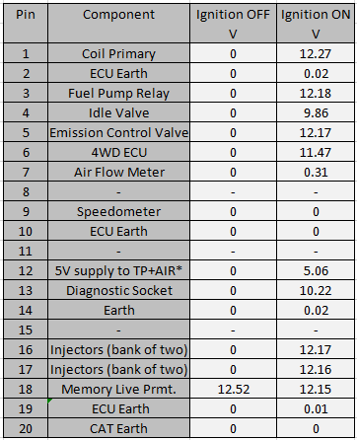

Figure 1: Pins 1-20, Static Testing Results
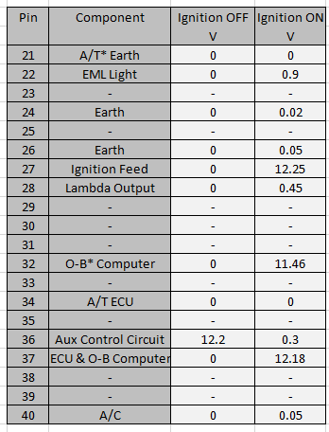

Figure 2: Pins 21-40, Static Test Results
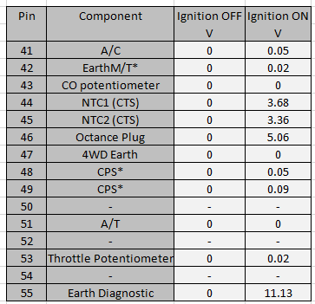

Figure 3: Pins 41-55, Static Test Results

Key For Pins Marked with *:

TP+AIR = Throttle Potentiometer and Air Potentiometer
A/T = Automatic Transmission
M/T = Manual Transmission
- B = On Board
CPS = Crank Shaft Position Sensor

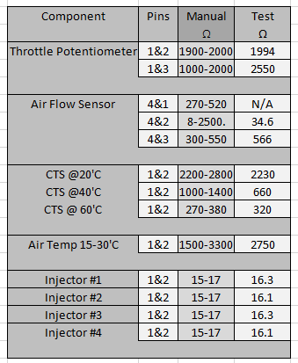

Figure 4: Motronic Component Static Testing

Dynamic Test Results

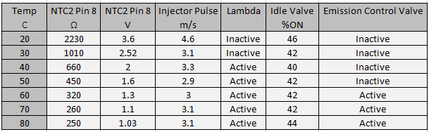
Figure 5: Motronic Component Dynamic Testing

Dynamic Test Oscilloscope Pattern

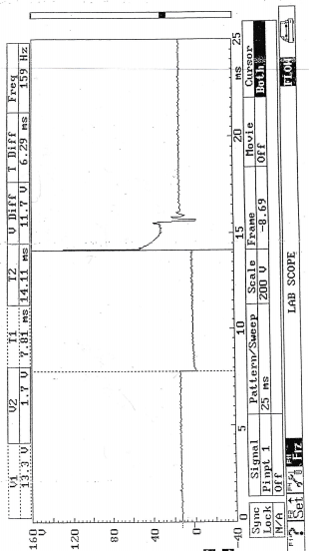
Figure 6: Pin 1 Ignition Coil Primary

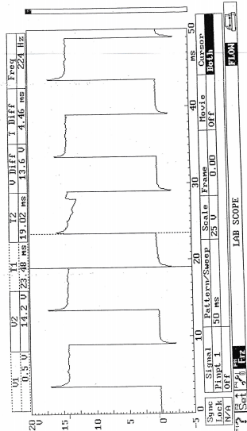

Figure 7: Idle Valve %ON time

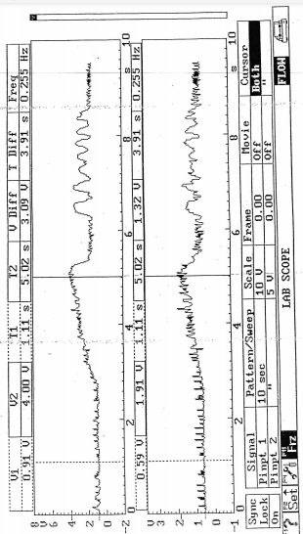

Figure 8: Pin 7, Pin 53

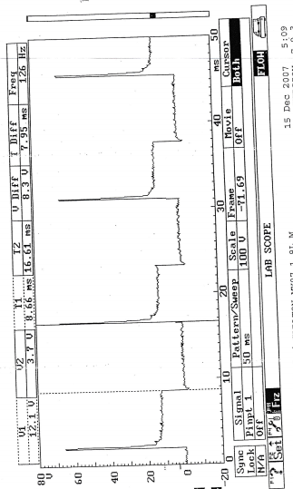

Figure 9: Pin 16, Injectors under acceleration

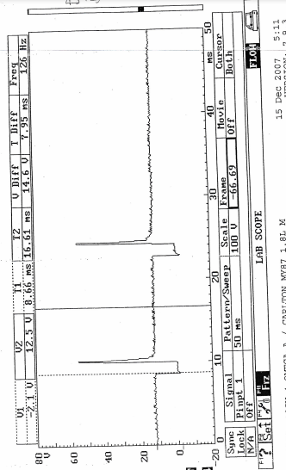

Figure 10: Pin 16, Injectors under deceleration
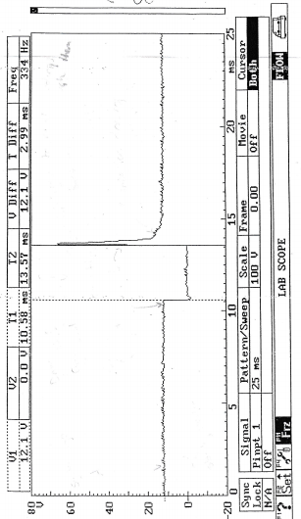

Figure 11: Injector Pulse

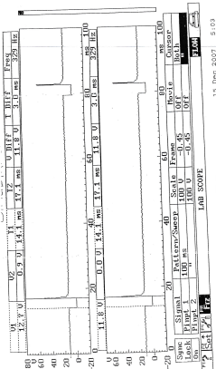

Figure 12: Pin 16&17, Both banks of Injectors

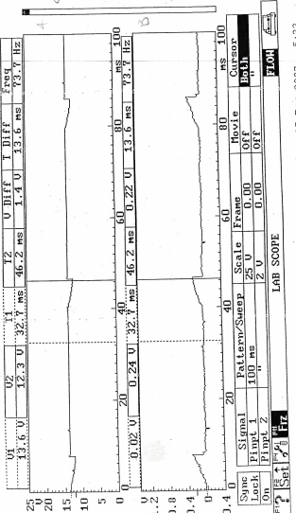

Figure 13: Pin 2&27, Ignition Supply with ECU Earth

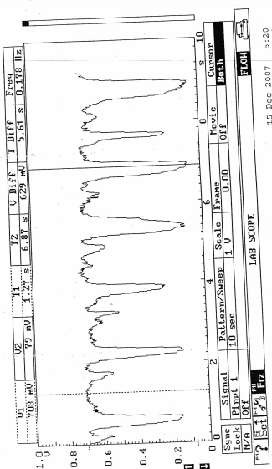

Figure 14: Pin 28, Lambda Sensor

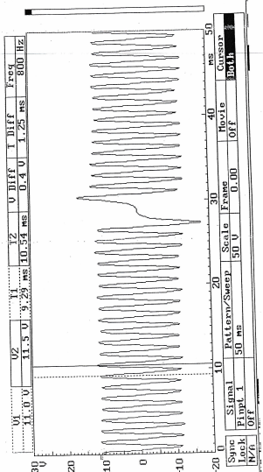

Figure 15: Pin 49, Crank Position Sensor

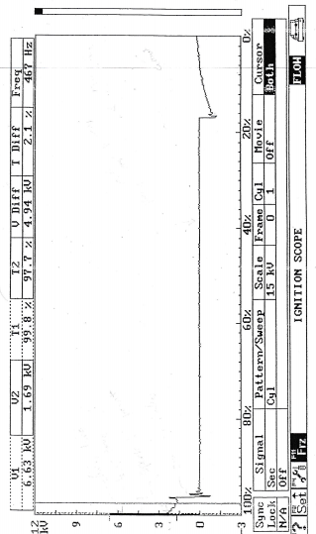
Figure 16: Secondary wave pattern

Jetronic/LE3

Static Results

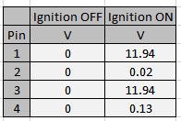

Figure 17: Amplifier Static Test

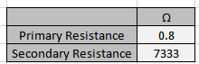

Figure 18: Primary & Secondary Resistance
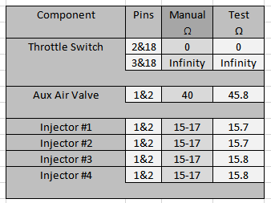
Figure 19: LE3 Component Dynamic Testing

Dynamic Test Results


Figure 20: LE3 Component Dynamic Testing

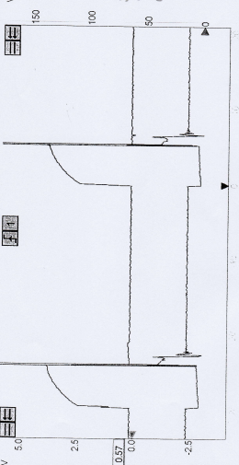

Figure 21: Pin 1&4, Amplifier Primary and Spark advance

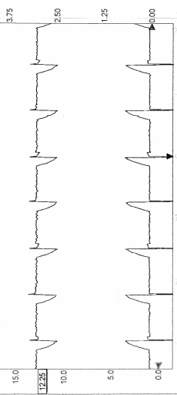

Figure 22: Pin 2&3 Amplifier Supply and Earth

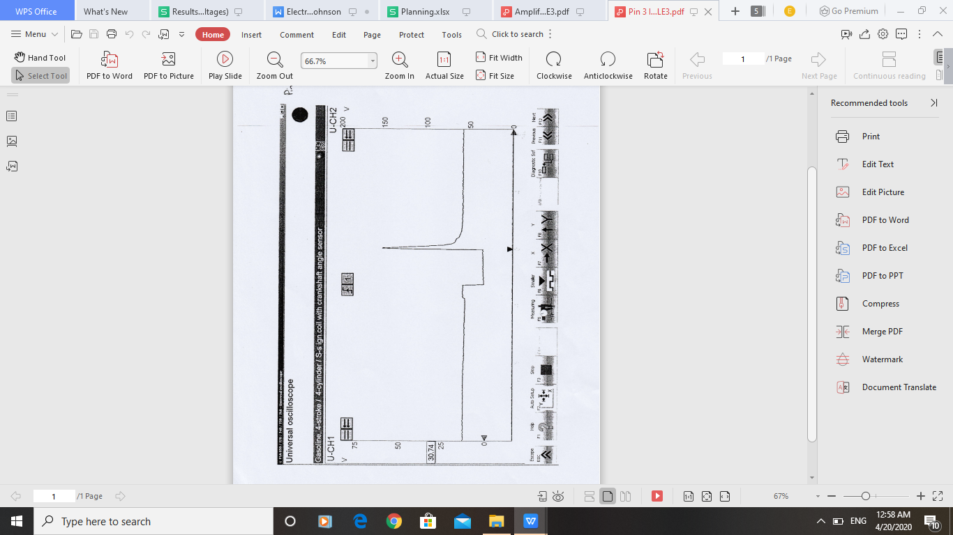

Figure 23: Pin 3, Fuel ECU Idle

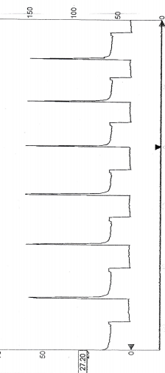

Figure 24: Pin 3, Fuel ECU Acceleration

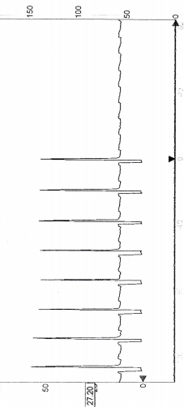

Figure 25: Pin 3, Fuel ECU deceleration

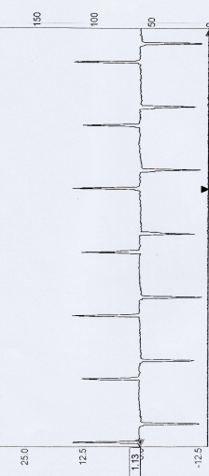

Figure 26: Pin 12, Crank Sensor Signal

Analysis

Jetronic/LE3 Ignition Analysis
There were multiple static and dynamic tests taken on this system, research has been carried out on each subject relating to the results to draw conclusions.

Primary Ignition

Looking at Fig 21, the voltage scope pattern for Pins 1&4 of the amplifier unit are visible. From the initial graph, Pin 1 shows the primary ignition pattern and Pin 4 shows the dwell time from the ECU. The primary circuit shows a typical spark shape. The typical spark shape consists of 5 points, shown in Fig 27 the first point (1) is where the voltage drops when the primary circuit is switched on. There is a flat section which is the dwell time(coil saturation) leading up to (2), there can sometimes be a small step in the dwell time, this is caused by a current limiting system (2). This is followed by a voltage spike (3), this is where the current influences the voltage and is released from the coil when primary is switched off. This is then followed by the burn time(spark duration) (4). Lastly there is turbulence from whats left of the power draining out (5). AutoDitex (2016). Primary Ignition.

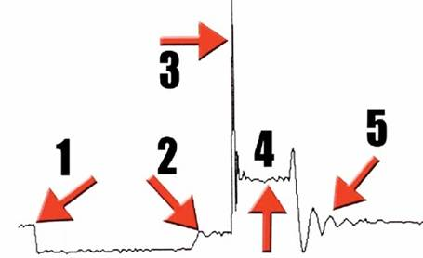
Figure 27: Stages of Ignition
AudioDitex (2016). Primary Ignition.

Fig 21 shows a similar pattern to Fig 27, disregarding the lengths of each stage. Some observations have been taken on the graph characteristics:
The voltage pattern is very clean(no noise) when compared to some other example patterns. Noise is commonly created by heat or electromagnetic interference Keim, R. (2018). What Is Electrical Noise and Where Does It Come From? This would suggest that there is little heat generated around this area, the electromagnetic forces must also be well contained by the HT leads looking at the rest of the oscilloscope.
Fig 21 shows no current limiting as shown in (2) of Fig 27. In this case the current must be limited by the resistance of the primary coil itself LaBundy, J. (2005). Trigger Box. Two very distinct features of the readings are the start and finish of dwell time, as shown in Fig 21 the start and end of the pattern on Pin 4 lines up exactly to the Pin 1 dwell time. This synchronization is due to the fact that Pin 4 shows the coil’s dwell period that includes when it is switched on and off, including dwell. Therefore when the primary is switched on at the coil, the Pin 1 waveform follows suit, showing the switch on of dwell time also. Fig28 demonstrates the synchronization of the two waveforms that is seen in Fig21.
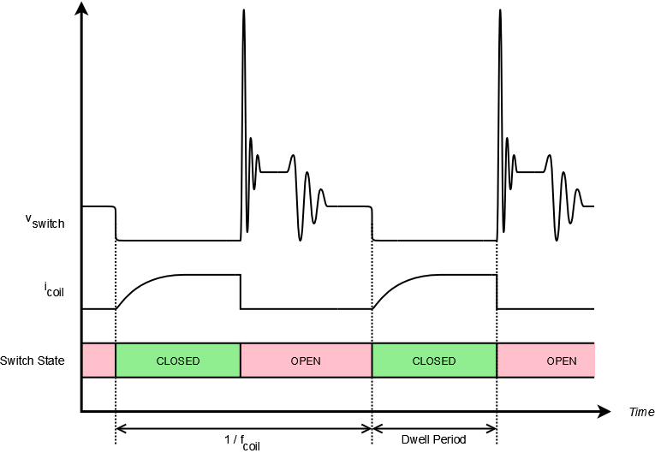
Figure 28: Ignition & Coil Waveform Differences
LaBundy, J. (2005). Trigger Box.

Primary Current
Fig29 demonstrates a correct primary current waveform, as shown on the graph. The current is the upward slope that starts and ends with the primary circuit charge time.The slope represents the current build up in the primary coil, once the electromagnetic field collapses the current drops to zero resulting in the voltage spiking and generating enough voltage to jump the spark plug gap. AutoDitex (2016). Primary Ignition.
This current shape can be seen in Fig22 on the top waveform. The graph also demonstrates the even spark timing. Under higher RPMs, these waveforms would be seen moving to earlier on the oscilloscope pattern because of the ignition advancement. Along the bottom waveform, it seems to be a reverse of the above. This is due to the two pins being tested, Pins 2&3 of the amplifier. Pin2 is the earth for the amplifier. The Earth is at 0V until the current reaches the pin, that current is that of the primary circuit, thus explaining the “mirror” like appearance.

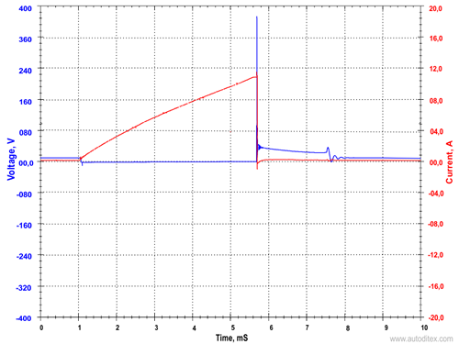
AutoDitex (2016). Primary Ignition.
Figure 29: Nominal Primary Current Waveform

Jetronic/LE3 Injection analysis
The injection time is the main focus of this report, for the Jectronic system there was no data for the ignition ON or cranking phases.

Engine Warm-Up
On inspection of Fig20 there is a clear decrease in injection on time as the engine warms up, starting at 4.3 m/s of injection at 20’C and running at 2.6 m/s at 60 & 66’C. There is a total injection time decrease of 1.7 m/s. Two graphs have been constructed showing NTC resistance and Fuel injection time vs coolant temperature to see the reliance of the ECU on coolant temperature.

Figure 30: LE3 NTC2 Resistance vs Temperature

Figure 31: LE3 Injector Pulse

As seen above, the two curves represent each other closely and proportionally. These graphs show a clear effect of the NTC2 resistance on the resultant injection time. The reason for this relationship is the system running in open loop, open loop is where the engine is trying to warm up to operating temperature as quickly as possible, the main inputs the ECU pays attention to are the Coolant Temperature Sensor and any Air Pressure/Barometric Sensors available. Allowing the system to calculate the necessary Air/Fuel ratio to run a cold engine up to temperature. This is done using a pre-determined ECU map for each temperature stage, explaining how the Injection time changes in different areas. Muskoplat, R. (2017). Open Loop Versus Cold Loop.
Fig20 and Fig30 show what could be interpreted as an anomaly, this area being at 66’C where the resistance increases from 390 to 568 Ω. This is due to the engine thermostat, when the engine is running, no coolant flows through the engine, once the operating temperature is achieved, the thermostat opens and coolant enters the engine, this coolant is still cold, explaining why the resistance increases across the CTS since it gets colder.
This is not the only time the coolant temperature sensor is useful, during engine running the coolant temperature sensor is used by the ECU to determine parameters such as: Fuel mixture, Injection time, Ignition timing and even when the radiator cooling fan should switch on. Prestone (2017). What is a coolant temperature sensor.

Acceleration
Fig24 shows the injector’s waveform under harsh/snap acceleration. At this point the throttle switch has hit the full load contact and is sending a signal to the ECU, the ECU anticipates more airflow to the engine, therefore increasing fuel injection time. The injection layout is simultaneous, firing all injectors at the same time, half the amount twice every 720’ MicroTronik(2016). Fuel injection types.
this is why there is only 1 pin to test, this system also has disadvantages related to fuel mixing, since some valves are closed when the injectors pulse, the fuel is only drawn in as large droplets that do not atomize well leading to poor combustion and high HC emissions.

Deceleration
Fig25 shows the injector’s waveform under deceleration, at this moment the throttle switch is on the idle position. Since the crank position sensor is indicating the engine running at speed the injection time is reduced to a minuscule amount, as demonstrated in Fig25 there is a clear reduction of injection ON time. This causes a rapid reduction in RPM until idle speed is met.

Idle Speed
Fig23 shows the injector waveform at idle speed, the throttle switch is at the idle position. The injector waveform is more simple than that of the ignition. Looking at Fig31, part A shows the point that the injector coil is energized, in this case the injectors are pulled to ground. This point is the time that the injector pintle is raised and fuel is injected into the manifold. Part B is the back EMF of the electromagnetic field collapsing as the circuit is cut. The injection does not stop physically stop until Part C where the voltage returns to normal. Markel, A. (2017). Fuel Injector Circuit Waveforms.

B

C
A
Figure 32: Injector Waveform

LE3 Other Analysis

Crank Position Sensor
Fig26 shows the crank sensor waveform, the waveform differs from the motronic (Fig15). In the ways that there is no regular pattern, instead there are less regular “spikes” in voltage. The difference, as stated earlier, is due to the reluctor type. Seen below is another example of this type of waveform.

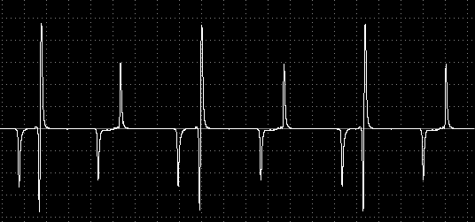
Figure 33: Nominal Crankshaft Signal
Autoscope Technology (2015). Inductive Sensor.

Motronic Ignition Analysis

Fig 6 shows the primary ignition pattern, this pattern is similar to Fig27, there is no current limiting on this system as there is no hump visible unlike Part 2 of Fig27. The spark duration runs for 1.47 m/s and the back EMF spikes to 129.2V. There is little noise suggesting good component condition and low heat interference as investigated in the Jetronic/LE3 system.

Secondary Wave Pattern
Fig16 very closely resembles Fig6, but these waveforms are not completely the same, the primary waveform comes from the primary circuit, everything from the ignition to the primary coil, where it is charged. The secondary waveform is from the secondary circuit, from the secondary coil down to the rotor arm. This is why the secondary waveform differs from the primary waveform. AutoDitex (2016). Secondary Ignition.
Shown in Fig6 the secondary waveform definitely follows the example secondary waveform in Fig34, visible is the current flowing through the primary circuit, that is visible in the primary waveform as well. No current limiting can be seen however, just like the primary circuit waveform. Spark duration is the same as the primary with turbulence (same as Fig34).
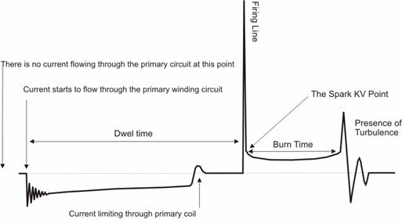
Figure 34: Secondary Wave Pattern
AudioDitex(2016). Secondary Ignition.

Primary Current
The primary current shown in Fig22, matches the Fig29 example. As explained in the Jetronic/LE3 current analysis. Instead of the system being in an amplifier, it is located in the ECU and earthed through Pin 2 according to the manual. Vauxhall (1989). Vauxhall 2.0 Litre Motronic Injection/Ignition.

Motronic Injection Analysis
There was no data available for the cranking phase of the engine, but voltage readings were taken for the ignition on phase.

Ignition ON Only
The static readings of Pins 16 & 17 on Fig1, the voltage readings show 12.17 & 12.16V. These readings can only be the potential difference between the injector and earth. Both pins read 0V with the ignition off.

Engine Warm Up

This testing phase is similar to the Jetronic/LE3 system, There is a decrease in injection time from 4.6 m/s at 20’C down to 3.1 m/s at 80’C. This is a similar decrease to the Jetronic/LE3 injection times. Two graphs for NTC2 resistance and Injection ON time vs Coolant Temperature.

Figure 35: Motronic NTC2 Resistance vs Temperature

Figure 36: Motronic Injector Pulse

There is a visible curve similarity between both the NTC2 resistance and the injection pulse. Like the Jetronic/LE3 system, this is again because of the engine running in open loop to achieve operating temperature. The change in injection time does not change between 70 & 80’C, this is because the NTC2 resistance does not change in those heat regions. The average injection ON time during warm up is 3-3.5 m/s according to the system manual Vauxhall (1989). Vauxhall 2.0 Litre Motronic Injection/Ignition. This can be easily seen in Fig35.

Acceleration
Looking at Fig9 there is the injection waveform under harsh/snap acceleration, this waveform is almost an identical pattern to the Jetronic/LE3. An increased injection time with no time gap between injections. This larger injection time is due to the two input sensors in the manifold, the Air Flow Meter and Throttle Potentiometer. These sensors are both potentiometers, the signal waveforms are shown in Fig8. Since both sensors are potentiometers, under acceleration it is expected that the two sensors look fairly similar in waveform. The scope pattern below shows how a potentiometer should look under gradual acceleration and then cut off (quick return to rest).

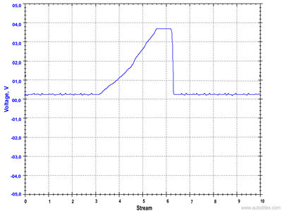
AutoDitex (2017). Throttle Position Sensor (TPS).
Figure 37: Nominal Throttle Potentiometer Waveform

This pattern is evident in both oscilloscope graphs, this shows a uniform rise in voltage with a sharp drop at the end. This is somewhat resembled in Fig8. Unfortunately unlike what was expected, both pin readings show the same waveform pattern. This may be partly for the fact that both potentiometers share common supply and common earth as shown in Fig38, these waveforms may be picked up by each meter. This is an unlikely circumstance since the readings were taken from the output pins, not the supply or earth.

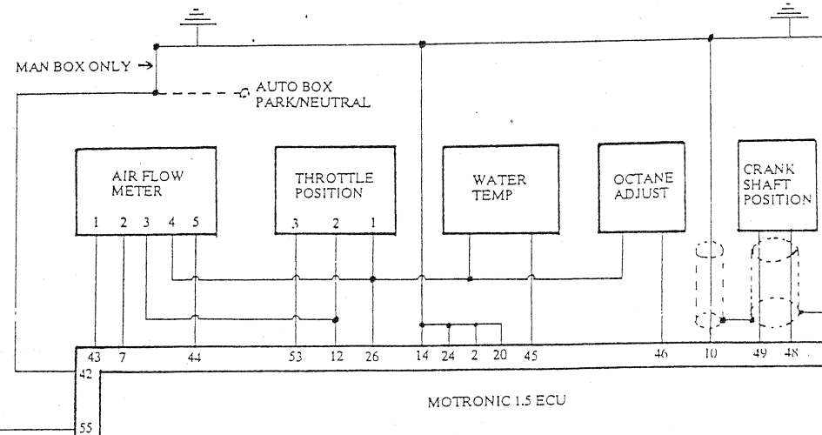
Connections
Vauxhall (1989). Vauxhall 2.0 Litre Motronic Injection/Ignition.
Figure 38: Relation between Throttle Potentiometer and Air Flow Meter

What was expected on Pin7 was a pattern more inline with this scope pattern detailed below. There are some oscillations on point 6 of the X-Axis in Fig8 that could be passed off as these signals, but the readings are not clear enough to make a solid decision, some extra individual component tests would be useful if this test was carried out in future.

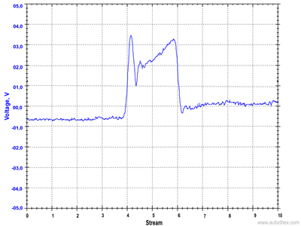
AutoDitex (2016). Mass Air Flow Sensor
Figure 39: Nominal Air Flow Meter Waveform

Returning to the Throttle Position Sensor, in the static tests there was a reading on the throttle potentiometer that was out of tolerance, this is shown in Fig4 between pins 1&3. The reading should have been between 1900 & 2000Ω, the value was recorded at 2550Ω. An increased resistance on the resistive track can lead to incorrect throttle position information being sent to the ECU, resulting in poor acceleration and sometimes high fuel consumption. Hella (2020). Throttle Potentiometer. In the same figure, there is a high resistance between 3&4 of the Air Flow Meter, this high reading could be responsible for a disrupted reading on the oscilloscope. Neither of these faults were causing noticeable trouble for the engine at the time of testing.
There are two conclusions that can be made with out the possibility of further investigation into the two potentiometer readings:

- The Air Flow Meter is not giving an output and the throttle potentiometer is faulty giving the oscillations at the later part of the graph.
- Both sensors are functioning correctly, with the throttle potentiometer waveform first with the Air flow Meter waveform last sharing a common ECU Earth.

For the information that is available it is more likely that option 2 is the explanation for the Fig8, explaining why both patterns show up on both pins, and why the graph is the shape that it is. If the faults continue to worsen, potentially there may be signs of the engine hesitating to accelerate along with high fuel consumption as stated earlier.

Deceleration
In Fig10 there are the waveforms of the injectors under deceleration, unlike Fig9 the injection times have reduced, not to the extent of the Jetronic/LE3 system, but there is an obvious decline of injection on time. In comparison to Fig 25 there is not a constant stream of short injections, but instead some longer, less frequent injections. This spacing of the waveforms show that injectors are not firing altogether in certain intervals. The injectors are in two banks but do not fire independently from each other, this can be seen in Fig 12. This gap in injection will save fuel and reduce the time taken to return to idle speed. ₋

Idle Speed
The injector pulse shown in Fig11 is the standard injector pulse shape as described in the analysis of Fig32. A steady even injection period that changes with coolant temperature. What is on this system that is not present on the Jetronic/LE3 system is an idle valve, the idle valve is pulse width modulated (can be opened a certain percentage). The Idle Valve activates whenever there is an increased electrical load on the engine, with no throttle change. This is to stop the alternator from stalling the engine. These increased loads can be due to the Air Conditioning (A/C) being activated, other electrical consumers and even in automatics at creep speed in 1st gear. Hella (2016). Idle Speed Controller & Actuator. In Fig7 the idle valve waveform can be seen.
The idle valve works on the principle of “Duty Cycle”, this means an intermittent voltage, a part of Pulse Width Modulation. A duty cycle percentage is determined by how much out of a frequency (one period of time) a component receives a voltage. If the component receives a voltage 50% of the period, and is then off for 50%, this is a 50% duty cycle; the width of the pulse has been modulated at 50%. Answinth, R. (2018). What is PWM: Pulse Width Modulation.
This can be seen in Fig7, a measurement of %ON time was not taken with the test equipment for this particular graph, but a figure was taken during the warm up phase. At operating temperature it is assumable that the idle valve %ON time can be taken from Fig5. This figure being 44% matches well to Fig7. This would likely rise in the event of extra loads being applied to the engine.

Motronic Other Analysis

Crank Position Sensor
Fig15 is the waveform generated by the inductive Crank Position Sensor, an example waveform is shown below. Both waveforms show a regular frequency with a noticeable change in the centre. What this represents is each tooth on a reluctor wheel, the centre part is the missing tooth as explained in the research section.

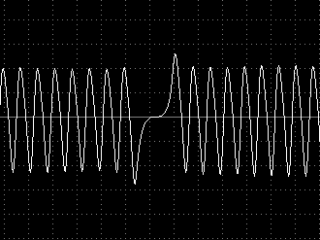
Figure 40: Nominal Inductive Sensor Waveform
AutoDitex (2015). Inductive Sensor.

Lambda Sensor
Fig14 outlines the Lambda sensor output during the running of the engine, what can be seen is the sensor notifying the ECU on whether the engine is running a rich or lean fuel mixture. As explained previously it is visible at the high points the Lambda sensor recognizes the exhaust content to be rich sending a high voltage reading ~0.9V. Then when the mixture goes lean due to injection time being lowered, the output is ~0.1V. This is explained in more detail in the research section.
Discussions

Differences between Motronic & Jetronic/LE3
During analysis of the data there have been some significant and less significant differences between the two systems. The next section will outline what differences have been found, and later a choice on how one of the systems could be improved.

Differences
The first difference between the two systems is the fact that the amplifier is no longer a separate piece to the ECU, it is incorporated. This means less chance of malfunction and less wiring. Having the amplifier within the ECU gives it protection from the elements and less exposure to heat, thus allowing for better performance.
In terms of injectors on the Motronic they are both still simultaneous in sequencing, but in the case of the Motronic the injectors are in two separate banks, seen in Fig12, looking at the data this does not make any change to the injections or the sequencing, and also still fire at the same time as illustrated in Fig12.
Upon deceleration the injectors on the Motronic cut off fuel supply. This is not seen in the Jetronic. The injectors on the Jetronic are all on the same circuit and are pulled to ground just the same as the Motronic, only when under deceleration the injectors still fire every revolution only the injection time is decreased to a minimum.
In the NTC2 vs Resistance there is a point in which the thermostat activates and lets coolant flow into the engine. The sudden rush of cold coolant increases the resistance across the CTS. This raise in resistance is not seen on the Motronic system.
Another difference between the two systems is the presence of an idle speed actuator, the idle speed actuator in the motronic is explained previously. The motronic system does not have this feature, there is an advantage to the motronic for having this system in that it can adapt to different loads being applied to it.
There is also the presence of a lambda probe in the Motronic system, explained in the research section, having the lambda probe in the inventory of sensors means that the Motronic system is able to adjust its fuel air ratio to keep it stoichiometric (14:1). The Jetronic system is unable to adjust its rich/lean combustion and emits higher emissions as a result.
The Motronic system has another sensory advantage over the Jetronic for it has a throttle potentiometer, where the Jetronic only has a throttle switch that provides “Full Load” “Partial Load” and “Idle” information. The Throttle Potentiometer provides exact throttle position at all times, meaning that the fuel mixture can be adjusted to any position from closed to open. This provides better power output for different loads, and also improves emissions.
One last difference is that the crank shaft position sensors on both systems are inductive, although they each put out a different waveform, this is down to the type of reluctor wheel used:

Jetronic/LE3 Waveform

The waveform shown in Fig26 is the crank sensor waveform, this waveform does not match many more common inductive signals like the one demonstrated in Fig40, this is because the reluctor wheel teeth are very large and spaced out from each other shown in Fig41. This causes the waveform to look different. AutoScope (2015). Inductive Sensor.
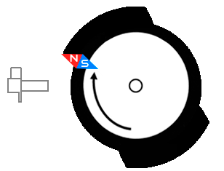
Figure 41: Jetronic reluctor wheel shape
AutoScope (2015). Inductive Sensor.

Motronic Waveform

The Motronic waveform in Fig15 shows the traditional waveform of an inductive sensor, instead of only counting a few teeth like in Fig41 there are many teeth in a regular order with one tooth missing as shown in Fig42. This creates the “gap” in the waveform. AutoScope (2015). Inductive Sensor.
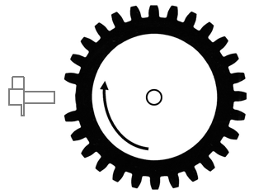
Figure 42: Motronic reluctor wheel shape
AutoScope (2015). Inductive Sensor.

Theoretical enhancements to the systems
The Motronic may be a more technically advanced system to the jetronic, but it is certainly not the best system that could be used. These systems in today’s standard are outdated, and do not meet emission regulations.
The Jetronic system can be easily improved upon by the addition of a lambda probe, having the presence of a Lambda probe allows the engine to adjust its fuel/air mixture to achieve the best emissions as explained in the research section.
The Motronic system can also be improved with another type of Lambda sensor, this time instead of using a narrow-band sensor, it is replaced with a broad-band sensor, allowing dynamic data of the exactly how rich, or how lean the mixture is, increasing fuel economy and reducing HC emissions.
One change that would increase fuel efficiency of both systems drastically would be the introduction of sequential injection. On the current systems, the fuel is injected at half the amount every 360’ crank rotation, regardless of whether the valves are open or not. This consequently results in poor atomization of the fuel and high HC output. The introduction of a sequential injection system would mean that the injectors each have their own earth path, allowing each injector to be fired in sequence according to the valve position. This increase in accuracy removes the poor atomization and reduces HC emissions. Another ability that could be achieved with sequential injection would be the ability to adjust fuel quantities for individual cylinders, allowing more complex control over running the engine. The addition of sequential injection would require a camshaft position sensor. MicroTronik (2016). Fuel injection types.
The presence of a camshaft sensor for the sequential injection would make way for a more advanced ignition system. The camshaft signal allows for a DIS ignition system to be fitted, explained in the research, this would remove all mechanical aspects of the ignition system thus improving reliability and longevity of the engine. The electrical load would be split between two coils instead of one, improving the spark quality and encouraging a better burn.
There are more complex enhancements that could be made to these systems including: Coil on Plug, Direct Injection, Fully Stratified Injection and more. These enhancements have been chosen because they would not require much modification to the engine block and head. Instead the chosen enhancements are electrical, meaning that the new components can be externally attached to the engine. This makes the modifications much more feasible to fit to the engine, spark plugs and HT leads can be left mostly unchanged and the injectors can stay in the same position.

Choice of Testing Equipment
During testing there were a few different pieces of equipment used for testing the engines, the reasoning for using this equipment is stated below.

Multimeter
The voltmeter was chosen for use mainly for its portability, the Bosch oscilloscope unit could perform the same task, but was slow and clumsy to be using for testing 50+ ECU pins. The volt meter was easy to use, quick for moving between pins, and performed the tasks it was needed for.

Bosch oscilloscope unit
The Bosch oscilloscope Unit was mainly used for a task that the Multimeter could not perform; the visual voltage readouts. The unit was chosen for its multitude of measuring capabilities, including scoping, temperature measurement, current measurement and dual channel readings. The unit performed as it should have giving out all data that was required for analysis.
Conclusion

This investigation has shown many different characteristics of both engines, and how, as a whole the control of an engine has improved through the generations. There is enough evidence to confidently conclude that the Motronic system is superior to the Jetronic. This is in the ways that the Motronic has more accurate sensing capability (use of potentiometers) and in some cases a larger inventory of sensors (Lambda Sensor). There have been discoveries of relationships between sensors and outputs, especially focused on the injection on time. This shows testament to the improvements of engine control between a generation, and many of the technologies used then, are still incorporated today.

“Failure is simply the opportunity to begin again, this time more intelligently.”

Henry Ford

Medrut, F. (2017). 25 Henry Ford Quotes to Make You Feel Like You Can Achieve Anything.

Review
As a whole the testing went to plan and a suitable amount of data was obtained to assess how injection ON time changes. All though throughout analysis it became apparent that there was a certain amount of data that would be useful to have during this report.

Throttle & Air Potentiometers
There was a level of confusion in analyzing the potentiometer waveforms for the motronic system, had there been the opportunity to investigate the condition of these sensors further, it would have resulted in a more certain conclusion.

A modern engine for comparison
Had there been the opportunity to run the same tests on a modern engine from the current automotive year, another comparison could have been made between the Motronic and current system.

Implementation of the theorized enhancements
For the most in depth analysis, the ability to adapt one of the engines to the new ignition and injection system would have allowed for a before/after comparison of the engine, and actual improvements on power, emissions and reliability.
Further Reading

During the research many sources contained interesting information and more detailed description of components, compiled here are some of the more significant material for those wishing to find out more about the mentioned topics.

The Motronic and Jetronic/LE3 systems
BOSCH explanation on the Jetronic/LE3:

http://br.bosch-automotive.com/en/internet/parts/parts_and_accessories_2/motor_and_sytems/benzin/injection_system/le_jetronic_1/le_jetronic.html

BOSCH explanation on the Motronic:

http://br.bosch-automotive.com/en/internet/parts/parts_and_accessories_2/motor_and_sytems/benzin/injection_system/motronic/motronic_1.html

First Emissions Laws
A.Smith,H.Davies (1996). A review of the history of emission legislation, urban and national transport trends and their impact on transport emissions. University of Central England, Birmingham, UK: WIT Press.

Electrical Noise
https://www.allaboutcircuits.com/technical-articles/electrical-noise-what-causes-noise-in-electrical-circuits/

10Hrs of calming music to help mark the other 30 assignments just like this one!

https://www.youtube.com/watch?v=EbnH3VHzhu8

Bibliography
A.Smith,H.Davies (1996). A review of the history of emission legislation, urban and national transport trends and their impact on transport emissions. University of Central England, Birmingham, UK: WIT Press. pg4

The Health & Safety Executive (2009). Health and safety in motor vehicle repair and associated industries. London: The HSE, Crown Copyright. Pg7-8.

Government Author. (1974). Health and Safety at Work etc. Act 1974. Available: http://www.legislation.gov.uk/ukpga/1974/37/contents. Last accessed 18/4/2020.

Anon. (2020). The contact breaker (points) ignition system. Available: https://krankengineering.com/tech/contact-breaker-points-ignition-system/. Last accessed 18/4/2020.

Corporate Author. (2015). TRANSISTOR IGNITION SYSTEM (BREAKER-POINT TYPE). Available: http://constructionmanuals.tpub.com/14050/css/Transistor-Ignition-System-96.htm. Last accessed 18/4/2020.

Corporate Author. (2020). Throttle Potentiometer. Available: https://www.hella.com/techworld/uk/Technical/Sensors-and-actuators/Throttle-potentiometer-3742/. Last accessed 20/4/2020.

Corporate Author. (2001). Ignition module (Trigger box). Available: https://www.hella.com/tibi/ti/en/electrics/TI_EN_ELECTRONICS_Ignition_Module.pdf. Last accessed 20/4/2020.

Corporate Author. (2016). Engine Coolant Temperature Sensor (ECT). Available: https://autoditex.com/page/engine-coolant-temperature-sensor-ect-13-1.html. Last accessed 20/4/2020.

Corporate Author. (2020). Coolant Temperature Sensor Testing - Symptoms, Cause of Failure & Troublesitting. Available: https://www.hella.com/techworld/uk/Technical/Sensors-and-actuators/Test-coolant-temperature-sensor-4277/. Last accessed 20/4/2020.

Corporate Author. (2018). Throttle Switch. Available: . Last accessed 20/4/2020.

Corporate Author. (2016). Secondary Ignition. Available: https://autoditex.com/page/secondary-ignition-33-1.html. Last accessed 21/4/2020.

Corporate Author. (2016). Primary Ignition. Available: https://autoditex.com/page/primary-ignition-32-1.html. Last accessed 21/4/2020.

LaBundy, J. (2005). Trigger Box. Available: http://labundy.com/trigger_box/trigger_box.html. Last accessed 21/4/2020.

Keim, R. (2018). What Is Electrical Noise and Where Does It Come From?. Available: https://www.allaboutcircuits.com/technical-articles/electrical-noise-what-causes-noise-in-electrical-circuits/. Last accessed 21/4/2020.

Corporate Author. (2015). Waveforms. Available: https://usbautoscope.eu/en/sig-atlas/ignition-sensor/. Last accessed 21/4/2020.

Markel, A. (2017). Fuel Injector Circuit Waveforms. Available: https://www.underhoodservice.com/fuel-injector-circuit-waveforms/. Last accessed 21/4/2020.

Corporate Author. (2018). Fuel Injectors. Available: https://usbautoscope.eu/en/sig-atlas/fuel-injectors/. Last accessed 22/4/2020.

Corporate Author. (2016). L-Jetronic Fuel Injection System. Available: http://howcarpartswork.blogspot.com/2016/03/l-jetronic-fuel-injection-system.html. Last accessed 22/4/2020.
Corporate Author. (2018). Throttle Position Sensor (potentiometer). Available: https://www.picoauto.com/library/automotive-guided-tests/throttle-position-potentiometer/. Last accessed 22/4/2020.
Corporate Author. (2017). What is a coolant temperature sensor. Available: https://www.holtsauto.com/prestone/news/coolant-temperature-sensor#what. Last accessed 22/4/2020.

Corporate Author. (2020). Motronic. Available: http://br.bosch-automotive.com/en/internet/parts/parts_and_accessories_2/motor_and_sytems/benzin/injection_system/motronic/motronic_1.html#. Last accessed 22/4/2020.

Corporate Author. (2020). LE-Jetronic. Available: http://br.bosch-automotive.com/en/internet/parts/parts_and_accessories_2/motor_and_sytems/benzin/injection_system/le_jetronic_1/le_jetronic.html. Last accessed 22/4/2020.

Muskoplat, R. (2017). Open Loop Versus Cold Loop. Available: https://ricksfreeautorepairadvice.com/open-loop-versus-closed-loop/. Last accessed 23/4/2020.

Nice, K. (2017). How Fuel Injection Systems Work. Available: https://auto.howstuffworks.com/fuel-injection2.htm. Last accessed 23/4/2020.

Corporate Author. (2016). Fuel injection types. Available: http://www.micro-tronik.com/learning/technical-information/automotive/repair-basics/general-engine-infromations/electronic-fuel-injection/injectors/injection-types/. Last accessed 23/1/2020.
Corporate Author. (2016). Idle Speed Controller & Actuator. Available: https://www.hella.com/techworld/uk/Technical/Sensors-and-actuators/Idle-speed-controller-3601/. Last accessed 23/4/2020.

Vauxhall (1989). Vauxhaull 2.0 Litre Motronic Injection/Ignition.

Corporate Author. (2017). Throttle Position Sensor (TPS). Available: https://autoditex.com/page/throttle-position-sensor-tps-22-1.html. Last accessed 23/4/2020.

Corporate Author. (2016). Mass Air Flow Sensor. Available: https://autoditex.com/page/mass-air-flow-sensor-maf-19-1.html. Last accessed 24/4/2020.
Answinth, R. (2018). What is PWM: Pulse Width Modulation. Available: https://circuitdigest.com/tutorial/what-is-pwm-pulse-width-modulation. Last accessed 24/4/2020.
Corporate Author. (2015). Inductive Sensor. Available: https://usbautoscope.eu/en/sig-atlas/inductive-sensor/. Last accessed 24/4/2020.
Corporate Author. (2018). How does the thermostat in a car's cooling system work?. Available: https://auto.howstuffworks.com/how-does-the-thermostat-in-a-cars-cooling-system-work.htm. Last accessed 25/4/2020.
Corporate Author. (2018). Crankshaft position sensor: how it works, symptoms, problems, testing. Available: https://www.samarins.com/glossary/crank_sensor.html. Last accessed 25/4/2020.
Corporate Author. (2016). Lambda Sensor - Cause of Failure, Testing And Troubleshooting. Available: https://www.hella.com/techworld/uk/Technical/Sensors-and-actuators/Test-lambda-sensor-4379/. Last accessed 25/4/2020.
Corporate Author. (2019). Wasted Spark Ignition Systems. Available: https://www.ngk.com/learning-center/article/815/wasted-spark-ignition-systems. Last accessed 26/4/2020.

Medrut, F. (2017). 25 Henry Ford Quotes to Make You Feel Like You Can Achieve Anything. Available: https://www.goalcast.com/2017/12/24/henry-ford-quotes/. Last accessed 26/4/2020.

Baker, B. (2018). Wideband Oxygen Sensors Vs. Narrowband: Understanding The Differences. Available: https://www.brakeandfrontend.com/wideband-oxygen-sensors-vs-narrowband-understanding-the-differences/. Last accessed 26/4/2020.

