Business management
ENTREPRENEURSHIP
LCBB5001
Assessment 1
Anca Larisa Costache
Student number
2021935
Contents
ESSAY 2
Introduction 2
An assessment of a business idea 2
Market research on GPS tracker enabled wallets and bags 3
Conclusion 6
REFLECTIVE NOTE 7
References 11

ESSAY

Introduction
An intricate evaluation of a particular business idea to be considered in this assessment with an intension to address the wants and needs of the target buyers. The business idea of online selling wallets and bags with GPS tracker to be considered for this purpose. Hence in assessment 1 the primary focus is to explore the business idea along with an intricate market research for the same.
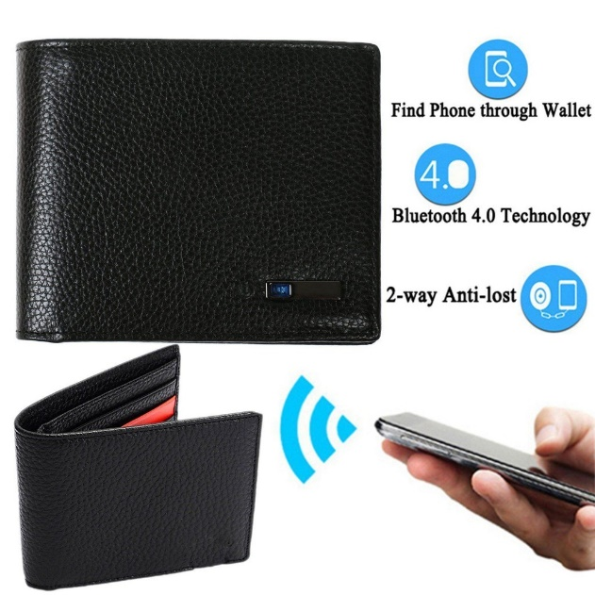
GPS enabled wallets and bags
Armisen and Majchrzak, 2015

An assessment of a business idea
A business idea can be defined as a concept that can be utilised for achieving a financial gain and is generally feasible through selling of a product or a service. In course of conceiving any business idea it is important to assure innovativeness and uniqueness on the same. A business idea which is not innovative fails to attract a target segment of buyers and also not capable of developing its own market niche and identity. Hence a business idea is evident to create a reason to invest and also assured desired sales and profitability. Moreover, in addition to generation of revenue it also offers ample scopes for future business expansion by penetrating the target market. Therefore, an innovative business idea can be considered as a pure essence of capitalism and more innovative the idea is, the lesser competitive pressure is exerted over the same (Armisen and Majchrzak, 2015).
An online shop selling GPS enabled wallets and bags is the main business innovative idea that has been considered to be executed in future. However, prior successful execution of this innovative business idea it is vital for carrying out an intense evaluation regarding the effectiveness and practical feasibility of the proposed idea and the overall customers demand for the selected product.
The emergence of the concept of smart gadgets and items can be also incorporated in products of our regular use like wallets and bag. The innovative business idea is to invest on setting up an online shop selling GPS trackers incorporated wallets and bags. Such products can be considered as smart wallets or smart bag. Incorporation of GPS tracker within wallets and bags is considered to be beneficial one preventing lost or theft of the same. It is with the GPS tracker incorporated within a wallet or a bag leads to effective prevention from lost with higher chances of product recovery. The GPS tracker that can be incorporated within the wallets and bags mainly utilise a noise emitting receiver that can be further activated using a transmitter. The sales of bags and wallets with GPS tracker is considered to be an effective business idea as the GPS tracker aid in tracking the routes or locations for a missing wallet and or bag. Hence understanding the importance of GPS tracking the GPS tracker that can be incorporated should have Bluetooth 5.5 long range connectivity, wireless and with an anti-distance alarm. The effectiveness of this GPS tracker can be enhanced by incorporating a proximity sensor to safe battery life (Khan and Umair, 2017).

Market research on GPS tracker enabled wallets and bags
In course of assessing the overall demand for GPS tracker enabled wallets and bags it is essential to investigate the current market size of the same. On a global scale it is observed that smart tracker market was estimated to be worth USD 413.14 million in 2019 and is also expected to reach USD 807.66 million by the end of year 2025, along with registering a CAGR of 12.4% during the tenure of 2019-2025. The business market of GPS tracker enabled wallets and bags is also evident to be an expanding one as the userbase and demand for such smart items are increasing at an exponential scale (Smart Tracker Market, 2022).
Therefore, considering the rapid proliferation of smart devices within the lives of the current population the demand for GPS tracker incorporated products like bags and wallets are prominent. Moreover, the consumer awareness for such products has also thereby elevated supporting a favourable market demand for such products. Justified to add, the rationale behind predicting an increased market demand for GPS tracker incorporated wallets and bags can be supported by the fact that such items are more vulnerable to get lost and GPS tracker if incorporated reduce the chances of getting them lost. High chances of product recovery are another reason for the higher demand for GPS tracker incorporated wallets and bags (Smart Tracker Market, 2022).
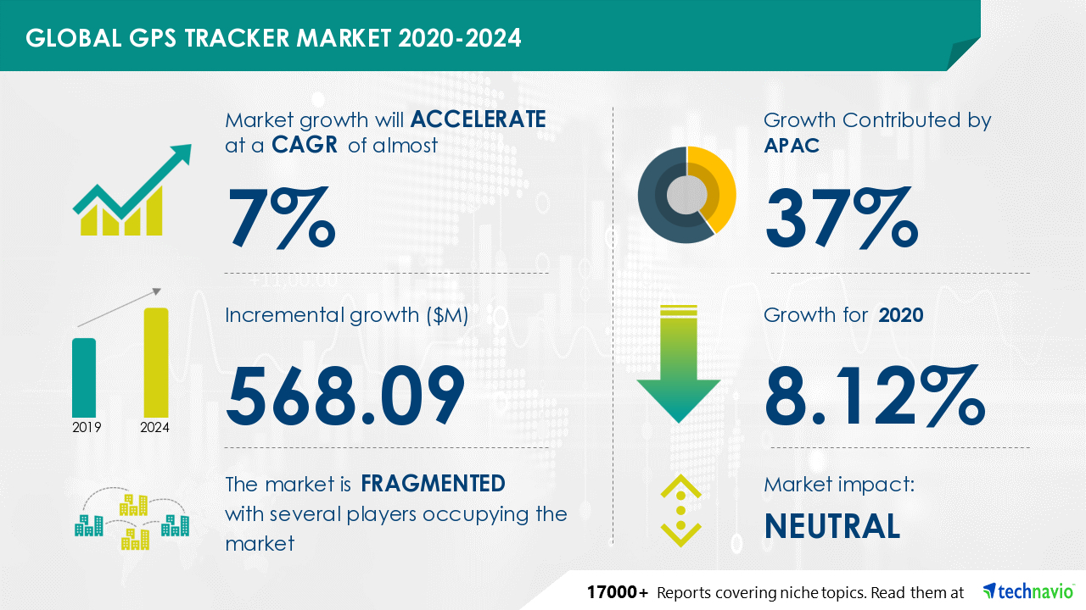
Source: (Technavio, 2022)
On a detailed analysis it can been revealed that a customer spent nearly 2.5 days a year looking for lost wallets and bash along with spending nearly USD 2.7 billion annually in replacing the missing wallet or bags. This excessive investment and time-consuming issue can be mitigated toa considerable extent by purchasing and using GPS tracker incorporated wallets and bags.
Also, according to market research greater demand for Bluetooth based GPS trackers incorporated within wallets and bags are perceived as it is expected to locate a lost wallet or bag within a building or a premise (Technavio, 2022).
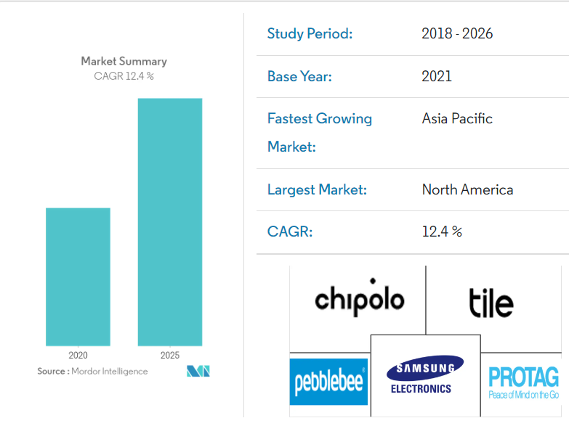
Source: (Smart Tracker Market, 2022)
Understanding the increasing demand for this particular product it can be also added that the smart tracker vendors in market are exponentially increasing thereby offering intuitive features as a part of the product offerings. Virtual assistant support can be considered as an innovative feature that can be incorporated within GPS trackers to strengthen the product attractiveness. In future successful incorporation of virtual assistant like Alexa or Google Home is expected to increase the market demand for GPS tracker incorporated bags and wallets (Smart Tracker Market, 2022).
In consideration to the market research conducted and understanding the immense demand for GPS tracker incorporated wallets and bags the proposed business idea is considered as a lucrative one. As evident from the market research that there is a huge demand for such product it is highly justified to develop a business plan and execute the same in subsequent course of time. The proposed idea of online selling of GPS tracker incorporated bags and wallets is also effective as online selling shall mitigate the additional investment of setting up and maintaining a physical store or an outlet at a prime location. Furthermore, investing to set up an online shop is also effective in targeting and attracting a broader segment of population (Ahmad et al., 2018).
The next assessment shall therefore focus on developing a business plan for successfully setting up an online virtual shop of GPS tracker incorporated wallets and bags.

Conclusion
On the final note of summation referring to the developed content it can be inferred that significant emphasis was given on intricate analysis of the conceived business idea, investing the current market demand for GPS enabled wallets and bags within the current population.

REFLECTIVE NOTE
This part shall accommodate a brief note of reflection on the personal development with respect to the participation of the concerned student towards the module. An evaluation of the entrepreneurial skills and knowledge that has been acquired in this process shall be undertaken. Here, I take the opportunity to incorporating a reflective note communicating my personal experiences based on the knowledge acquired and skills developed while completing the assignment of this academic module.
To begin with I was enrolled as a student of University of Wales under the BA Business management program. My reflection regarding the skills acquired and knowledge gathered shall be focused on the academic module entitled as ‘Entrepreneurship.’ Getting an opportunity to being associated with this module I was able to acquire several entrepreneurial skills and gathered considerable knowledge regarding the same. Hence my reflective note shall be aligned with the Kolb’s reflective learning cycle (Lew and Schmidt, 2019).
However, prior I begin with this note of reflection, I would like to convey my sincere note of gratitude to my module supervisor for the excellent mentoring and guidance offered. I am also thankful to my fellow class mates for being my continuous source of motivation of support. I am not hesitant to convey that it would have not been possible for me to successfully complete the academic tasks offered in this module without the guidance and help of my teacher and my fellow mates.
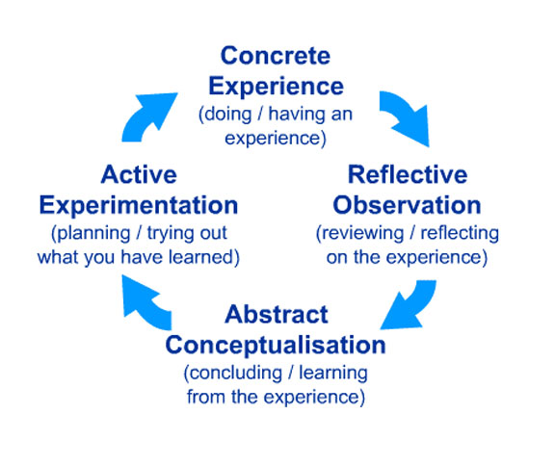
Source: (Morris, 2020)
Stage 1: Concrete experience –
Being enrolled in the course of BA business management I was assignment to complete the tasks allotted within my academic module entitled as ‘Entrepreneurship.’ The fundamental of this module were focused towards enhancing the overall employability skills and knowledges regarding the same. After being a part of this academic module while completing the assignments offered, I had an exciting experience. I was utterly excited to learn the things taught through this module. Overall, I felt that after completing this module I shall be able to develop a good insight regarding the fundamental of entrepreneurial skills and shall also become more confident (O’Brie et al., 2022).
Stage 2: reflective Observation –
Passing through this second stage of Kolb’s cycle I would like to comment that the assignments offered in this module were highly interesting and also increased my tenacity to learn more about entrepreneurship and entrepreneurial skills. I am happy to convey that getting an opportunity participate in the academic activities offered in this module, my overall knowledge regarding employability skills increased my several fold. I became aware regarding the importance of employability skills and the overall process of entrepreneurship. I also learnt that entrepreneurial practices and directly influenced by the entrepreneurial skill development competency by an individual. Justified to add, that after completing the tasks of this module I was able not only able to nurture my cognitive skill but also improved my existing practical skills. Overall, I am extremely satisfied and content with the techniques and approaches of problem solving that has been taught through this module. Currently I find myself to be confident regarding the underlying concepts of entrepreneurship and the entrepreneurial skills (Bandaranaike, 2018).
Stage 3: Abstract Conceptualisation –
Intending to reflective on my learning experiences that I was able to gather through this module I would like to say that this module has completely enriched my knowledge and has been major contributor towards my overall skill development process. I am extremely happy to being able to acquire the skills of critical thinking, time management, logical reasoning and decision-making following completion of the given assignments. Furthermore, I am currently confident with my problem-solving ability and capable to recognizing a problematic issue. Moreover, I presently realise that my communication and active listening skill has been commendably improved and at present I am well capable of exhibiting my negotiation skill. Last but not the least I have been able to successfully acquire the skill of networking, creative thinking and risk taking after completing this module (Akhmetshin et al., 2019.).
Therefore, concluding on my knowledge acquisition and skill development process I would like to say that after being able to acquire knowledge and skills related with entrepreneurship; I believe that skill development is a crucial part of continuous learning process which is slow and steady. Moreover, I also believe that skill development both entrepreneurial and personal skills are vital components in the lifelong learning process of an individual. It is the overall effectiveness of entrepreneurial skills acquired act as a major determinant in shaping the overall personality a person.
Stage 4: Active Experimentation –
The fourth stage is identified as the final stage of Kolb’s reflective learning cycle. At this stage the future planning associated with skill development remains a priority. At this stage I would like to focus on sharing my experiences regarding my skills gaps that I would definitely like to improve in near future. I sincerely confess that completing al the tasks of this module were not an easy job for me and I had faced ample challenges. Adhering with my experiences achieved on entrepreneurial skills I would like to improve my communication and business management skills. Moreover, I find myself to be lack of confidence in course of exhibiting the skill of problem solving.
Hence understanding my skill gaps; I look forward eagerly to participate in relevant skill development workshops in order to nurture the identified weak skills of mine. I also plan to take up certain online skill development tutorials and videos in order to carry out my skill development process.
Realising the significance of entrepreneurial and entrepreneurial skills I also intend to involve myself in similar academic activity and also look forward to pursue with an academic project independently (Jeske and Linehan, 2020).
The reflective note accommodated in the later segment of this essay has projected the overall learning experiences of the concerned student assuring the adequate knowledge and reflected entrepreneurial skills are highly demanded for pursuing with a successful and sustainable entrepreneurial venture.

References
Ahmad, S., Rouyu, L. and Hussain, M.J., 2018. Never Lose! Smart Phone based Personal Tracking via Bluetooth. International Journal of Academic Research in Business and Social Sciences, 4(3), p.528.
Akhmetshin, E.M., Mueller, J.E., Yumashev, A.V., Kozachek, A.V., Prikhodko, A.N. and Safonova, E.E., 2019. Acquisition of entrepreneurial skills and competences: Curriculum development and evaluation for higher education. Journal of Entrepreneurship Education, 22(1), pp.1-12.
Armisen, A. and Majchrzak, A., 2015. Tapping the innovative business potential of innovation contests. Business Horizons, 58(4), pp.389-399.
Bandaranaike, S., 2018. From research skill development to work skill development. Journal of University Teaching & Learning Practice, 15(4), p.7.
Businesswire.com. 2022. Global GPS Tracker Market to Grow by Over $ 568 Million During 2020-2024 | APAC to Register Significant Growth | Technavio. [online] Available at: <https://www.businesswire.com/news/home/20201217005111/en/Global-GPS-Tracker-Market-to-Grow-by-Over-568-Million-During-2020-2024-APAC-to-Register-Significant-Growth-Technavio> [Accessed 20 July 2022].
Jeske, D. and Linehan, C., 2020. Mentoring and skill development in e-internships. Journal of Work-Applied Management.
Khan, A.A. and Umair, S. eds., 2017. Handbook of research on mobile devices and smart gadgets in K-12 education. IGI Global.
Lew, M.D. and Schmidt, H.G., 2019. Self-reflection and academic performance: is there a relationship? Advances in Health Sciences Education, 16(4), pp.529-545.
Mordorintelligence.com. 2022. Smart Tracker Market | 2022 - 27 | Industry Share, Size, Growth - Mordor Intelligence. [online] Available at: <https://www.mordorintelligence.com/industry-reports/smart-tracker-market> [Accessed 20 July 2022].
Morris, T.H., 2020. Experiential learning–a systematic review and revision of Kolb’s model. Interactive Learning Environments, 28(8), pp.1064-1077.
O’Brien, S., McNamara, G., O’Hara, J., Brown, M. and Skerritt, C., 2022. Students as co-researchers in a school self-evaluation process. Improving Schools, 25(1), pp.83-96.

