Student name: sarah Doody
Student number: 2407283
Moodle: BMHP5014
Module: change makers: creativity and value creation
Assignment title: Component 2 written report
SFairCare: Equality in Health and Social Care
Discrimination in health and social care remains one of the most persistent and harmful barriers to achieving fair, high‑quality treatment for everyone in the UK. Despite decades of legislation, policy guidance, and professional standards, many individuals continue to experience unequal treatment based on who they are rather than what they need. FairCare is a national campaign designed to confront this issue directly. Through mandatory staff training, an independent reporting system, and community‑led engagement, FairCare aims to embed equality into everyday practice and ensure that every person receives respectful, safe, and dignified care. This pitch outlines the need for FairCare, the evidence behind the initiative, and the transformative impact it can have across health and social care settings.

The Scale of the Problem
The Equality and Human Rights Commission (2023) reports that one in five people accessing health services have experienced unfair treatment linked to a protected characteristic such as race, disability, age, gender, or sexual orientation. For some groups, the figures are significantly higher. Disabled people frequently report feeling dismissed or not believed about their symptoms. Black and Asian communities experience poorer communication, lower pain relief, and reduced access to specialist services. LGBTQ+ individuals often face assumptions, stigma, or a lack of understanding about their needs. These experiences are not isolated incidents; they reflect systemic patterns that undermine trust and worsen health outcomes.
The Care Quality Commission (2024) highlights that bias, both conscious and unconscious, directly affects clinical decisions, including diagnosis, treatment planning, and the urgency with which care is provided. This means that two people with the same symptoms may receive different levels of care depending on their identity. Such disparities contribute to widening health inequalities, particularly for communities already facing socioeconomic disadvantage.
Under‑reporting is another critical issue. According to NHS England (2024), many service users do not raise concerns because they fear retaliation, believe they will not be taken seriously, or simply do not know how to complain. Traditional complaint systems are often complex, slow, and intimidating, especially for those who already feel marginalised. Staff also face challenges: many want to provide equitable care but lack confidence, training, or clear guidance on how to recognise and address bias in themselves or colleagues. Without a safe and accessible way to report discrimination, harmful practices continue unchecked.

Why FairCare Is Needed
FairCare responds directly to these gaps. It is built on three core foundations: education, voice, and accountability.
Education is essential because many staff members have never received comprehensive training on equality law, unconscious bias, or culturally competent communication. FairCare provides mandatory, interactive training for all health and social care staff, ensuring they understand their legal duties under the Equality Act 2010 and know how to deliver respectful, inclusive care. Training is accessible online and in person, with regular refreshers to maintain high standards.
Voice is central to FairCare’s mission. The initiative introduces a simple, independent reporting system that allows service users, carers, and staff to raise concerns safely. Reports can be made online, by phone, or using paper forms, with full accessibility features such as translation, easy‑read formats, and screen‑reader compatibility. Crucially, FairCare offers an anonymous reporting option, giving people confidence to speak up without fear of repercussions.
Accountability ensures that discrimination is not only reported but addressed. FairCare collects and analyses data from reports to identify trends, hotspots, and recurring issues. This information is shared with providers, commissioners, and regulators to drive targeted improvements. Instead of relying on generic policies, FairCare enables evidence‑based action that responds to real experiences.

Who Benefits from FairCare
FairCare benefits everyone involved in health and social care. Service users gain safer, fairer treatment and a trusted way to raise concerns. Those most at risk of discrimination, including ethnic minorities, disabled people, older adults, LGBTQ+ individuals, and people living in poverty, gain a stronger voice and greater protection.
Staff benefit from clearer guidance, improved confidence, and support when challenging poor practice. FairCare reduces moral distress by giving professionals the tools they need to deliver equitable care.
Providers and policymakers benefit from reliable data that highlights where improvements are needed. This helps target resources effectively, strengthens community trust, and supports compliance with legal and regulatory standards.

Implementation Plan
FairCare will be developed and delivered in partnership with NHS trusts, care providers, equality organisations, and community groups. The design process will be led by people who have experienced discrimination, ensuring the system is accessible, respectful, and culturally relevant.
The implementation follows four phases:
1. Co‑design (Months 1–4): Workshops with communities, experts, and frontline staff to shape training materials, reporting tools, and communication resources.
2. Pilot (Months 5–8): Testing FairCare in five diverse regions, gathering feedback to refine every aspect of the programme.
3. Roll‑out (Months 9–18): Launching FairCare across England, integrating training into staff induction and ongoing development.
4. Expansion (Year 2 onwards): Extending FairCare UK‑wide, embedding it into national standards and inspection frameworks.

Legal and Ethical Foundations
FairCare aligns fully with the Equality Act 2010, ensuring all nine protected characteristics are recognised and protected. It supports compliance with the Care Act 2014, Human Rights Act 1998, and CQC Fundamental Standards, particularly those relating to respect, consent, and non‑discrimination.
All data collected through FairCare is protected under UK GDPR and the Data Protection Act 2018. Confidentiality, safety, and transparency are prioritised. Oversight is provided by an independent board with community representation, ensuring fairness and accountability.

Conclusion
Discrimination in health and social care is unacceptable, illegal, and preventable. FairCare provides the tools, training, and trust needed to eliminate it. By embedding fairness, dignity, and equality into everyday practice, FairCare will transform health and social care across the UK. Every person deserves to be treated with respect, no exceptions. FairCare makes that promise real.
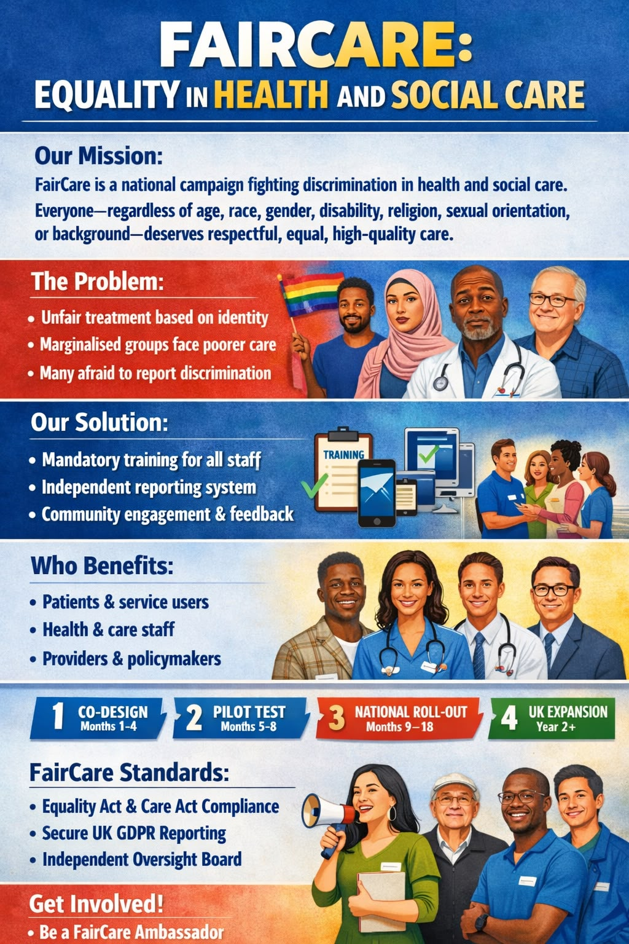
Reference
Care Quality Commission (2024) Bias and Discrimination in Health and Social Care: Rapid Review.
Equality and Human Rights Commission (2023) Is Fair Treatment a Right or a Privilege? Experiences of Discrimination in Health Care.
NHS England (2024) Tackling Discrimination and Advancing Equality: Progress Report.
UK Government (2010) Equality Act 2010.
UK Government (2014) Care Act 2014.
UK Government (1998) Human Rights Act 1998.
Information Commissioner’s Office (2018) Guide to the General Data Protection Regulation (GDPR).

