
The Global business environment influence on Mercedes brand success

Module name: The Global Business Environment
Module code: LCBB4005
Student Name: Olga Andronic
Student Number: 2119164

Lecturer: Rexon Nting
Submitted date: 3rd of April 2022

Table of content

1. Introduction…………………………………………………………………..3
2. The importance of understanding business environment…………………..4-5
2.1 Mercedes origin and history………………………………………………5-6
2.2 Mercedes PESTLE analysis…………………………….………………...6-8
2.3 SWOT Analysis of Mercedes……………………………………………8-10
3. Conclusion…………………………………………………………………..11
4. Reference list ……………………………………………………………….12

- Introduction

Mercedes-Benz is a German top quality automobile manufacturer. They design and build both business and consumer expensive cars.
Mercedes-Benz sold 2.31 million passenger cars in 2018, making it the world's premium vehicle biggest market.

The company created the world's first automobile, the Benz Patent Motorwagen, in January 1886. Gottlieb Daimler and Carl Benz, the company's entrepreneurs, created the automobile. The first Mercedes-Benz was built in Germany, which is also the brand's international headquarters and the location of many of its manufacturing plants. Mercedes-Benz manufacturing, on either hand, is not restricted to Germany; it is spread across approximately 22 other countries.

The first Mercedes-Benz brand name automobiles were manufactured in 1926, following the merger of Karl Benz's and Gottlieb Daimler's firms to form the Daimler-Benz company. Many of Mercedes-technological Benz's and security advances have since become standard in other vehicles. Mercedes-Benz is one of the world's most well-known and respected automobile brands, as well as the world's oldest automotive brand that is still in operation today.

Mercedes-Benz is one of the world's most successful automakers and one of the world's leading providers of premium and luxury cars and vans.

The company supplying financing, leasing, automobile subscriptions, and rental, as well as fleet management, digital charging and payment services, insurance brokerage, and new mobility services.
(Mercedes-Benz Star Motorcars, 2022 )
[Accessed on 09 May 2022]
As a leader in automotive engineering, Mercedes-Benz sees making the future of mobility comfortable and secure as a motivation and function.
As a result, the company's focus remains on innovative and environmentally friendly technologies, as well as securing the vehicles that fascinate and stimulate. Mercedes-Benz continues to invest in the advancement of efficient powertrains while charting the path toward an all-electric future:
Where business conditions allow, the three-pointed star aspires to go all-electric.
The world's leading luxury car manufacturer is accelerating its transition to an emissions-free and technology future, shifting from electric-first to electric-only vehicles.

- The importance of understanding business environment

A company can be founded, but it will need resources such as money to make progress , which it will have to supply on financial institutions. Social approvement, which is a society-dependent phenomenon. Market conditions that are appropriate, for which it must rely on the market. The sale of goods and services, for which clients are required.
It must rely on society for its labour.

"The total of all personnel, institutions, and other forces that are outside the control of a commercial entity but affect the overall success and sustainability of the business," says the definition of business environment.

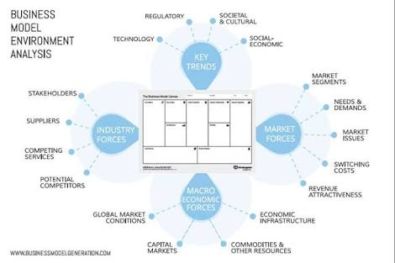
These factors, on which a company's success is based, are dynamic and always changing.
The corporate environment includes moving client needs as well as new market innovations. In this technology era, the challenge for firms is to survive rather than to go into market. To stay afloat in the market, you must be able to quickly adjust to changes. Being aware of the corporate environment is required to adapt to change.
The business environment consists of providers, competitors, consumer groups, media, government, consumers, economic conditions, market conditions, investors, technologies, trends, and a wide range of other entities operating outside of a corporation. Even if they are beyond the scope of the business, these pressures have an influence on it.
(Toppr Guides,Business-environment 2022 )
[Accessed on 09 May 2022]

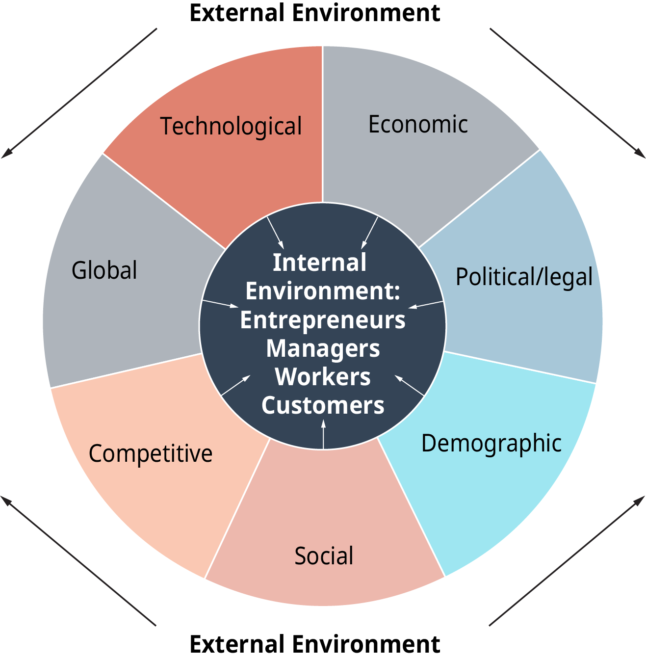

Despite a few difficulties, the market environment has many advantages, such as contributing new technology, improving infrastructure, management skills, creating jobs, better service supply, and attracting capital investment from other countries through exporting products.
  - Mercedes origin and history

The invention of the high-speed motor in Germany in the 1880s allowed both inventors to set the groundwork for a shift in road transportation.
Benz & Cie and Daimler-Motoren-Gesellschaft were founded independently by both owners.

Due to significant inflation, luxury businesses found it highly challenging to keep their client base during the First World War. As a result, former rivals associate to form Daimler-Benz AG, which was found in 1926.

DMG's three-pointed star was encompassed by its trade brand 'Mercedes' as well as the famous name 'Benz,' whose laurel wreath intertwined the two names. The insignia we all know and love today is the product of a mix of these three influences.

Mercedes-Benz has been around for 89 years and has established itself as one of the most dependable brands in the industry, which is unsurprising given its long history.

(Motorrange, blog 2022 )
[Accessed on 09 May 2022]
The first gasoline car, the Benz Patent Motorwagen, was invented in January 1886, and afterward that year, Gottlieb Daimler and engineer Wilhelm Maybach transformed a carriage by adding a petrol engine. In 1901, Daimler Motoren Gesellschaft initiated the Mercedes automobile to the public. The first Mercedes-Benz brand name automobiles were produced in 1926, following the merger of Karl Benz's and Gottlieb Daimler's firms to form the Daimler-Benz company.
Many of Mercedes-technological Benz's and safety advances were becoming standard in other vehicles. Mercedes-Benz is one of the most very well created vehicle brands in the world, as well as the world's oldest automotive brand that is still in operation today. In order to gain a better understanding of the well-known.
(Mercedes Driving blog spot, 2022 )
[Accessed on 09 May 2022]

  - Mercedes PESTLE analysis

PESTEL (Political, Economic, Social, Technological, Environmental, and Legal Analysis) is an abbreviation for Political, Economic, Social, Technological, Environmental, and Legal Analysis. This environment scanning tool is primarily used to understand external macroeconomic effects on an industry, a specific sector, a company, and its goods options.

PESTEL analysis is a simple and straightforward environment scanning methodology that aids in understanding of a company's overall environment. It inspires management to think wisely and respond quickly to external changes in order to minimize or mitigate negative impact on company operations. It also motivates management to look at the external business environment from various angles.

The following are the political aspects in the Mercedes-Benz
PESTLE Analysis:

Political Factors:
If legislative and economic problems accept vehicle clearance could expand by two-digits. What is going on politically is not well known, but it is a big burden that could prevent India from progressing. The interest in foundation is most likely the second. If the structure interest is not handled correctly right away. The amount given would block Mercedes Benz's evolution which is already a problem.
Economic Factors:
Some economic factors influence Mercedes Benz's performance.
With an average of 35000-40000 units sold over the last three years, or around 1.17 percent of the overall motor vehicle market, the luxury automobile market is the smallest among the major economies. According to major industry figures, the industry is experiencing its worst decline in ten years.
Social Factors:
The following are the social factors that influence Mercedes-Benz PESTLE Analysis:

Mercedes-Benz makes a concerted action to show up beside issues where networks can take advantage and assistance can be offered. Their main goal are to improve education quality, provide infrastructure, improve the lives and supply great and safe drinking water systems to the local network. Against the fact that Mercedes Benz does not have a problem with brand awareness, differentiation is a hyper-focused market that is assisting the company in delivering a state of craft driving history.

Technological Factors:

The technological factors in Mercedes-PESTLE Benz's analysis are as follows:

Current automotive producers are being forced to keep up with changing customer preferences as the automobile industry undergoes significant turmoil. Even a high-quality brand, such as Mercedes-Benz, must do more to maintain a competitive advantage, and this is where testing comes into play. Mercedes-business Benz's is clearly regarded as the best in terms of technology performance, structure, security, and environmental issues.

Legal Factors:
The technological factors in Mercedes-PESTLE Benz's analysis are as follows:
The legal factors in the Mercedes Benz PESTLE Analysis are as follows:
Going to follow the Supreme Court's December 2015 restriction on new diesel vehicle certification in the National Capital District, and the NGT's hearing of an attraction to make a similar move in 11 major metropolitan urban communities across the country, Mercedes-Benz determined that, in the long run, they would have to return to diesel to address contamination concerns. Particulate emission levels from gasoline and diesel are comparable at the BS-VI level, but CO2 emissions from gasoline are higher.

Environmental Factors:
The environmental factors affecting Mercedes-business Benz's are listed below in the PESTLE Analysis:
Mercedes-Benz is accomplished to protecting the environment as part of its company main goal.
Daimler does not differentiate between condition insurance and other goals. Rather, it is a critical component of a company's long-term value creation strategy. Any future power source may be expensive due to unavailable and changing causes ;even so it may receive support from the company as well as its customer base, who wish to make a purchase a premium for Mercedes Benz products.
PESTEL is a helpful strategic planning technique that can serve Mercedes-Benz in developing successful business strategies. Mercedes-Benz can make the best international company evolution decisions if it has a thorough appreciation of external environmental. Mercedes-Benz can stay ahead of the competition by approval the external business environment's opportunities and instability early and adapting company strategy correspondingly.
(Mbaskool, Pestle Analysis 2022 )
[Accessed on 10 May 2022]

2.3 SWOT Analysis of Mercedes
SWOT Analysis is a actually attempted management tool that enables Mercedes-Benz to investigate its business achievement in relation to competitors and the industry.

Strengths in the SWOT Analysis of Mercedes Benz:
- Mercedes-Benz, like Audi and BMW, is one of the most popular premium automobile manufacturers in the world.
- It’s brand focusses its sponsorship efforts on New York Fashion Week, golf, and tennis.
- The company has assembling plants on six continents and in 26 countries, allowing the company to keep its handling low costs and generate profits.
- The corporation of Mercedes Benz, has always been known for its technological progress. Mercedes Benz pioneered the internal combustion engine in 1886 and introduced "pre-safe" technology in 2013. Mercedes-Benz was maintain on the vehicle's safety measures.
- Financial stability: Daimler, the parent firm of a number of other world-famous brands, has a strong financial position.
- Mercedes-Benz has a stronghold in developing countries, such as India, where premium carmakers such as AUDI, BMW, and others compete. In emerging markets, Mercedes-primary Benz's goal is to become the market leader in the Luxury Segment.
- Mercedes-Benz offers a various product line that selection from cars to SUVs, allowing them to compete with other manufacturers.

Weaknesses in Mercedes-SWOT Benz's Analysis:

- Maintenance and Service Costs: One of the most important factors influencing the sale of any car or vehicle is the pricing of servicing. Mercedes-Benz has increased maintenance costs when compared to other participants in a same industry.
- Even as Mercedes-Benz has the capacity to grow rapidly, it has been found to have a medium rate of increase because it proceeds its vehicle distribution moderately limited, influencing production and thus brand equity.
- Differing Priorities: Because Daimler is such a huge organization, it is viable that conflicting objectives will affect it. This may have an instant effect on Mercedes-Benz.

Opportunities in the SWOT Analysis of Mercedes Benz:

Enhanced request for premium vehicles: Because of tariffs for luxury public transportation, companies such as VOLVO, Audi, and BMW have increased their premium vehicle offerings.

Strategic Alliances: This can be an effective strategy for automobile companies. They can distinguish their services by implementing new skills and collaborating with other businesses.

While the US and European businesses continue to drive this industry, it is expanding into emerging markets such as India, China, and other Asian countries as disposable income rises, lifestyles evolve, and economic conditions remain stable.

The Automobile Industry is Growing: Autonomy and economic growth are exemplified by the automotive industry. Automobiles have enabled people to live, work, and play in previously unimaginable ways. Vehicles have access to healthcare, markets, and job opportunities. Almost every journey concludes with a cash transaction or another benefit to the living standards of others.

Mercedes-Benz can become a world market leader by developing futuristic technologies, fuel-efficient vehicles, and hybrid vehicles.

Threats in the SWOT Analysis of Mercedes Benz:

Competitors such as Audi, BMW, Volvo, and others are investing a lot of effort to rise up as a global player and industry leader in most markets.

Fuel Price Volatility: Differences in fuel prices remain to be the decisive factor in the passenger segment's progress. The government regulates alternative fuels, such as compressed natural gas. The consequence of Shell gas on stockpiles is also significant.

Economic Instability: macroeconomic insecurity, economic downturn, job losses, and other economic issues will continue to affect the car industry for some time.

As a result of overpopulation in developed economies, the industry is planning to migrate to new markets via manufacturing facilities and Research centres, though the advantages of these decisions are still to be achieved.

Government Policies: Contributing to global warming by discouraging the use of private transportation, rapidly changing fuel prices, limiting the significance of road approvals, and severely limiting the entry of non-state vehicles are just a few of the restrictions that have already been implemented in different parts of the world and are having an impact on the system.

Rising steel and other cost of raw materials could have an affect on Mercedes-Benz manufacturing expenses.

Price War: A price competition is another threat to the company.

(Projects Swot Analysis of Mercedes Benz, Pestle Analysis 2022 )
[Accessed on 11 May 2022]

- Conclusion

The global marketing environment is defined as "all the variables and forces that affect the marketing strategy to establish and sustain effective connections with targeted customers, whether they are inside or outside an organisation or firm."

Active participation in the globalized world can be exceptionally beneficial to a company, but it can also be extremely risky. Because changes in international environment can both help and restrict a company's ability to operate, all businesses must be prepared for them and willing to adjust their strategies as needed.

Their main goal in global business is to make the most money possible through various marketing tactics such as advertisements, promotion strategies, and internet use.

The dangers and benefits of the global environment are better defined by dividing it into two interacting contexts: the adaptive control and the environment in general.

Political hazards, cultural differences, exchange concerns, and legal and taxes issues are all part of the international business environment. As a result, the political, economic, regulatory, tax, social and cultural, legal, and technological settings make up the Global Business Environment .

Even after several challenges, the global expansion has many advantages, such as making a contribution new technology, infrastructure development, management skills, business growth, improved public services, and attracting investment funds from other countries through export oriented products.
(Sage pub Global Business Environment 2022 )
[Accessed on 11 May 2022]

References

1. https://mercedesbenz.starmotorcars.com/blog/mercedes-benz-production- factory-locations/
2. https://www.toppr.com/guides/business-studies/business-environment/introduction-meaning-importance-of-business-environment/
3. https://www.motorrange.co.uk/blog/a-brief-history-of-mercedes-benz
4. http://mercedes-driving.blogspot.com/p/company-history.html
5. https://www.mbaskool.com/pestle-analysis/companies/18037-mercedes-benz.html

6. https://www.projects4mba.com/swot-analysis-of-mercedes-benz/4844

7. https://us.sagepub.com/en-us/nam/global-business-environment/book270053

