Professional Career Development

Luciana Di Napoli
student number 1906889
Module code BMSW4005_BIRM
Lecturer: Abdi Rahman

Task 3

Birmingham, November 2020

Contents

1. Introduction…………………………………………………………….3
2.Personal Development Planning………………………….................4
3. What is the Best Method to Train New Employees?......................9
4. The Professional Career Development Module Reflection...........14
5. Conclusion.....................................................................................17
6. References....................................................................................18

Introduction

The aim of this paper is to analyse and promote self-awareness regarding professional career development. In addition, a discussion based on personal developing plan, learning styles and the module reflexive experience were the topics for a complete insight.

2. Personal Development Planning
Personal Development Planning also known as PDP “is a continuous lifelong process of nurturing, shaping and improving skills and knowledge to ensure maximum effectiveness and ongoing employability” (Maguire and Blaylock, 2017)
Tucker, Duncan and Davis (2011) agreed that PDP can be utilized to develop individuals an enhance candidates career prospects for example increasing employment opportunities. This can be achieved by enrolling new courses. The PDP will also increase aptitude for personal development. Reflecting on the personal learning and performances this technique will help people to be successful and to achieve goals or improving purposes.
The PDP is such a powerful tool that can be used as a guideline for unknown answers. That line comes from the past, flies along the present and travels to the future. Moreover, some questions like: ‘What have I done so far? or ‘Where am I going?’, 'How am I going?’ and ‘What is the next step to take?’ can be reflected on PDP. When the inconsistency in the outcome takes place there will be an opportunity to review concepts and processes according to Beausaert, Segers and Gijselaers (2011).
I have a passion for food. My degree in Gastronomy some time ago helped me to explore even more this field and enjoyed a successful career for so many years working with food styling. Nowadays my personal life has changed radically and getting out of the comfort zone is essential. After researching the market, and obeying and following my primary instincts, a Registered Dietitian will be the profession I will carry for the rest of my life.
My research showed me that Registered Dietitian is a requested job in United Kingdom. Luckily, there are some career paths this degree enables students to choose. According to Coventry University most of the students decide to become part of the NHS as their first job (Coventry University, 2020). However, at the private sphere a Dietitian is very important in the Food and Pharmaceutical Industries where to promote and market high standard food products focusing a business environment (Hussain, 2017).
Advising clients about how to get a healthier life in a sustainable manner is a satisfaction. In one hand people are overactive and in the other hand sometimes cooking absorbs too much space during the day. What do people have been doing to fulfil their necessities? The ready meal food and the microwave oven.
Precooked meals are frequently wealthy in energy, fat and sugar and lacks in vegetables consequently it is known that the ready meal market had an extensive growth over the years. Simultaneously, the traditional kitchen lost its power.
So, according to Kearney and McElhone (1999) some factors such as irregular working hours, giving up preferred foods, busy lifestyle, lack of willpower, price of healthy food, taste preferences of family and friends, lack of healthy options and unappealing foods are barriers to healthy eating.
Logically, a Registered Dietitian are regulated healthcare professionals and I must be introduced to these concepts to avoid any mistreatment. My next step is applying for the Ungraduated Studies where I will learn the theory.

Dietetics Studies Table
Goal | Why | What I´ve been doing? | What resources will I need? | How will you know you achieved it? | When will I achieve this?
Have a Registered Dietitian Degree | Personal predilection and market requirement | Gastronomy Certificate. Prepared a smart letter for the application | A positive evaluation about my previous studies | A positive feedback | As soon the University´s evaluation

In addition, communication skills are very important in the first approach with University. Probably there will be an interview and I must be precise and clear when I will be questioned about my background. Moreover, concepts such as body language exhaustively discussed on lectures must be applied during this dialog.
Communication Skills Table
Goal | Why | What I´ve been doing? | What resources will I need? | How will you know you achieved it? | When will I achieve this?
Communicate smartly and fluency | Show more professionalism on interviews and workplace | Studying about Communication Skills/ NLP therapy | Time to study and attend to therapy | The tranquility indicates a positive outcome | About a month with practice

There is another important tool for a more detailed self-awareness called The SWOT Analysis where the acronym will be explained bellow:
S- strengths
W- weaknesses
O- opportunities
T- threats
This analysis is very interesting because it covers external and internal aspects. When facing the external view, threats and opportunities must be developed whereas internal goes through strengths and weaknesses.
The SWOT analysis is important because it brings to reality a full overview about us confronting to the world. Moreover, this analysis will bring to the light the weapons we have and how to deal with threats. (Gurel and Tat, 2017)

Dietetics Studies
 | Strengths | Weakness
Internal | • Previous studies in Gastronomy  • Smart cover letter  • Advice from Mrs. Daniella Waar  •Passion for Food  •Strong willpower | • Lack in English language  • Insecurity  • Communication skills/ body language (still improving)
 | Opportunities | Threats
External | • Eligible in student finance  • Family support | • Covid-19  • Not be accepted  •High demand applicants

Communications Skills
 | Strengths | Weakness
Internal | • Recognise the  weakness  •Willpower to change | • Shyness  •Nervousness
 | Opportunities | Threats
External | • N.L.P. therapist  •Lecturer´s support  •Presentations at University where I can practice | • A strict Lecturer

Looking at both analysis it is clear they may complement each other moreover, organising topics according to their background is a smart way to visualise the past, present and future.
Concluding the Personal Development Planning helps human being along the maturation process as well as an essential tool for every individual who aspires a continuous improvement in labor or personal territories. As described above this technique bring into the light hidden or unknown facts that prevents or guide us towards a future success. This outcome can be achieved through specific questions. Additionally, the SWOT Analysis shows other aspects such as internal and external backgrounds not explored previously. In general, thanks to its coverage PDP is an extremely valuable reference to support the enrollment for Dietetics Bsc course.

3. What is the Best Method to Train New Employees?
Starting a new job may cause a lot of stress and nervousness. New employees will have to learn many theories in a short time, adapt to new colleagues and new bosses. A leader must, among many other things, use empathy to put itself in the place of the employee. If the company wants a good performance and a productive team, it is necessary to foster commitment, responsibility and enthusiasm. It is not something simple, because everyone absorbs knowledge in different ways according to Pashler, McDaniel, Rohrer and Bjork.
However, if we get committed employees, productivity will come by itself as a consequence. We must have a broad vision, be observant and know how to detect its strengths in order to achieve their full potential. It's also important to acknowledge work and stay motivated. Fortunately, some learning styles techniques such as Kolb, Honey & Mumford, and VARK will help students and lectures along the path.

3.1 Kolb´s Module
A learning cycle published by David Kolb in 1984 basically involves four stages: concrete learning, reflective observation, abstract conceptualization and active experimentation.

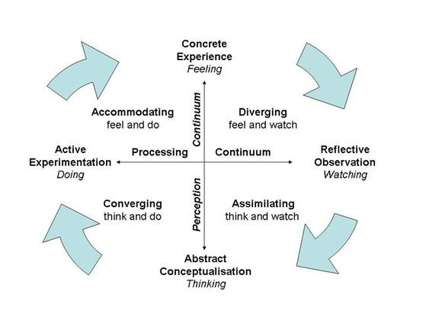
Figure1: Kolb, D. (1984) “The Experimental Learning Cycle”. Available at: https://www.simplypsychology.org/learning-kolb.html (Accessed 11/09/2020)

Undoubtedly this method has many benefits. As the diagram describes the student has the opportunity to experience, to reflect, to think, and to act increasing the learning power conforming Borredon, Defayet, Baker and Kolb which ‘et al’ agree that this method promotes deep learning enhancement. Here is a brief detainment on each quadrant:

Diverging (feeling and watching)

These individuals can take a gander at things from alternate points of view. They work on a kinesthetic channel. They like to observe instead of do, tending to assemble data and use creative mind to take care of issues. They are best at facing solid circumstances from many perspectives. These group perform effectively in brainstorms.

Assimilating (watching and thinking )
This learning practice includes a compact, coherent methodology. Thoughts and ideas are a higher priority than individuals.
This group requires a great clear clarification as opposed to a pragmatic approach. They dominate at seeing wide-ranging data and arranging it in a clear, sensible organization moreover, they fit well for science careers for example because they can decode abstract concepts.

Converging (doing and thinking )

Individuals with a converging learning style can tackle issues and will utilize their abilities to transform a challenge in a hands-on bases solution. They enjoy dealing with technical tasks, and are less worried about individuals and relational perspectives. They have the ability for bringing new ideas and working in practical situations.

Accommodating (doing and feeling)
The Accommodating learning style fits for proactive people, and depends on instinct instead of rationale. These individuals utilize others investigations, and want to take a commonsense, experiential methodology. They are pulled in to new difficulties and experiences, and to executing plans.

Being aware that Kolb includes all of these profiles on his diagram it is suitable to indicate that an Assistant Manager will benefit from this method on a training because tasks will be tailored exclusively for each individual. In a large scale, if the group leader benefits from each quadrant profile the group will enjoy synergy causing gains in productivity.

3.2 Honey& Mumford
This method was inspired on Kolb's diagram, however Honey and Mumford builded their own learning style questionnaire according to managers necessities. Affirming that, a special attention to this model should be undertaken since the task is new employees training is in discussion. Another important aspect considered in this model is about general behavioral tendencies.
The reasoning behind this analysis is that the vast majority have never intentionally thought about how they truly learn. Furthermore, to be a powerful student, the individual must think about their own learning styles or inclinations and discover approaches to master utilizing those strategies.

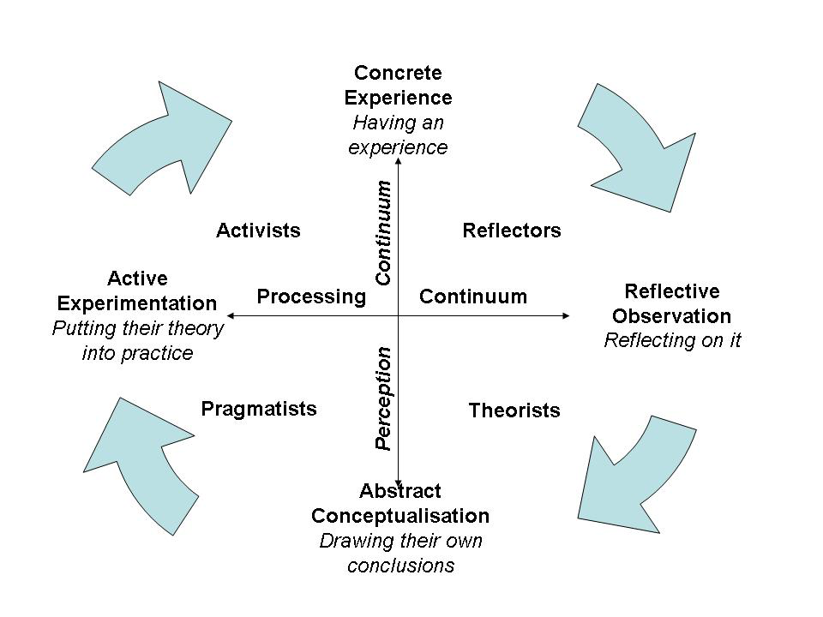
Figure 2: Mumford, A. and Honey, P. (1986) Honey and Mumford Model
Activists: they learn by doing and are good at brainstorming, problem solving, group discussion, etc.
Reflectors: they learn by watching and examining what occurred. They like to match conversations, self-awareness questionnaires, interviews etc.
Theorists: these learners want to know the true behind the scenes. They require models, thoughts, and data with a particular ultimate objective to partake in the learning technique. They are skilled on statistics, quotes, background information and so forth.
Pragmatists: This group perform well on bringing to reality concepts they have learned. They speculate new ideas and methods and try to fit which one is the best. They perform better when case studies, problem solving, and discussions are included in the process. (University of Leister, 2020)

3.3 VARK

Neil Flemming broke up his diagram as well in four learning styles:

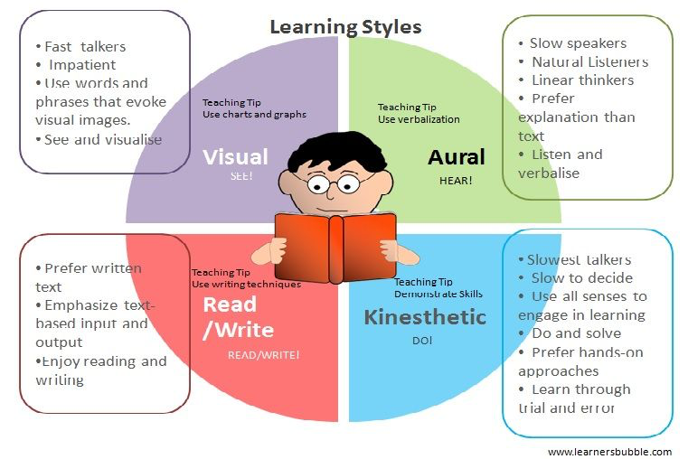
Figure3: Flemming, N. (1987) The VARK Model of Learning Styles

Visual (V): these students retain information decoding graphs, pictures, diagrams and so on.
Aural(A): this group of students feel comfortable analyzing situations and listening to people.
Reading(R): they just prefer decoding letters. Reading for them is the best method.
Kinesthetic(K): they include the senses in the learning. Generally, connect the concepts with some previous experience. (Othman and Amiruddin, 2010)
According to Neil Flemming statement in his interview for the University of Windsor there is the Multi Modal learner as well. Here the individual may combine two, three or four letters and feel enjoyable on these channels. (Flemming, 2020)
Having analyzed all three methods...which one is suitable to train new employees?
Well, it is wise to say that the combination of the three concepts will deliver the manager a holistic view of the circumstances.
In one hand, Kolb´s method has four learning styles which travels across two dimensions established on people´s learning perception (concrete x abstract) and processes data (active x reflective). On the other hand, on Honey &Mumford scheme as stated previously its map is focused on information to help on people management. For example, at the diagram on stage 1, there are the Activists (individuals who search for challenges), on stage 2, Reflectors (the analysts), on stage 3, Theorists (people who are based on logics) and finally stage 4 Pragmatists (the innovative group). Finally, the VARK model evidences the human senses (visual, aural, read/write and kinesthetic) which are vital to place the student in its best category. It is convenient to say that at first time impressions may be builded based around Mr. Flemming´s studies then across the training the manager may apply with supplementary technics.
Conclusively, being aware of this valuable information and a common sense will produce substantial facts and figures.

4. The Professional Career Development Module Reflection

In a general overview of this module undoubtedly enriched me very much. The classes were dynamic since the rapport lecturer- student was in a continuous motion and evolution.
The Professional Career Development Module is relevant because from my perception it connects the University to the external world. The subjects addressed such as “Improving Self-Awareness” in week two or “Employment Legislation” in week eight are concepts I will carry for a lifetime. The idea of how to evaluate the students was brilliant. The process of building a Cv from scratch and the cover letter helped by Mrs. Danielle Waar and then in a second task facing a fake job interview gave me the security on how to behave in front of an interviewer. As a result, from the activity I have a professional curriculum and I can use it if I decide to apply for a true job.
Furthermore, the daily activities were interesting because it involved action like tests, the learning log or simply forcing us to think about....” Why?” transformed a four-hour online class come to an end very quickly. Consequently, twelve weeks flown away!
Before this module I had the misconception about planning my career and life. At that time my conduct was basically live each day at a time. The normal routine at the workplace for example was to arrive on time and develop daily designated activities. Reflections about myself and how the outside word impacts on me were not a matter that used to occupy my thoughts that much. The future was so far away. This module opened my mind. Concepts such as strengths, weaknesses, internal, external and much more came in to transform a way of life. Furthermore, self-awareness also discussed along the classes covered even more the whole experience.
Self-awareness is a quite complex theory studied by phycologists in the past years. Abbreviatedly, self-awareness is a deep understand about us including our feelings which drives us behaving in a certain way. The most valuable part is, that being conscious about this tool, there will be the possibility to take over the reins of our life and tailor the future. (Warwick University, 2020)
From this concept I realised that it is vital to become a better person at the workplace and personal life since it brings many benefits such as improving self-regulated behavior, psychological well-being and consequently increases mental health. (Sutton, Williams, Helen and Allinson, 2015)
After the module when I look back and think about what I have learned I feel the sensation of fulfillness. Basing on my student life experience this is a very positive outcome.
In special, the job interview was very rewarding experience for me. The process of the cv creation and the interview itself showed based on my grade 78% that I will survive in the outside world.
My main difficulty in general is about communication skills which I have been working on deeply since September. Communication skills in the workplace is fundamental because according to (Coffelt, Grauman and Smith, 2019) many employers express on the job description that the candidate must have some high dominance in interpersonal, written, or oral are primary issues for employers. Moreover, communication skills are not only essential for everyone, it extends through teams and it interferes on the organization outcomes. (Kinnick and Parton, 2005)
I must admit that the interviewer had a friendly behavior and professional. It helped me to feel welcomed and calm. As discussed on class, an interviewer may have a rough attitude, and I must be ready for that. Certainly, this should be a task to work on in the next step on my communication skills development.
I reaffirm that I extremely enjoyed the Professional Career Development Module because each week the subjects like, improving self-awareness, exploring employment opportunities, writing a cv and facing an interview, the mock interview itself, career development and the discussion about the alternatives after the graduation were developed wisely and dynamically by the Lecturer. Mr. Abdi Rahman is a strong leader, a great communicator and, he is updated to the market these are main the reasons the students could absorb fresh knowledge.
I hope as soon as possible I will have the possibility to use all tools learned during these twelve weeks. It was a privilege I could learn all these concepts in a University and having colleagues to discuss and professionals where I could have a support.

4. Conclusion
Concluding the PDP is a powerful tool for an individual who dreams about getting improvement into work and personal life. Its process allows a deep personal research where characteristics come to the surface promoting self-awareness.
In addition, a combination of the three methods Kolb, Huney&Munford and VARK models promotes an ample view for a manager to decide which is the best procedure to train a new employee as well as each system has its own particularities. A smart training will merge all of them according to the employee´s necessities.
Finally, Professional Career Development Module was very interesting because the topics discussed along the twelve weeks were important not only for new knowledge but, planning the future and how to put a step on the labour market.

5. References

Beausaert, S., Segers, M. and Gijselaers, W. (2011) “Using a Personal Development Plan for Different Purposes: Its Influence on Undertaking Learning Activities and Job Performance” volume 4, pages231–252

Borredon, L., Deffayet, S., Baker, A. and Kolb, D. (2010) “Enhancing Deep Learning: Lessons from the Introduction of Learning Teams in Management Education in France” https://doi-org.ezproxy.uwtsd.ac.uk/10.1177/1052562910368652

Coffelt, A., Grauman, D. and Smith, F. (2019) “Employers’ Perspectives on Workplace Communication Skills: The Meaning of Communication Skills” https://doi-org.ezproxy.uwtsd.ac.uk/10.1177/2329490619851119

Coventry University (2020) Employability. Available at: https://www.coventry.ac.uk/course-structure/ug/2021-22/hls-nhs/dietetics-bsc-hons/ (Accessed on November 14th)

Emet, G. and Merba, T. (2017) “Swot Analysis: A Theoretical Review" Htp://dx.doi.org/10.17719/jisr.2017.1832

Figure 2: Mumford, A. and Honey, P. (1986) Honey and Mumford Model Learning Theories. Available at: https://sites.google.com/site/instructionaldesignandtraining/learning-the/honey-and-mumford (Accessed November 1st)

Figure1: Kolb, D. (1984) “The Experimental Learning Cycle”. Available at: https://www.simplypsychology.org/learning-kolb.html (Accessed 11/09/2020)
Figure3: Flemming, N. (1987) The VARK Model of Learning Styles. Introduction to Vark. Available at: https://vark-learn.com/introduction-to-vark/ multi modal learner (Accessed on November 1st)

Fleming, N. (2020) Interviewed by Dr. Alan Wright, https://vark-learn.com/introduction-to-vark/.
Kearney JM. and McElhone S. (1999) “Perceived Barriers in Trying to Eat Healthier–Results of a Pan-EU Consumer Attitudinal Survey.”

Kinnick, K. and Parton,S. (2005) “Workplace Communication: What the Apprentice Teaches About Communication Skills”

Maguire, W. and Blaylock, P. (2017)” Preparing a Personal Development Plan for all Members of the Dental Team" vol.223 (6), p.402-404

Othman, N. and Amiruddin, M. (2010) “Different Perspectives of Learning Styles from VARK Model¨.

Pashler, H., McDaniel, M., Rohrer,D. and Bjork, R. (2009) “Learning Styles: Concepts and Evidence” https://doi-org.ezproxy.uwtsd.ac.uk/10.1111/j.1539-6053.2009.01038.x
Pinho, M., Mackenback, J., Charreire, H., Oppert, J., Bárdos, H., Glontil, K. Hutter, H., Compernolle, S., De Bourdeaudhuij, I, Beulens, J. Brug, J. and Lakerveld, J. (2017) “Exploring the Relationship Between Perceived Barriers to Healthy Eating and Dietary Behaviors in European Adults”

Sutton, A., Williams, H., Christopher, A., (2015) “Mixed method evaluation of self-awareness training in the workplace” vol. 39, Iss. 7.

Tucke, F., Duncan, A. and Davis, L. (2015)” Investing in Yourself’: Personal development planning in Practice” pages 10-13. https://doi-org.ezproxy.uwtsd.ac.uk/10.11120/plan.2011.00240010
University of Leister( 2020) Theories/Honey-Mumford. Available at: https://www2.le.ac.uk/departments/doctoralcollege/training/eresources/teaching/theories/honey-mumford (Accessed: November 1st 2020)

Warwick Wellbeing Support Services (2020) Available at: https://warwick.ac.uk/services/wss/topics/selfawareness/ 2020 wellbeing support services. (Accessed on November 4th)

Zainab, H. (2017) “Role of Dietitian in a Food Service Industry”

