-
Project Initiation Document qatar airways
M6X02113- Consultancy Project

13/03/20

Dee Lee Jones & Olivia Griffiths
1700521 & 1703630

A Project Initiation Document submitted in fulfilment of the requirements for Course M6X02113, Consultancy Project, University of Wales Trinity Saint David

Table of Contents
1.0 Aims and Objectives 3
2.0 Project Justification 4
3.0 Business Case and Approach 5
4.0 Project Team 6
5.0 Planned Communication Strategy 6
6.0 Project plan 7
7.0 Research methodology 8
8.0 Costs 9
9.0 Benefits to the company 9
10.0 Appendices 11
10.1 Gantt Chart 11
10.2 SWOT of Qatar Airways 12
10.3 PESTEL 13
11.0 References 14

1.0 Aims and Objectives

Aim
Raise awareness of the long-haul flights and destinations on offer from Cardiff Airport with Qatar Airways, resulting in an increase in passenger numbers.
Objectives
- Increase number of passengers flying with Qatar Airways from Cardiff Airport in 2020 compared to 2019, by highlighting the advantage of travelling from Cardiff Airport (rather than other airports).
- Create marketing material that will demonstrate that Qatar Airways is a luxury, affordable brand with over 160 destinations from Cardiff Airport (Qatar Airways, 2020).
- Undertake primary and secondary research to analyse why customers chose to fly from other airports and provide actionable recommendations for the airline to overcome this.
- Look for new opportunities which will increase revenue with a low cost to the airline, such as smaller sponsorship opportunities with local businesses and events.

2.0 Project Justification

The justification for undertaking this project is that there is a lack of public awareness of the flights which Qatar Airways offer from Cardiff Airport.
Due to this lack of awareness, many potential customers fly from competitor airports, such as Birmingham or London Heathrow, meaning that the revenue that could be generated from the Cardiff to Doha route is currently not being maximised. Qatar Airways’ target is to increase their passenger numbers and they acknowledge that an increase in awareness is key in this progression.
Qatar Airways began flying out of Cardiff Airport in 2018 (BBC News, 2018). Bristol Airport was also in competition for the route (The Independent, 2018).

In the first twelve months of the route, occupancy was at 55% with 82,000 passengers and although customer figures have increased from its inaugural year, there is still room for improvements (Business Live, 2019).
There are a number of constraints which may cause limitations on the quality of analysed data being found due to the restraint involved with interviewing passengers and customers of the airline. However, the aim is to increase awareness of the airline and its routes, and members of the public in Swansea and Cardiff are going to be interviewed which will provide an insight into the knowledge local residents have of what is on offer.
Another factor is the lack of information available to us in regards to confidential figures held by Qatar Airways. This will be taken into consideration throughout the project as well as when the findings are analysed.
An assumption of the findings is that the levels of awareness of the route in Wales and the surrounding areas is poor and that this will need to be addressed in terms of moving towards a new sales strategy to progress this service.
A further assumption of undertaking this report is that Qatar Airways will continue to work with the consultants throughout the project and fully co-operate, we well as taking recommendations on board.
Other organisations which will be linked to this project are Cardiff Airport, who have not agreed to work on the project. As the aircraft departs from Cardiff Airport it is important to acknowledge they are stakeholders in this project and will also benefit with increased passenger numbers.
A SWOT analysis has been undertaken to analyse the businesses internal strengths and weaknesses as well as the external factors affecting the business in a PESTEL, see Appendix 10.2 and 10.3.

3.0 Business Case and Approach

The conclusions from the report must fit with the business’s needs and consider the culture of the business as well as the importance of confidentiality and the lack of figures available to the consultants whilst undertaking the report.
There are possible risks involved to the airline, such as;
- Lack of experience working within the airline industry previous to this project. This will be overcome by the consultants not acting on the behalf of the airline at any point and working interpedently as to not represent the airline in public.
- Both consultants are full time students at university, which does mean that the project will be undertaken at the same time as other work. However, this will be overcome by regular communication, the creation of a Gantt chart and both consultants acknowledging the importance of prioritising workloads.
- There is limited chance that this project will create damage to the company and its reputation as at no point will the consultants be talking to members of the public on behalf of the organisation, and will make it clear that it is part of a university project.
- Both consultants will keep all work fully confidential and not disclose any outcomes or results with any person who Qatar Airways have not given permission to be told.
- All work will be undertaken for free, and so there is no financial cost to the business

4.0 Project Team

- The consultants will provide an independent report due to having no links to the business prior to this project being undertaken. Having an independent view of the business will provide an impartial outlook and recommendations which will be of an advantage to the business.
- Both consultants are free of charge, which again is of advantage to the business, as consultants can charge thousands of pounds per project (Consultant Journal, 2020). This means that there are no financial losses to the company throughout this project.
- Both consultants have industry knowledge and experience, as well as flying with the airline and visiting the airport numerous times. This results in first-hand experience of the route, product offering to customers and facilities on offer by the airline and airport.

- Both consultants have experience undertaking and analysing both primary and secondary research as well as marketing and market research.

5.0 Planned Communication Strategy

In order for the communication strategy to be successful throughout the process the following will be implemented throughout;
- Both consultants will have weekly meetings with each other as well as communicating between these meetings
- Regular email communication with the airline
- Monthly meetings with the airline to discuss progress of report
- Sending finalised BID presentation and PID to the airline to ensure they agree with all work undertaken.

Minutes of all meetings will be taken, in order for all involved to keep on track and be able to refer back to previous discussions.

6.0 Project plan

The project plan consists of:
- Defining the problems identified by the consultants and the airline
- Design all forms of primary research (such as interviews and questionnaires) as well as the structure of the report
- Research - Undertaking primary research and gather secondary research (see 7.0)
- Analyse all research undertaken
- Conclude - Creating a 7000-word report detailing all the findings from the above, creating recommendations for improvement for Qatar Airways. Creating marketing material Qatar Airways can use to publicise their routes through Cardiff in Wales as well as helping the airline with their brand identity to impact customer figures.
- Brainstorming- A review of results and out comes from research to create a new sales strategy so the airline could increase passenger numbers
- Actionable Recommendations - Provide the airline with realistic actionable recommendations which will help increase passenger numbers, revenue and awareness of the airline
- Action Follow Up – After the report has been published for Qatar Airways, to communicate with the business to advise where needed and ensure there aims and objectives are met from the report.

To keep up to date with all work already undertaken as well as work due to be undertaken, a Gantt chart has been created. A Gannt chart will be used as it is significantly important when carrying out a project, with Li & Zhang (2012) confirm that the purpose of having a Gannt chart is to create an effective plan through the breakdown, classification and explanation of specific tasks, this can include work content, completion time and schedule, cost estimation etc. The Gannt chart can be found in the appendices as Appendix 10.1.

7.0 Research methodology

To undertake this project, the research will be primary and secondary to give a broader understating of the topic, industry and business.
The primary research undertaken will be as follows;
- Questionnaires
- Interviews with key staff members
- Interview travel agents to fully understand why customers chose to fly from other airports
- Interviewing people in Welsh cities and communities (such as Cardiff, Swansea and more rural locations)
- Analysing social media comments
- Look more in-depth at price differences between CWL and LHR as well as competitor analysis by looking at other airlines

The secondary research undertaken will be as follows;
- Academic journals
- Industry related books
- News articles
- Research already conducted by Qatar Airways
- Government statistics
- Industry reports
- Companies house records
- Census information
- ABTA
- IATA
- ATOL

8.0 Costs

As previously mentioned, the project will be completed for free for Qatar Airways. This will save Qatar Airways potentially thousands of pounds (Consultant Journal, 2020).

9.0 Benefits to the company
The benefits the company will receive from this project are;
- Varied amount of primary research undertaken which will save the business time
- Secondary research analysed (such as competitor analysis) which will then be comprised into a 7000-word report
- List of actionable recommendations for the airline which are concluded from all research undertaken
- Marketing material for the airline to use will be created
- Independent consultants which enable an impartial outcome
- Smaller scale sponsorship deals will be analysed such as Ffos Las, local university awards and smaller businesses, to increase connections and brand awareness.
- All of the above is free of charge

The report will outline all of the results from the research undertaken throughout the project including a strategic plan of actionable recommendations.
‘Strategy is the determination of the basic long-term goals and objectives of an enterprise, and the adoption of courses of action and the allocation of resources necessary for carrying out these goals’ (Chandler, 1962).
Chandler explains how businesses, such as Qatar Airways, need a strategy in order to reach their target passenger numbers and reach all objectives created by the business.

10.0 Appendices

10.1 Gantt Chart

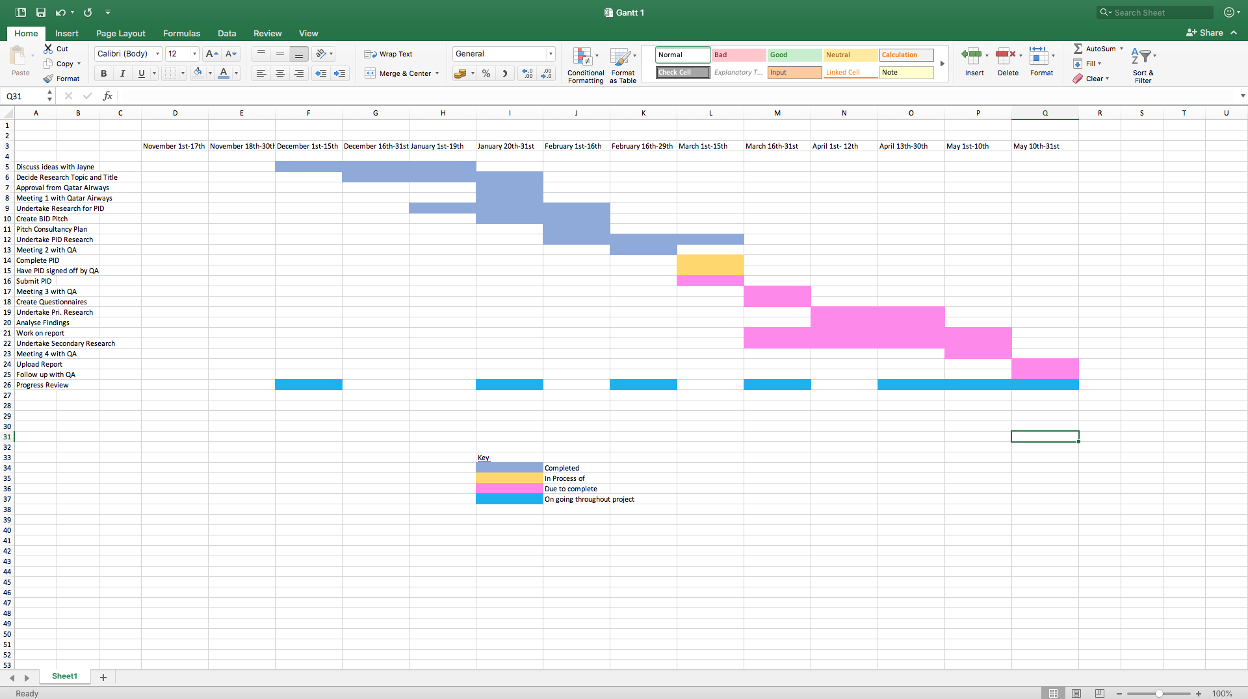

10.2 SWOT of Qatar Airways
Strengths  - World’s best Airline – Only carrier to win 5 times ‘Airline of the Year’  - Has maintained a Skytrax five-star ranking since 2004 (Oneworld.com, 2020).  - Can be seen adapting the business to involve sustainability measures (Qatar Airways Policy, 2017) | Weaknesses  - Only five flights a week  - Limited connections for business customers  - Lack of awareness of routes available  - Location of Cardiff Airport  - Transport links to the airport
Opportunities  - Connections to over 170 countries  - Opportunity to add additional flights if sales increase | Threats  - Other airlines as competitors  - Other airports as competitors  - Lack of customers  - Coronavirus (Topham, 2020)  - Terrorism  - Overseas travel may be on the decrease due to increased awareness of Climate Change

10.3 PESTEL
Political  - Declined M4 relief road  - Qatar Blockade (Aljazeera.com, 2019) | Economic  - Global economic issues – Recession  - Stock markets shares  - Price of oil – Qatar  - Cardiff Airport financial loss (BBC News, 2019)  - Rise in fuel/slots
Social  - Coronavirus (The Independent, 2020)  - Awareness of climate change reducing air travel | Technological  - Digital inflight magazines on flight  - Working with Airbus and Boeing to create best technology (Qatar Airways Press Release, 2019)  - Apps to book tickets and check in
Legal  - Regulations for all the countries/ destinations the airline serves  - Paris Climate Agreement | Environment  - Climate change  - Activism

11.0 References
Aljazeera.com. (2019). Qatar blockade: Five things to know about the Gulf crisis. [online] Available at: https://www.aljazeera.com/news/2019/06/qatar-blockade-gulf-crisis-190604220901644.html [Accessed 2 Mar. 2020].
BBC News. (2018). First Qatar flight lands in Cardiff. [online] Available at: https://www.bbc.co.uk/news/uk-wales-south-east-wales-43951623 [Accessed 20 Jan. 2020].
BBC News. (2019). Cardiff Airport posts £18.5m pre-tax loss. [online] Available at: https://www.bbc.co.uk/news/uk-wales-50955180 [Accessed 4 Mar. 2020].
Business Live. (2019). First year passenger figures for Qatar Airways' Cardiff to Doha route. [online] Available at: https://www.business-live.co.uk/economic-development/how-many-passengers-flew-first-16701011 [Accessed 20 Jan. 2020].
Chandler, A. (1962). Strategy and Structure: chapters in the history of the industrial enterprise. Boston Mass: M.I.T. Press, p.801.
Consultant Journal. (2020). Consulting fee rates | Consultant fees - ConsultantJournal.com - Become a Consultant. [online] Available at: https://consultantjournal.com/blog/setting-consulting-fee-rates [Accessed 2 Mar. 2020].
Li, Z. & Zhang, L. (2012). “A Study on Multi-Project Management Based on Gantt Chart and Network Planning Technique”. Applied Mechanics and Materials, 174-177, pp.2854–2860.
Oneworld.com. (2020). Airline Detail - Qatar Airways | oneworld | oneworld. [online] Available at: https://www.oneworld.com/members/qatar-airways [Accessed 22 Jan. 2020].
Qatar Airways Policy. (2017). Qatar Airways Group Environmental Policy. [online] Available at: https://www.qatarairways.com/content/dam/documents/environmental/Environmental-policy-EN.pdf [Accessed 2 Mar. 2020].
Qatar Airways Press Release. (2019). Qatar Airways Converts 10 of its 50 Airbus A321neo on Order to the Longer Range Airbus A321LR. [online] Available at: https://www.qatarairways.com/en/press-releases/2019/January/EngAirbusA321Lr.html [Accessed 4 Mar. 2020].
Qatar Airways. (2020). Qatar Airways Destinations. [online] Available at: https://www.qatarairways.com/en-gb/discover.html [Accessed 2 Mar. 2020].
The Independent. (2018). Cardiff to Doha passenger numbers are 'disappointing', says Qatar Airways. [online] Available at: https://www.independent.co.uk/travel/news-and-advice/qatar-airways-cardiff-airport-doha-flights-passenger-numbers-akbar-al-baker-a8450646.html [Accessed 2 Mar. 2020].
The Independent. (2020). Airlines struggle as coronavirus causes ‘bookings to collapse to zero’. [online] Available at: https://www.independent.co.uk/travel/news-and-advice/coronavirus-flight-travel-bookings-outbreak-latest-a9371291.html [Accessed 4 Mar. 2020].
Topham, G. (2020). Airline industry braced for major threat from coronavirus turmoil. [online] The Guardian. Available at: https://www.theguardian.com/business/2020/mar/02/airline-industry-braced-for-major-threat-from-coronavirus-turmoil [Accessed 2 Mar. 2020].

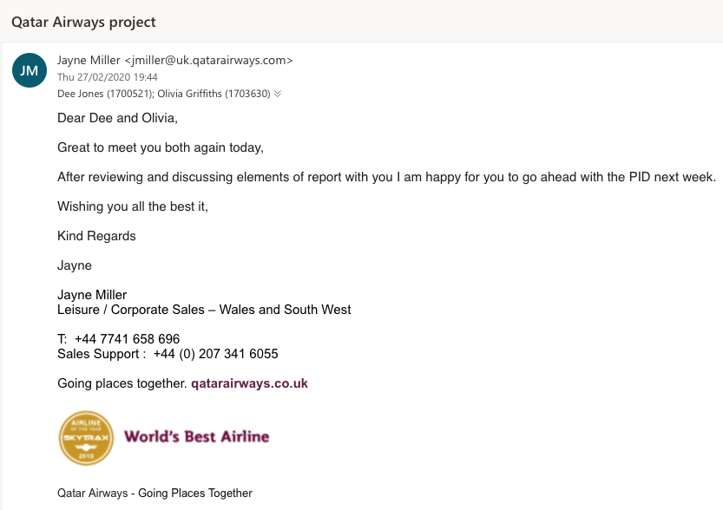
Email confirming Jayne Miller (Qatar Airways) is satisfied with the project:

