Managing Enterprise: Wedding planner Business Plan
Lecturer: Malani Gunaratnam
Name of the Student: Mihaela Tomsa
Student number: 2014051

Executive summary
The wedding planning industry is one of the prospective service-oriented industries operating in the UK with a staggering worth of £6.25 billion having a significant impact on the economy. The business plan of the new venture Dream Wedding Planner Company has been discussed. The plan includes the description of the services offered by the company with a description of the location marketing strategy, operation plan and organisational structure of the business. The plan further focuses on financial plan and forecasting along with the description of the overall start-up cost required for the development of the business. The company through coordination of different strategies aims to gain a strong position among other competitors in the market.
Table of Contents
Business details 3
Service description 3
Target market 4
Location 5
Industry analysis 5
Competition and pricing strategy 7
Operations Plan 8
Risks 9
Sales and marketing strategy 9
Finance and funding plans 10
Management team 11
References 12

Business details
The business details of the Dream Wedding Planner includes the fact that it is a licensed and standard professional wedding planning company based in London. The business would operate from all aspects of the wedding planning that would include wedding coordination, Bachelor's eve or wedding shower (Surplice, 2020). It is a client focus business and focuses upon the result-driven planning of weddings to make the wedding day of the bride and the groom the best day of their lives. The business idea is of event management with a specific focus on wedding planning and the idea is to plan everything from the scratch regarding the different wedding event that takes place. A comprehensive wedding plan would be prepared by the company with the consultation of the bride and the groom and their respective families so that they do not have to bear the hassle of looking after the details of the wedding events you can enjoy the wedding to the fullest without taking much responsibility for the arrangements (Lahtinen, 2017). It had been noted that the event industry in the UK is well established and his work around £42 billion that includes direct expenditure of the event delegates, organizers and participants and in this event industry. The planning market for wedding events is worth around £10 billion that has been one of the most motivating factors for the business idea of planning weddings in the UK (Bandfbusinessplans, 2021). The idea is to approach families that are willing to outsource the wedding activity for avoiding the hassle of planning every detail of the wedding and to ensure that all the details of the wedding planning can be managed professionally for the best outcomes.

Service description
The business idea of event management with a specific focus on wedding planning is directed towards several activities that might today be from the hiring of the venue, decoration of the venue, supply of the food and the beverages (Bandfbusinessplans, 2021). The idea is to arrange all the activities of the wedding such as videography and photo-taking, as well as having a magic mirror that wil add more fun, entertainment music arrangements, arrangements for the wedding cake and other printed materials as well as the makeup and salon arrangements of the bride and the groom (Lahtinen, 2017). The other services included in the wedding planning business would include services at affordable fee along with party coordination and pre-wedding events. The overall services provided would begin from the conceptualisation of wedding theme and to plan the design of the venue, the decorations and arranging for the costumes, salon services, not just for the bride and the groom but also for their respective family members (Dashper and Finkel, 2020). The services offered would also include a helper for the management of the guests in the wedding by taking charge of the reservations and Hotel bookings; arranging for the Spa services for the guests and also booking transportation and porter services for effective guest management at the wedding for best guest experience in the wedding planning (Surplice, 2020).
Mission statement: The mission is to offer trusted wedding planning services that will assist the clientele in achieving personal objectives as related to the wedding event. The business will be positioned strongly to differentiate from the competitors and develop as a leading brand.
Vision statement: the vision of the company is to develop as a professional wedding planning service reflecting integrity excellence, teamwork and service.

Target market
Dream Wedding will initially operates small events not more than 150 people and later will focus on the development of an expansion strategy that will help in consolidating a strong position among other competitors. As a standardised licensed company a wide range of services will be offered that will ensure assessment of the customer-centric approach of the clientele base. The target market of the company, therefore, comprises of
- Bachelors
- Spinsters
- Religious institutions
- About to wed couples

Location
The business initially will begin with the idea that the office of the Dream Wedding Planner Company would be set up in London considering there are many target audiences in London. However, after six months of the operation of the business, the services will be provided in other cities in the UK .

Industry analysis
The wedding planning industry is one of the most obvious service-oriented industry operating in the UK with a staggering worth of £6.25 billion having a significant impact on the economy. More than 20% of the couple in the UK hire a wedding planner and there are more than 37,500-50,000 conducted daily by using a wedding planner. More than 250,000 couples get married each year and the average cost of a wedding in the region as per data of 2019 is £25,000-£35,000 (Sandu and Dobre, 2019).
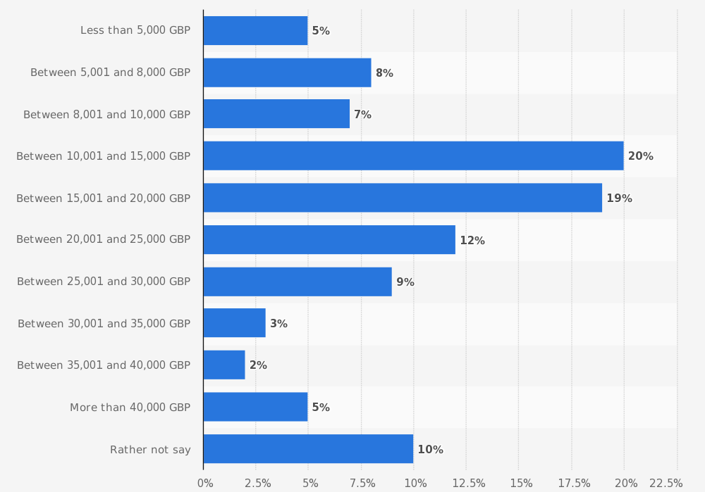
Figure 1: Most common budget ranges for weddings in the UK
(Source: Karush, 2020)
Research estimates have showed that more than 2000 wedding planners are operating in the UK working on more than 25 weddings annually. On average clothing, the cost ranges from £6,000-£6,300. Approximately 100 guests are arriving at a regular wedding in the UK and spending is mainly is on food, drinks, honeymoon, gifts, venue, entertainment, flowers, outfits (Finnell, 2018).
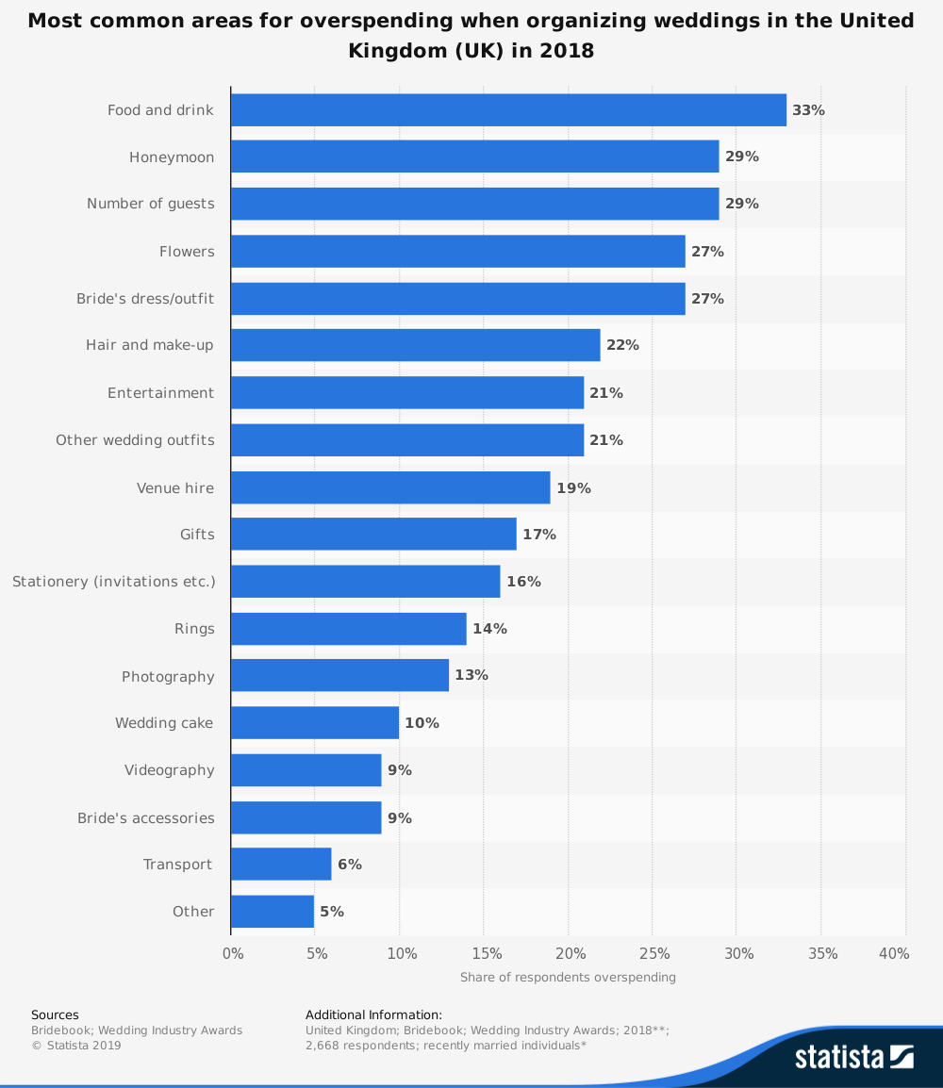
Figure 2: Most common spending areas in weddings in the UK
(Source: Karush, 2020)
The average industry growth was from 2015-20 reached 7.6% showing that the sector experienced strong growth capabilities during the period. However, the declining slowdown and the increase in economic vulnerabilities due to the global pandemic situation there is a certain negative impact (Daniels and Wosicki, 2020). However, the major players are optimistic about growth and adopting new approaches of remote working and different digital initiatives to cope with the current market situation.

Competition and pricing strategy
The major market player is operating in the sector including Tabby & Co., Wedding Creations, Illy Elizabeth, Katrina Otter Weddings. There is a significant level of competition and therefore the development of a strong competitive edge is one of the most important goals of the business. Using a client-centric approach, teaching unique elements by having an online consultation with the couple, using seasonal flowers, managing the best-customised cakes, having vegan options, coordinating with the client-specific restaurant for catering are the specialities the company has planned to differentiate and gain a stronger position in the market. The pricing strategy adopted by the company is a flexible and competitive pricing strategy that will help in increasing business value (Finnell, 2018) .

Operations Plan
The operation plan will coordinate the fulfilment of the strategic business objective by integrating a comprehensive operation plan. This will include coordinating with suppliers, hiring contractual workers and managing the assessments.
Operation: this includes collaboration of chefs, bakers decorators designers, utility providers and technology specialist to coordinate the different events of the wedding that includes catering, managing songs, coordinating entertainment and communicating with the couple and guests during the wedding (Dashper and Finkel, 2020)
Cost and working hours: there will be fixed cost for the services offered and contractual costs have to be gained according to the number of workers hired on daily basis in the region. There is flexibility in working hours helping in effective planning of the different operational activities
Location and personnel: Employees working in the kitchen, party room, wedding location will be provided with specific tasks to do the operation. Staffs are selected according to the set of responsibilities that have to be fulfilled to successfully plan to complete the wedding event.

Risks
The key risk associated with the business idea of wedding planning in the market of the event industry is the very negative impact of the event management industry in the UK. It is noted that the bridal industry that includes hotels, bridal retail and travel services in the UK had been adversely affected as 80% of the wedding gowns supplied to weddings are manufactured in China (Real Wedding, 2021). There had also been a delay of up to over 3 weeks in the shipping of the bridal retailing products in the UK in 2020. Even many suppliers of wedding insurance had suspended the new applications because of the impact of the coronavirus and many families in 2020 have opted to postpone the wedding because of the risk of virus being spread (Cranmer and Pocklington, 2020). This has resulted in financial risks. Operational risks can aggravate with absence of high skilled professional available in the challenging period. The underlying risks of the business include technical differences which effect the development of the business.

Sales and marketing strategy
The marketing strategy that Dream Wedding will apply includes a coordination of traditional and modern marketing approaches that will ensure effective brand visibility development among large number of targeted audience in the region. The company will use different tactical procedures to gain marketing capabilities to assess better brand awareness.
- Facebook marketing
- Instagram marketing
- Content marketing
- Flyer based advertisement
- Developing a strong website
- Email marketing
- Listing in yellow pages
- Promotion through strategic alliance with restaurants, hotels

Finance and funding plans
The revenue projects of the company have been shown to evaluate the capability of the business in the current market situation.
Start-up costs of the company
We are 5 members in the business and each and one of us will come up with £5,000 each for the start-up of the company. The main funding sources that will be leveraged by the company to ensure effective establishment in the region has to be integrated with sound planning. This will be developed to ensure effective assignment of financial resources in different section of the business. The main funding sources include
Since we are only starting with small events and we can progress from there on. Of course, there are other ways we can fund money, such as:
- Bank credit
- Personal savings
- Crowd funding platforms
We are trying to reduce certain costs by hiring staff such as chefs only when events take place, not hiring them full time since we do not know if we are going to have events every week so it would reduce our costs massively.

Management team
The organisational structure of Dream Weddings is shown below:

Figure 3: Organisational structure of the business
(Source: Created by author)
The organisational structure illustrated above shows that the CEO will be responsible for navigating the success strategy development for the growth of the business. Operational managers, marketing professionals and wedding planners will report to the CEO regarding the different activities and managing of the events. Chefs will offer unique dishes, party coordinators will conduct entertainment activities, suppliers will provide input and the overall team will work to develop the business successfully. We will also be working with local farmers and local florists to make sure others in the community grow as well and the clients reap the benefits.

References
Coronavirus: How It's Impacting The Wedding Industry - Real Wedding. Real Wedding. (2021). Retrieved 5 April 2021, from https://realwedding.co.uk/coronavirus-wedding-industry.
Cranmer, F. and Pocklington, D., 2020. The Impact of the Covid-19 Pandemic on the Exercise of Religion in the United Kingdom. Revista General de Derecho Canónico y Derecho Eclesiástico del Estado, 54, p.2020.
Daniels, M. and Wosicki, C., 2020. Wedding planning and management: Consultancy for diverse clients. Routledge.
Dashper, K. and Finkel, R., 2020, August. Accessibility, diversity, and inclusion in the UK meetings industry. In Journal of Convention & Event Tourism (Vol. 21, No. 4, pp. 283-307). Routledge.
Event Management & Wedding Planning |B&F Services. Bandfbusinessplans.co.uk. (2021). Retrieved 5 April 2021, from https://bandfbusinessplans.co.uk/events-wedding-planning-business-plans.
Finnell, C., 2018. A History and Analysis of Weddings and Wedding Planning.
KARUSH, G., 2020. PLANNING AND MARKETING FOR SMALL SCALE BUSINESS-WEDDING INDUSTRY (Doctoral dissertation).
Lahtinen, K., 2017. Wedding trends in Finland 2017.
Sandu, A. and Dobre, A.I., 2019. The Social Construction of a Postmodern Industry: the Wedding-Planning. Logos Universality Mentality Education Novelty: Social Sciences, 8(2), pp.43-62.
Surplice, P., 2020. Future of the Wedding industry: Is the party over?.

