

Operating Systems

Module Name: Computer Architecture & OS
Module Code: ACCA 4022
Student Name: Assadullah Gulamhussein
Student ID: 2509693
Lecturer Name: Md Shantanu Islam

Submission date: June 8, 2026

Contents
Contents 2
Introduction 3
1. Key functions of general Operating Systems 4
Task management 4
Application and program management 5
File and directory management 6
Device management 7
Security management 8
2. Use of Windows OS CLI commands 9
Example 1: Get-Process 9
Example 2: Stop-Process 10
Example 3: Get-ChildItem -Force 10
Example 4: New-Item -ItemType Directory -Name LabWork 11
Example 5: Copy-Item .\a.txt .\Backup\ 11
Example 6: Test-Connection 8.8.8.8 -Count 4 12
Example 7: ipconfig /all 13
Example 8: netstat -ano 13
Example 9: net user 14
Example 10: net user Student2 P@ssw0rd /add 15
Example 11: schtasks /create /tn DailyCheck /tr notepad.exe /sc daily /st 09:00 15
Example 12: Get-ScheduledTask 16
3. Use of Linux OS CLI commands 17
Example 1: ps -ef 17
Example 2: top 17
Example 3: kill -15 <PID> 18
Example 4: ls -la 18
Example 5: mkdir -p Projects/Lab1 19
Example 6: cp report.txt backup/report.txt 19
Example 7: mv draft.txt archive/ 20
Example 8: ping -c 4 8.8.8.8 20
Example 9: ip addr show 21
Example 10: ss -tulpn 21
Example 11: id and useradd -m labuser 22
Example 12: crontab -e and crontab -l 23
4. Use of Windows OS scripts 25
Example 1: Batch script to count items in a folder 25
Example 2: Batch score calculator 26
5. Use of Linux OS scripts 29
Example 1: Disk and folder check 29
Example 2: Backup helper 30
Conclusion 32
References 33

Introduction
Operating systems (OS) are vital software platforms that control computer hardware and software resources and serve as a bridge between the computing devices and the user [4]. They serve essential roles like process management, memory allocation, file operations, device control, security checks, and more, ensuring that systems function smoothly and effectively [12]. Today's operating systems, such as Microsoft Windows and Linux, have graphical user interfaces (GUIs) as well as command line interfaces (CLIs) to facilitate the administration and use of various tasks [5,8]. This report discusses the primary role of general-purpose OS and shows how to use the Windows and Linux command line. It also covers some of the automation techniques with scripting in both environments. The report includes examples that illustrate the ways operating systems facilitate system administration, resource management, productivity and system automation in modern computing systems.

1. Key functions of general Operating Systems
There are many more things that modern operating systems do than run applications. They manage processor time, memory, storage, devices, users and security to ensure that hardware can be safely and efficiently shared. But, Windows is a good illustration of this as the responsibilities can be seen in the graphical tools, in Task Manager, in File Explorer and in Settings. In the screenshots in this section the operating system presents itself to the user as it works internally [1, 2].

Task management
The component of OS that determines which programs will receive CPU time and when they will terminate is task management. It also monitors background processes, startup entries and app responsiveness. Task Manager shows a real-time snapshot of currently running tasks and identifies applications consuming excess resources. This helps to spot freezes, unusual load peaks and programs that should be terminated.
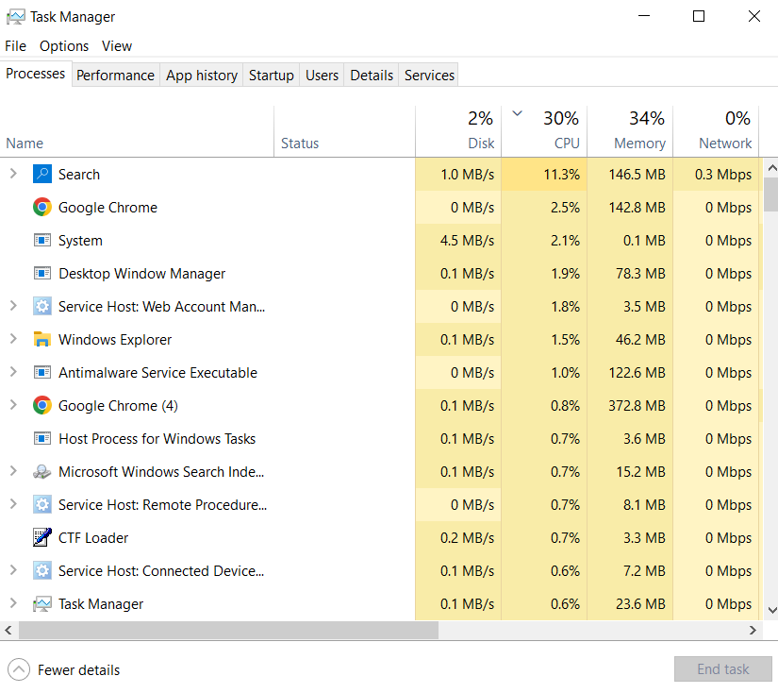
Figure 1: Task Manager process view

Application and program management
Application control is not exclusively about running or stopping apps. The OS loads executable code, provides shared libraries, maintains status data and prevents overwriting of applications. The performance tab of the Task Manager will provide a better indication if the processor is being used due to a single heavy program or a workload in general. When checking if the machine is balanced or overloaded, this is important.
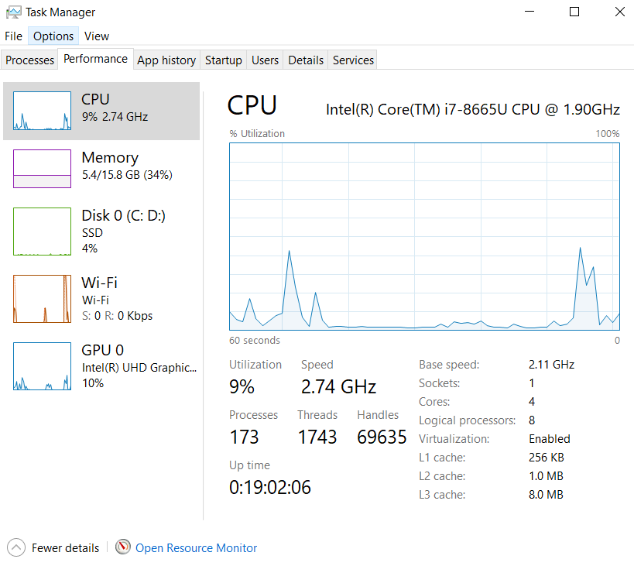
Figure 2: Task Manager performance view

File and directory management
Folders, file names, permissions and metadata are used to organise data in an operating system. A user-friendly view of that structure is provided by Windows File Explorer, and it allows users to create, rename, move, copy and delete objects. The OS does the same thing in the background that helps to keep files in their right place and makes them easier to avoid getting accidentally damaged. Properly organizing a file system will remove a lot of complications and simplify backup.
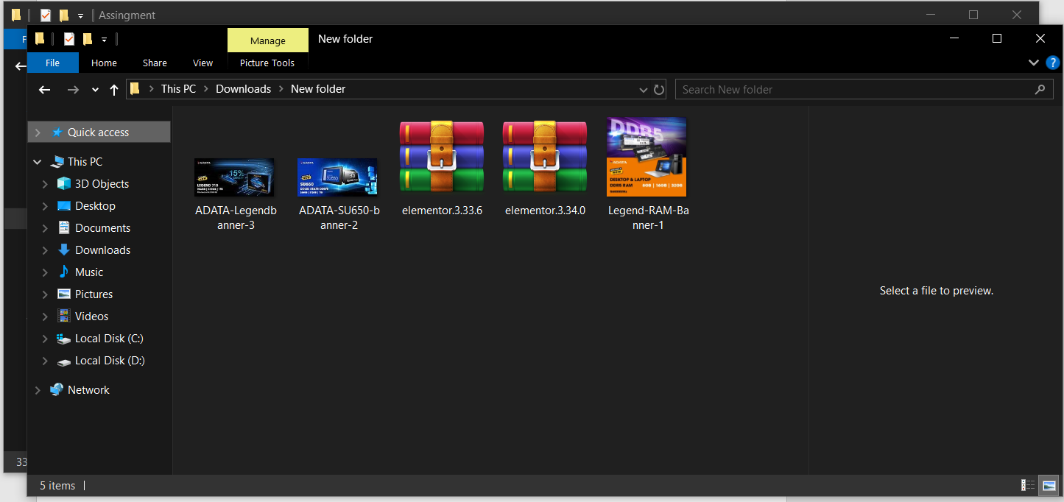
Figure 3: File Explorer view

Device management
The device management includes how the OS communicates with printers, disks, network adapters and other peripherals using devices drivers. Each application can't communicate directly with hardware, the OS is responsible for controlling and translating. This guarantees stability and allows for sharing without conflicts among many programs. Control panels such as Windows Settings can be helpful places to monitor devices associated state and behaviour.
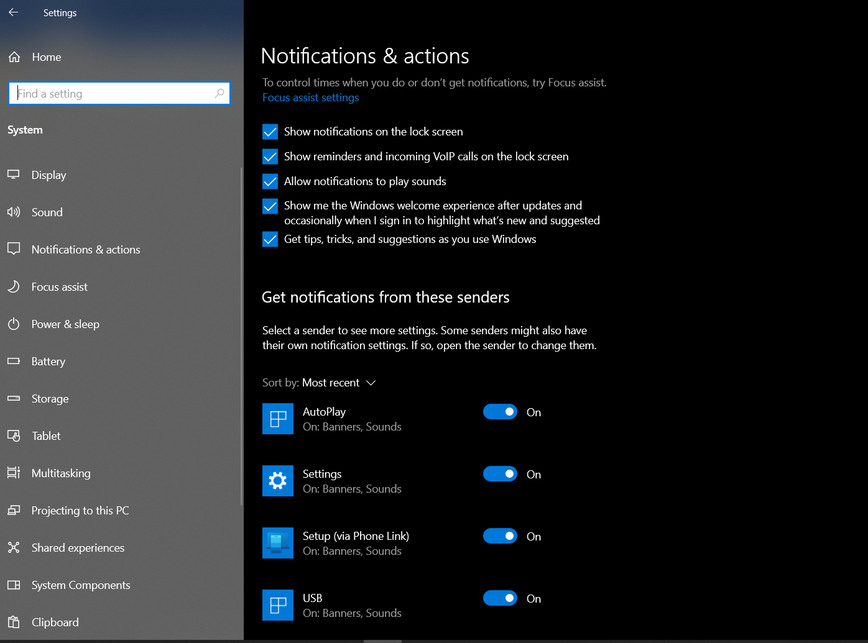
Figure 4: Windows Settings for system notifications

Security management
Security is also an integral part of the OS, it decides who can log in and what they can read; what they can do. This layer includes user accounts, permissions, updates and controls for notifications. In Windows, there is no separation between normal use and privileged operations, as there is in the Settings app and administrative tools. This helps to prevent inadvertent modification and safeguard private information.
All these functions demonstrate that a general-purpose operating system is the master of the entire computing environment. It schedules work, maintains an order in the storage, sets up devices and applies simple protection rules. These roles are also reflected in the GUI but can be performed equally from the command line, so there's a reason why the administrators sometimes switch between both methods [1] [2].

2. Use of Windows OS CLI commands
The power of PowerShell and command-line utilities is that they can help minimize repetitive clicking and output results that can be pasted in a log file or script. These are particularly helpful for processes, files, network checks, users and scheduled tasks [1] [7]. The following examples demonstrate a lab environment workflow, the command typed will be shown as well as the output.

Example 1: Get-Process
Get-Process returns a list of processes that are currently running. The command is used to investigate Notepad in the screenshot, which is useful to determine which modules and resources a program has loaded [2].
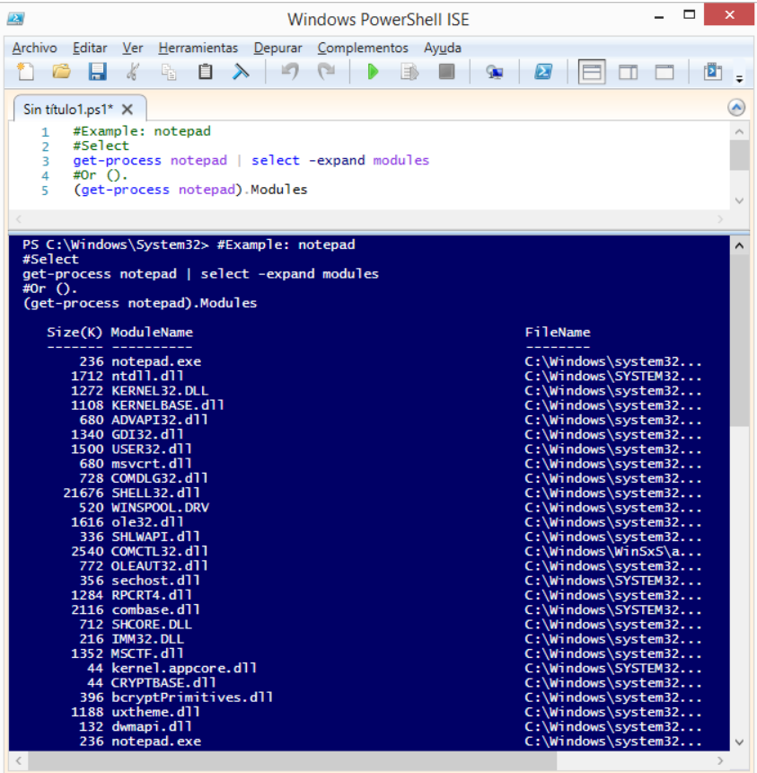
Screenshot: Example 1: Get-Process

Example 2: Stop-Process
Stop-Process is the safe method of stopping a task when a program has been frozen or is no longer required. It can be precise enough to target a process by its name or PID [3]
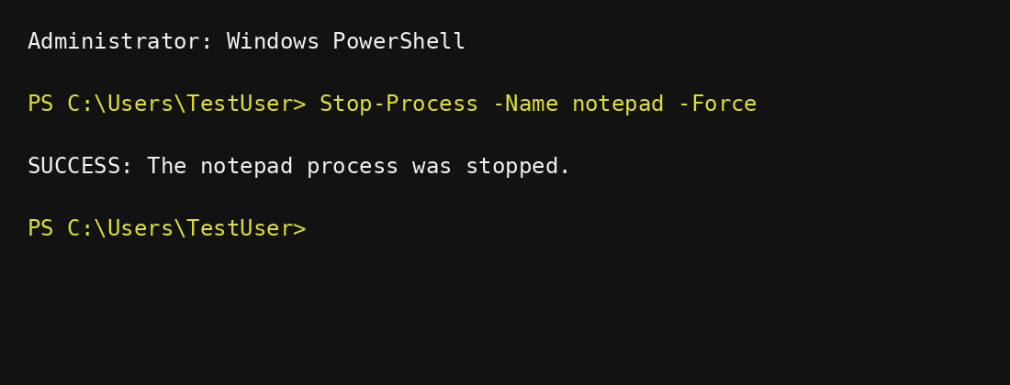
Screenshot: Example 2: Stop-Process

Example 3: Get-ChildItem -Force
The Get-ChildItem command displays a list of folders and files. It is also handy for viewing the contents of a directory, including hidden items, with the -Force switch [4,5].
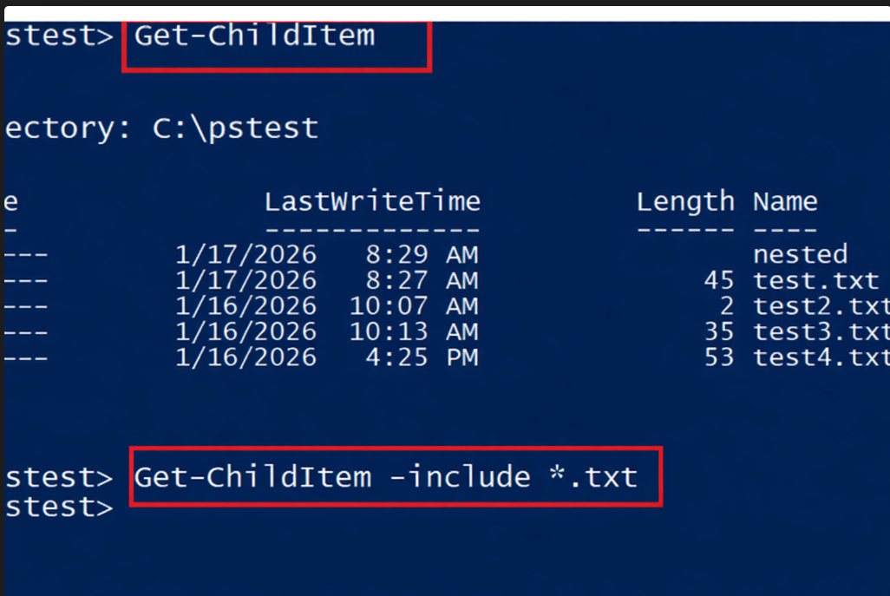
Screenshot: Example 3: Get-ChildItem -Force

Example 4: New-Item -ItemType Directory -Name LabWork
New-Item creates a new directory for work to be organised. The LabWork folder is created and the output shows the path that was added [5] as seen in the screenshot.
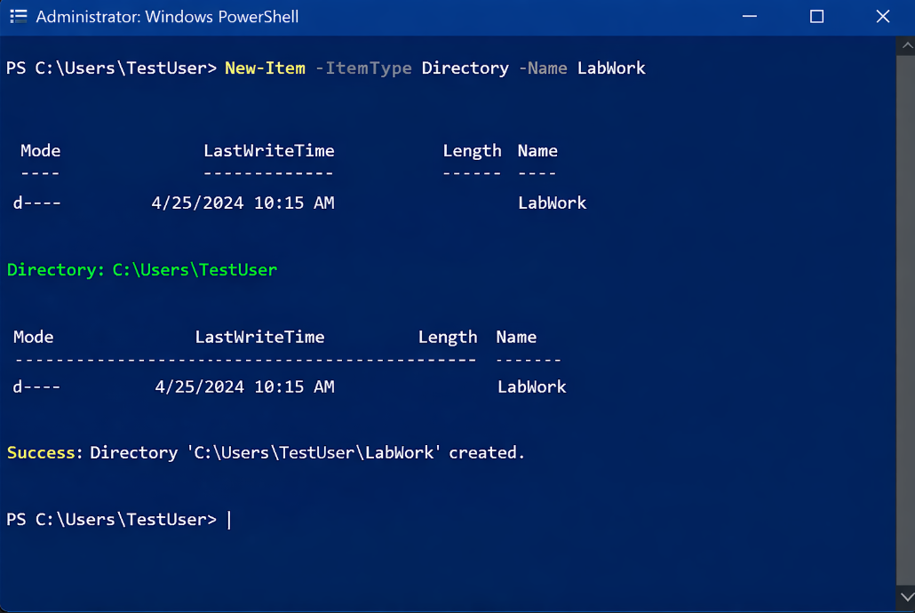
Screenshot: Example 4: New-Item -ItemType Directory -Name LabWork

Example 5: Copy-Item .\a.txt .\Backup\
Copy-Item copies a file to a backup folder without removing the original file. This is a fast method to create a copy for working with it before editing or archiving it [5].
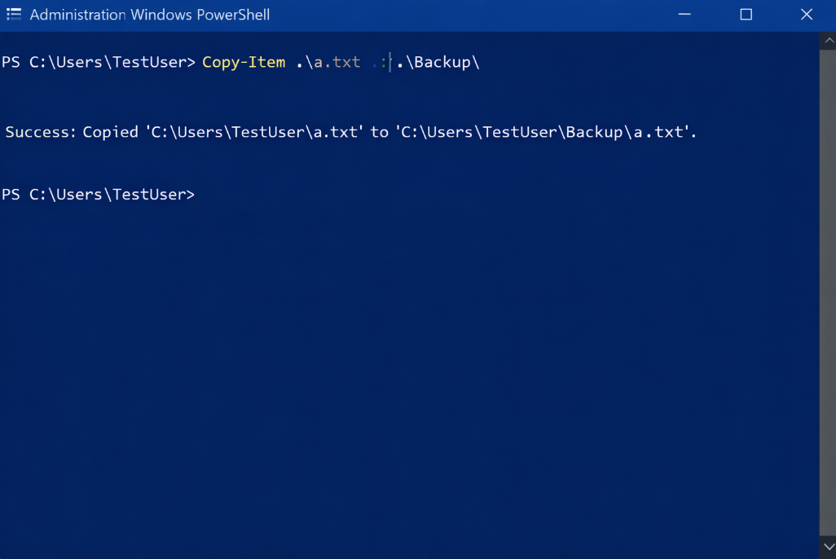
Screenshot: Example 5: Copy-Item .\a.txt .\Backup\

Example 6: Test-Connection 8.8.8.8 -Count 4
Test-Connection will attempt to deliver multiple test packets to a destination. Reply times and zero loss summary indicate that the network path is responsive and available [5].
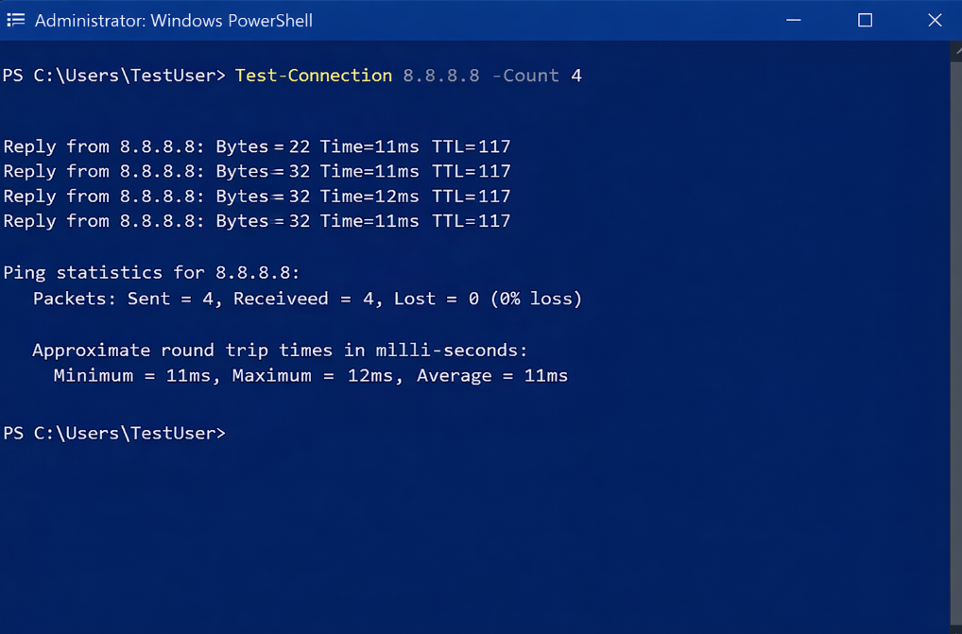
Screenshot: Example 6: Test-Connection 8.8.8.8 -Count 4

Example 7: ipconfig /all
The command ipconfig /all will display all the information regarding the adapters including IP address, DNS server and gateway. It is one of the fastest methods in order to verify if the machine is connected to the network or not [7].
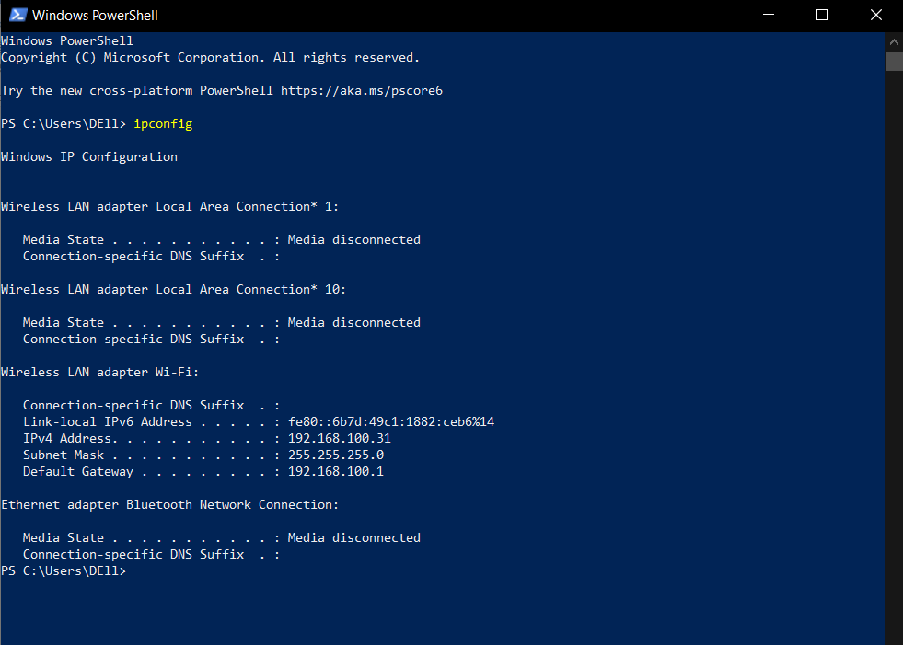
Screenshot: Example 7: ipconfig /all

Example 8: netstat -ano
netstat -ano displays all current connections and listening ports as well as the process ID. Which makes it handy for determining which application is attached to a particular port number [7].
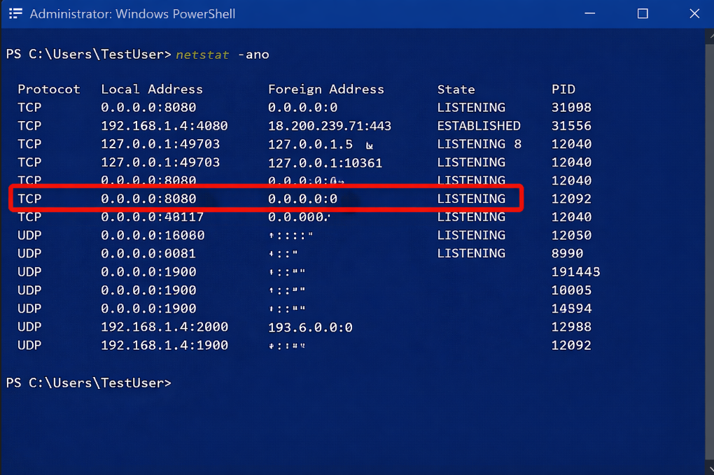
Screenshot: Example 8: netstat -ano

Example 9: net user
net user – Lists the local accounts. It is used by administrators to check for existing accounts on the device before changing access [6] [7].
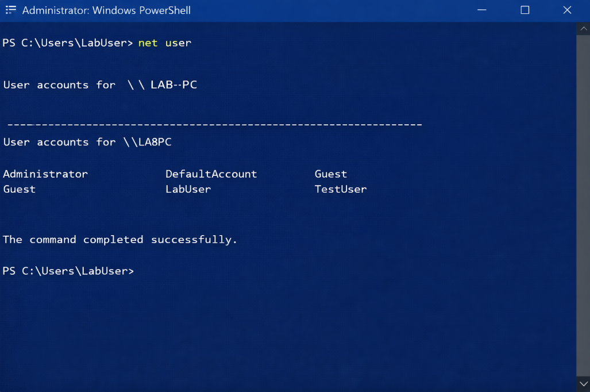
Screenshot: Example 9: net user

Example 10: net user Student2 P@ssw0rd /add
This command is used to create a new local account for a test environment. The successful account creation is confirmed with the message as seen in the screenshot below [6].
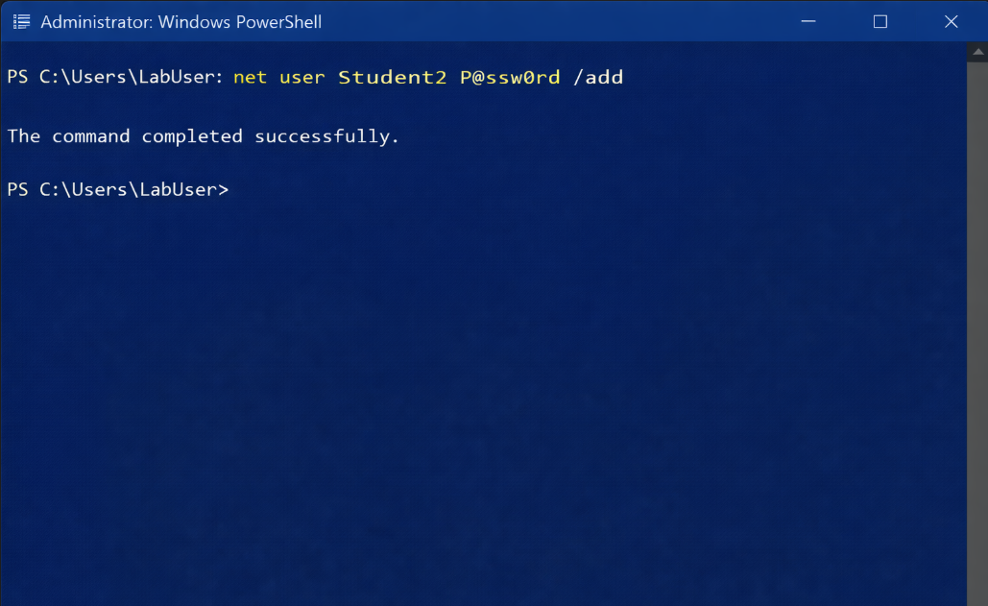
Screenshot: Example 10: net user Student2 P@ssw0rd /add

Example 11: schtasks /create /tn DailyCheck /tr notepad.exe /sc daily /st 09:00
schtasks is a tool which is used to create a scheduled task that will run a program automatically. In the screen shot below, the task DailyCheck is registered and assigned a daily start time [7].
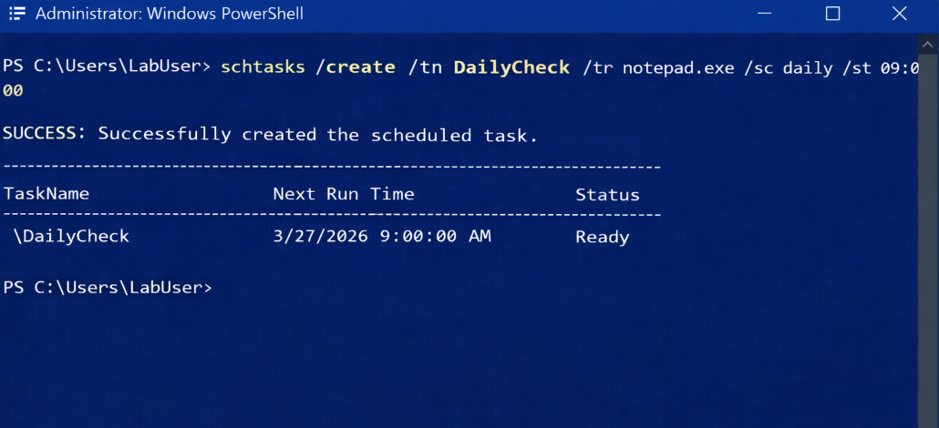
Screenshot: Example 11: schtasks /create /tn DailyCheck /tr notepad.exe /sc daily /st 09:00

Example 12: Get-ScheduledTask
Get-ScheduledTask lists out the tasks in Task Scheduler. The output verifies the existence of and the readiness of the automation job [1] [7].
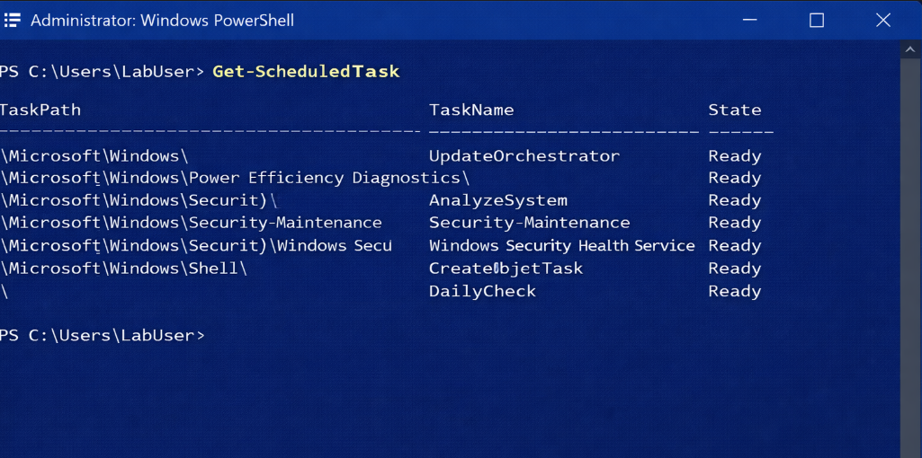
Screenshot: Example 12: Get-ScheduledTask

3. Use of Linux OS CLI commands
The philosophy of Linux administration is based on little commands that can be joined together with pipes, redirection and scripts. This design is efficient for tasks that are repeated often like checking processes, moving data, verifying connectivity and scheduling tasks [8]-[12]. The following examples were selected to correlate with the same practical areas as the Windows section.

Example 1: ps -ef
ps -ef yields a complete list of running processes and their owners, PIDs and commands. It is superb when an administrator wishes to find out what is going at a certain point of time [11].
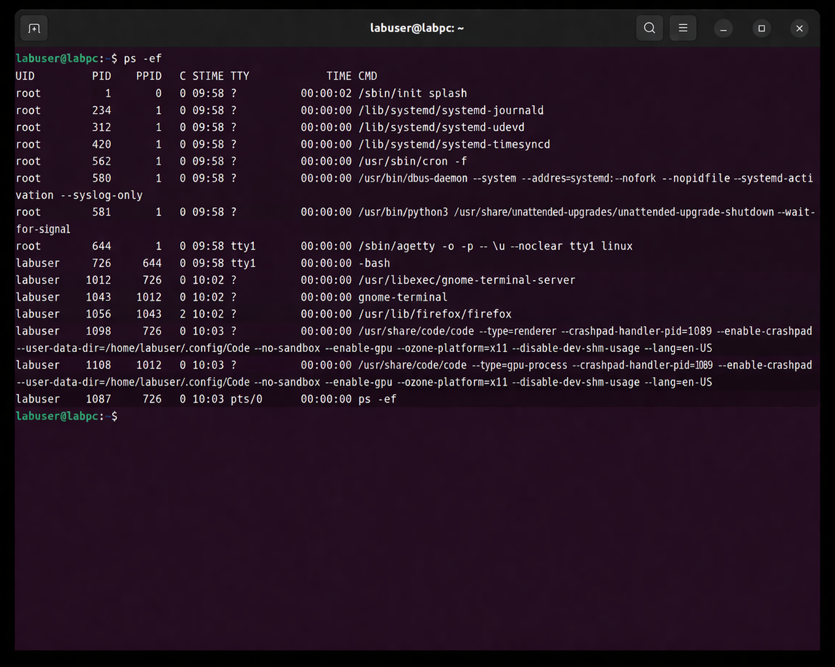
Screenshot: Example 1: ps -ef

Example 2: top
top is constantly updated and displays real-time CPU, memory and process utilization. This renders it appropriate for identifying heavy work and short bursts [11].
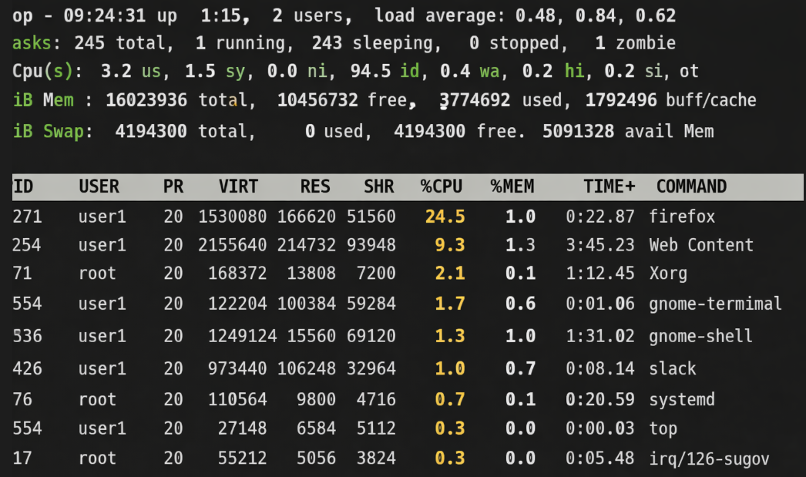
Screenshot: Example 2: top

Example 3: kill -15 <PID>
kill -15 will gracefully terminate a process. When the intent is to allow the application to be terminated gracefully, rather than abruptly, the command is preferred [11].
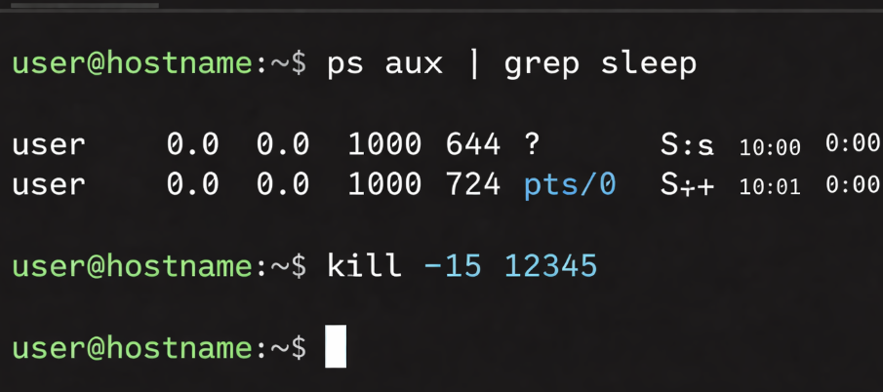
Screenshot: Example 3: kill -15 <PID>

Example 4: ls -la
ls -la will show the permissions, owner, size and hidden files. The output is helpful in determining the contents of a directory before performing modifications [8].
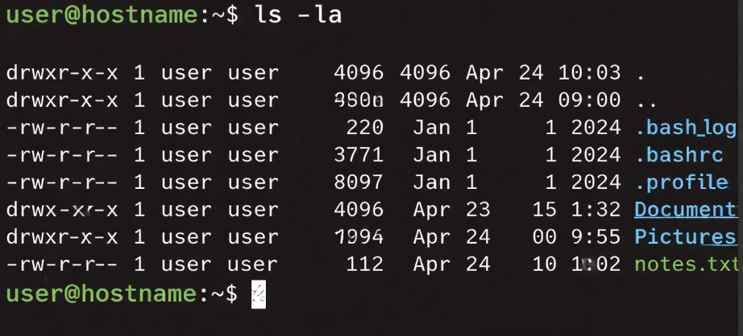
Screenshot: Example 4: ls -la

Example 5: mkdir -p Projects/Lab1
mkdir -p will create nested directories in one go. With the -p option, the parent directory is created if it doesn't exist, thus preventing errors.
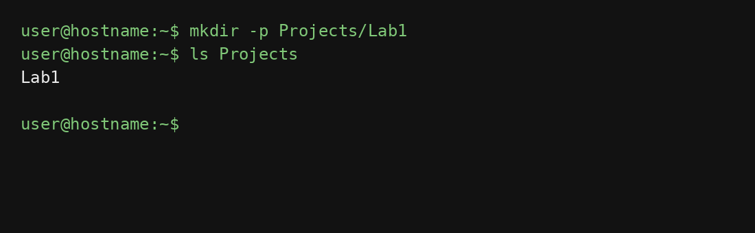
Screenshot: Example 5: mkdir -p Projects/Lab1

Example 6: cp report.txt backup/report.txt
cp copies a file into a backup location, but does not delete the original. It is a simple, but important, safety measure while handling files [8].
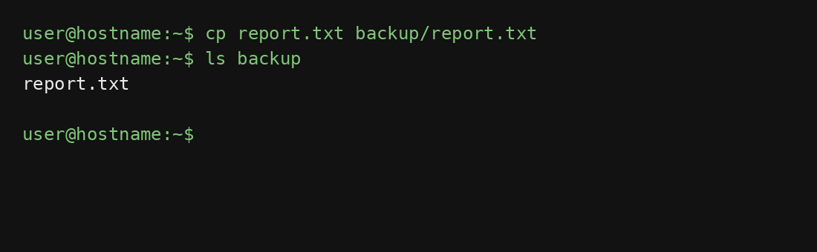
Screenshot: Example 6: cp report.txt backup/report.txt

Example 7: mv draft.txt archive/
mv copies or renames a file. It is actually used for cleaning up files and completing a controlled file transfer in practice [8].
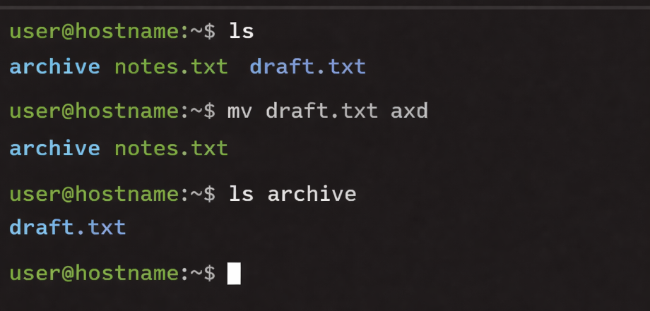
Screenshot: Example 7: mv draft.txt archive/

Example 8: ping -c 4 8.8.8.8
ping is used to send test packets and to report latency as well as packet loss. If the network path is functioning, then the clean reply set is produced [11].
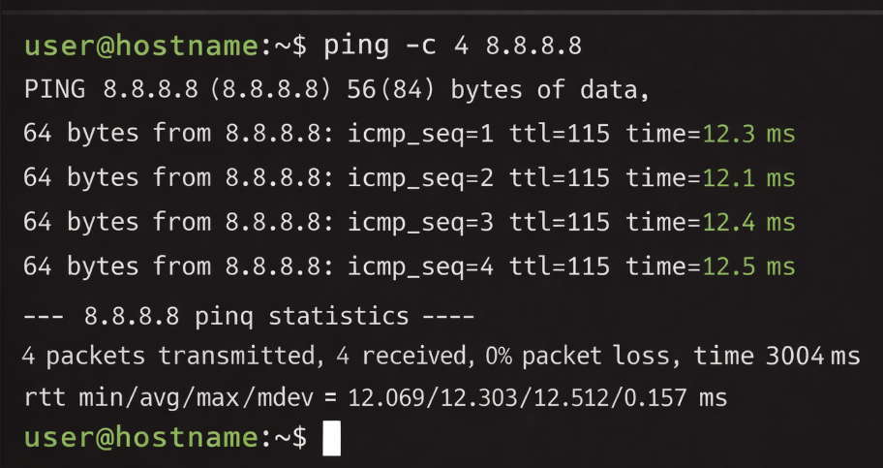
Screenshot: Example 8: ping -c 4 8.8.8.8

Example 9: ip addr show
Use ip addr show to view interfaces, addresses and link state. Now it is used as a replacement for old network tools, as it clearly shows the active configuration [11].
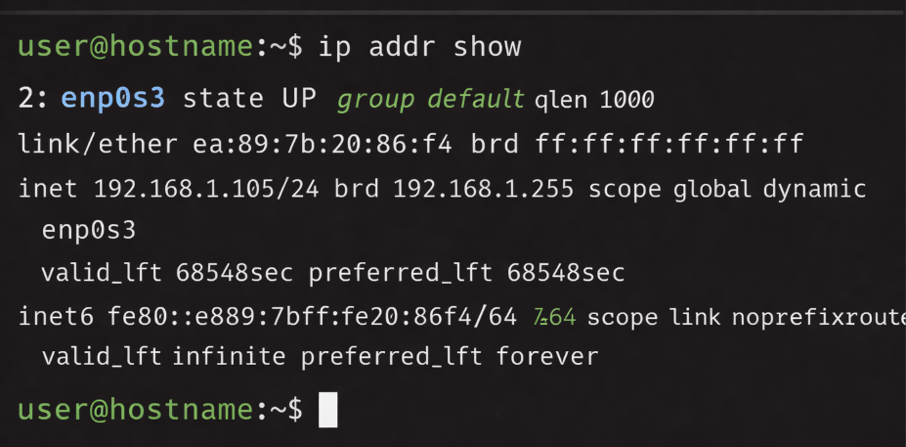
Screenshot: Example 9: ip addr show

Example 10: ss -tulpn
ss -tulpn displays listening sockets and the process that own them. It facilitates the detection of exposed services and unexpected network exposure [12].
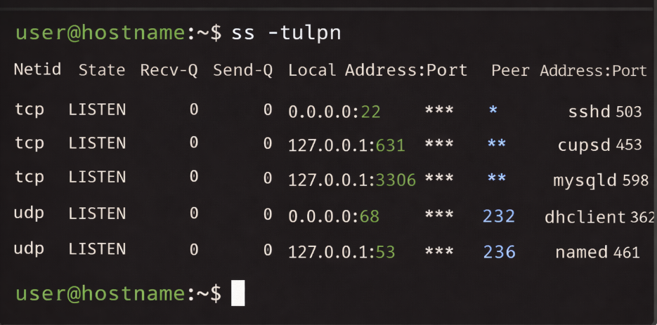
Screenshot: Example 10: ss -tulpn

Example 11: id and useradd -m labuser
id shows the user and group ID numbers of the current user, and useradd -m labuser adds a new user and a home directory for the user. As a pair they demonstrate how Linux deals with identity and account creation [10].
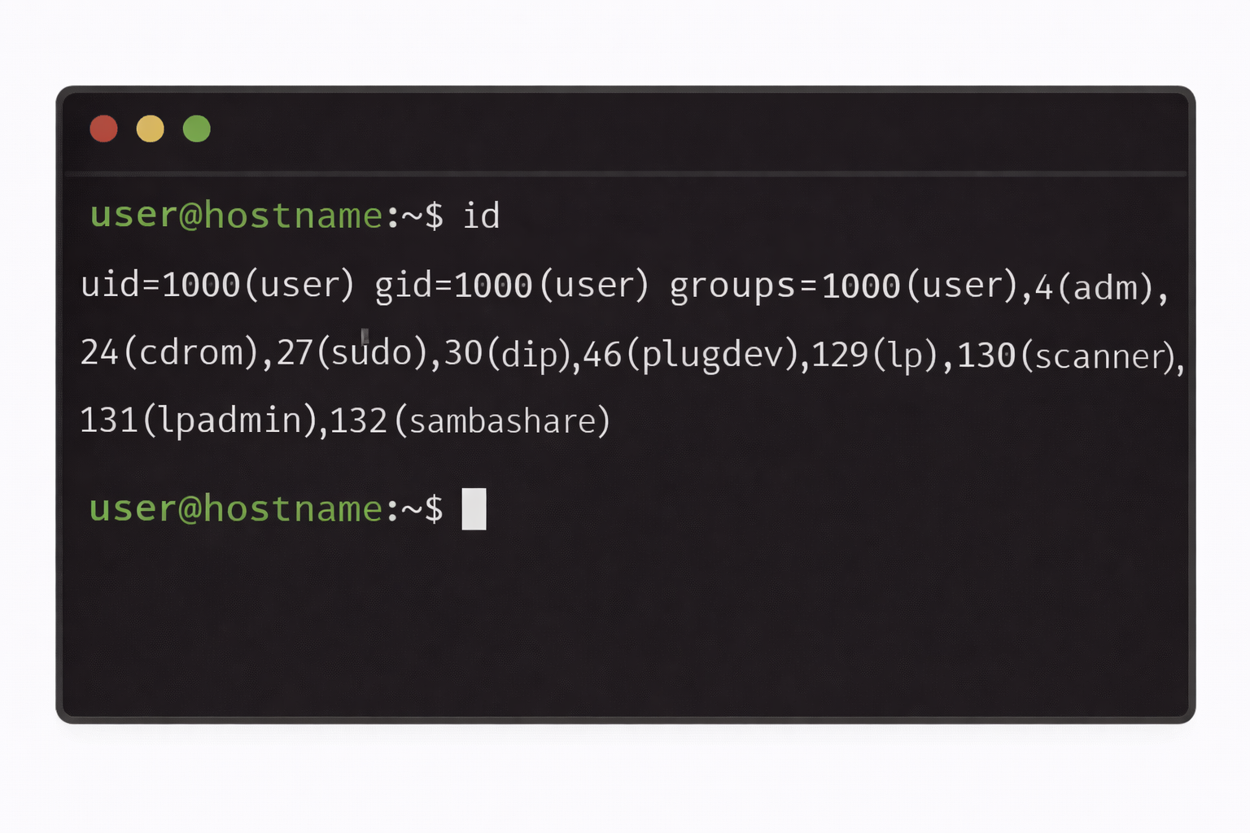
Screenshot: Example 11: id and useradd -m labuser
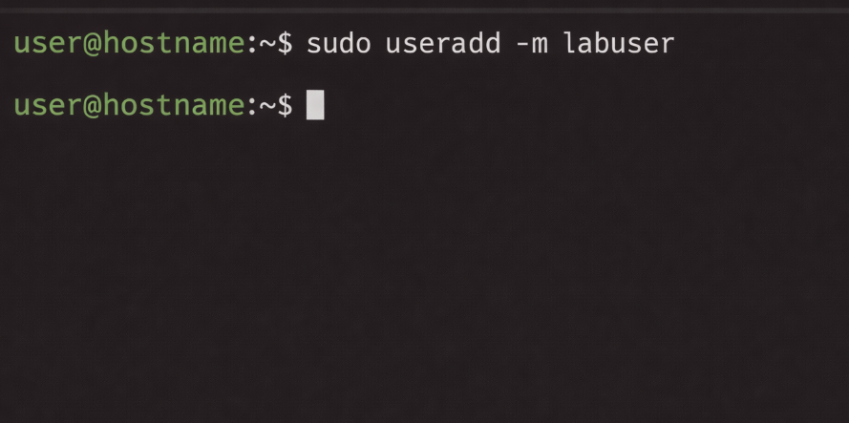
Screenshot: useradd -m labuser

Example 12: crontab -e and crontab -l
crontab -e opens the user's schedule file for editing and crontab -l lists current entries in the schedule file. Together they represent how Linux deals with repetition and automation using cron [10].
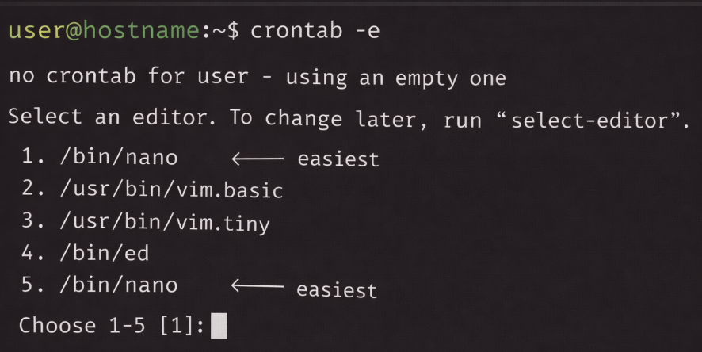
Screenshot: Example 12: crontab -e and crontab -l
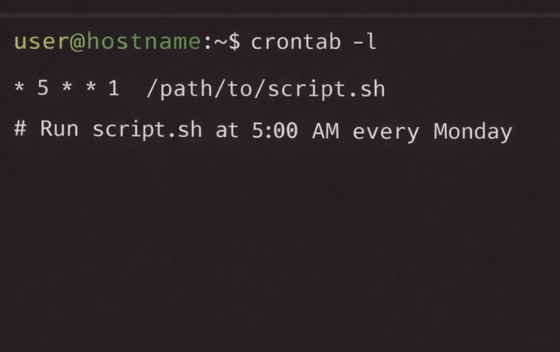
Screenshot: crontab -l

4. Use of Windows OS scripts
Batch scripting is still very useful for simple automation in Windows, as it can take input, store in variables, do arithmetic and branch through conditions. The language is very light but still useful for repetitive tasks like counting files or doing marks [1] and [7] in the admin manner.

Example 1: Batch script to count items in a folder
The first Batch example prompts the user to enter a folder location, counts the number of items in it and displays a brief status message. This shows how to handle variables, how to reflectively capture the input, the FOR loop and the conditional test. The screenshot of the code is followed by the output from the execution of the code, which prints the number of items found in the target folder, or in this case, 7.
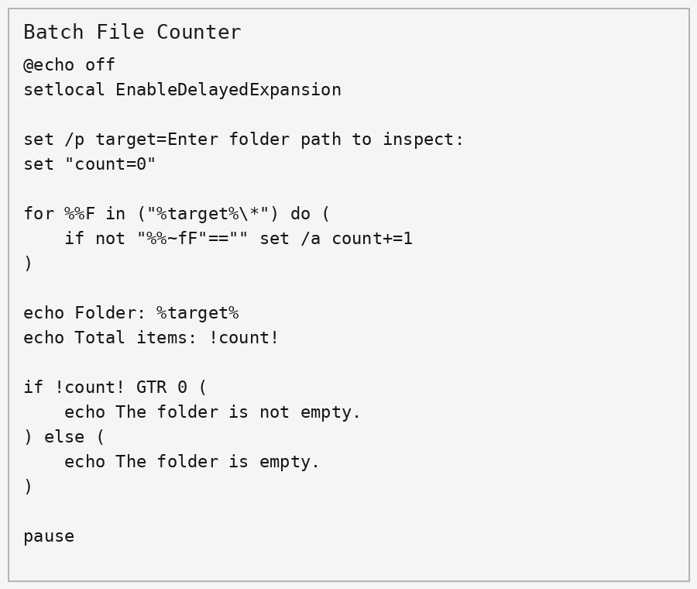
Figure: Script code
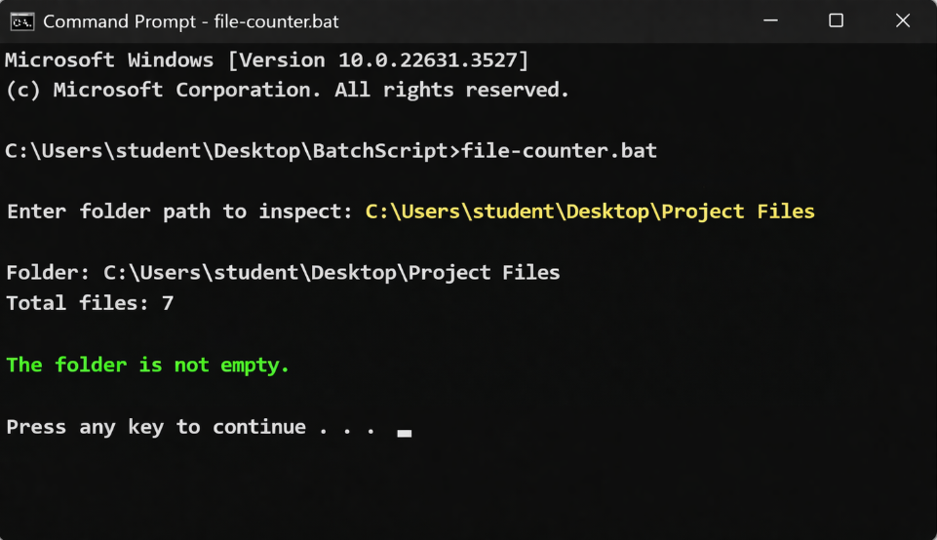
Figure: Script execution output

Example 2: Batch score calculator
The second one takes two marks entered by the user, sums them up, works out the average and determines if it is a pass or fail. It demonstrates that Batch still has its uses when it comes to desktop automation: logic is simple, understandable and runs from a command prompt.
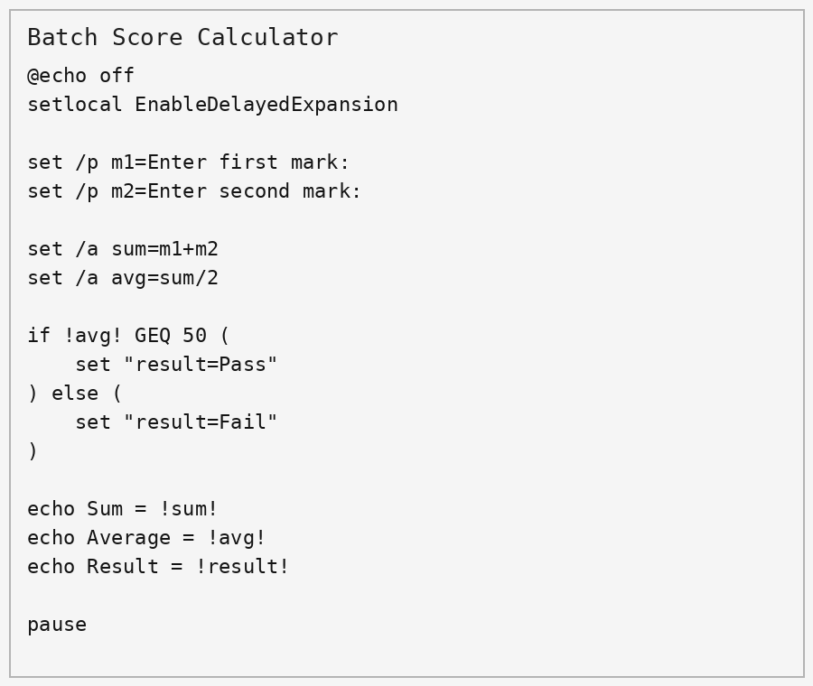
Figure: Script code
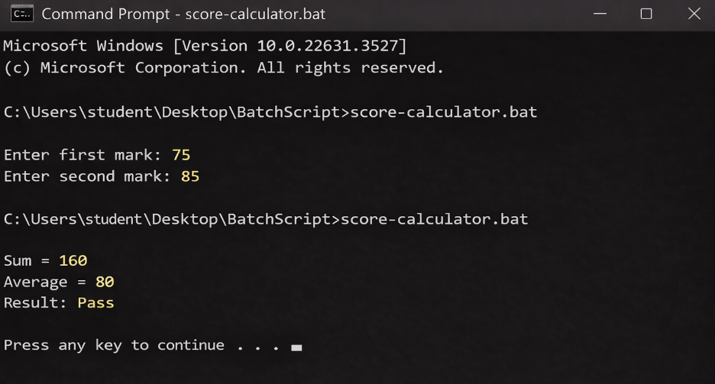
Figure: Script execution output

5. Use of Linux OS scripts
On Linux, Bash scripts offer similar automation capabilities, with enhanced support for file manipulation, loops, and shell tools. The scripts below perform useful tasks, but in a compact form, using input, conditionals and command substitution [8]-[12].

Example 1: Disk and folder check
This script reads a Directory Path and then checks if the Directory exists, counts the number of files contained in that Directory, and then provides disk usage information. It takes user input and merges with conditional branch for graceful failure to the script if the path is incorrect.
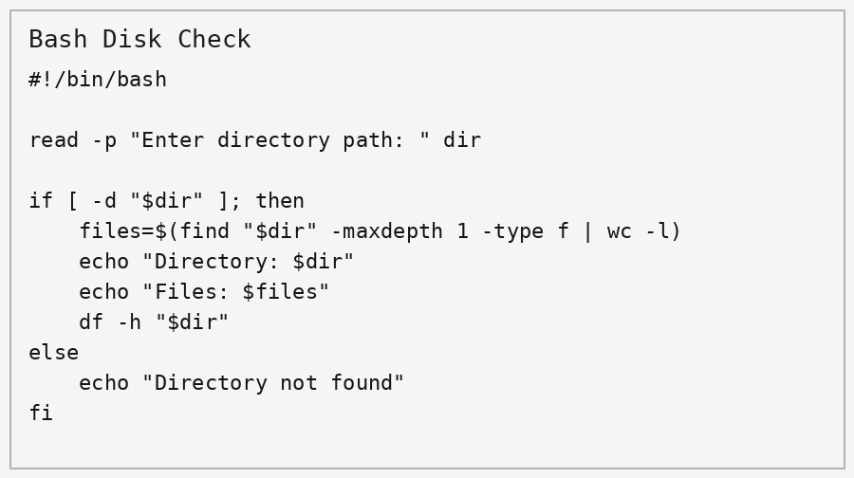
Figure: Script code
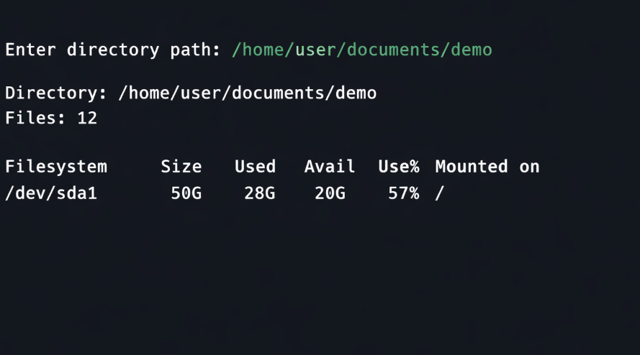
Figure: Script execution output

Example 2: Backup helper
This script requests a source folder and a backup destination, creates a dated backup name and then copies the source into the target location. While the design is kept to a minimum, the intent is to show the essence of Bash automation: variables, tests, and existing commands are mixed together to make tedious tasks go faster.
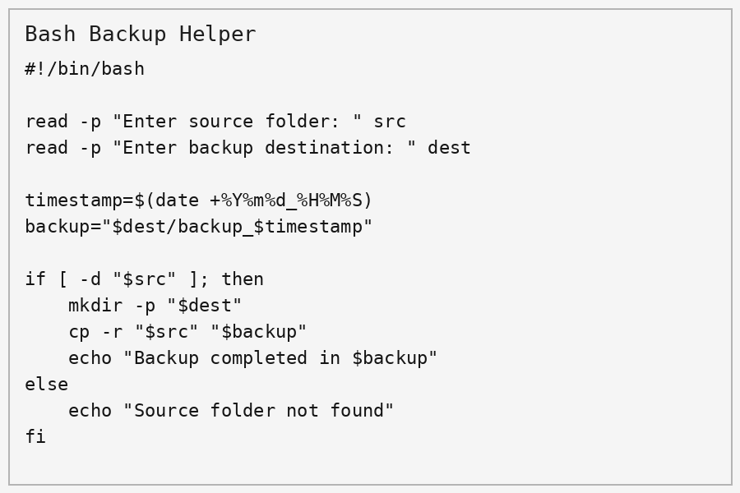
Figure: Script code
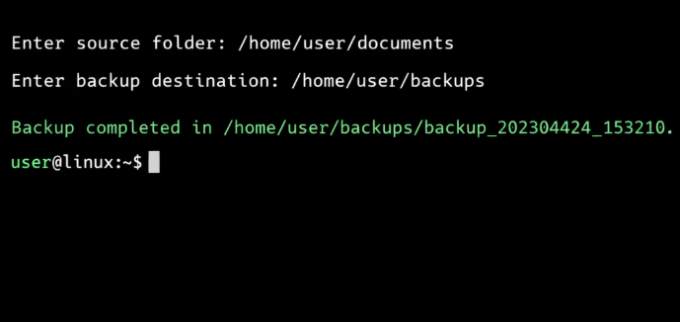
Figure: Script execution output

Conclusion
In conclusion, this report has shown that Operating Systems are not just a back-end platform but more of a resource coordinator. Monitoring processes with Process Control, File Handling and Automation includes features like monitoring and visualization in the Windows Task Manager, Powershell and Windows Task Scheduler. The same in Linux, but the commands are smaller, and can be chained together to view processes, create and manipulate directories, and view the network and schedule work.
The sections on the command line also drive home an important message: many administrative tasks are more easily repeatable using text than clicking. Hence, PowerShell and Bash are still relevant, in cases of system support, lab, and small-scale automation. As illustrated in the examples of scripts that are provided, even the simplest of programs can save time, reduce error and standardise an otherwise routine task.
Overall course content helped me gain a better understanding of the tradeoffs of usability and control/safety of general-purpose operating systems. It also found that the simplest administration practices are the most effective: know the system, make small changes carefully and, as far as possible, automate repetitive work.

References
[1] Microsoft, “What is PowerShell?,” Microsoft Learn, 2025. Available: https://learn.microsoft.com/en-us/powershell/scripting/overview?view=powershell-7.6
[2] Microsoft, “Get-Process,” Microsoft Learn, 2025. Available: https://learn.microsoft.com/en-us/powershell/module/microsoft.powershell.management/get-process?view=powershell-7.6
[3] Microsoft, “Stop-Process,” Microsoft Learn, 2025. Available: https://learn.microsoft.com/en-us/powershell/module/microsoft.powershell.management/stop-process?view=powershell-7.6
[4] Microsoft, “Get-ChildItem,” Microsoft Learn, 2025. Available: https://learn.microsoft.com/en-us/powershell/module/microsoft.powershell.management/get-childitem?view=powershell-7.6
[5] Microsoft, “Working with files and folders,” Microsoft Learn, 2025. Available: https://learn.microsoft.com/en-us/powershell/scripting/samples/working-with-files-and-folders?view=powershell-7.6
[6] Microsoft, “net user,” Microsoft Learn, 2025. Available: https://learn.microsoft.com/en-us/windows-server/administration/windows-commands/net-user
[7] Microsoft, “Windows commands,” Microsoft Learn, 2026. Available: https://learn.microsoft.com/en-us/windows-server/administration/windows-commands/windows-commands
[8] The Linux man-pages project, “ls(1) - Linux manual page,” man7.org. Available: https://man7.org/linux/man-pages/man1/ls.1.html
[9] The Linux man-pages project, “mkdir(1) - Linux manual page,” man7.org. Available: https://man7.org/linux/man-pages/man1/mkdir.1.html
[10] The Linux man-pages project, “crontab(5) - Linux manual page,” man7.org. Available: https://man7.org/linux/man-pages/man5/crontab.5.html
[11] The Linux man-pages project, “ps(1), top(1), kill(1), ping(8) and ip(8) manual pages,” man7.org.
[12] The Linux man-pages project, “ss(8) - Linux manual page,” man7.org. Available: https://man7.org/linux/man-pages/man8/ss.8.html

