Advanced Cyber Security ACCB6000
university of wales trinity saint david | London
Advanced cyber Security Assessment feb 2026
Catalin Dragomir - 2327893
2026
Contents
Introduction 2
TASK 1 : Network Test 3
TASK 2 : Network Security Assessment For SWANSEA ACCA Network 5
Setup Security Focused Operating System 5
Vulnerability Assessment 6
TASK 3 : Ethically Hacking SWANSEA ACCA Network 8
Exploitation 8
Post-Exploitation 10
TASK 4 : Network Security measures for SWANSEA ACCA Network 11
Preventive Measures Implemented 11
Conclusion 13
References 13

Introduction
This report presented a practical cybersecurity assessment of the SWANSEA.ACCA network used by SOAC Inc, which operated across two locations, Swansea and London. The network included a Windows Server 2022 Domain Controller in Swansea, along with multiple client systems connected through an Active Directory environment. Both locations were linked using a site-to-site VPN, which allowed communication between the networks and supported domain operations across different systems.
The work focused on understanding both defensive and offensive aspects of cybersecurity. From a defensive point of view, the network was analysed to identify potential risks, misconfigurations, and weak points that could affect security. At the same time, an offensive perspective was considered by testing how these weaknesses could be exploited in a controlled and ethical way. This approach was commonly used in real-world environments to improve system security and reduce the risk of cyber attacks . [1]
During the assessment, different tools and techniques were used to analyse the network and evaluate its security level. Network configuration and connectivity were first verified to ensure that all systems were correctly communicating. After that, vulnerability scanning tools such as Nmap and Nessus were used to identify open ports, running services, and possible vulnerabilities within the infrastructure. These tools were widely used in cybersecurity to gather information and detect weaknesses in systems . [2]
The process also involved ethical hacking techniques, where selected vulnerabilities were tested to understand how an attacker could gain access to the network. This helped in evaluating the real impact of the identified issues and showed how small misconfigurations could lead to serious security problems if not addressed. In addition, different security measures were applied to improve the overall protection of the network, including system hardening, access control, and traffic monitoring.
Overall, the assessment provided a better understanding of how enterprise networks operate and how they can be secured using both technical tools and structured methodologies such as those provided by National Institute of Standards and Technology. It also showed the importance of continuous testing and monitoring in order to maintain a secure and stable network environment. [3]

TASK 1 : Network Test
The first step of the assessment focused on testing the network connectivity between all virtual machines in the SWANSEA.ACCA environment. This step was necessary to confirm that all systems were correctly configured and able to communicate before performing any security testing. In real-world scenarios, network validation is important because vulnerability scanning tools depend on proper connectivity to provide accurate results . [4]
The virtual machines were imported into the virtualization platform and powered on successfully. After that, command line tools were used on both Windows and Linux systems to verify the network configuration and test connectivity between the Swansea and London locations.
On the S-DC server, the command IPCONFIG was executed to display detailed network configuration. The output confirmed that the IP address, subnet mask, and default gateway matched the expected topology. This showed that the Domain Controller was correctly configured within the Swansea network. After verifying the configuration, multiple ping tests were performed to check communication with other systems. [5]
The first test was pinging 192.168.1.10, which returned successful replies. This confirmed that communication within the Swansea network was working correctly. The next test was ping 192.168.2.1, which was used to verify connectivity with the London network through the VPN. The result was successful, indicating that the VPN connection between the two sites was active. Finally, the command ping 192.168.2.10 was executed, and it also returned successful results. This confirmed that full communication between both locations was established. The results of these tests are shown in Fig. 1.
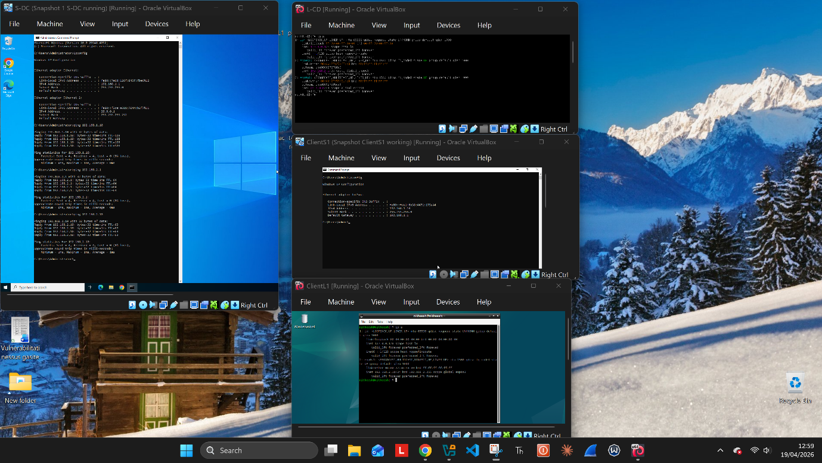
On the L-CD server, similar tests were performed using Linux commands. The command ip address was used to verify the network configuration. The output showed that the IP address was correctly assigned according to the London network settings. After this, ping tests were performed to check communication with both local and remote systems. [6]
The command ping 192.168.1.10 was executed to test connectivity with the Swansea server, and the result was successful. This confirmed that the VPN allowed communication from London to Swansea. The next test was ping 192.168.1.1, which verified that the gateway connection was working properly. Finally, the command ping 192.168.2.10 was executed, and the successful response confirmed internal communication within the London network. These results are presented in Fig. 2.
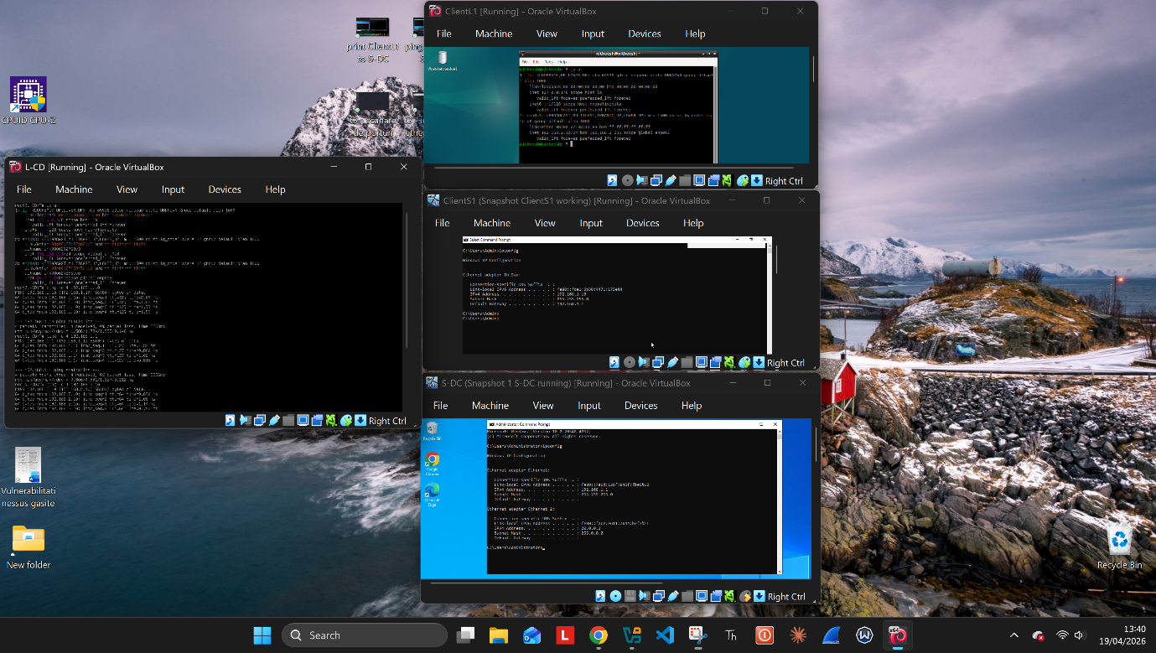
All connectivity tests were successful, and no packet loss was observed during testing. This indicated that the network was correctly configured and ready for further security analysis. Ensuring stable communication between systems was an important step, as it allowed accurate vulnerability scanning and reduced the risk of false results . [7]

TASK 2 : Network Security Assessment For SWANSEA ACCA Network

Setup Security Focused Operating System
Kali Linux was added to the network as a security-focused operating system to simulate an attacker perspective and assess the security of the SWANSEA.ACCA network. A static IP address of 20.0.0.100 was assigned to the Kali system, placing it within the external network segment. After configuring the network interface, connectivity tests were performed to confirm that Kali could reach both Swansea and London network segments. All ping tests to the servers and clients were successful, confirming that the system had full access to the internal network. The results are shown in Fig. 3.
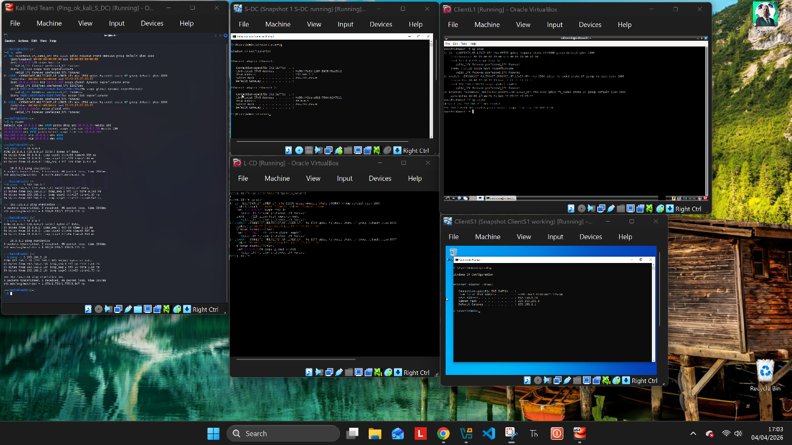

Vulnerability Assessment
Following the vulnerability scanning process, multiple security issues were identified across the SWANSEA.ACCA network. These vulnerabilities were analysed and classified based on their severity level, using a standard risk-based approach. A total of five vulnerabilities were selected for further discussion, including one high severity, two medium severity, and two low severity issues. Fig 4.
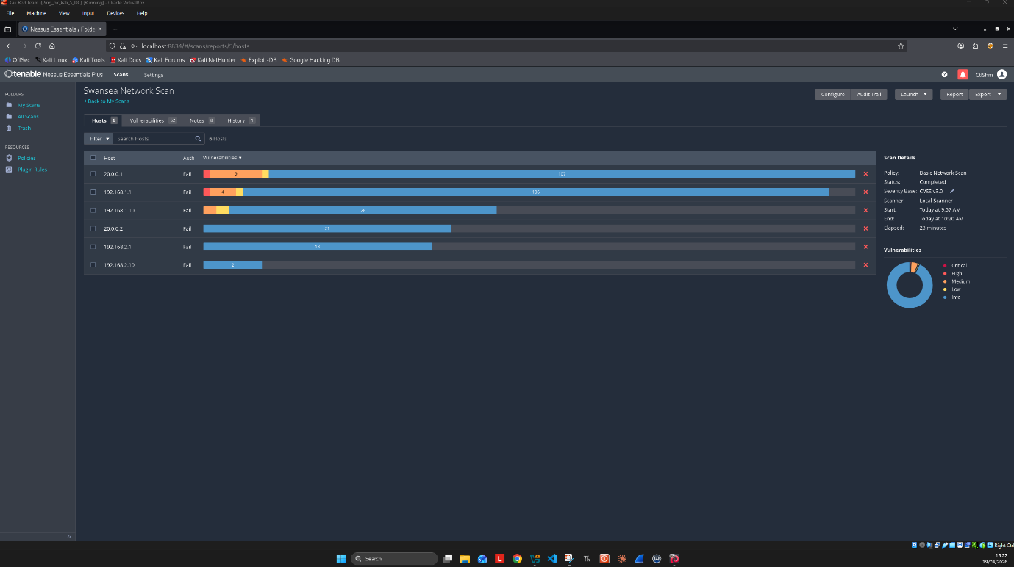

High Severity Vulnerabilities
A high severity vulnerability was identified as IP Forwarding Enabled on the host 20.0.0.1. This meant that the server was configured to forward network traffic between different segments without proper security controls in place. An attacker could take advantage of this misconfiguration to route traffic through the server and gain access to restricted areas of the network. This represented a significant risk as it increased the attack surface and could allow lateral movement between the Swansea and London networks.
Medium Severity Vulnerabilities
One of the medium severity issue identified was related to SMB configuration. The issue "SMB Signing not required" was detected on the host 192.168.1.10. This vulnerability allowed attackers to perform Man-in-the-Middle attacks, specifically SMB relay attacks. In such scenarios, an attacker could intercept authentication traffic and execute commands without needing valid credentials. This represented a serious risk to the network, especially because it affected domain-level systems . [8]
A medium severity issue was identified as "TLS v1.0 / v1.1 Detection" on the host 192.168.1.1. These protocols were considered outdated and insecure. Attackers could exploit weaknesses in older encryption standards to decrypt sensitive data such as login credentials or communication traffic. Even though encryption was present, the use of weak protocols reduced the overall security level . [9]
Low Severity Vulnerabilities
One of the low severity issues identified was "ICMP Timestamp Request", which affected multiple systems in the network. This vulnerability allowed attackers to obtain the system time from a remote machine. While this might seem minor, it could be used in more advanced attacks, such as predicting TCP sequence numbers.
Another low severity vulnerability was "Chargen UDP Service DoS" on the host 20.0.0.1. This was an outdated service that could be exploited in reflection-based Denial of Service attacks. Although it did not directly compromise the system, it could be used to generate large amounts of traffic and disrupt network availability . [10]

TASK 3 : Ethically Hacking SWANSEA ACCA Network

Exploitation
After completing the vulnerability assessment, an attempt was made to exploit the identified weaknesses in the SWANSEA.ACCA network. The process started with testing a well-known vulnerability related to SMB services, specifically using an EternalBlue-based approach.
The initial step involved scanning the target system to check for SMB-related vulnerabilities. A script-based scan was executed to identify if the system was vulnerable to SMB exploits. The results showed that the SMB port was open, but the system did not appear to be directly vulnerable to the EternalBlue exploit. This indicated that either the system was patched or additional protections were in place. The results of this attempt are shown in Fig. 5.
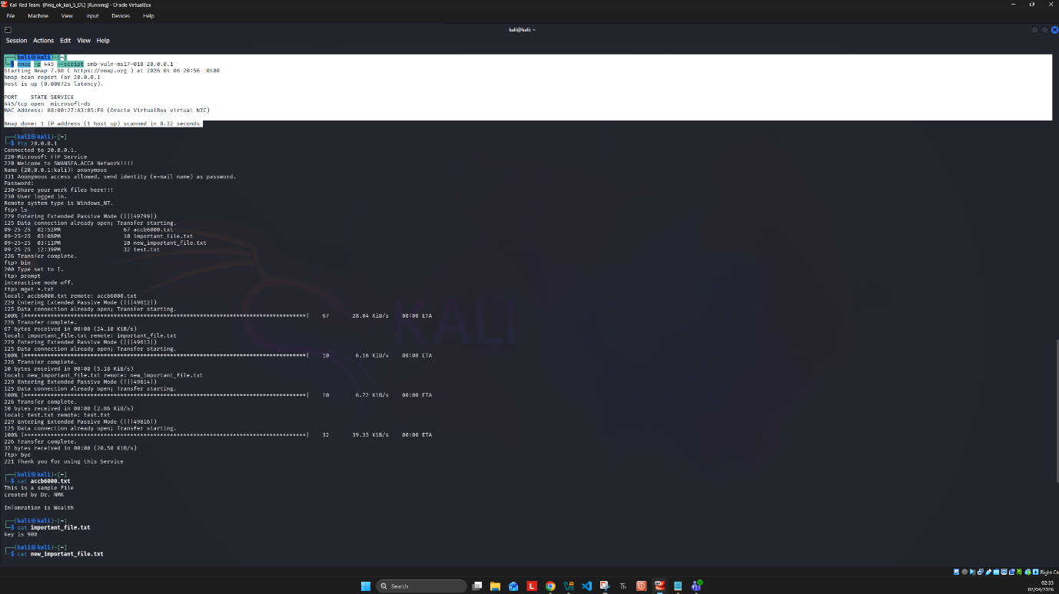
Since the initial exploitation attempt was not successful, the approach was changed to further reconnaissance. A full port scan was performed using network scanning tools in order to identify other available services. The scan revealed multiple open ports, including port 21 (FTP), which was identified as a potential entry point. These results are presented in Fig. 6.
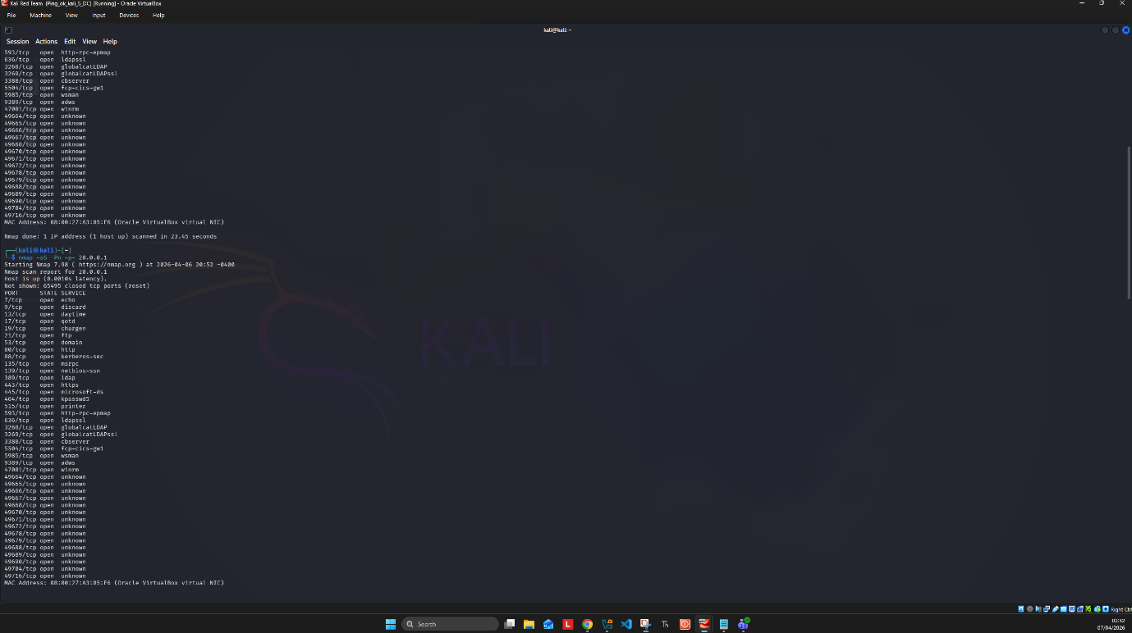
After identifying the FTP service, a connection was established using anonymous login. The server allowed access without requiring authentication, which represented a serious security misconfiguration. Once connected, the directory structure was explored, and multiple files were discovered on the system.
During this stage, several files were successfully downloaded from the target system. The extracted files included sample data and text files containing information such as keys and internal messages. This demonstrated that sensitive data could be accessed without proper authorization. The process of accessing and downloading these files is shown in Fig. 7 and Fig. 8. [11]
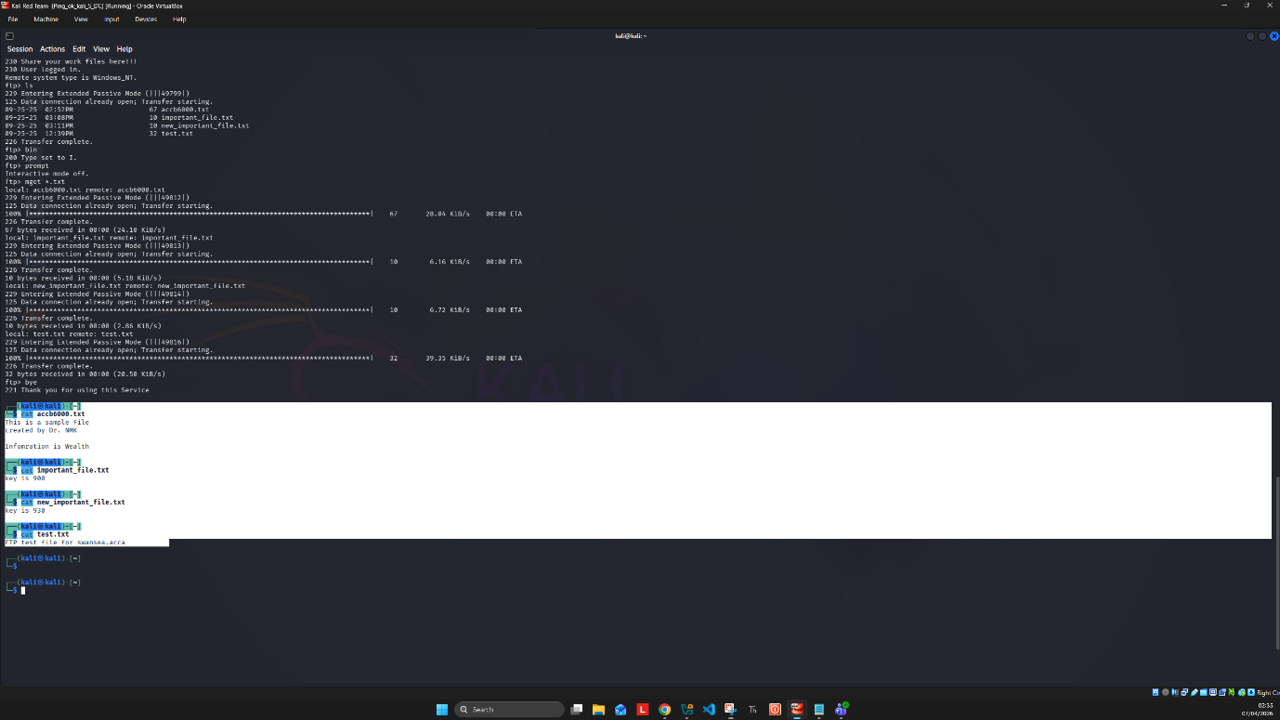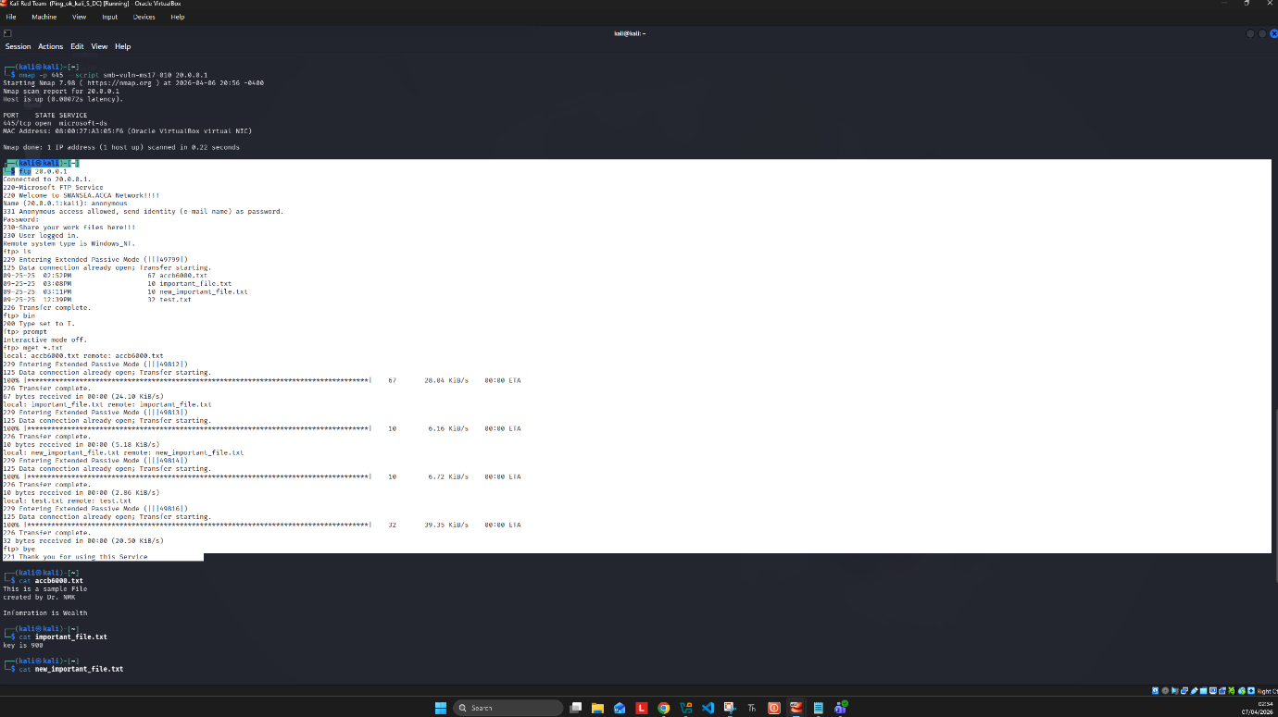
This exploitation scenario showed that even when high-level vulnerabilities such as SMB exploits were not successful, attackers could still gain access through weaker services such as FTP. The presence of anonymous login significantly increased the risk, as it allowed unauthorized users to access internal data without any credentials.

Post-Exploitation
After gaining access to the FTP service, the next step was to analyse the level of access and the potential impact on the network. The successful download of files confirmed that the attacker could access internal data without authentication. This showed that sensitive information could be exposed and used for further attacks.
Although full system control was not achieved, the access obtained was enough to demonstrate a partial compromise. The attacker could continue exploring available directories, collect useful data, or attempt to upload malicious files to the system. This type of access could also be used to identify additional vulnerabilities.
In a real-world scenario, an attacker would use this initial access to move laterally across the network or combine it with other weaknesses to gain deeper control. These actions are known as post-exploitation techniques and are commonly used after initial access is obtained . [12]

TASK 4 : Network Security measures for SWANSEA ACCA Network

Preventive Measures Implemented
Based on the vulnerabilities identified during the assessment phase, several security measures were implemented in order to reduce the risk level of the SWANSEA.ACCA network. The main focus was on mitigating the FTP vulnerability, which allowed unauthorized access through port 21, as shown in Fig. 9. [13]
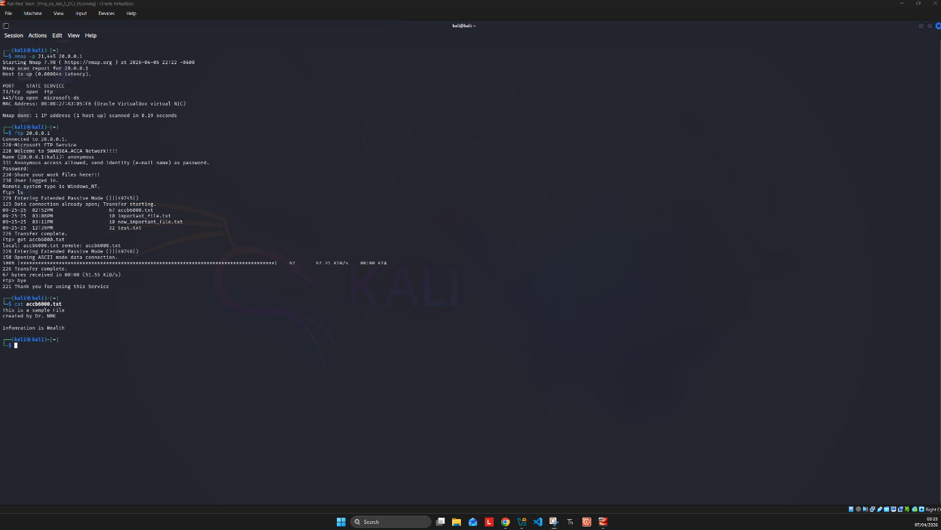
The first security measure involved restricting access to the FTP service. This was done by accessing the server configuration through IIS Manager and reviewing the FTP Authentication settings. Anonymous access was identified as the main issue, as it allowed users to connect without credentials. By disabling or restricting this authentication method, unauthorized access to the FTP service was prevented. In addition, firewall rules were reviewed using the Windows Firewall console (wf.msc), and inbound FTP rules were disabled to further limit access , shown in Fig . 10.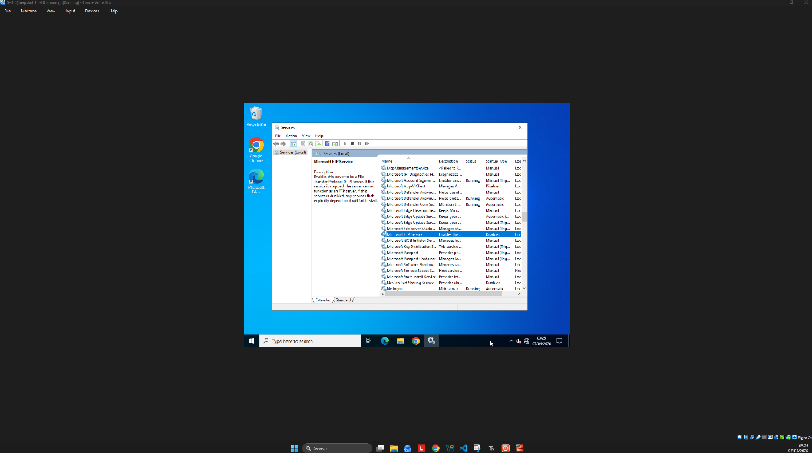
The second security measure involved completely disabling the FTP service on the server. This was done using administrative tools, such as the Services console and command prompt. [14]
This action ensured that the service was no longer running, which resulted in port 21 being closed. After applying this measure, a new scan was performed from the attacker machine, and the port was confirmed as closed, as shown in Fig. 11. [15]
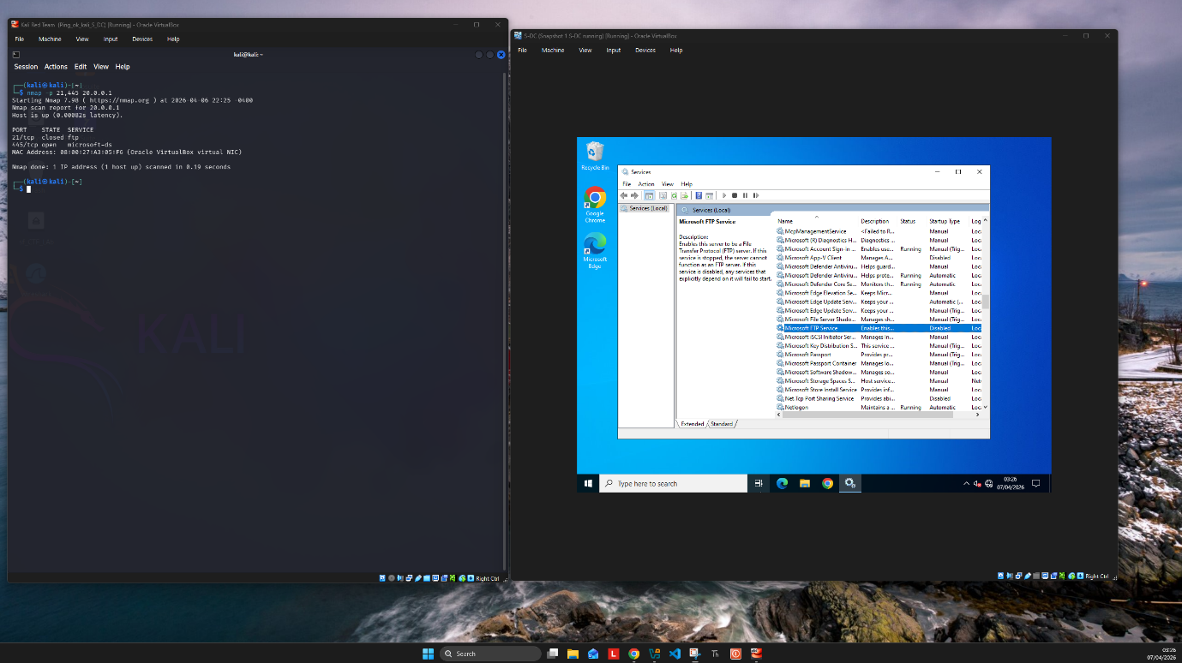
This demonstrated that the vulnerability was fully mitigated and no further FTP connections could be established.
These two steps showed a layered approach to security. First, access to the service was restricted, and second, the service itself was disabled. This reduced the attack surface and eliminated the risk associated with the vulnerable FTP configuration. Such practices are considered essential in system hardening and are commonly recommended in secure network environments .
In addition, network traffic monitoring was configured using Wireshark on the attacker machine to log and analyse suspicious activity across the network. Traffic was captured on the active network interface and filtered to identify unusual patterns, unauthorised connections, and potential attacks. This provided an additional layer of visibility into the network and supported the overall security assessment process.

Conclusion
This assessment provided a practical understanding of how network security vulnerabilities can be identified, tested, and mitigated in a real environment. The initial network testing confirmed that all systems were properly connected, allowing further analysis to be carried out. The vulnerability assessment phase revealed several security weaknesses, including misconfigured services and outdated protocols. During the ethical hacking stage, it was demonstrated that even when some attacks failed, alternative methods could still be used to gain access, such as exploiting the FTP service. Finally, security measures were successfully applied to reduce the attack surface and prevent unauthorized access. Overall, the assessment showed the importance of combining testing, analysis, and mitigation in order to maintain a secure and reliable network environment.

References

[1] | nmap.org, Nmap Network Scanning.
[2] | Nmap.org, “Official Nmap Project Guide to Network Discovery and Security Scanning”.
[3] | NIST, “The NIST Cybersecurity Framework 2.0,” 26 02 2024. [Online]. Available: https://nvlpubs.nist.gov/nistpubs/CSWP/NIST.CSWP.29.pdf.
[4] | Cisco, “Configure IP Addresses and Unique Subnets for New Users,” 07 07 2023. [Online]. Available: https://www.cisco.com/c/en/us/support/docs/ip/routing-information-protocol-rip/13788-3.html.
[5] | Microsoft, “Ipconfig,” 02 06 2026. [Online]. Available: https://learn.microsoft.com/en-us/windows-server/administration/windows-commands/ipconfig.
[6] | “ip-address(8) — Linux manual page,” [Online]. Available: https://man7.org/linux/man-pages/man8/ip-address.8.html.
[7] | TechTarget, “What is ping and how does it work?,” 14 05 2025. [Online]. Available: https://www.techtarget.com/searchnetworking/definition/ping.
[8] | Microsoft, “SMB security enhancements,” [Online]. Available: https://learn.microsoft.com/en-us/windows-server/storage/file-server/smb-security.
[9] | Microsoft, “Update: Azure support for TLS 1.0 and TLS 1.1,” [Online]. Available: https://learn.microsoft.com/en-us/lifecycle/announcements/tls-support-ending-10-31-2024.
[10] | Cloudfare, “What is a DDoS attack?,” [Online]. Available: https://www.cloudflare.com/learning/ddos/what-is-a-ddos-attack/.
[11] | Varonis, “What is Metasploit? The Beginner's Guide,” 24 02 2024. [Online]. Available: https://www.varonis.com/blog/what-is-metasploit.
[12] | R. Docs, “About Post Exploitation,” [Online]. Available: https://docs.rapid7.com/metasploit/about-post-exploitation/.
[13] | N. C. S. Centre, “External attack surface management,” [Online]. Available: https://www.ncsc.gov.uk/guidance/external-attack-surface-management-buyers-guide.
[14] | M. B. 2026, “Guidance on disabling system services on Windows Server 2016 with Desktop Experience,” [Online]. Available: https://learn.microsoft.com/en-us/windows-server/security/windows-services/security-guidelines-for-disabling-system-services-in-windows-server.
[15] | N. C. S. Centre, “Vulnerability management,” [Online]. Available: https://www.ncsc.gov.uk/collection/vulnerability-management/guidance.

