Henry Rennison (2218326)
(ACDA6001)
Electronics II

Contents
Abstract 2
Introduction 3
Background and Literature Review 4
Braun Multiplier 4
Design and Implementation of Braun 4
Hardware Implementation Braun 6
Wallace Tree Multiplier 9
Design and Implementation of Wallace 11
Hardware implementation Wallace Tree 13
Results/ Comparison 16
Conclusion 18
Future Recommendations 18
Bibliography 19
Appendix 20
Other test examples for Braun 20
Wallace tree Extra tests 21
Braun Multiplier VHDL Code 22
Wallace Tree VHDL Code 36

Figure 1 Braun Sketch 5
Figure 2 Braun RTL Diagram 5
Figure 3Braun Simulation test 6
Figure 4 hex calculator 7
Figure 5 Braun device allocation 8
Figure 6 Braun Implementation diagram 8
Figure 7Braun Pin Allocation 9
Figure 8 Braun FPGA 10
Figure 9 Wallace RTL 11
Figure 10 Wallace Hex test 12
Figure 11Hex calculator result for Wallace 12
Figure 12 Wallace Device allocation 13
Figure 13Wallace implementation image 14
Figure 14Wallace Pin allocation 14
Figure 15FPGA Board Wallace 15
Figure 16Wallace Timing summary 16
Figure 17Braun Timing summary 16
Figure 18 Wallace space allocation 16
Figure 19Braun space allocation 16
Figure 20Braun Power summary 17
Figure 21Wallace tree power summary 17

Abstract
This report presents a comparative study of two 8x8 digital multiplier architectures—Braun and Wallace Tree—implemented using VHDL in Vivado. Both multipliers were designed, simulated, and deployed on an FPGA to assess their performance in terms of speed, area utilization, power consumption, and implementation complexity. signed numbers, and conducting real-time power analysis on physical FPGA hardware.

Introduction

This assignment will compare and discuss the differences between two digital multipliers Braun and Wallace tree using VHDL in Vivado. A digital multiplier is a digital circuit or system that is designed to multiply two binary inputs. There are different types of multipliers depending on the design goals. There is Combinational Multipliers (Wallace), Sequential Multipliers, Booths Multipliers and shift and add multipliers. [1] The models will be created in an 8x8 format and all code will be included in the assignment. The performance of both of the multipliers will then be compared for the efficiency of them, the speed in which they run, the amount space/ resources used and complexity of design to implementation. The Multipliers will be tested in Vivado and will also be applied and tested on an FPGA.

Background and Literature Review

Braun Multiplier
A Braun multiplier is an example of a combinational digital multiplier, it uses AND gates and adders to work out the product of two unsigned binary numbers. It works by generating partial products using the AND gates for each bit of two unsigned binary numbers being multiplied. Then each row of the partial products corresponds to one bit of the multiplier and is shifted according to its position. These products are then added together using a series of adders arranged in a regular pattern. The final result is the sum of all the partial numbers. [2]
The Braun multiplier has a relatively simple and regular design, which makes it much easier to lay out in hardware or to draw on a piece of software. It is also fast for small bit widths and doesn’t require a clock. Finally, it is also a very scalable multiplier and can easily made much bigger or smaller to suit the use case. [3]
Some of the draw backs to using a Braun multiplier are that it can require a lot of logic gates so is quite hardware intensive. It also cannot work with signed numbers and only allows unsigned multiplication. Can be quite slow compared to other multipliers of the same size. It is also known for having rather high-power consumption due to the large number of gates and switching. [3]

Design and Implementation of Braun

This part of the report will cover how the Braun 8x8 was created on vivado. From the initial design phase to the actual implementation on Vivado. The first step was to draw an initial design of the 8x8 Braun. As the Multiplier was an 8x8 in consists of 64 AND gates, 8 Half adders and 48 Full adders.
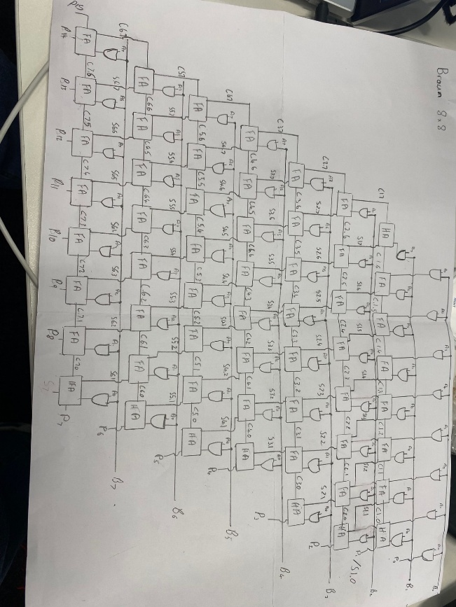
Figure 1 Braun Sketch
This design takes Two 8-bit inputs labelled A[7:0] and B[7:0] and will output a 16bit output P[15:0] which represents the product of the two inputs. The process begins with the partial products and using AND gates. Each bit of the operand A is ANDed with each bit of operand B this then results in 64 partial products. These partial products are then summed added together to form the final product. The outputs of the AND gates are arranged in a matrix structure corresponding to the bit positions forming the base of the multiplication process.
The addition of these partial products is performed by using half adders and full adders. As in the image above the first row (Bank 0) consists solely of AND gates and directly forms the least significant bit P0. From bank 1 onwards the circuit uses partial products along with the carry outputs from the previous row. Half adders are used when only two bits are added while the full adders are used to sum three inputs (two partial products and a carry-in). this design then carries on in a diagonal fashion until all partial products are accumulated and the final result is obtained.
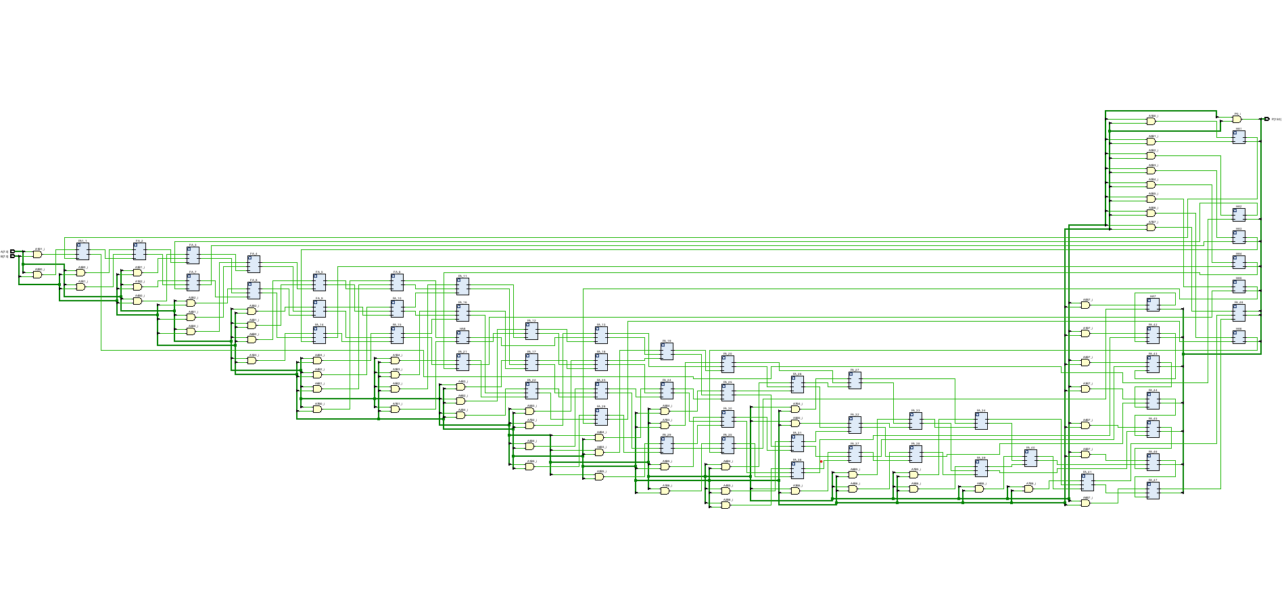
Figure 2 Braun RTL Diagram
Above is the RTL (Register Transfer Level) diagram in Vivado, it is a visual representation of a digital design described in VHDL code. It represents how the data flows between registers and logic blocks at an architectural level. It is generated after the design is input and illustrates the hierarchy of modules, signal connections, logic connections and the data paths of the design.
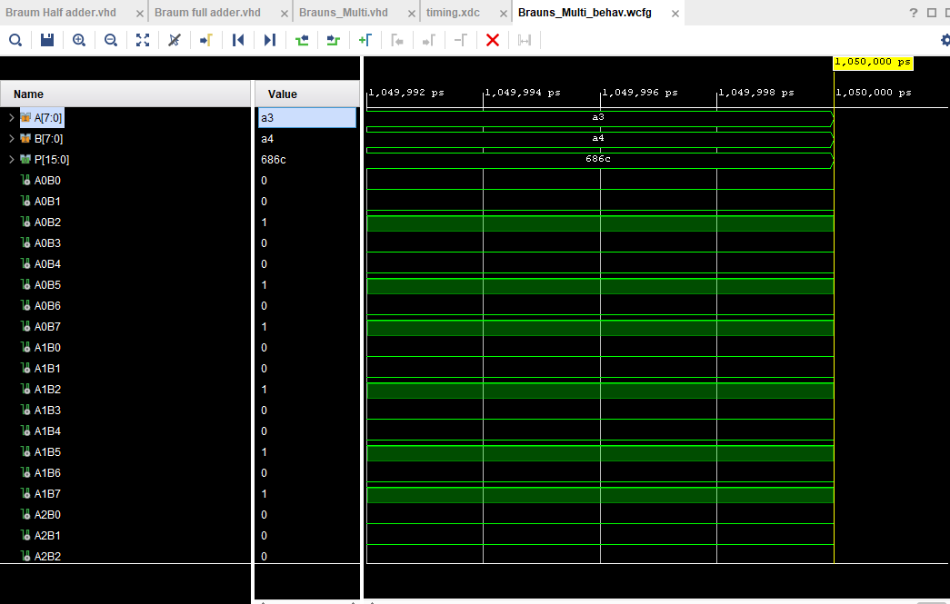
Figure 3Braun Simulation test
To ensure the design and VHDL code is correct the design was run through the behavioural simulation in Vivado. The inputs were set at a3 and a4 which output 686c. To ensure this was correct the results were tested against an online hex calculator as seen in the image below.
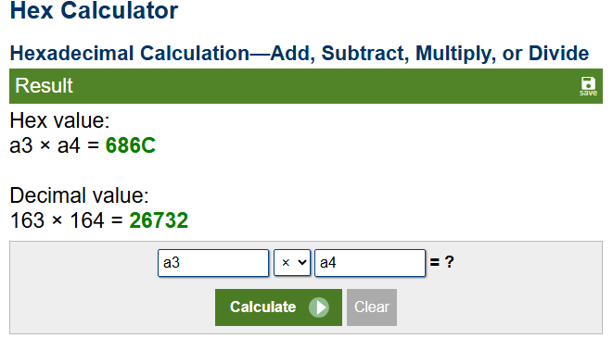
Figure 4 hex calculator

Hardware Implementation Braun

Once the Braun multiplier had been implemented on Vivado the next task was to implement the design onto an FPGA board. Vivado has an in-built Device allocation which assists in the implementation to the FPGA as seen in the image below.
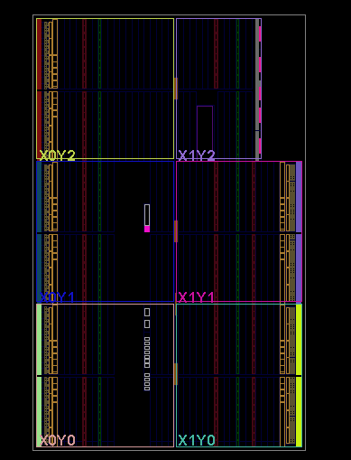
Figure 5 Braun device allocation
It also has an in-built implementation schematic which gives a detailed image of the design and shows all the necessary wiring needed to implement the design as seen in the image below:
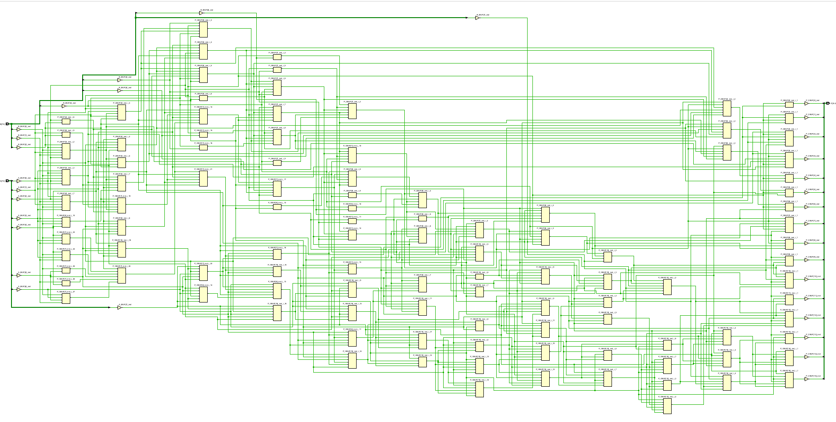
Figure 6 Braun Implementation diagram
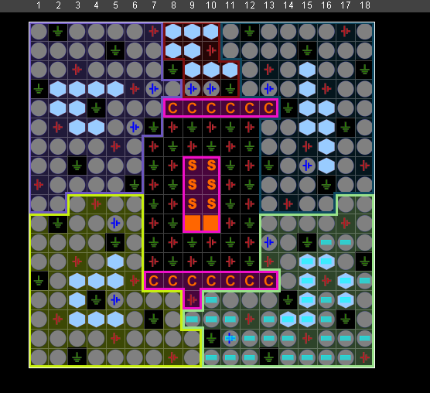
Figure 7Braun Pin Allocation

The above image is from Vivado and displays the pin allocation of the Braun multiplier design.
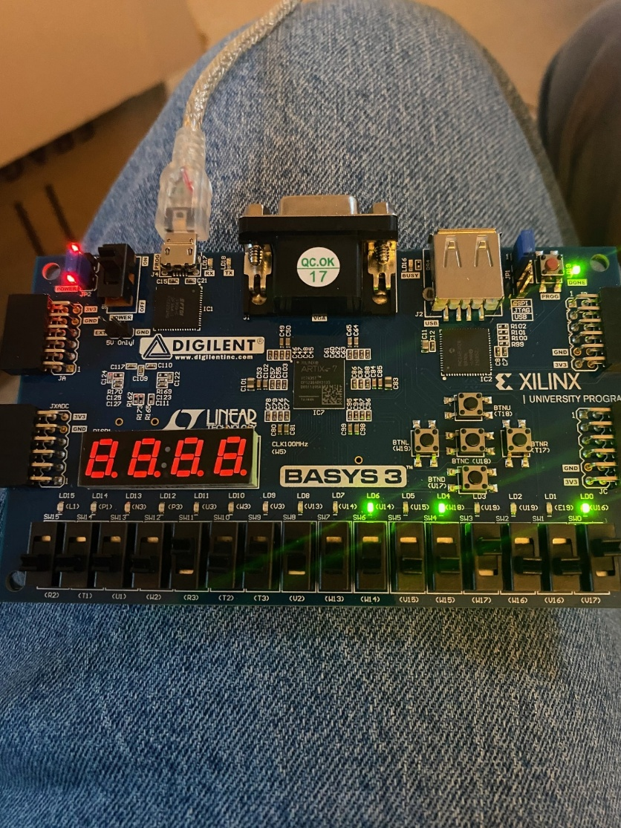
Figure 8 Braun FPGA
This image is of the FPGA connected to Vivado running the Braun multiplier, the inputs were set to 8x9 and the binary output that is displayed is 101001 when this is converted back to a decimal number the result is 81. This is the expected result for this example suggesting that it is working correctly.

Wallace Tree Multiplier
A Wallace tree multiplier is a hardware efficient multiplier for binary numbers, it does this by reducing the number sequential adding operations required to sum partial products. It works by generating all the partial products of the two binary numbers using AND gates. Instead of adding these partial products one by one it instead uses a tree-like structure of carry-save adders to reduce them in parallel and then grouping bits and adding them together at the same time. It repeats this process until there is only two rows of bits left over. These two bits are then added using an Adder to produce the final multiplication. [4]
Wallace tree multipliers are quite high speed and are generally faster than traditional array/Braun multipliers especially when dealing with larger bit widths due to the pathing that the Wallace tree uses. This in turn makes it more efficient as the size of the multiplier increases when compared to when the size of the Braun Multiplier increases. [5]
Some drawbacks to a Wallace Tree Multiplier are that it can be quite a complex design as the structure is difficult to design and optimize compared to other digital multipliers. This can make the layout very difficult when trying to replicate a design into hardware. It can use more power than some simpler designs and when using hardware can require more wiring depending on the design. [5]

Design and Implementation of Wallace

This part of the report will cover how the Wallace 8x8 was created on Vivado. From the initial design phase to the actual implementation on Vivado. The first step was to draw an initial design of the 8x8 Wallace. As the Multiplier was an 8x8 in consists of 64 AND gates, 8 Half adders and 48 Full adders.
AS with the Braun the process begins by generating 64 partial products using the AND gates for each combination of bits from the inputs A[7:0] and B[7:0]. These partial products are then organised into the matrix-based position. However, unlike Braun the partial products are calculated in layers rather than row-by-row.
The main difference is that the Wallace multiplier uses carry-save adders to reduce the number of partial product rows in each stage. It also groups the partial products into sets of three and applies full adders to each group which then generates a sum and carry output. These outputs are then shifted accordingly and fed to the next bank. If only two bits exist in a position a half adder is used, if there is only one it is fed to the next level unchanged. This process continues in a tree like structure until only two rows remain, which are then summed together to produce the final product P [15:0]
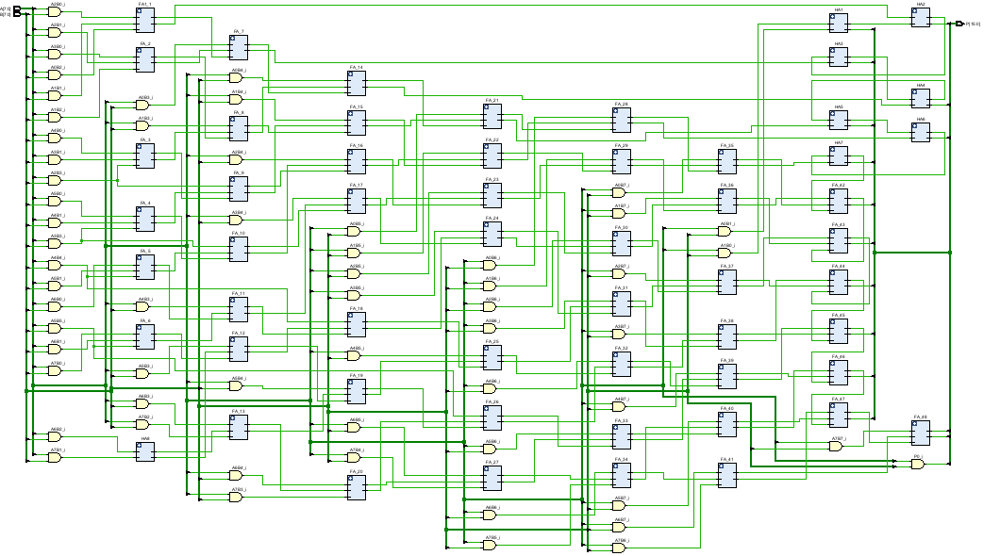
Figure 9 Wallace RTL
As with the Braun Multiplier the Wallace Tree multiplier was then imported and coded in VHDL in Vivado in order to create the above RTL diagram. It visually represents the design and shows all the connections between the Blocks and ADDERs.
The Wallace multiplier was then tested in Vivado as in the image below:
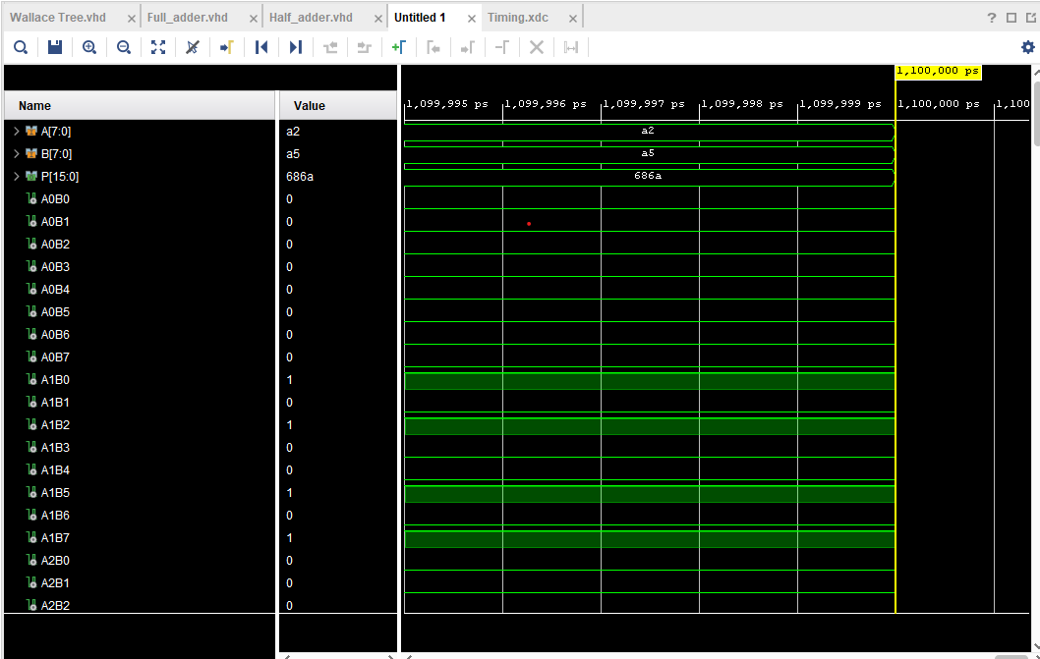
Figure 10 Wallace Hex test
For the Wallace Tree Multiplier, the inputs were set to a2 and a5 which gave an output of 686a which was also checked in an online hex calculator and showed to be the expected result.
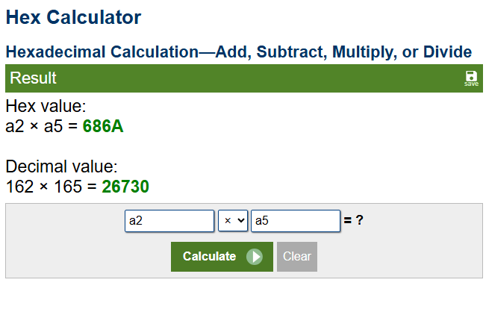
Figure 11Hex calculator result for Wallace

Hardware implementation Wallace Tree
AS with the Braun multiplier the Wallace tree was then implemented onto an FPGA board using the tools in built to Vivado This first was to create the device allocation image as in the image below:
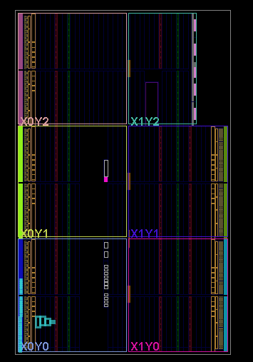
Figure 12 Wallace Device allocation
The design was then implemented on to Vivado implementation schematic to see the design and all the wired connections:
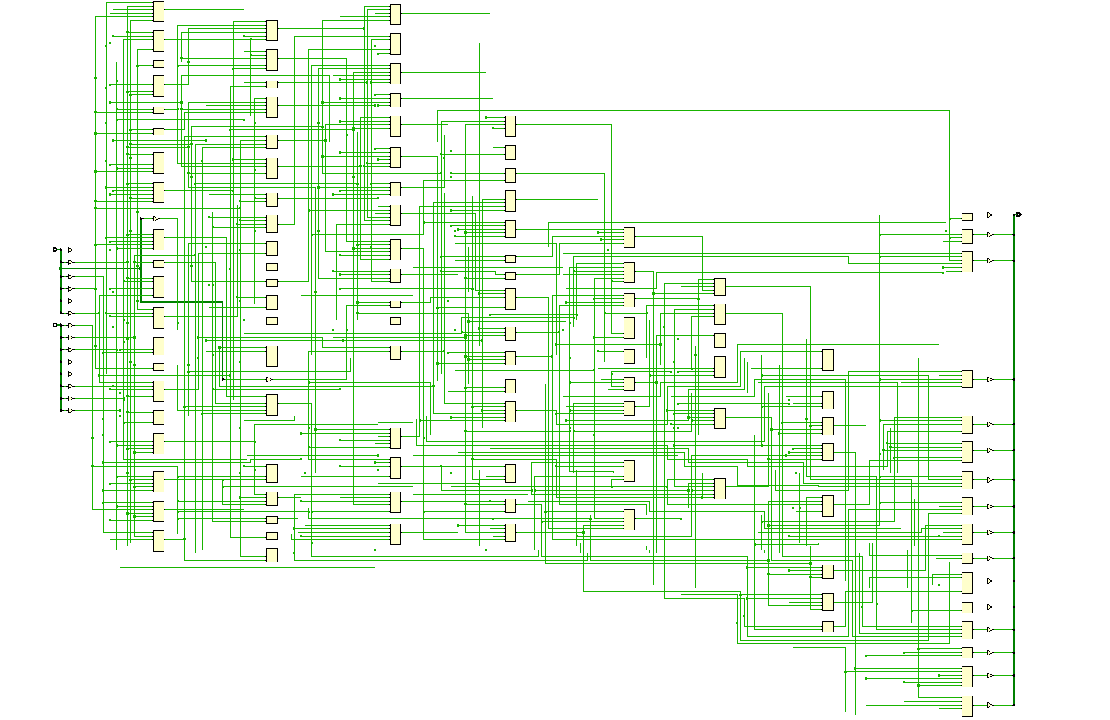
Figure 13Wallace implementation image
The final image to get from Vivado is the Pin allocation image as seen below:

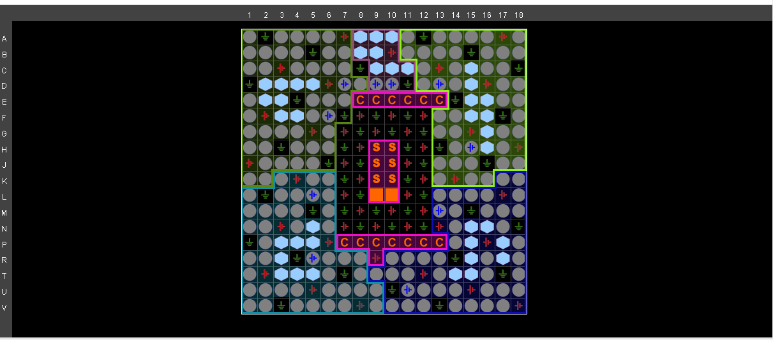
Figure 14Wallace Pin allocation
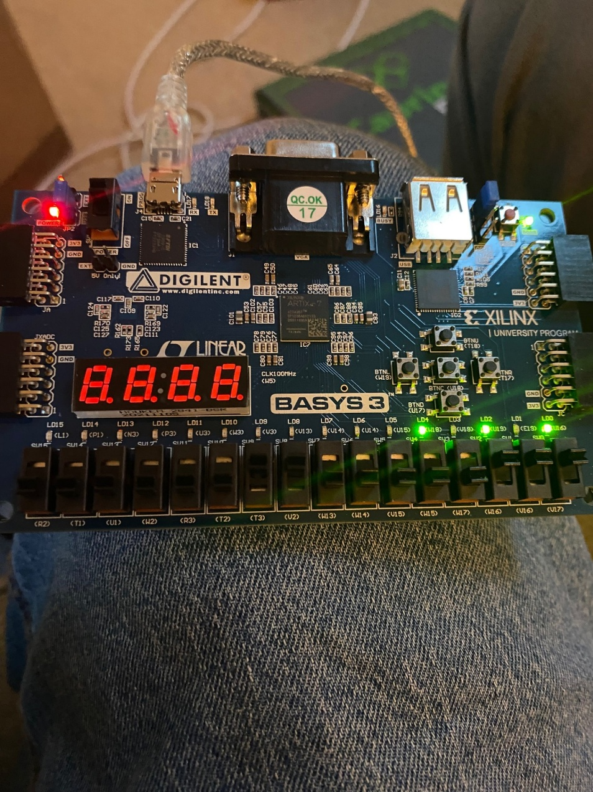
Figure 15FPGA Board Wallace
The above image is if the FPGA board connected to Vivado using the Wallace tree model. The inputs were 3x7 which output the binary number of 10101 which when converted back to decimal it comes out as 21 which is the expected result.

Results/ Comparison
This section of the report will look at both the Braun multiplier and the Wallace tree multiplier. It will then compare the results and highlight the main differences.
The first thing to look at was the speed in which both of the multipliers run the simulations to give the results, as with the design and implementation this was done using Vivado. This was done setting both the multipliers to the longest possible route that a multiplication could follow to try replicate worst case scenarios for both models. The results are in the figures below
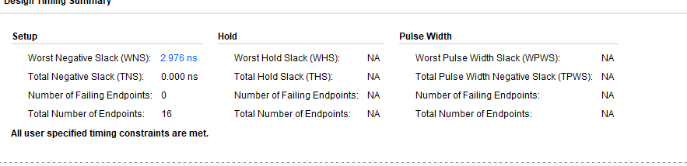
Figure 16Wallace Timing summary
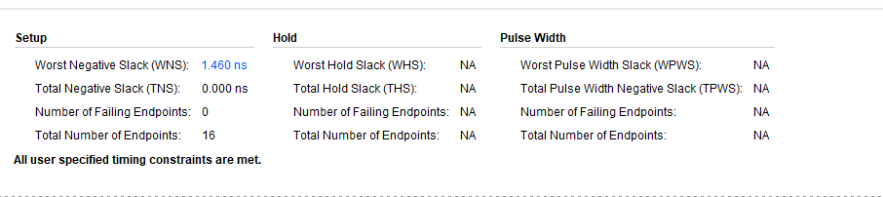
Figure 17Braun Timing summary
As seen in the images above the Wallace Timing summary shows the worst negative stack as 1.460ns and the Braun timing summary has a speed of 2.976ns. this shows that the Wallace Tree multiplier is almost half the time that the Braun multiplier takes to run.

The next thing to compare was the amount of spacing both models use to complete the simulations:

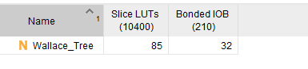
Figure 18 Wallace space allocation
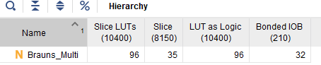
Figure 19Braun space allocation

As seen in the images above the Braun multiplier uses more space within the design in order to complete the simulations.

The next thing to compare between the two multipliers was the power consumption/usage for each simulation run:
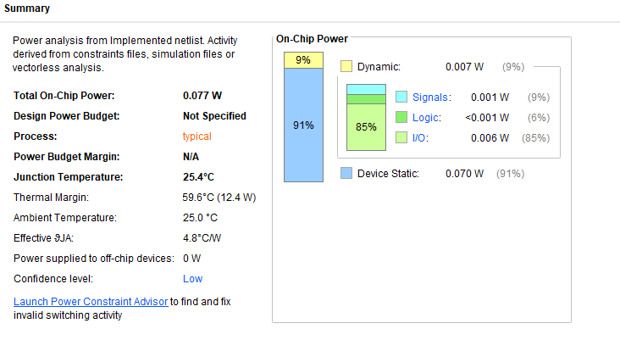
Figure 20Braun Power summary
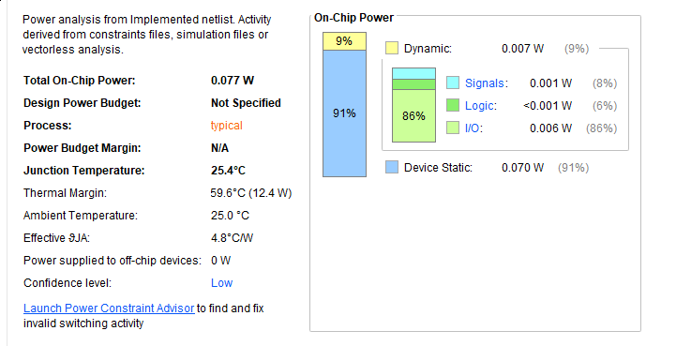
Figure 21Wallace tree power summary
In this example the Braun multiplier uses the same power as the Wallace tree however in general the Wallace tree is more efficient as it uses less steps to run each simulation. This could be due the fact this is juts a simulation on Vivado. This could be corrected if the simulation was remade and re tested possibly.

Another thing that should be considered when comparing the two multipliers is the complexity of the designs, meaning which one is easier to replicate or build from scratch. In this Category the Braun multiplier is easier to build and simulate than the Wallace tree.

Conclusion
This report presented a comprehensive comparison between Braun and Wallace Tree multipliers through design, simulation and hardware implementation using VHDL in Vivado. Both of the multipliers were designed in 8x8 configuration and tested under the same conditions to provide an even test scenario. Results show that the Wallace Tree Multiplier demonstrated far superior performance in terms of delay and overall execution speed with nearly 50% faster response time to that of the Braun Multiplier. This is due to the optimised carry-save addition structure that the Wallace tree implements. This greatly reduces the critical path delay. That being said the Braun multiplier although slower and more resource intensive it is much simpler to design and implement making it a better option for beginners or for cases when speed is not the primary concern.
The power consumption was equal in the simulations, but this may not fully reflect real world FPGA usage where Wallace Tree multipliers often prove to be more efficient due to their reduced number of additional stages.
Ultimately the choice between the two multipliers should depend on the specific application requirements, if speed and performance are essential then the option should be Wallace Tree Multiplier. If the main goal is simplicity and ease of implementation then Braun may be a better choice.

Future Recommendations
Possible future recommendations to improve any future tests on Braun and Wallace Tree could be to Analyse the power on a physical FPGA and run it in real time. This would help as power behaviour can differ from theoretical values. Another possible change could be to extend both designs to handle signed numbers especially the Braun multiplier which currently supports only unassigned numbers. One final change could be to try higher bit width testing, this would mean scaling the designs to 16x16 or 32x32 to evaluate how well each of the multipliers handles larger input sizes and test whether the trends continue (Speed, Efficiency and power usage)

Bibliography
[1]
“Welcome to Real Digital,” www.realdigital.org. https://www.realdigital.org/doc/42f40f5d5d502c3672477a2bbd78b697
[2]
S. C. Avinash. Bikkina and Nekkanti. Mouni, “Design and Implementation of Braun Multiplier using Parallel Prefix Adders,” International Journal of Engineering and Advanced Technology, vol. 9, no. 4, pp. 1251–1254, Apr. 2020, doi: https://doi.org/10.35940/ijeat.d8075.049420.
[3]
T. Prabhu, V. Madhubala, and M. Mahalakshmi, “SURVEY OF VLSI MULTIPLIERS.” Accessed: Apr. 25, 2025. [Online]. Available: https://ijarse.com/images/fullpdf/1508765456_3054_ijarse.pdf
[4]
V. Kaushik and H. Saini, “A Review on Comparative Performance Analysis of Different Digital Multipliers,” vol. 10, no. 5, pp. 1257–1272, 2017, Available: https://www.ripublication.com/acst17/acstv10n5_54.pdf
[5]
H. Bansal, K. Sharma, and T. Sharma, “Wallace Tree Multiplier Designs: A Performance Comparison Review,” Online), vol. 5, no. 5, 2014, Accessed: Apr. 25, 2025. [Online]. Available: https://core.ac.uk/download/pdf/234643291.pdf

Appendix

Other test examples for Braun
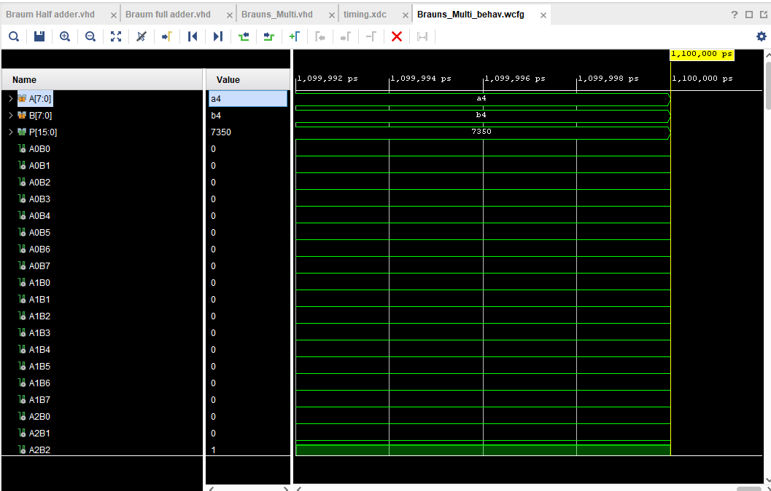
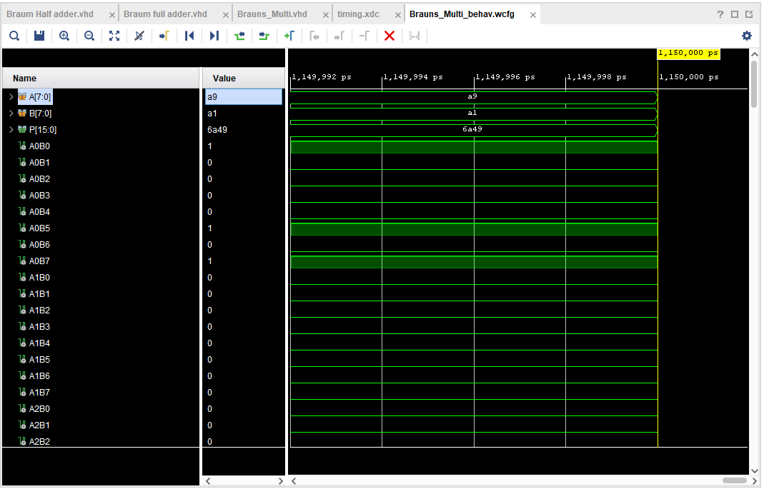
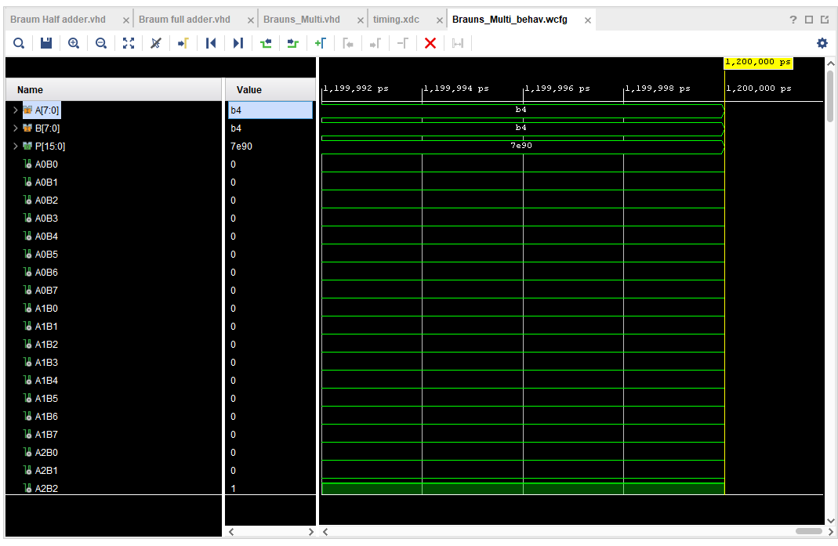

Wallace tree Extra tests
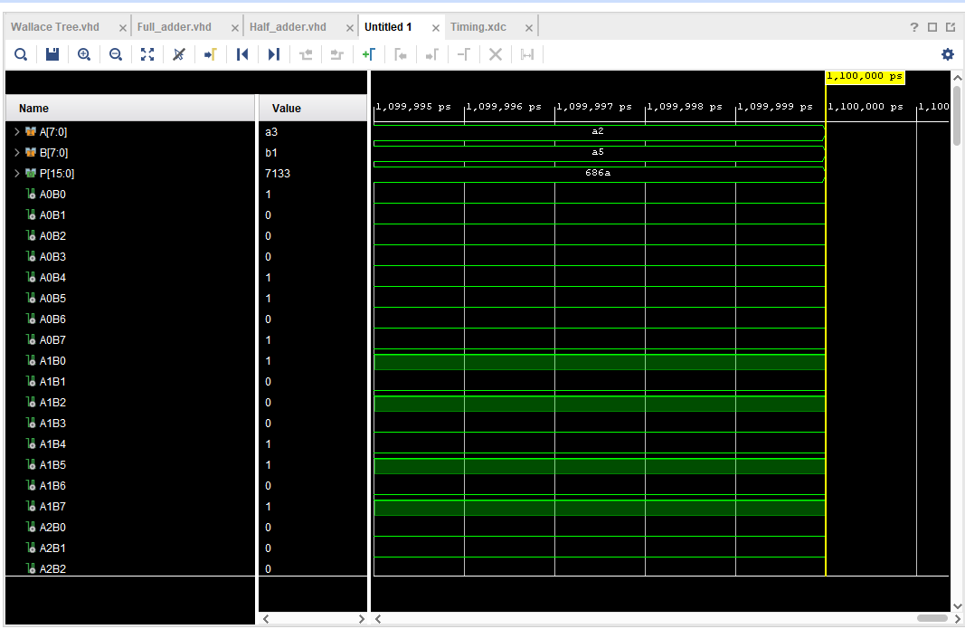
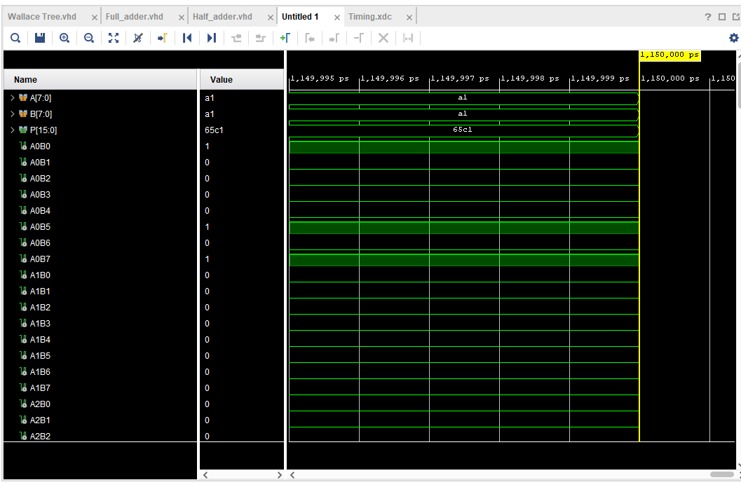
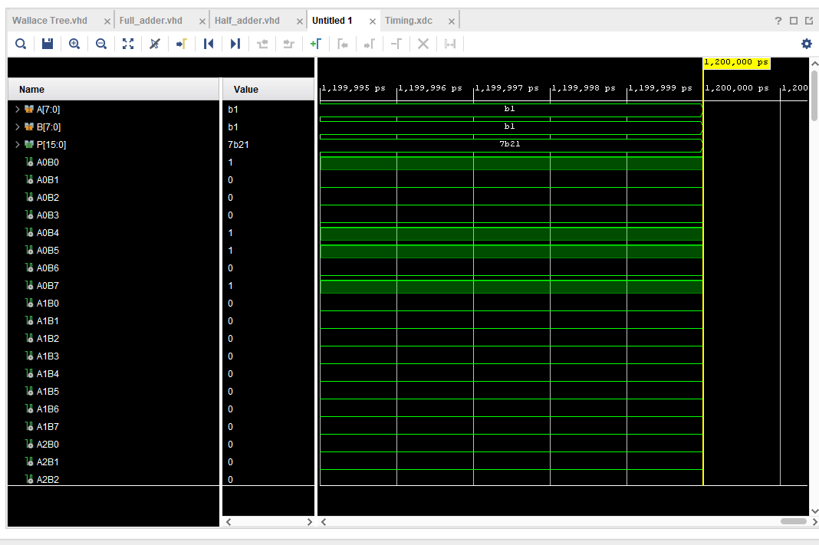

Braun Multiplier VHDL Code

library IEEE;
use IEEE.STD_LOGIC_1164.ALL;
use IEEE.std_logic_arith.All;
use IEEE.std_logic_unsigned.All;

-- Uncomment the following library declaration if using
-- arithmetic functions with Signed or Unsigned values
--use IEEE.NUMERIC_STD.ALL;

-- Uncomment the following library declaration if instantiating
-- any Xilinx leaf cells in this code.
--library UNISIM;
--use UNISIM.VComponents.all;

entity Brauns_Multi is
Port ( A : in std_logic_vector (7 downto 0);
B : in std_logic_vector (7 downto 0);
P : out std_logic_vector (15 downto 0));
end Brauns_Multi;

architecture Behavioural of Brauns_Multi is

signal A0B0 : std_logic;
signal A0B1 : std_logic;
signal A0B2 : std_logic;
signal A0B3 : std_logic;
signal A0B4 : std_logic;
signal A0B5 : std_logic;
signal A0B6 : std_logic;
signal A0B7 : std_logic;

signal A1B0 : std_logic;
signal A1B1 : std_logic;
signal A1B2 : std_logic;
signal A1B3 : std_logic;
signal A1B4 : std_logic;
signal A1B5 : std_logic;
signal A1B6 : std_logic;
signal A1B7 : std_logic;

signal A2B0 : std_logic;
signal A2B1 : std_logic;
signal A2B2 : std_logic;
signal A2B3 : std_logic;
signal A2B4 : std_logic;
signal A2B5 : std_logic;
signal A2B6 : std_logic;
signal A2B7 : std_logic;

signal A3B0 : std_logic;
signal A3B1 : std_logic;
signal A3B2 : std_logic;
signal A3B3 : std_logic;
signal A3B4 : std_logic;
signal A3B5 : std_logic;
signal A3B6 : std_logic;
signal A3B7 : std_logic;

signal A4B0 : std_logic;
signal A4B1 : std_logic;
signal A4B2 : std_logic;
signal A4B3 : std_logic;
signal A4B4 : std_logic;
signal A4B5 : std_logic;
signal A4B6 : std_logic;
signal A4B7 : std_logic;

signal A5B0 : std_logic;
signal A5B1 : std_logic;
signal A5B2 : std_logic;
signal A5B3 : std_logic;
signal A5B4 : std_logic;
signal A5B5 : std_logic;
signal A5B6 : std_logic;
signal A5B7 : std_logic;

signal A6B0 : std_logic;
signal A6B1 : std_logic;
signal A6B2 : std_logic;
signal A6B3 : std_logic;
signal A6B4 : std_logic;
signal A6B5 : std_logic;
signal A6B6 : std_logic;
signal A6B7 : std_logic;

signal A7B0 : std_logic;
signal A7B1 : std_logic;
signal A7B2 : std_logic;
signal A7B3 : std_logic;
signal A7B4 : std_logic;
signal A7B5 : std_logic;
signal A7B6 : std_logic;
signal A7B7 : std_logic;

signal C1_0 : std_logic;
signal S1_0 : std_logic;
signal C1_1 : std_logic;
signal S1_1 : std_logic;
signal C1_2 : std_logic;
signal S1_2 : std_logic;
signal C1_3 : std_logic;
signal S1_3 : std_logic;
signal C1_4 : std_logic;
signal S1_4 : std_logic;
signal C1_5 : std_logic;
signal S1_5 : std_logic;
signal C1_6 : std_logic;
signal S1_6 : std_logic;
signal C1_7 : std_logic;
signal S1_7 : std_logic;

signal S2_0 : std_logic;
signal S2_1 : std_logic;
signal S2_2 : std_logic;
signal S2_3 : std_logic;
signal S2_4 : std_logic;
signal S2_5 : std_logic;
signal S2_6 : std_logic;
signal S2_7 : std_logic;

signal C2_0 : std_logic;
signal C2_1 : std_logic;
signal C2_2 : std_logic;
signal C2_3 : std_logic;
signal C2_4 : std_logic;
signal C2_5 : std_logic;
signal C2_6 : std_logic;
signal C2_7 : std_logic;

signal S3_0 : std_logic;
signal S3_1 : std_logic;
signal S3_2 : std_logic;
signal S3_3 : std_logic;
signal S3_4 : std_logic;
signal S3_5 : std_logic;
signal S3_6 : std_logic;
signal S3_7 : std_logic;

signal C3_0 : std_logic;
signal C3_1 : std_logic;
signal C3_2 : std_logic;
signal C3_3 : std_logic;
signal C3_4 : std_logic;
signal C3_5 : std_logic;
signal C3_6 : std_logic;
signal C3_7 : std_logic;

signal S4_0 : std_logic;
signal S4_1 : std_logic;
signal S4_2 : std_logic;
signal S4_3 : std_logic;
signal S4_4 : std_logic;
signal S4_5 : std_logic;
signal S4_6 : std_logic;
signal S4_7 : std_logic;

signal C4_0 : std_logic;
signal C4_1 : std_logic;
signal C4_2 : std_logic;
signal C4_3 : std_logic;
signal C4_4 : std_logic;
signal C4_5 : std_logic;
signal C4_6 : std_logic;
signal C4_7 : std_logic;

signal S5_1 : std_logic;
signal S5_2 : std_logic;
signal S5_3 : std_logic;
signal S5_4 : std_logic;
signal S5_5 : std_logic;
signal S5_6 : std_logic;
signal S5_7 : std_logic;

signal C5_0 : std_logic;
signal C5_1 : std_logic;
signal C5_2 : std_logic;
signal C5_3 : std_logic;
signal C5_4 : std_logic;
signal C5_5 : std_logic;
signal C5_6 : std_logic;
signal C5_7 : std_logic;

signal S6_1 : std_logic;
signal S6_2 : std_logic;
signal S6_3 : std_logic;
signal S6_4 : std_logic;
signal S6_5 : std_logic;
signal S6_6 : std_logic;
signal S6_7 : std_logic;

signal C6_0 : std_logic;
signal C6_1 : std_logic;
signal C6_2 : std_logic;
signal C6_3 : std_logic;
signal C6_4 : std_logic;
signal C6_5 : std_logic;
signal C6_6 : std_logic;
signal C6_7 : std_logic;

signal C7_0 : std_logic;
signal C7_1 : std_logic;
signal C7_2 : std_logic;
signal C7_3 : std_logic;
signal C7_4 : std_logic;
signal C7_5 : std_logic;
signal C7_6 : std_logic;

component Braun_Half_adder
Port ( A : in STD_LOGIC;
B : in STD_LOGIC;
C : out STD_LOGIC;
S : out STD_LOGIC);
end component;

component Braun_full_adder
Port ( A : in STD_LOGIC;
B : in STD_LOGIC;
Cin : in STD_LOGIC;
C : out STD_LOGIC;
S : out STD_LOGIC);
end component;

begin

-- Row A0
A0B0 <= A(0) and B(0);
A0B1 <= A(0) and B(1);
A0B2 <= A(0) and B(2);
A0B3 <= A(0) and B(3);
A0B4 <= A(0) and B(4);
A0B5 <= A(0) and B(5);
A0B6 <= A(0) and B(6);
A0B7 <= A(0) and B(7);

-- Row A1
A1B0 <= A(1) and B(0);
A1B1 <= A(1) and B(1);
A1B2 <= A(1) and B(2);
A1B3 <= A(1) and B(3);
A1B4 <= A(1) and B(4);
A1B5 <= A(1) and B(5);
A1B6 <= A(1) and B(6);
A1B7 <= A(1) and B(7);

-- Row A2
A2B0 <= A(2) and B(0);
A2B1 <= A(2) and B(1);
A2B2 <= A(2) and B(2);
A2B3 <= A(2) and B(3);
A2B4 <= A(2) and B(4);
A2B5 <= A(2) and B(5);
A2B6 <= A(2) and B(6);
A2B7 <= A(2) and B(7);

-- Row A3
A3B0 <= A(3) and B(0);
A3B1 <= A(3) and B(1);
A3B2 <= A(3) and B(2);
A3B3 <= A(3) and B(3);
A3B4 <= A(3) and B(4);
A3B5 <= A(3) and B(5);
A3B6 <= A(3) and B(6);
A3B7 <= A(3) and B(7);

-- Row A4
A4B0 <= A(4) and B(0);
A4B1 <= A(4) and B(1);
A4B2 <= A(4) and B(2);
A4B3 <= A(4) and B(3);
A4B4 <= A(4) and B(4);
A4B5 <= A(4) and B(5);
A4B6 <= A(4) and B(6);
A4B7 <= A(4) and B(7);

-- Row A5
A5B0 <= A(5) and B(0);
A5B1 <= A(5) and B(1);
A5B2 <= A(5) and B(2);
A5B3 <= A(5) and B(3);
A5B4 <= A(5) and B(4);
A5B5 <= A(5) and B(5);
A5B6 <= A(5) and B(6);
A5B7 <= A(5) and B(7);

-- Row A6
A6B0 <= A(6) and B(0);
A6B1 <= A(6) and B(1);
A6B2 <= A(6) and B(2);
A6B3 <= A(6) and B(3);
A6B4 <= A(6) and B(4);
A6B5 <= A(6) and B(5);
A6B6 <= A(6) and B(6);
A6B7 <= A(6) and B(7);

-- Row A7
A7B0 <= A(7) and B(0);
A7B1 <= A(7) and B(1);
A7B2 <= A(7) and B(2);
A7B3 <= A(7) and B(3);
A7B4 <= A(7) and B(4);
A7B5 <= A(7) and B(5);
A7B6 <= A(7) and B(6);
A7B7 <= A(7) and B(7);

P0 :P(0) <=A(0) and B(0);

--P1 :Braun_Half_adder port map (A => A1B0, B=> A0B1,S=> P(1), C=> C1_0);

--C_2_0 : Braun_full_adder port map (A => A2B0, B => A1B1 , Cin => C1_0 , S=> S1_1, C =>C1_1);
--P2 : Braun_Half_adder port map (A => S1_1 , B => A0B2 , S=> P(2) , C => C2_0);

--C_3_0 : Braun_full_adder port map (A =>

HA1: Braun_Half_adder port map (A => A1B0, B => A0B1, C =>C1_0, s =>P(1));

FA1_1:Braun_full_adder port map (A=> A2B0, B=> A1B1, Cin => C1_0, C =>C1_1, s => S1_1);

FA_2: Braun_full_adder port map (A=> A3B0, B=> A2B1, Cin => C1_1, C =>C1_2, s => S1_2);

FA_3: Braun_full_adder port map (A=> A4B0, B=> A3B1, Cin => C1_2, C =>C1_3, s => S1_3);

FA_4: Braun_full_adder port map (A=> A5B0, B=> A4B1, Cin => C1_3, C =>C1_4, s => S1_4);

FA_5: Braun_full_adder port map (A=> A6B0, B=> A5B1, Cin => C1_4, C =>C1_5, s => S1_5);

FA_6: Braun_full_adder port map (A=> A7B0, B=> A6B1, Cin => C1_5, C =>C1_6, s => S1_6);

HA8: Braun_half_adder port map (A=> C1_6, B=> A7B1,C=> C1_7, s => s1_7);

--Bank 2

HA2: Braun_Half_adder port map (A => A0B2, B => S1_1, C=> C2_0, S=>P(2));

FA_7: Braun_full_adder port map (A=> A1B2, B => S1_2, Cin => C2_0, C=> C2_1,S=> S2_1);

FA_8: Braun_full_adder port map (A=> A2B2, B => S1_3, Cin => C2_1, C=> C2_2, S=> S2_2);

FA_9: Braun_full_adder port map (A=> A3B2, B => S1_4, Cin => C2_2, C=> C2_3, S=> S2_3);

FA_10: Braun_full_adder port map (A=> A4B2, B => S1_5, Cin => C2_3, C=> C2_4, S=> S2_4);

FA_11: Braun_full_adder port map (A=> A5B2, B => S1_6, Cin => C2_4, C=> C2_5, S=> S2_5);

FA_12: Braun_full_adder port map (A=> A6B2, B => S1_7, Cin => C2_5, C=> C2_6, S=> S2_6);

FA_13: Braun_full_adder port map (A=> A7B2, B => C1_7, Cin => C2_6, C=> C2_7, S=> S2_7);

--Bank 3

HA3: Braun_Half_adder port map (A => A0B3, B => S2_1, C=> C3_0, S=>P(3));

FA_14: Braun_full_adder port map (A=> A1B3, B => S2_2, Cin => C3_0, C=> C3_1,S=> S3_1);

FA_15: Braun_full_adder port map (A=> A2B3, B => S2_3, Cin => C3_1, C=> C3_2,S=> S3_2);

FA_16: Braun_full_adder port map (A=> A3B3, B => S2_4, Cin => C3_2, C=> C3_3,S=> S3_3);

FA_17: Braun_full_adder port map (A=> A4B3, B => S2_5, Cin => C3_3, C=> C3_4,S=> S3_4);

FA_18: Braun_full_adder port map (A=> A5B3, B => S2_6, Cin => C3_4, C=> C3_5,S=> S3_5);

FA_19: Braun_full_adder port map (A=> A6B3, B => S2_7, Cin => C3_5, C=> C3_6,S=> S3_6);

FA_20: Braun_full_adder port map (A=> A7B3, B => C2_7, Cin => C3_6, C=> C3_7,S=> S3_7);

-- Bank 4
HA4: Braun_Half_adder port map (A => A0B4, B => S3_1, C => C4_0, S => P(4));

FA_21: Braun_full_adder port map (A => A1B4, B => S3_2, Cin => C4_0, C => C4_1, S => S4_1);
FA_22: Braun_full_adder port map (A => A2B4, B => S3_3, Cin => C4_1, C => C4_2, S => S4_2);
FA_23: Braun_full_adder port map (A => A3B4, B => S3_4, Cin => C4_2, C => C4_3, S => S4_3);
FA_24: Braun_full_adder port map (A => A4B4, B => S3_5, Cin => C4_3, C => C4_4, S => S4_4);
FA_25: Braun_full_adder port map (A => A5B4, B => S3_6, Cin => C4_4, C => C4_5, S => S4_5);
FA_26: Braun_full_adder port map (A => A6B4, B => S3_7, Cin => C4_5, C => C4_6, S => S4_6);
FA_27: Braun_full_adder port map (A => A7B4, B => C3_7, Cin => C4_6, C => C4_7, S => S4_7);

-- Bank 5
HA5: Braun_Half_adder port map (A => A0B5, B => S4_1, C => C5_0, S => P(5));

FA_28: Braun_full_adder port map (A => A1B5, B => S4_2, Cin => C5_0, C => C5_1, S => S5_1);
FA_29: Braun_full_adder port map (A => A2B5, B => S4_3, Cin => C5_1, C => C5_2, S => S5_2);
FA_30: Braun_full_adder port map (A => A3B5, B => S4_4, Cin => C5_2, C => C5_3, S => S5_3);
FA_31: Braun_full_adder port map (A => A4B5, B => S4_5, Cin => C5_3, C => C5_4, S => S5_4);
FA_32: Braun_full_adder port map (A => A5B5, B => S4_6, Cin => C5_4, C => C5_5, S => S5_5);
FA_33: Braun_full_adder port map (A => A6B5, B => S4_7, Cin => C5_5, C => C5_6, S => S5_6);
FA_34: Braun_full_adder port map (A => A7B5, B => C4_7, Cin => C5_6, C => C5_7, S => S5_7);

-- Bank 6
HA6: Braun_Half_adder port map (A => A0B6, B => S5_1, C => C6_0, S => P(6));

FA_35: Braun_full_adder port map (A => A1B6, B => S5_2, Cin => C6_0, C => C6_1, S => S6_1);
FA_36: Braun_full_adder port map (A => A2B6, B => S5_3, Cin => C6_1, C => C6_2, S => S6_2);
FA_37: Braun_full_adder port map (A => A3B6, B => S5_4, Cin => C6_2, C => C6_3, S => S6_3);
FA_38: Braun_full_adder port map (A => A4B6, B => S5_5, Cin => C6_3, C => C6_4, S => S6_4);
FA_39: Braun_full_adder port map (A => A5B6, B => S5_6, Cin => C6_4, C => C6_5, S => S6_5);
FA_40: Braun_full_adder port map (A => A6B6, B => S5_7, Cin => C6_5, C => C6_6, S => S6_6);
FA_41: Braun_full_adder port map (A => A7B6, B => C5_7, Cin => C6_6, C => C6_7, S => S6_7);

-- Bank 7
HA7: Braun_Half_adder port map (A => A0B7, B => S6_1, C => C7_0, S => P(7));

FA_42: Braun_full_adder port map (A => A1B7, B => S6_2, Cin => C7_0, C => C7_1, S => P(8));
FA_43: Braun_full_adder port map (A => A2B7, B => S6_3, Cin => C7_1, C => C7_2, S => P(9));
FA_44: Braun_full_adder port map (A => A3B7, B => S6_4, Cin => C7_2, C => C7_3, S => P(10));
FA_45: Braun_full_adder port map (A => A4B7, B => S6_5, Cin => C7_3, C => C7_4, S => P(11));
FA_46: Braun_full_adder port map (A => A5B7, B => S6_6, Cin => C7_4, C => C7_5, S => P(12));
FA_47: Braun_full_adder port map (A => A6B7, B => S6_7, Cin => C7_5, C => C7_6, S => P(13));
FA_48: Braun_full_adder port map (A => A7B7, B => C6_7, Cin => C7_6, C => P(15), S => P(14));

end Behavioural;

Wallace Tree VHDL Code

library IEEE;
use IEEE.STD_LOGIC_1164.ALL;
use IEEE.std_logic_arith.All;
use IEEE.std_logic_unsigned.All;

-- Uncomment the following library declaration if using
-- arithmetic functions with Signed or Unsigned values
--use IEEE.NUMERIC_STD.ALL;

-- Uncomment the following library declaration if instantiating
-- any Xilinx leaf cells in this code.
--library UNISIM;
--use UNISIM.VComponents.all;

entity Wallace_Tree is
Port ( A : in std_logic_vector (7 downto 0);
B : in std_logic_vector (7 downto 0);
P : out std_logic_vector (15 downto 0));
end Wallace_tree;

architecture Behavioural of Wallace_tree is

signal A0B0 : std_logic;
signal A0B1 : std_logic;
signal A0B2 : std_logic;
signal A0B3 : std_logic;
signal A0B4 : std_logic;
signal A0B5 : std_logic;
signal A0B6 : std_logic;
signal A0B7 : std_logic;

signal A1B0 : std_logic;
signal A1B1 : std_logic;
signal A1B2 : std_logic;
signal A1B3 : std_logic;
signal A1B4 : std_logic;
signal A1B5 : std_logic;
signal A1B6 : std_logic;
signal A1B7 : std_logic;

signal A2B0 : std_logic;
signal A2B1 : std_logic;
signal A2B2 : std_logic;
signal A2B3 : std_logic;
signal A2B4 : std_logic;
signal A2B5 : std_logic;
signal A2B6 : std_logic;
signal A2B7 : std_logic;

signal A3B0 : std_logic;
signal A3B1 : std_logic;
signal A3B2 : std_logic;
signal A3B3 : std_logic;
signal A3B4 : std_logic;
signal A3B5 : std_logic;
signal A3B6 : std_logic;
signal A3B7 : std_logic;

signal A4B0 : std_logic;
signal A4B1 : std_logic;
signal A4B2 : std_logic;
signal A4B3 : std_logic;
signal A4B4 : std_logic;
signal A4B5 : std_logic;
signal A4B6 : std_logic;
signal A4B7 : std_logic;

signal A5B0 : std_logic;
signal A5B1 : std_logic;
signal A5B2 : std_logic;
signal A5B3 : std_logic;
signal A5B4 : std_logic;
signal A5B5 : std_logic;
signal A5B6 : std_logic;
signal A5B7 : std_logic;

signal A6B0 : std_logic;
signal A6B1 : std_logic;
signal A6B2 : std_logic;
signal A6B3 : std_logic;
signal A6B4 : std_logic;
signal A6B5 : std_logic;
signal A6B6 : std_logic;
signal A6B7 : std_logic;

signal A7B0 : std_logic;
signal A7B1 : std_logic;
signal A7B2 : std_logic;
signal A7B3 : std_logic;
signal A7B4 : std_logic;
signal A7B5 : std_logic;
signal A7B6 : std_logic;
signal A7B7 : std_logic;

signal C1_0 : std_logic;
signal S1_0 : std_logic;
signal C1_1 : std_logic;
signal S1_1 : std_logic;
signal C1_2 : std_logic;
signal S1_2 : std_logic;
signal C1_3 : std_logic;
signal S1_3 : std_logic;
signal C1_4 : std_logic;
signal S1_4 : std_logic;
signal C1_5 : std_logic;
signal S1_5 : std_logic;
signal C1_6 : std_logic;
signal S1_6 : std_logic;
signal C1_7 : std_logic;
signal S1_7 : std_logic;

signal S2_0 : std_logic;
signal S2_1 : std_logic;
signal S2_2 : std_logic;
signal S2_3 : std_logic;
signal S2_4 : std_logic;
signal S2_5 : std_logic;
signal S2_6 : std_logic;
signal S2_7 : std_logic;

signal C2_0 : std_logic;
signal C2_1 : std_logic;
signal C2_2 : std_logic;
signal C2_3 : std_logic;
signal C2_4 : std_logic;
signal C2_5 : std_logic;
signal C2_6 : std_logic;
signal C2_7 : std_logic;

signal S3_0 : std_logic;
signal S3_1 : std_logic;
signal S3_2 : std_logic;
signal S3_3 : std_logic;
signal S3_4 : std_logic;
signal S3_5 : std_logic;
signal S3_6 : std_logic;
signal S3_7 : std_logic;

signal C3_0 : std_logic;
signal C3_1 : std_logic;
signal C3_2 : std_logic;
signal C3_3 : std_logic;
signal C3_4 : std_logic;
signal C3_5 : std_logic;
signal C3_6 : std_logic;
signal C3_7 : std_logic;

signal S4_0 : std_logic;
signal S4_1 : std_logic;
signal S4_2 : std_logic;
signal S4_3 : std_logic;
signal S4_4 : std_logic;
signal S4_5 : std_logic;
signal S4_6 : std_logic;
signal S4_7 : std_logic;

signal C4_0 : std_logic;
signal C4_1 : std_logic;
signal C4_2 : std_logic;
signal C4_3 : std_logic;
signal C4_4 : std_logic;
signal C4_5 : std_logic;
signal C4_6 : std_logic;
signal C4_7 : std_logic;

signal S5_1 : std_logic;
signal S5_2 : std_logic;
signal S5_3 : std_logic;
signal S5_4 : std_logic;
signal S5_5 : std_logic;
signal S5_6 : std_logic;
signal S5_7 : std_logic;

signal C5_0 : std_logic;
signal C5_1 : std_logic;
signal C5_2 : std_logic;
signal C5_3 : std_logic;
signal C5_4 : std_logic;
signal C5_5 : std_logic;
signal C5_6 : std_logic;
signal C5_7 : std_logic;

signal S6_1 : std_logic;
signal S6_2 : std_logic;
signal S6_3 : std_logic;
signal S6_4 : std_logic;
signal S6_5 : std_logic;
signal S6_6 : std_logic;
signal S6_7 : std_logic;

signal C6_0 : std_logic;
signal C6_1 : std_logic;
signal C6_2 : std_logic;
signal C6_3 : std_logic;
signal C6_4 : std_logic;
signal C6_5 : std_logic;
signal C6_6 : std_logic;
signal C6_7 : std_logic;

signal C7_0 : std_logic;
signal C7_1 : std_logic;
signal C7_2 : std_logic;
signal C7_3 : std_logic;
signal C7_4 : std_logic;
signal C7_5 : std_logic;
signal C7_6 : std_logic;

component Half_adder
Port ( A : in STD_LOGIC;
B : in STD_LOGIC;
C : out STD_LOGIC;
S : out STD_LOGIC);
end component;

component full_adder
Port ( A : in STD_LOGIC;
B : in STD_LOGIC;
Cin : in STD_LOGIC;
C : out STD_LOGIC;
S : out STD_LOGIC);
end component;

begin

-- Row A0
A0B0 <= A(0) and B(0);
A0B1 <= A(0) and B(1);
A0B2 <= A(0) and B(2);
A0B3 <= A(0) and B(3);
A0B4 <= A(0) and B(4);
A0B5 <= A(0) and B(5);
A0B6 <= A(0) and B(6);
A0B7 <= A(0) and B(7);

-- Row A1
A1B0 <= A(1) and B(0);
A1B1 <= A(1) and B(1);
A1B2 <= A(1) and B(2);
A1B3 <= A(1) and B(3);
A1B4 <= A(1) and B(4);
A1B5 <= A(1) and B(5);
A1B6 <= A(1) and B(6);
A1B7 <= A(1) and B(7);

-- Row A2
A2B0 <= A(2) and B(0);
A2B1 <= A(2) and B(1);
A2B2 <= A(2) and B(2);
A2B3 <= A(2) and B(3);
A2B4 <= A(2) and B(4);
A2B5 <= A(2) and B(5);
A2B6 <= A(2) and B(6);
A2B7 <= A(2) and B(7);

-- Row A3
A3B0 <= A(3) and B(0);
A3B1 <= A(3) and B(1);
A3B2 <= A(3) and B(2);
A3B3 <= A(3) and B(3);
A3B4 <= A(3) and B(4);
A3B5 <= A(3) and B(5);
A3B6 <= A(3) and B(6);
A3B7 <= A(3) and B(7);

-- Row A4
A4B0 <= A(4) and B(0);
A4B1 <= A(4) and B(1);
A4B2 <= A(4) and B(2);
A4B3 <= A(4) and B(3);
A4B4 <= A(4) and B(4);
A4B5 <= A(4) and B(5);
A4B6 <= A(4) and B(6);
A4B7 <= A(4) and B(7);

-- Row A5
A5B0 <= A(5) and B(0);
A5B1 <= A(5) and B(1);
A5B2 <= A(5) and B(2);
A5B3 <= A(5) and B(3);
A5B4 <= A(5) and B(4);
A5B5 <= A(5) and B(5);
A5B6 <= A(5) and B(6);
A5B7 <= A(5) and B(7);

-- Row A6
A6B0 <= A(6) and B(0);
A6B1 <= A(6) and B(1);
A6B2 <= A(6) and B(2);
A6B3 <= A(6) and B(3);
A6B4 <= A(6) and B(4);
A6B5 <= A(6) and B(5);
A6B6 <= A(6) and B(6);
A6B7 <= A(6) and B(7);

-- Row A7
A7B0 <= A(7) and B(0);
A7B1 <= A(7) and B(1);
A7B2 <= A(7) and B(2);
A7B3 <= A(7) and B(3);
A7B4 <= A(7) and B(4);
A7B5 <= A(7) and B(5);
A7B6 <= A(7) and B(6);
A7B7 <= A(7) and B(7);

P0 :P(0) <=A(0) and B(0);

HA1: Half_adder port map (A => A1B0, B => A0B1, C => C1_0, s => P(1));

FA1_1: full_adder port map (A => A2B0, B => A1B1,Cin=> A0B2, C => C1_1, s => S1_1);

FA_2: full_adder port map (A => A3B0, B => A2B1, Cin => A1B2, C => C1_2, s => S1_2);

FA_3: full_adder port map (A => A4B0, B => A3B1, Cin => A2B3, C => C1_3, s => S1_3);

FA_4: full_adder port map (A => A5B0, B => A4B1, Cin => A3B3, C => C1_4, s => S1_4);

FA_5: full_adder port map (A => A6B0, B => A5B1, Cin => A4B4, C => C1_5, s => S1_5);

FA_6: full_adder port map (A => A7B0, B => A6B1, Cin => A5B5, C => C1_6, s => S1_6);

HA8: half_adder port map (A => A6B2, B => A7B1, C => C1_7, s => s1_7);

--Bank 2

HA2: Half_adder port map (A => S1_1, B => C1_0, C => C2_0, S => P(2));

FA_7: full_adder port map (A => A0B3, B => S1_2, Cin => C1_1, C => C2_1, S => S2_1);

FA_8: full_adder port map (A => A1B3, B => S1_3, Cin => C1_2, C => C2_2, S => S2_2);

FA_9: full_adder port map (A => A2B3, B => S1_4, Cin => C1_3, C => C2_3, S => S2_3);

FA_10: full_adder port map (A => A3B3, B => S1_5, Cin => C1_4, C => C2_4, S => S2_4);

FA_11: full_adder port map (A => A4B3, B => S1_6, Cin => C1_5, C => C2_5, S => S2_5);

FA_12: full_adder port map (A => A5B3, B => S1_7, Cin => C1_6, C => C2_6, S => S2_6);

FA_13: full_adder port map (A => A6B3, B => C1_7, Cin => A7B2, C => C2_7, S => S2_7);

--Bank 3

HA3: Half_adder port map (A => C2_0, B => S2_1, C => C3_0, S => P(3));

FA_14: full_adder port map (A => A0B4, B => S2_2, Cin => C2_1, C => C3_1, S => S3_1);

FA_15: full_adder port map (A => A1B4, B => S2_3, Cin => C2_2, C => C3_2, S => S3_2);

FA_16: full_adder port map (A => A2B4, B => S2_4, Cin => C2_3, C => C3_3, S => S3_3);

FA_17: full_adder port map (A => A3B4, B => S2_5, Cin => C2_4, C => C3_4, S => S3_4);

FA_18: full_adder port map (A => A4B4, B => S2_6, Cin => C2_5, C => C3_5, S => S3_5);

FA_19: full_adder port map (A => A5B4, B => S2_7, Cin => C2_6, C => C3_6, S => S3_6);

FA_20: full_adder port map (A => A6B4, B => C2_7, Cin => A7B3, C => C3_7, S => S3_7);

-- Bank 4
HA4: Half_adder port map (A => C3_0, B => S3_1, C => C4_0, S => P(4));

FA_21: full_adder port map (A => A0B5, B => S3_2, Cin => C3_1, C => C4_1, S => S4_1);
FA_22: full_adder port map (A => A1B5, B => S3_3, Cin => C3_2, C => C4_2, S => S4_2);
FA_23: full_adder port map (A => A2B5, B => S3_4, Cin => C3_3, C => C4_3, S => S4_3);
FA_24: full_adder port map (A => A3B5, B => S3_5, Cin => C3_4, C => C4_4, S => S4_4);
FA_25: full_adder port map (A => A4B5, B => S3_6, Cin => C3_5, C => C4_5, S => S4_5);
FA_26: full_adder port map (A => A5B5, B => S3_7, Cin => C3_6, C => C4_6, S => S4_6);
FA_27: full_adder port map (A => A6B5, B => C3_7, Cin => A7B4, C => C4_7, S => S4_7);

-- Bank 5
HA5: Half_adder port map (A => C4_0, B => S4_1, C => C5_0, S => P(5));

FA_28: full_adder port map (A => A0B6, B => S4_2, Cin => C4_1, C => C5_1, S => S5_1);
FA_29: full_adder port map (A => A1B6, B => S4_3, Cin => C4_2, C => C5_2, S => S5_2);
FA_30: full_adder port map (A => A2B6, B => S4_4, Cin => C4_3, C => C5_3, S => S5_3);
FA_31: full_adder port map (A => A3B6, B => S4_5, Cin => C4_4, C => C5_4, S => S5_4);
FA_32: full_adder port map (A => A4B6, B => S4_6, Cin => C4_5, C => C5_5, S => S5_5);
FA_33: full_adder port map (A => A5B6, B => S4_7, Cin => C4_6, C => C5_6, S => S5_6);
FA_34: full_adder port map (A => A6B6, B => C4_7, Cin => A7B5, C => C5_7, S => S5_7);

-- Bank 6
HA6: Half_adder port map (A => C5_0, B => S5_1, C => C6_0, S => P(6));

FA_35: full_adder port map (A => A0B7, B => S5_2, Cin => C5_1, C => C6_1, S => S6_1);
FA_36: full_adder port map (A => A1B7, B => S5_3, Cin => C5_2, C => C6_2, S => S6_2);
FA_37: full_adder port map (A => A2B7, B => S5_4, Cin => C5_3, C => C6_3, S => S6_3);
FA_38: full_adder port map (A => A3B7, B => S5_5, Cin => C5_4, C => C6_4, S => S6_4);
FA_39: full_adder port map (A => A4B7, B => S5_6, Cin => C5_5, C => C6_5, S => S6_5);
FA_40: full_adder port map (A => A5B7, B => S5_7, Cin => C5_6, C => C6_6, S => S6_6);
FA_41: full_adder port map (A => A6B7, B => C5_7, Cin => A7B6, C => C6_7, S => S6_7);

-- Bank 7
HA7: Half_adder port map (A => C6_0, B => S6_1, C => C7_0, S => P(7));

FA_42: full_adder port map (A => S6_2, B => C6_1, Cin => C7_0, C => C7_1, S => P(8));
FA_43: full_adder port map (A => S6_3, B => C6_2, Cin => C7_1, C => C7_2, S => P(9));
FA_44: full_adder port map (A => S6_4, B => C6_3, Cin => C7_2, C => C7_3, S => P(10));
FA_45: full_adder port map (A => S6_5, B => C6_4, Cin => C7_3, C => C7_4, S => P(11));
FA_46: full_adder port map (A => S6_6, B => C6_5, Cin => C7_4, C => C7_5, S => P(12));
FA_47: full_adder port map (A => S6_7, B => C6_6, Cin => C7_5, C => C7_6, S => P(13));
FA_48: full_adder port map (A => A7B7, B => C6_7, Cin => C7_6, C => P(15), S => P(14));

end Behavioural;

