
Master of Business Administration
International Business pathway


Contemporary employability skills
Assessment 1: Individual report. Weight: 100%

Module Name: International Business Concepts
Module Code: LCMB7034
Lecturer: Charles Oham

Student name: Ishan Dineshbhai Rana
Student ID: 2507137

Word count: 5260
Submission date: 14th August 2026
Title: Strategic International Business Entry of Nidec Corporation into Nigeria
Executive Summary
Nidec's entry into Nigeria is a very long-term opportunity but with significant political-economic infrastructure and cultural challenges. Nigeria is short of proper infrastructure and strong customer purchasing power; hence the organisation will find it difficult to expand its activities in Nigeria because of its lack of organisational and technology capabilities and activeness in responding to the Nigeria market. From the OLI framework, it is noted that Nigeria are highly attractive to attain strategic business growth, but the economic instability and market volatility hinders sustainable business performance. It is recommended that Nidec use a joint venture market entry mode with a local partner, which will provide the location advantages, the ownership advantages and local market access in Nigeria; this can give Nidec the initial business expansion growth in Nigeria.

Table of Contents
Section 1: Nidec Corporation’s International Market Entry into Nigeria 4
1. Introduction 4
2. Organisational Classification and Global Strategy 4
2.1 Bartlett and Ghoshal’s International Strategy Framework 4
2.2 Critical Analysis of Nidec’s Strategic Choice 5
2.3 Nidec’s Global Geographic Configuration and International Operations to Competitive Advantage 6
3. Macro-Environmental Appraisal and Market Attractiveness 7
3.1 Nigeria Market Overview using External factors 7
3.2 Dunning’s Eclectic Paradigm — OLI Framework 14
4. Entry Mode Strategy and Strategic Synthesis 16
4.1 Historical Entry Mode Pattern 16
4.2 Suitability of Nidec’s Historical Entry Mode for Nigeria 18
4.3 Recommended Entry Mode for Nidec Nigeria 19
5. Conclusion and Recommendations 19
Section 2: Reflection 21
References 24

Section 1: Nidec Corporation’s International Market Entry into Nigeria

1. Introduction
Globalisation became one of the competitive strategies for MNCs, which helps to trade people, money, ideas, services, and across borders. Globalisation increases market competition and helps MNCs to explore new emerging markets to achieve comparative business growth and profitability. This particular report analyse Nidec Corporation’s potential market entry activities which is a Japan based electric motors manufacturing company. Report explore the Business expansion opportunity into Nigeria where has no personal activity in the current situation. Using Bartlett and Ghoshal's framework, PESTLE analysis and market entry approaches, this report critically examines international expansion strategy and recommends the most suitable approaches to achieve the desired business expansion intention into Nigeria.

2. Organisational Classification and Global Strategy

2.1 Bartlett and Ghoshal’s International Strategy Framework
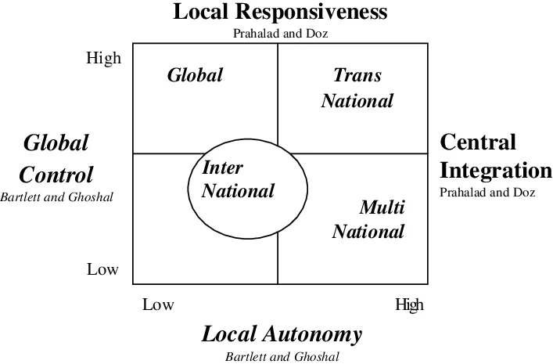
Figure 1: Bartlett and Ghoshal’s International Strategy Framework
(Source: Lehmann, 2022)
Figure 1 shows Bartlett and Ghoshal's International strategy framework, which identifies international strategies based on the degree of global integration and local responsiveness of the MNCs. There are four types of strategies, such as International, multinational, transnational, and global, which help organisations to select the best approach to increase responsiveness to global customers, regulatory, and infrastructure requirements to maintain a comparative position (Lehmann, 2022).

2.2 Critical Analysis of Nidec’s Strategic Choice
International Strategy
Nidec Corporation is one of the major Japanese companies headquartered in Kyoto, Japan. The organisation is recognised for its leading comprehensive motor-producing capability ranging from tiny Precision spindle motors to large industrial machinery and home appliances (NIDEC, 2024). As an international strategy, Nidec intends to exchange home-country knowledge, technology and capability with the international market to increase comparative advantage. However, the international strategy influences organisations to reduce limited local adaptation, which may affect local engagement and understanding of customer requirements. But Nunes et al. (2024) pointed out that depending too much on external customers' needs and innovations reduce its capacity to respond to local needs. In terms of long-term competitive advantage, however, international labour market and the use of sophisticated technology to favour strategic and comparative advantage.
Multidomestic Strategy
The multidomestic strategy is intended to adopt a strong approach towards local customer requirements and create an opportunity for foreign subsidiaries to adapt organisational products and services. To promote better understanding of local industrial customer needs along with foreign industry preferences. can maintain a better balance between local business performance while aligning with Foreign organisational growth, which has become important to maintain strategic, technology-intensive operations across countries. However, Buckley (2023) argued that a multi-domestic strategy requires high operating costs, inconsistent brand messaging across regions and a lack of economies of scale. These disadvantages need to be understood for my decision to maintain a better strategic selection for Organisational growth.
Global Strategy
The Global strategy adoption promotes the organisation to focus on centralised coordination, cost efficiency and standardisation of business (Works, 2022). has a great approach towards Global strategy adoption to maintain standardisation of motor Technology manufacturing processes and quality controls. Such activities contribute to Nidec's economic balance and strategic development. According to Ristovska (2022), however, dependence on global strategy is not always appropriate for an organisation because it is crucial for a business to have a balance between needs of the local market and those of the global market to ensure business growth in the long run.
Transnational Strategy
The goal of the transnational strategy is to foster better balance between Global integration and local responsiveness (Isolauri and Ameer, 2023). Striking a balance between local and global demands to ensure long-term business expansion and customer retention is crucial for Nidec. Hence, there is a strategic approach that has to be Global technological efficiency with local market adaptation to encourage sustainable long-term growth.

2.3 Nidec’s Global Geographic Configuration and International Operations to Competitive Advantage
Nidec has maintained a strong geographically diversified International network across Asia, Europe, North America and other important Global markets (Nidec Corporation, 2026). In all these markets, Nidec's business activities are backed up by strong manufacturing facilities, research and development centres, and sales subsidiaries that allow Nidec to meet local customer needs and have strong autonomy in the electronics and industrial markets. In a global market segment, however, Nidec plans to remain competitive and responsive to drive growth of its business activity in Nigeria, which is an emerging market with tremendous growth opportunities. The main objective of this strategic decision is to uphold robust geographical diversification, while leveraging the development of competitive advantages regarding technology and knowledge transfer, economies of scale and promoting trust and flexibility in supply chains for long-term business growth.

3. Macro-Environmental Appraisal and Market Attractiveness

3.1 Nigeria Market Overview using External factors
Political Factor
Key Political Factors | Description | Impact
Political stability | Nigeria's political stability index as per 2023 was -1.77 (Worldscorecard, 2024) | Negative
Corruption | Nigeria scored 26/100 and ranked 142nd out of 182 countries in terms of corruption (Transparency, 2026) | Negative
FDI Policy Environment | Nigeria contributed to improved investment conditions for foreign businesses and aims to strengthen fiscal sustainability (World Bank, 2024) | Positive
Table 2: Political factors of Nigeria
(Source: Self-Created)
Table 2 depicts the political factors influencing Nigeria's business environment, which is important to understand the Nidec proposed market entry suitability into Nigeria. Madueke (2026) stated that the Nigerian political condition represents a mixed but predominantly challenging environment for organisations to maintain proper business growth opportunities.
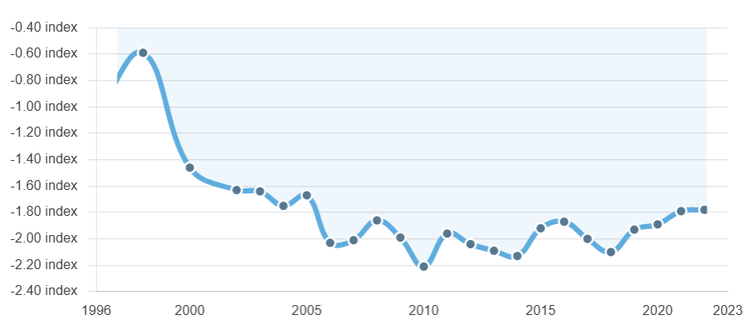
Figure 2: Political Stability Index of Nigeria
(Source: Worldscorecard, 2024)
For example, it is clear from Figure 2 that the political stability of Nigeria scored around minus 1.77 in 2023, which indicates increased risk of exposure to political and security concerns (Worldscorecard, 2024).Father The dramatic reduction of political stability indicate increasing complexity in managing strong political performance and support for the organisations, and it may increase the risk of corruption and other critical issues in the country. These activities critically harm organisations and growth, performance and business improvement activities. It is further evident that Nigeria scored 26/100 and ranked 142nd out of 182 countries in terms of corruption in terms of corruption (Transparency, 2026). This means that there is a lack of political power in controlling the growing corruption rate in Nigeria, its effect on organisational growth and performance. Al-Jundi, Shuhaiber and Al-Emara (2022) suggested that the presence of a high level of corruption and lack of political support makes organisational growth vulnerable, and when the financial situation of an organisation becomes strained and the company experiences liquidity problems, organisational capability to sustain high profitability and business performance is broken. These are some of the critical challenges which can influence Nidec’s performance and affect the reliability of the supply chain, transportation network, employee security, and long-term investment planning.
However, in terms of FDI policy, Nigeria maintains a positive opportunity, which indicates a positive market entry and growth for Nidec. The Nigerian government has been firm on foreign exchange policies as it aimed at bolstering physical reforms and private sector investments. Disability policies may be useful to make Nigeria more attractive to Nidec in the medium to long-term and to build an investment-friendly environment. Such a change can be a positive opportunity for Nidec growth, but if there is no political support and escalating corruption and sudden policy changes can impact the growth opportunities of the organisation. Depending only on positive FDI policy should not make decisions to expand the business in Nigeria, as it can be harmful for long-term strategic business growth for the organisation.
Economic Factor
Key Economic Factors | Description | Impact
Economic growth | Nigeria’s GDP increased to 4% in 2025 (Finance.gov.ng, 2025) | Positive
Market size | Nigeria had a strong population of 237.5 million in 2025 (The World Bank, 2025) | Positive
Inflation | CPI was 23% in 2025 and 33.2% in 2024 (MacroTrends, 2025) | Negative
Purchasing power | Nigeria has more than 56 million poor and vulnerable people with access to electricity for 61% of the population (World Bank, 2025) | Negative
Table 2: Economic factors of Nigeria
(Source: Self-Created)
Table 2 represents the economic factors of Nigeria, where economic growth, market size, imp, and has been provided to understand the Business expansion opportunity for Nidec. Nigeria represents a mixed economic environment with a 4% GDP growth rate, indicating improving economic activity and Resilience (Finance.gov.ng, 2025). This increasing GDP growth opportunity significantly indicates a positive Business expansion opportunity and growth in the electric motor and manufacturing segment. Also, Nigeria's population has been determined to be over 237.5 million as of 2025 which positions Nigeria as one of the largest consumer and industrial market (World Bank, 2025). With the rise in the GTP and population, it's a clear positive growth opportunity in the business for Nidec. The authors Kopczewska, Kubara and Kopyt (2024) stated that countries with high population density can boost the rate of customers' purchases, and high customers density is linked to high business profitability.
Despite the high GDP growth, the inflation rate in Nigeria remains very high, around 33.2% in 2024 and 23% in 2025. Despite the reduction of CPI index, it shows high rate of inflation which could impact the oil price, consumer purchasing intention, capability and organisational activities. Carrière-Swallow et al. (2023) proposed that the rising inflation rate will lead to higher transport cost, labour cost, energy cost and imported component cost, which will have a significant impact on the performance of the organisations' supply chain and operation cost, which will affect the profitability of the business.
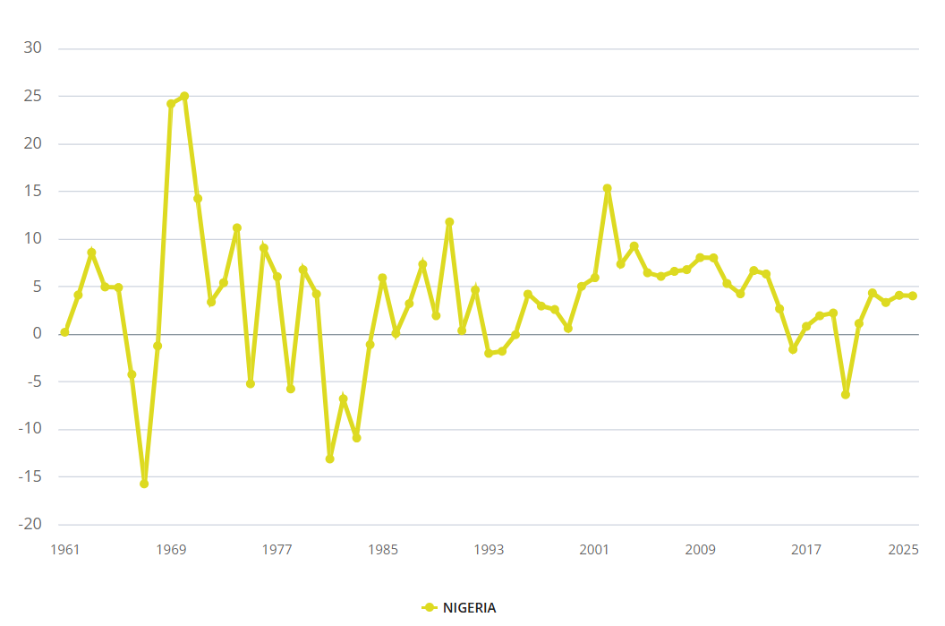
Figure 3: Nigeria GDP Growth rate
(Source: World Bank, 2025)
It is clear from Figure 3 that Nigeria’s GDP growth rate significantly fluctuates, ranging between -6.37 to 5.92%, which indicates extreme market volatility and economic fluctuations, which may create insatiable business performance (World Bank, 2025). This is accentuated by the customers' weak purchasing power in Nigeria. There is no doubt that Nigeria has more than 56 million poor people and only 61% of the population has access to electricity (World Bank 2025). As Nidec operates mainly in the electric and machinery component manufacturing, a population with a lack of electricity may create complex challenges for the organisation to maintain a strong profit margin despite having a large population. Hence the only parameter to ensure market attractiveness and Business expansion opportunity for Nidec in Nigeria is population size consideration and initial GDP growth, which is not sufficient.
Legal Factor
Key Legal Factors | Description | Impact
Company registration and corporate law | Companies and Allied Matters Act (CAMA) 2020 need to be adhered to during initial market entry (NIPC, 2025) | Positive
Patent and technology protection | Strictly follows the Patents and Designs Act in Nigeria (WIPO, 2022) | Positive
Foreign ownership and FDI protection | The NIPC Act protect transferability and nationalisation of capital and returns (NIPC, 2025) | Positive
Table 3: Key Legal Factors of Nigeria
(Source: Self-Created)
Countries' legal factors significantly affect the organisational business growth and performance. Table 3 represents key legal factors of Nigeria which can influence Nidec Corporation's proposed market entry into Nigeria. It is identified that Nigeria maintains a strong Companies and Allied Matters Act (CAMA) 2020, which provides a strong corporate and legal framework in Nigeria that aligns with the corporate governance and reporting requirements during the initial market entry into Nigeria. This kind of compliance can demand administrative fees and native authorized counsel, and can produce preliminary complexities for companies such as Nidec Corporation in obtaining correct support to make a foray into the Nigerian market. Furthermore, if the organisation trades in any of the countries, it becomes essential to review the IP protection measures for the protection of component designs and business patents. In Nigeria, they are the Patents and Designs Act and the latter offers legal protection for industrial designs and inventions. This represents a positive and strategically beneficial approach, as an effective way of keeping business activities going, but not interfering with industrial designs and inventions. Any type of technology leakage or unauthorised access can pose problems for organisations, argues Rajeh (2022). For this reason, it is essential for Nidec Corporation to implement robust technological security measures before making their way into the Nigerian market. Further, the NIPC Act can also afford protection to Nidec against foreign direct investment and protection activities of capital transfer and return. Nigeria's overall legal environment suggests that it provides an opportunity for business entry, but it is imperative that they have an active risk management strategy to achieve better strategic control and secure increased organisation ownership, as well as enable long-term growth for the organisation in Nigeria.
Cultural Factor
In assessing the cultural market opportunity and complexities of a country, Hofstede's cultural dimensions framework can be used (Kole, 2023). Assessing the power distance, individualism, uncertainty avoidance, masculinity vs femininity, long-term orientation and indulgence vs restraints can help Nidec Corporation to make strategic decisions to enter the Nigerian market.
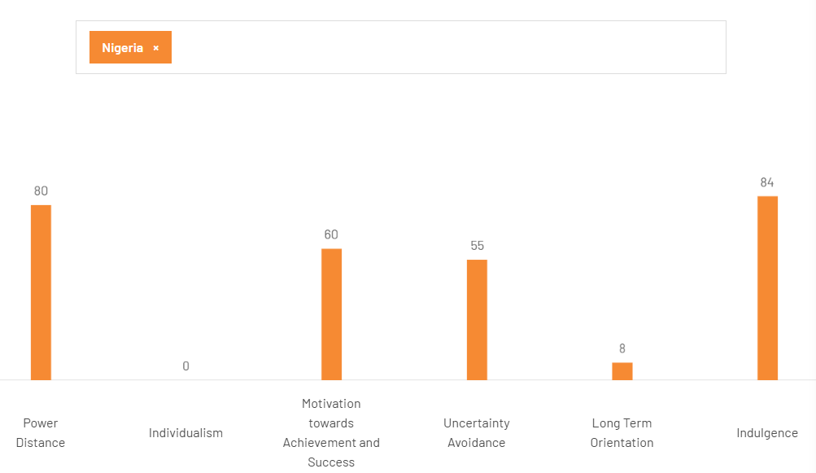
Figure 4: Hofstede cultural dimensions of Nigeria
(Source: The Culture Factor, 2025)
Figure 4 shows the Hofstede cultural dimensions data of Nigeria, which indicates a distinctive cultural profile, which is important to evaluate to enter Nidec Corporation's business entry in Nigeria. Nigeria scored 80 in terms of power distance, which indicates strong acceptance of hierarchy and unequal distribution in terms of organisational decision-making power. Nidec, on the other hand, has a well-organized management system in Japan; hence, it was beneficial for Nidec to adopt strict and strategic reporting relationship. Baporikar (2025) noted, however, that a very tight organisational structure based on a strict hierarchy may lower employee morale, engagement and local responsiveness. Hence, Nidec must continue to have a strong managerial approach and delegate the Nigerian manager for improved organisational performance.
Nigeria is also very collectivism-oriented as it scores 0 in terms of individualism, social networking and group relationships are very important for the operation of business organisations and better reporting performance are ensured by loyalty and humbleness (Zemojtel-Piotrowska and Piotrowski, 2023). This also aids Nidec to keep its stakeholders, such as local communities, government, customers, employees and shareholders happy, for long-term profit.
Nigeria, on the other hand, has a score of 60 for Achievement/Masculinity which implies a high focus on achievement, success and performance, which will help to propel strategic business growth and productivity for Nidec in Nigeria. Nigeria is, at the same time, as far as uncertainty is concerned, scored 55, indicating moderate preference for structure and predictability. It is important to train employees on proper use, and establish clear procedure and optional guidelines for introducing new technology and production systems among the Nigerian employees. Lastly, with respect to long-term orientation, Nigeria's score was 8 which corresponds to a compatible short-term orientation, this may pose challenges for organisations investments in Nigeria. But it is vital to make a clear and firm commitment to invest in organisation development and to create long-term strategic organisation development.

3.2 Dunning’s Eclectic Paradigm — OLI Framework
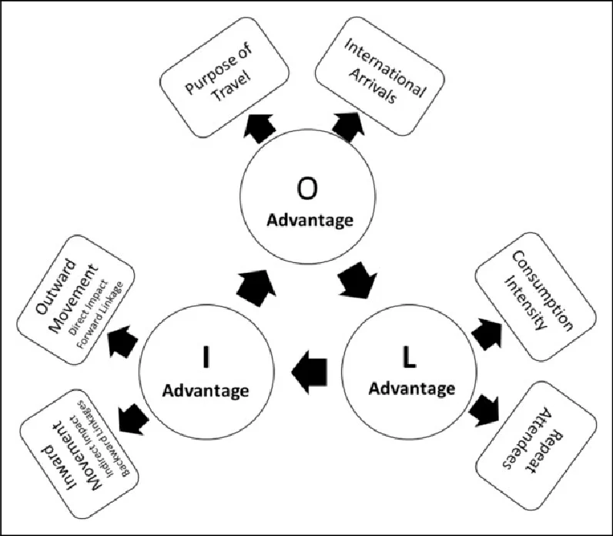
Figure 5: OLI’s framework
(Source: Rivera, Semrad and Croes, 2025)
OLI framework comprises ownership advantages, location advantages and internationalisation advantages. Effective use of all can help organisations to make market entry decisions and identify strategic benefits to establish direct pigeons in the market (Rivera, Semrad and Croes, 2025). Thus, the OLI framework can be a cornerstone of adopting international business expansion activity for Nidec.
OLI Element | Nidec–Nigeria Assessment | Strategic Implication
Ownership (O) | Strong | Nidec's technology, patents, R&D and global expertise provide significant competitive advantages.
Location (L) | Moderate–Strong | Large market and industrial potential are attractive, but infrastructure, inflation and political risks reduce attractiveness.
Internalisation (I) | Strong | Technology protection and quality requirements favour Nidec retaining substantial control.
Overall | Potentially attractive | Entry is justified, but a gradual and risk-controlled approach is preferable.
Table 4: Application of OLI for Nidec Corporation
(Source: Self-Created)
Table 4 shows the application of the OLI framework in terms of Nidec’s business expansion activity into Nigeria. Proper evaluation reveals both the strategic opportunities and better decision-making for Nidec.
Ownership Advantages (O)
In terms of promoting a strong internationalisation approach, the organisation should have substantial ownership advantages. In the case of Nidec, it has advanced electric motor technology, patents, engineering expertise and R&D capabilities (Nidec Corporation, 2026). These resources are proprietary and can enable Nidec to keep its business competitive in the market and distinguish it from other organisations in the market. However, the existence of these resources in the complex market is crucial to maintain business activity, productivity and perform logistics operations in a target market such as Nigeria. The absence of one resource could adversely affect the actual business growth performance of an organization as well as the performance in the long run strategic. Hence, the organisations should carry out a market assessment and market analysis by engaging in surveys with customers, business organizations, and partners in the local market to gain an understanding of the market position before making decision about the expansion of business (Lan, 2023).
Location Advantages (L)
Location advantages are another important factor which helps organisations to make business expansion decisions. Organisations such as Nidec can accurately make business expansion decisions into Nigeria by evaluating the existing population, economic growth, and industrial activity. Specifically there are over 237.5 million of people in Nigeria, with over 56 million of those in the poor and vulnerable category. Firstly, it has the potential of seeing a significant market entry opportunity since Nigeria is one of the biggest countries with the highest population in Africa (World Bank, 2025). But with the rise in the number of poor people, it's not possible for Nidec to build a solid customer base, which can impact the business organizational profitability and the long run performance. In the beginning, the market in Nigeria appears promising, but there is a risk of it providing a good business growth in the long-term.
Internalisation Advantages (I)
Internalisation helps organisations to keep activities within the organisation instead of transferring them to other third parties or external independent firms through outsourcing and licensing. As the internalisation approach is particularly applicable in the case of Nidec it allows for preserving high competitive advantages in the target market while not losing control of the organisation. In addition, the IP protection and ensuring a good product quality must be viewed from an internalisation perspective (Wang and Ayob, 2024). It is therefore advocated that Nidec should venture into the Nigerian market through a wholly owned subsidiary, due to the regulatory and legal challenges in Nigeria. This is also useful in avoiding conflicts in the partnership and ensuring that the maximum profit benefits are gained in the target market.

4. Entry Mode Strategy and Strategic Synthesis

4.1 Historical Entry Mode Pattern
Year | Market | Entry Mode | Strategic Purpose
1990 | Thailand | Greenfield investment | Established manufacturing capacity close to Asian customers.
2006 | France | Acquisition | Acquired automotive motor technology and market capabilities.
2010 | USA | Acquisition | Expanded motors, technology, brands and customer networks (Nidec, 2022).
2012 | Italy | Acquisition | Strengthened industrial automation and energy technologies.
2015-2018 | Europe, USA, India | Acquisition | Acquired Leroy-Somer and Control Techniques, adding 9,500 employees across 42 countries (Nidec, 2022).
2019 -2025 | Global/Embraco | 100% acquisition | Acquired Embraco for ¥122.4 billion to expand refrigeration-compressor technology (Nidec, 2022).
Table 5: Historical Entry Mode Pattern of Nidec
(Source: Nidec, 2022)
Table 5 indicates the historical market entry mode adopted by Nidec from 1990 to 2025, which includes wholly owned subsidiaries, acquisitions, into several countries like Thailand, France, the USA, Italy, India, Brazil, and other markets. From the historical market entry pattern of Nidec, it has been identified that Nidec prefers acquisition, wholly controlled subsidiaries and a selective greenfield investment market entry strategy. From the official M&A strategy, it has been identified that Nidec adopted an acquisition approach to create strong sales channels and obtain digital technologies and created 346 group companies worldwide as of 31st March 2025 (Nidec, 2022). It has further been identified from the historical business expansion table that, from 2006 onwards, acquisition has become increasingly prominent for Nidec. The adoption of the France acquisition approach helped the organisation to maintain strong automatic motor technology and establish a capable business entry in the market. Acquisition is one way to ensure strategic resource allocation and better performance and growth. The organisation took over the Motors brand and the Motors customer network in 2010 and, in 2015, contributed to sustaining its business activities on an international level. The development of 9500 employees in 42 countries demonstrated how acquisition approaches help Nidec to maintain a rabbit business expansion geographically and enhance Technology. An investment of $122.4 billion further demonstrates Nidec's eagerness to seek out complementary Technology and to continue to maintain a robust market position (Nidec, 2022).
Overall, the historical business expansion pattern shows that Nidec uses acquisitions most of the time to accelerate business internationalisation, maintain substantial operational control and obtain technology and a customer base across different markets. However, the strategy cannot be adopted in all countries as there are different rules, regulations and policies which mainly influence the market entry mod selection for Nidec.

4.2 Suitability of Nidec’s Historical Entry Mode for Nigeria
From the historical market entry modes, it is also evident that Nidec entered Thailand by adopting acquisitions of Valeo’s motors and Emerson’s motors & controls. Most of the time, adoption of these approaches provides Nidec with strong control over product quality, customer relationships and intellectual property. In terms of access to the Nigerian market, however, organisation high commitment is important. Despite macroeconomic pressures, the recent GDP growth of 4% has reached $290.8 billion, which is resilient (The World Bank, 2025). These circumstances can be conducive to Nidec achieving a strategic business growth opportunity. However, from the historical performance, everything in this type of activity is important to maintain a strategic business growth opportunity for the organisation.
But Nigeria has limited location specific advantages as it has a smaller customer base, and the purchasing power of its consumers is limited because of a high inflation rate. As shown, Nigeria's inflation rate was 23% in 2025, which meant that Nigeria experienced high inflation and affected the purchasing power of its customers as well as the cost of operating the organisation (MacroTrends, 2025). This has also led to a rise in poverty in the country. Thus, the adoption of an acquisition or Greenfield FDI approach seems to be not suitable in this case. Use of acquisition market entry can also lead to further exposure to the risk of over-planning for local business organisations, potentially challenging reputed business growth opportunity. In addition, it is also essential to have a good infrastructure with the adoption of the acquisition market entry mode. In Nigeria, however, only approximately 40% of the populace has appropriate electrical access, that is, about 80 million people (World Bank, 2026). This means that there is no strict electrical infrastructure and it is not applicable to the adoption of the acquisition approach as Nidec deployed for several years.

4.3 Recommended Entry Mode for Nidec Nigeria
From the available and adopted market henry mode examination reveals that acquisition, wholly owned subsidiary, green field investment will not be so effective for Nidec to enter the Nigerian market. Thus, it is recommended to adopt a joint venture market entry mode with an established electoral-equipment of Nigeria. Ma, Sonobe and Gong (2024) stated that the joint venture market entry mode promotes better control over the products, access to local knowledge, reduces investment risk and improves market responsiveness in a new market. For Nidec, a suitable solution would be to implement a joint venture, because although it is a very strong company, it may be difficult for Nidec to function as a 100 per cent subsidiary organisation in Nigeria. High inflation and low-growth GDP can affect the organisational supply chain performance and disrupt organisational activities. Adoption of a joint venture promotes better control over the organisation in the target market and strengthens capability to build strong customer relationships and understand target market culture (Mumin and Yakubu, 2023). Further, the joint venture is also appropriate for Nidec's transformation of its operations and adds to the firm's ownership advantages. Additionally, a Nigerian partnership also helps to improve location advantages in Nigeria and enhance organisational performance, activity and better technological growth, which is more relevant compared to other available market entry modes like licensing, exports and partnership.

5. Conclusion and Recommendations
In conclusion, the market entry of Nidec into Nigeria significantly represents a long-term opportunity but considerable political-economic infrastructure and cultural challenges. Based on the organisation and Technology capabilities and local responsiveness, expansion into Nigeria can be challenging for the organisation, as Nigeria lacks proper infrastructure and lack of strong purchasing power of customers. Based on the OLI framework, Nigeria's strategic business growth is attractive but its lack of economic stability and market volatility has a significant impact on sustainable business performance in Nigeria. On the other hand though, a joint venture market entry mode with a local partner is recommended to enter the Nigerian market and enjoy location advantage and ownership advantage and to make a quick start into the market in Nigeria, which could result in a steady initial growth of Nidec's business.

Section 2: Reflection
Description
During the Master of Business Administration programme, I was engaged to perform the international business concept module, where I selected Nidec Corporation as the business organisation, and selected Nigeria as the target market entry country. Nidec Corporation is a Japanese multinational corporation in the electronics technology and devices manufacturing industry (NIDEC, 2024). I have used the knowledge that I acquired as a result of the module to complete this module assignment and I have taken a structured manner in conducting research and in writing my report for this module. During the data collection activities, I have mainly collected secondary data available in public sources like Google Scholar, ProQuest, and other industrial and business-related data evidence. Additionally, I have applied the OLI framework, Hofstede's cultural dimension model and Bartlett and Ghoshal’s international business expansion strategies to analyse Nidec’s current market expansion activity and future expansion planning to enter the Nigerian market.
Feelings
During the initial time after starting the assignment, I felt relatively nervous as this assessment seemed to be complex to complete for me as it includes different theoretical implications, data collection and proper use of data to find critical strategic solutions and adopt a better market entry strategy for Nidec to enter the Nigerian market. I sought assistance from my colleagues and my supervisor who showed me how to use the theories and how to seek out the sources to get credible data evidence such as Nigerian GDP rate, inflation rate, population, political stability index, regulatory acts and other reliable data evidences. I realised that Nigeria has strong legal strength but a high inflation rate, volatile GDP growth and low purchasing power of customers, making it not suitable for Nidec to enter the market. Additionally, I have applied the OLI framework to check Nidec’s advantages and why it is not suitable to enter the Nigerian market. Rahman et al. (2026) mentioned that the OLI framework is used to identify ownership advantage, location advantage and internalisation advantage. The findings indicate that although they strongly agree with these three advantages, weak infrastructure and low purchasing power of the customers coupled with political complexities can pose problems for Nidec to enter the Nigerian market.
Evaluation
Although I encountered several difficulties while I was doing the assessment, I have achieved many learning outcome and it helps me improve my skills. . First of all, the critical data collection and analysis approach help me to improve my data analytic skills and research skills. Han and Ren (2024) stated that in professional life, research and data analytic skills are important to maintain strong career growth opportunities. On the other hand, based on the historical market and strategic adoption of Nidec, I have analysed and suggested better market and strategy to enter the Nigerian market. However, during performing the external market analysis, it was challenging to avoid purely descriptive analysis, and strong guidance from my supervisor helped me to address this challenge and create a critical analysis of the Nigerian current business market and suggest to Nidec to make strategic decision to enter the Nigerian market.
Analysis
After performing overall market entry analysis, I have suggested adopting a joint venture market strategy for Nidec to enter the Nigerian market. joint venture strategy provides better flexibility and control over the organisation and improves access to local information and public requirements, which promotes better decision-making in enhancing organisational growth and strategic profit-making approaches (Rijal, 2023). It has also been established that Nigeria is one of the emerging markets, which have been identified as having a great opportunity to improve organisational growth despite the various challenges encountered in the market. I realise that better control over the organisation's strategic relationship with political leaders and collaboration with developed local organisations can help to promote better strategic market entry and business growth development approaches for the organisation. Overall, I have applied the Oli framework, performed external market analysis, and align Nidec’s international business growth strategy with Bartlett and Ghoshal’s framework. This activity enhanced my knowledge, critical thinking, problem solving, and achieve better decisions to improve market expansion growth for the organisation.
Conclusion
Overall I feel that I have gained a good knowledge of the activities of business market expansion and decision making. . Additionally, I have applied different frameworks and theories and align with organisational business growth and an international approach. It has honed my critical thinking skills when it comes to International strategies and taking evidence-based decisions to help facilitate market entry into a new country.
Action Plan
In terms of promoting my future performance, I will adopt more systematic research process, and I will join workshops or online classes to enhance my data collection and analytical skills. I think I can improve these skills in the next 3 months. Additionally, I will emphasize more external environmental factor analysis, and practice critical writing skills to decrease descriptive writing approaches. I will practise regular critical writing activities to build my critical writing skills in the next four-month period.

References
Al-Jundi, S., Shuhaiber, A. and Al-Emara, S.S., (2022). The effect of political instability and institutional weakness on administrative corruption. Contemporary Economics, 16(2), pp.168-181. https://papers.ssrn.com/sol3/Delivery.cfm?abstractid=4267054
Baporikar, N., (2025). Hierarchy in Organizational Design as a Strategy to Build Resilience. In Enhancing Resilience in Business Continuity Management (pp. 77-104). IGI Global Scientific Publishing. https://www.igi-global.com/chapter/hierarchy-in-organizational-design-as-a-strategy-to-build-resilience/370110
Batschauer da Cruz, C.B., Eliete Floriani, D. and Amal, M., 2022. The OLI Paradigm as a comprehensive model of FDI determinants: a sub-national approach. International Journal of Emerging Markets, 17(1), pp.145-176. https://www.researchgate.net/profile/Claudia-Cruz-7/publication/329151644_The_Eclectic_Paradigm_as_a_Comprehensive_Model_to_Analyze_Subnational_Determinants_of_FDI/links/5f76e322a6fdcc0086502bc6/The-Eclectic-Paradigm-as-a-Comprehensive-Model-to-Analyze-Subnational-Determinants-of-FDI.pdf
Buckley, P.J., (2023). Corporate reactions to the fracturing of the global economy. International Business Review, 32(6), p.102014. https://eprints.whiterose.ac.uk/id/eprint/185964/3/Fracturing%20the%20Global%20Economy.pdf
Carrière-Swallow, Y., Deb, P., Furceri, D., Jiménez, D. and Ostry, J.D., (2023). Shipping costs and inflation. Journal of International Money and Finance, 130, p.102771. https://pmc.ncbi.nlm.nih.gov/articles/PMC9700066/pdf/main.pdf
Finance.gov.ng (2025). Nigeria records over 4% GDP growth in Q4 2025, signaling broad-based economic growth and momentum – federal ministry of finance. [online] Finance.gov.ng. Available at: https://finance.gov.ng/nigeria-records-over-4-gdp-growth-in-q4-2025-signaling-broad-based-economic-growth-and-momentum/ [Accessed 6 Aug. 2026].
Han, F. and Ren, J., (2024). Analyzing big data professionals: Cultivating holistic skills through university education and market demands. IEEE access, 12, pp.23568-23577. https://ieeexplore.ieee.org/iel7/6287639/6514899/10424984.pdf
Isolauri, E.A. and Ameer, I., (2023). Money laundering as a transnational business phenomenon: a systematic review and future agenda. Critical Perspectives on International Business, 19(3), pp.426-468. https://www.emerald.com/cpoib/article-pdf/19/3/426/161763/cpoib-10-2021-0088.pdf
Kole, J.K.T., (2025). Applying Hofstede’s cultural dimensions in education: Insights, critiques, and implications for diverse classrooms. Open Journal of Social Sciences, 13(5), pp.94-110. https://www.scirp.net/pdf/jss_1769799.pdf
Kopczewska, K., Kubara, M. and Kopyt, M., (2024). Population density as the attractor of business to the place. Scientific Reports, 14(1), p.22234. https://www.nature.com/articles/s41598-024-73341-8.pdf
Lan, T.T.N., (2023). Market development strategy of renewable energy industry in Vietnam. International journal of business and globalisation, 1, pp.1-9. https://www.researchgate.net/profile/Tony-Ng-Hoang-Tien-Nguyen/publication/368987885_Market_development_strategy_of_renewable_energy_industry_in_Vietnam/links/6547880db86a1d521bb90138/Market-development-strategy-of-renewable-energy-industry-in-Vietnam.pdf
Lehmann, H. (2022). International Information Systems in the literature. The Dynamics of International Information Systems, pp.9–17. doi:10.1007/978-1-4419-5750-4_2.
Ma, W., Sonobe, T. and Gong, B., (2024). Linking farmers to markets: Barriers, solutions, and policy options. Economic Analysis and Policy, 82, pp.1102-1112. https://www.sciencedirect.com/science/article/pii/S0313592624001188
MacroTrends (2025). Nigeria inflation rate 1960-2024. [online] Macrotrends.net. Available at: https://www.macrotrends.net/global-metrics/countries/NGA/nigeria/inflation-rate-cpi [Accessed 6 Aug. 2026].
Madueke, O., (2026). Weak parties, strong elites: political institutionalisation and democratic fragility in Nigeria. African Identities, pp.1-20. https://www.tandfonline.com/doi/pdf/10.1080/14725843.2026.2657558
Mumin, M.A. and Yakubu, I.N., (2023). Beyond supply chains: investigating the economic impact of logistics performance. Journal of International Business, Economics and Entrepreneurship, 8(2), pp.7-16. https://journal.uitm.edu.my/index.php/JIBE/article/view/879/162
Nidec (2022). Global Business Expansion and Active M&A. [online] NIDEC CORPORATION. Available at: https://www.nidec.com/en/corporate/about/history/nidec_history/chapter3/ [Accessed 7 Aug. 2026].
NIDEC (2024). NIDEC corporation. [online] NIDEC CORPORATION. Available at: https://www.nidec.com/en/ [Accessed 8 Aug. 2026].
Nidec Corporation (2026). Nidec. [online] NIDEC CORPORATION. Available at: https://www.nidec.com/en/corporate/network/ [Accessed 8 Aug. 2026].
Nidec Corporation (2026b). [online] NIDEC CORPORATION. Available at: https://www.nidec.com/en/corporate/network/rd/ [Accessed 8 Aug. 2026].
NIPC (2025). About us. [online] Nigerian Investment Promotion Commission. Available at: https://nipc.gov.ng/about-us [Accessed 6 Aug. 2026].
Nunes, R.D.C., (2024). Technical Progress And Technological Dependence In Developing Economies. IOSR Journal of Humanities and Social Science (IOSR-JHSS), 29(10), pp.07-17. https://www.researchgate.net/profile/Ricardo-Nunes-9/publication/384561481_Technical_Progress_And_Technological_Dependence_In_Developing_Economies/links/66fd3709b753fa724d5691c9/Technical-Progress-And-Technological-Dependence-In-Developing-Economies.pdf
Rahman, A., Rowlinson, S., Xia, B., Mahmood, M.N. and Hubbard, B., (2026). Testing the multinational contracting OLI framework: Australia as a host market. Engineering, Construction and Architectural Management, 33(8), pp.6464-6488. https://www.academia.edu/download/124852648/Published_Paper_2_2025_10_1108_ecam_12_2024_1651.pdf
Rajeh, W., (2022). Hadoop distributed file system security challenges and examination of unauthorized access issues. Journal of Information Security. https://www.academia.edu/download/84349786/PaperDownload.pdf
Rijal, S., (2023). The importance of community involvement in public management planning and decision-making processes. Journal of Contemporary Administration and Management (ADMAN), 1(2), pp.84-92. http://journal.literasisainsnusantara.com/index.php/adman/article/download/27/42
Ristovska, N., (2022). Developing Strategic Framework for Competitiveness in the Global Market. Икономика и управление, 19(1), pp.52-64. http://em.swu.bg/images/SpisanieIkonomikaupload/FullText/Full_EM_XIX_1_2022_compressed.pdf#page=57
Rivera, M.A., Semrad, K.J. and Croes, R. (2025). The internationalization benefits of a music festival. Tourism Economics, 22(5), pp.1087–1103. doi:10.5367/te.2015.0485.
The Culture Factor (2025). Country comparison tool. [online] Theculturefactor.com. Available at: https://www.theculturefactor.com/country-comparison-tool?countries=nigeria [Accessed 7 Aug. 2026].
The World Bank (2025). Nigeria | data. [online] Worldbank.org. Available at: https://data.worldbank.org/country/nigeria [Accessed 6 Aug. 2026].
Transparency (2026). 2025 Corruption perceptions index - explore Nigeria’s results. [online] Transparency.org. Available at: https://www.transparency.org/en/cpi/2025/index/nga [Accessed 5 Aug. 2026].
Wang, H. and Ayob, A.H., (2024). Mental Capital and the Internationalization of Chinese IP-Sensitive Enterprises: The Impact of WTO Intellectual Property Protection Policies on Entrepreneurial Performance. China and WTO Review, 10(2), pp.38-54. https://cwto.net/index.php/CWR/article/download/242/180
WIPO (2022). Patents and designs act (chapter 344). [online] Wipo.int. Available at: https://www.wipo.int/wipolex/en/legislation/details/5414 [Accessed 6 Aug. 2026].
Works, H.I., (2022). Paper Example on International Strategic Management. https://proessays.net/essays/paper-example-on-international-strategic-management
World Bank (2024). Staying the course on reforms: Progress amidst challenges. [online] World Bank. World Bank Group. Available at: https://www.worldbank.org/en/news/press-release/2024/10/17/nigeria-staying-the-course-on-reforms-progress-amidst-challenges [Accessed 5 Aug. 2026].
World Bank (2025). Nigeria | World Bank Group. [online] Worldbank.org. Available at: https://www.worldbank.org/ext/en/country/nigeria [Accessed 8 Aug. 2026].
World Bank (2026). Expanding Nigeria’s mini grid market. [online] Worldbank.org. Available at: https://www.worldbank.org/en/news/feature/2025/03/07/expanding-nigeria-s-mini-grid-market [Accessed 8 Aug. 2026].
Worldscorecard (2024). Nigeria’s Political Stability. [online] worldscorecard. Available at: https://worldscorecard.com/scorecards/nigerian-scorecard/political-stability [Accessed 5 Aug. 2026].
Żemojtel-Piotrowska, M. and Piotrowski, J., (2023). Hofstede’s cultural dimensions theory. In Encyclopedia of sexual psychology and behavior (pp. 1-4). Cham: Springer International Publishing. https://www.researchgate.net/profile/Magdalena-Zemojtel-Piotrowska/publication/371822907_Hofstede%27s_Cultural_Dimensions_Theory/links/65ba71e434bbff5ba7db3ff0/Hofstedes-Cultural-Dimensions-Theory.pdf

