The Task is to design and build a database for a book store looking to automate and improve on customer service. The design involves entity relationship diagram and normalisation to 3NF. This report articulates the process taken to achieve this, from planning to implementation and testing.
Dylan’s Book Store
Database Design in Access
1809693 - Mark Huntly
School of Applied Computing
Web Development Level 4
Table of Contents
1.0 Planning 2
2.0 Implementation 6
3.0 Testing 8
4.0 Conclusion 9
References 9
Appendix 10

Planning
Planning is key to the good implementation of a seamless database, from the data flow to the entity relationship diagram (ERD) [1] and even the design and flow of the forms. After establishing the data flow and tables needed, through sketches and whiteboard (see figure 1),
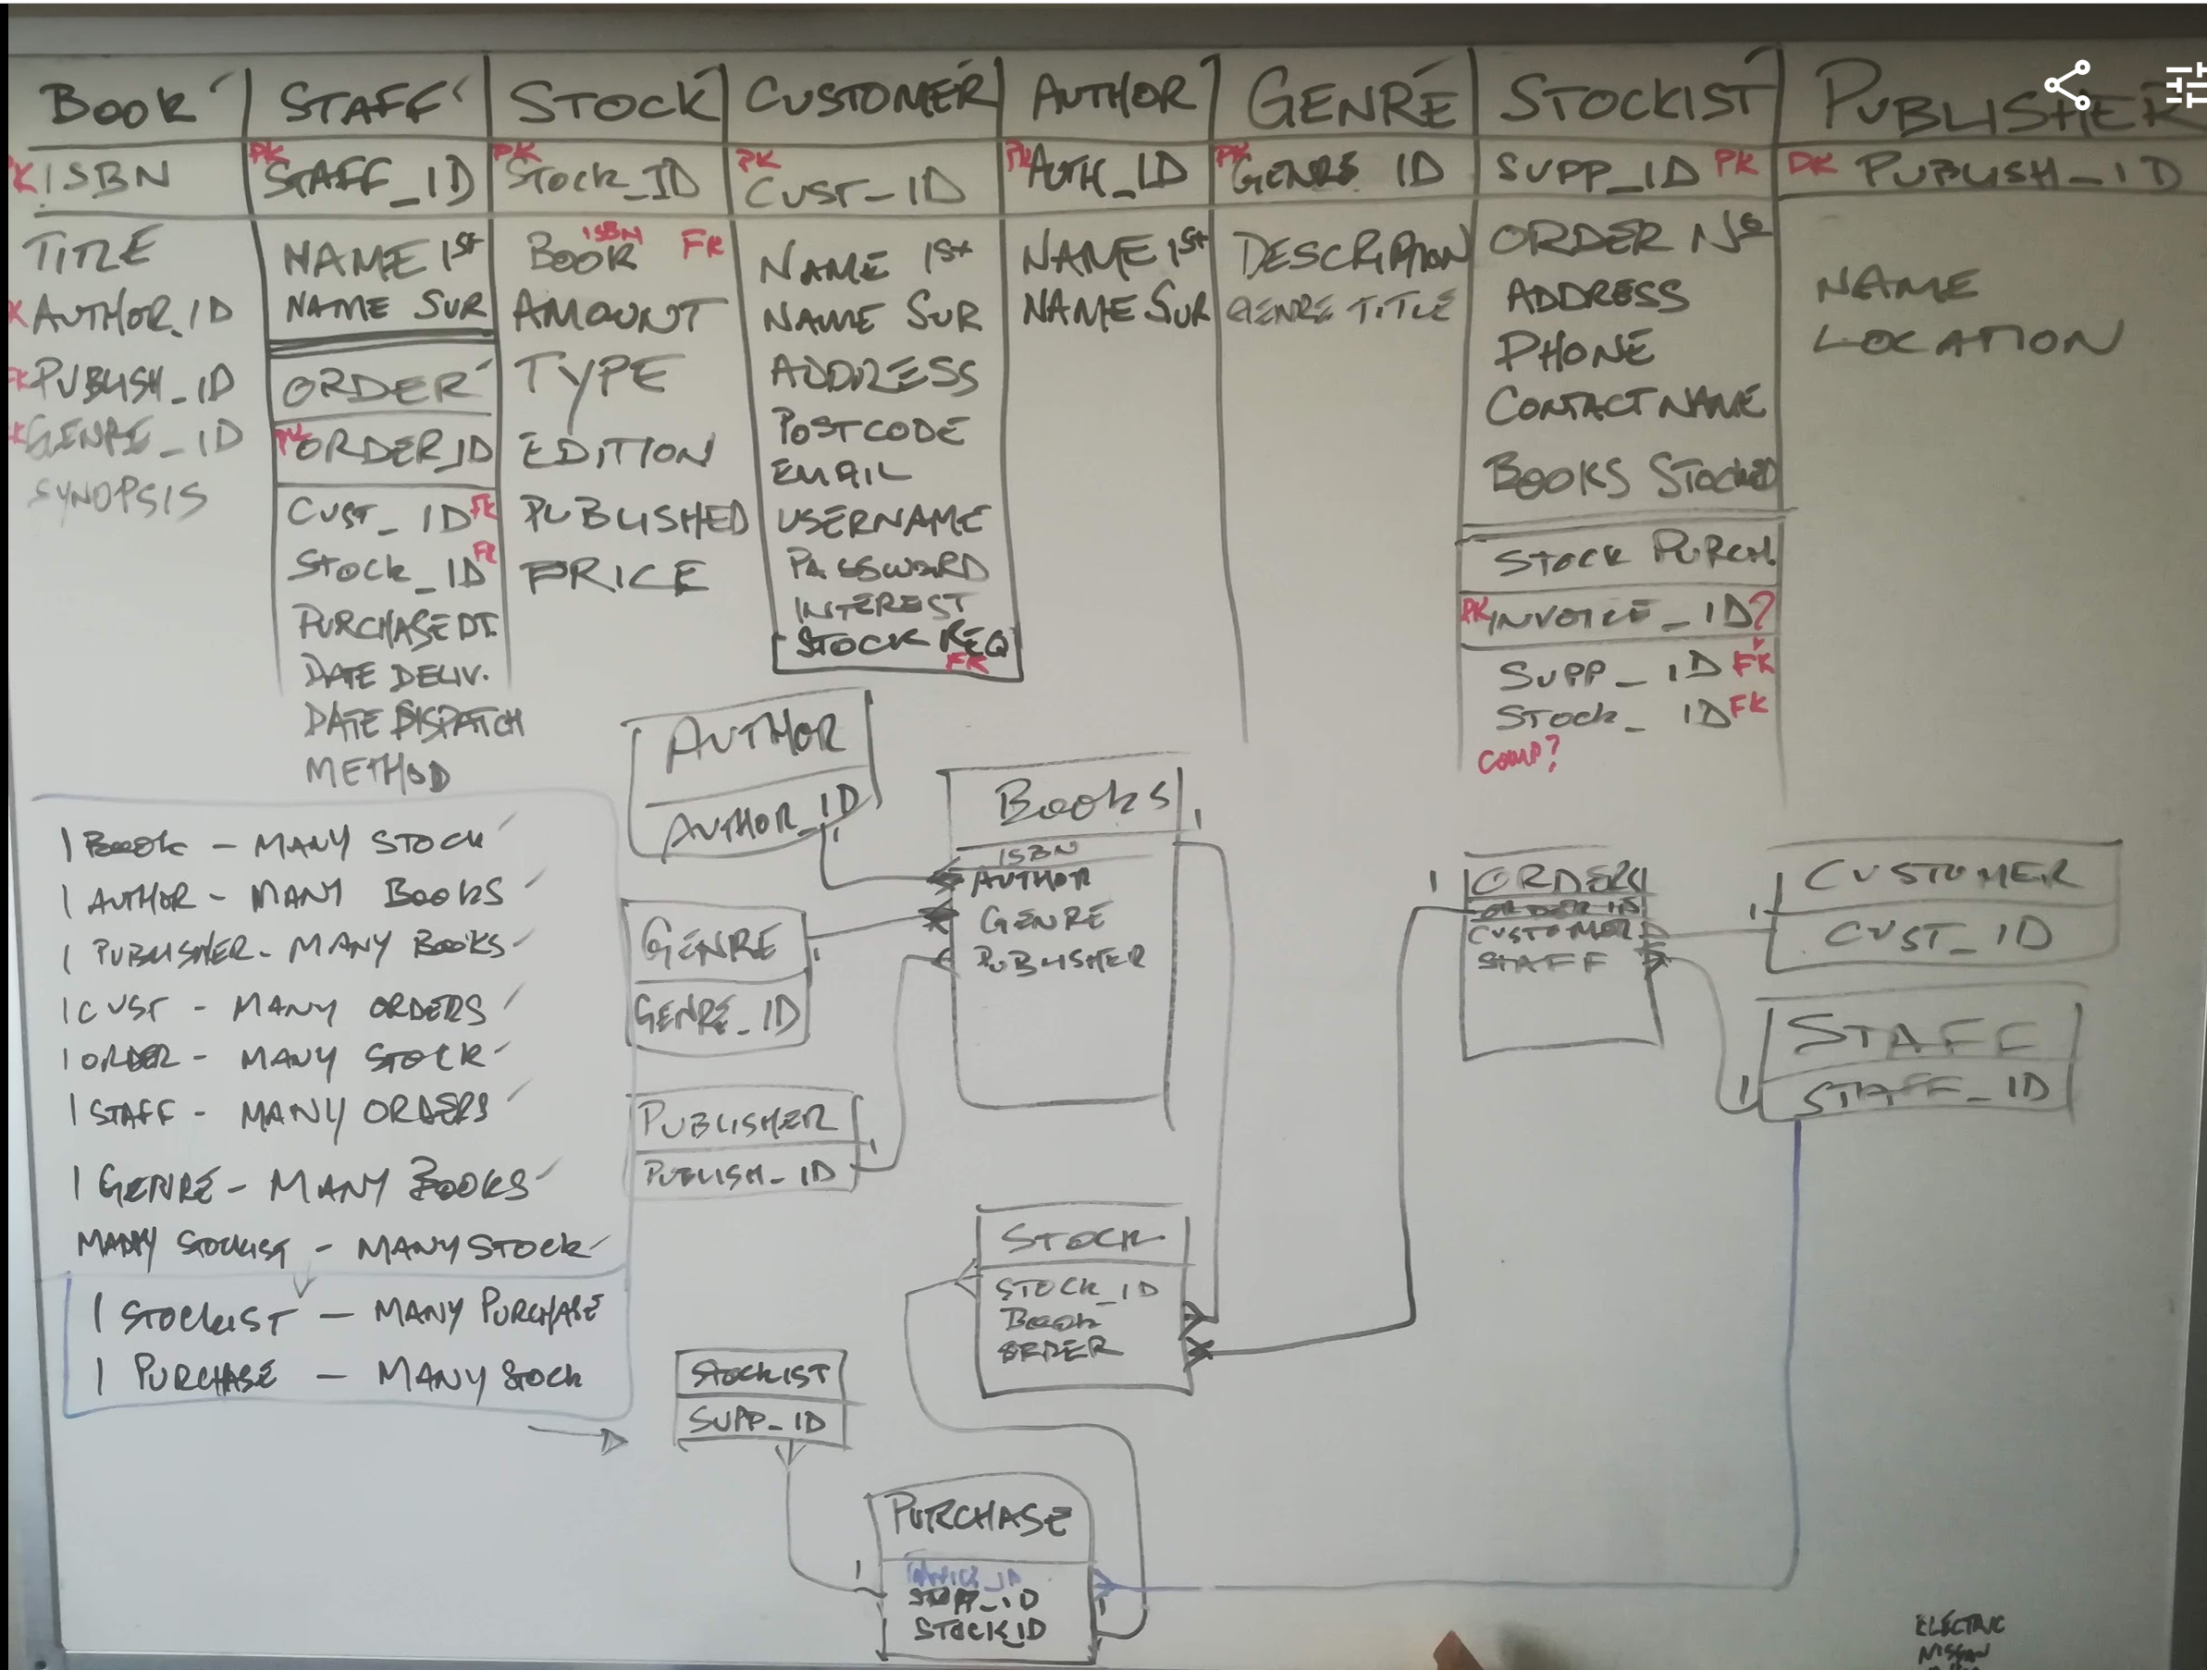
Figure 1 - Whiteboard Data Table Design

the next stage was checking the normalisation. This was done using all the fields in one table and running through the process from 1NF (normal form) through to 3NF. [2]
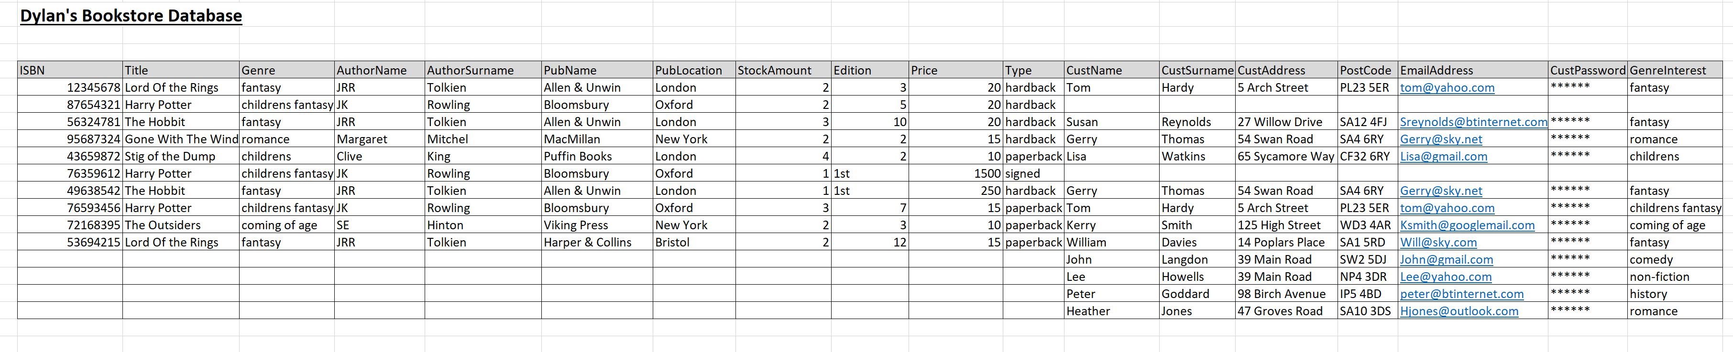
Figure 2 - Full table with all fields
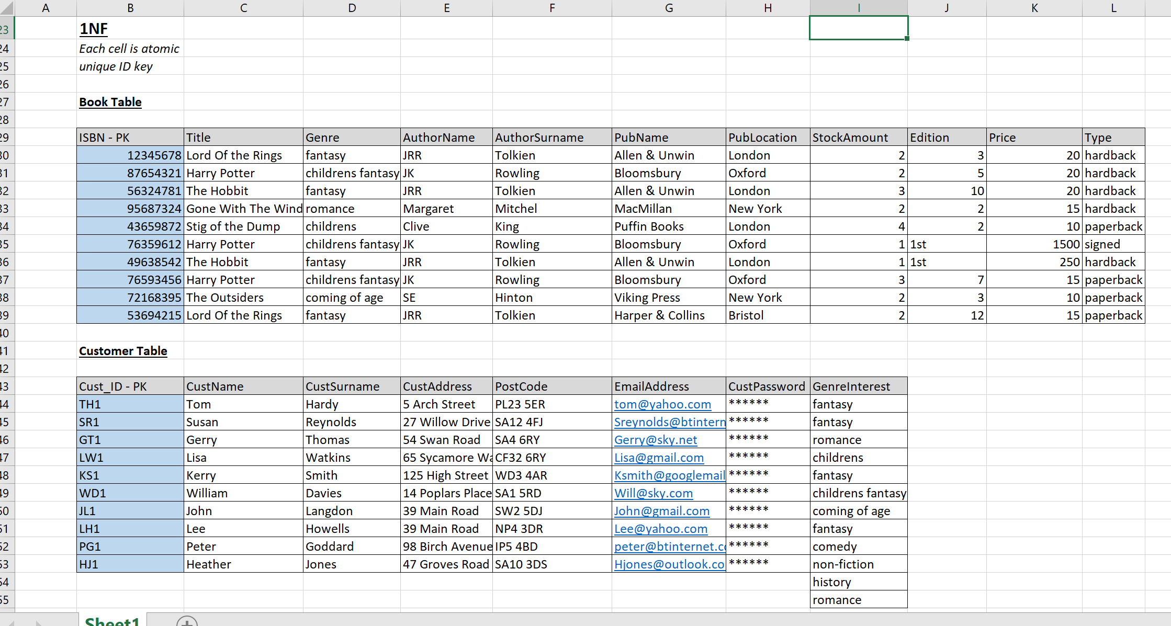
Figure 3 - Tables to 1NF
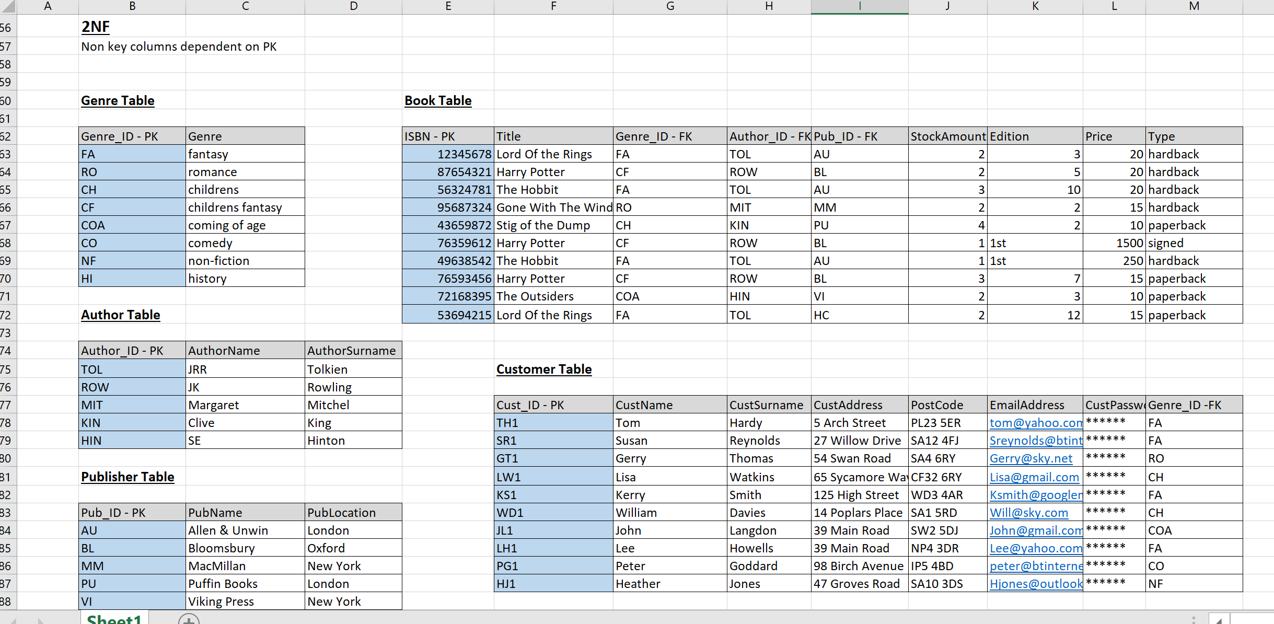
Figure 4 - Tables to 2NF
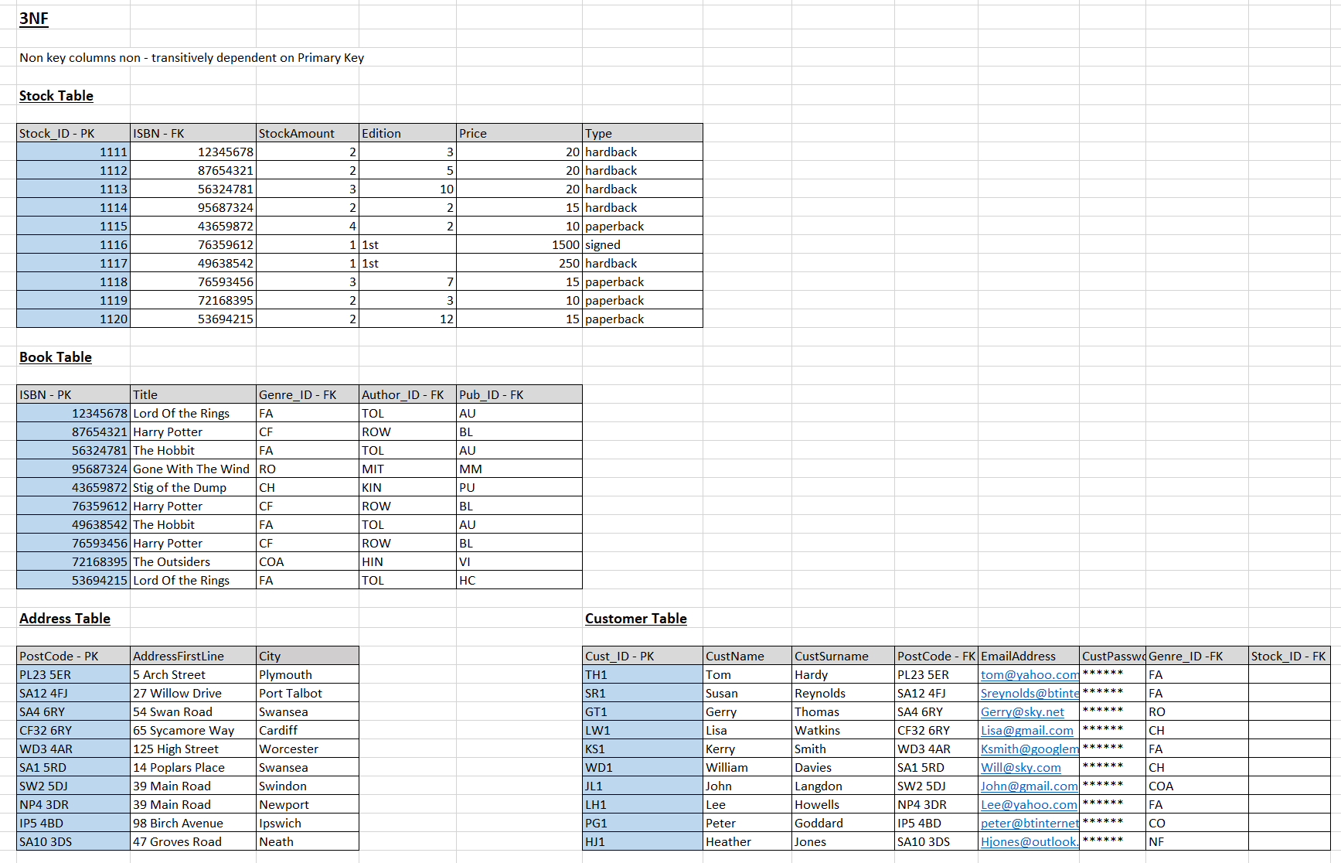
Figure 5 - Tables to 3NF
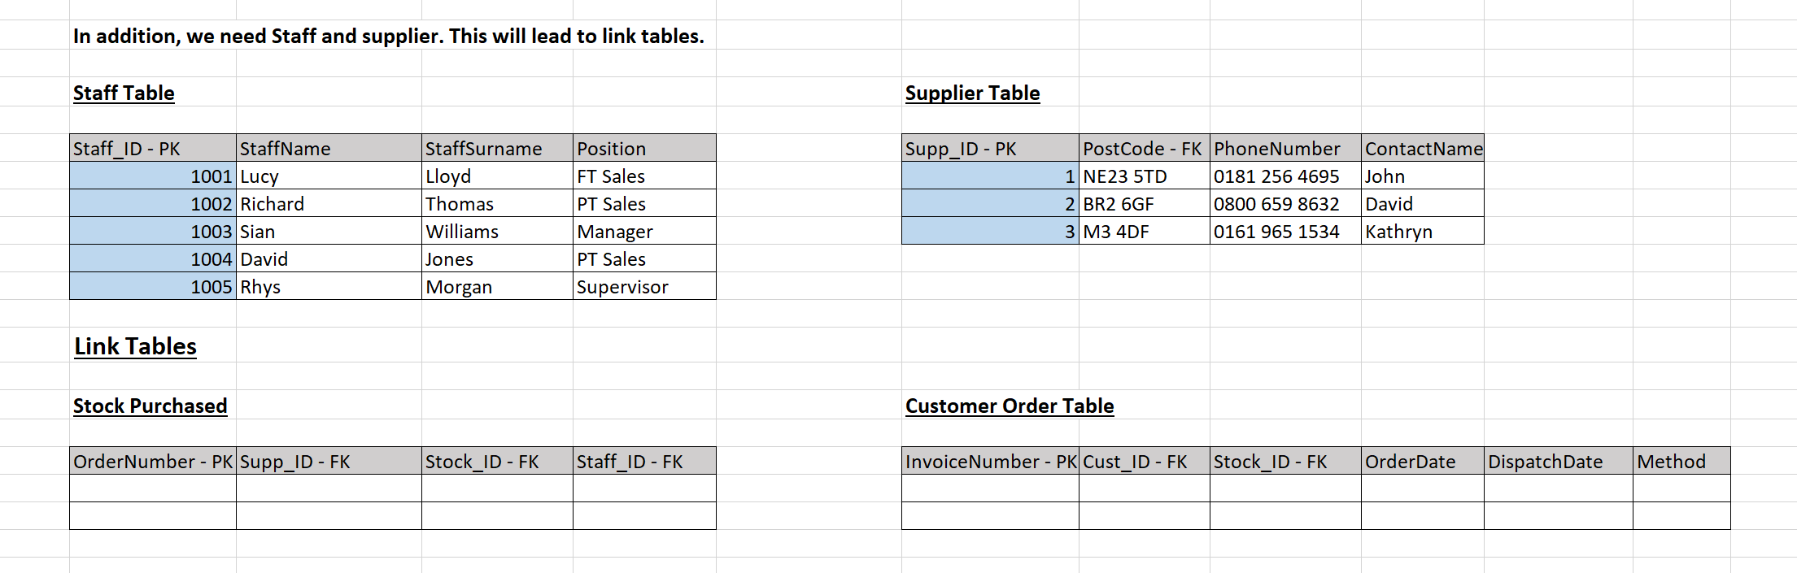
Figure 6 - Additional Tables
Following this process, and using the normalised tables created, an ERD was finalised.

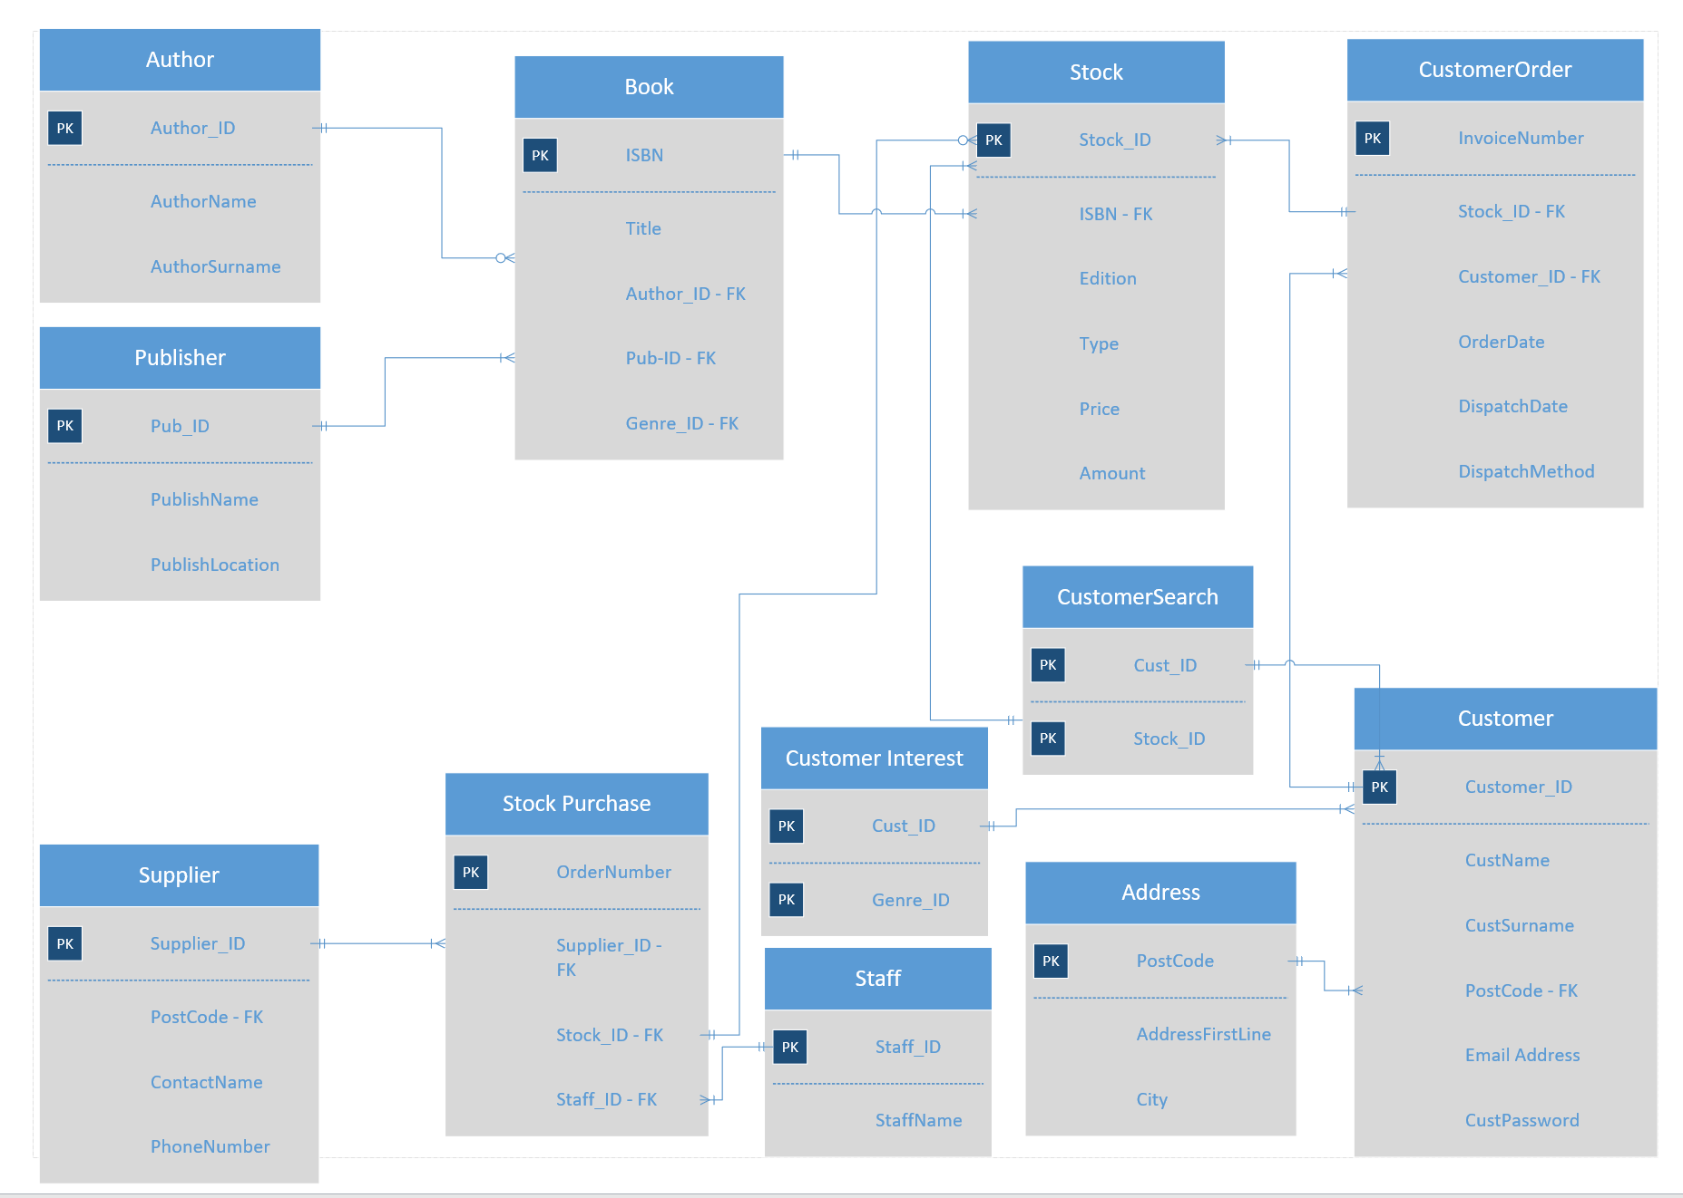
Figure 7 - Original ERD Design
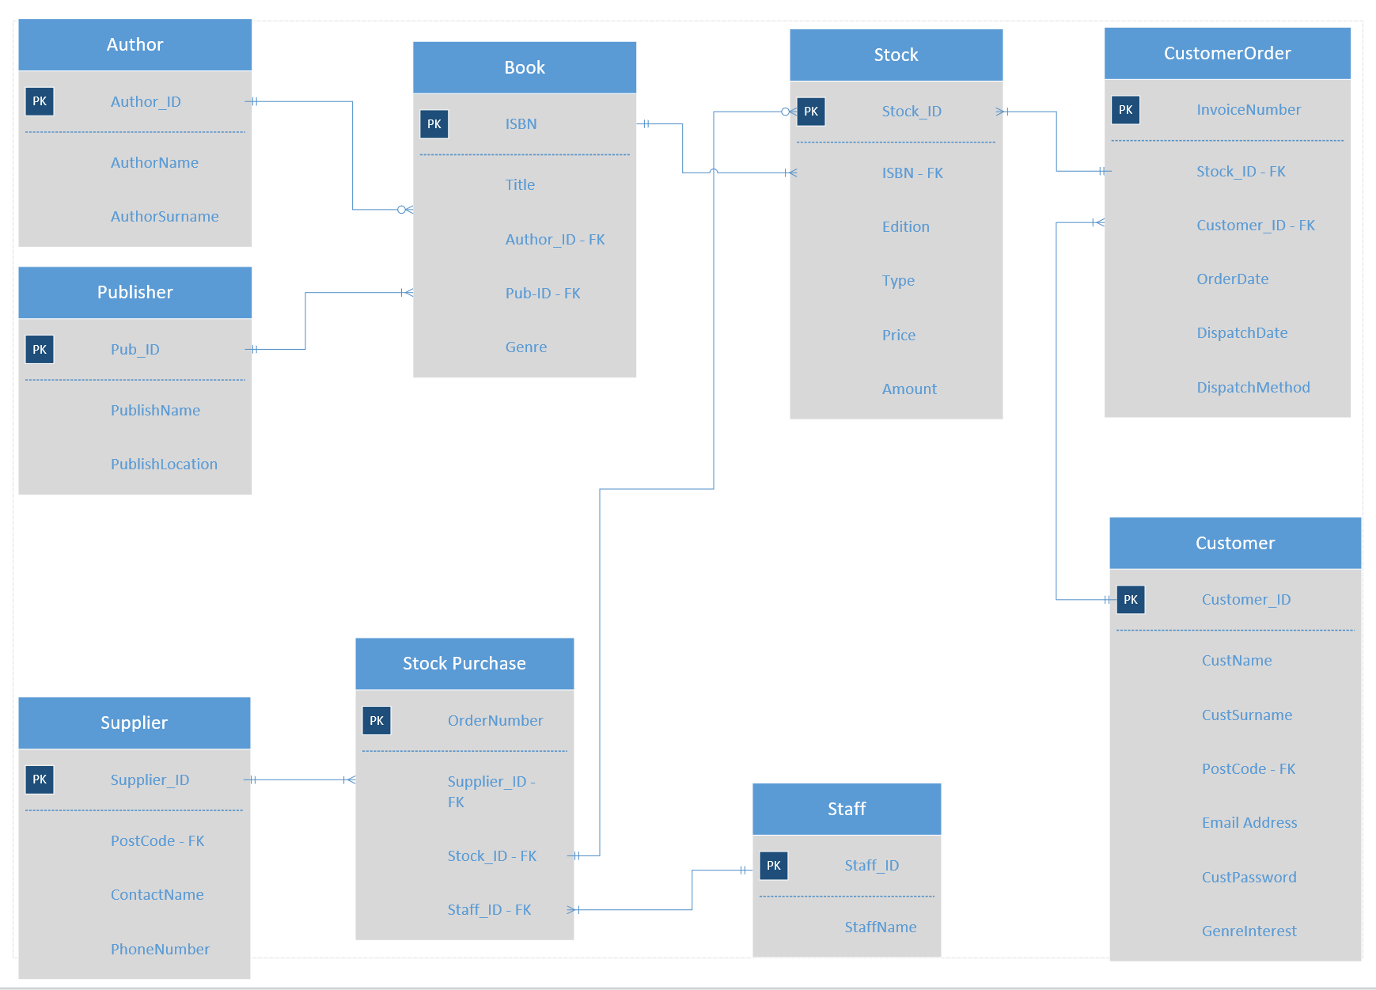
Figure 8 - Final ERD Design
It was key to then check the relationships between the tables and ensure their integrity. Although having the good plan and design in place, it is always worth keeping a flexible approach to be able to change what may not work or may work better.

Implementation
Once the plan is in place, the database is created, as per brief, using Microsoft Access. Initially the tables have been formed using programming with SQL. Some adjustment was made to the fields of the tables to allow for lookups through the design mode.
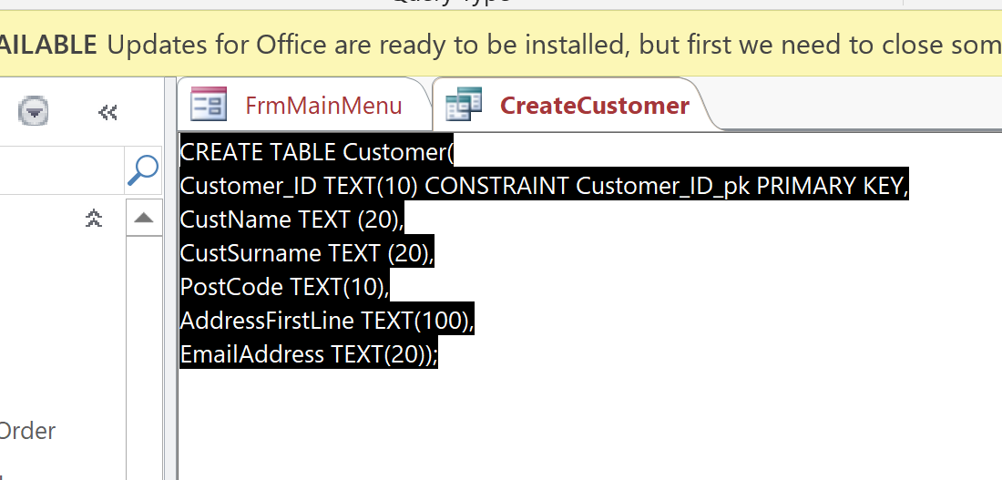
Figure 9 - Example Of SQL in MS Access
Once completed, it is possible to show the relationship diagram and test the integrity of its relationships. Test data is then generated to populate the tables so that they can be fully tested, and queries can be produced.
The next stage is to produce the queries necessary for the requirements of the brief. It is important to form the queries correctly as to enable the lookups needed through table relationships. From the queries, the tables and reports can be generated based on the needs. It is important at this point to ensure the naming conventions are used, Tbl for table, Qry for query, Frm for form etc. The reports and tables are generally lookups for the information needed. Within Access, this was done using the form wizards, creating buttons for navigation and operation, removing visuals such as navigation bar, and positioning the layout. Each form was generated, as per the brief, to allow the user to navigate through the information, create records and lookup data. For things like customer ordering, it was best done using an embedded form, to allow stock entry. The calculations were also included to allow for line totals and grand total. Finally, a main menu was created and set to open when Access is opened to allow smooth operation for the user.

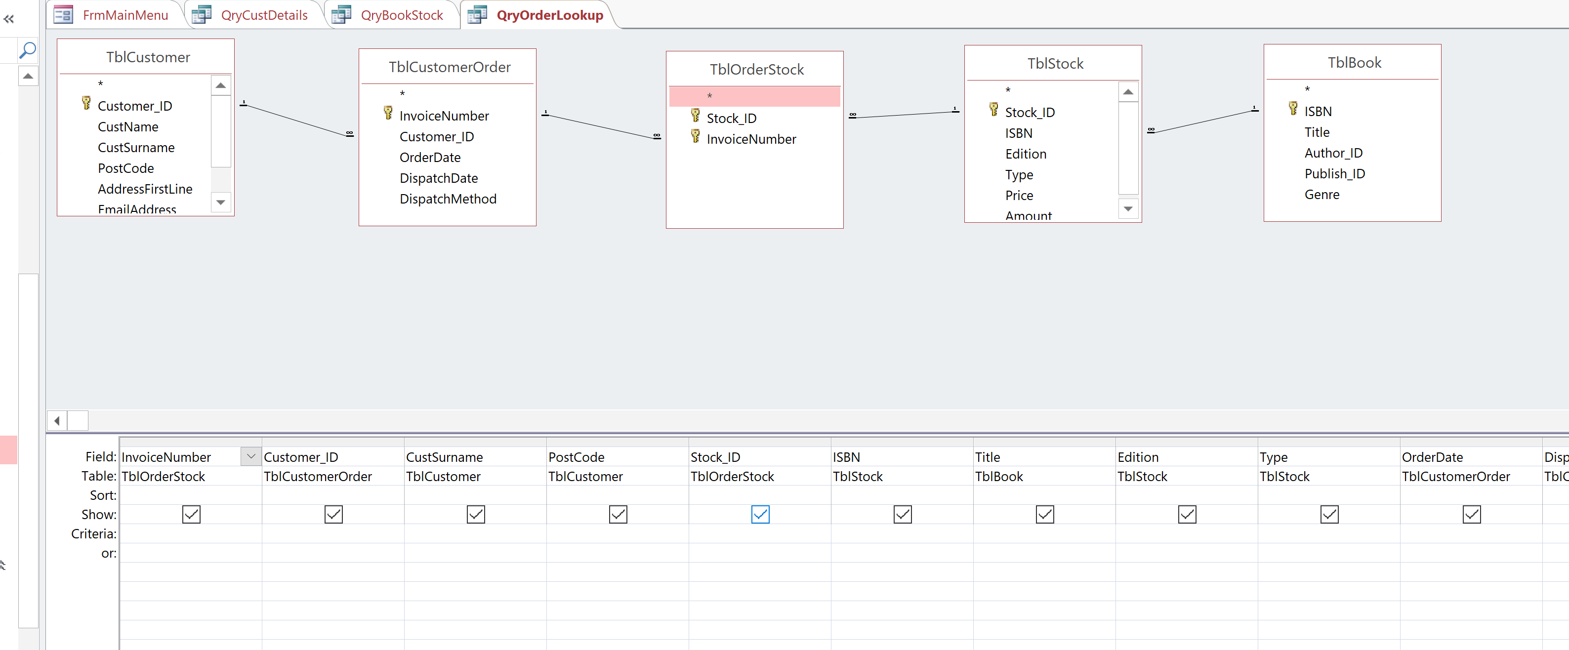
Figure a0 - Query Creation in MS Access
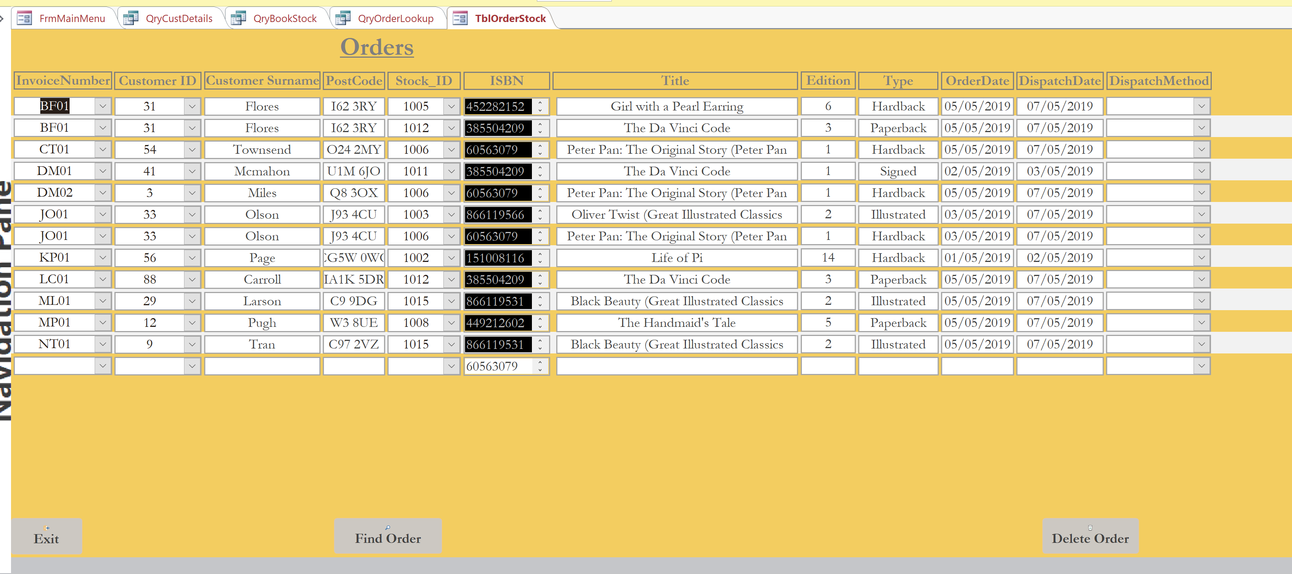
Figure 1b - Form created from query in MS Access
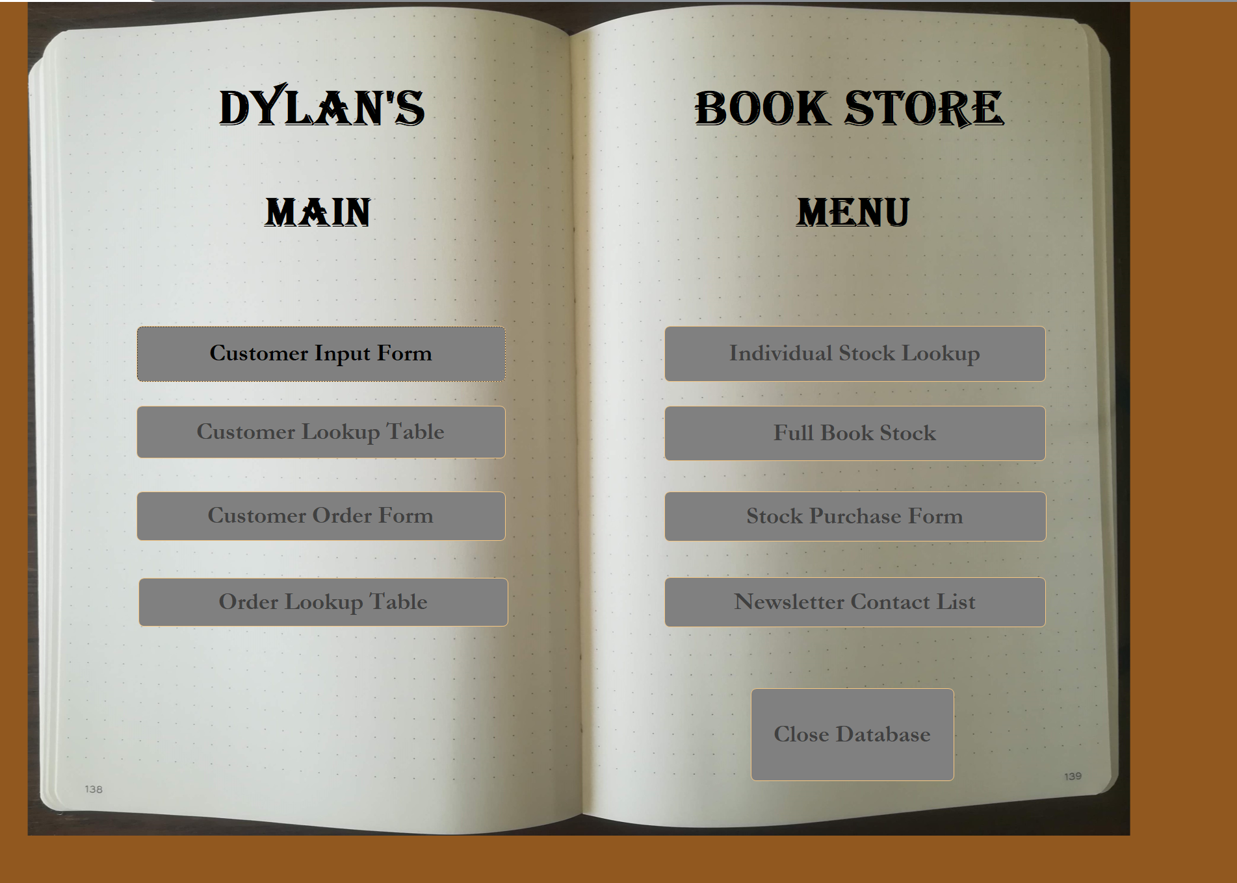
Figure 1c - Main Menu in Access

Testing
Whilst testing through the forms and lookups, it was evident that the consistency was needed through the queries. Some changes were made for this. It was also evident that some of the table fields needed to be changed and some field properties were needed to be changed, to lookup / combo boxes for example. By doing this it allowed a smoother operation and navigation of the database. These changes were made as testing was carried out throughout the build.
Once the database was complete, all functions and operations were tested to ensure navigation was smooth, data entry was possible, all tables gave correct data, and the integrity of the data was intact.
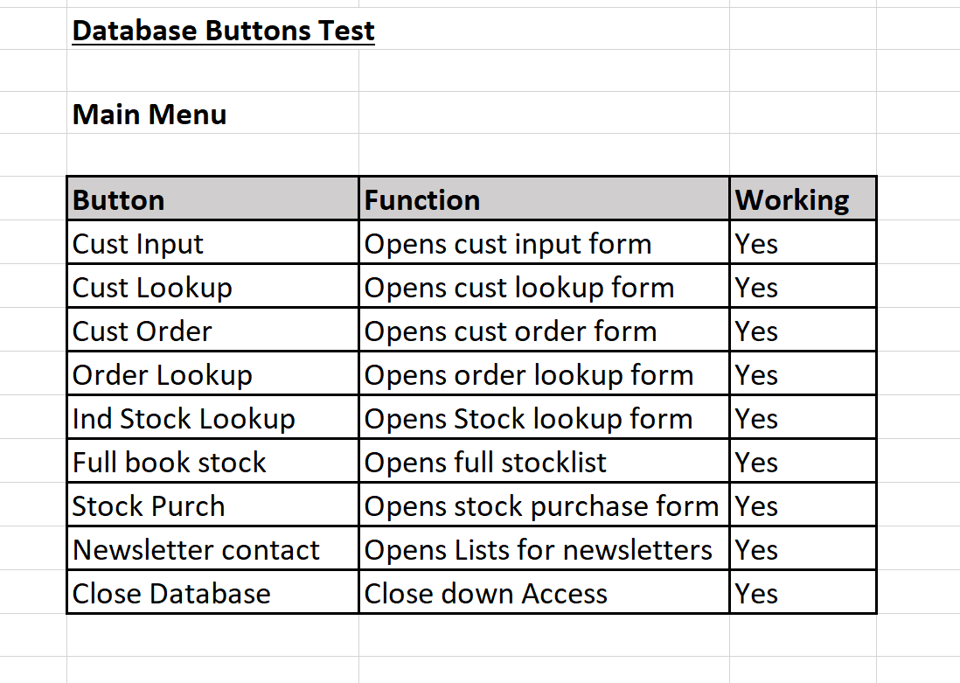
Figure 1d - Example of button testing
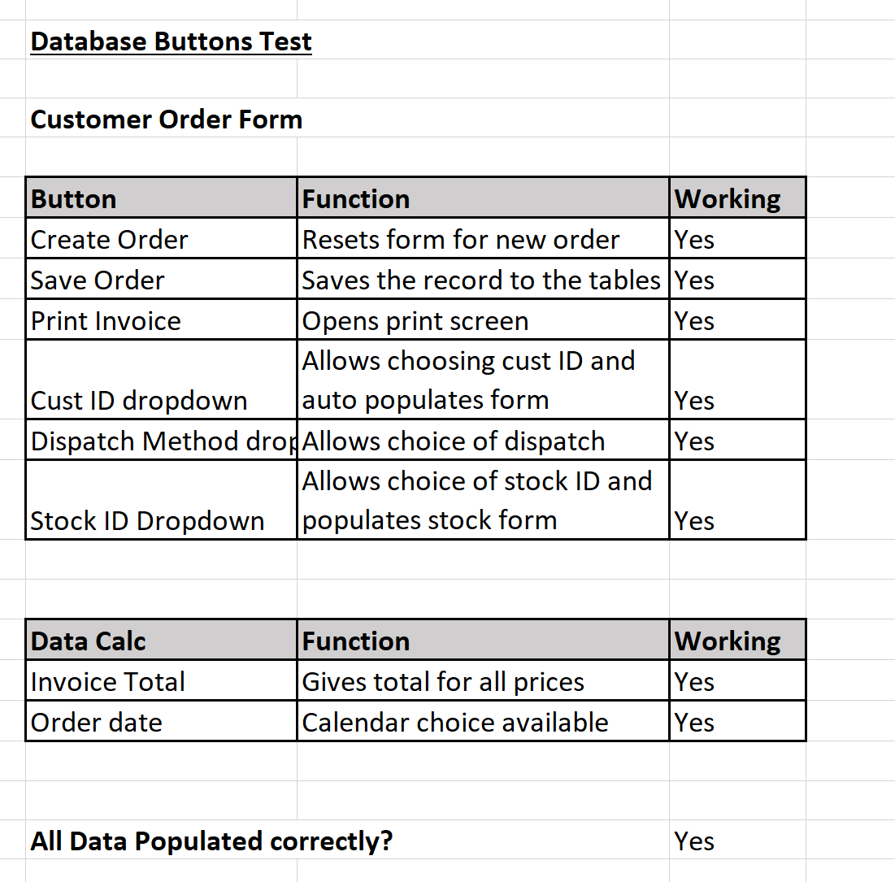
Figure e - Example of form testing

Conclusion
The smooth operation and integrity of a database is important. It is vital to ensure a good plan through data flow diagrams and entity relationship diagrams, ensuring the relationships are correct. Queries are the backbone to the navigation, with forms being built from these.
To improve this database, exploration of the database security would be undertaken, ensuring that the data integrity was maintained through authorisation and accountability of persons using the database.

References

[1] | S. Bagui and R. Earp, Database Design Using Entity-Relationship Diagrams, Auerbach Publications, 2003.
[2] | T. Connolly and C. Begg, Database Systems A Practical Approach to Design, Implementation, and Management, 5th ed., Harlow: Pearson Education, 2015.

Appendix
Screenshots of Forms
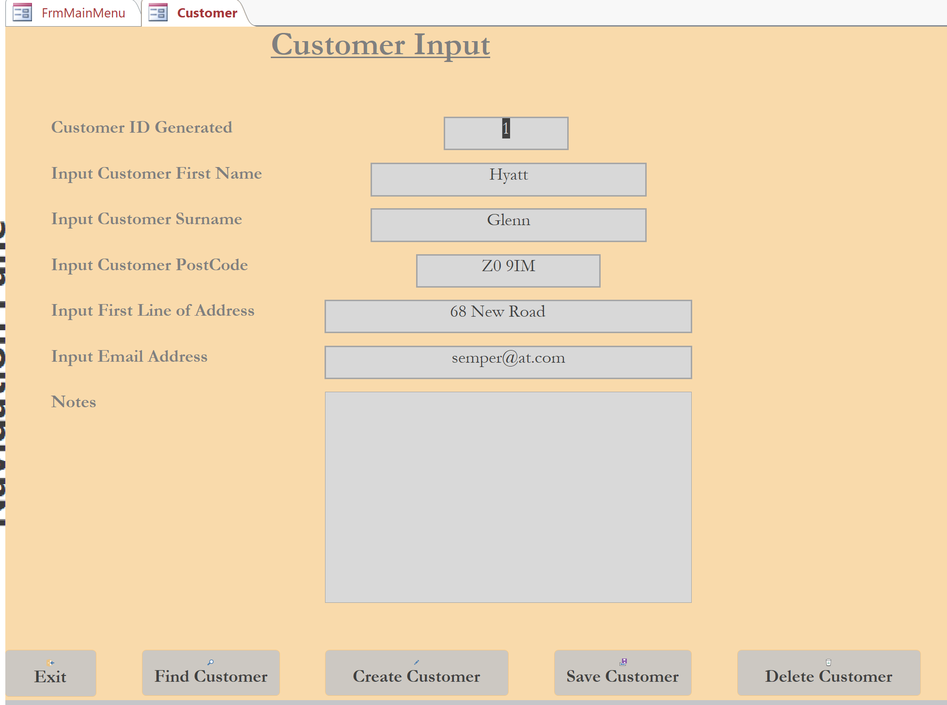
Customer Input Form
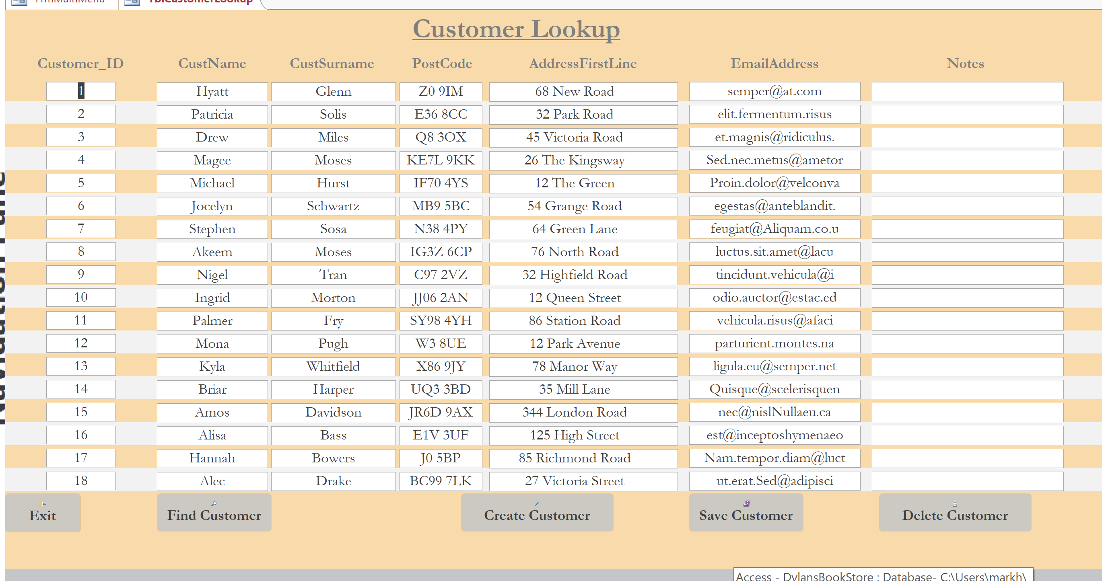
Customer Lookup Table
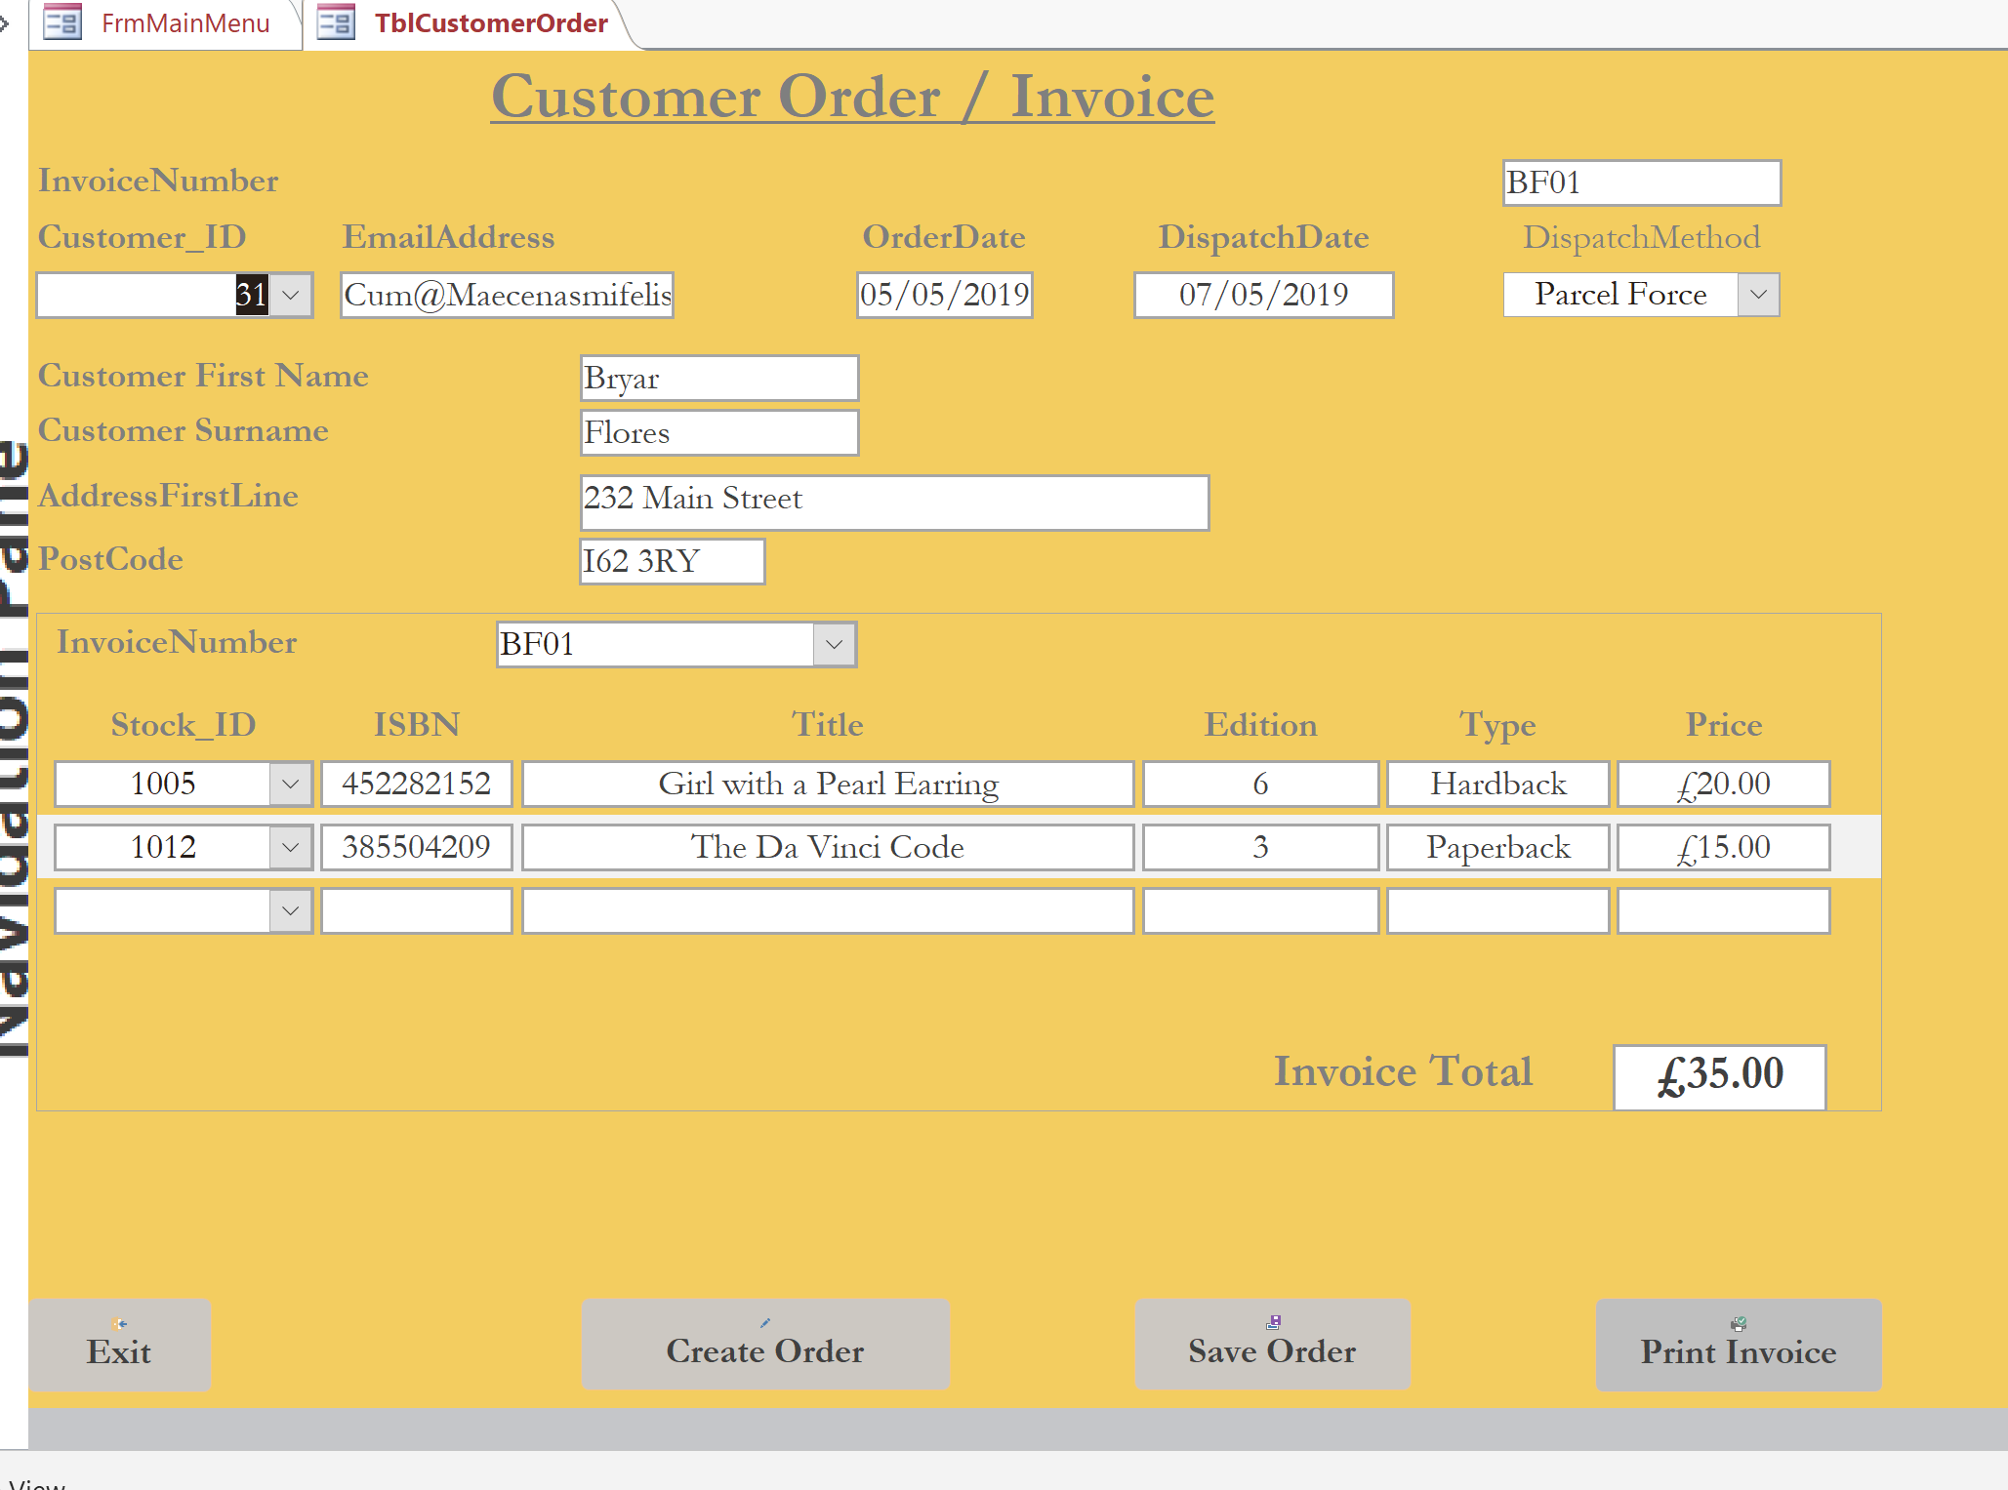
Customer Order Form
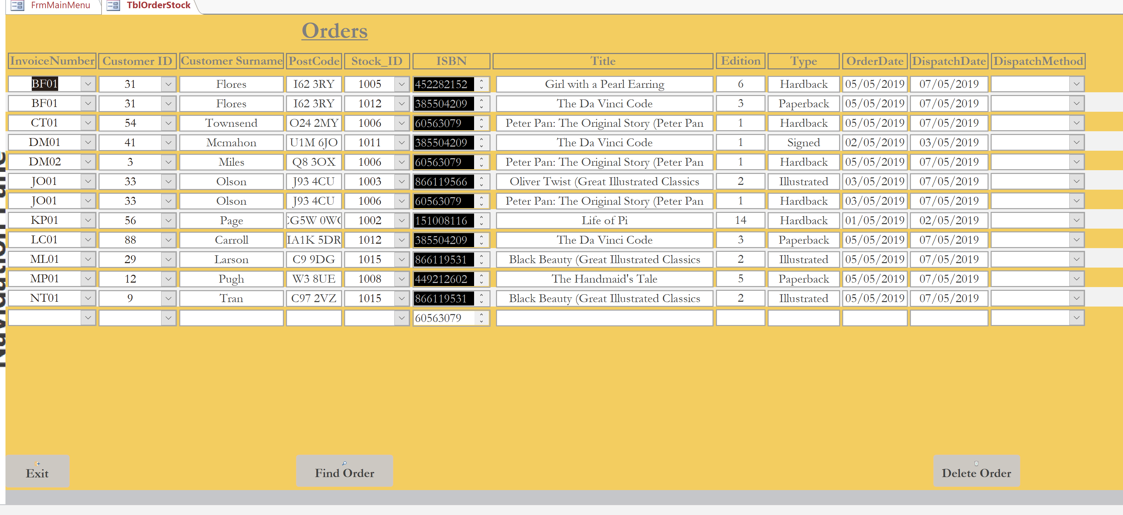
Order Lookup Table
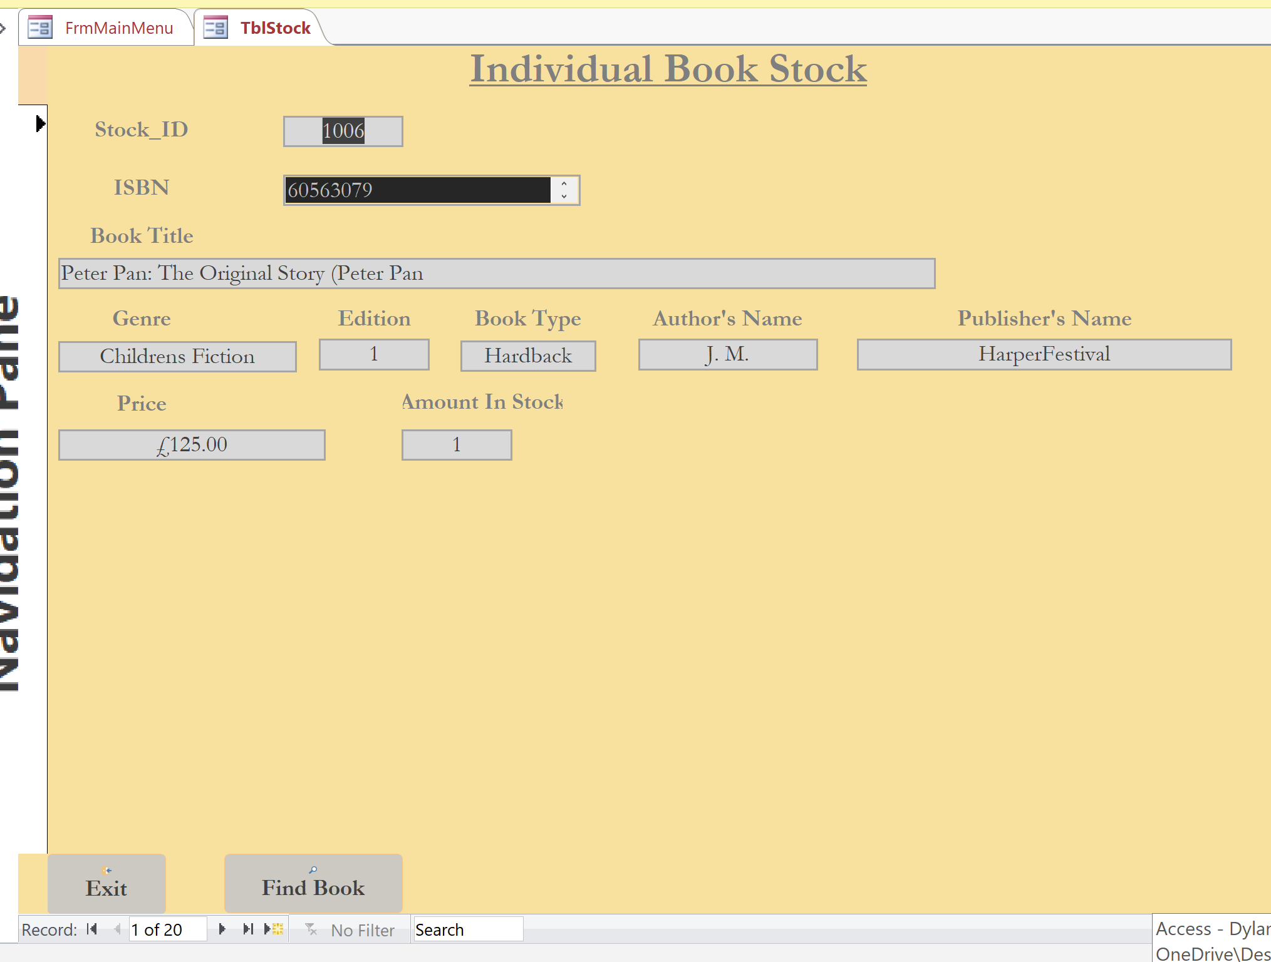
Individual Book stock Form
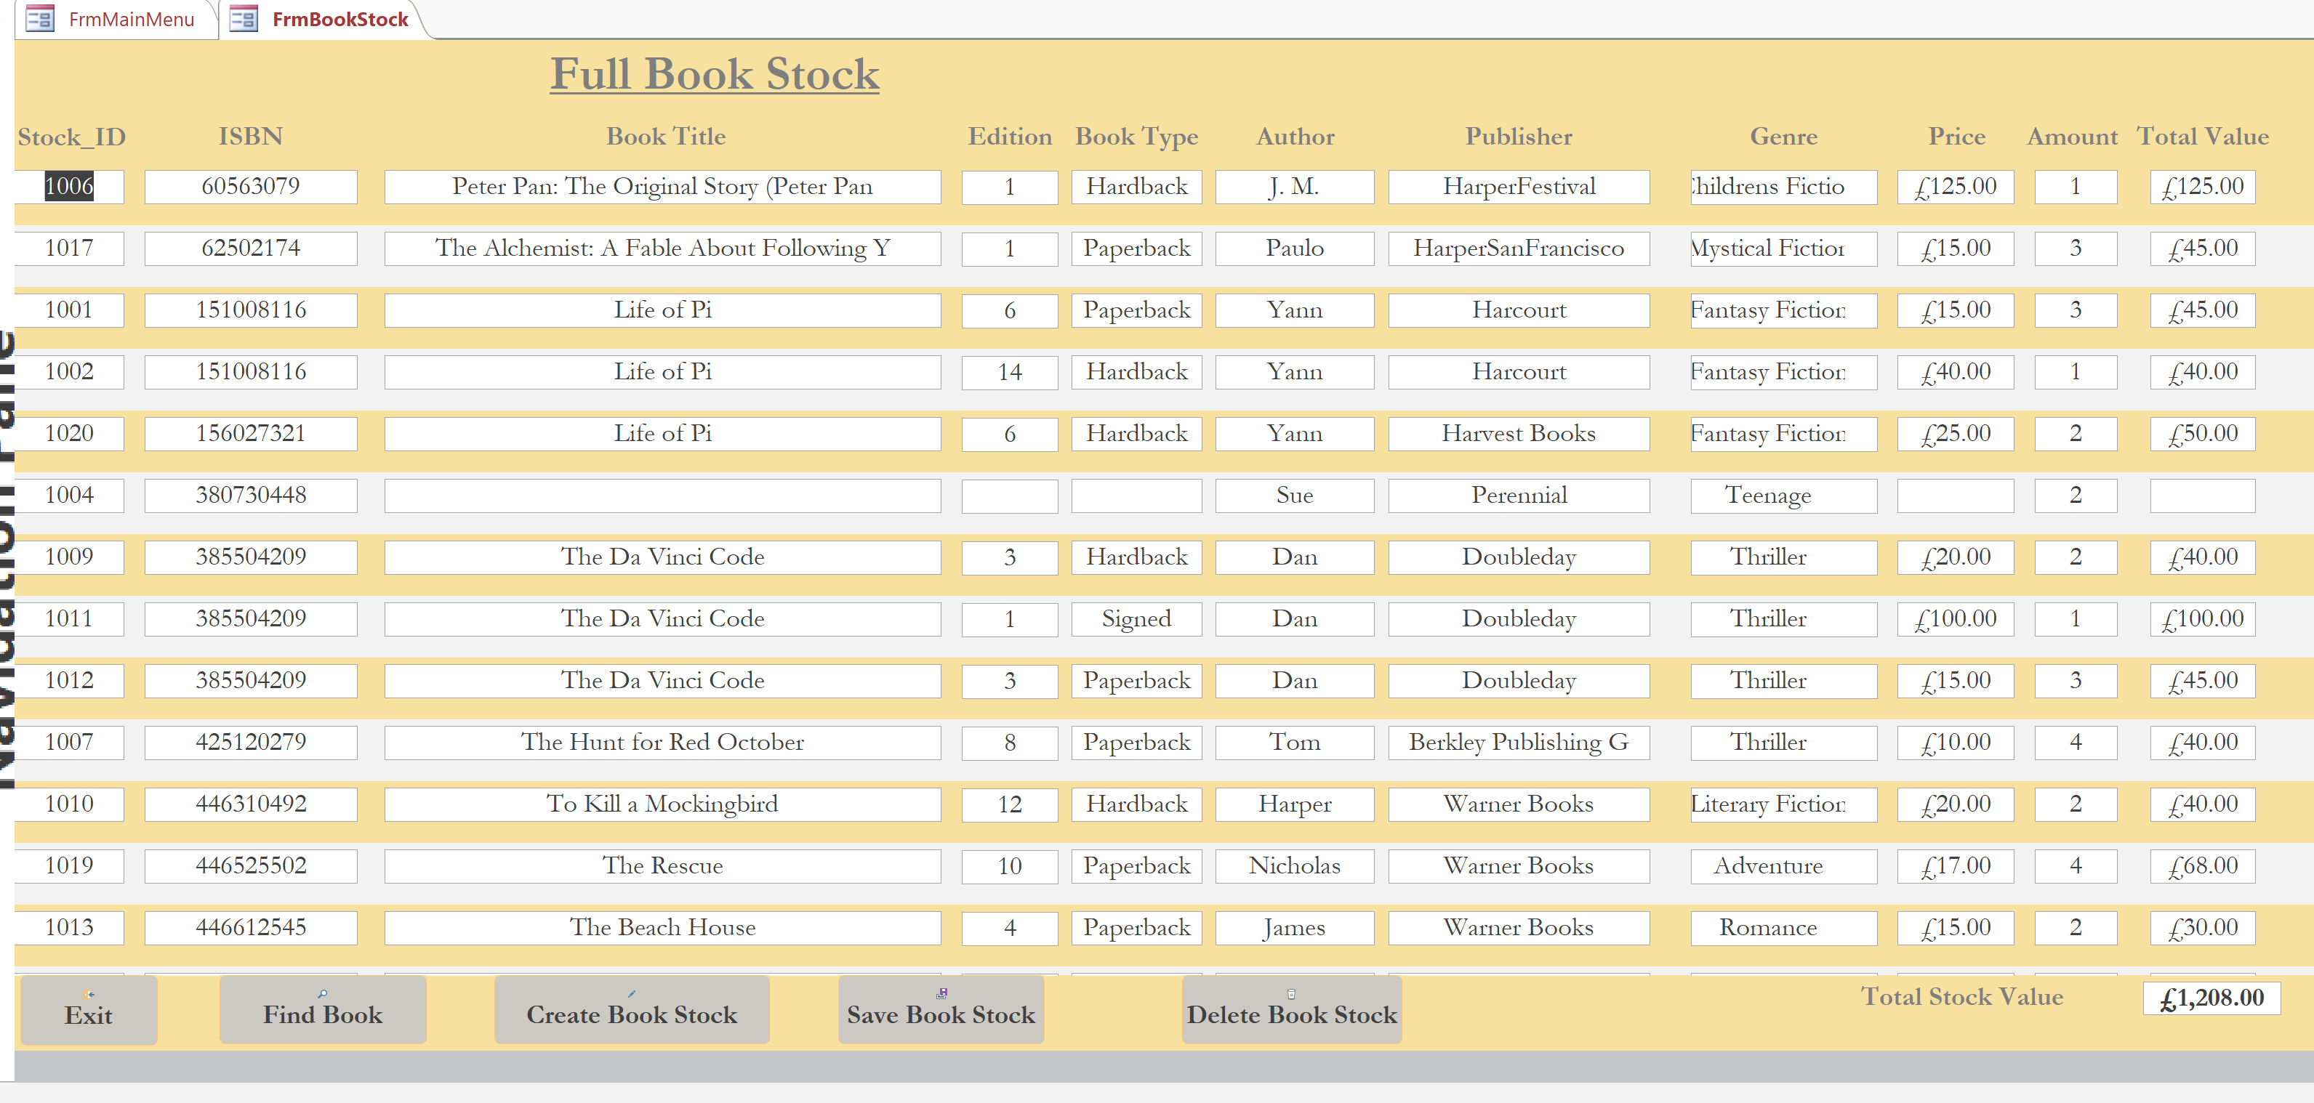
Total Stock Holding Table
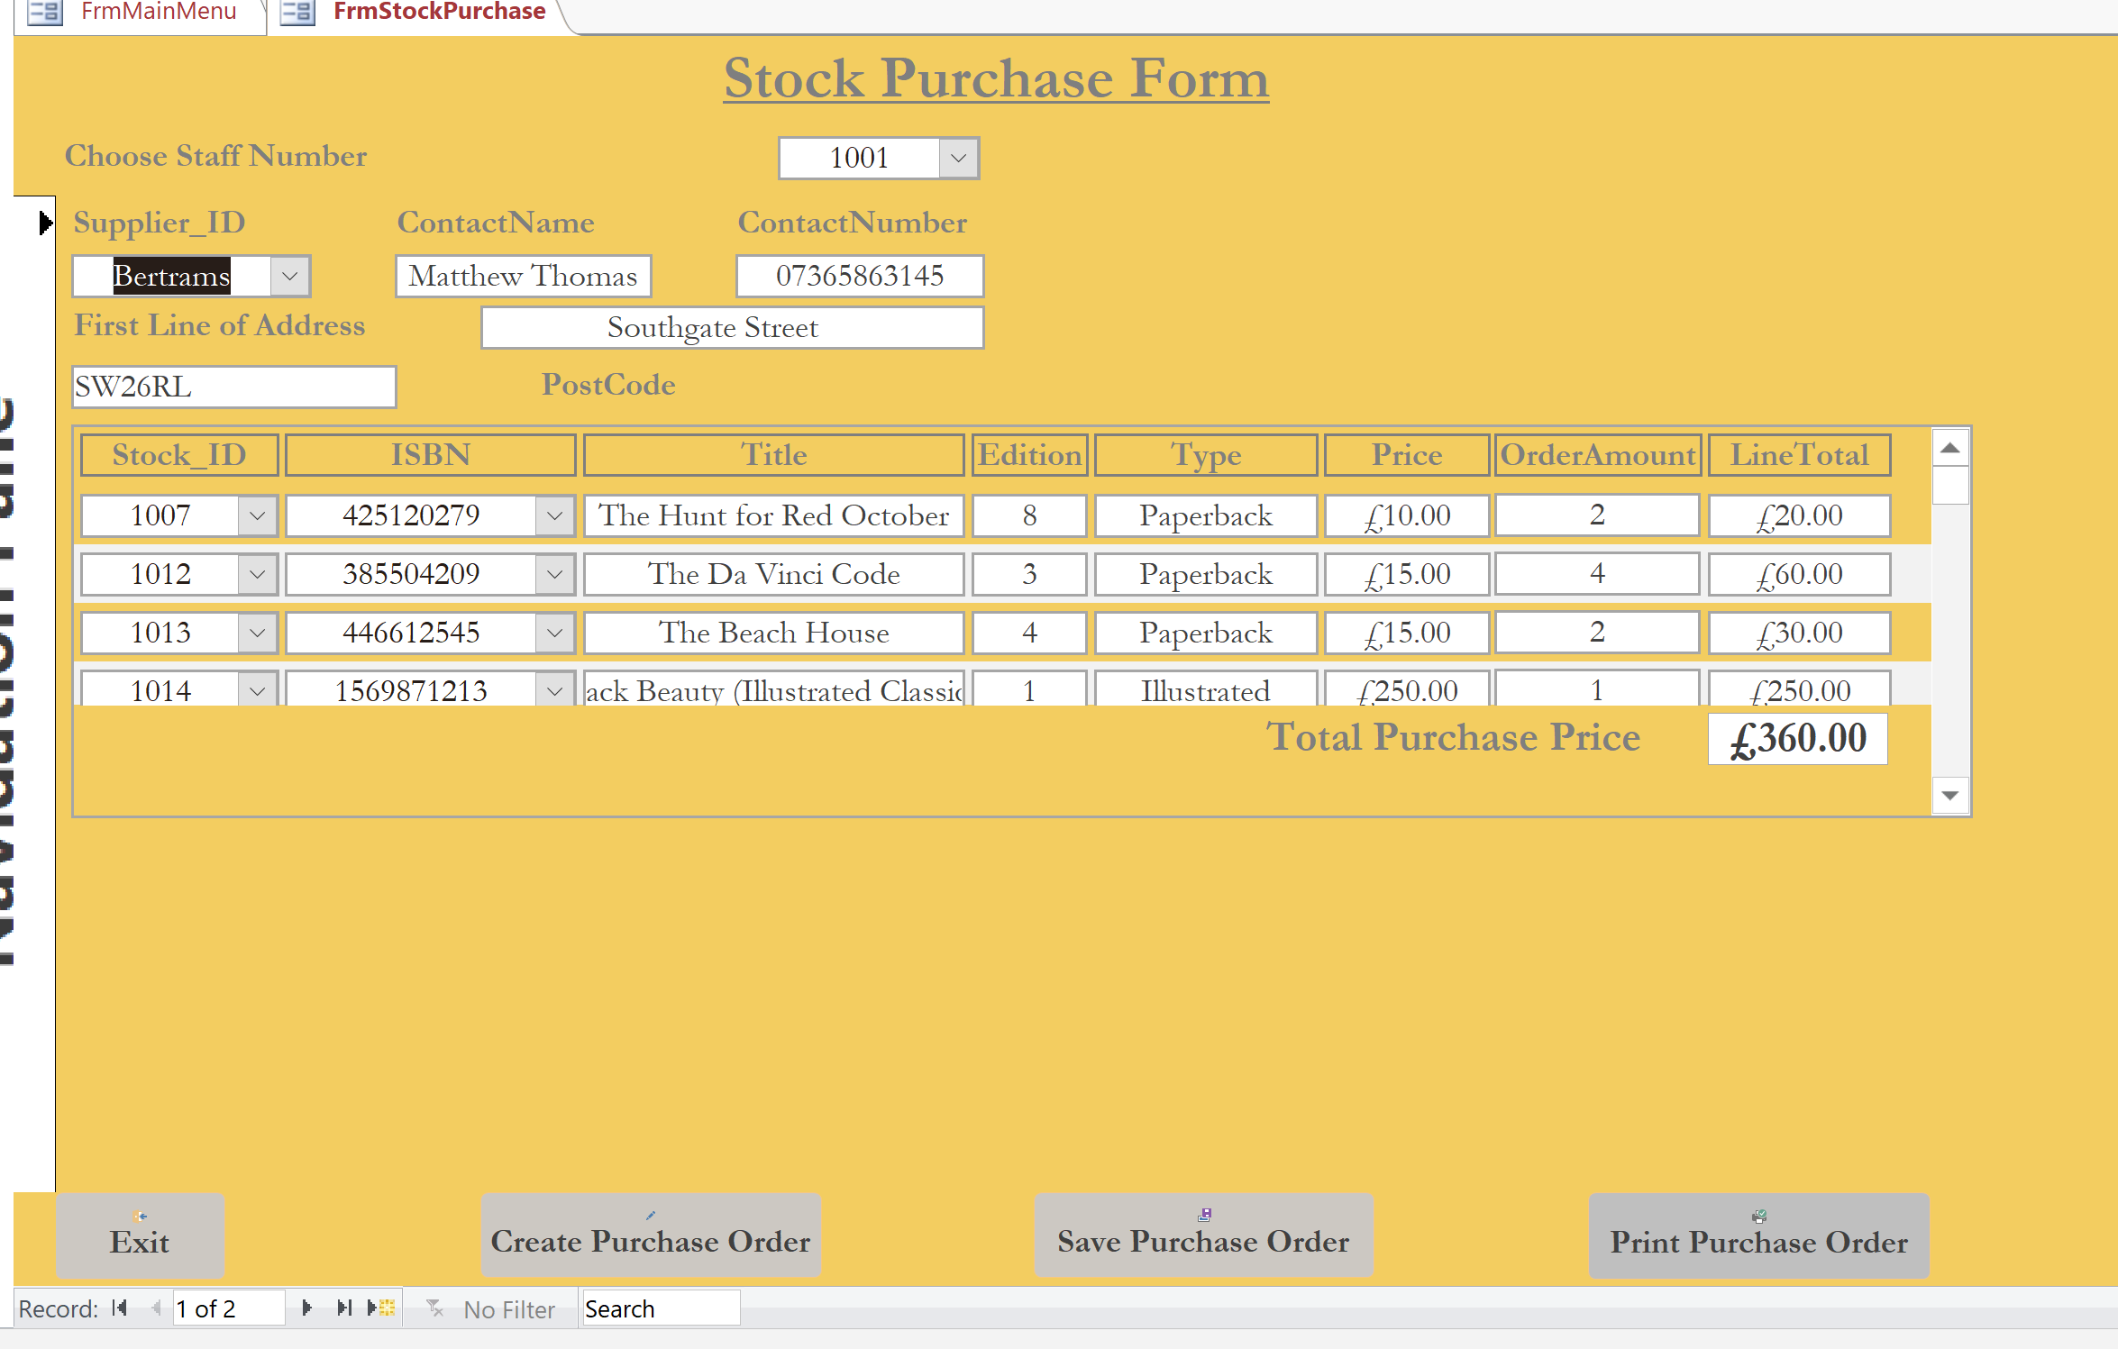
Stock Purchase Form
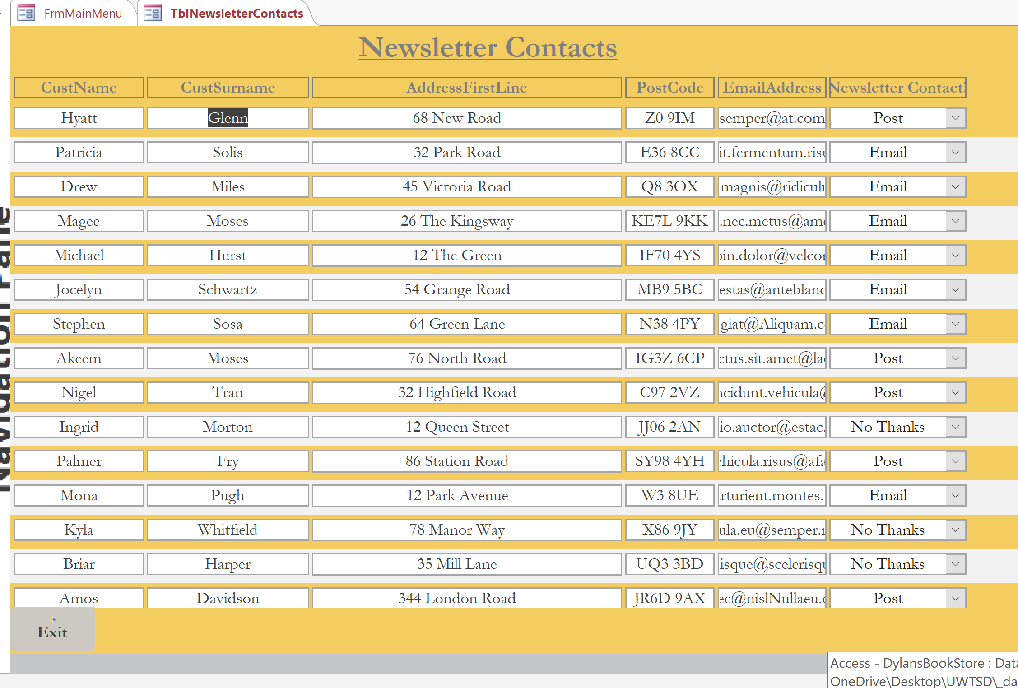
Newsletter Contact Table
User Guide for Dylan’s Bookstore Database

The database is designed and operating through Microsoft Access. On opening the database, the main menu appears. Use the buttons to navigate the forms, data lookup and data creation.

Main Menu:
Within the main menu are nine buttons, laid out so that all customer operations are to the left-hand page and all the stock operations are to the right-hand side of the page. These are as follows;
- Customer Input Form – This will open a form to allow input of customer details or to lookup details and notes on individual customers.
- Customer Lookup table – This will lead you to a table of all existing customers and allow search, input and deletion of customer data.
- Customer Order Form – This will open the order form to allow processing of the order including creation of an order and printing of an invoice.
- Order Lookup Table – This will lead to a table of all existing orders and allow search and editing.
- Individual stock lookup – This will open a form to allow the individual lookup of books in stock with all details to allow search of stock id, title or ISBN.
- Full book stock – This will open a table with full existing stock carried, including prices and total value of stock carried.
- Stock Purchase Form – This will open a purchase order form to allow staff to order books.
- Newsletter Contact List – This will open a full table of all customers with contact type.
- Close Database – This will close the application completely and come out.
Form and Table Buttons:
All forms and tables within the application will allow navigation through the buttons below. These will comprise of;
- Find – This will open a search box to allow the user to search by any of the fields within the form.
- Create – This will allow the user to create a new record, presenting a blank form.
- Save – This will allow the user to save the newly created record.
- Delete – This will allow the user to delete any record within the application.
- Print – There are two forms with print buttons, allowing the printing of both customer orders and invoice, and stock purchases.
- Exit -v This will close the form and go back to main menu.
Customer Order and Stock Purchase:
These forms will allow the choice of books for order by Dylan’s Staff or customer orders. Within these forms will be several choice fields with dropdown choices. This will allow the user to choose specific information needed, and in the case of stock ID, allow a lookup and populate the form with the details relating to that stock.

It is important to navigate through the application using the buttons provided and ensure accountability when using the database.

