nick hinder
P148207
advanced web development
Assignment 2

Contents
Introduction 2
Web Application 2
Testing 3
Black Box Testing 3
White Box Testing 3
Testing Frameworks 3
Behaviour Driven Development 6
References 8

Introduction
This report details the development of a tournament organising web application using typescript. The application will allow a user to create a tournament or view existing tournaments. Each tournament will consist of a number of rounds and teams whilst each round would consist of a number of matches. The matches would each have two participating teams and allow for one winning team.
The report then proceeds to discuss testing and behaviour driven development.

Web Application
The web application was developed using .net core 3.1 as its framework. The application consists of a .net core web API and a website consisting of html pages utilising typescript.
Whilst developing the API, swashbuckle was introduced so as to have an appropriate display for testing the API.
Once the website was introduced, swashbuckle was no longer used as the default route when the root of the application is accessed. However swashbuckler was not removed from the project as in the long term, the website and API would ideally be decoupled and hosted separately; allowing the API to utilise swashbuckle once again.
The API models were created by scaffolding a db-context from a local SQL database; these models were then used to scaffold appropriate controllers as necessary.
The website made use of Fetch, which is available on most modern browsers, in order to facilitate ajax requests to the API. Using fetch means that no additional libraries need to be used such as the JQuery library.
The controllers endpoints facilitate getting data through a GET request, updating data through PUT requests, creating data with a POST request and deleting data with a DELETE request. Fetch receives the response from these methods and allows the data to be read, in this case JSON.
In order to better interact with the returned JSON data, the data is often cast into a typescript class so that it is strongly typed; An example of this is the TournamentDTO class.
Unfortunately, whilst developing the application, there appeared to be setup issues with the API / fetch solution whereby despite the API appearing to return data correctly, and the fetch request receiving an OK request response; the request payload seemed to be lacking a data object.
Due to this issue, it was not possible to complete the tournament screen. Without the ability to properly administer tournaments, it was not possible to create the round screen as there was no way to set up the matches in the round.

Testing

Black Box Testing
The most common method of testing is black box testing; this often takes the form of manual testing whereby the tester will execute a specified series of actions with the expectation of yielding a specific resultant behaviour. If the behaviour deviates from what is expected, the deviation is noted and the test is deemed a failure.
An example of black box testing would be for a tester to know that if they press a button to pay for their basket, then they should expect the purchase to be completed and receive a digital receipt.
One of the major benefits of this form of testing is that testers do not need to know the intricacies of the system; in fact they only need to behave as an end user would. This can mean that the testers need not have any technical expertise, but also due to the lack of technical expertise, can aid developers understand how an end user would approach the application.
In the above example; the end user / tester would expect that paying for their basket would complete the purchase. However, they would not necessarily know, nor need to know, that the code not only completes the purchase, but reduces the stock levels and if the stock level crosses the re-order threshold, then a new stock request is made to the purchases company.
These tests are simple in nature; and can allow for edge case scenarios to occur where an unexpected series of actions results in unintended results. However, these tests can be structured into test plans that cover all features of a system, meaning that each feature is tested with a series of expected actions. This simple form of test plan can ensure that under normal usage, the system works as expected.

White Box Testing
White box testing follows the same fundamentals as black box testing, however is undertaken by a tester with knowledge and understanding of the systems design and implementation.
The principle of the tests are the same, however the tests are developed based on the proviso that the tester knows what is going on inside the box rather than just the input and output. This form of testing means that when a test fails, the tester should be able to deduce why or where the erroneous behaviour is originating.
Following the example from the black box testing section; when a tester presses the pay for basket button, they not only expect that the purchase would complete but would also expect the stock levels to be checked. This means that the tester could also test the other potential output of this operation, the request for new stock, and could even make educated assumptions as to why erroneous behaviour is being exhibited when the test does not succeed.
White box testing is most commonly used by developers whilst developing the features, however it is also very effective for testers to have this understanding whilst testing as it can lead to a more thoroughly tested application.

Testing Frameworks
Testing frameworks are seeing an increased adoption rate due to how effective they are in testing and supporting an application through its lifecycle.
Automation testing frameworks work alongside behaviour driven development (discussed later) in order to allow autonomous, quick testing that provides a developer swift feedback whilst developing.
There are numerous testing frameworks for testing and the frameworks see usages through the various levels of an application. For example Unit testing frameworks are often used with server side code, whilst there are a number of client side testing frameworks such as Jasmine.
Such frameworks allow for a number of tests to be defined and to be called at will; these test cases should comprise every feature of the application. If a test does not return a successful response, then the overall test is deemed a failure, however each tests result should be viewable by the tester.
The tests that are defined by test frameworks tend to follow a similar pattern, albeit often with syntactical differences. These tests will define checks of the test value against a static expected value for the test given the operation of the test.
This may be through use of an Assert (Unit test) or Expect (Jasmine) statement, which declares that this is a check that we want to make sure of, followed by what the check is actually on i.e. that 2 * 2 is in fact 4.
An example feature that could be tested would that of two lists of books; one list of available books, the other a list of checked out books. One potential action that could occur would be for a book to be checked out, thus moving from one list to the other at the press of the button.
Following is some example pseudocode that could be used for this.
// Set up the arrays
Let availableBooks = [];
Let checkedOutBooks = [];

Function CheckOutBook(bookId){
// find the book in available array and remove it
var index = availableBooks.indexOf(bookId);
if (index !== -1) availableBooks.splice(index, 1);
// add the book to the checked out array
checkedOutBooks.push(bookId);
}
The above code would permit for two lists of books to be instantiated and for available books to be checked out as needed. In its current state however it is untestable; following is an example of how jasmine would test the function above.
Describe(“Library”, function(){
// Test Case: 1
It(“The CheckOutBook method”, function(){
availableBooks = [1,2,3];
checkedOutBooks = [4,5,6];
CheckOutBook(2);
Expect(checkedOutBooks.toContain(2));
Expect(availableBooks.not.toContain(2));
});
});
This syntax defines that the tests are describing the Library feature and only contains 1 test, which is the CheckOutBook method.
When the test case is run, there are two checks it is expecting to be correct – that checkedOutBooks contains book id 2 and that availableBooks does not contain book id 2. However, prior to the assertion of these expectations, the two arrays are populated with known data and the method called with a known value. This is important as it ensures that the test is carried out in a way that the expected result can be calculated, meaning that the test can be carried out definitively.
A well used test framework will sport a large number of checks, all of which are independent of one another and all of which need to pass in order to ensure a healthy state for the features of the application. Most framework will be able to run all tests in a batch and some can even be set to run automatically when a project is built or even integrated with Continuous Integration platforms such as TeamCity.
Below is an image posted by Anastasia Kazakova on the Resharper C++ blog (1).
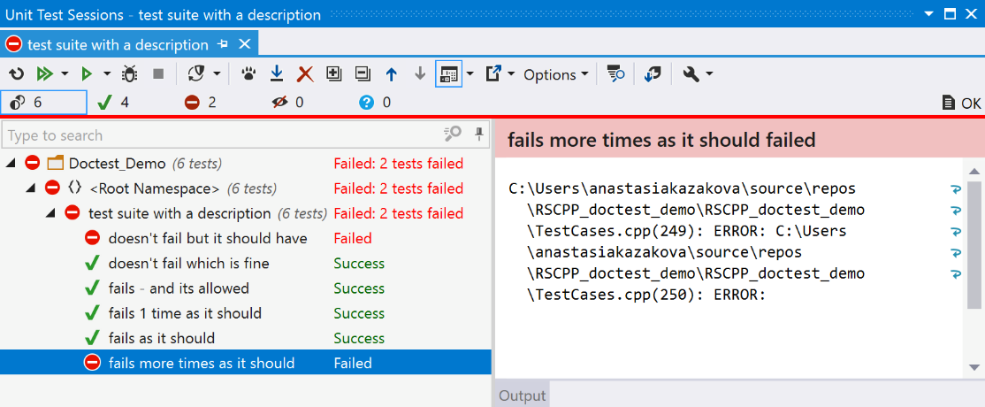
This image is a good example of doctest – the C++ testing framework provided by Jet Brains.
Most testing frameworks use a similar approach for displaying the tests for a project, meaning that this serves as a good example for testing frameworks.
In the image it can be seen that despite numerous successful tests, the overall project Doctest_Demo has yielded a failure due to there being 2 tests within it that failed.
For each test in the project, the status of the test and the tests description are clearly shown; allowing for users to easily interpret the results of the test and pinpoint the origins of the failures.

Behaviour Driven Development
Behaviour driven development is a common agile test driven development technique that is used to help ensure that deliverables operate as intended by both developer and product owner.
Test driven development is where before developing a feature, the tests for that feature are first implemented. These tests will continue to fail until the feature has later been implemented correctly. This test driven methodology ensures that there is a defined “correct” working state for the related features and it allows developers to easily see when a change causes the feature to fall outside of an acceptable result.
A large part of behaviour driven development is that of user stories / functional specifications. A user story is an effective way of describing the behaviour of features such as:
As an administrator
I want to modify the library
So that users can see the books that are available right now
This is an effective way of establishing and recording user interactions with the features, however leaves a lot of room for interpretation from developers. Nor does this methodology outline how to test to ensure that the user story is fully satisfied.
However, Functional behaviour driven development specifications provide a far clearer definition of acceptance criteria through structures such as:
Given that a logged in user accesses the library page
When that user is an administrator
Then the Manage Catalogue button will show
This form of behaviour driven development allows for the user stories, which define what a user wants to do, to be converted into behaviours of the system. Thus informing developers and testers exactly how the system is supposed to be behaving in a given circumstance. Due to this better defined behaviour, there will be a resultant reduction in discrepancies between the behaviour of the system and intended behaviour of the system; with developers knowing better how to program the system to behave, and testers knowing better how the user wants the system to behave.
Despite the increased specificity of this definition in comparison to that of a user story, the fact that the specification is written in simple, everyday language means that it is still easily understandable to involved parties as opposed to requiring a higher level of technical ability.
One of the primary downsides to behavioural driven development is that whilst it uses simple language and should ideally cover every behaviour that the system will exhibit, it is also possible to not fully specify details well enough, resulting in a substandard specification.
Overall, behaviour driven development is an effective approach in communicating the specification of an application between product owners, developers and testers; leading to more well developed applications that better suit the needs of the client and are more supportable in the long run due to the test driven nature intrinsic in their design.
Behaviour driven development has become a key skill within agile development and the industry as a whole; this trend is unlikely to change in the foreseeable future.

References
1. Kazakova, Anastasia. Better Ways to Test with doctest – the Fastest C++ Unit Testing Framework. RESHARPER C++ BLOG. [Online] 10 July 2019. https://blog.jetbrains.com/rscpp/better-ways-testing-with-doctest/.

