

LCBB5005

Project Management

Student Name: Ileana Cristina Greurus
Student Id: 2122653
Table of Contents
Introduction 2
Definitions of project management 3
Project management principles and approaches 4
Evaluation of project management tools and techniques 5
Core Elements of Project Management A. Budget Evaluation 8
Adoption of Project Management Methodology 9
Critical Evaluation of the Google Headquarters Project 10
Conclusion 12
References 13

Table of Figures
Figure 1: Project Management 3
Figure 2: Project Management Tools 6
Figure 3: Project management practice toolset relationships 7

Introduction
To set the scene for the assessment the evaluation covers three key areas: definitions of project management, approaches and principles of project management and the assessment of tools and techniques of project management all of which are framed by the massive Google Headquarters project in King's Cross London. This thorough analysis makes its way through a variety of definitions, construction principles and a critical assessment of the instruments and methods that are guiding the project. The goal is to clarify the complexities of project management as well as emphasize how essential it is to achieve ambitious goals. This review written in the third person reveals a story that clarifies the complex aspects of successful project management.

Definitions of project management
Definition 1: In order to accomplish predetermined project goals and requirements, project management entails applying abilities, expertise, resources and methods to project activities.
Explanation and Key Elements: A methodical method for initiating, planning, carrying out, overseeing, and concluding projects is encompassed by project management (Aguda et al., 2021). Effective interaction, risk management, stakeholder involvement and a commitment to completing projects within the allotted scope, time, and budget are crucial components.
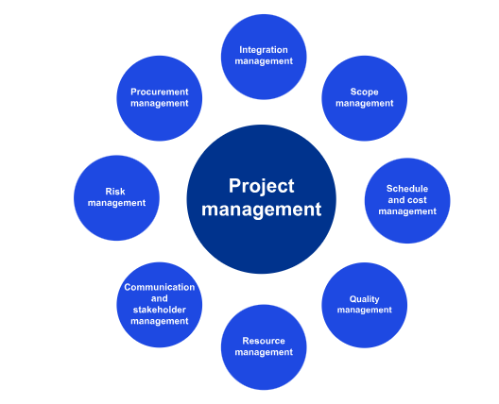
Figure 1: Project Management
Source: (KPMG, 2023)
Definition 2: Project management is a short-term activity done to produce a special good, service, or outcome.
Explanation and Key Elements: This definition highlights the transient and distinct character of projects, underscoring the necessity of meticulous planning, resource distribution, and oversight. Stakeholder collaboration, project duration management and an organized approach to obtaining the objectives of the project (Armenia et al., 2019).
Definition 3: Project management is the process of integrating tools, techniques, knowledge and abilities into project activities in order to fulfil project requirements.
Explanation and Key Elements: Project management's dynamic and process-oriented character is highlighted in Schwalbe's definition. It emphasizes the ongoing use of knowledge through the course of a project incorporating flexibility and experience-based learning. Important components include integrating project components having a strong commitment to project success and exercising effective leadership.
Together, these three definitions highlight the multifaceted nature of project management, acknowledging its transient nature, systematic procedures and the critical roles that effective communication and leadership play in achieving project goals.

Project management principles and approaches
A. Overview of Project Management Principles
The construction of Google's new London headquarters in King's Cross provides an example of how basic project management concepts are applied (Gillespies, 2022). Project management is the process of planning short-term initiatives to accomplish special results; in Google's case, this was building a cutting-edge office building (Kocakaya, 2019). The project's guiding principles include setting specific goals, creating an organized plan, and spending resources wisely.
The project lays out specific objectives, including building high-end office space, housing thousands of workers, and boosting the local economy. In project management, specific goals are essential because they give the whole team a road map and guarantee that everyone is aware of the expected results.
B. Application of Project Management Approaches
The strategic planning and project management of the Google headquarters project clearly demonstrates the use of project management techniques. The need for a structured approach is highlighted by the use of more than 60,400 square meters of land, the construction of an 11-story building as well as the inclusion of various facilities like cafes, gyms and recreational areas. To accomplish project success the process of project management is essential because it makes sure that every stage—from planning to execution—is methodically handled.
Another important strategy is stakeholder collaboration, which is demonstrated by the need for coordination between Google, developers as well as local government. To guarantee that all stakeholders are in agreement with the project's objectives and facilitate a seamless execution, efficient interaction and cooperation are essential components of project management.
C. Importance of Adopting Project Management Principles
Complex projects such as Google's new headquarters require the adoption of project management principles (Müller et al., 2019). The project's complexity and size demand a methodical and structured approach. A system for managing uncertainties, reducing risks, and making sure the project stays on track is provided by project management.
Efficient project management advances the overall economic growth of the King's Cross area within the framework of the expanding knowledge-based economy. It guarantees that timetables are met resources are maximized, and the project is in line with more general economic objectives.
The Google headquarters venture serves as an excellent example of how project management techniques and principles can be applied highlighting the significance of precise goals, organized planning, stakeholder cooperation and methodical execution for the accomplishment of challenging projects.

Evaluation of project management tools and techniques
- Introduction to Project Management Tools
Within the complex world of project management, methods and tools act as a road map for carrying out complex projects successfully (Sawhney et al., 2020). The one-billion-pound project that Google is undertaking to open its new headquarters in King's Cross London, calls for a careful analysis of project management techniques. These tools are essential to managing the project's complex dance of risk factors, stakeholders, budget, time and quality.
B. Critical Evaluation of Different Project Management Techniques
1. Budgeting Tools
A sizeable budget is at the centre of Google's King's Cross project, necessitating close examination (Stanitsas et al., 2021). Tools for budgeting become essential components of financial governance. One particularly effective method for comparing project performance to budgetary plans is Earned Value Management (EVM). The project's financial stability is influenced by ongoing monitoring of expenses, resource allocation, as well as predictive financial analyses. In addition to ensuring that budgetary restrictions are followed, this financial vigilance makes it easier to make strategic decisions in response to shifting financial conditions.
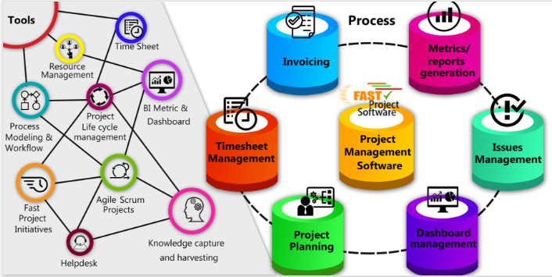
Figure 2: Project Management Tools
Source: (Project Management, 2019)
2. Time Management Techniques
In the context of project completion, time is of the essence. Effective time management is essential for the King's Cross project due to its size and complexity (Tereso et al., 2019). The stage is taken by Critical Path Analysis (CPA), which deconstructs the order of tasks essential to project deadlines. Gantt charts, milestone tracking, and regular project reviews all contribute to efficient temporal management, which guarantees that the project stays on track. The thorough time management strategy also permits flexibility allowing the project to adjust to unanticipated difficulties without jeopardizing its overall schedules.
3. Quality Assessment Tools
Maintaining unmatched quality for a project this size is not negotiable. Six Sigma methods and Quality Function Deployment (QFD) stand out as guardians of ongoing quality improvement. Regular inspections, following industry standards, and carefully planning quality control procedures all work together to maintain high standards during the course of the project (Trasberg and Cheshire, 2023). Google's track record for excellence is enhanced by its continual process of quality assessment which guarantees that the project not just fulfils but exceeds expectations.
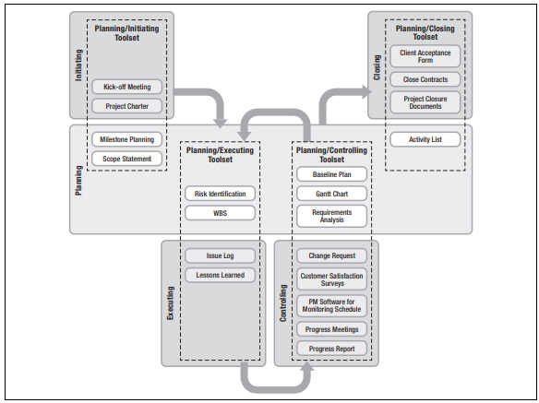
Figure 3: Project management practice toolset relationships
Source: (Tereso et al., 2019)
4. Stakeholder Analysis Methods
Stakeholder management becomes a fine art in the vast environment of the King's Cross project. The Stakeholder Salience Model and Power/Interest Grid come to the fore to help with stakeholder identification and prioritization (Wiewiora et al., 2020). Consistent channels of communication, prompt feedback systems, and skilful management of stakeholder concerns cultivate positive relationships, guiding the project through Potential Pitfalls. Stakeholder management done right reduces risks and boosts project synergy while creating a collaborative environment across organizational boundaries.
5. Risk Management Techniques
The project's grandeur also entails inherent risks necessitating proactive action. A structured method for understanding risk is provided by risk assessment tools like the Failure Mode along with Effect Analysis (FMEA) and Risk Matrix. The project's resilience toward potential disruptions is strengthened by proactive risk mitigation strategies, strategic contingency planning and regular risk evaluations. Risk management's iterative process guarantees ongoing development by converting obstacles into chances for creativity and expansion (Willumsen et al., 2019).
The analysis of methods and instruments used in Google's King's Cross project demonstrates the complex underpinnings of effective project management. It is not only strategic but also essential to integrate risk management, budgeting, time management, stakeholder analysis and quality assessment. The project's cyclical process which is essential to its success guarantees that goals are met with ease enhancing the Knowledge Quarter and advancing King's Cross toward a flourishing knowledge-based economy. The project's long-term effects are characterized by constant improvement and flexibility.

Core Elements of Project Management
A. Budget Evaluation
Budgetary Constraints and Allocations: The one-billion-pound project for Google's new London headquarters at King's Cross necessitates a thorough analysis of financial factors. The project's large scale—60,400 square meters spread over 11 stories, with space for up to 4,500 people—implies a significant financial outlay. Ino ensure the best possible allocation of resources for construction as well as ancillary spaces, the budget evaluation entails a careful analysis of financial constraints as well as allocations. This is essential to meeting project goals and preserving financial discipline.
B. Time Management
Project Timeline and Critical Path Analysis: Time management skills are essential to completing the large project on schedule. The project, which is scheduled to begin next year, necessitates a careful review of the critical path analysis and project timeline. Since the Google campus is made up of several buildings, it is essential that construction activities be coordinated. The assessment process entails determining significant turning points, possible obstructions, and essential routes to prevent delays and conform to strategic goals.
C. Quality Assessment
Quality Management Processes: High standards are crucial because Google wants to build a landmark structure. An extensive analysis of construction techniques, materials, and conformity to industry standards are all part of the quality assessment. To create a work environment that is conducive to productivity, high-quality construction must be maintained in conjunction with ancillary spaces such as cafes, gyms, as well as recreational areas.
D. Stakeholder Analysis
Identification and Management Strategies: Considering the size of the project, a thorough stakeholder analysis is essential. Stakeholder identification and the application of efficient management techniques are essential elements of project management success. Building strong relationships with regulatory agencies, local communities, internal teams, and potential tenants is essential to the success of any project.
E. Risk Factors
Risk Identification and Mitigation: Large-scale projects are dynamic, which brings with it inherent risks that need to be carefully considered. Risk factor evaluation entails determining possible obstacles and developing effective mitigation plans. This entails evaluating the risks related to building, adhering to regulations unanticipated delays and outside influences. By making sure there are backup plans in place in case of emergencies, an anticipatory approach to risk administration increases the resilience of the project.

Adoption of Project Management Methodology
A. Overview of Project Management Methodologies
The ambitious £1 billion project that Google is undertaking for its new headquarters in King's Cross, London, necessitates an organized strategy to project management techniques. A well-defined methodology is necessary to guarantee seamless execution of the complex development, which spans over 60,400 sqm and can accommodate up to 4,500 people throughout multiple stories. Project management methodologies offer a structured approach to organizing, carrying out, and overseeing the various aspects of a project.
B. Rationale for Adopting a Specific Methodology
Choosing a particular project management methodology has become a crucial choice that affects how well the project works. Considering the scope and intricacy of Google's project a methodology's justification needs to take a number of things into account. The Agile methodology which is renowned for its flexibility and iterative style might be a good option. Agile methodology facilitates adaptability to modifications which is essential in projects with changing specifications and designs. The project's board of directors might be improved by incorporating PRINCE2 methodology components assuring efficient control and accountability.
The necessity of stakeholder engagement and collaboration also serves as justification for adopting a particular methodology. A wide range of stakeholders are involved in Google's project, including local communities, architects, builders and potential occupants. Promoting a positive project in the environment requires a methodology that prioritizes stakeholder involvement, collaboration, and clear communication.
Structure, flexibility, and stakeholder involvement are the main reasons behind Google's King's Cross project's embrace of a project management methodology. The methodology chosen must take into account the dynamic nature of the project in order to facilitate efficient management of the financial resources schedule quality stakeholders as well as risk factors.

Critical Evaluation of the Google Headquarters Project
A. Overview of the Google Headquarters Project
With an ambitious one billion pounds project Google hopes to construct a state-of-the-art facility that extends over 60,400 square meters for its new headquarters in King's Cross, London. This building has 11,500 square feet of luxurious office space that can accommodate up to 4,500 people. It is significant because it is the first fully owned as well as intended Google building outside of the US helping to form a campus that can accommodate 7,000 employees.
B. Assessment of Project Management Success/Failure Factors
Budget Evaluation: This enormous project's budget needs to be thoroughly examined. The project's vision must guide the distribution of resources for building, interior design, or amenities like cafes, gyms, along with outdoor areas. It takes constant observation to handle any financial restrictions and guarantee effective resource use.
Time Management: The project schedule, which includes important checkpoints, must be carefully considered. There may be a domino effect from delays on the entire schedule. In order to meet deadlines and guarantee that the project continues in the direction it needs to go in order it is imperative to use efficient time management methods and tools.
Quality Assessment: Every stage of the construction process needs to incorporate quality management procedures. The standards for the main office space, supporting spaces, and outside spaces should be the highest. Conducting routine inspections and audits is essential to ensure that a top-notch facility is delivered.
Stakeholder Analysis: A project's ability to identify and manage stakeholders is essential to its success. An extensive stakeholder analysis is required due to the diverse group of parties involved in this project, which includes architects, builders, local communities as well as future occupants. To meet the needs and concerns strategies for collaboration and effective communication should be developed.
Risk Factors: Conducting a comprehensive risk assessment is essential to foresee and minimize possible obstacles. The project plan needs to identify and address all construction-related risks as well as risks relating to unexpected events and regulatory compliance. Frequent risk assessments guarantee proactive management and lessen the effect of unanticipated events.
C. Recommendations for Improvement
Drawing from the critical assessment of the Google Headquarters initiative, the ensuing suggestions are put forth:
- Providing a strong system of oversight and management to ensure budget compliance.
- Improving channels of communication to guarantee the successful involvement of stakeholders.
- To reduce possible difficulties put proactive risk management techniques into practice.
- Carrying out recurring quality assessments to maintain the project's goals and standards.
By taking care of these issues Google can increase the chances that the project will succeed and make the new headquarters a King's Cross landmark and an example of successful project management.

Conclusion
The Google Headquarters project in King's Cross, London, is a prime example of how project management techniques, tools and principles interact in complex ways. The various definitions of project management highlight how dynamic and multidimensional it is and how important leadership and communication are. Applying project management methodologies to the construction process and critically analysing tools and methods reveals a methodical approach to managing stakeholder engagement, budgets, schedules, quality, and risks. The implementation of an organized project management approach that incorporates PRINCE2 and Agile components demonstrates the project's dedication to control, flexibility, and stakeholder participation. To create a successful and historic Google headquarters in King's Cross it is recommended that oversight, communication, risk management that is proactive, and regular quality assessments be strengthened.

References
Aguda, R., Bonilla, S., Hmida, J.B. and Revellame, E.D., 2021. Challenges and Opportunities in Developing Project Management Decision-Making Tools. Journal of Engineering, Project & Production Management, 11(2). https://www.researchgate.net/profile/Remil-Aguda-3/publication/344632429_Challenges_and_Opportunities_in_Developing_Project_Management_Decision-Making_Tools/links/5f85b8dfa6fdccfd7b5d0366/Challenges-and-Opportunities-in-Developing-Project-Management-Decision-Making-Tools.pdf
Armenia, S., Dangelico, R.M., Nonino, F. and Pompei, A., 2019. Sustainable project management: A conceptualization-oriented review and a framework proposal for future studies. Sustainability, 11(9), p.2664. https://www.mdpi.com/2071-1050/11/9/2664/pdf
‌Gillespies 2022) Google Headquarters - Projects . [online] Gillespies. Available at: https://www.gillespies.co.uk/projects/google-headquarters [Accessed 25 Nov. 2023].
Kocakaya, M.N., 2019. Building information management (BIM), a new approach to project management. Journal of sustainable construction materials and technologies, 4(1), pp.323-332. https://dergipark.org.tr/en/download/article-file/834601
KPMG. 2023. Project Management - KPMG India. [online] Available at: https://kpmg.com/in/en/home/services/advisory/business-consulting/transformation-business-excellence/project-management.html [Accessed 23 Nov. 2023].
Müller, R., Drouin, N. and Sankaran, S., 2019. Modeling organizational project management. Project Management Journal, 50(4), pp.499-513. https://biopen.bi.no/bi-xmlui/bitstream/handle/11250/2633658/Muller_Modelling_AM.pdf?sequence=1
Project Management. 2019. Project Management Tools | Web based project management tools. [online] Available at: https://www.fastprojectsoftware.com/project-management-tools-and-processes/ [Accessed 23 Nov. 2023].
Sawhney, A., Riley, M., Irizarry, J. and Riley, M., 2020. Construction 4.0. Sawhney, A., Riley, M., Irizarry, J., Eds. https://api.pageplace.de/preview/DT0400.9780429675119_A38620781/preview-9780429675119_A38620781.pdf
Stanitsas, M., Kirytopoulos, K. and Leopoulos, V., 2021. Integrating sustainability indicators into project management: The case of construction industry. Journal of Cleaner Production, 279, p.123774. https://www.academia.edu/download/64660997/1-s2.0-S0959652620338191-main.pdf
Tereso, A., Ribeiro, P., Fernandes, G., Loureiro, I. and Ferreira, M., 2019. Project management practices in private organizations. Project Management Journal, 50(1), pp.6-22. https://journals.sagepub.com/doi/pdf/10.1177/8756972818810966
Trasberg, T. and Cheshire, J., 2023. Spatial and social disparities in the decline of activities during the COVID-19 lockdown in Greater London. Urban Studies, 60(8), pp.1427-1447. https://journals.sagepub.com/doi/pdf/10.1177/00420980211040409
Wiewiora, A., Chang, A. and Smidt, M., 2020. Individual, project and organizational learning flows within a global project-based organization: exploring what, how and who. International journal of project management, 38(4), pp.201-214. https://www.sciencedirect.com/science/article/am/pii/S0263786320300284
Willumsen, P., Oehmen, J., Stingl, V. and Geraldi, J., 2019. Value creation through project risk management. International Journal of Project Management, 37(5), pp.731-749. https://research.cbs.dk/files/60830808/joana_geraldi_et_al_value_creation_through_project_risk_management_acceptedversion.pdf
‌

