

Image Processing: An Iteration in Augmented Reality

by
Evan Smith

Supervisor: Andrew Baker
Second Marker: Gordon Dickers

Project submitted as part of the requirements for the award of BSc (Hons) Computer Games Development

April 2018

Declaration FORM AND FORM OF CONSENT
DECLARATION

I, ............................................………………………………… declare that I am the sole author of this Project; that all references cited have been consulted; that I have conducted all work of which this is a record, and that the finished work lies within the prescribed word limits.

This work has not previously been accepted as part of any other degree submission.

Signed: .............................................

Date: ...............................................

FORM OF CONSENT

I ................................................………………………………… hereby consent that my Project, submitted in candidature for the B.Sc. Computer Games Development degree, if successful, may be made available for inter-library loan or photocopying (subject to the law of copyright), and that the title and abstract may be made available to outside organisations.

Signed: .............................................

Date: ...............................................

ABSTRACT
Augmented Reality is a blend of two environments, creating an environment where interaction is achievable. In the process, a marker is scanned and processed, utilizing the principles of Image Processing. The aim of this project is to examine two image processing algorithms in the category of edge detection and compare in terms of graphic quality and execution time. The objectives of this project are to develop an understanding of both Augmented Reality and Image Processing by conducting a Literature Review and a case study into algorithms and practises. An application, to load an image and apply the algorithms specified must also be produced. Finally, an analysis must be undertaken to examine the test images after the algorithms are applied, and to produce a comparison framework, citing the graphical quality produced as well as the execution time. An application of loading and applying the algorithms described to the image using software development practises. The development was not successful and is now the focus of future research as well as development of tracking algorithms and a new algorithm specifically for augmented reality marker based applications.

Contents
Declaration FORM AND FORM OF CONSENT i
ABSTRACT ii
Contents iii
Table of figures vi
1 Introduction 8
1.1 Aim 8
1.2 Objectives 8
1.3 Structure of the Report 9
2 Research and Review of Literature 10
2.1 Abstract 10
2.2 Introduction 11
2.3 Evolution of AR – A Brief History Examination 12
2.4 Edge Detection – A Section of Image Processing 16
2.4.1 Timeline of Edge Detection Algorithms 16
2.4.2 Image Convolution 17
2.5 Development of Augmented Applications 18
2.6 Types of Augmented Reality 18
2.6.1 Markerless 18
2.6.2 Marker Based 19
2.6.3 Detection and Recognition 20
2.6.6 Marker Based vs Markerless 28
2.7 SDK 30
2.7.1 Vuforia 30
2.7.2 ARToolKit 31
2.7.3 Wikitude 31
2.7.4 Metaio 32
2.7.5 Kudan 32
2.8 Current Trends of Augmented Reality 33
2.8.1 Construction Field 33
2.8.2 Games Industry 34
2.8.3 Tourism Field 34
2.8.4 Medical Field 35
2.8.5 Military 35
2.8.6 Education 36
2.9 Current Trends of Edge Detection Algorithms 37
2.9.1 Sobel 37
2.9.2 Canny 38
2.10 Conclusion 39
3 Case study 40
3.1 Approaches 40
3.1.1 Approach 1: Improvements of the Sobel Operator. 40
3.1.2 Approach 2: Image Segmentation in Sobel 43
3.1.3 Sobel Edge Detection Algorithm Proposal 44
4 Research and/or Development Methodology 45
4.1 Research Methodologies 45
4.1.1 Philosophy 45
4.1.2 Approach 45
4.1.3 Strategies 46
4.2 Research Overview 50
4.2.1 Research Deliverables 50
4.3 Development Methodology 50
4.4 Conclusion 53
5 Design and Implementation 54
5.1 Problem Formulation 54
5.2 Design 54
5.3 Implementation 55
5.3.1 Inception 56
5.3.2 Elaboration 58
5.4 Conclusion 66
6 Results and Analysis 67
6.1 Test Images 67
6.2 Results 68
6.2.1 Execution Time 68
6.2.2 Memory Used 69
6.2.3 Graphic Quality 70
6.3 Conclusion 72
7 Evaluation 73
8 Conclusions and Recommendations 74
8.1 Summary 74
8.2 Conclusion 74
8.3 Recommendations for Further Research 75
9 Reflection 76
10 References 77
11 Bibliography 81
12 Appendices 82

Table of figures
Figure 1 A Head-Mounted Three-Dimensional Display 12
Figure 2 Milgram's Reality Continuum 14
Figure 3: ARQuake 15
Figure 4 Marker Based Structure 19
Figure 5 Flow Diagram of a Marker Based Application 20
Figure 6 Sobel: Before and After 21
Figure 7 Canny Output Result 22
Figure 8 Robinson Kernels 23
Figure 9 Prewitt Mask 24
Figure 10 SUSAN Mask 25
Figure 11 Intensity Pixel Calculation 26
Figure 12 SURF Process 27
Figure 13 Vuforia Architecture 30
Figure 14 45 and 135 Degree Kernel 40
Figure 15 Edge Refinement Equation 40
Figure 16 Before Filter 42
Figure 17 After Filter 42
Figure 18 Flow Chart of Image Segmentation 43
Figure 19 Before and After Image Segmentation 43
Figure 20 Types of Testing 48
Figure 21 Overview of RUP 51
Figure 22 Use Case Scenarios 56
Figure 23 Domain Diagram 58
Figure 24 Architecture Diagram 59
Figure 25 System Sequence Diagram 60
Figure 26 Class Diagram 61
Figure 27 OpenCV Sobel Calculation GX 62
Figure 28 OpenCV Sobel Calculation GY 62
Figure 29 OpenCV Robinson North Mask Calculation 63
Figure 30 OpenGL Writing Bitmap File Code 64
Figure 31 OpenGL Loading Bitmap File Code 65
Figure 32 Cat 67
Figure 33 Lena 67
Figure 34 Albert Einstein 67
Figure 35 A Comparison Chart of Execution Time between Sobel and Robinson 68
Figure 36 A comparison chart of memory used for Sobel and Robinson 69
Figure 37 After Sobel 70
Figure 38 Lena after Sobel 70
Figure 39 Einstein after Sobel 70
Figure 40 Cat after Robinson 71
Figure 41 Einstein after Robinson 71
Figure 42 Lena after Robinson 71

Introduction
Augmented Reality has been continually evolving since the late 1960’s, from Ivan Sutherland’s 3-Dimensional Headset codenamed “Sword of Damocles” to Niantic’s Pokémon GO. One of the iterations of any Marker Based Application is Image Processing. The Research aim is to explore the field of Augmented Reality and Image Processing as well as the current and future trends in the public sector that utilizes the technology. With this aim, the problem of how to process a marker can be recognised as well as a solution to address it. The Structure of this report is also set while the methodologies that are used will also be described.

Aim
The main aim of this report is the development of two image processing algorithms and compare both in terms of Graphic quality and execution time. This will determine which is the most efficient to use in a marker-based Augmented Reality Application.

Objectives
The Objectives of this project involves both Augmented Reality and Image Processing. Six objectives are presented below.
- Establish an Understanding of Image Processing and the Principles.
- Establish an Understanding of Augmented Reality.
- Provide a literature Review of Augmented Reality, its History, The development and current and future trends in the fields of the public sector.
- Provide a Case Study detailing algorithms in Edge and Corner Detection, Approaches by professionals in the field and propose own solution.
- Develop an edge detection algorithm.
- Analyse results of performance and quality of the new images calculated.

Structure of the Report
The project contains three main parts. First, the theory of Augmented Reality, specifically focusing on the history including the figures and events that made the field popular among researchers. The Second, the development aspect that specifies the types of Augmented Reality, techniques used in applications as well as Software Development Kits (SDK) that are used and current and future trends in the public sector. The third and final, current and future trends in the public sector, examining the use of Augmented Reality in Medical, Army, Civil Engineering, Games Industry and Tourism.

Chapter One: illustrates an overview of the report. It details the aims and objectives that once achieved will bring success to this research.
Chapter Two: examines the Literature Review conducted into the field of Augmented Reality.
Chapter Three: Details the case study of approaches in image processing
Chapter Four: Details the research and development methodologies
Chapter Five: Details Design and Implementation
Chapter Six: Details Tests and Analysis
Chapter Seven: Evaluates the project
Chapter Eight: Conclusions and Recommendations
Chapter Nine: Reflections
Chapter Ten: References
Chapter Eleven: Bibliography
Chapter Twelve: Appendix

Research and Review of Literature
The Field of Augmented Reality and Image Processing are continuously expanding, a substantial amount of research has been conducted. In this chapter, the literature of both Augmented Reality and Image Processing are examined. This includes projects, algorithms as well as the current trends.

Abstract
For over 50 years, Augmented Reality (AR) as a concept has grown into a technology that has become part of today’s society. The technology is used in the public sector such as Construction, medical and including the games industry. With games, such as Pokémon Go, AR has been placed in the public spotlight and interest has grown.

This project consists of developing a game scene in AR, utilizing the technology and creating a mobile App in Unity 3D. The aim of this project is to explore the development of a game scene in AR. Although implementing a full game including the logic will take many months which exceeds the time for the project, the focus of the project will have examined on the comparison and development of image processing algorithms used in a marker based AR application. The objectives of the project are to explore the current literature of Augmented Reality, examining the history, development and the current trends in the field. A case study will also be conducted.

Introduction
The term of Augmented Reality has always been viewed differently by many people. Chavan [1] believes that AR is a “live direct or indirect view of a physical, real-world environment whose elements are augmented by computer-generated sensory input”. While others believe that it is simply overlaying digital information over real life environment. Virtual Reality is the opposite of AR that requires hardware in a form of a headset. Most notable headsets are the Oculus Rift which was bought by Facebook for “$2 billion” and the HTC Vive. The main significant difference that was stated by Chavan [1] is that “Augmented reality add something to the existing environment to enhance the real world, whereas virtual reality actually create an entirely new artificial world.” Augmented Reality’s main feature is to generate digital objects that are created by the developers while Virtual Reality requires an environment that is digitally created.

Evolution of AR – A Brief History Examination
Augmented Reality has a history of evolving from one generation to the next. Evolving over the course of over 40 years since the 1960’s, Augmented Reality itself grew into a technology that became a part of today’s society. In this section of the literature review, the history of Augmented reality will be examined which will look at some of the names that help elevate it to become a research field.

The concept of AR began in 1968 where a computer scientist, Ivan Sutherland created a head ware device that allows the user to see digital images overplayed in the real world. The fundamental idea behind this as Sutherland [2] described that the “three-dimensional display is to present the user with a perspective image which changes as he moves”. In more detail, if the user turns his head around, the photo that is digitally simulated changes. He later describes the main objective of his project which was to “surround the user with displayed three-dimensional information”. What he was referring to is the fact that when you put on the headset, all you can see around is the images. The conference paper laid the foundation of AR and the definition of it. Since the paper was officially published, many more projects involving the technology went underway.
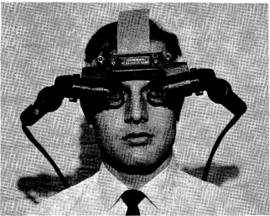

Figure 1 A Head-Mounted Three-Dimensional Display

It was not until the 1970’s where Augmented Reality advanced further. Myron Krueger, A computer graphics lecturer conducted a project to build an Artificial Laboratory in the University of Connecticut that was known as “Videoplace”. Originally called “PHYSICS SPACE”, Krueger began to develop it as a responsive environment, essentially it “perceives a participant’s actions and responds in real-time with visual and auditory displays” [3]. The project was developed for a time of 16 years and the project was a success. When it was developed in the 1970’s, the hardware at the time was not designed for high performance graphics as Krueger intended for his project. It was not until 1992 in a conference, Krueger [4] later explained in a paper about the architecture of the project that “Artificial Reality Systems are slow primarily because not enough specialized hardware and software have been built.” This explains why it took him 16 long years for the project to develop. The whereabouts of the project now is understood to be shown as an exhibition in the University of Connecticut.
Then in the 1990s, Augmented Reality became a field of study for computer scientists. Thomas P. Caudell was the first to name the term of Augmented Reality. He [5] stated that “This technology is used to “augment” the visual field of the user with information necessary in the performance of the current task, and therefore we refer to the technology as “augmented reality””.
Ronald Azuma conducted a survey of Augmented Reality in 1997. In his survey, he clearly established the definition of AR. He stated that AR is a “Variation of virtual environment (VE), or virtual reality as it is more commonly called”. What Azuma means by his definition of augmented reality is that it is just one variation of virtual reality. So, it takes some of the principles of virtual environments but added new principles at the same time to make it different. What Azuma [6] has iterated is that “AR allows the user to see the real world, with virtual objects superimposed upon or composited with the real world. Therefore, AR supplements reality, rather than completely replacing it” What Azuma means is that the whole idea of AR was to combine digital objects in the real world without replacing the reality.

The survey establishes the definition of the technology as well as the applications that are used such as medical and manufacturing. Paul Milgram became another important figure as he proposed a scale diagram that is known as the Virtuality Continuum which is designed to represent two environments, Real and Virtual Environment. For the Software Development aspect, Hirokazu Kato, a professor from Japan, created ARToolKit, an open sourced SDK (Software Development Kit) and was released in 1999.
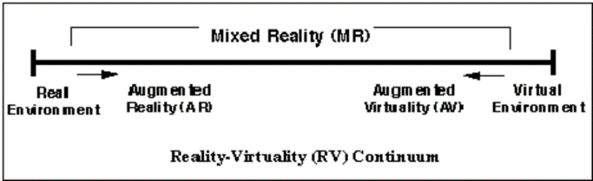

Figure 2 Milgram's Reality Continuum

In 2000, Bruce Thomas, a senior lecturer at the University of South Australia, created the first outdoor AR Game known as ARQUAKE. Thomas [7] stated that the aim of the project was to “construct a first-person-perspective game with the following attributes”. Which he later described as being able to move in the real world as well as the physical world with better controls. The view is then created by the user’s head’s orientation and position and a transparent HMD for the Augmented Reality experience. The project required the assets from Quake, developed by id software in 1996, it was used to develop the gameplay. The reason why Quake was chosen was due to many reasons. The first was the AR model they were seeking. Thomas [8] explained that “Quake fits the general model of AR which are we studying, as it is a first-person 3D application with autonomous agents to interact with the user”. The source code for the game was in the public domain. Finally, the graphics engine that is used to which Thomas [8] claimed was “very quick and runs on a wide range of computing platforms and quick operating systems.” The project was a success, becoming the first game designed for AR systems.
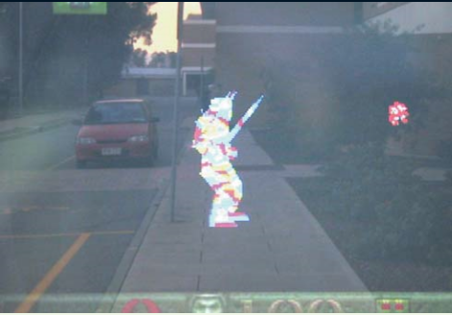

Figure 3: ARQuake

From 2010, Augmented Reality began to find its way to the mobile devices in terms of games. In 2012, American mobile game developer known as Niantic released an app called Ingress, a location based mobile game that primarily used the location of the player while implying augmented reality components for the gameplay. However, Augmented Reality did not become popular in the eyes of the media until July 6th 2016 when Niantic released the phenomenon that was known as Pokémon Go. Since the release of the app, the mainstream media covered it, putting it in the spotlight for many months. This gave Augmented Reality a substantial amount of attention and interest. It has also been the focus of many case studies thus, from the positives to the concerns of health.

Over the years since it was introduced, Augmented Reality has evolved to become a technology that is part of today’s society. It is used in Medical, Construction and tourism as well as the social media platforms and mobile games. With recent events, such as Microsoft’s AR project known as the HoloLens and many more headwear on the market, the technology will evolve rapidly over the next few years. The market is booming with AR technology in most of its applications, generating a substantial amount of money for businesses

Edge Detection – A Section of Image Processing
Edge Detection has been well established since the 1960’s, ironically the same period as when Augmented Reality has also been presented for the first time. With many projects proposing to address issues that other algorithms that came before have presented to experts in the field, it can be described as a continuous cycle of fixing another’s problem. In this section, the aspect of Image Processing will be examined including the principles of changing pixel data to present a new value in return.

Timeline of Edge Detection Algorithms
The sub section of Image processing was first established in the 1960’s as when the majority of fields such as Artificial Intelligence and Augmented Reality started to arise. Image Processing is used for calculating the current data of the test image and outputting a new value of the image. A number of algorithms designed to perform the process has been created over the years. A time line is presented.
Roberts Cross
Sobel
Prewitt
Kirsch
Robinsons
1977
SUSAN
Canny
1986

1963
1968
1970
1971
1995
The first edge detection algorithm that was introduced was the Roberts Cross. Then Sobel and Feldman came up with an idea of calculating a more efficient result and propose a better method at a SAIL laboratory in 1968. Prewitt proposed her algorithm in 1970 that is similar to Sobel. In 1970s then saw the emergence of compass operators, specifically, Kirsch and Robinsons. 1986 then saw John Canny propose a laplacian type algorithm that is more advanced than Sobel and Prewitt. Finally in 1995 saw SUSAN being developed which is unique due to the use of a circular mask.

Image Convolution
One method that the majority of edge detection algorithms use is image convolution. Image convolution is where the use of a kernel is applied to the image, multiplying the values of every pixel in the image to present a result. This process applies to all neighbouring pixels within the image. The processes mathematics is the use of matrix multiplication as the images data is stored in a 2D array.


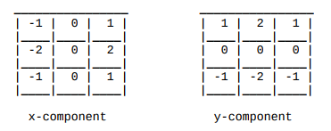

x
50 | 20 | 15
100 | 100 | 50
60 | 20 | 100

The main purpose of the technique is to provide a filter effect. The justification can be for a number of reasons. The first reason is to enhance the quality of the image. It could be sharpened, smoothed, or just enhance the quality. This is used in programs such as Paint.Net and Adobe Photoshop. The majority of kernels that are used can be a 3x3, a standard format. However they may not achieve the best quality result so the kernels are increased to 5x5 and 9x9 and although it does increase quality in the image, it takes a substantial amount of time and processing power to achieve it.

Development of Augmented Applications
Augmented Reality application development can be done in many different methods. In the Games Industry, it uses two main technologies, Marker less and Marker Based or also known as “Fiducial and Non-Fiducial” per Mousa [9]. As well as the technologies, there are many other different features that help compose a game built for AR. In this section of the literature review, all the components of development will be examined and its current applications used in Games.

Types of Augmented Reality

Markerless
Markerless is described by Katiyar, Kalra and Garg [10] as a different type of Augmented Reality that the image is “gathered through internet and displayed on any specific location (can be gathered using GPS),” This is per them being more interactive than using marker based. For example, Pokémon Go uses Marker less technology because it is easier to generate Pokémon rather than having millions of markers around the world.

5.1.1.1 Detection and Recognition
There are four main components of Marker less AR, Detector, Descriptor, Matcher and Pose Estimation. The detector is designed to detect the image that is looked on through the camera and scan it through the database to find a reference to it for the object to be generated. It scans the whole image including the edges, points and corners. The descriptor is described by Yee, Arshad and Abdullah [11] as it “must be created to identify the keypoint of reference image and the image stored in the database.” The matcher is the component that searches the database for the closest detail that is captured by the descriptor and uses it to find the image stored on the database. The Pose Estimation is where it determines how far the image is from the camera and whether it can generate the object at a suitable distance.

The technology is more advanced than using Marker Based. The areas that use the technology are most notably game publishers, advertising/ promotion and agencies. Game publishers use the technology as it is easier to develop with and can optimize the location based elements into its gameplay.

Marker Based
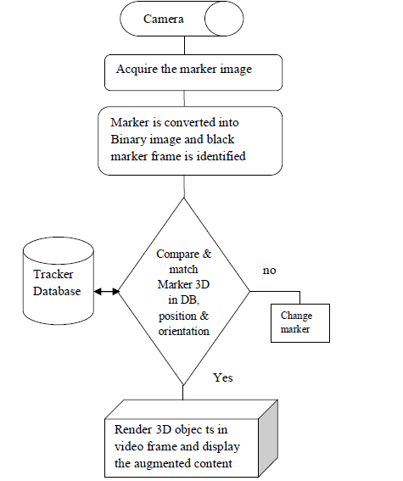
According to Gao, Wang and Bian, “Markers used in the marker-based AR for 3D registration are mostly black and white and planar.” [12]. It is normally used in smaller projects more specifically independent developers. To make a Marker Based application, developers require two components, the Marker and a database. The database specifically contains the data of the object that can be generated when the marker recorded is scanned by the camera. Developers can design their own markers, this is however depending on the software they are using. Some contain generators that generate a design for them without launching Adobe Photoshop to create it single handed.

Figure 4 Marker Based Structure

Detection and Recognition
Marker Based recognition procedure involves that is according to Katiyar, Kalra and Garg [10], “image unwrapping”. The procedure, in detail is designed to remove the black and white borders around the image and place the image from the current angle to facing up towards the camera, scanning the ID of the image. The database would then look for the ID scanned until it finds the image scanned and the object can be generated.


Figure 5: Flow Diagram of a Marker Based Application
Figure 5 Flow Diagram of a Marker Based Application

Another method of processing a marker is to scan and process the ID. This is done using the principles of Image Processing, a subject in the field of Computer Vision. Image recognition is conducted using image processing, a method to enhance pixels within an image. There are three types of algorithms, Edges, Corners and Blabs.

2.6.4 Edge Detection
Edge Detection functions in three main stages. The first, removing any form of noise in an image does improve the quality of the operator itself. The second, iterate throughout the image in all rows and columns to apply the kernels to the image. The third and final stage, checking the edges that have been detected and to determine if they are false as to which they will be removed. There are many algorithms to use to detect images in the image. Five algorithms are presented.

2.6.4.1 Sobel
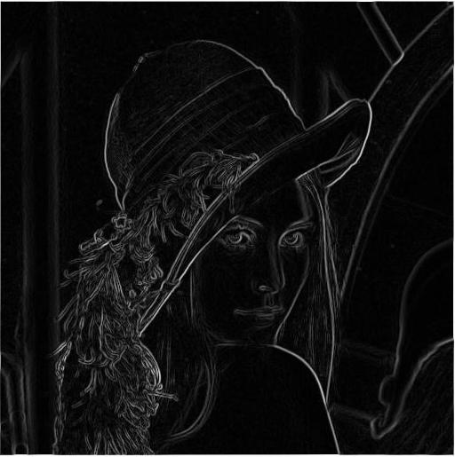

Sobel or Sobel Operator is an algorithm that results in scanning the image and creating a new image, making the edges clearer to see while removing the colour from the original. Originally named by Irvin Sobel and Gary Feldman at the Stanford Artificial Intelligence Laboratory (SAIL), it is commonly used in image processing and computer vision. Using two kernels, both in the horizontal and vertical directions, it creates a new value for the masked image. Sobel [13] stated that the intentions of implementing this algorithm was purely based on calculating “gradient estimate which would be more isotropic”. Sobel does refer to another algorithm, The Roberts Cross operator. In Roberts Cross, the kernel is only 2x2 array while the constants are only 0 and 1.
Figure 5 Sobel: Before and After
Figure 6 Sobel: Before and After

While Sobel can be done using two kernels, it can also be done using the compass principle known in Robinson’s algorithm. Detecting edges in eight directions, it does increase the amount of edges shown. Archana and Soumya T [14] addressed one of the issues Sobel has, the accuracy. They stated that the “accuracy is relatively low because it only uses two convolution masks to detect the edge of image.” This in turn gives the benefit of not using the square root equation to calculate the output, an expensive function.

2.6.4.2 Canny
Canny, designed by John F Canny in 1986, uses a multi stage algorithm that detects the edges in an image. Designed to extract information from vision objects, it is one of the most used algorithms in the field of computer vision. The algorithm addresses three main aspects. The first, to achieve good detection of edges, Canny [15] states “There should be a low probability of failing to mark real edge points, and low probability of falsely marking non-edge points.” Essentially meaning that if there is a low probability of failure, the edges can be detected. The second criteria are to achieve good localization. In this instance to achieve the best corner in an image, the edges that are marked should be short in distance to the centre of a true edge. The third and final criteria is the limit of one response to one edge. There is a contradiction to the first criteria as Canny states where there normally are two responses to a single edge however he stated later that “one of them must be considered false”.
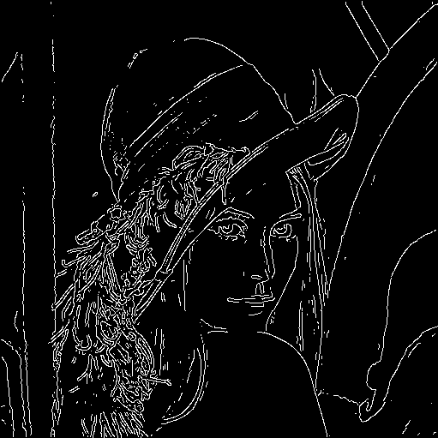
Figure 5 Canny Result
Figure 7 Canny Output Result

2.6.4.3 Robinson
Developed in 1977, Guner S Robinson created an algorithm that utilizes the idea of a compass. Essentially in this operator, eight kernels are introduced. The first four represent the main directions of the compass, North, South, East and West. The last four are Secondary directions, North West, North East, South West and South East. Essentially, it takes a single kernel and rotates it in different angles that represent all directions of the compass. The result of which, is a thin yet a grey edge line.

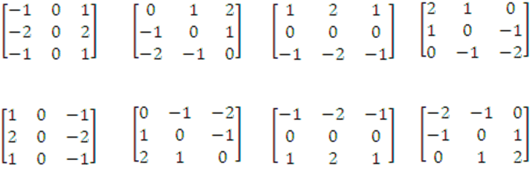
Figure 8 Robinson Kernels
It is important to note that this is not the only operator that utilizes the compass principle. Another operator known as the Kirsch operator uses the eight kernels described above, the only difference is the constants, only ranging from 0, 3 and 5. There is however one important fact to note, compass operators require 8 kernels to calculate the pixel value while gradient operators such a Sobel only require two. This is found by Čisar, Čisar and Markoski [16], who stated that “compass operator needs 8 convolutions for each pixel, whereas the gradient operator needs only 2,”

2.6.4.4 Prewitt
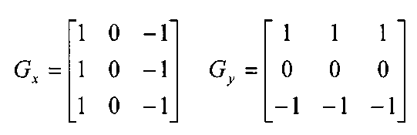
Prewitt algorithm is known as the classical operator in image processing. Developed by Judith M.S. Prewitt, the algorithm is similar to the Sobel operator however the difference between the two is the use of the kernels, more specifically, constants. The constants that were used in both the horizontal and vertical kernels i.e. X and Y use only 0’s and 1’s. In Sobel, the constants are 0, 1 and 2. There are a number of weaknesses that were highlighted by Prewitt. In the book “Picture Processing and Psychopictorics” which was published in 1970, she described her solution presents an issue. The issue was due to the amount of noise and signal within the image that is calculated. Noise is a term that is defined as random value of brightness within the image. Prewitt [17] stated that this results in “overemphasis of accidental fluctuations”. The solution to this would be in two methods, removing the laplacian operator with a “Second derivative in the direction n of the local gradient” is the first method. The second method is to use a technique known as contour enhancement.
Figure 9 Prewitt Mask

2.6.4.5 SUSAN
SUSAN, which stands for “Smallest Univalue Segment Assimilating Nucleus” is an edge detection algorithm. Presented in 1995 by scholars Smith and Brady who studied at the University of Oxford, it uses grey scale to detect the edges. During the process, the algorithm measures the corner towards a specific threshold. Li and Yang [18] states “If it is bigger than a certain threshold and it is the local maximum, such point is considered as a corner.” It can be certain that when the process is near its end, a comparison is conducted comparing the pixel value at a corner to a typical threshold value to determine if that point in the image is a corner. The method is done, using a nucleus or in easier approach of understanding, a circular mask.

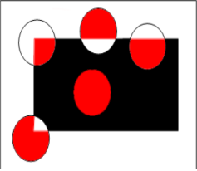
Figure 10 SUSAN Mask

2.6.5 Corner Detection
Corner Detection algorithms perform the process that is familiar to edge detection algorithms, however they detect corners within the image. Three algorithms in this field are presented below.

2.6.5.1 FAST
FAST (Feature Accelerated Segment Test), developed by Edward Rosten and Tom Drummond from the department of Engineering at the University of Cambridge, is a corner detection algorithm that is built around the idea of continuous testing. The algorithm iterates throughout the image and calculates the value of the intensity of 16 pixels within each region. The algorithm determines how bright or dark each pixel is when the process is concluded. In terms of advantages, Rosten and Drummond [19] stated that the algorithm “is many times faster than other existing corner detectors”. Despite this, the three main problems that the algorithm does pose is that the operator does not work with high noise in the image, secondly, it relies on the value of the threshold, thirdly and finally, it can only respond to one pixel at certain angles.
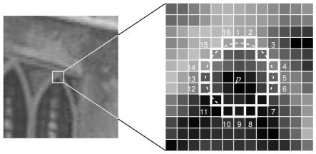
Figure 11 Intensity Pixel Calculation

2.6.5.2 Harris and Stephens
Harris and Stephens are a corner detection algorithm that is a modification on Moravec’s corner detection algorithm. Introduced in 1980, Moravec’s algorithm was designed to test the pixel if a corner is presented. Known as one of the earliest algorithms during that time, it was used to detect the intensity of the pixel. There were a number of issues that were raised including the high level of noise in the image and the operator responds too readily to edges. Chris Harris and Mike Stephens presented their own solution to the problems highlighted.

2.6.5.3 SURF
SURF (Speeded-Up Robust Features) is a corner detection algorithm, much. The process of the algorithm is separated into two parts. Part A is the feature point extraction. This process is designed to examine if the point processed is an extreme point. The mathematics behind this is specifically the Hessian matrix. The hessian matrix, created by German mathematician Ludwig Otto Hesse is a second order derivative of the scalar field. Bay [20] et al justified their decision to use Hessian Matrix as it provides “good performance in accuracy”.
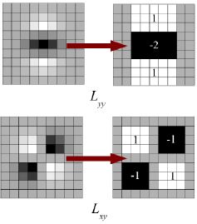
Figure 12 SURF Process

Marker Based vs Markerless
The main difference between Marker Based and Markerless according to Cheng, Chen and Chen [20], Marker based’s development consists with “each virtual product is linked with a particular marker” whilst Markerless development consists of “each virtual product is assigned a coordinate value of longitude and latitude”.

The main advantage of using Marker Based is that it requires less cost in terms of servers. Marker Based only requires a marker and a database. This can be used for small scale projects and easier for developers to work with. However, there are issues when using Marker Based. The most significant problem is the Marker detection algorithm, the marker is scanned based on the edges, lines and patterns that are recorded in the database. If the marker is damaged via tear or drawn over, the camera would not recognise it as the pattern is damaged. This would then require a new marker to be printed to replace the damaged marker. The second problem is the complexity of the marker design. The most common advice when creating markers, is to keep them simple. For example, use the “HIRO” marker that only contains HIRO. This is easier to scan. However, if a marker has a complex design, the camera may not be able to scan it correctly mostly due to the many vertices, edges and even shapes that make the image. The best practise is to keep the marker design simple so it can be easier to recognise. The third issue is the shape that has to be used with Markers. According to Demidova [21], she stated that “they must be square”.

As for Marker less the main advantage is the increased stabilization. Marker less AR is designed for larger projects, for example, Pokémon GO. Marker less AR are used by Game Publishers, Agencies and AR publishers. It constantly tracks the player when the app is used and with great accuracy. Another advantage is time. It saves time rather than using Marker Based. In the case of Pokémon GO, Niantic could not use Marker Based as it will have to be placed everywhere and when millions of players look for the marker, it seems inefficient. This saves time in the long term.

The issue with Marker less is the black spots throughout the world. Blackspots are defined as areas with no GPS signal. If the user is using a GPS based app and is in a rural location and they cannot gain a signal to the servers, the app will not function, making the technology useless. The second issue is the cost, servers are expensive and are required to hold player data. The most famous of those is the constant problems with Pokémon GO’s servers. It is important to note that the argument for this case is that millions of players log on every day since launch causing the servers to be overwhelmed.

SDK
Augmented Reality is developed through SDK’s (Software Development Kit). Developers can use a variety of SDK available, they come in two main categories, proprietary and open source. Proprietary means that a company owns the SDK and if the developers wish to use it, must pay a fee. Open Source means that the SDK is free and is not owned by a corporation. Gaythri, Kumar and Ram [22] stated that the SDK focus on “AR recognition, AR tracking and AR content rendering.” In this section, the SDK used by developers will be examined.

Vuforia
Vuforia is a SDK that allows developers to develop augmented reality applications for the mobile market. In terms of features, Vuforia mainly focuses on tracking and local detection as its main draw for developers. Tracking is a term that is defined when the user tries to fix the camera onto a marker so that the object will spawn and animate. According to a comparative study conducted by Amin and Govilkar [23], they stated that tracking is improved more specifically in “low light conditions and even though target is covered partially”. For example, tracking can work in dark rooms with some form of light as well as if the target is covered by an object partially. Vuforia has two main tracking methods. Xiao and Lifeng [24] stated that the two methods are “image recognition and text recognition”.
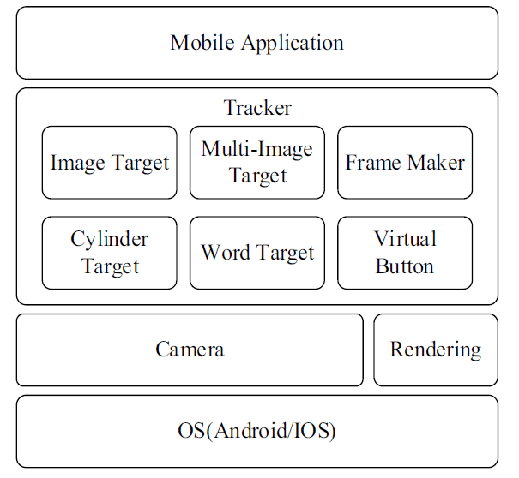

Figure 13 Vuforia Architecture

ARToolKit
ARToolKit is an open source SDK that does not require a license or form of payment. Per Amin and Govilkar [23], they stated that ARToolKit is an “open source marker AR Library”. ARToolKit’s main features comes in three main areas, Tracking, Camera and Optimization/ Support. For the tracking aspect, ARToolKit introduces “Robust Tracking” which does include Natural Feature Tracking. Natural Feature Tracking. For the camera, the calibration process is supported as well as stereo. It is optimised well for mobile devices including IOS, Android and Windows. ARTOOLKIT does provide support for developers who design their applications in Unity by providing a package specifically for Unity.

Wikitude
Wikitude is another open source SDK that is used for AR applications. Wikitude’s main features focus primarily on the assets that the application uses as well additional features such as Direction Indicator and Location Tracker. Amin and Govilkar [23] has stated that one of Wikitude’s features “Supports 3D model in .fdx and .collada file format which is converted internally using Wikitude encoder”. Collada files are an interchange file format while FDX is a XML file format. It is worth noting that at this stage during the research, it is led to believe that the authors of the comparative study were meant to mention FBX which is another interchange file format, created by Autodesk who developed Maya and 3ds Max. As well as that, it provides “both 3D and 2D transformation”

Metaio
Metaio is another SDK that is proprietary. The SDK is compatible with Android, IOS, Unity3D and Microsoft Windows. Metaio has features that are more focused on ease of development than the other SDKs that have been briefly examined. Per Amin and Govilkar [23], they stated that Metaio “Provides high level of abstraction”. This means that the developer can use low level implementations as well as design and develop applications which does result in greater ease, greater efficiency and productivity enhancement. Metaio does have their own rendering engine as well that is completely designed to perform advance tracking as well as being executed in suitable time more specifically on low cost devices. In terms of file format, Metaio supports .obj (object file format) as well as FBX and md2. Metaio does also utilizes the SLAM technology for its 3D aspect. According to Jiang and Kuang [25], “The SLAM can create temporary augmented reality in the real world”. SLAM which stands for Simultaneous Localization and Mapping is designed to create a GPS map and work in real time. The technology originally contained sensors. Taketomi, Uchiyama and Ikeda [26] stated the sensors such as “laser range sensors, rotary encoders, inertial sensors, GPS, and cameras” were in the early algorithms.

Kudan
Kudan is another AR toolkit that is in fact a competitor to Vuforia. Kudan is another proprietary SDK that does require a license to use the SDK for development. Kudan uses two main technologies which are Marker less and SLAM. Kudan does not require a marker for objects to appear. In terms of Images, 25,000 can be detected which is a significant amount as well as Camera images themselves can be pre-processed before being recognised. The main benefit is that Kudan does not have a limit of how many detectable images can be picked up. For tracking, multiple markers can be tracked as well again with no limit. Recognition has been extended that means the user can recover lost trackings without the issue of returning to the original distance or angle.

Current Trends of Augmented Reality

AR is not just used in the games industry, it is used in multiple fields such as the construction field, Medical and Military aspects. This section will examine the current trends in Augmented Reality in several different fields, the benefits, current challenges and the future of Augmented Reality.

Construction Field
AR in Civil Engineering is described by Mekni and Lemieux [27]. In terms of its application, AR is used in the design phase when designers and architects determine how the buildings are designed. Software is normally used to help designers create ideas on how the building should look when completed and Architects can discuss how the building should be structured. However, the real need of AR comes when Engineers need to determine how the building should be developed, including measurements such as how wide and tall the building should be. This can be further elaborated as Agarwal [28] has stated in his review on Application of AR in Civil Engineering that “Currently, the engineers in the field rely on scaled drawings in all projects that are used for all practical purposes”. The issue with this is that the measurements can be incorrect by human intuition. While this may not be an issue at the current stage, it will cause problems later. Agarwal [28] later states that “With the concept of AR, the engineer can review the structure as it progresses with the drawings by projecting the drawing onto the field”. He believes that AR can allow the engineer too continuously adjust measurements, essentially solving the human error of miscalculating measurements.

Games Industry
The games industry is where AR grew popular in the public eye. The most popular examples of these are Ingress and Pokémon Go, all created from the same developer, Niantic. Most these applications require a crucial function, GPS. The function is main element in the games which is to track whether the user goes and placing Pokémon or bases in the real world. As of today, Augmented Reality is still evolving in the Games field. Although it has not reached the AAA market like Virtual Reality has with Oculus and HTC Vive, it has impacted the mobile market, bringing it to the attention of the media. With Pokémon GO’s spotlight now faded, it is only a matter of time until something else takes its place as the latest trend in the Games Industry.

Tourism Field
Tourism uses AR to a huge extent when it comes to promoting their business to consumers from foreign or local countries. It is essentially a marketing tactic, drawing consumers to explore their values and encourage them to buy their products.
In terms of its application, AR in tourism is mainly GPS based and used only on mobile devices requiring the download of the app and have it access the camera. How the objects can be viewed from the camera is decided by the developer themselves. For example, if it is a cultural heritage topic, the objects would be past castles and a brief description of the history. Archeoguide Research was a project that started in 2001 with the intention of covering “Fields of cultural Heritage and Archaeology from the technology point of view” as stated by Peter Mesároš [29] etc al. An example would be the Woodlands Trust “Nature Detectives Family Trail”. Developed by Jam Creatives Studios, the app was designed specifically for children and “teaching them about the importance of protecting native bluebells” [30]. The app serves as an education scenario as it teaches the younger generation of persevering the blue bells by not walking over them and staying on the path.

Medical Field
The medical field has seen a lot of technology advances for many years. From VR to Robotics, AR joins the list of technologies used in the field. However, one of its current motivations as quoted by Mekni and Lemieux [22] is the requirement of “visualizing medical data and the patient within the same physical space”.
In terms of its current uses, AR is used in training students who are looking to become doctors or medical nurses. The example that Alkhamisi and Monowar [31] used to illustrate the effect is that “Such program or application may contain the main list of medical mea-sures for the healthcare providers to select from. Once the healthcare provider chooses one of the measures from the list, the first screen will display where the tracking patterns should be situated in the sick person’s body.

Military
The most common use of AR in the military is Simulations. The US army in particular has “not yet formally fielded an AR Training capability” according to LTC Stevens and Eifert [32]. Since the publication of the conference paper, there have been little documents detailing the military’s use of Augmented Reality meaning that either it has not made their way into the field or they are using it but are keeping it classified.

Education
Augmented Reality is used as an effective tool to help teach students in their subjects. One of those features is the use of “3D synthetic objects to augment the visual perception” [33]. Students would find it easier when a 3D model appears, reinforcing their learning. In particular, the Marker Based Applications have been designed to help “Students to improve their spatial abilities” [34] Augmented Reality also applies to disabled children who have difficulties. For example, a project was carried out to evaluate AR in terms of undertaking tasks by students from elementary school who have Autism. The study conducted was a success that according to Chiak [35] et al, he concluded that with Augmented Reality intervening, that “all students acquired and maintained the chain task of brushing their teeth independently and a functional relationship was established”. However, according to Jorge Bacca [36] et al, there are “difficulties maintaining superimposed information, paying too much attention to virtual information and the consideration of AR as an intrusive technology”

Current Trends of Edge Detection Algorithms
Much like Augmented Reality, there are a number of trends at present in Image Processing. In this section, the current trends of Image processing are examined. These involve projects, surveys and experiments conducted by academic professionals.

Sobel
Sobel has been used in many different aspects. As well as that, there a number of projects that consists of creating new approaches to solve problems. One of those is Face Detection. Facial Recognition has been used mainly in security and networking aspects, specifically Neural Networks. One project that was conducted by Joseph et al used the Sobel algorithm to pre-process images before they can be used in the network. However, Joseph [37] et al noted that there is a risk of “Removing Objects which are in fact faces”. This describes the issue of not being able to recognise he individual’s face later on. Another aspect that Sobel’s been used to enhance MRI scans. The project conducted by Anilkumar, Muralikrishna and Lakshmidevi, they created a new approach to enhance image of MRI scans. For this case, the Log Sobel was created and described by Anilkumar, Muralikrishna and Lakshmidevi [38] as a way to “image with the logarithm of luminosity (luminous density) not with luminosity” The results include a clear image of MRI brain or knee scans.

Canny
The majority of trends that are in the interest of Canny are optimisation solutions to the original algorithm which paves the way for new algorithms or modified/improved versions of the Canny algorithm. One project conducted by Feng, Zhang and Wang focused on the improvement of Canny to produce a graphically enhanced image that does not use Gaussian Filtering. They use the median filter to solve this, stating that it can be used to “preserve the details of the image and remove the noise” [40]

The algorithms that are highlighted are used in many different fields particularly to enhance images. Many projects however did not use the original as it presents problems that can hinder their aims and objectives. Therefore, modified algorithms are created to suit their needs which is the common trend in the majority of the algorithms and will most likely be the future trend moving forward.

Conclusion
The literature review covers the field of Augmented Reality and Image Processing. Augmented Reality has been rapidly developing in recent years and will continue to do so. While the literature review examines Augmented Reality as a field, it does examine the implementation side which is the main focus of this dissertation. The Edge and Corner Detection algorithms are examined, detailing the mathematics used to highlighted corners/edges in the image.

The literature review shows that Augmented Reality has continually evolved and will do so in the future. As for Edge Detection in Image Processing, the current trend is the continuous cycle of creating new approaches to solve problems in other fields. However, this is not just for other fields, this is also for original algorithms. The future for Augmented Reality is bright, with many companies now investing their interest and money in projects, the number of applications will grow rapidly. While Image Processing will remain the same with the continuous cycle. Although the 1970’s was the decade for Computer Graphics overall, with many algorithms introduced, in terms of edge detection, the time between one algorithm and another seems long in between.

Overall, Augmented Reality’s future will be successful and is proven to go beyond Virtual Reality while edge detection algorithms copy another’s ideas while few are unique in their own way.

Case study

Approaches
Many professionals in the field of Image Processing have used many approaches to implement some of the algorithms described in the previous section. In the case of this project, the algorithm chosen is the Sobel Operator. It is to be noted that each approach presents several benefits and problems. In this section of the case study, two approaches will be examined, critically evaluating it and assessing the strengths and weaknesses it shows.

Approach 1: Improvements of the Sobel Operator.
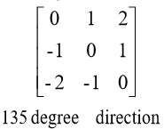
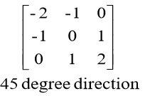
Zhan and Fang, students of the Inner Mongolia University of Technology created an improvement over the original algorithm Sobel presented in 1968. In the original publication, the directions Sobel used were Horizontal and Vertical. However, Zhan and Fang have presented a slight modification to that matter. Two additional directions are now added, 45 and 135 degrees. The new directions kernels are presented below.
Figure 14 45 and 135 Degree Kernel

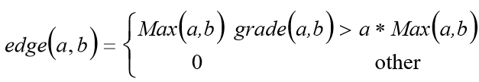
For the edge detection process, there is an additional step that Zhan and Fang proposed, an edge thinning process. The problem that was stated by Zhan and Fang is that to have a thinner edge, it would have to use a threshold that is submitted to the process of binarization. The value of the threshold cannot be found. To resolve this, the edge of the gradient is refined before submission to the binarizing process. The following equation can be seen below.
Figure 15 Edge Refinement Equation
The refinement process can be achieved with the equation before using the binarization process. Binarization is a process that turns a pixel image to a binary image. For the selection of that process, another method is used, the Otsu Method. The Otsu method, named after a Japanese student, Nobuyuki Otsu from the University of Tokyo, operates by determining threshold automatically.

The approach highlighted was a success, Zhan and Fang [41] reported that “Compared with the traditional Sobel Algorithm, it displayed more information of original image; the edge is more specific and contains more information.” As the images shown, the difference between the original and the improved Sobel Effect image shows the edges. The benefits of using two additional directions as according to Zhan and Fang [41] is the weight in the “template in the direction of oblique edge”. The edge thinning Process makes the binarization process less difficult at a later stage and does save a lot of time. It is stated that according to Zhan and Fang, the original algorithm does lose edges in the process. They are correct, the original algorithm is not accurate in terms of highlighting all edges in the photo.

However, there are problems that do have to be highlighted. The time consumption is higher than the usual time the algorithm took to execute. This can be due to the additional methods of edge thinning and Otsu method. In the case of Zhan and Fang, it took 1.2 seconds to execute. However, if it was used for a more complex image, it will take much longer to execute. This is the case of achieving the best outcome while sacrificing time.

Overall, the theory that Zhan and Fang introduced addresses the problems that were raised with the original algorithm proposed in 1968. It achieves its outcome, highlighting all edges while taking longer to execute. This algorithm is designed to highlight all edges in the image, if the programmer has no issue with execution times being longer than usual, this algorithm is suitable for them and the purpose of the study is complete.
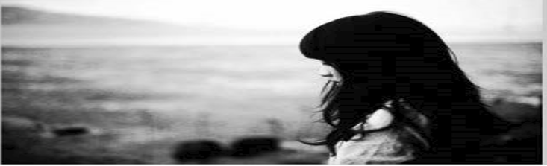
Figure 16 Before Filter

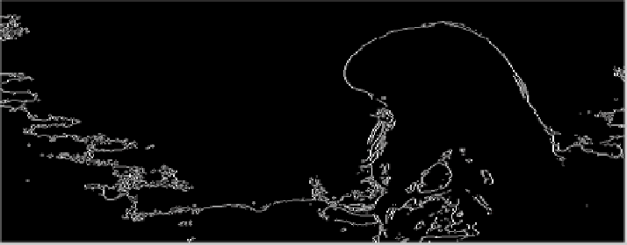
Figure 17 After Filter

Approach 2: Image Segmentation in Sobel
Another study conducted by Zhang, Yang and Tang, followed a similar approach. Using the Otsu method, they performed the image segmentation process in the aims of an automatic threshold selection. The following algorithm they have proposed is presented here.
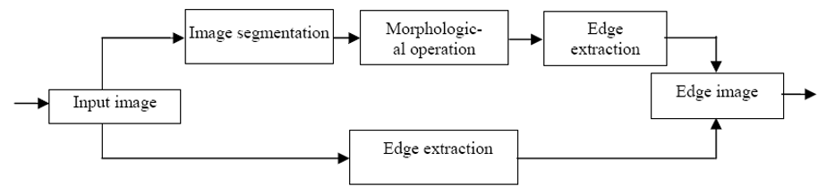
Figure 18 Flow Chart of Image Segmentation
What is different from this approach to Zhan and Fang’s approach is the use of Morphological operation. Two methods are recalled, Erosion would change a pixel, located in the foreground to background if that pixel in the background has a 4 neighbour. Dilation works the opposite path of Erosion. This is an information retrieval process. Zhang, Yang and Tang used the clean, fill and open operator to achieve a more accurate result in defining edges.

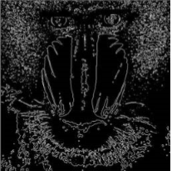
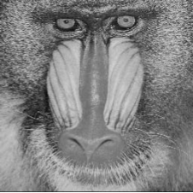
The approach described above is familiar Zhang, Yang and Tang however it does not have the edge thinning process that is described previously. This approach was successful. The results can be seen below.
Figure 19 Before and After Image Segmentation

The algorithm does highlight all edges seen. However, comparing the final image to that of the previous approach, this image is not clearly visible. It appears the image output has lost brightness throughout the image.

Sobel Edge Detection Algorithm Proposal
After examining both approaches listed in the previous section, it is understood that the Sobel Algorithm was used as the base for the framework. The additional functionalities were designed to further enhance the algorithm and fixing the issues previously. In this section, a proposal algorithm is described that uses the Sobel Operator in the field of image processing when it comes to Augmented Reality.

The original Sobel algorithm can be viewed in the Edge Detection section above. However, in the case of recognising an image, every edge must be intact and not lost. If edges were lost, the process would remain tricky to achieve the best result. To achieve this, the Otsu method will have to be practised and applied here. The equations can be viewed in the appendix.

In the interest of the project, the process of using an improved Sobel Algorithm will be different. In work highlighted above, the professionals used an image loader, however, this project uses the camera to obtain the image. The operation would prove challenging to execute. In most applications, it requires a scanning algorithm to scan the marker image at a suitable distance. Only then can the Sobel algorithm can be applied.

Research and/or Development Methodology
With the previous section examining the current literature of both Augmented Reality and Image Processing, Research and development Methodologies are used for this. In this chapter, the methodologies will be detailed in brief, of how the application will be developed.

Research Methodologies

Philosophy
The project’s research is in the interest of facts and statistics. The philosophy that is chosen is positivism. Positivism, is the philosophy that all data is fact and not analysed in the belief of thoughts and feelings. The choice regarding the philosophy chosen is justified due to the data that will be used which will be used in developing the application. The advantage of using this philosophy is that the data is specific and precise as the test results conducted requires specific time that the algorithm finished. The second advantage is that quantitative data is required due to the statistics of performance of each algorithms tested. The final advantage is that the data is reliable as the data that is produce through testing is accurate. The disadvantages of this philosophy is that the validity is low and low in terms of quality.

Approach
The approach taken is deductive, an approach suited for projects whose subjects have been well established with a range of resources of research and projects. The choice is purely due to the factor that Augmented Reality and Image processing are well established and contain many resources. This approach will require a hypothesis that is created along with a theory.

Strategies

3.1.3.1 Literature Review
The strategies are used to investigate the literature of the project’s area of subject. Three are chosen. The first, the literature review. A document that is used to examine the current state of the field, examine project findings, algorithms and both current and future trends. Alternatively this can be thought of as a snapshot of the field. This is chosen as the field of Image processing and Augmented Reality requires an understanding that is beneficial when developing the application.

The advantage of using the literature review is that all of the algorithms and projects that were conducted are examined, including the strengths and weaknesses of an algorithm. This does increase intelligence and improve a greater understanding of the field which is crucial with this project. The second advantage, is identifying the questions about the field. This gives motivation for projects to answer questions that are identified during the research process. The third and final advantage is the research into expert’s findings within the field. This presents the reader a more detailed review of the literature and the findings they found from their projects.

The disadvantage of using the literature review is the restriction of access to the resources that are required to analyse the field of the chosen subject. The majority of books and journal articles are accessed through academic libraries. However some of them do require payment in order to access the materials required. This eliminates the use of a primary source which is crucial to the research as payment is required to access for a specific length of time. If a researcher wishes to access a document that is from the author who wrote it which is a primary source and requires payment to access, they can either pay and get access depending on the length of time or not pay and lose a vital source of information.

The second disadvantage is the amount of time it can take to produce the document. The literature review requires a substantial amount of reading to understand the content in a book, journal article or technical document. This can take months to complete.

3.1.3.2 Case Study
The Case study is also used as in the Literature Review, the algorithms are described, however in terms of implementation, and there are many methods of implementing it. The case study examines the approaches to the problem and evaluate it in terms of its advantages and disadvantages. The choice to use this strategy is to examine the approaches that are used by academic professionals and to be able develop a solution to the problem. The advantages of using this strategy is that it can be used to examine approaches with the algorithms and which is the most efficient approach to use.

The disadvantages of using the case study is that the data can be created based on the factor of bias. Most case studies that are conducted can produce data to suit their agenda and to make the argument they have at present. The second disadvantage is that it is time consuming. The document requires a substantial amount of data that is required from projects conducted in the field and access has to be provided in order to examine the data.

3.1.3.3 Software Development
The third and final strategy is software development. The project requires the development of two edge detection algorithms. This requires a development methodology in order to develop a fully functioning application. This is required due to the nature of the project which is to examine and compare algorithms in the form of graphic quality and the time it took to execute in the form of test images. The advantages of using this method is that the algorithms implemented can be tested and analyse in terms of performance, for example, what is the execution time of the algorithm? How much memory does the algorithm utilize? How expensive is the algorithm? The tests answer the questions that are asked when the application is executed. The second advantage is to create statistical data to present your solution to the problem. To determine which algorithm is the best to use in an Augmented Reality application, test data has to be created to show the computational aspect of the algorithms. With this, performance, graphical quality and time are present.
There are a number of issues to be raised with this strategy. The first, the application may not be developed in time due to problems within the aspects of applying the calculations to the image. Some issues may not be solvable hence the development side of the project starts to fall down. To address the issue, the problem will have to be examined in detail and ask the question, how is this caused? And what can be done to address it?
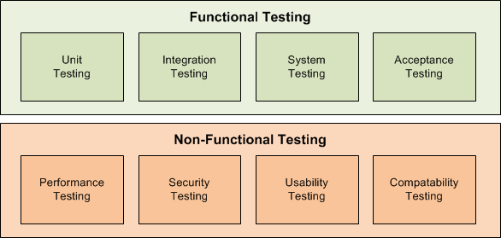
Figure 20 Types of Testing
In the interest of testing, there are two types of testing, functional and non-functional. Functional testing is where the application is tested with the requirements kept in the process. Non-functional testing is defined as where the application is tested that its part of the non-functional requirements. In the project, functional testing is used as the requirements state of the implementation of Sobel and Robinson. In this case, unit testing is used. Unit testing is defined as specific parts of the code are tested. This is used because the focus of testing is on the algorithms implemented.

Research Overview

Research Deliverables
The main outputs from the research is the test data produced from the tests conducted to test the algorithms. The tests include the test images after image convolution, test reports that are generated using the performance profiler, a feature that can be accessed using Visual Studio. They conceive statistics such as execution time, processes required and memory required.

Development Methodology
In the aspect of Software Development, there are a range of development methodologies to utilize. From Agile to Waterfall, each has their own uses and strengths and weaknesses. In this section, a method will be chosen and evaluated to match the project requirements.
Agile has many methods, from SCRUM to Feature Driven Development, there are many to choose from. One method is Rational Unified Process or UP. UP is designed for iterative development, essentially Iterations replace the term of Tasks. For example, Iteration one can be Image Processing while Iteration two can be tracking. The model consists of four phases, Inception, Elaboration, Construction and Transition. Inception is a phase that collects data from stakeholders and users about the requirements of a new system that can solve problems that can make their tasks easier to achieve. Four documents are required, Use Case, Vision, Glossary and Supplementary specification.
The Elaboration takes the information collected during the Inception phase and expands on it. Diagrams are created at this stage which includes the Domain Diagram which represents the business side of the system. The architecture diagram represents the structure of the system and the packages that builds the system. The System Sequence Diagram demonstrates how the user interacts with the system and the process that takes place from the event of the user interacting with the system. The Class Diagram presents the use of variables in classes. C++ is specialised in object oriented programming, meaning that classes are required to store methods and variables.
The Construction phase takes everything in the Elaboration phase and transforms it into a fully coded system. The diagrams guide the programmers into implementing the system. The Transition phase occurs when the Construction phase is completed and the system is ready to be used by the stakeholder and the users.

The justification behind the choosing of the method is that the amount of time studying and practising the method is beyond three months that is required to be able to use the method. If another method is chosen for example Feature Driven Development, time will be required to study and practise the method which at this stage in the project is inefficient. The main advantage of using rational unified process is that it leads to clean code due to the amount of documentation throughout the Inception and Elaboration phases.
The disadvantage of using Rational Unified Process is the amount of documentation required before construction. This can depend on how complex the system is and the scope, the more complex the system is and the more detailed the documentation will be.
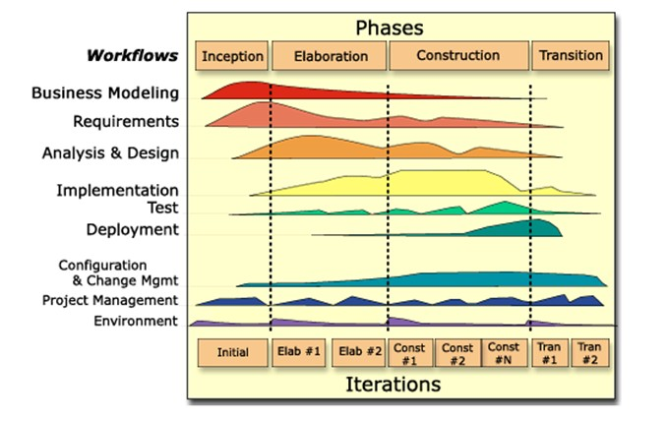
Figure 21 Overview of RUP

The images are collected in a file format known as Bitmaps or .bmp. They are chosen for this project due to the file structure that is implemented in C++ that is known as “BitmapInfoHeader”. This is a structure of data that is contained in each image. The alternative to this would be to use a JPEG which is the opposite of bitmaps due to compression techniques that are used as well as the advantage of utilizing an alpha channel in bitmaps. With this, an image file loader was required for this to effectively read and write the bitmap image to be used. The data type used is unsigned chars due to the colour data in every pixel. The file format has 3 channels, red, green and blue. When Sobel and Robinson are executed, the colour data changes.

The second requirement was to use a graphical API. With this, OpenGL is used for development. OpenGL, in the same way as CUDA, which communicates to the Graphics Card to render the scene when debugging. OpenGL renders all the textures that are applied onto objects as well as lighting elements. Bitmaps are a perfect example of textures being used.

For this project, hardware such as webcams will not be required, however, a good spec of hardware such as suitable graphics card and a CPU with a reasonable speed of above 3.0GHz. C++ is an extension of C, developed by Bjarne Stroustrup, it is used for creating Objects and Classes. The justification behind using C++ is the main programming language is that OpenGL does rely on the use of C++ and it is more efficient to create a class that handles a task and not contained along with other code for other tasks in the same CPP file. It is the best practise to separate tasks into their own classes.

Conclusion
In Summary, the research methodologies have been chosen and elaborated in terms of advantages and disadvantages in using them. The philosophy, approach, strategies are chosen based on the nature of the project which is a software development project, requiring the Literature Review, Case Study and Software Development. The development methodology, Rational Unified Process has been chosen purely on the basis of familiarity and practise. If another approach was to be undertaken, there would not be enough time to familiarise and practise the process of the development methodology. Other aspects such as Hardware, additional libraries and programming languages are highlighted as well as the justifications in the use of these additional materials.

Design and Implementation
With the research detailed in the previous section, the Design and Implementation will take effect. In this section, the Design and implementation will be described for the application of this project.

Problem Formulation
The problem consists of the choice of the edge detection algorithms suitability for marker based Augmented Reality application. In this application, two operators will be used. The first, Sobel Operator, which calculates the length of an edge using two kernels. The second, the Robinsons Operator, an operator that utilizes the principle of a compass, calculating the image data in eight directions. To test the performance of each operator, test images are used. Five sets of Images are used for the experiments, ranging from simple to complex.

Design
The design of the application is created purely on the basis of the literature review and the case study conducted into practises and approaches of implementing edge detection algorithms. The design is requiring the use of a bitmap loader that can be used to load the image. With the rational unified process, the design of the application can be created. This is done by following the process of Inception and Elaboration.

Implementation
The project requirements are described as the image being loaded in a form of a bitmap as well as the implementation of two edge detection algorithms, Sobel and Robinson. The project also required testing of the algorithms on test images and to be compared in terms of graphical quality. Originally, OpenCV was used to learn the implementation of the algorithms. The justification behind this was the majority of journal articles stated that they developed their algorithms using OpenCV.
During development, a system model was created to describe the system. This was done as a use case. A use case is the first step in the Inception Phase, it describes what the system will do when running.
In terms of problems that were encountered during the duration of coding, there were many issues occurred, particularly with the loading of the image. When first loading the image, the texture will appear to have a pink colour attached. This is due to the lighting variables such as Ambient and Diffuse. If this is removed, it gives the original colour of the texture as intended. However, the process does involve a number of code successes, particularly the success of loading an image. Another success is the implementation of Sobel and Robinsons.
The testing of the code is unit testing as the Sobel and Robinson’s algorithm had to be tested individually. Unit testing is where selected pieces of the code are tested and not the whole project.

Inception

Use Case
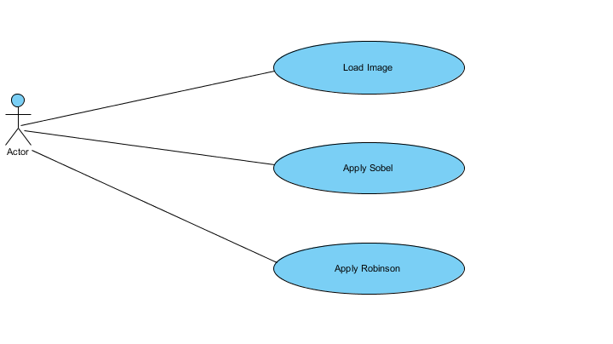
Figure 22 Use Case Scenarios
The use case above illustrates what the actor will be doing when the program is used. It also illustrates what activities are going to be performed. The first use case is loading the image. The second, applying the sobel filter to a copy of the original image. The last, same process as Sobel, apply the Robinsons algorithm to a copy of the original image.

Glossary
Please Refer to the Appendix

Vision
Please Refer to the Appendix

Supplementary Specification
Please Refer to the Appendix

Elaboration

The elaboration phase takes all data obtained in Inception and Elaborates, creating four main diagrams.

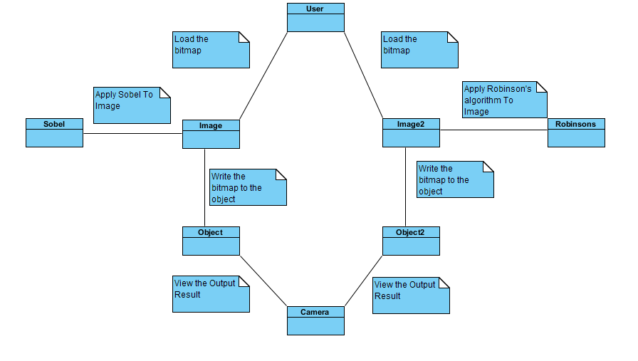
Domain Diagram
Figure 23 Domain Diagram
The domain diagram represents the overview of the system. The user loads the bitmap, one for sobel and another for Robinsons. The image will then be written via Sobel or Robinson and will be displayed onto the object which will be created when the program is executed. The camera will then allow the user to view the output result of the algorithms.

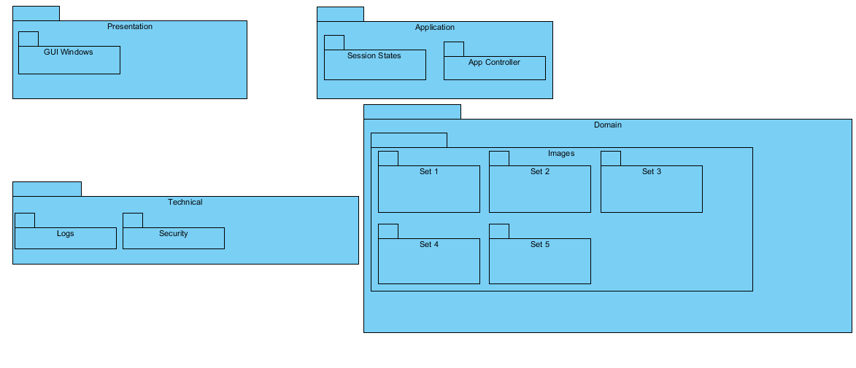
Architecture Diagram
Figure 24 Architecture Diagram
The architecture diagram above represents the structure of the application. This represents four main packages, presentation, Application, Technical and Domain. Presentation is where the windows will be generated. Whenever the program is running, a window will have to appear to show the image. The technical package represents logs that are recorded as well as security. The application represents the current state of the session. Finally the Domain diagram represents the five sets of test images that are used to test the algorithms.

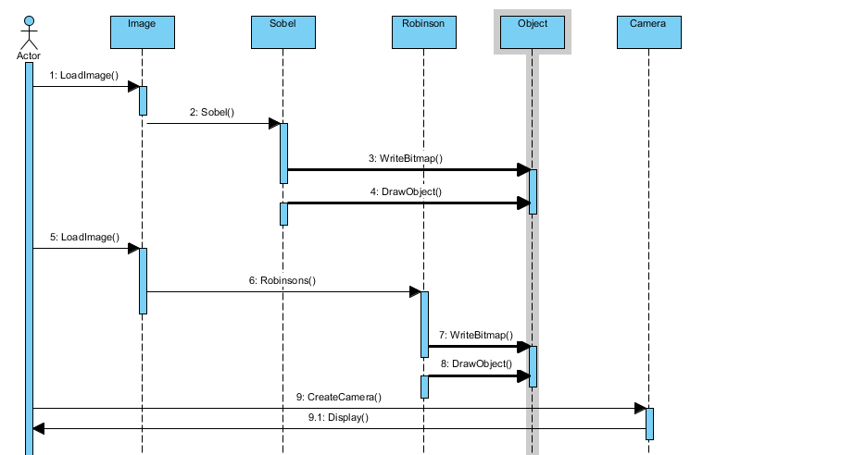
System Sequence Diagram
Figure 25 System Sequence Diagram
The System Sequence Diagram represents how the system will function when being used. To start, the actor will load the image, the Sobel will then be used and write the new calculations to the image. When the image processing aspect is completed, the rest of the scene including drawing objects and creating the camera will follow. This process will take place with Robinsons and repeat.

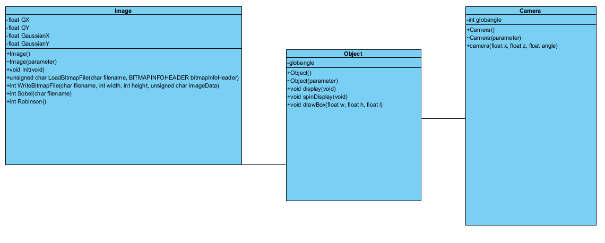
      - Class Diagram
Figure 26 Class Diagram
The class diagram above represents the variables, constructors and operations each class will contain. This gives a structure for each class. The image class handles the process of writing and loading an image. The object class is designed to create an object for the image to be displayed on. The Camera class is designed to allow the user to view the image.

      - Code Snippets
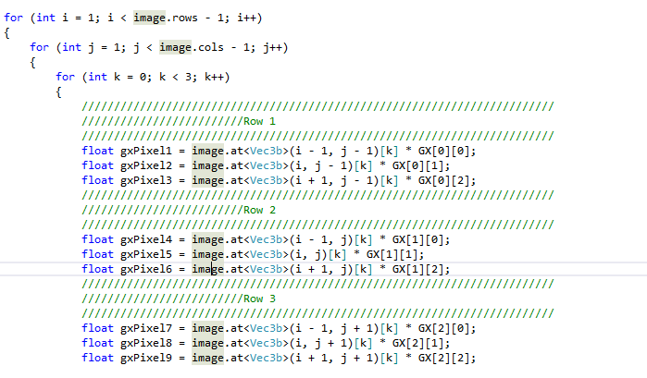
OpenCV
Figure 27 OpenCV Sobel Calculation GX

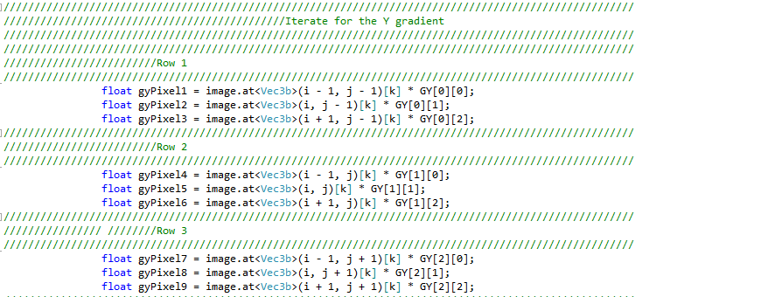
Figure 28 OpenCV Sobel Calculation GY

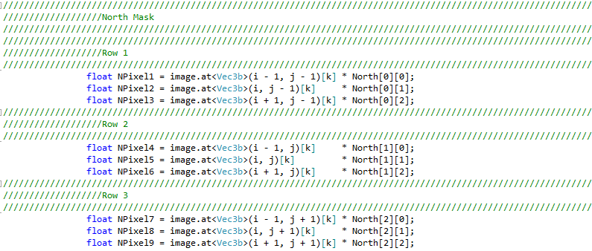
Figure 29 OpenCV Robinson North Mask Calculation

OpenGL
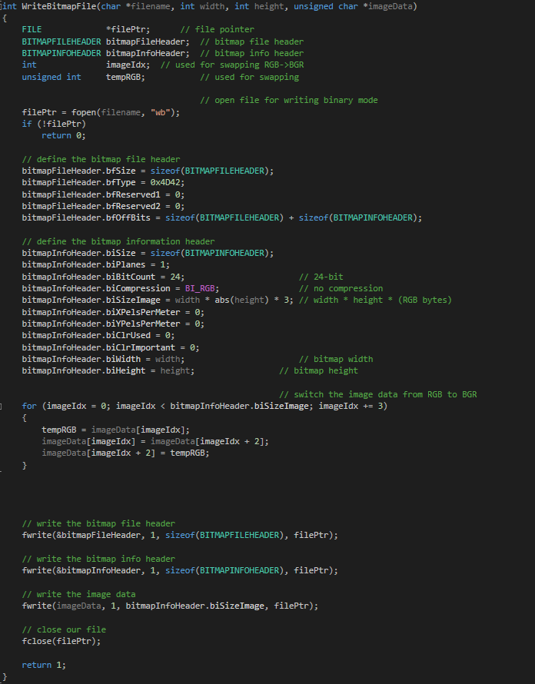
Figure 30 OpenGL Writing Bitmap File Code

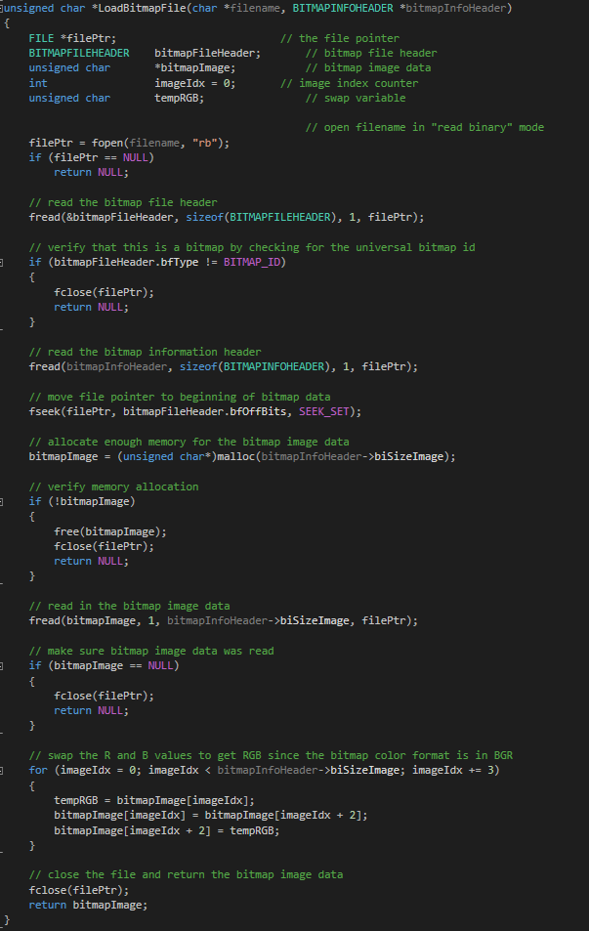
Figure 31 OpenGL Loading Bitmap File Code

Conclusion
This section examines of the problem that the project is trying to tackle, how the system was designed and how it was implemented to solve the problem described earlier in this chapter. All of the diagrams were designed following the guidelines of the Rational Unified Process. Snippets of both OpenCV and OpenGL are provided above.

Results and Analysis
The algorithms implemented in OpenCV were a success while OpenGL did not succeed due to time constraints. In this section, a comparison framework is created to compare the implementation of Sobel and Robinson in the interest of Graphic quality and speed time.

Test Images
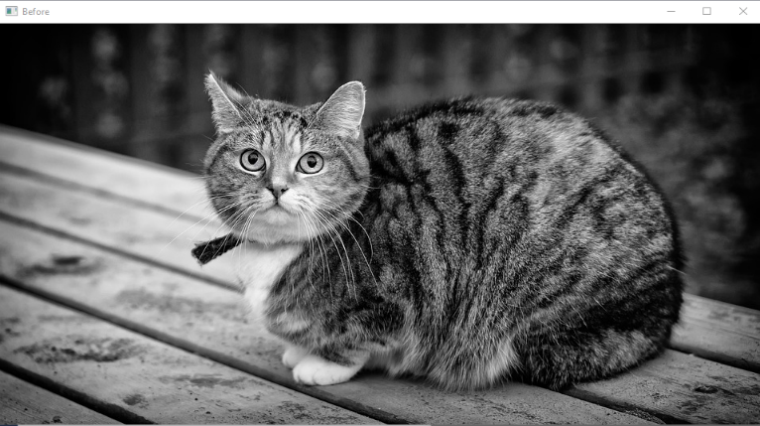
The images used were collected and placed into sets to test how the performance of the algorithms from simple images to complex images. The images seen below are used for the experiments.
Figure 32 Cat


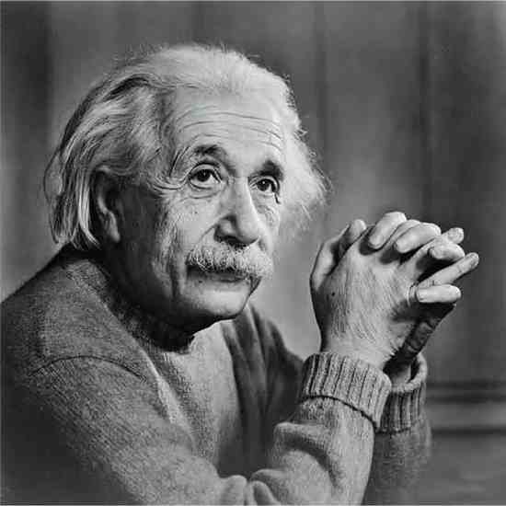
Figure 33 Lena
Figure 34 Albert Einstein

Results
The results produced come in three main categories, execution time, Memory used for the algorithms and Graphic Quality.

Execution Time

Figure 35 A Comparison Chart of Execution Time between Sobel and Robinson

This category examines how fast the algorithms are applied to the image. The line graph above demonstrates the execution time each algorithm is used for the three images. The legend is also provided. From examining the results, Sobel operates faster than Robinsons. The main factor for this is that Sobel uses only two kernels for the image convolution while Robinsons used eight kernels. The result came down to the amount of processing the algorithm has to perform before displaying the result. In this instance, Sobel is the fastest to use.

Memory Used

Figure 36 A comparison chart of memory used for Sobel and Robinson

The second category of testing is the use of memory for each image filtered. The above 2D bar chart represents each image tested and measured in terms of the amount of memory used to perform the algorithm. The two images, both Cat and Einstein are at an equal level for both Sobel and Robinson, meaning that they do not use greater memory than the other. However for the Lena image, Sobel required 9 MB of memory to perform the effect on the image while Robinson only required 6 MB of Memory. From the results, Robinsons does not require as much memory as Sobel does.

Graphic Quality
Third and final test category is graphic quality, this is important as the output must display the majority of edges it can detect.

6.2.3.1 Sobel
Sobel’s implementation required two kernels, Horizontal and Vertical. The image that was used was a cat. The filtered images are presented below.


Figure 37 After Sobel

Figure 38 Lena after Sobel
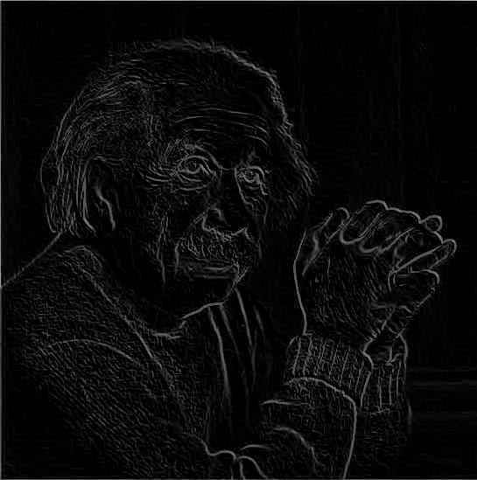
Figure 39 Einstein after Sobel
The above results showed that by using only two kernels, it highlighted the majority of edges in the images.

6.2.3.2 Robinsons
Robinson’s algorithm composes of 8 kernels, four primary and four secondary. The images are tested again.
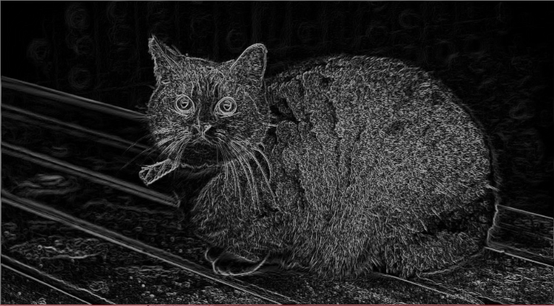
Figure 40 Cat after Robinson

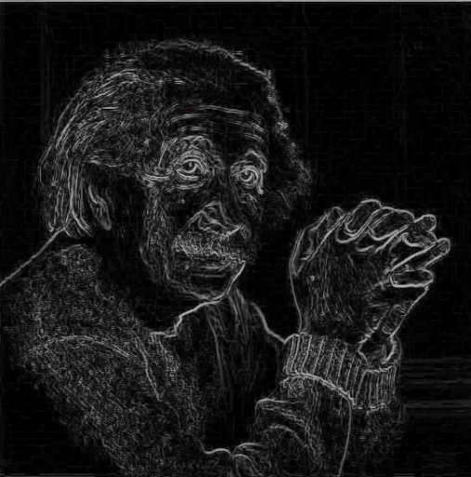
Figure 41 Einstein after Robinson

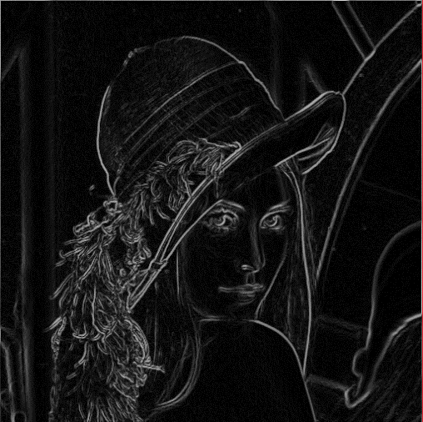
Figure 42 Lena after Robinson

The result of Robinsons does highlight more edges in comparison to Sobel but in terms of Graphic quality, it is much lower than Sobel. If this was tested on a much complex image, it will highlight the edges. In terms of brightness, the Robinsons image is brighter than Sobel due to the amount of kernels used for the image convolution process.

From examining the images tested, Sobel does not highlight as much edges as Robinson does when being compared. Although Sobel is the quickest to use, it does not cover all of the edges in an image. Sobel is not brighter than Robinsons as when looking at a glance, the edges can not be seen however when looking at glance at Robinsons, the edges can be viewed easily.

Conclusion
Overall the tests that were performed in OpenCV were successful. Sobel is found to be the fastest algorithm to use while Robinson does provide more edges, brighter quality while more detailed examination does show that the quality of the image can be unpleasant to look at.

The choice as to which algorithm to use from can be declared. If the user wants to use a fast algorithm to process an image or marker, Sobel will be sufficient to use. However if the user wants to process an image and detect an edge possible, Robinson algorithm is the best to use.

Evaluation
The aim was not met due to issues in the development side. The first issue is the tools. Originally OpenCV was used to master the algorithms that were required which was successful in that case. However when performing it in OpenGL using a bitmap loader, the image data was overwritten and the image is essentially turned blank. A number of objectives have been met. Mostly, from the research elements of this project. The literature of both Image Processing and Augmented Reality are understood, the case study analysis provides two approaches for the Sobel algorithm and proposal algorithm to achieve best performance and graphical quality.

The development aspect was not successful. There are three main reasons. The first, data types. The buffer that was allocated memory for the images was an unsigned char data type, giving the image pixels values from 0 to 255. The kernels used was also unsigned char for consistency. The result of the process does not give the result that was expected from the time spent in OpenCV. When printing all the values from before and after the process, symbols are shown, this makes it hard to determine the value of the pixel. The second reason was the amount of extra work required. OpenCV is a special library, designed for image processing operations. The solution in OpenGL does not use any special libraries, meaning that memory allocation practises had to be applied. This required more extra work and although loading an image was successful, the application of Sobel and Robinson was not. The third reason is time constraints. There was not enough time to solve the problem in OpenGL and will be continued in the future. Overall, the project provided much insight into the practises and literature of the topics discussed.
However, the answers were not shown due to problems in developing the algorithms in the solution project that utilises OpenGL. If the project was done all over again, there is one aspect that would change, essentially the development aspect would be more researched and elaborated in the beginning, in terms of tools, Software Development Kits and more.

Conclusions and Recommendations
Overall the project provides much literature in the interest of Augmented Reality and Image Processing. While the development side was a disappointment, the project will continue on, in the author’s curiosity and interest. With Augmented Reality ever growing at a rapid pace, there are many things to be discovered, perhaps to help the disabled with their everyday lives. The implementation of the algorithms will also further be explored, how to optimise them to the best performance possible, what further modifications can be done to improve the original algorithms mentioned in the literature review and what new algorithms can be created based on the ideas of the authors such as Sobel, Prewitt and Robinson have already established. These questions highlighted have provided much curiosity to continue research into the field of Augmented Reality and Image Processing.

Summary
In summary, the literature review and case study have been conducted as well as the research and development methodologies have been chosen and justified, however the development process did not succeed and leaves much to be desired. The tests for OpenCV were conducted due to curiosity and a comparison framework was created. Sobel is beneficial as a fast algorithm to use but does not detect all edges while Robinson does detect the majority of edges, However it takes time to execute.

Conclusion
The Literature Review and Case Study conducted provides much insight, the research and development methodologies are specified, highlighting the advantages and disadvantages for each method/strategy used. The development process followed the phases as planned. However it was not successful.

.

Recommendations for Further Research
With the field of Augmented Reality growing at a rapid pace, many interesting projects were conducted. There are many possibilities of further research. There are three main areas in particular. The first is tracking, tracking is the second iteration of any marker based project. While image processing was the first iteration, tracking is the next step in generating an object. The second area would be to create an image processing algorithm specifically designed for an augmented reality application, in particular, edge detection.

Reflection
Throughout most of the time spent on this project, there is one important lesson that is learned. That a self-created project can change from time to time. It can depend on two main factors, the first, complexity. How complex is it? If it isn’t complex enough, there is not much of a challenge in that project. The second factor, is there enough meat on the bones of the project? If there isn’t, there is not enough to work on. Originally, the project was about the development of an AR application, however as time went on, the complexity and meat on the bones was very limited, hence the project had to be altered to some degree. This gave insight of project management and how worthy it is to pursue.
The research process of both Image Processing and Augmented Reality does peak curiosity to a certain extent. The fields are growing rapidly and more advanced. Interest in the field of Augmented Reality has risen over time and would study it more in detail.
The problems that have been encountered over the course of project are technical aspects for the majority of it. More specifically relating to Images and perfecting the algorithms mentioned in this dissertation.
The question, could the project have been done better? Yes, always. If there is one thing that can be done better is more preparation of the implementation aspect in the beginning. There were many changes on the development aspect, not the research side. There was more focus on changing project to meet the challenge of a project than there was of doing the project. That was the biggest downfall of the project.
Overall, the experience taught the lesson of preparing a detailed and well thought project should the route of undertaking a self-created project be taken again in the future. This project shaped the skill of researching, the ability to enhance knowledge and Intellect. But the disadvantage of this is that the aims of the project can change sometimes even midway through a semester due to lack of challenge.

References

[1] | S. R. Chavan, “Augmented Reality vs. Virtual Reality: Differences and Similarities,” International Journal of Advanced Research in Computer Enginnering & Technology, vol. 5, no. 6, pp. 1947 - 1952, 2016.
[2] | I. E. Sutherland, “A Head-Mounted Three Dimensional Display,” in AFIPS, California , 1968.
[3] | S. W. Myron W.Krueger, “VIDEOPLACE: A Report from the ARTIFICIAL REALITY Laboratory,” Leonardo, vol. 18, no. 3, pp. 145 - 151, 1985.
[4] | M. W. Krueger, “An Architecture for Artificial Realities,” in COMPCON '92 Proceedings of the thirty-seventh international conference on COMPCON, San Francisco, California, USA, 1992.
[5] | T. P. C. A. D. W. IZELL, “Augmented Reality: An Application of Heads-Up Display Technology to Manual,” in Proceedings of the Twenty-Fifth Hawaii International Conference on System Sciences, Kauai, HI, USA, 2002.
[6] | R. T. Azuma, “A Survey of Augmented Reality,” Teleoperators and Virtual Enviroments, vol. 6, no. 4, pp. 355 - 385, 1997.
[7] | B. T. Wayne Piekarski, “ARQuake: The Outdoor Augmented Reality Gaming System,” Communications of the ACM, vol. 45, no. 1, pp. 36-38, 2002.
[8] | B. C. J. D. J. S. P. D. B. M. M. a. W. P. Bruce Thomas, “ARQuake: An Outdoor/Indoor Augmented Reality First Person Application,” in Digest of Papers. Fourth International Symposium on Wearable Computers, Atlanta, GA, USA, 2000.
[9] | M. S. S. H. K. A. R. A. A.-D. M. A.-R. Rania Mousa, “Marker Hiding Methods: Applications in Augmented Reality,” Applied Artificial Intelligence , vol. 29, no. 2, pp. 101 - 118, 2015.
[10] | K. K. G. Anuroop Katiyar, “Marker Based Augmented Reality,” Advances in Computer Science and Information Technology , vol. 2, no. 5, pp. 441- 445, 2015.
[11] | H. A. A. A. Siok Yee Tan, “Development of a PC-Based Markerless Augmented Reality,” in International Conference On Electrical Engineering And Informatics 2015, Denpasar, Indonesia, 2015.
[12] | H.-Y. W. X.-N. B. Yan-Fei Gao, “Marker Tracking For Video-Based Augmented Reality,” in Proceedings of the 2016 International Conference on Machine Learning and Cybernetics, Jeju, South Korea, 2016.
[13] | I. Sobel, “An Isotropic 3x3 Image Gradient Operator,” 14 June 2014. [Online]. Available: https://www.researchgate.net/publication/239398674_An_Isotropic_3_3_Image_Gradient_Operator. [Accessed 25 February 2018].
[14] | S. T. H. R. Archana, “Edge Detection Using the Sobel Compass Operator,” International Journal of Electrical Electronics & Computer Science Engineering, Vols. Special Issue - NEWS 2016, no. Special Issue - NEWS 2016, pp. 98-101, 2016.
[15] | J. F. Canny, “A Computational Approach To Edge Detection,” IEEE Transactions on Pattern Analysis and Machine Intelligence, vol. 8, no. 6, pp. 679-698, 1986.
[16] | S. M. Č. B. M. Petar Čisar, “Kernel Sets in Compass Edge Detection,” in 2013 IEEE 14th International Symposium on Computational Intelligence and Informatics (CINTI), Budapest, Hungary, 2016.
[17] | A. R. Bernince Sacks Lipkin, Picture Processing and Psychopictorics, Cambridge, Massachusetts, United States: Academic Press Inc, 1970.
[18] | C. Y. Shuying Li, “Corner Feature Detection Based on Improved Harris Method,” Boletín Técnico, vol. 55, no. 3, pp. 322-328, 2017.
[19] | T. D. Edward Rosten, “Machine Learning for High Speed Corner Detection,” in 9th European Conference on Computer Vision, Graz, Austria, 2006.
[20] | A. E. T. T. ,. L. V. G. Herbert Bay, “Speeded-Up Robust Features (SURF),” Computer Vision and Image Understanding, vol. 110, no. 3, pp. 346-359, 2008.
[21] | K. C. W. C. Jack C. P.Cheng, “Comparison of Marker-based AR and markerless AR: A Case Study on Indoor Decoration System,” in Lean & Computing in Construction Congress (LC3), Heraklion, Greece, 2017.
[22] | L. Demidova, “Augmented Reality and ARToolkit for Android: the First Steps,” in 2016 International Conference “Education Environment for the Information Age, Moscow, Russia, 2016.
[23] | O. K. S. S. R. C. Gayathri D, “Theory and applications of marker-based augmented reality,” International Journal for Research in Applied Science & Engineering, vol. 4, no. 8, pp. 153-158, 2016.
[24] | S. G. Dhiraj Amin, “Comparative Study of Augmented Reality SDK's,” International Journal on Computational Sciences & Applications, vol. 5, no. 1, pp. 11-26, 2015.
[25] | Z. L. Cheng Xiao, “Implementation of Mobile Augmented Reality Based on Vuforia and Rawajali,” in 2014 IEEE 5th International Conference on Software Engineering and Service Science, Beijing, China, 2014.
[26] | Y. K. Jie Jiang, “The implementation of literacy and sign language learning system for deaf children based on the augmented reality,” in 2014 IEEE Workshop on Advanced Research and Technology in Industry Applications, Ottawa, ON, Canada, 2014.
[27] | H. U. a. S. I. Takafumi Taketomi, “Visual SLAM algorithms: a survey from 2010 to 2016,” IPSJ Transactions on Computer Vision and Applications, vol. 9, no. 1, pp. 1-11, 2017.
[28] | A. L. Mehdi Mekni, “Augmented Reality: Applications, Challenges and Future Trends,” in Applied Computer and Applied Computational Science, Malaysia, 2014.
[29] | S. Agarwal, “Review on Application of Augmented Reality in Civil Engineering,” in International Conference on Inter Disciplinary Research in Engineering and Technology 2016, New Delhi, 2015.
[30] | T. M. M. M. F. H. B. K. C. S. Š. M. M. L. H. P. B. R. D. Peter Mesároš, “Use of Augmented Reality and Gamification techniques in tourism,” e-Review of Tourism Research (eRTR), vol. 13, no. 1/2, pp. 366 - 381, 2016.
[31] | Welsh Government, “Augmented reality app brings fairies to Bluebell Woods,” The Journal For Science, Enginnering and Technology, vol. 1, no. 82, pp. 10-11, 2017.
[32] | M. M. M. Abrar Omar Alkhamisi, “Rise of Augmented Reality: Current and Future Application Areas,” International Journal of Internet and Distributed Systems, vol. 1, no. 4, pp. 25-34, 2013.
[33] | L. E. Jonathan Stevens, “Augmented reality technology in U.S. army training (WIP),” in Proceedings of the 2014 Summer Simulation Multiconference , Monterey, California, 2014.
[34] | S. W.-Y. L. H.-Y. C. J.-C. L. Hsin-Kai Wu, “Current Status, Opportunities and Challenges of Augmented Reality in Education,” Computers and Education, vol. 62, no. March, pp. 41-49, 2013.
[35] | D. V. A. D. S. C. D.-K. María Blanca Ibáñez, “The Acceptance of Learning Augmented Reality Enviroments: A Case Study,” in 2016 IEEE 16th International Conference on Advanced Learning Technologies, Austin, Texas, USA, 2016.
[36] | E. J. M. R. E. W. D. D. M. M. G. a. C. S. David F. Cihak, “Evaluating Augmented Reality to Complete,” Journal of Special Education Technology, vol. 31, no. 2, pp. 99-108, 2016.
[37] | S. B. F. S. G. a. K. Jorge Bacca, “Augmented Reality Trends in Education: A Systematic Review of Research,” Journal of Educational Technology & Society, vol. 17, no. 4, pp. 133-149, 2014.
[38] | S. R. R. A. T. S. X. Sheeba Joseph, “Face Detection Through Neural Network,” in 2nd International Conference on Current Trends in Engineering and Technology, Tamil Nadu, India, 2014.
[39] | P. N. L. B Anilkumar, “Performance Analysis of Image Edge Detection using Hybrid, Sobel and Log Sobel Methods,” International Journal of Current Trends in Engineering & Research, vol. 2, no. 4, pp. 684 - 694, 2016.
[40] | J. Z. S. W. Yingke Feng, “A New Edge Detection Algorithm Based on Canny Idea,” in 2nd International Conference on Materials Science, Resource and Environmental Engineering , Zhuhai City, China, 2017.

Bibliography

[1] | M. G. B. S. F. B. L. Jaime Cisternas, “Variational Principles in Image Processing and the Regularization of Orientation Fields.,” International Journal of Bifurcation and Chaos, vol. 19, no. 8, p. 2705–2716, 2009.
[2] | H. Papagiannis, Augmented Human: How Technology Is Shaping the New Reality, California: O'Reilly Media, 2016.

12 Appendices
During the development process, a number of documents were created, designed to hold information, specifically from the Inception Phase. In this section, all of the documents created can be examined here.
Use Case 1: Loading an Image
The first step in applying an edge detection algorithm to an image is to load the image into an application.
Brief Description
The user, will run the program and an image will appear in the form of the window.
Flow of Events
Basic Flow
The actor launches the application on the desktop, the image, loaded from the project file is displayed onto an object.

Flow of Events
Basic Flow
The first alternative flow is that the basic flow can be disrupted. The first instance is the message that can appear in front of the actor stating that the image cannot be found. This is a common error that is well known in the field of image processing, describes that it is trying to access the location of the image you are specifying is not retrieved. This can mean two things, either there is a spelling mistake in the location name or the image is not in the location.

< Second Alternative Flow >
The second alternative flow is that the file format of the image is not correct and therefore the image can not be displayed
Special Requirements
There are a number of special requirements that are required.
< Performance >
The process of loading an image must be fast for the image to be processed.

<Timer>
The main special requirement is the stopwatch that must record how quick the edge detection can be implemented.
Preconditions
Preconditions have to be in place before the basic flow can be realized.
< Correct File Format >
The user must specify the file format used in the image. If they specify a bmp file format in the code while the image they are trying to access is a .jpg, they will not find it and will report back with a message indicating they cannot find the correct file format.
<Correct Image Location>
The first precondition is that the location of the image specified in the variable to store the image data.
<Memory Allocation>
Memory to hold the image data must be allocated before the image can be loaded in to avoid memory leaks.

<Timer Setup>
The timer must be created up along with the image in order for the edge detection algorithms can be recorded for analysis.
Post conditions
Post conditions occur when the use case is executed and the image is displayed.
<Free Memory>
The memory used to hold the image data before and after the image has been processed must be closed in order to prevent a memory leak as well as the best course of action in the interest of best software engineering practices.
<Timer Stops>
The stopwatch time to record how quick the edge detection algorithm can be implemented will have to be stopped as the key to compare speed with the edge detection algorithms.

Use-Case Specification: < Applying Sobel>
When the image is loaded, the Sobel Edge Detection algorithm is applied to the data of the image
Use-Case Name
Brief Description
The user, will run the program and apply the Sobel Edge Detection algorithm to the image.
Flow of Events
Basic Flow
The actor launches the application on the desktop, the image, loaded from the project file is displayed onto an object. At this point, the Sobel algorithm is applied to the image data, stored as a 2D array. The result is outputted to the user.
Alternative Flows
<Memory Issue>
The first alternative flow is that the basic flow can be disrupted. The first instance is the possibility of memory issues relating to the image loaded as a texture. The texture’s data is stored as an unsigned character with a pointer to the memory. The algorithm requires a loop throughout the columns and rows of the image so the calculations can occur.
< Second Alternative Flow >
The second alternative flow is that the result of the process does not illustrate the expected outcome and presents a new result. In this case, the image will look like it was corrupted.

Special Requirements
There are a number of special requirements that are required.
< Performance >
The process of applying the algorithm must be fast for the test results to be accurate.
<Timer>
The main special requirement is the stopwatch that must record how quick the edge detection can be implemented. This is important for the tests as it can determine if Sobel is faster than Robinson.
Preconditions
Preconditions have to be in place before the basic flow can be realized.
< Correct File Format >
The user must specify the file format used in the image. If they specify a bmp file format in the code while the image they are trying to access is a .jpg, they will not find it and will report back with a message indicating they cannot find the correct file format.
<Correct Image Location>
The first precondition is that the location of the image specified in the variable to store the image data.
<Memory Allocation>
Memory to hold the image data must be allocated before the image can be loaded in to avoid memory leaks.
<Timer Setup>
The timer must be created up along with the image in order for the edge detection algorithms can be recorded for analysis.

Post conditions
Post conditions occur when the use case is executed and the image is displayed.
<Free Memory>
The memory used to hold the image data before and after the image has been processed must be closed in order to prevent a memory leak as well as the best course of action in the interest of best software engineering practices.
<Timer Stops>
The stopwatch time to record how quick the edge detection algorithm can be implemented will have to be stopped as the key to compare speed with the edge detection algorithms.

Use Case 3: Robinsons
The third step is to apply the Robinsons compass operator to the image.
Brief Description
The user, will run the program and an image will appear. Then the Robinsons operator will be applied to the image.
Flow of Events
Basic Flow
The actor launches the application on the desktop, the image, loaded from the project file is displayed onto an object.
Alternative Flows
< Image Not found>
The first alternative flow is that the basic flow can be disrupted. The first instance is the message that can appear in front of the actor stating that the image cannot be found. This is a common error that is well known in the field of image processing, describes that it is trying to access the location of the image you are specifying is not retrieved. This can mean two things, either there is a spelling mistake in the location name or the image is not in the location.
< Second Alternative Flow >
The second alternative flow is that the file format of the image is not correct and therefore the image can not be displayed
Special Requirements
There are a number of special requirements that are required.
< Performance >
The process of loading an image must be fast for the image to be processed. Due to the nature of the project, the image should not take a substantial amount of time to load.
<Timer>
The main special requirement is the stopwatch that must record how quick the edge detection can be implemented.
Preconditions
Preconditions have to be in place before the basic flow can be realized.
< Correct File Format >
The user must specify the file format used in the image. If they specify a bmp file format in the code while the image they are trying to access is a .jpg, they will not find it and will report back with a message indicating they cannot find the correct file format.
<Correct Image Location>
The first precondition is that the location of the image specified in the variable to store the image data.
<Memory Allocation>
Memory to hold the image data must be allocated before the image can be loaded in to avoid memory leaks.
<Timer Setup>
The timer must be created up along with the image in order for the edge detection algorithms can be recorded for analysis.
Post conditions
Post conditions occur when the use case is executed and the image is displayed.
<Free Memory>
The memory used to hold the image data before and after the image has been processed must be closed in order to prevent a memory leak as well as the best course of action in the interest of best software engineering practices.

<Timer Stops>
The stopwatch time to record how quick the edge detection algorithm can be implemented will have to be stopped as the key to compare speed with the edge detection algorithms.

Vision
Introduction
The purpose of this document is to detail a vision of the project. It contains information and requirements that are highlighted when the implementation phase begins. This also includes detailed description of the people involved in the project, most notably the stake holder.

Positioning
Problem Statement
The problem that is presented is that with the many edge detection algorithms to be used in an Augmented Reality application, the question is, which one is the fastest to use for scanning an image.

The problem of | The problem presented is the range of edge detection algorithms to choose from, the speed of applying the operators to the image for processing.
affects | Users using an Augmented Reality application that utilizes Image Processing elements of scanning and process an image.
the impact of which is | The impact is that they can choose the suitable algorithm without taking long periods of time to process the image.
a successful solution would be | To compare edge detection algorithms with five sets of images ranging from simple to complex of how long will it take for the image to be processed to determine the best algorithm to use.

Product Position Statement
For | Development of an Augmented Reality application
Who | The best edge detection algorithm to use for processing an image.
The (product name) | The name of the product is named “Edge Detection Comparison”.
That | The key benefit of this project is to test edge detection algorithms
Unlike | Most applications that involve using edge detection algorithms or own modifications without comparing performance, amount of edges and quality of images based on the five sets of Images.
Our product | The main difference between the proposed product and other projects is that the test images used are ranged from simple to complex and to examine how the algorithms perform throughout the scale of complexity.

Glossary
Introduction
The glossary document contains definitions of key terms that are used throughout the project. The person who receives the project after launch with the intentions of maintaining the application, should refer to this document in order to gain an understanding of the meaning of the terms used in the documents of implementation. This document does provide more information regarding the scope and reason the project existed.
Purpose
The purpose of this document is to provide new developers the definition of key terms that are used in the development documents throughout the project. Those who are unfamiliar with the field of image processing must refer to this before undertaking any maintenance tasks.
Scope
The scope of the glossary is to provide readers the sense of understanding of all technologically terms mentioned.
References
N/A
Overview
The rest of this document from this point onwards is a collection of terms that you may come across with little understanding or concept of the meaning of these terms.

Definitions
Below are the definitions that are used throughout the documentation of the implementation phase of this project.
<Augmented Reality>
Augmented Reality is a technology that blends two environments, one digitally and one real life into one combined reality. Through the headset or camera, the user can see a digital object, for example a Pikachu.
<Sobel Algorithm>
The Sobel Algorithm is an edge detection method, designed to highlight the edges in the image, in the case of this project, the marker. The method uses a 3x3 gradient mask for both x and y and is applied to the marker image data to create a new image. The magnitude which as recalled is the method that finds the length of the edge. This is calculated via the Pythagoras Theorem. The value in which is calculated is a decimal value, this represents the size of the edges. The direction can be found by using the formula of inverse tan or “Arctan” of both the gradient of X and Y. An example image can be found below.
<Robinsons Algorithm>
The Robinsons algorithm is an edge detection method, much like Sobel, it uses 8 kernels for its image convolution process, 4 primary which represents the North, South, East and West, and 4 secondary which represents the South East, South West, North East and North West. The process remains the same as Sobel however the direction aspect is not required nor is the Pythagoras theorem is used to determine the length
<Otsu Method>
Otsu Method is an Image Segmentation method, designed to determine threshold automatically.

<Image processing>
Image processing is a technique that is by definition a way to extract image data to further enhance the quality of the original Image.
<Edge Detection>
Edge Detection is a technique that is designed to extract original source image data and create a new image, removing the RGB values, leaving only the edges and its intensity calculated in the form of a gradient.
<Gradient>
The gradient is referred in the Sobel algorithm, the definition is variable to store the intensity of the RGB value in the image. It is commonly used in edge detection algorithms

Supplementary Specification
Introduction
The supplementary specification details the projects purpose, the scope and some of the system elements that will need to be development and kept in check. This document examines the application standards and regulatory requirements as well as quality attributes of the system as well as other requirements such as operating systems and environments.
Purpose
The purpose of the supplementary specification document is to describe the quality attributes that the application requires. This also details the scope of this document as well as the definitions and abbreviations.
Scope
The scope of the Supplementary Specification is to provide more detailed Functionality, Usability, Reliability, Performance, Supportability as well as the design constraints that could pose a problem to the applications design itself.
Definitions, Acronyms, and Abbreviations
The definitions that are used in all documents relating to both the Inception and Elaboration phases can be viewed in the Glossary document.
Overview
The overview of this document describes the requirements the application must meet in terms of FURPS.

Functionality
This section of the quality attributes that must be specified before implementing the application itself. First, functionality. Functionality focuses on how the application is going to function, what data it will use and what features are implemented in the app.
<Load Image>
The user will need to be able to load the image from the destination location for the image to be processed.
<Process Image>
The second step of the core process of an Augmented Reality application. The Sobel filter then takes place, creating a new image in the process. This is important as in an Augmented Reality application, the image can be used to find the right image in the database.
<Timer>
Once the image and the edge detection algorithms are calculating the new value of the pixel data within the image, the timer will begin to record the speed of applying the algorithm.

Usability
This section examines the requirements that involves usability. This does include how long it will take to execute tasks.
<Scanning Times>
The Task times for processing the image must be short. If the Sobel algorithm was applied to a 4k image, the process would take longer.
Reliability
This section examines the Reliability factors that the app will have to focus on.
<Availability>
The memory must be free before the process can begin. As well as the correct format and location of the images are specified.
<Accuracy>
Accuracy is important most specifically during the image processing stage. The edge detection detects as many edges within the image.
<Bugs>
During development, there will be bugs, minor, significant and critical. To define this, minor bugs include no response from UI buttons, significant bugs mean no updates to database and Critical includes memory loss, Disruption to Tracking. This will be elaborated further when test plans are created.
Performance
Performance is crucial for the application in order for the core processes to be fast and efficient.
<Response Time>
It is important that the response time is short. The program should not take minutes to execute and should be milliseconds.

<Memory>
Memory allocation is important as it will need to be optimized when the process of Image processing is running.
Supportability
<Coding Standards>
Coding standards are important throughout the implementation phase of the project. When another developer takes over the project when the product is launched, the coding standards must be understood. It is to note that the developer’s standards may be far different than the coding standards used in the project. It is crucial to note as if there were no standards in place, the developer will not be able to support the project in future due to difference in standards practiced.
<Naming Conventions>
Naming conventions is another way of making sure that the individual who takes over the role of supporting the system can understand how the data types, the functions and even the types that are used in the system. Again, this is an issue of difference and perspective. The main benefit of this for the person is that they can read the code and how it works. For the most part, it is important for the individual to understand the code and how it functions as if there is a bug somewhere in the code then they will need to fix it so the system can be functional and running smoothly.
<Class Libraries>
Class libraries contain functions specifically for one purpose. During development, programmers use a selection of different libraries that contains functions that they need for their solution to a problem. In this case however, the individual who takes over, may see the libraries and they may not know what they include. It is important for the developer to specify what the libraries are and what they provide. Not every developer may use a lot of libraries therefore they may have no idea on how to use them.

Design Constraints
When designing the system, it is important to examine any design constraints that may arise and pose an issue. They are mainly addressed by decisions made by designers. Some of these constraints may be software languages, SDKs, architecture and design constraints of the system. These are some of the constraints that may arise and it is important to address them before moving on to develop the system.
<Software Language>
The Software Language used is C++, an extension of the C language. There are many different software languages available to develop the system. Once a language has been chosen, you cannot change it during the process of development. If someone took over and uses Java and the system is coded in C++, they cannot support it as they do not code in C++.
Online User Documentation and Help System Requirements
The user documentation will need to list how to use the system. Most systems have an online user documentation to support customers on how to use their products and errors if they encounter any.

