Maciek Kucinski (2003891)
10/04/2022
Introduction to Web and Database concepts
HTML & CCS Web Development

Table of Contents
Introduction 2
Abstract 2
Requirements 3
Purpose 4
Subject matter 4
Target audience 4
Implementation 6
Home page 6
The services 7
The categories 8
The products 8
The blog post 9
Contact us Page 9
Validation 11
Website usability 12
Website accessibility 13
Search engine optimization 13
Bibliography 17
Appendices 19

Introduction

Abstract
Websites are a popular asset for both organizations and individuals. Websites provide an online presence that allows organizations and individuals to advertise their products and reach more new customers. This paper is a report on websites demonstrating the knowledge of the standards, principles, and implementation of websites. The article begins by implementing a website for an organic foods store. The website is hand-coded with HTML and styled using CSS. The website was validated to identify the errors available in the separate HTML and CSS files and remove the errors encountered. The paper covers the evaluation process, majoring on the three main attributes: usability, accessibility, and search engine optimization. I then evaluated the organic foods store concerning the three attributes, accessibility, SEO, and usability. Website evaluation is performed to optimize the website in terms of speed, ease of use, and rendering of the services intended.

Requirements
The website was built for an Organic foods shop. The website provides an online presence for the organic food store and allows users to order the foods online. The website has several web pages, each representing an independent sector of the store. The home page introduces the customer to the store and informs them of the store's intentions. From the home page, the customer can take a tour of the services provided by the store. The bottom of the home page summarizes the information about the store.

Purpose
The objectives of building the website of the organic food include:
- To create a website that makes an online presence for the organic foods store and therefore advertises it
- To create a website that allows the organic food store to offer its services to remote customers, including remote buying, payment, and doorstep delivery.
- To develop a website that shows the customers the categories and the specific organic products available.
- To develop a website that offers logs on organic foods to promote healthy living.

Subject matter
The organic food website's subject matter is to reach out to customers to sell them organic foods and teach them the importance of eating organic foods. The website allows customers to select the products, view the price, and add them to a cart to sell organic foods. The website has a blog section to teach people about healthy living and the importance of organic foods.

Target audience
The subject matter of the organic foods store did aim at all people. In recent years, there has been a rampant growth of internet users. Therefore, the website aims to target internet users to capture them as customers and advise them on healthy living.

Implementation

Home page
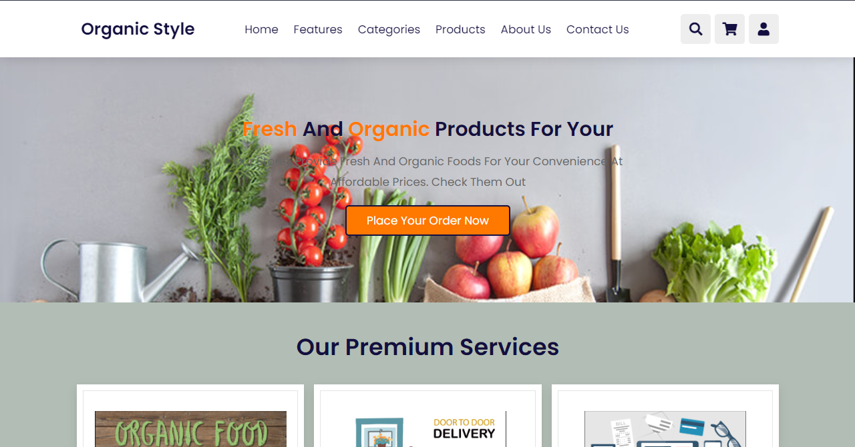
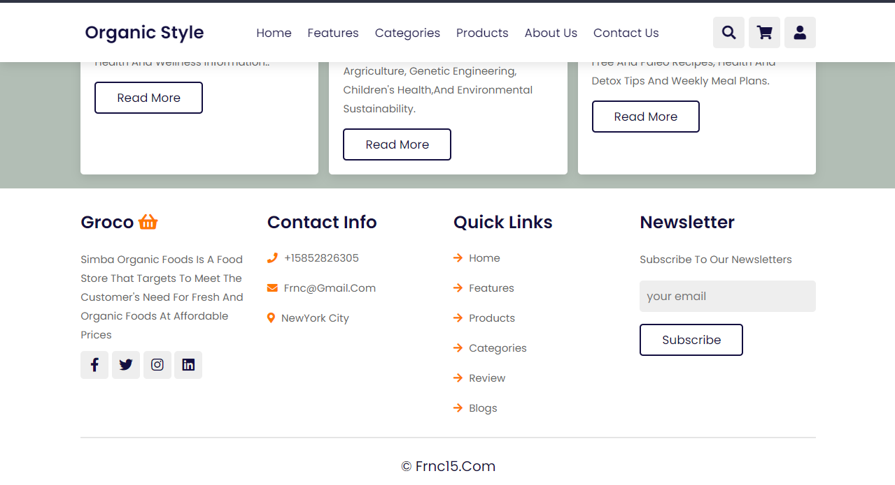
The above shows the home page of the organic food website.

The services
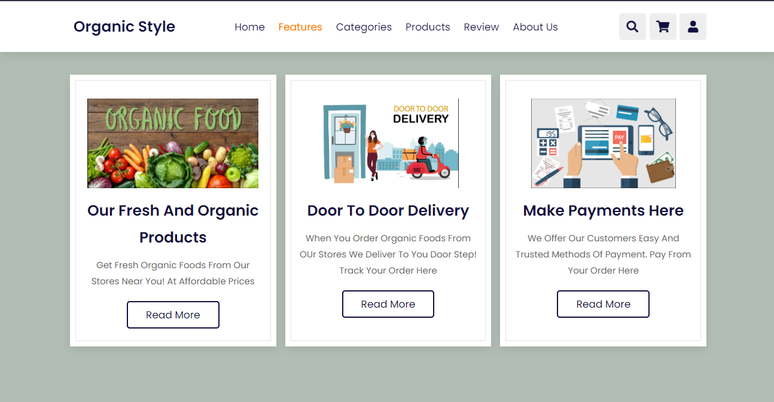
The features page of the website shows the services offered by the website. The fresh and organic products features allow users to view and purchase organic foods. The door-to-door delivery feature indicates that the organization provides the customers with doorstep delivery of their products. The make payment features allow users to make payments remotely for the goods they purchased.

The categories
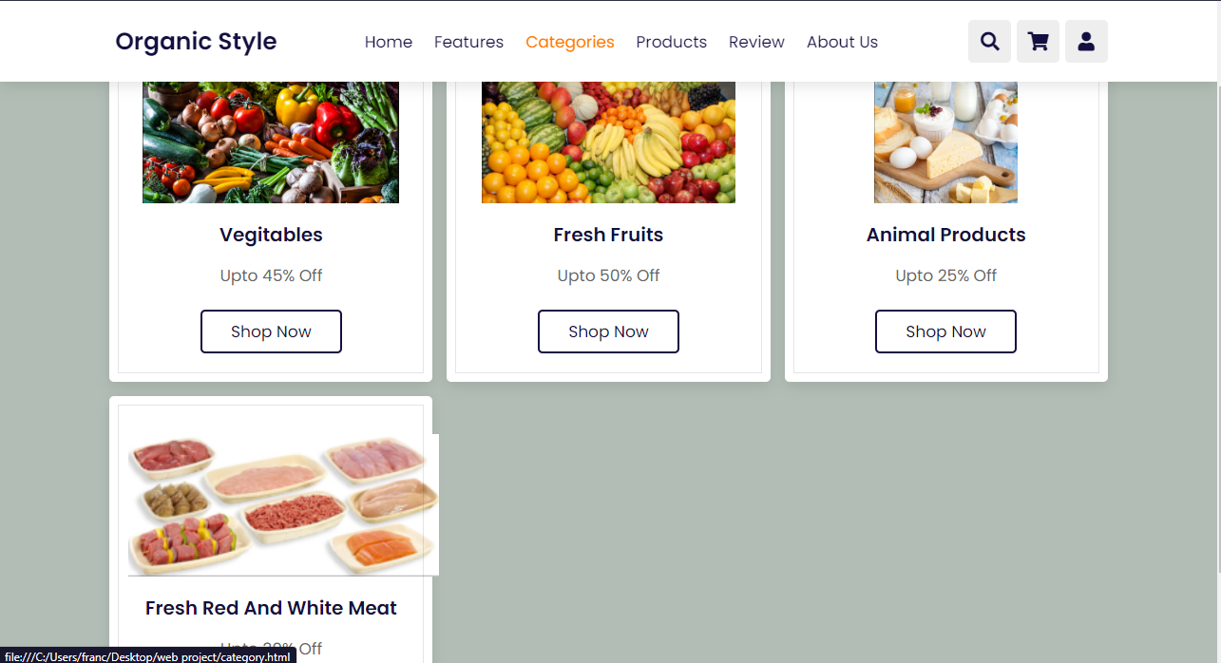
The categories page shows the categories of the organic products offered by the Organic foods store. The types include vegetables, fresh fruits, and animal products, including meat, dairy, and eggs.

The products
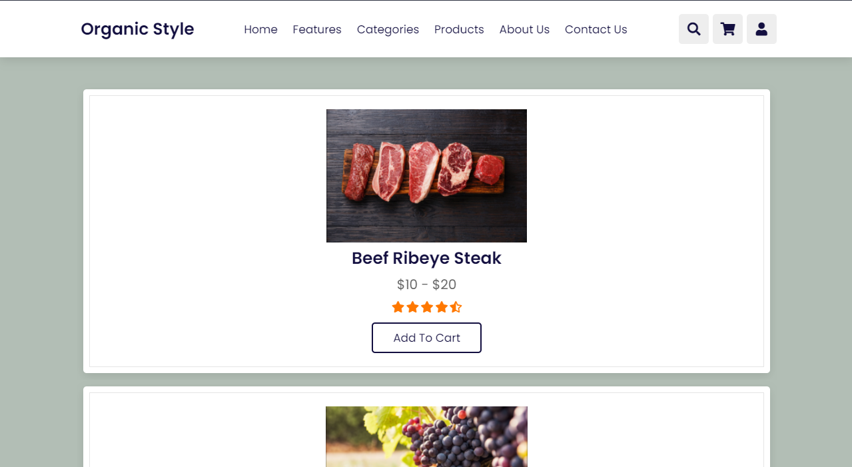
The products page allows the users to view the products available in the store. The customer can add the product they want to buy to their cart.

The blog post
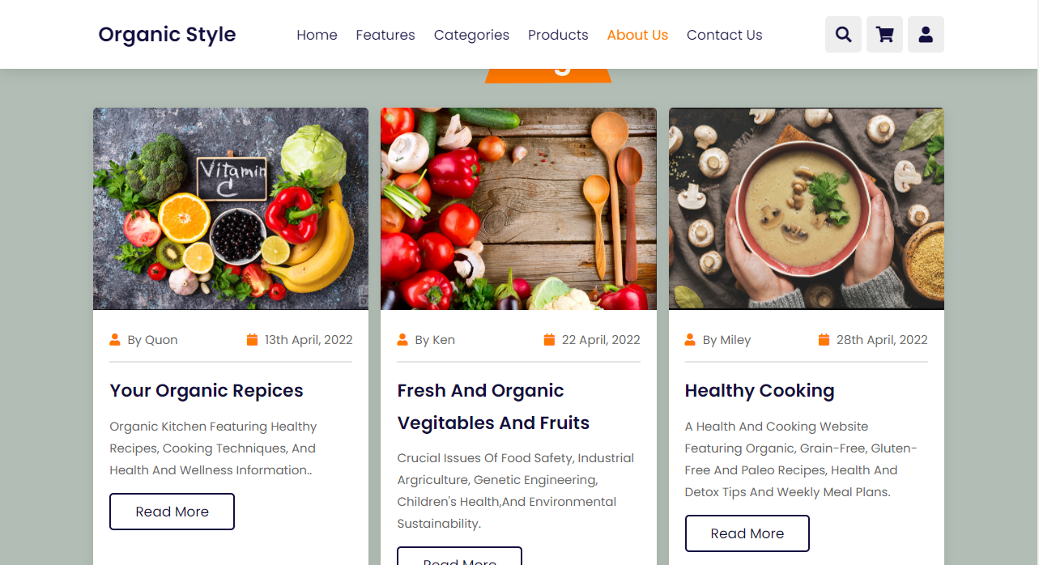
The organization posts blogs about healthy eating and provides recipes for preparing organic foods in the blog post section.

Contact us Page
The page provides a convenient channel for communication where the customer can post their reactions or ask queries.
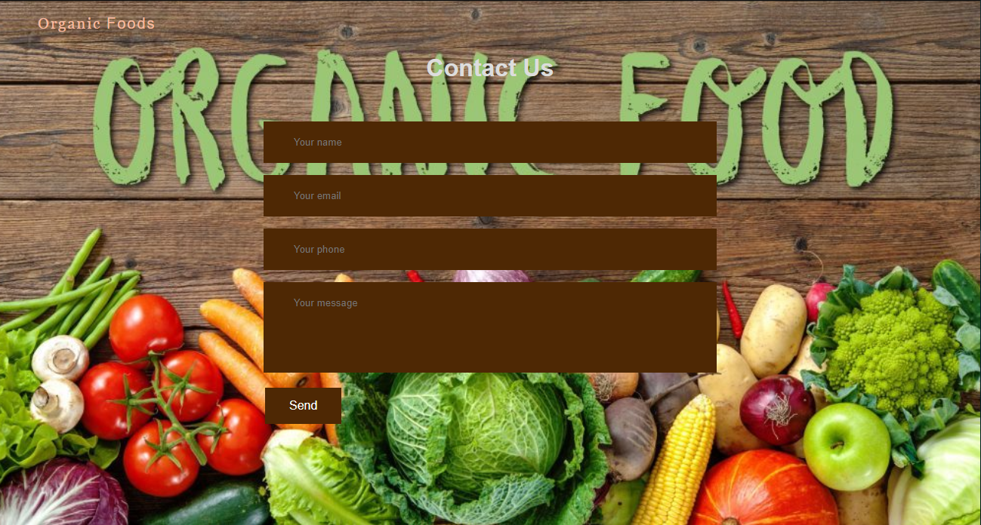

Validation
HTML Validation
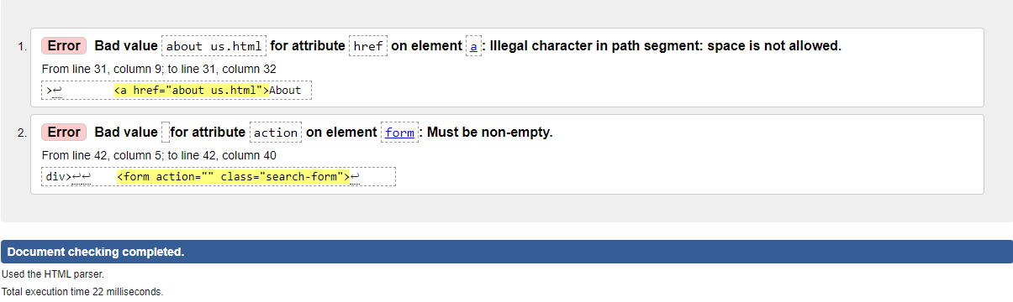
I encountered an error during the validation of the index.html file. The error discovered was the Bad Value error.
The first instance of the Bad value error occurred due to having a space value for attribute 'href' on element <a>. The space character is considered illegal. I renamed the about us.html file to aboutus.html to eliminate the unlawful nature to correct the error.
The second instance of Bad Value error left the attribute 'action' on element 'form' empty. To correct the mistake, I added the character #.
CSS Validation
After validating the main CSS file, I encountered two types of warnings. The first warning was that Imported style sheets are not checked indirect input and file upload modes. The second warning experienced was, "Due to their dynamic nature, CSS variables are currently not statistically checked." The latter, however, occurred many times.

Evaluation
Evaluation is the activity of critically examining a program, in this case, a website. The evaluation process is a procedure that starts by collecting then analyzing information about the activities of the website, its characteristics, and finally, the outcomes. The sole aim of evaluating a website is to judge the website's performance and therefore help improve its effectiveness.
When evaluating a website, there are three features that a very crucial in determining the quality of the website. The features include website usability, accessibility, and search engine optimization.

Website usability

Website usability is the quality of a website that makes it user-centered. A usable website means that the prospective customer can make their goal for using the website, their mental picture of the website, and their requirements met. For a website to have an excellent website usability status, several principles have to be completed by that website. The regulations include accessibility and availability, where the user can easily use the website's resources at any time they wish. Second, the website should be clear; a usable website should be simple, familiar, consistent, and guide both new users and regular users clearly and precisely. For a website to be classified as functional, the website's features should be easy to navigate, allowing users to learn fast how to perform all actions on the website in the least time possible.
Belanche et al., 2012, analyzed the impact of a website's usability on both the satisfaction of the users and the primary goal of that website [3]. In the paper, they concluded that the usability of a website affects the users' satisfaction that, consequently, affects the purpose for which one built that website. A twist, however, occurs as usability does not have a direct impact on the original meaning of the website,

Website accessibility

An accessible website is one where all users of the website are allowed to have access to the features and resources of the website equally without the discrimination of the devices, they use to access the website. Web Content Accessibility Guidelines outline the standards against which one should judge the accessibility of a website. The measures as per the guidelines include Operability, robustness, understandability, and permeability of the content.
In the year 2009, Eleanor et al., in their paper on the state of the corporate website accessibility, showed that organizations failed to tune the accessibility of their websites as a result of discriminating against blind users. Eleanor et al. created three classes to help them classify the accessibility errors they encountered. They proposed that "user checks" be used over the automated validation error checker [2]. They give an instance where an automated checker cannot determine if the alternative image provided is relevant or not.

Search engine optimization

The root aim of developing a website is to increase an organization's sales, which comes from increased traffic on the website. Search engine optimization is the procedure implemented to increase the visibility of a website/webpage when the search engine is dialed. The more the website is visible, the more the chances of new users visiting the website, resulting in more traffic and sales.
In their paper role of search engine optimization in search marketing, Berman and Katona show how search engine optimization improves the search engine's ranking quality [1]. In the paper, they show how search engine optimization positively increases the quality ranking, giving the users more trust. Search engine optimization improves the quality provided by a website by correlating to the customers.
Organic Foods website evaluation
Usefulness evaluation
Utility evaluation
To evaluate the utility of a website, one has to answer the question, "Does the website perform the operations it should perform?". Utility evaluation checks to see if the website users get the tools they expected from the website. If a website fails to have the means the user was looking for, they are not motivated to come back and use the website again.
When visitors visit an online organic food store, they look for organic food products, want to explore different categories of organic foods, blogs on healthy eating, and recipes for preparing organic foods. The visitor expects that they can view all the available products and buy the product they wish. The customer expects tools to ensure that the product they purchased is delivered to their address and a device to ensure they pay for their order. The customer also expects the store's contact information.
The Organic food store meets the customer's expectations for the services available in an organic foods store. The design of the website is customer-centered.

Usability evaluation
I measured the usability of a website concerning the user's subjective satisfaction, the time it takes to complete a task, whether a customer can execute the operations, and the rate at which the user encounters errors. The website should look and feel easy to use.
In light of the organic foods store, the website is easy to use as it has a few well-visible features. The organic foods store meets the usability metrics and classifies as a usable website.
Content evaluation
Content evaluation measures the general information provided on the website, determines whether it is high quality, and passes the correct information to the customers. I did the content evaluation as the same information could mean different to different people.
To evaluate the content of the organic foods, store several features are considered. The features included the audience targeted by the website, the accuracy of the content, and accountability. In addressing the target audience, language that appeals to people who adore organic foods is used, and while targeting new customers, blogs to promote organic foods are used. In addressing the accuracy of the content, some typo errors were identified and corrected. The website includes their contact information which shows that there are accountable.

Search Engine Optimization
- Provides other alternatives incase on fails
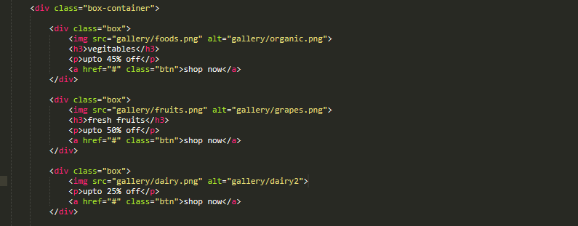
- Inclusion of metadata
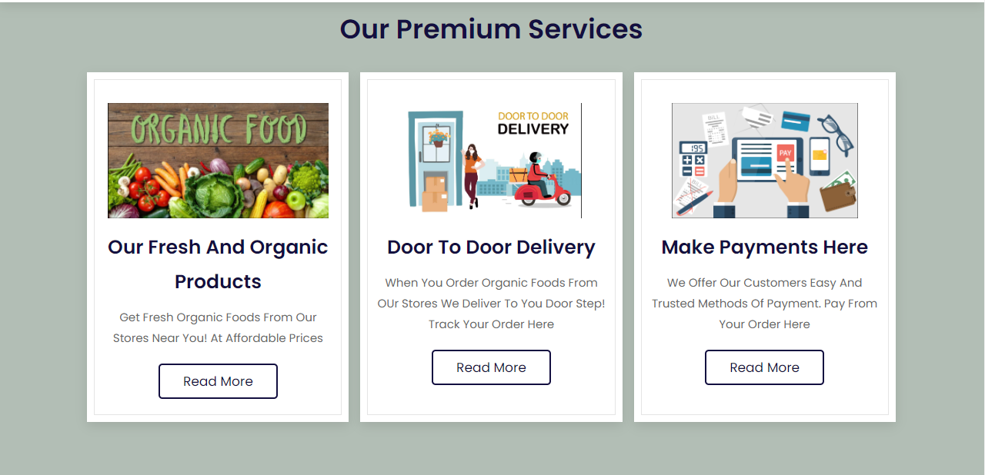
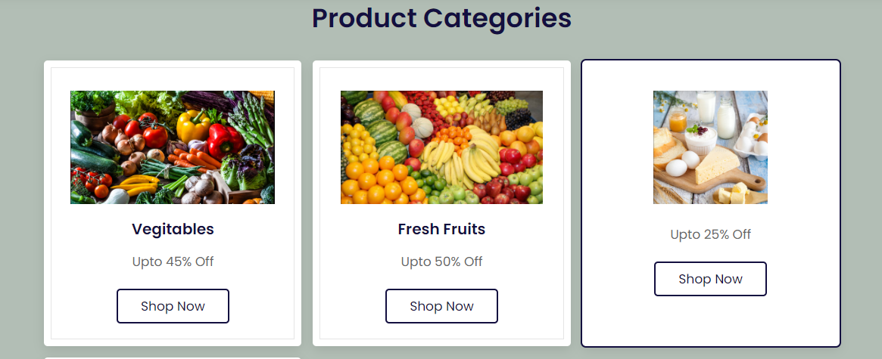
- Optimized for mobile use
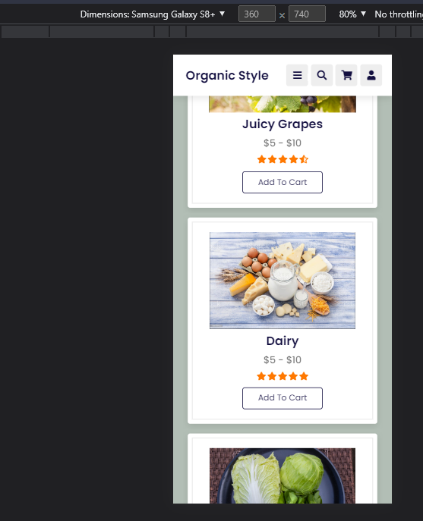

Bibliography
[1]
E. T. Loiacono, N. C. Romano, and S. McCoy, “The state of corporate website accessibility,” Communications of the ACM, vol. 52, no. 9, p. 128, Sep. 2009, doi: 10.1145/1562164.1562197.
[2]
R. Berman and Z. Katona, “The Role of Search Engine Optimization in Search Marketing,” Marketing Science, vol. 32, no. 4, pp. 644–651, Jul. 2013, doi: 10.1287/mksc.2013.0783.
[3]
D. Belanche, L. V. Casaló, and M. Guinalíu, “Website usability, consumer satisfaction and the intention to use a website: The moderating effect of perceived risk,” Journal of Retailing and Consumer Services, vol. 19, no. 1, pp. 124–132, Jan. 2012, doi: 10.1016/j.jretconser.2011.11.001.

Appendices
Index.html
<!DOCTYPE html>
<html lang="en">
<head>
<meta charset="UTF-8">
<meta http-equiv="X-UA-Compatible" content="IE=edge">
<meta name="viewport" content="width=device-width, initial-scale=1.0">
<title>Simba - Organic Foods</title>
<link rel="stylesheet" href="https://unpkg.com/swiper@7/swiper-bundle.min.css" />
<! -- font awesome cdn link -->
<link rel="stylesheet" href="https://cdnjs.cloudflare.com/ajax/libs/font-awesome/5.15.4/css/all.min.css">
<! -- custom css file link -->
<link rel="stylesheet" href="css/style.css">
</head>
<body>
<! -- header section starts -->
<header class="header">
<a href="#" class="logo"> <i class="fa fa-circle-o" aria-hidden="true"></i> <span>Organic</span> Style </a>
<nav class="navbar">
<a href="#home">home</a>
<a href="features.html">features</a>
<a href="category.html">categories</a>
<a href="product.html">products</a>
<a href="about us.html">About Us</a>
<a href="contact.html">Contact us</a>
</nav>
<div class="icons">
<div class="fas fa-bars" id="menu-btn"></div>
<div class="fas fa-search" id="search-btn"></div>
<div class="fas fa-shopping-cart" id="cart-btn"></div>
<div class="fas fa-user" id="login-btn"></div>
</div>
<form action="" class="search-form">
<input type="search" id="search-box" placeholder="search here...">
<label for="search-box" class="fas fa-search"></label>
</form>
</header>
<!-- header section ends -->
<! -- home section starts -->
<section class="home" id="home">
<div class="content">
<h3><span> fresh</span> and <span>organic</span> products for your</h3>
<p>Our stores provide fresh and organic foods for your convenience at affordable prices. Check them out</p>
<a href="#" class="btn btn-information">Place Your Order Now</a>
</div>
</section>
<! -- home section ends -->
<! -- features section starts -->
<section class="features" id="features">
<h1 class="heading"> our Premium Services</h1>
<div class="box-container">
<div class="box">
<img src="gallery/organic.png" alt="">
<h3>Our Fresh and Organic Products</h3>
<p>Get Fresh Organic Foods from Our stores Near you! At affordable prices</p>
<a href="#" class="btn">read more</a>
</div>
<div class="box">
<img src="gallery/delivery.png" alt="">
<h3>Door to Door Delivery</h3>
<p>When you order Organic foods from Our Stores, we deliver to Your door Step! Track your order here</p>
<a href="#" class="btn">read more</a>
</div>
<div class="box">
<img src="gallery/pay.png" alt="">
<h3>Make Payments Here</h3>
<p>We offer our customers easy and trusted methods of payment. Pay from your order here</p>
<a href="#" class="btn">read more</a>
</div>
</div>
</section>
<! -- features section ends -->
<! -- categories section starts -->
<section class="categories" id="categories">
<h1 class="heading"> product Categories</h1>
<div class="box-container">
<div class="box">
<img src="gallery/foods.png" alt="">
<h3>vegitables</h3>
<p>upto 45% off</p>
<a href="#" class="btn">shop now</a>
</div>
<div class="box">
<img src="gallery/fruits.png" alt="">
<h3>fresh fruits</h3>
<p>upto 50% off</p>
<a href="#" class="btn">shop now</a>
</div>
<div class="box">
<img src="gallery/dairy.png" alt="">
<h3>Animal products</h3>
<p>upto 25% off</p>
<a href="#" class="btn">shop now</a>
</div>
<div class="box">
<img src="gallery/meat.png" alt="">
<h3>fresh red and white meat</h3>
<p>upto 30% off</p>
<a href="#" class="btn">shop now</a>
</div>
</div>
</section>
<! -- categories section ends -->
<! -- products section starts -->
<section class="products" id="products">
<h1 class="heading"> Items on Our Shelves</h1>
<div class="swiper product-slider">
<div class="swiper-wrapper">
<div class="swiper-slide box">
<img src="gallery/beef.png" alt="">
<h3>Beef Ribeye Steak</h3>
<div class="price"> $10 - $20</div>
<div class="stars">
<i class="fas fa-star"></i>
<i class="fas fa-star"></i>
<i class="fas fa-star"></i>
<i class="fas fa-star"></i>
<i class="fas fa-star-half-alt"></i>
</div>
<a href="#" class="btn">add to cart</a>
</div>
</div>
</div>
<div class="swiper product-slider">
<div class="swiper-wrapper">
<div class="swiper-slide box">
<img src="gallery/grapes.png" alt="">
<h3>Juicy Grapes</h3>
<div class="price"> $5 - $10</div>
<div class="stars">
<i class="fas fa-star"></i>
<i class="fas fa-star"></i>
<i class="fas fa-star"></i>
<i class="fas fa-star"></i>
<i class="fas fa-star-half-alt"></i>
</div>
<a href="#" class="btn">add to cart</a>
</div>
</div>
</div>
<div class="swiper product-slider">
<div class="swiper-wrapper">
<div class="swiper-slide box">
<img src="gallery/dairy2.png" alt="">
<h3>Dairy</h3>
<div class="price"> $5 - $10</div>
<div class="stars">
<i class="fas fa-star"></i>
<i class="fas fa-star"></i>
<i class="fas fa-star"></i>
<i class="fas fa-star"></i>
<i class="fas fa-star"></i>
</div>
<a href="#" class="btn">add to cart</a>
</div>
</div>
</div>
<div class="swiper product-slider">
<div class="swiper-wrapper">
<div class="swiper-slide box">
<img src="gallery/cab.png" alt="">
<h3>Cabbage the New Kale</h3>
<div class="price"> $5 - $10</div>
<div class="stars">
<i class="fas fa-star"></i>
<i class="fas fa-star"></i>
<i class="fas fa-star"></i>
<i class="fas fa-star"></i>
<i class="fas fa-star-half-alt"></i>
</div>
<a href="#" class="btn">add to cart</a>
</div>
</div>
</div>
</section>
<!-- products section ends -->
<!-- blogs section starts -->
<section class="blogs" id="blogs">
<h1 class="heading"> our <span>blogs</span> </h1>
<div class="box-container">
<div class="box">
<img src="gallery/blog5.png" alt="">
<div class="content">
<div class="icons">
<a href="#"> <i class="fas fa-user"></i> by Quon </a>
<a href="#"> <i class="fas fa-calendar"></i> 13th April, 2022 </a>
</div>
<h3>Your Organic Repices</h3>
<p>Organic kitchen featuring healthy recipes, cooking techniques, and health and wellness information..</p>
<a href="#" class="btn">read more</a>
</div>
</div>
<div class="box">
<img src="gallery/blog4.png" alt="">
<div class="content">
<div class="icons">
<a href="#"> <i class="fas fa-user"></i> by Ken </a>
<a href="#"> <i class="fas fa-calendar"></i> 22 April, 2022 </a>
</div>
<h3>fresh and organic vegitables and fruits</h3>
<p>Crucial issues of food safety, industrial argriculture, genetic engineering, children's health,and environmental sustainability.</p>
<a href="#" class="btn">read more</a>
</div>
</div>
<div class="box">
<img src="gallery/blog3.png" alt="">
<div class="content">
<div class="icons">
<a href="#"> <i class="fas fa-user"></i> by Miley </a>
<a href="#"> <i class="fas fa-calendar"></i> 28th April, 2022 </a>
</div>
<h3>Healthy Cooking</h3>
<p>A health and cooking website featuring Organic, Grain-free, Gluten-free and paleo Recipes, health and detox tips and weekly meal plans.</p>
<a href="#" class="btn">read more</a>
</div>
</div>
</div>
</section>
<!-- blogs section ends -->
<!-- footer section starts -->
<section class="footer">
<div class="box-container">
<div class="box">
<h3> groco <i class="fas fa-shopping-basket"></i> </h3>
<p>Simba Organic Foods is a food store that targets to meet the customer's need for fresh and Organic foods at affordable prices</p>
<div class="share">
<a target="_blank" href="#" class="fab fa-facebook-f"> </a>
<a href="#" class="fab fa-twitter"></a>
<a href="#" class="fab fa-instagram"></a>
<a href="#" class="fab fa-linkedin"></a>
</div>
</div>
<div class="box">
<h3>contact info</h3>
<a href="#" class="links"> <i class="fas fa-phone"></i> +15852826305 </a>
<a href="#" class="links"> <i class="fas fa-envelope"></i> frnc@gmail.com</a>
<a href="#" class="links"> <i class="fas fa-map-marker-alt"></i> NewYork City </a>
</div>
<div class="box">
<h3>quick links</h3>
<a href="#" class="links"> <i class="fas fa-arrow-right"></i> home </a>
<a href="#" class="links"> <i class="fas fa-arrow-right"></i> features </a>
<a href="#" class="links"> <i class="fas fa-arrow-right"></i> products </a>
<a href="#" class="links"> <i class="fas fa-arrow-right"></i> categories </a>
<a href="#" class="links"> <i class="fas fa-arrow-right"></i> review </a>
<a href="#" class="links"> <i class="fas fa-arrow-right"></i> blogs </a>
</div>
<div class="box">
<h3>newsletter</h3>
<p>subscribe to our newsletters</p>
<input type="email" placeholder="your email" class="email">
<input type="submit" value="subscribe" class="btn">
<img src="image/payment.png" class="payment-img" alt="">
</div>
</div>
<div class="credit">&copy; frnc15.com</div>
</section>
<!-- footer section ends -->
<script src="https://unpkg.com/swiper@7/swiper-bundle.min.js"></script>
</body>
</html>

The features
<!DOCTYPE html>
<html lang="en">
<head>
<meta charset="UTF-8">
<meta http-equiv="X-UA-Compatible" content="IE=edge">
<meta name="viewport" content="width=device-width, initial-scale=1.0">
<title>Simba - Organic Foods</title>
<link rel="stylesheet" href="https://unpkg.com/swiper@7/swiper-bundle.min.css" />
<!-- font awesome cdn link -->
<link rel="stylesheet" href="https://cdnjs.cloudflare.com/ajax/libs/font-awesome/5.15.4/css/all.min.css">
<!-- custom css file link -->
<link rel="stylesheet" href="css/style.css">
</head>
<body>
<!-- header section starts -->
<header class="header">
<a href="#" class="logo"> <i class="fa fa-circle-o" aria-hidden="true"></i> <span>Organic</span> Style </a>
<nav class="navbar">
<a href="index.html">home</a>
<a href="features.html">features</a>
<a href="category.html">categories</a>
<a href="product.html">products</a>
<a href="about us.html">About Us</a>
<a href="contact.html">Contact us</a>
</nav>
<div class="icons">
<div class="fas fa-bars" id="menu-btn"></div>
<div class="fas fa-search" id="search-btn"></div>
<div class="fas fa-shopping-cart" id="cart-btn"></div>
<div class="fas fa-user" id="login-btn"></div>
</div>
<form action="#" class="search-form">
<input type="search" id="search-box" placeholder="search here...">
<label for="search-box" class="fas fa-search"></label>
</form>

</header>
<section class="features" id="features">
<h1 class="heading"> our Premium Services</h1>
<div class="box-container">
<div class="box">
<img src="gallery/organic.png" alt="">
<h3>Our Fresh and Organic Products</h3>
<p>Get Fresh Organic Foods from Our stores Near you! At affordable prices</p>
<a href="#" class="btn">read more</a>
</div>
<div class="box">
<img src="gallery/delivery.png" alt="">
<h3>Door to Door Delivery</h3>
<p>When you order Organic foods from OUr Stores We deliver to You door Step! Track your order here</p>
<a href="#" class="btn">read more</a>
</div>
<div class="box">
<img src="gallery/pay.png" alt="">
<h3>Make Payments Here</h3>
<p>We offer our customers easy and trusted methods of payment. Pay from your order here</p>
<a href="#" class="btn">read more</a>
</div>
</div>
</section>
</body>
</html>

The Categories
<!DOCTYPE html>
<html lang="en">
<head>
<meta charset="UTF-8">
<meta http-equiv="X-UA-Compatible" content="IE=edge">
<meta name="viewport" content="width=device-width, initial-scale=1.0">
<title>Simba - Organic Foods</title>
<link rel="stylesheet" href="https://unpkg.com/swiper@7/swiper-bundle.min.css" />
<!-- font awesome cdn link -->
<link rel="stylesheet" href="https://cdnjs.cloudflare.com/ajax/libs/font-awesome/5.15.4/css/all.min.css">
<!-- custom css file link -->
<link rel="stylesheet" href="css/style.css">
</head>
<body>
<!-- header section starts -->
<header class="header">
<a href="#" class="logo"> <i class="fa fa-circle-o" aria-hidden="true"></i> <span>Organic</span> Style </a>
<nav class="navbar">
<a href="index.html">home</a>
<a href="features.html">features</a>
<a href="category.html">categories</a>
<a href="product.html">products</a>
<a href="aboutus.html">About Us</a>
<a href="contact.html">Contact us</a>
</nav>
<div class="icons">
<div class="fas fa-bars" id="menu-btn"></div>
<div class="fas fa-search" id="search-btn"></div>
<div class="fas fa-shopping-cart" id="cart-btn"></div>
<div class="fas fa-user" id="login-btn"></div>
</div>
<form action="" class="search-form">
<input type="search" id="search-box" placeholder="search here...">
<label for="search-box" class="fas fa-search"></label>
</form>
</header>
<section class="categories" id="categories">
<h1 class="heading"> product Categories</h1>
<div class="box-container">
<div class="box">
<img src="gallery/foods.png" alt="">
<h3>vegitables</h3>
<p>upto 45% off</p>
<a href="#" class="btn">shop now</a>
</div>
<div class="box">
<img src="gallery/fruits.png" alt="">
<h3>fresh fruits</h3>
<p>upto 50% off</p>
<a href="#" class="btn">shop now</a>
</div>
<div class="box">
<img src="gallery/dairy.png" alt="">
<h3>Animal products</h3>
<p>upto 25% off</p>
<a href="#" class="btn">shop now</a>
</div>
<div class="box">
<img src="gallery/meat.png" alt="">
<h3>fresh red and white meat</h3>
<p>upto 30% off</p>
<a href="#" class="btn">shop now</a>
</div>
</div>
</section>
</body>
</html>

The blog post
<!DOCTYPE html>
<html lang="en">
<head>
<meta charset="UTF-8">
<meta http-equiv="X-UA-Compatible" content="IE=edge">
<meta name="viewport" content="width=device-width, initial-scale=1.0">
<title>Simba - Organic Foods</title>
<link rel="stylesheet" href="https://unpkg.com/swiper@7/swiper-bundle.min.css" />
<!-- font awesome cdn link -->
<link rel="stylesheet" href="https://cdnjs.cloudflare.com/ajax/libs/font-awesome/5.15.4/css/all.min.css">
<!-- custom css file link -->
<link rel="stylesheet" href="css/style.css">
</head>
<body>
<!-- header section starts -->
<header class="header">
<a href="#" class="logo"> <i class="fa fa-circle-o" aria-hidden="true"></i> <span>Organic</span> Style </a>
<nav class="navbar">
<a href="index.html">home</a>
<a href="features.html">features</a>
<a href="category.html">categories</a>
<a href="product.html">products</a>
<a href="aboutus.html">About Us</a>
<a href="contact.html">Contact us</a>
</nav>
<div class="icons">
<div class="fas fa-bars" id="menu-btn"></div>
<div class="fas fa-search" id="search-btn"></div>
<div class="fas fa-shopping-cart" id="cart-btn"></div>
<div class="fas fa-user" id="login-btn"></div>
</div>
<form action="" class="search-form">
<input type="search" id="search-box" placeholder="search here...">
<label for="search-box" class="fas fa-search"></label>
</form>
</header>
<section class="blogs" id="blogs">
<h1 class="heading"> our <span>blogs</span> </h1>
<div class="box-container">
<div class="box">
<img src="gallery/blog5.png" alt="">
<div class="content">
<div class="icons">
<a href="#"> <i class="fas fa-user"></i> by Quon </a>
<a href="#"> <i class="fas fa-calendar"></i> 13th April, 2022 </a>
</div>
<h3>Your Organic Repices</h3>
<p>Organic kitchen featuring healthy recipes, cooking techniques, and health and wellness information..</p>
<a href="#" class="btn">read more</a>
</div>
</div>
<div class="box">
<img src="gallery/blog4.png" alt="">
<div class="content">
<div class="icons">
<a href="#"> <i class="fas fa-user"></i> by Ken </a>
<a href="#"> <i class="fas fa-calendar"></i> 22 April, 2022 </a>
</div>
<h3>fresh and organic vegitables and fruits</h3>
<p>Crucial issues of food safety, industrial argriculture, genetic engineering, children's health,and environmental sustainability.</p>
<a href="#" class="btn">read more</a>
</div>
</div>
<div class="box">
<img src="gallery/blog3.png" alt="">
<div class="content">
<div class="icons">
<a href="#"> <i class="fas fa-user"></i> by Miley </a>
<a href="#"> <i class="fas fa-calendar"></i> 28th April, 2022 </a>
</div>
<h3>Healthy Cooking</h3>
<p>A health and cooking website featuring Organic, Grain-free, Gluten-free and paleo Recipes, health and detox tips and weekly meal plans.</p>
<a href="#" class="btn">read more</a>
</div>
</div>
</div>
</section>
</body>
</html>

Contact Us page
<!DOCTYPE html>
<html lang="en" dir="ltr">
<head>
<meta charset="utf-8">
<title>Contact Us</title>
<link rel="stylesheet" href="style.css">
<meta name="viewport" content="width=device-width, initial-scale=1">
<style>*{
margin: 0;
padding: 0;
font-family: "montserrat",sans-serif;
}
body,html{
height: 100%;
}
.navbar-brand {
color: rgba(255, 192, 167, 0.932);
font-size: 20px;
font-family: Georgia, 'Times New Roman', Times, serif;
letter-spacing: 2px;
position: absolute;
top: 20px;
left: 50px;
}
.contact-section{
background: url("gallery/organic.png");
background-repeat: no-repeat;
background-position: center ;
height: 100%;
background-size: cover;
/*padding: 40px 0;*/
}
.contact-section h1{
text-align: center;
color: #ddd;
}
.border{
width: 100px;
height: 10px;
background: #34495e;
margin: 40px auto;
}

.contact-form{
max-width: 600px;
margin: auto;
padding: 0 10px;
overflow: hidden;
}

.contact-form-text{
display: block;
width: 100%;
box-sizing: border-box;
margin: 16px 0;
border: 0;
background: #4e2804;
padding: 20px 40px;
outline: none;
color: rgb(255, 255, 255);
transition: 0.5s;
}
.contact-form-text:focus{
box-shadow: 0 0 10px 4px rgba(255, 192, 167, 0.932);;
}
textarea.contact-form-text{
resize: none;
height: 120px;
}
.contact-form-btn{
background-color :#4e2804;
border: none;
color: white;
padding: 15px 32px;
text-align: center;
text-decoration: none;
display: inline-block;
font-size: 16px;
margin: 4px 2px;
cursor: pointer;
}
.contact-form-btn:hover{
background:#f59f7d;
}
</style>
</head>
<body>
<div class="contact-section">
<p class="navbar-brand" href="#">Organic <span>Foods</span></p><br><br>
<br><br>
<h1>Contact Us</h1>
<br><br>
<form class="contact-form" action="index.html" method="post">
<input type="text" class="contact-form-text" placeholder="Your name">
<input type="email" class="contact-form-text" placeholder="Your email">
<input type="text" class="contact-form-text" placeholder="Your phone">
<textarea class="contact-form-text" placeholder="Your message"></textarea>
<input type="submit" class="contact-form-btn" value="Send">
</form>
</div>
</body>
</html>
The products page
<!DOCTYPE html>
<html lang="en">
<head>
<meta charset="UTF-8">
<meta http-equiv="X-UA-Compatible" content="IE=edge">
<meta name="viewport" content="width=device-width, initial-scale=1.0">
<title>Simba - Organic Foods</title>
<link rel="stylesheet" href="https://unpkg.com/swiper@7/swiper-bundle.min.css" />
<!-- font awesome cdn link -->
<link rel="stylesheet" href="https://cdnjs.cloudflare.com/ajax/libs/font-awesome/5.15.4/css/all.min.css">
<!-- custom css file link -->
<link rel="stylesheet" href="css/style.css">
</head>
<body>
<!-- header section starts -->
<header class="header">
<a href="#" class="logo"> <i class="fa fa-circle-o" aria-hidden="true"></i> <span>Organic</span> Style </a>
<nav class="navbar">
<a href="index.html">home</a>
<a href="features.html">features</a>
<a href="category.html">categories</a>
<a href="product.html">products</a>
<a href="aboutus.html">About Us</a>
<a href="contact.html">Contact us</a>
</nav>
<div class="icons">
<div class="fas fa-bars" id="menu-btn"></div>
<div class="fas fa-search" id="search-btn"></div>
<div class="fas fa-shopping-cart" id="cart-btn"></div>
<div class="fas fa-user" id="login-btn"></div>
</div>
<form action="" class="search-form">
<input type="search" id="search-box" placeholder="search here...">
<label for="search-box" class="fas fa-search"></label>
</form>
</header>
<section class="products" id="products">
<h1 class="heading"> Items on Our Shelves</h1>
<div class="swiper product-slider">
<div class="swiper-wrapper">
<div class="swiper-slide box">
<img src="gallery/beef.png" alt="">
<h3>Beef Ribeye Steak</h3>
<div class="price"> $10 - $20</div>
<div class="stars">
<i class="fas fa-star"></i>
<i class="fas fa-star"></i>
<i class="fas fa-star"></i>
<i class="fas fa-star"></i>
<i class="fas fa-star-half-alt"></i>
</div>
<a href="#" class="btn">add to cart</a>
</div>
</div>
</div>
<div class="swiper product-slider">
<div class="swiper-wrapper">
<div class="swiper-slide box">
<img src="gallery/grapes.png" alt="">
<h3>Juicy Grapes</h3>
<div class="price"> $5 - $10</div>
<div class="stars">
<i class="fas fa-star"></i>
<i class="fas fa-star"></i>
<i class="fas fa-star"></i>
<i class="fas fa-star"></i>
<i class="fas fa-star-half-alt"></i>
</div>
<a href="#" class="btn">add to cart</a>
</div>
</div>
</div>
<div class="swiper product-slider">
<div class="swiper-wrapper">
<div class="swiper-slide box">
<img src="gallery/dairy2.png" alt="">
<h3>Dairy</h3>
<div class="price"> $5 - $10</div>
<div class="stars">
<i class="fas fa-star"></i>
<i class="fas fa-star"></i>
<i class="fas fa-star"></i>
<i class="fas fa-star"></i>
<i class="fas fa-star"></i>
</div>
<a href="#" class="btn">add to cart</a>
</div>
</div>
</div>
<div class="swiper product-slider">
<div class="swiper-wrapper">
<div class="swiper-slide box">
<img src="gallery/cab.png" alt="">
<h3>Cabbage the New Kale</h3>
<div class="price"> $5 - $10</div>
<div class="stars">
<i class="fas fa-star"></i>
<i class="fas fa-star"></i>
<i class="fas fa-star"></i>
<i class="fas fa-star"></i>
<i class="fas fa-star-half-alt"></i>
</div>
<a href="#" class="btn">add to cart</a>
</div>
</div>
</div>
</section>
</body>
</html>
The CSS files
@import url('https://fonts.googleapis.com/css2?family=Poppins:wght@100;300;400;500;600&display=swap');
:root{
--orange:#ff7800;
/* #ff7800 */
--black:#130f40;
--light-color:#666;
--box-shadow:0 .5rem 1.5rem rgba(0,0,0,.1);
--border:.2rem solid rgba(0,0,0,.1);
--outline:.1rem solid rgba(0,0,0,.1);
--outline-hover:.2rem solid var(--black);
}
*{
font-family: 'Poppins', sans-serif;
margin:0; padding:0;
box-sizing: border-box;
outline: none; border:none;
text-decoration: none;
text-transform: capitalize;
transition: all .2s linear;
}
html{
font-size: 62.5%;
overflow-x: hidden;
scroll-behavior: smooth;
scroll-padding-top: 7rem;
}
body{
background:#b2beb5;
}
section{
padding:2rem 9%;
}
.heading{
text-align: center;
padding:2rem 0;
padding-bottom: 3rem;
font-size: 3.5rem;
color:var(--black);
}
.heading span{
background: var(--orange);
color:#fff;
display: inline-block;
padding:.5rem 3rem;
clip-path: polygon(100% 0, 93% 50%, 100% 99%, 0% 100%, 7% 50%, 0% 0%);
}
.btn{
margin-top: 1rem;
display: inline-block;
padding:.8rem 3rem;
font-size: 1.7rem;
border-radius: .5rem;
border:.2rem solid var(--black);
color:var(--black);
cursor: pointer;
background: none;
}
.btn:hover{
background: var(--orange);
color:#fff;
}
.header{
position: fixed;
top:0; left:0; right: 0;
z-index: 1000;
display: flex;
align-items: center;
justify-content: space-between;
padding:2rem 9%;
background:#fff;
box-shadow: var(--box-shadow);
}
.header .logo{
font-size: 2.5rem;
font-weight: bolder;
color:var(--black);
}
.header .logo i{
color:var(--orange);
}
.header .navbar a{
font-size: 1.7rem;
margin:0 1rem;
color:var(--black);
}
.header .navbar a:hover{
color:var(--orange);
}
.header .icons div{
height: 4.5rem;
width: 4.5rem;
line-height: 4.5rem;
border-radius: .5rem;
background: #eee;
color:var(--black);
font-size: 2rem;
margin-left: .3rem;
cursor: pointer;
text-align: center;
}
.header .icons div:hover{
background: var(--orange);
color:#fff;
}
#menu-btn{
display: none;
}
.header .search-form{
position: absolute;
top:110%; right:-110%;
width: 50rem;
height:5rem;
background: #fff;
border-radius: .5rem;
overflow: hidden;
display: flex;
align-items: center;
box-shadow: var(--box-shadow);
}
.header .search-form.active{
right:2rem;
transition: .4s linear;
}
.header .search-form input{
height:100%;
width:100%;
background: none;
text-transform: none;
font-size: 1.6rem;
color:var(--black);
padding:0 1.5rem;
}
.header .search-form label{
font-size: 2.2rem;
padding-right: 1.5rem;
color:var(--black);
cursor: pointer;
}
.header .search-form label:hover{
color:var(--orange);
}
.header .shopping-cart{
position: absolute;
top:110%; right:-110%;
padding:1rem;
border-radius: .5rem;
box-shadow: var(--box-shadow);
width:35rem;
background: #fff;
}
.header .shopping-cart.active{
right:2rem;
transition: .4s linear;
}
.header .shopping-cart .box{
display: flex;
align-items: center;
gap:1rem;
position: relative;
margin:1rem 0;
}
.header .shopping-cart .box img{
height:7rem;
}
.header .shopping-cart .box .fa-trash{
font-size: 2rem;
position: absolute;
top:50%; right:2rem;
cursor: pointer;
color:var(--light-color);
transform: translateY(-50%);
}
.header .shopping-cart .box .fa-trash:hover{
color:var(--orange);
}
.header .shopping-cart .box .content h3{
color:var(--black);
font-size: 1.7rem;
padding-bottom: 1rem;
}
.header .shopping-cart .box .content span{
color:var(--light-color);
font-size: 1.6rem;
}
.header .shopping-cart .box .content .quantity{
padding-left: 1rem;
}
.header .shopping-cart .total{
font-size: 2.5rem;
padding:1rem 0;
text-align: center;
color:var(--black);
}
.header .shopping-cart .btn{
display: block;
text-align: center;
margin:1rem;
}
.header .login-form{
position: absolute;
top:110%; right:-110%;
width:35rem;
box-shadow: var(--box-shadow);
padding:2rem;
border-radius: .5rem;
background: #fff;
text-align: center;
}
.header .login-form.active{
right:2rem;
transition: .4s linear;
}
.header .login-form h3{
font-size: 2.5rem;
text-transform: uppercase;
color: var(--black);
}
.header .login-form .box{
width: 100%;
margin:.7rem 0;
background:#eee;
border-radius: .5rem;
padding:1rem;
font-size: 1.6rem;
color:var(--black);
text-transform: none;
}
.header .login-form p{
font-size: 1.4rem;
padding:.5rem 0;
color:var(--light-color);
}
.header .login-form p a{
color:var(--orange);
text-decoration: underline;
}
.home{
display: flex;
align-items: center;
justify-content: center;
background: url(../gallery/blog2.png) no-repeat;
background-position: center;
background-size: cover;
padding-top: 17rem;
padding-bottom: 10rem;
}
.home .content{
text-align: center;
width:60rem;
}
.home .content h3{
color:var(--black);
font-size: 3rem;
}
.home .content h3 span{
color:var(--orange);
}
.home .content p{
color:var(--light-color);
font-size: 1.7rem;
padding:1rem 0;
line-height: 1.8;
}
.features .box-container{
display: grid;
grid-template-columns: repeat(auto-fit, minmax(30rem, 1fr));
gap:1.5rem;
}
.features .box-container .box{
padding:3rem 2rem;
background: #fff;
outline: var(--outline);
outline-offset: -1rem;
text-align: center;
box-shadow: var(--box-shadow);
}
.features .box-container .box:hover{
outline: var(--outline-hover);
outline-offset: 0rem;
}
.features .box-container .box img{
margin:1rem 0;
height: 15rem;
}

.features .box-container .box h3{
font-size: 2.5rem;
line-height: 1.8;
color:var(--black);
}
.features .box-container .box p{
font-size: 1.5rem;
line-height: 1.8;
color:var(--light-color);
padding:1rem 0;
}
.products .product-slider{
padding:1rem;
}
.products .product-slider:first-child{
margin-bottom: 2rem;
}
.products .product-slider .box{
background: #fff;
border-radius: .5rem;
text-align: center;
padding:3rem 2rem;
outline-offset: -1rem;
outline: var(--outline);
box-shadow: var(--box-shadow);
transition: .2s linear;
}
.products .product-slider .box:hover{
outline-offset: 0rem;
outline: var(--outline-hover);
}
.products .product-slider .box img{
height:20rem;
}
.products .product-slider .box h3{
font-size: 2.5rem;
color:var(--black);
}
.products .product-slider .box .price{
font-size: 2rem;
color:var(--light-color);
padding:.5rem 0;
}
.products .product-slider .box .stars i{
font-size: 1.7rem;
color:var(--orange);
padding:.5rem 0;
}
.categories .box-container{
display: grid;
grid-template-columns: repeat(auto-fit, minmax(26rem, 1fr));
gap:1.5rem;
}
.categories .box-container .box{
padding:3rem 2rem;
border-radius: .5rem;
background:#fff;
box-shadow: var(--box-shadow);
outline:var(--outline);
outline-offset: -1rem;
text-align: center;
}
.categories .box-container .box:hover{
outline:var(--outline-hover);
outline-offset: 0rem;
}
.categories .box-container .box img{
margin:1rem 0;
height:15rem;
}

.categories .box-container .box h3{
font-size: 2rem;
color:var(--black);
line-height: 1.8;
}
.categories .box-container .box p{
font-size: 1.7rem;
color:var(--light-color);
line-height: 1.8;
padding:1rem 0;
}
.review .review-slider{
padding:1rem;
}
.review .review-slider .box{
background: #fff;
border-radius: .5rem;
text-align: center;
padding:3rem 2rem;
outline-offset: -1rem;
outline: var(--outline);
box-shadow: var(--box-shadow);
transition: .2s linear;
}

.review .review-slider .box:hover{
outline:var(--outline-hover);
outline-offset: 0rem;
}
.review .review-slider .box img{
height:10rem;
width:10rem;
border-radius: 50%;
}
.review .review-slider .box p{
padding:1rem 0;
line-height: 1.8;
color:var(--light-color);
font-size: 1.5rem;
}
.review .review-slider .box h3{
padding-bottom: .5rem;
color:var(--black);
font-size: 2.2rem;
}
.review .review-slider .box .stars i{
color:var(--orange);
font-size: 1.7rem;
}
.blogs .box-container{
display: grid;
grid-template-columns: repeat(auto-fit, minmax(30rem, 1fr));
gap:1.5rem;
}
.blogs .box-container .box{
overflow: hidden;
border-radius: .5rem;
box-shadow: var(--box-shadow);
background:#fff;
}
.blogs .box-container .box img{
height:25rem;
width:100%;
object-fit: cover;
}
.blogs .box-container .box .content{
padding:2rem;
}
.blogs .box-container .box .content .icons{
display: flex;
align-items: center;
justify-content: space-between;
padding-bottom: 1.5rem;
margin-bottom: 1rem;
border-bottom: var(--border);
}
.blogs .box-container .box .content .icons a{
color:var(--light-color);
font-size: 1.5rem;
}
.blogs .box-container .box .content .icons a:hover{
color:var(--black);
}
.blogs .box-container .box .content .icons a i{
color:var(--orange);
padding-right: .5rem;
}
.blogs .box-container .box .content h3{
line-height: 1.8;
color:var(--black);
font-size: 2.2rem;
padding:.5rem 0;
}
.blogs .box-container .box .content p{
line-height: 1.8;
color:var(--light-color);
font-size: 1.5rem;
padding:.5rem 0;
}
.footer{
background: #fff;
}
.footer .box-container{
display: grid;
grid-template-columns: repeat(auto-fit, minmax(25rem, 1fr));
gap:1.5rem;
}
.footer .box-container .box h3{
font-size: 2.5rem;
color:var(--black);
padding:1rem 0;
}
.footer .box-container .box h3 i{
color:var(--orange);
}
.footer .box-container .box .links{
display: block;
font-size: 1.5rem;
color:var(--light-color);
padding:1rem 0;
}
.footer .box-container .box .links i{
color:var(--orange);
padding-right: .5rem;
}
.footer .box-container .box .links:hover i{
padding-right: 2rem;
}
.footer .box-container .box p{
line-height: 1.8;
font-size: 1.5rem;
color:var(--light-color);
padding:1rem 0;
}
.footer .box-container .box .share a{
height:4rem;
width:4rem;
line-height:4rem;
border-radius: .5rem;
font-size: 2rem;
color:var(--black);
margin-right: .2rem;
background: #eee;
text-align: center;
}
.footer .box-container .box .share a:hover{
background: var(--orange);
color: #fff;
}
.footer .box-container .box .email{
width: 100%;
margin:.7rem 0;
padding:1rem;
border-radius: .5rem;
background: #eee;
font-size: 1.6rem;
color:var(--black);
text-transform: none;
}
.footer .box-container .box .payment-img{
margin-top: 2rem;
height: 3rem;
display: block;
}

.footer .credit{
text-align: center;
margin-top: 2rem;
padding:1rem;
padding-top: 2.5rem;
font-size: 2rem;
color:var(--black);
border-top: var(--border);
}
.footer .credit span{
color:var(--orange);
}
/* media queries */
@media (max-width:991px){
html{
font-size: 55%;
}
.header{
padding:2rem;
}
section{
padding:2rem;
}
}
@media (max-width:768px){
#menu-btn{
display: inline-block;
}
.header .search-form{
width:90%;
}
.header .navbar{
position: absolute;
top:110%; right:-110%;
width:30rem;
box-shadow: var(--box-shadow);
border-radius: .5rem;
background: #fff;
}
.header .navbar.active{
right:2rem;
transition: .4s linear;
}
.header .navbar a{
font-size: 2rem;
margin:2rem 2.5rem;
display: block;
}
}
@media (max-width:450px){
html{
font-size: 50%;
}
.heading{
font-size: 2.5rem;
}
.footer{
text-align: center;
}
.footer .box-container .box .payment-img{
margin: 2rem auto;
}
}

