Mohamed Osman Sesay
Student Number: 1905636
Lecturer: Ejiro Esohwode
Module Code: BMSW4003

The Impact of Visual Learning Environment on Students Learning Experience at University of Wales Trinity London Campus

Table of Contents
1 Introduction
2 Visual learning Environment
3 Summary and Conclusion
3 References

- Introduction

In this research report I will be looking at the impact of virtual learning environment of students of the University of Wales Trinity London campus. I sent email questionnaires to twenty-five students and got eleven response. I have translated the responses into chart as illustrated in subsequent paragraph. The responses received from students will form my primary data. For my secondary data, I have looked at two articles relating to an impact of virtual learning environment on students and learning outcomes.

Primary data is data that is collected by a researcher from first-hand sources, using methods like surveys, interviews, or experiments Hox (2005).

Secondary data is the data that has already been collected through primary sources and made readily available for researchers to use for their own research. Johnston (2017).

I will give a few advantages and disadvantages of both primary and secondary data before I proceed with my research findings.

Primary data is gathered first-hand, following careful operationalisation of variables and using carefully chosen procedures, consideration is given to what is being gathered in terms of data that they are about real life In general, primary data should be valid because the study is designed and carried out for the main purpose of research.

Primary data might be more trustworthy, in that they have greater validity than secondary data. If they are collected objectively, with careful planning and sampling controls in place and other features of methodology adhere to, then they are likely to be scientifically gathered for the stated aim of the study. This means they are credible.

Even though primary data is more reliable, it has disadvantages:
It is expensive to obtain because each researcher or research team must start from the beginning of study and follow the whole study through, finding participants organising materials and running the study.

It is limited to time, place and number of participants etc, whereas secondary data can come from different sources to give more range and detail.

Secondary data is usually convenient as it is carried out at home, in libraries, and other similar places.

Secondary research is also usually cheaper than primary research. As the research is carried out mostly indoor, it does not usually cost that much.

There is availability of information- due to the advancement of technology information is available online.

Secondary data also has it disadvantages - secondary data sometimes may include information which is not valid any longer.

Secondary data may also not be specific sometimes. In some cases, it is not presented in a way that would address the researcher needs. Vidya (2014).

- Virtual Learning Environment
Virtual learning organisation is a learning experience that is enhance through utilizing computers and internets both outside and inside the facilities of the educational organisation. Dillenbourg (2002). The instruction most commonly takes place in an online environment. Virtual learning has the potential to improve student’s achievement, educational access and cost effectiveness. Specifically, virtual learning uses computer software, the internet or both to deliver instructions to students.

After conducting my research by sending questionnaires to twenty-five students, eleven responded regarding the impact virtual learning has on their learning outcomes. The graph below represented the data of the responses. This constituted my primary data.
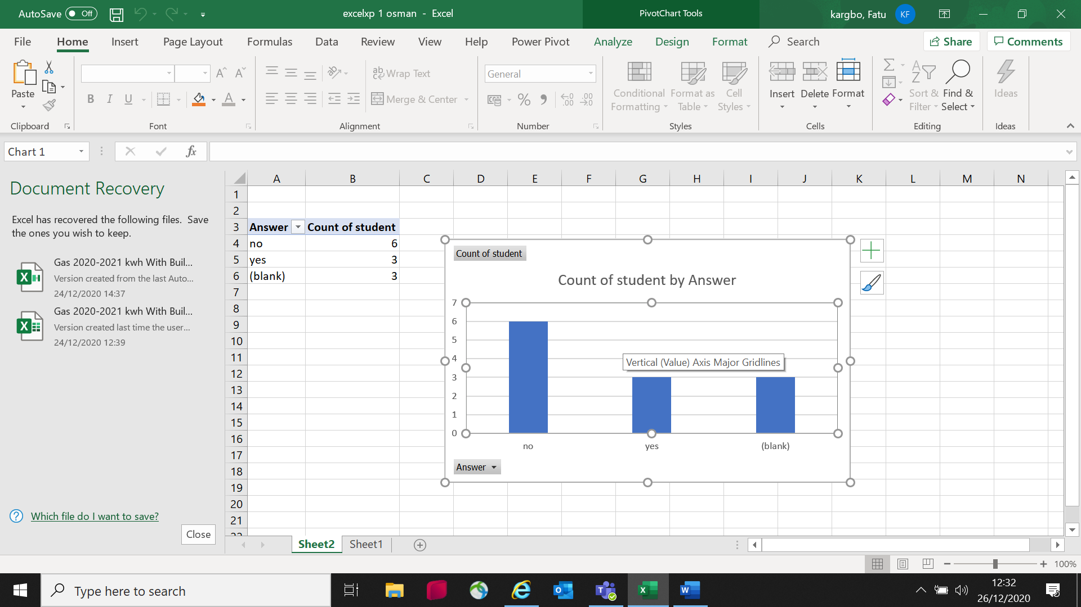

From the eleven students that responded, six said virtual learning does not positively impacted on their learning outcomes, three said virtual learning positively impacted on their learning outcomes and three said virtual learning neither impacted positively nor negatively impacted on their learning outcomes.

From this information obtained showing on the chart, one could see that although virtual learning environment has been useful for most students, there are still many students that virtual learning does not impact on their learning outcomes. Only three people that said virtual learning does impact positively on their learning outcomes. Despite the widely used of virtual or online learning, most students are not impacted by using it.

In my secondary research I looked at two articles. The first article is called “Virtual reality and mixed reality for virtual learning environments Pan (2006). The research was mainly focussed on virtual and mixed reality and how it impacted on students learning outcomes. The research stated that virtual reality is the use of computers graphics systems in combination with various display and interface devices to provide effect of immersion in the interactive 3D computer generated environment. Such an environment is call virtual environment. A mixed reality was referred to incorporation of virtual computer graphics objects into a real three-dimensional scene or alternatively the inclusion of real-world element into a virtual environment. Both the virtual reality and mixed reality have been proposed as technological break through that holds the power to facilitate learning. The research and application of virtual reality and mixed reality technology in education have enriched the form of teaching and learning in current educational strategy. Virtual learning environment not only provides rich teaching patterns and teaching contents but also helps to improve learning’s ability of analysing problems and exploring new concepts. It also builds a suitable virtual learning space all kinds of learners inhabited in the virtual community.

Base on the virtual and mixed techniques, the researchers went on to state that learning action may be processed as following scenery: History students can learn about ancient Greece by walking its streets, visiting its buildings and interacting with its people. Biology students can learn about anatomy and physiology through adventures inside the human body. The range of world’s that people can explore, and experience is unlimitedly ranging from factual to fantasy, set in the past, present or future. In the virtual learning environment learners can model, act and express anything they want if the system provides the tool.
The article listed some merits of virtual learning environment as follows:

- It provides knowledge space for integrated learning resources including the tool that helps to access to learning resources, assessment and guidance.
- It facilitates communication including emails, group discussion, web access and social communication
- It provides active functions as the tool for learners that express their active actions- in other words, in virtual learning environment, learners are not simple knowledge acceptors, they are information provides, question askers, question answers and concept analysers.

The second secondary data I looked at for the purpose of this report is Computers and Education (2010) – Elsevier. In this article, the research was carried out by Ear Lee, KW Wong, and CC Fung. Kang (2012). In their research, they examined how virtual reality enhances learning and not merely influence learning. They stated that various relevant constructs and their measurement factors were identified to examine how particularly desktop virtual reality enhances learning and fit of the hypothesized model was analysed using structural equation modelling. The results supported the indirect effect of virtual reality features to the learning outcomes, which was mediated by the interaction experience and the learning experience. The article mentioned that learning experience, which was individually measured by logical factors, this is presence motivation, cognitive benefits control active learning, and reflective thinking took central stage in affecting the learning outcomes in the virtual learning environment. The article also examined the moderating effect of student characteristics such as ability and learning styles. The result show instructional designers and virtual reality software developers how to improve the learning effectiveness and further strengthen their virtual learning implementation.

The secondary data emphasised on the good of virtual learning in relation to the modern-day technology as opposed to the adverts. It has become a promising solution and convenient learning environment that continues to grow and attract most students. Lots of students enjoy virtual learning as it provides them easy access to learning materials, information and resources. For most, learning becomes easier as they do not depend on human presence to provide them the information and materials they require. Also, most students/learners, enjoy learning independently at their own pace not being supervised by someone. Other students or learners also prefers virtual learning because of ease of material accessibility and information sharing. For these students virtual learning environment will impact positively on their learning outcomes.

Despite the positive impacts of virtual learning environment, some students learning outcome is adversely impacted. For example, some may find it difficult to concentrate and digest information quickly. They may feel cut off from lectures or teachers during lessons, or loss the benefit of verbal interaction of colleagues and connection with friends, and lectures. Furthermore, most learners or students enjoy being in the classroom where they get information from their lecturers or teachers, making it easier for them to learn.

The information obtained from the two mentioned articles clearly shows that Virtual learning environment has impacted positively on students. They have indicated that virtual learning is the easiest, quickest, and effective form of learning in this modern day. Despite this information obtained from the above research findings, it is also important to note that people learn differently and learning outcomes impact differently on them. To some, sitting in the classroom and taking lectures directly gives them more satisfaction. To others, virtual learning gives them better satisfaction. It can be deduced that; virtual learning environment has scientifically grown over the years as more and more learners/students prefer it to the traditional classroom-based learning. For other students/learners, classroom learning will never be replaced

- Summary and Conclusion

From the information obtained from both my primary and secondary data, for the purpose of this report, I can assert that even though virtual learning is seen and use by many students in modern technology, there is still many other students who prefer the traditional classroom learning. The responses from the students of University of Wales London Campus proves that to a large extent some students are not impacted by the virtual learning environment. It is true that in this time of the pandemic for virtual learning is very beneficial for majority of students, but it is not necessary that it reflect positively on their learning outcomes. Most people still enjoy face-to-face learning as it gives them positive satisfaction.

In summary, the primary data gives me results to believe that in this present day of modern technology, virtual learning does not positively impact on most students and therefore not preferable to them. They might be impacted positively by face-to -face learning. The secondary data also gives more advantages of virtual learning environments. Conclusion from the secondary data shows that many students acquire more benefit from virtual learning as they find obtaining learning materials and information access easy and simple.

To me personally as a student who is on this course trying to gain qualification and knowledge, I do enjoy virtual learning to a large extent especially during this pandemic where lives are at risk of the virus. I can get learning materials I need by using the university portal and use the internet at anytime of my convenience. Time for lectures, I do not have to travel instead will login onto my PC and relax in my living room or bedroom and enjoy my lectures. I can mute my phone during lecture and have private conversation without distraction anyone in the lecture. After my lecture, I do not have to warry about traveling back home to re-unite with my family which is cost saving for me.

Despite the easy of learning with virtual learning, I prefer classroom learning where I personally get the best satisfaction and better learning outcomes for me.

References

- Dillenbourg, P., Schneider, D. and Synteta, P., (2002), September. Virtual learning environments. In Proceedings of the 3rd Hellenic conference information & communication technologies in education (pp. 3-18).

- Hox, J.J. and Boeije, H.R., (2005). Data collection, primary versus secondary.

- Johnston, M.P., (2017). Secondary data analysis: A method of which the time has come. Qualitative and quantitative methods in libraries, 3(3), pp.619-626.

- Kang, J.H., Park, R.Y., Lee, S.J., Kim, J.Y., Yoon, S.R. and Jung, K.I., (2012). The effect of the forward head posture on postural balance in long time computer-based worker. Annals of rehabilitation medicine, 36(1), p.98.

- Pan, Z., Cheok, A.D., Yang, H., Zhu, J. and Shi, J., (2006). Virtual reality and mixed reality for virtual learning environments. Computers & graphics, 30(1), pp.20-28.

- Vidya, T.N.C., (2014). Large, secondarily collected data in biological and environmental sciences. Indian Academy of Sciences.

