

LEVEL 4 ASSESSMENT SPECIFICATION
Student name: | Luke Eden | Student ID number: | 1400112
Programme: | HNC Process Operations Engineering
Module: | Plant Maintenance and Asset Care
Module code: | PCPO4005 | Contribution to Overall Module Assessment (%): | 100%
Lecturer: | N Richards | Internal Verifier: | Lance Rutherford
Assignment Title: | Asset Management | Word count (or equivalent): | 2000
Submission deadline: | 30th March 2022 | Return date of provisional marks & written feedback: | 27th April 2022
Submission method: | All written assessments, where practical and possible, must be submitted via Turnitin unless otherwise instructed by the Lecturer. (Please DO NOT put this assessment specification into Turnitin or it will match many similarities with other students’ submissions.)  Alternative submission method (if applicable):  Late submission of the assessment will result in a late penalty mark. Penalties for late submission: Up to one week late, maximum mark of 40%. Over one week late, 0%. Only the Extenuating Circumstances Panel may approve a change to submission dates.
Academic honesty / referencing: | Academic honesty is required. In the main body of your submission you must give credit to authors on whose research and ideas your work is based. Append to your submission a reference list that indicates the books, articles, etc. that you have used, cited or quoted in order to complete this assessment.
Module Learning Outcomes
(from module syllabus)
Explain maintenance strategies and asset care methodologies.

Select an appropriate maintenance strategy based on an assessment of the operational, business and legal requirements for the asset.

Develop and implement asset care improvement techniques

Student FEEDBACK FORM
This section details the extent to which the assessment criteria are demonstrated by you, which in turn determines your mark. The marks available for each category of skill are shown. Lecturers will use the space provided to comment on the achievement of the task(s), including those areas in which you have performed well and areas that would benefit from development/improvement.
Generic Assessment Criteria | Marks available | Marks  awarded
1. Engagement with Literature Skills
 | 10
2. Knowledge and Understanding Skills
 | 40
3. Cognitive and Intellectual Skills
 | 20
4. Practical Application Skills
 | 20
5. Transferable Skills for Life and Professional Practice
 | 10

Assessment Mark (Assessment marks are subject to ratification at the Exam Board. These comments and marks are to give feedback on module work and are for guidance only until they are confirmed. ) | Late Submission Penalties (tick if appropriate) | %

Luke Eden
167873

Plant maintenance and asset care
Asset Management

Contents Page

Task 1: Maintenance Strategies…………………………………………………. Page 2

Task 2: Asset Care Assessment……………………………………………….... Page 3

Task 3 a): ………………………………………………………………………….. Page 7

Task 3 b): ………………………………………………………………………….. Page 8

Task 3 c): ………………………………………………………………………….. Page 9

Reference List: ……………………………………………………………………. Page 10

Table of Figures: ………………………………………………………………….. Page 11

Task 1. Maintenance Strategies

Explain why a combination of maintenance methods (UCM, PPM, CBM) are required when optimising asset utilisation in order to satisfy operational, business and legal requirements.

Within maintenance, there are a number of different strategies which are used to ensure that standards are met, this includes operational, business and legal. For these standards to be met, it is beneficial to use a range of maintenance strategies together in relation to one another as part of a complete maintenance plan.

One of these strategies is Unplanned Corrective Maintenance (UCM), is a maintenance strategy where no maintenance is carried out until the system fails or there is an issue (also known as Run to Failure). This strategy is typically used for small non-essential components which can be repaired fairly quickly and of which there are a lot of spares readily available. However, this type of maintenance is not suitable for essential or dangerous pieces of equipment.

Planned Preventative Maintenance (PPM) is a strategy where maintenance is carried out after a certain amount of time to reduce the probability of a breakdown and to correct any faults or defects before a breakdown occurs. For this to take place the staff will need to be aware of the specific components history and previous failures to give an estimate of the time period between failures (Sagnier, 2018). This is important so that you do not let the component run for too long causing a total breakdown. Also, so that you do not maintain the component too early, thus taking it out of service too often and losing money.

Condition based maintenance (CBM) is a strategy in which maintenance is carried out based on the condition of the system and the components. This requires constant inspection and testing to check the wear and performance of the components. This is used within many maintenance plans as it can be seen as saving the company money and time. This is due to maintenance only being carried out when it is necessary and before the system has failed. based on the information collected through condition monitoring. It consists of three main steps: data acquisition, data processing and maintenance decision-making. Diagnostics and prognostics are two important aspects of a CBM program. “in CBM, a damage parameter is continuously monitored by a structural health monitoring (SHM) system, whereby maintenance is requested when the value of damage parameter exceeds a certain threshold.” (Dong, T., Hafta, R & Kim, N. 2019)

These three types of maintenance are typically used in conjunction with one another to construct a maintenance strategy. They will all be used for different pieces of equipment dependant on their criticality, safety and type of equipment. For critical pieces of equipment or dangerous parts of the process, PPM or CBM is used. For example, a critical pump which would cause major issues if it was to fail will need to be constantly monitored to check the condition of the pump and whether it was working correctly or within the operable limits. By using CBM, trends can be found to see what the most common failure mode is or what component is has the smallest mean time between failures. This can then determine how often planned maintenance can be carried out to maximise productivity whilst also ensuring the safety of personnel or plant. This will then help to adhere to business Whilst PPM is used periodically based on the trends found, CBM will still need to be used to monitor the condition of the components and this can include daily visual checks to look for any signs of wear, routine checks of vibrations, temperature and pressure.

Task 2. Asset Care Assessment
Assets deteriorate over time which risks affecting production requirements.
For an asset that you are familiar with at your place of work, conduct an asset care assessment.
Based on your assessment, develop an asset care improvement plan and describe how this might be implemented.

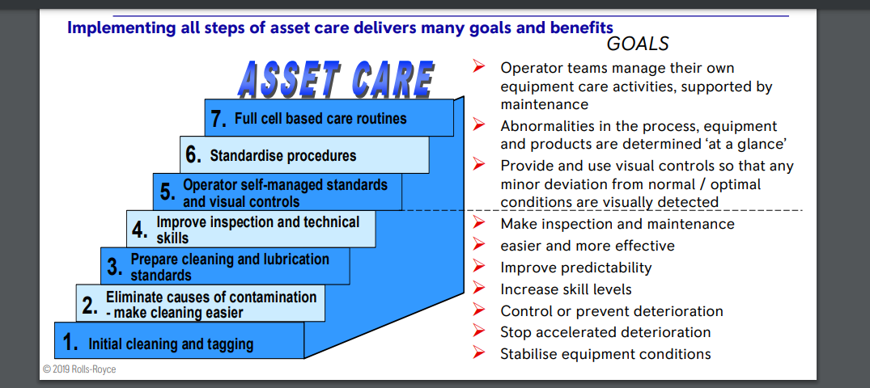

Figure 1

One piece of equipment on site at Valero that requires good asset care is the Wet Gas Compressor (shown in figures 2 & 3) on the Fluid Catalytic Cracking Unit (FCCU). The purpose of this piece of equipment is to transfer a large volume of gas from a low-pressure system to a high-pressure system by compressing it. This compressor is a centrifugal compressor which accelerates gas using blades on a rotating impeller and converts the energy into high pressure. This is a vital component within the FCCU and cannot afford to be offline.
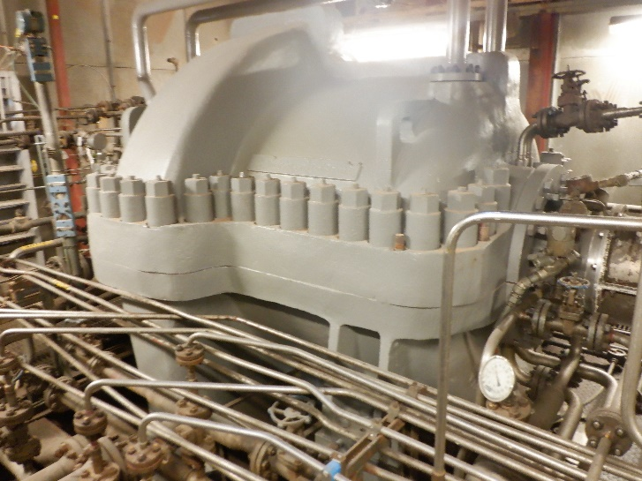
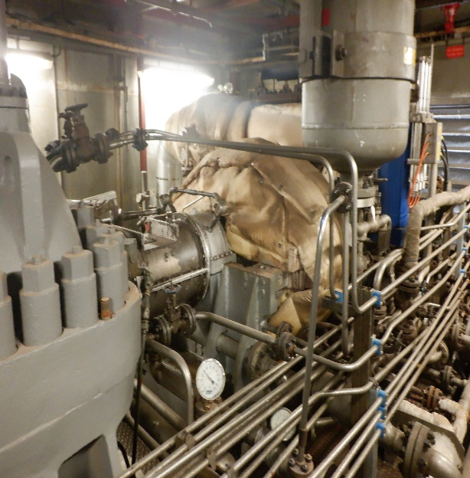

Figure 2 Figure 3

As this piece of equipment is so vital to the unit and to the process as a whole, a lot of care is given to it and it is constantly checked and monitored to ensure that it is constantly running smoothly. As shown in Figure 1, the operations team for the FCCU will follow an asset care procedure and carry out a series of steps to ensure the compressor is correctly maintained. Firstly, as with all essential equipment on site, the compressor will be clearly tagged as well as all of its components. This is so plant operators are aware of its location and the location of its main components. Next, it is vital that the components are free from any contaminants and are regularly cleaned so that it is easier to identify and carry out work on. One of the main checks which needs to be carried out on the compressor is the lube oil pressure. As the compressor is made up of a series of impellers, it is important that they are lubricated well so they do not seize or run hot and cause damage to the equipment. To ensure that these levels and temperatures are correct, the plant operator will carry out checks on the compressor every day as part of their rounds. To ensure that these are completed, the operator is given a task list on a handheld device (which includes other tasks to be carried out). On this handheld, the readings for the compressor will need to be entered daily. This includes the pressures, speeds, temperatures and levels within different components of the compressor.

As well as the daily checks which need to be carried out on the compressor, there are also auto cut in checks which are carried out every 10 days. These are checks which are carried out to ensure the back-up power supplies will cut in if there is a failure. For the compressor, the failure which will cause an auto cut is low lube oil pressure. The lube oil is powered by an electrical pump which allows the pressure to be kept at a certain level. If the electrical pump fails or trips, then a steam pump will automatically cut in and continue to pressure up the lube oil. If this does not cut in, then a diesel generator will cut in, again allowing for the lube oil to continue to be pressured.
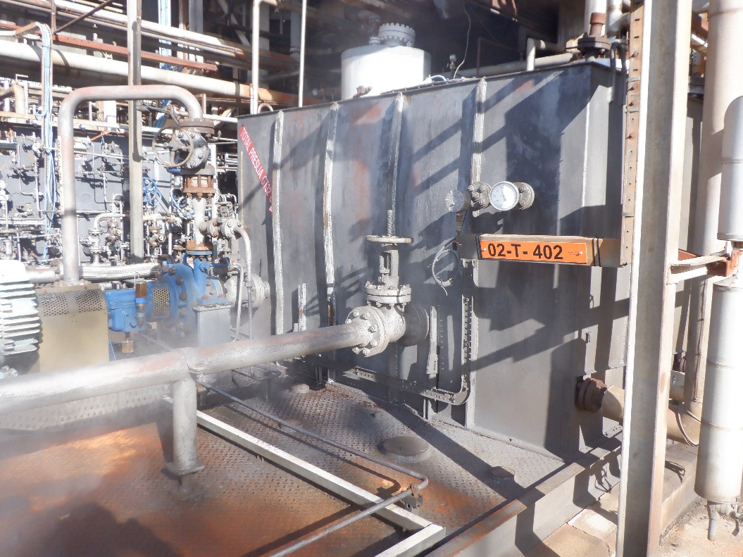
Figure 4

Figure 4 shows the lube oil reservoir where the lube oil is stored and pumped into the compressor from. This is where the auto cut-in checks are carried out.

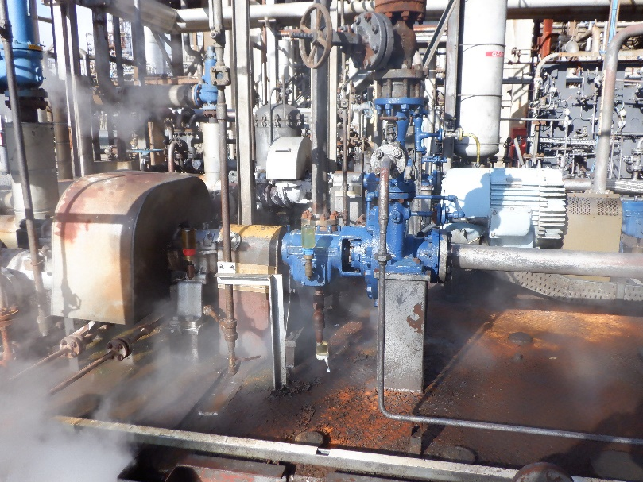
Steam Powered Pump

Electrical Powered Pump

Figure 5

Figure 5 shows the electrical powered pump which feeds the lube oil into the compressor and ensures that the level and pressure of the lube oil is kept at a certain level. Figure 5 also shows a steam powered pump which is a back up to the electrical pump and will automatically cut in if the electrical pump fails, ensuring the lube oil is still pumped into the compressor.

Task 3. Maintenance Strategy
Solero Energy Systems has recently installed a Cooling Water Supply System consisting of two new electrically driven centrifugal pumps (Figure 1).

The pumps will be operated in a Duty / Standby configuration and should always supply cooling water to a chemical processing vessel carrying out an endothermic reaction. You are leading a maintenance department assessment of the new equipment to determine the most appropriate intervention strategy. In order that a maintenance strategy can be put in place, operating information must be gathered from the new plant.

Figure 1: Cooling Water Supply System

- Explore the range of monitoring equipment which can be used to obtain this information.
- Vibration tool – a tool which is pressed against the various parts of the pumps which will measure the level of vibration.
- Temperature gun – a tool which points a laser at various parts of the pump to measure their temperature in °C
- Level sensor – A sensor which is used to show the lube oil level within different parts of the pump. This could include a sight level gauge for operators to physically see the level.
- Pressure Gauge – A gauge which will show different pressures within the pump including discharge pressure, lube oil pressure and suction pressure.

- With respect to the above scenario and equipment, discuss the main considerations as well as the advantages and disadvantages of adopting either a run to failure or a planned preventative maintenance strategy.

Run to Fail (RTF), is a maintenance strategy which consists of running a piece of machinery until it completely breaks, thus using it to its full lifespan. Dutschke (2022) refers to RTF as “Unlike unplanned & reactive maintenance, proper run-to-failure maintenance is a deliberate and considered strategy that is designed to minimize total maintenance costs.” RTF is a contentious strategy and is not suitable for specific machines or components. This maintenance strategy is considered an effective method for small non-critical and non-significant components which can be replaced quickly and easily. When RTF is implemented, it is important that critical spares are available on demand, so to reduce downtime by replacing the component quickly after failure. Furthermore, RTF could be used as there is a backup pump that would be used if pump 1 was to fail. One advantage of this strategy is that there will not be much downtime on the pumps for regular maintenance and will free up man power to be used elsewhere on a unit. As well as this, there will be a lower maintenance cost for the most part as regular maintenance is not being carried out. A disadvantage of this strategy is that if one pump was to fail it would be much more difficult to repair and may have an impact on other components within the system. As well as this, there would be a greater amount of downtime one pump 1 and may be out of service for a long time. This could be detrimental to the cooling system as, if the pumps do not have an automatic cut in, the water supply will stop until the standby pump is manually started up.

Another maintenance strategy which can be used is planned preventative maintenance (PPM). PPM is a strategy in which “is essentially a scheduled maintenance routine, set out to ensure machinery, services and equipment are all maintained at regular intervals.” (ECMS, 2017). PPM is a strategy used to minimise the risk of complete failure by maintaining the components well before they reach the end of their lifespan. One advantage of using PPM is that it will increase the safety of the system and will reduce the risk of there being a failure as the operator will be able to continuously monitor the condition of the pump as well as continuously maintain the pump and make improvements. One disadvantage, however, is that there could be increased costs due to maintenance being carried out more frequently. In doing so, the pump will need to be taken out of service more often and will However, there could be increased cost with RTF as there could be complete failure of a component which could, in turn, cause more damage to the other components within the system. SMGlobal (2019) argues that “A reactive approach to equipment maintenance means waiting for something to break before you fix it. This means you are not really in control. You will be scrambling to fix problems as they occur. Preventive maintenance plans allow you to take a more proactive strategy.”

- Select which strategy you would adopt, providing your justifications based on operational, business and legal requirements.

The two maintenance strategies mentioned in part b could both be used for the scenario provided. Of the two which are provided, I believe that planned preventive maintenance would be the best option and would be the strategy which I would use. I would choose this due to the criticality of the component to the process and the safety issues it could pose to plant and person. Although this strategy would be more expensive in the day to day operation of the plant, it would be less expensive than if there were to be an issue and a complete breakdown, as the process would not be able to cool the product and could lead to issues further downstream. If this occurs, then there may need to be a greater level of maintenance or repair work carried out to resolve the issue, costing a greater amount of money. To avoid unnecessary maintenance being carried out, I would also implement a CBM factor to the plan, where the condition of the pumps would be checked daily and readings taken from the various gauges measuring devices. Furthermore, if one pump was used continuously on an RTF strategy and it underwent a complete failure, it may need to be replaced fully which could take up a lot of time and man hours. This could be costly as it would be expensive to replace the pump with a new one and would take man power away from other jobs. As well as this, the pump would not be able to be used for a large amount of time and would mean that, if pump 2 was to fail during this time, there would be no way of feeding the water to the cooling system, causing major issues to the process. Whereas, if PPM was used, pump 1 would be out of service for a short period of time to carry out maintenance, ensuring it was to a good standard and would then be able to be put back into service upon the completion of the maintenance activities.

Mechanical Services LTD states that “Routine PPM includes statutory maintenance to comply with building and Health and Safety regulations. For example, you are required by law to undertake the following:

- Gas Services Management
- Testing & Inspection of Electrical Systems
- Management and Treatment of Water Systems
- Management of Pressure & Aircon Refrigeration Systems”

Therefore, by law it would not be applicable to use an RTF strategy on a cooling water system such as this, so CBM would be the most effective and relevant strategy to use.

Reference List

Dutschke, J. (2022) Run to Failure: Make it Part of Your Maintenance Planning. Fiix Software. [Online] Available at: https://www.fiixsoftware.com/blog/run-failure-make-part-maintenance-planning/ (Accessed 2/3/22)

Dong, T., Hatafa, R. & Kim, N (2019). Advantages of Conditioned Based Maintenance over Scheduled Maintenance Using Structural Health Monitoring System. Reliability Maintenance. 4th edn. [Online]. Available at: https://www.intechopen.com/chapters/65134 (Accessed: 2/3/22)

ECMS. (2017) What is Planned Preventive Maintenance & Why does it matter? [Online] Available at: https://www.ecms-ltd.co.uk/what-is-planned-preventative-maintenance/ (Accessed: 17/2/22)

Mechanical Services LTD. (No Date) Planned Preventative Maintenance. [Online] Available at: https://www.jhmechanical.co.uk/planned-preventative-maintenance/#:~:text=Planned%20preventive%20maintenance%20(PPM)%20is,and%20Health%20and%20Safety%20regulations. (Accessed: 9/3/22)

Sagnier, C. (2019). Types of Maintenance: 5 Must-Know Examples. Mobility Work. [Online]. Available at: https://mobility-work.com/blog/5-types-maintenance-you-should-know/ (Accessed: 22/2/22)

SMGlobal. (2019) PPM, Planned Preventive Maintenance – The Right Way To Do It. [Online] Available at: https://www.smglobal.com/blog/planned-preventive-maintenance-what-does-it-really-mean/ (Accessed: 18/2/22)

Table of Figures

Figure No. | Source
Figure 1 | Rolls-Royce (2019) How to Implement Asset Care. Slide 7. Value Chain Competitiveness (VCC). Version 1. [Online]. Available at:  https://moodle.pembrokeshire.ac.uk/pluginfile.php/263305/mod_resource/content/1/---%20Rolls%20Royce-Asset-care%20---.pdf Accessed on (10/3/22)
Figure 2 | Personally taken on camera
Figure 3 | Personally taken on camera
Figure 4 | Personally taken on camera
Figure 5 | Personally taken on camera

