Module: Business and Web Management
Lecturer: Md Sadeque Imam Shaikh
University of Wales Trinity Saint David
Website Redesign for
Online Business
Presence
Module Code: ACCA5019
EduNehttps://marcualina58.wixsite.com/edunext
Ionela Alina Marcu (2321713)

Table of Contents
Introduction 2
EduNext Website Redesign 3
What’s Not Working on the Current EduNext Platform 3
Proposed Solutions 4
Responsive Design Implementation 5
Why Responsive Design Matters 5
How We Built Responsiveness into the Design 5
Real-World Examples to Learn From 6
What This Means for EduNext 6
Implementation Section (Humanized Version) 7
Mood Board (Framer) 7
Wireframes (Framer) 9
Home Page Wireframe 9
Courses Page Wireframe 10
About Page Wireframe 10
Register Page Wireframe 11
Contact Page Wireframe 11
Interactive Prototype (Wix) 12
Home Page Prototype 13
Courses Page Prototype 14
About Page Prototype 15
Register Page Prototype 15
Contact Page Prototype 16
Summary of Implementation Approach 16
Conclusion 17
References 18

Introduction

This report takes you through the redesign journey of the EduNext e-learning platform, using a structured and thoughtful UI/UX process. While we didn’t build a live website, we created all the key design elements like a mood board, wireframes, and a polished, interactive prototype using tools like Framer and Wix. Along the way, we backed up our design decisions with current research on usability, accessibility, and user-focused design in the e-commerce space.
Why was a redesign needed in the first place? The original EduNext platform struggled with several issues confusing navigation, outdated branding, visuals that didn’t connect, low-quality media, and a clunky enrolment process. This project aimed to fix all that by creating a design that’s more user-friendly, visually appealing, and focused on turning visitors into active users. The goal? To boost enrolments, reduce dropouts, and build greater trust with users.
Throughout this report, you'll find a deep dive into the design process from the reasoning behind key decisions to how academic ideas were brought into practice. We’ll also touch on the challenges of designing for different screen sizes and reflect on the practical skills gained along the way.

EduNext Website Redesign

What’s Not Working on the Current EduNext Platform
A deep usability check, guided by Nielsen’s well-known heuristics, highlighted several critical problems on the existing EduNext website. Let’s break them down:
Confusing Navigation
Users are having a tough time finding courses. Why? The menus aren’t clear, and filtering options are limited. That’s a big problem when good navigation should help users find what they need fast and easily [2].
Outdated Visuals = Low Trust
The site lacks a strong visual identity, and that matters more than you might think. Research shows that learners are less likely to sign up for a course if the platform looks unprofessional or outdated [3].
No Mobile-Friendly Layout
Here’s a major miss: over 60% of people access e-learning on their phones [4], but EduNext’s layout doesn’t adapt to smaller screens. That’s a direct hit to engagement and usability.
Poor Media Quality
Grainy images and inconsistent video use? Not ideal. High-quality visuals aren’t just for show, they help users learn better, according to multimedia learning theory [5].
Enrolment is a Headache
The sign-up process is long and confusing. Multi-step forms with no progress bar frustrate users, which can lead to drop-offs. Streamlined forms, on the other hand, can boost conversions by up to 30% [6].
No Personalisation
Today’s top e-learning platforms tailor the user experience with smart recommendations. EduNext isn’t doing this, which means it’s missing out on a proven way to keep users engaged [7].
Accessibility Falls Short
There are no alt texts, contrast is off, and the HTML structure isn’t screen-reader friendly. This excludes users with disabilities and fails to meet WCAG 2.2 standards [8].

Weak Calls-to-Action (CTAs)
CTAs are buried or hard to see due to poor placement and colour contrast. If users can’t clearly see what to do next, they’re less likely to enrol.
In short, the current EduNext site is holding itself back with these issues. The redesign isn’t just a visual update; it’s a complete usability and engagement overhaul.

Proposed Solutions
Here’s how the redesign tackles EduNext’s main problems, using smart, user-first design strategies that line up with UI/UX best practices:
Smarter Navigation & Structure
We simplified the top menu to include just the essentials: Courses, About, Register, and Contact. It’s clean, intuitive, and modelled after successful platforms like Coursera and Udemy. To help users explore more easily, we also added dropdown mega-menus and filters for things like course level, length, price, and topic.
A Visual Identity That Actually Says Something
The redesign features a modern, cohesive look using high-contrast blues and oranges. Why those colours? Studies show they build trust, signal professionalism, and add a creative vibe [9]. It’s not just pretty, it’s purposeful.
Designed for Every Device
No matter the screen size, the new layout works. We used a flexible grid system and scalable components to make sure the site looks great on phones, tablets, and desktops. Fluid fonts and smart breakpoints help everything feel natural and readable.
Better Use of Media
We ditched the pixelated images and brought in high-res, professional course visuals. Plus, instructor intro videos are now front and centre, right at the top of the page. That small change alone can boost enrolment by up to 35% [10].
Enrolment Made Easy
Signing up are now just three simple steps, with a progress bar to show users where they are. Returning users will find some fields already filled in, saving them time and reducing drop-off.

Personalisation that Feels Personal
We added a “Recommended for You” section that tailors course suggestions based on user activity, like Netflix’s algorithm [11]. This keeps users engaged and makes the platform feel more relevant to them.
Accessibility Upgrades
Accessibility isn’t an afterthought here. All images now have alt text, contrast meets WCAG AA standards, and we’ve improved keyboard navigation. We’re also planning to roll out semantic HTML to support screen readers.
Stronger, Smarter CTAs
The main call-to-action “Enrol Now” has been redesigned for visibility. It uses a bright accent colour and appears consistently across the site, guiding users clearly toward acting.
These updates don’t just fix what was broken, they move EduNext into a new era. With these changes, the platform is positioned to feel more modern, more intuitive, and more competitive, while directly supporting its goals of boosting enrolment, keeping learners engaged, and earning user trust.

Responsive Design Implementation
In today’s digital world, responsive design isn’t just a nice-to-have, it’s essential. Whether you're selling products or offering online courses, how your site performs on mobile can make or break the user experience.

Why Responsive Design Matters
Think about this: Google reports that 70% of users are more likely to stick around on a mobile-friendly site [12]. That’s a huge number, and a clear sign that responsiveness is key. For platforms like EduNext, which rely on subscriptions and enrolments, a mobile-optimised experience directly boosts conversions. In fact, mobile-optimised sites have been shown to increase sales by up to 32% [13]. So yeah, it matters, a lot.

How We Built Responsiveness into the Design
To make sure EduNext works seamlessly across devices, we followed a few proven principles:
- Fluid Grids: Instead of fixed widths, we used percentage-based layouts, so content adjusts smoothly on different screens.
- Flexible Media: Images automatically resize while keeping their proportions, so nothing looks squished or blurry.
- Breakpoints: We designed for the most common screen widths 480px, 768px, 1024px, and 1440px, to ensure everything looks great on phones, tablets, laptops, and desktops.
- Mobile-First Approach: We started designing from the smallest screens up. This means the essentials always stay front and centre, no matter what device you're using.

Real-World Examples to Learn From
We didn’t design in a vacuum. Here are a few platforms that inspired our approach:
- Coursera: Their card-style course layout looks clean and stays readable on any screen size.
- Wix: Since we used Wix for the EduNext prototype, we took advantage of its responsive templates, which follow best practices for mobile-first design.
- Amazon: With millions of users, Amazon nails responsive design. Their site stays consistent and easy to use whether you’re shopping on your phone or your laptop.

What This Means for EduNext
Here’s how responsive design benefits the platform:
- Better Engagement: No more endless zooming or awkward scrolling, just a smoother experience overall.
- Improved Accessibility: It’s easier to navigate with screen readers or just a keyboard, opening the platform up to more users.
- Mobile Enrolments: Mobile-friendly course pages make it easier for users to sign up on the go.
- Higher Search Rankings: Since Google now uses mobile-first indexing, a responsive design helps EduNext show up higher in search results [14].
All in all, responsive design isn’t just a technical detail, it’s a strategic advantage. For EduNext, it’s a game-changer that boosts usability, accessibility, and performance across the board.

Implementation Section (Humanized Version)
This section walks through the key design deliverables created during Task 1, including the mood board, wireframes, and the interactive prototype. These artefacts bring the EduNext redesign to life, each playing a role in shaping the platform’s look, structure, and user experience.
All visual elements were built using Framer (for the mood board and wireframes) and Wix (for the high-fidelity prototype).

Mood Board (Framer)
The mood board helped define EduNext’s visual identity and overall brand personality. Created in Framer, it brings together design elements that reflect a modern, trustworthy, and engaging learning platform.
Here’s what it includes:
- A bold, professional colour palette:
  - Deep Green (#393D32)
  - Light Beige (#F1E3C8)
  - Brick Red (#AA3D1D)
- Clean sans-serif fonts like Poppins and Open Sans for readability and a modern feel
- Imagery representing professionalism, digital learning, and inclusive learning environments
- UI ideas pulled from big players like Udemy, Skillshare, and Coursera
How It Influenced the Final Design:
- Drove consistent use of colour across buttons and navigation
- Set a cohesive visual tone across all screens
- Helped shape font pairings and hierarchy
- Reinforced a strong emotional tone that supports user trust


Figure 1. EduNext Mood Board created in Framer

Figure 1 shows the design foundation for EduNext, including colour choices, typography, and brand tone.

Wireframes (Framer)
Before jumping into styling, we used Framer to sketch out the layout and user flow. These low-fidelity wireframes helped map the structure of each page and ensure the interface would be intuitive.
Key features built into the wireframes:
- A simplified top navigation menu
- Hero sections with brief, punchy messaging
- Course cards with titles, images, ratings, and a Learn More button
- Sidebar filters to help users narrow course options
- A clean, three-step registration form with minimal friction
How They Helped Shape the Final Site:
- Established the information hierarchy
- Set up the structure for page layouts
- Mapped out key user pathways and flow
- Placed CTAs and interactive elements strategically

Home Page Wireframe
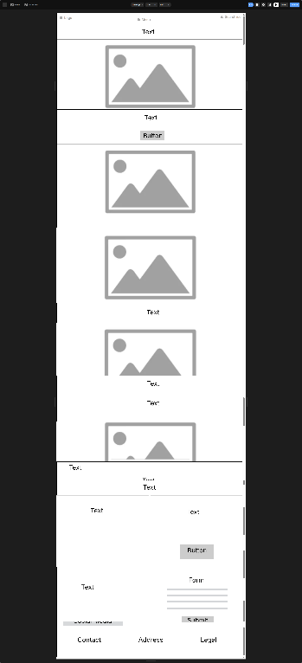
Figure 2. Low-fidelity Home Page wireframe designed in Framer

Figure 2 outlines the homepage layout, focusing on user flow, key CTAs, and course visibility.

Courses Page Wireframe
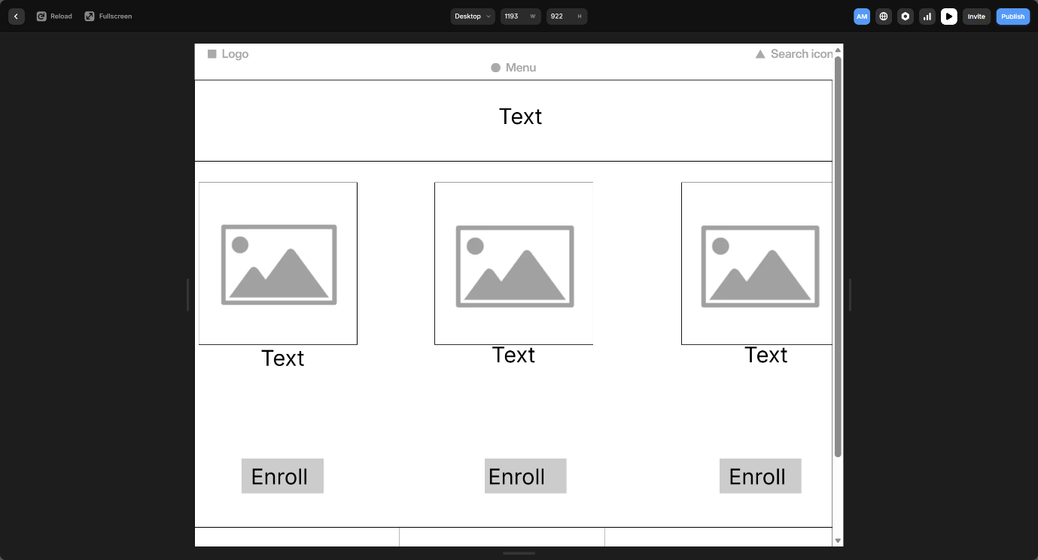
Figure 3. Wireframe of the Courses Page with filtering sidebar
Figure 3 shows how users can browse and filter courses, supported by a clear card-based layout.

About Page Wireframe
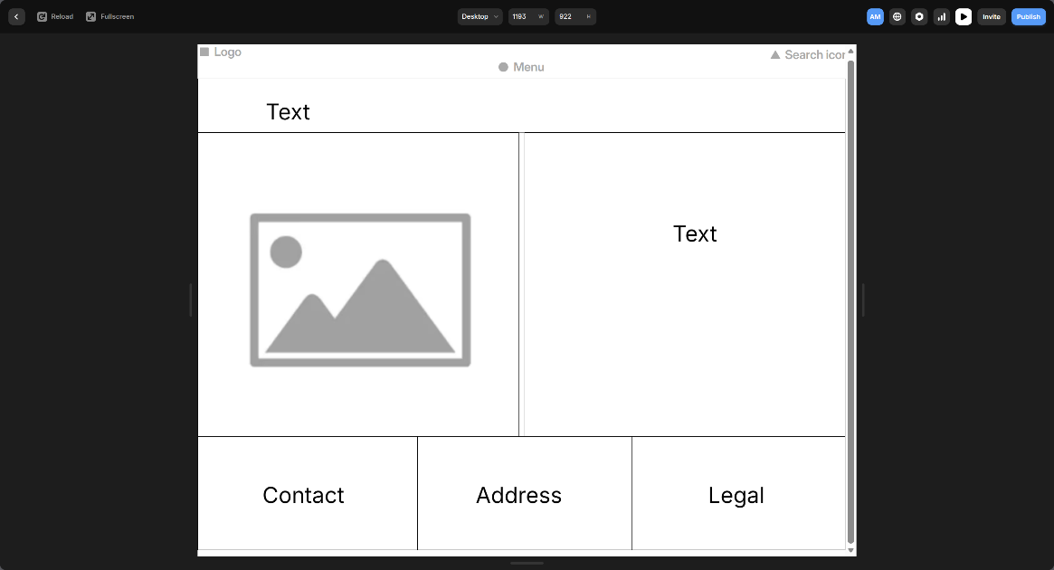
Figure 4. Wireframe of the About Page showing mission and instructor layout

Figure 4 highlights how EduNext presents its mission and team to build user trust and brand authenticity.

Register Page Wireframe
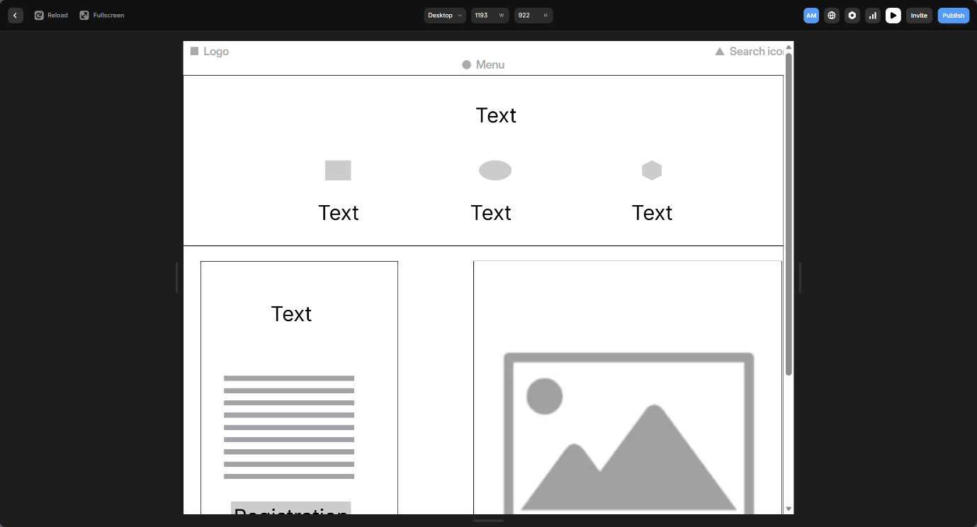
Figure 5. Wireframe of the multi-step Register Page
Figure 5 shows a streamlined sign-up form designed to reduce friction and improve completion rates.

Contact Page Wireframe
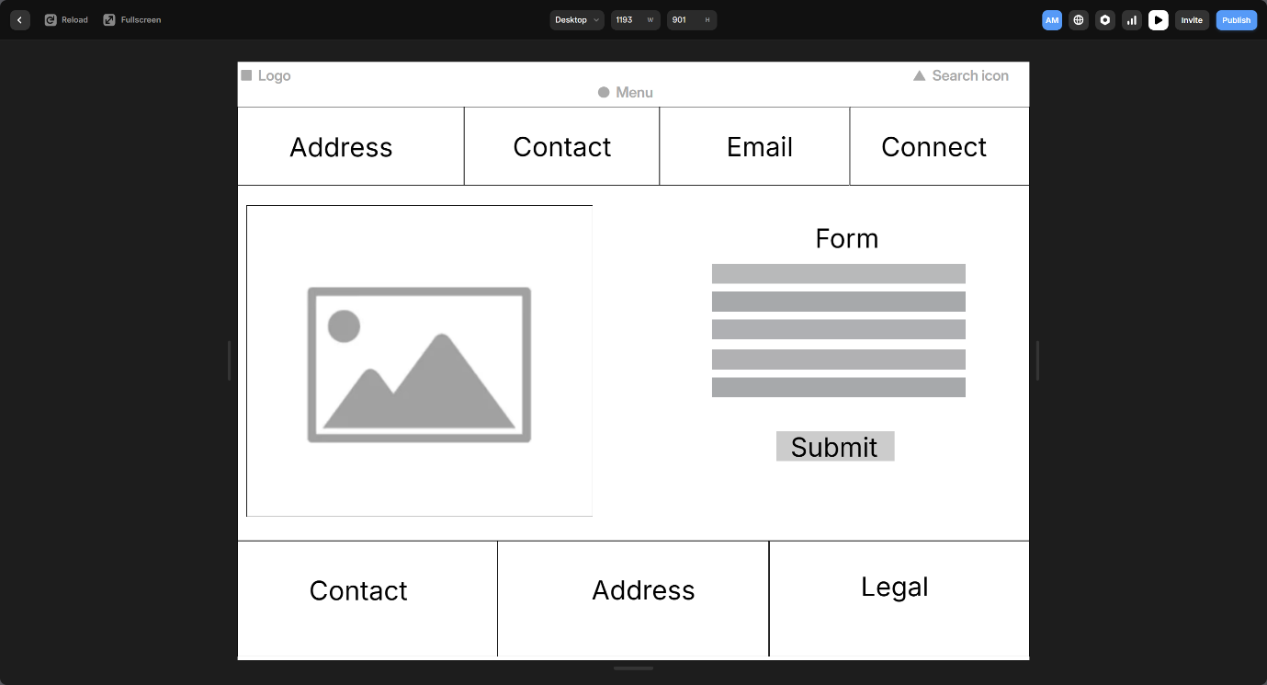
Figure 6. Contact Page wireframe with form and quick links
Figure 6 maps out how users can get support or connect with EduNext through a clear, accessible contact section.

Interactive Prototype (Wix)
The interactive prototype was built using Wix, translating all previous planning into a fully styled and interactive site experience. This prototype simulates how the final platform would feel to a user, from page layouts and responsive design to buttons, filters, and forms.
The prototype includes these five fully interactive pages:
- Home Page: Hero section, featured courses, testimonials, and strong CTAs
- Courses Page: Filterable, scrollable course cards with category tiles
- About Page: Mission, instructor bios, and platform values
- Register Page: Multi-step sign-up form with progress indicators and validation
- Contact Page: Embedded map, support form, and quick links
What’s Interactive?
- Hover effects and button animations
- Clickable CTAs and page navigation
- Working filters on the Courses page
- Validated forms for enrolment

Home Page Prototype
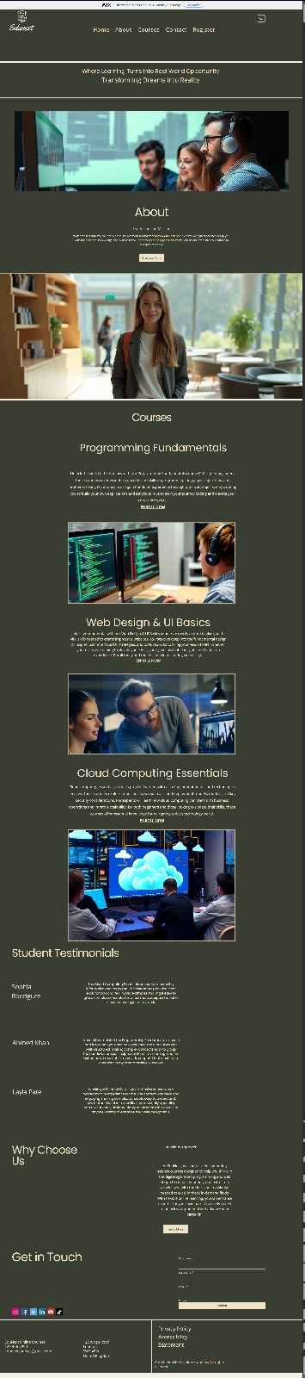
Figure 7. High-fidelity prototype of the Home Page created in Wix

Figure 7 displays the final styled homepage, featuring strong calls-to-action and clean visual hierarchy.

Courses Page Prototype
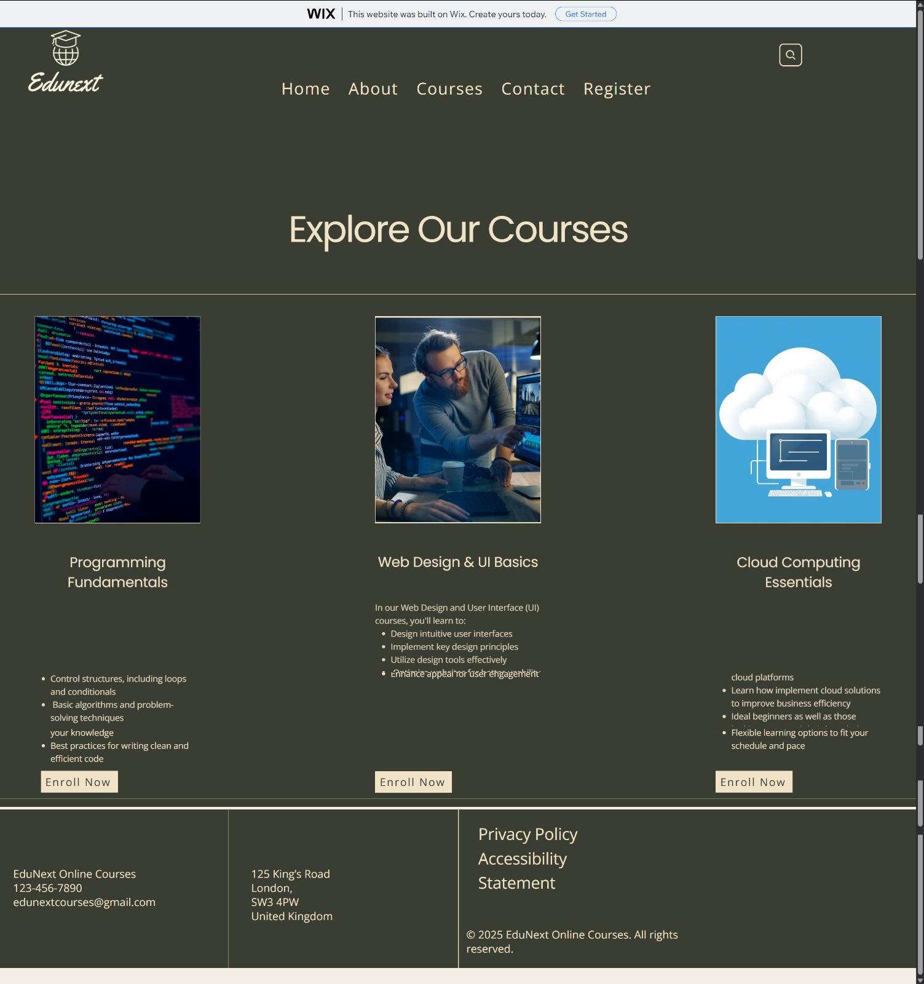
Figure 8. High-fidelity Courses Page prototype with interactive filters

Figure 8 shows the course discovery interface, including responsive filters and dynamic course cards.

About Page Prototype
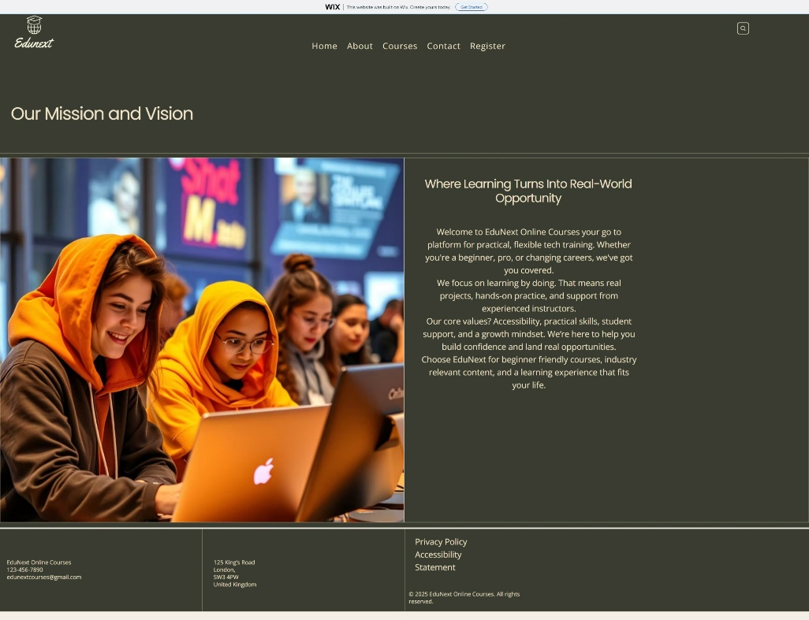
Figure 9. High-fidelity About Page prototype showing platform values

Figure 9 captures EduNext’s brand story, values, and teaching team.

Register Page Prototype
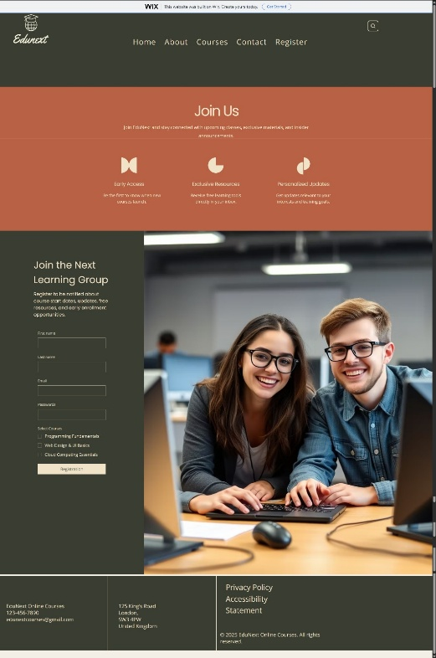
Figure 10. High-fidelity Register Page with multi-step form

Figure 10 presents a clean, accessible enrolment experience with progress tracking.

Contact Page Prototype
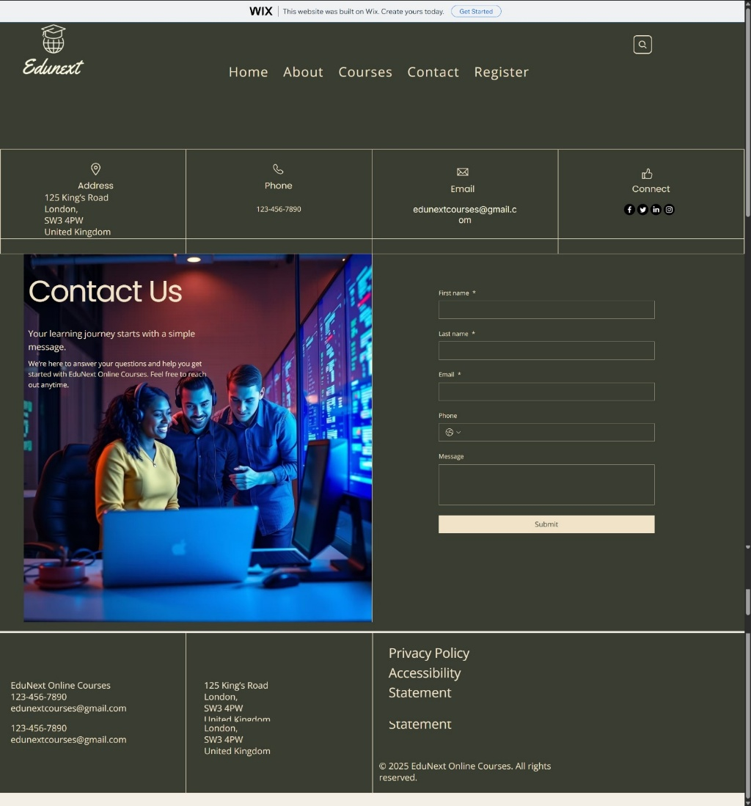
Figure 11. High-fidelity Contact Page including form and map section

Figure 11 provides users with multiple support options, including a contact form and location map.

Summary of Implementation Approach
From mood board to wireframes to interactive prototype, this design journey followed a professional UX workflow:
- Mood board = Visual direction and brand personality
- Wireframes = Structure, flow, and usability planning
- Prototype = Full user interface with realistic interaction and styling
Each stage helped shape a user-friendly, modern platform, positioning EduNext as a trustworthy and competitive e-learning provider. This step-by-step process reflects best practice in design thinking and puts the user experience at the heart of every decision.

Conclusion

This project clearly shows how a structured UI/UX design process can transform an outdated e-learning platform into something modern, accessible, and user-focused. By building out a mood board, wireframes, and a high-fidelity prototype, the redesigned EduNext experience directly tackles key issues like poor navigation, unresponsive layouts, weak branding, and accessibility gaps.
Each design decision wasn’t just based on instinct; it was backed by academic research and best practices from the UX and e-learning industries. Responsive design stood out as especially important, proving to be a major driver of better user experiences and stronger enrolment outcomes, especially on mobile.
On a personal level, this project sharpened my skills across the board, from usability evaluation to responsive design and digital prototyping. I gained hands-on experience with tools like Framer and Wix, which mirror the fast-paced, practical workflows used in today’s design and tech teams. These are valuable, real-world skills I can carry into careers like UX/UI design, front-end development, product design, or digital consultancy.
In the end, this redesign is more than just a visual update. It sets EduNext up for long-term success by offering a cleaner, more intuitive, and scalable user experience. It’s a future-ready concept that puts the user at the centre, right where they should be.

References

[1] J. Nielsen, “10 Usability Heuristics for User Interface Design,” Nielsen Norman Group, 2020.
[2] P. Morville and L. Rosenfeld, Information Architecture for the Web and Beyond, 4th ed. Sebastopol, CA: O’Reilly Media, 2015.
[3] C. Perron-Brault, “Trust Factors in Online Education Platforms,” Journal of Digital Learning, vol. 12, no. 2, pp. 45–59, 2021.
[4] Statista, “Mobile Share of Online Learning Traffic Worldwide,” 2023.
[5] R. Mayer, Multimedia Learning, 3rd ed. Cambridge: Cambridge University Press, 2021.
[6] Baymard Institute, “Form Usability Guidelines,” 2022.
[7] A. K. Jain and R. Sharma, “Personalised E-Learning Recommendation Systems: A Review,” IEEE Access, vol. 8, pp. 120–145, 2022.
[8] W3C, “WCAG 2.2 Accessibility Guidelines,” 2023.
[9] L. Palmer and D. Schloss, “The Psychology of Colour Preferences,” Psychonomic Bulletin & Review, vol. 27, pp. 1–23, 2020.
[10] Coursera Research, “Impact of Instructor Video Introductions on Enrolment,” 2022.
[11] Netflix Tech Blog, “Personalisation at Scale,” 2021.
[12] Google, “The Importance of Mobile-Friendly Websites,” 2020.
[13] Adobe Analytics, “Mobile Commerce 2023 Report,” 2023.
[14] Google Search Central, “Mobile-First Indexing Best Practices,” 2022.
[15] S. Krug, Don’t Make Me Think, 3rd ed. Berkeley, CA: New Riders, 2019.
[16] J. Garrett, The Elements of User Experience, Pearson, 2017.
[17] Shopify UX Team, “E-Commerce UX Best Practices,” Shopify, 2022.
[18] UXPin, “Design Systems and Scalable Interfaces,” 2021.
[19] Wix Design Academy, “Responsive Design in Modern Web Builders,” 2023.
[20] T. Bednarik, “User Engagement Patterns in Online Learning Interfaces,” International Journal of Human–Computer Studies, vol. 150, 2021.

