ASSESSING THE IMPACT OF MICROFINANCE ON SMALL AND MEDIUM-SIZED ENTERPRISES IN THE UNITED KINGDOM
Student id: 2109442
Course name: Master In Business Administration
Student name: Vidhi Jayantilal Kawa
Subject name: Corporate Finance

Master’s Degrees by Examination and Dissertation
Declaration Form.

1. This work has not previously been accepted in substance for any degree and is not being concurrently submitted in candidature for any degree.
Signed: Jia Miao
Date: 31.10.22

2. This dissertation is being submitted in partial fulfilment of the requirements for the degree of Master in Business Administration.
Signed: Jia Miao
Date 31.10.2022

3. This dissertation is the result of my own independent work/investigation, except where otherwise stated.
Other sources are acknowledged by footnotes giving explicit references.
A bibliography is appended.
Signed candidate: Vidhi Kawa
Date: 31.10.2022

4. I hereby give consent for my dissertation, if accepted, to be available for photocopying, inter- library loan, and for deposit in the University’s digital repository
Signed (candidate) Ms. Vidhi Jayantilal Kawa
Date 31.10.2022

Supervisor’s Declaration.
I am satisfied that this work is the result of the student’s own efforts.
Signed: Jia Miao
Date 31.10.2022

University of Wales: Trinity Saint David

E-Thesis Deposit Agreement

Details of the Work
I would like to deposit the following item in the digital repository maintained by the University, and/or in any other repository authorized for use by the University:

Title Ms. Vidhi Jayantillal Kawa, this item is a product of my own research endeavours and is covered by the agreement below in which the item is referred to as “the Work”. It is identical in content to that deposited in the Learning Resources Centre, subject to point 4 below.
I agree that the University of Wales: Trinity Saint David may electronically store, copy or translate the Work to any approved medium or format for the purpose of future preservation and accessibility. The University is not under any obligation to reproduce or display the Work in the same formats or resolutions in which it was originally deposited.

UW: TSD Digital Repository
I understand that work deposited in the digital repository will be accessible to a wide variety of people and institutions, including automated agents and search engines via the World Wide Web.
I understand that once the Work is deposited, the item and its metadata may be incorporated into public access catalogues or services, such as national databases of electronic theses.

I agree as follows:
- That I am the author or have the authority of the author/s to make this agreement and do hereby give the University of Wales: Trinity Saint David the right to make available the Work in the way described above.
- That the electronic copy of the Work deposited in the digital repository and covered by this agreement, is identical in content to the paper copy of the Work.
- That I have exercised reasonable care to ensure that the Work is original, and to the best of my knowledge, does not breach any laws including those relating to defamation, libel and copyright.
- That I have, in instances where the intellectual property of other authors or copyright holders is included in the Work, gained explicit permission for the inclusion of that material in the Work, and in the electronic form of the Work as accessed through the open access digital repository, or that I have identified and removed that material for which adequate permission has not been obtained and which will be inaccessible via the digital repository
- That University of Wales: Trinity Saint David does not hold any obligation to take legal action on behalf of the Depositor, or other rights holders, in the event of a breach of intellectual property rights, or any other right, in the material deposited.
- That I undertake to indemnify the University of Wales: Trinity Saint David against all actions, suits, proceedings, claims, demands and costs occasioned by the University in consequence of any breach of this agreement

Signature Vidhi Kawa

Date 31.10.2022

Acknowledgement
In this research, my teachers and lectures helped me figure out what to do and how to do it. I used online sites to get information from articles, journals, and websites. I appreciate publishers and authors who put information on online platforms. I'm thankful that my university gave me the chance to do research on microfinance and how it affects small and medium-sized enterprises (SMEs). Furthermore, the reports available online helped me in finding alternative ways of finance which can be used by the UK SMEs.

Abstract
This study looks at how microfinance affects small and medium-sized businesses (SMEs) in the United Kingdom and what are the alternative source of financing. This study is split into five parts: the introduction, a review of the literature, the method, the results and a discussion of them, and the conclusion and suggestions. In the first chapter, the ideas of microfinance and small and medium-sized businesses (SME) are explained (SMEs). The chapter also talks about the research's goals, objectives, and questions. The second part of this research is a review of the literature, which talks about the idea of microfinance and how it affects and is important to SMEs in the UK. SMEs also get benefits and problems from microfinance, which is evaluated in this chapter, and defining the literature gap is the last thing to do. The third chapter of this research methodology describes the research philosophy, approach, strategy, and data collection methods. For this research, the researcher would use the interpretivism research philosophy, the inductive research approach, and the secondary data collection method. In the fourth chapter of this research, "Findings and Discussion," there are five different research-related themes that were used to gather information. Based on the whole discussion of themes that fit with the research goals. The fifth chapter of this research is called "Conclusion and Recommendations," and its purpose is to wrap up the research and suggest strategies for the future.
Table of Contents:
Chapter 1: Introduction 5
1.1 Background of the study 5
1.2 Rationale of the study 5
1.3 Research Aim 6
1.4 Research Objectives 6
1.5 Research Questions 6
1.6 Significance of research 7
1.7 Dissertation structure 7
Chapter 2: Literature Review 9
2.1 Concepts associated with microfinance 9
2.2 Impact and significance of microfinance on SMEs in the UK 13
2.3 Benefits associated with micro financing for UK SMEs 15
2.4 Challenges associated with micro financing for UK SMEs 16
2.5 Literature Gap 17
2.6 Conceptual framework 17
Chapter 3: Methodology 19
3.1 Introduction 19
3.2 Research philosophy 19
3.3 Research Approach 20
3.4 Research strategy 21
3.5 Research choices 22
3.6 Time Horizons 22
3.7 Data Collection Method 22
3.8 Data analysis 23
3.9 Limitations of the study 24
3.10 Ethical consideration 24
3.11 Timescale 24
Chapter 4: Findings and Discussion 26
Findings 26
4.1 Role of microfinance in the present economic scenario of the UK 26
4.2 Growing importance of Micro finance for small and medium enterprises 27
4.3 Alternatives of microfinance for SMEs in the UK 29
4.4 Solutions that can be used to mitigate the challenges of using microfinance in UK SMEs 29
4.5 Advantages and limitations of applying the solutions by UK SMEs 32
Discussion 34
Chapter 5: Conclusion and recommendation 37
5.1 Conclusion 37
5.2 Linking with objectives 37
5.3 Recommendation 38
5.4 Future scope 41
References: 42
Appendices 48

Chapter 1: Introduction

1.1 Background of the study
Microfinance helps entrepreneurs and small business owners from underprivileged backgrounds by levelling the playing field with the help of finance. Entrepreneurs may get financing for development rather than turning to payday lenders or taking on expensive loans that they most likely won't be able to repay (Dahal and Fiala, 2020). Without insurance, funding business visionaries bring fresh viewpoints to the table and can spur new development. Giving independent businesses money results in a more enjoyable and distinctive unregulated economy, from food trucks to application designers.
Microfinance is a banking service that helps people who are unemployed or have low incomes and don't have any other way to get money. Microfinance makes it easier for people to get small business loans that are fair and follow ethical lending practices. Microfinance can get rid of any problems and help low-income families get a steady income and save some of it for the future. Based on research, it is thought that about 5–6% of the population has access to a formal bank (Gakpo et al., 2021, p. 2). Small businesses have limited access to formal financial institutions in terms of loans, deposits, and other financial services. But in 2016, nearly 138 million Europeans were financially cut off from society because they didn't have bank accounts or other ways to pay (Sani et al., 2018).
The backdrop of the research is to focus on three main variables, which are small as well as medium-sized enterprises in the United Kingdom, microfinance, and its impact. The case study of SMEs in the UK will help understand the extent of impact and growth of small and medium-sized businesses due to microfinance which has been instrumental in the success of such businesses (Yusufu et al., 2020, p. 127). The study will also state areas where efficiency has been registered due to the impact. The analysis also provides an understanding of the concepts which will at end help in understanding how micro financing can help in increasing the efficiency of UK SMEs.

1.2 Rationale of the study
The idea behind this research is that it will help people who don't have enough money to get resources and access to capital. The goal of this study is to learn about microfinance and how it affects small and medium-sized businesses (SMEs) in the UK (Farghly et al., 2018, p. 420). Microfinance is thought of as a tool for economic growth that helps poor people get out of poverty. By doing this research, it would be possible to give people permanent access to good financial services like saving, insurance, and transferring money. It is one of the most important things that can be done to end poverty. Access to financing continues to be a major barrier for UK projects with restricted scope. Credit needs for working capital and raw materials have been present (Nautwima and Asa, 2021, p. 12). The majority of SMEs also lack the necessary collateral to get loans from financial institutions, which prevents them from routinely obtaining long-term funding to support and expand their businesses. In addition to various financial requirements, the majority of UK owners and managers of small businesses face challenges such as a lack of specialised knowledge, talented employees, management skills for managing commercial initiatives, and a lack of business ideas. Their potential for development remains stagnant. Since most businesses still use outdated hardware and find it difficult to acquire replacement components to purchase, there is also the question of how to approach modern innovation (Eggers, 2020). The availability of microfinance to SMEs can lead to the overall growth of the economy. The research is conducted to understand the importance of microfinance for the growth of small and medium-sized enterprises in the UK and how it can boost economic growth of the country.

1.3 Research Aim
The primary aim of this research is to assess the impact of microfinance on SMEs in the United Kingdom.

1.4 Research Objectives
The main objectives set for this particular research to direct the path of the study are as follows:
- To find the role of microfinance in the present economic scenario of the UK.
- To analyse the impact and significance of microfinance on SMEs in the UK.
- To study the benefits and challenges associated with micro financing for UK SMEs.
- To recommend alternative ways of financing and how it can be utilised by UK SMEs.

1.5 Research Questions
The study will provide answers to numerous queries on how microfinance affects SMEs in the UK. The following inquiries will guide the study's execution:
- What are the concepts related to microfinance?
- What function does microfinance play in the current economic climate of the United Kingdom?
- What is the impact as well as the relevance of microfinance for SMEs in the UK?
- What are the opportunities and limitations associated with microfinancing for UK SMEs?
- How well do UK SMEs make excellent use of microfinance?
- How does microfinance impact the operational activities of SMEs and economic growth in the UK?

1.6 Significance of research
Recent advancements in microfinance have made it crucial for SMEs to have access to financial services by providing help that is specifically tailored to their needs, something that traditional Formal Financial Institutions failed to achieve. Small and medium-sized businesses (SMEs) typically have very limited access to retail locations, credit offices, and other financial assistance services provided by formal financial institutions (FFIs). This is because these SMEs cannot provide the considerable guarantee security required by these appropriate facilities, and banks also struggle to recoup the sizable expenditure associated with managing small businesses. Additionally, banks find it difficult to handle tiny projects due to the associated risks associated with lending to SMEs. Since the monetary administrative sector of the economy typically rejects the poor, MFIs have emerged to remedy this market disappointment. By filling this market gap in a financially sensible manner, an MFI may become crucial to a country's official financial system and get access to capital business sectors to subsidise their loaning portfolios, allowing them to significantly increase the number of needy people they can assist.
To consider the importance of little money in assisting small and medium-sized endeavours, this study will draw on key pieces of writing and a new crucial evaluation where the researcher can reach varied conclusions. The research reflects the value of small money, but little research has been done to determine its demand, supply, and whole size up to this time (Gyimah and Boachie, 2018).
The findings of this study suggest that small-scale support benefits organisations overall by closing the asset gap for private businesses. Through subsequent investments in supporting and planning non-monetary administrations, small funding has a significant potential to increase the display of private ventures.

1.7 Dissertation structure
This dissertation has five different chapters, each of which talks about a different idea related to the research topic. In the first chapter of this research, the background and reasons for doing the research were given. Along with that, the research goals and objectives, as well as the research questions, were also mentioned. Lastly, this chapter shows how research is done and describes the kinds of methods that will be used in this research. The second part of this research is a review of the literature, which explains the importance, sources, and effects of microfinance. Lastly this chapter demonstrates talks about the ideas that current research hasn't been able to show but will be looked at in future research. The third chapter of this research is methodology which defines types of methods that would be used for collecting information and evidence. The fourth chapter of this research is finding and analysis where researcher collected different information and evidence related to the research topic. The fifth chapter of this research is conclusion and recommendation where the research has come to a conclusion and recommended some strategies for future research.

Chapter 2: Literature Review

2.1 Concepts associated with microfinance
Microfinance institutions provide financial services to individuals or groups devoid of employment or who have a common source of income. Microfinance supports small business enterprises with proper financial support, which is related to ethical lending practices, as noted by (Belhadi et al., 2018). According to Dahal and Fiala (2020), they have become a source of primary credit and lending facilities unavailable from the organized financial sectors. Moreover, since they are available at affordable interest rates and are given without documentation, the SMEs' financial performance has constantly been improving. Further, Eggers (2020) has observed that the customized financial support and the easy access make such institutions a clear point for small and medium-sized businesses. Furthermore, the positive impact of such institutions is also apparent in how they aid SMEs' business expansion in the present economic scenario. The UK government describes SMEs as organizations with less than 250 employees with a turnover of less than €50 million. According to the data for 2021, there were 5.6 million SMEs in the UK, making it a significant contributor to the overall economy (£2.3 trillion (52%) (Belhadi et al., 2018).
It has also been observed that there is an absence of a regulatory framework for microfinance in the UK since it is not considered a specific sector. Yet, the reliance upon it by SMEs is relatively remarkably high as the lending ranges from £1000 to £500,000. The growing importance of these firms is much related to the clauses and support provided by these institutions. According to (Gyimah and Boachie, 2018), it is not only expanding the business but also improving the firms' overall performance, leading to a more significant contribution to the economy.
According to Khan, (2020, p. 115), refinance is when banks and other financial institutions give small loans to low-income people. These loans can be used for savings, insurance, or to send money to someone else. Small and medium-sized businesses can save, invest, and make money with the help of these basic financial services. Small and medium-sized businesses (SMEs) might have enough cash flow or collateral, but the bank won't be interested because it only needs a small amount. Microfinance, on the other hand, has nothing to do with making money, even though these programs help pay for things like food, medicine, and school. Compared to 2004, the amount of loans made through microfinance has reached huge levels. There are almost 10,000 microfinance institutions, which means that there are a lot of them around the world (Akingunola et al., 2018, p. 163). Most microfinance is done for countries like Honduras, Serbia, Indonesia, and Uganda that are still developing. On the other hand, most microfinance organizations are geared toward helping women. The World Bank says that about 500 million people directly or indirectly benefit from the operations related to microfinance. 120 million people will directly benefit from microfinance operations in the year 2021. Some of the world’s poor can do these things, but an estimated 1.7 billion people can't because they don't have access to basic financial accounts (TORIOLA, 2021, p. 102).
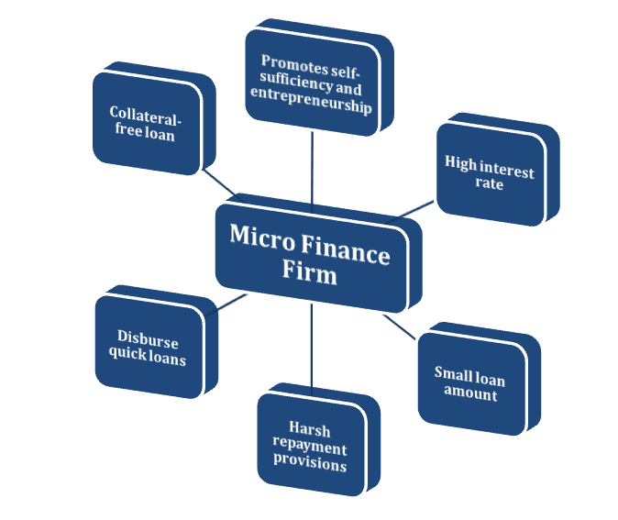
Figure 1: Concepts of microfinance
(Source: TORIOLA, 2021, p. 102)
Sources of finance of a Microfinance company
Banks have started showing concern for the needs of the medium and small Microfinance institutions. The needs of these institutions are now being attained through a regulatory framework giving them confidence about lending. MFI mostly receive their funds from agents like grants from outright donors, subsidies from the government, debt capital, loans from partner banks, private investors, public investors, own capital, and so on.
Funding from bilateral or multilateral organizations is generally long-term. However, own capital is short-term. The internal source of funds is therefore derived from the own capital of such Microfinance Institutions. According to Islam (2021), there is also an impact of capital resources on the performance of the profit. Thus, the influence of the characteristics of influence on external sources of funds must be understood. Thus, there are two main sources for microfinance to derive their funds which are the internal and external sources funds.
As per the view of Félix and Belo, (2019, p. 100590), Private equity is ownership or an interest in a business that is not open to the public. Private equity firms look to high-net-worth individuals (HNWI) for investment capital. They buy shares in private companies and control public companies with plans to take them private and take them off the stock exchange. Institutional investors, such as large private equity firms with funds and pension funds, make up private equity. Accredited investors also make up private equity. Private equity involves making direct investments and getting a say or control over how a business or firm runs. Different firms and funds have different minimum amounts of capital that accredited investors must have. Some of the funds require at least $250,000 to join, while others need millions. The main reason for these commitments is the desire to get a positive return on investment (ROI) (Mia, 2022, p. 47). Partners of private equity firms raise money and manage it so that shareholders get a good return on their investment. The way private equity firms set their fees vary, but they usually have management fees and performance fees. Annual management fee of 2% of assets and 20% of the company's gross profits, which is a common amount, from the sale of the business. Deal values in the middle market range from $50 million to $500 million, and associates can make low six figures in salary and bonuses (Tanima et al., 2021, p. 1083).
Venture capital is a type of equity financing in which money is invested in exchange for equity or a minority stake in a business that is expected to grow significantly. Venture capital is a type of private equity, and private equity is used by firms to put money into businesses that are already doing well. Most angel investors invest their own money, while most venture capitalists work for firms that get money from outside investors. Capital-raising is how VCs get money to invest in businesses that have shown they can grow quickly and have a lot of growth potential (ZEB et al., 2021, p. 117). Venture capital funding has different stages that correspond to different stages of a company's growth. VC is known as a good way to fund tech companies because it is easy to scale up, but it can also be used to invest in non-tech businesses. VC is thought to be one of the best options for small and medium-sized businesses and entrepreneurs with big goals who don't want to keep full control of their company's growth. When investors look at a business, they look for things like how well it solves a strong customer pain, how easy it is to grow, and how many customers it can serve. Financial services are not only nice to have, but they also need to solve problems for customers and give them real value. VC has a possible way to get out of a business to make money and pay back investors. VCs look for companies that can increase sales and growth in ways that are both cheap and effective (Upravitelev, 2022, p. 134).
How microfinance works
Microfinance refers to all financial products and services made for people who can't get them through traditional banking channels. Microfinance promotes social and banking inclusion by giving people who are socially vulnerable access to productive loans, ways to save money, and a lot more. The main difference between these and "Classic" products and services is that these only lend out small amounts of money. In the UK, microfinance loans cannot be for more than P- 150, 000 (Sunitha et al., 2019, p. 94). Microfinance institutions help people who want to borrow money and give them microloans. These borrowers don't have a solid promise to pay back the loan, but the money they make from microloans and other economic activities helps them pay off the loan balance.
Microfinance can be done as a non-profit organization (NGO), a mutual fund, a cooperative, or a for-profit business. There are also local projects like tontines (in Africa) and self-help groups that don't have any legal standing but are still thought of as a way to give out microcredit (India). MFI operates in different ways for each entity and can also change its status to offer more services. Customers can't give money to a non-profit in the form of savings. Several countries are asked to convert to companies that are allowed to do the transaction and are regulated. MFI's main goal is to help people save money together and get small business loans so they can invest in small and medium-sized enterprises (SMEs) (Briones, 2020, p. 88).
Mobilization: People in a trusted group of 75 to 100 people who know each other well and are willing to co-guarantee each other's loans.
Formation: Members start saving money and learn about money and how to run a business. A board is chosen from the members. These people are trained in good governance and are in charge of keeping an eye on all group meetings and transactions. Group makes up its own rules and holds elections every year. After 6 months they can start lending to each other and the fund grows via charging interest (Grimpe, 2019, p. 87). Since each member has put money into a loan fund, experience shows that the groups make good credit decisions. During that time, members get training on basic business skills regularly.
Launch of loan program: After 18 months, it tends to start going down as groups get older and can run on their own. Groups keep saving and lending money, which keeps businesses growing by providing a safety net through savings (Zhong and Zhou, 2020, p. 5367).

2.2 Impact of microfinance on SMEs in the UK
The impact of microfinance is most importantly registered in the growth of income, creation of assets, along with reduction of the vulnerability of humans. There is also an impact on the dimensions of poverty, leading to the overall growth of household income and improvement in the sectors like health and education (Dahal and Fiala, 2020). Microfinance, most importantly, empowers society with a sense of independence at a low cost and great efficiency.
The rural economy is regarded as the backbone of the majority of developed nations, although its development in infrastructure is frequently challenging (Eldridge et al., 2021, p. 105). In such situations, microfinance institutions are seen as a means to reduce poverty and improve economic conditions. Small and Medium-Sized Enterprises (SMEs) are one of the primary sources of employment and income in the majority of developed nations. When it comes to expansion, microfinance is one of the most important factors for generating stable work capital. Microfinance is essential for the growth of small businesses to the next level of output and revenue.
Facilitates access to credit facilities, Microfinance organizations serve as the major credit and lending institutions for small and medium-sized businesses that have been repeatedly rejected by commercial banks. MFIs typically offer microloans and other financial services with reasonable interest rates and streamlined procedures. The financial performance of small and medium-sized enterprises depends on the accessibility and desirability of microfinance loans. Using inclusive policies in practice, for operational routine, SMEs frequently employ unskilled and semi-skilled laborers, the majority of whom are economically disadvantaged and marginalized. Microfinance lenders target this group's objectives for building business models that aim to alleviate poverty and raise living standards. Facilitating business growth, one of the most important roles of microfinance supplied to SMEs is the business expansion and operational footprint expansion help. This helped boost the number of outlets and access to undiscovered business areas for small and medium-sized enterprises, allowing them to become powerful competitors in the current market. Credit facilities for microfinance businesses can be obtained by a group of people with shared goals and interests. Microfinance is typically regarded as relative and is more likely to repay debts and lead to additional lending. Consequently, Microfinance is one of the most efficient means for SMEs to employ cash and boost productivity and profit operations. Small and medium-sized enterprises have a propensity to trust microfinance institutions, which is one of the reasons for tailoring financial products to the precise needs and characteristics of SMEs (Chikwira et al., 2022, p. 393). Microfinance loans and microfinance institutions have been adopted by developing nations despite their scepticism. Thus, microfinance loans tend to assist SME owners with mainstream integration and connection maintenance.

2.3 Significance of microfinance on SMEs in the UK
The need for microfinance has become quite universal. The following are the main reasons for the need for it in the present economic scenario.
They are the source of immediate funds. They provide access to credit. The rates for repayment of loans are far more improved. They provide funds to the unnoticed. They also provide funds to receive an education. They ensure the possibility of future investments. They have been able to create Real Jobs. They have led to considerable economic gains for many people (Gyimah and Boachie, 2018).
Microfinance enables small firms and entrepreneurs from uncertain financial backgrounds to compete on a level playing field. Instead of turning to payday lenders or high-interest loans that are impossible to repay, business owners would have access to small sums of capital for growth investments. Funding small and medium-sized businesses without collateral reflects a new perspective on business elements and emphasises innovative new outcomes. From food trucks to app developers, providing money to small enterprises helps to produce a more equitable and diversified free market. It is believed, from a global perspective, that microfinance tends to expand economically and advance. Smartphones allow access to bank accounts and improve financial literacy. Microfinance mostly provides microloans to women, who comprised 80% of loan beneficiaries in 2018. If they did not reside in rural areas, the majority of women would not have access to traditional finance for company ideas. Proponents associate it with high goals of breaking the cycle of poverty, lowering unemployment rates, and enhancing economic impact. Due to the substantial default risk, microfinance loans are not always successful. Individuals living in poverty may be required to use funds on essentials rather than launching a small business, preventing them from generating new income.
Meanwhile, microfinance is one of the effective strategies that directly contributes to the expansion of small and medium-sized businesses. It is likely to give a long-term solution to poverty and stop the cycle for future generations. MFI plays a significant role in tracking crucial political and economic goals, such as eradicating poverty and enhancing chances for economically disadvantaged and marginalized populations. However, the existing legal system needs to improve MFIs' ability to achieve their aims. Some governments adopt customer processes that address barriers to the poor's financial inclusion. Small and medium-sized businesses account for 33% of the gross domestic product in South Asia and Africa, where informal businesses account for 90% of employment. Small- and medium-sized enterprises (SMEs) serve consumers in rural and urban regions with inadequate infrastructure for major corporate or public sector operations. There are several significant opportunities for advancing economic development. One of the issues faced by small and medium-sized businesses is gaining access to capital for expansion. They could not repay the enormous loan sums made available by lenders. Thus, MFI focuses on providing loans to low-income borrowers, whereas commercial banks only provide credit to larger firms, which are frequently viewed as high-risk and costly due to their various financing requirements. In addition, commercial banks and lenders required registration and documentation that was often difficult for SMBs to furnish.

2.4 Benefits associated with micro financing for UK SMEs
The microfinance industry considers the various advantages of microfinance for boosting SME productivity and economic growth. This is a key reason for the economic growth of small and medium-sized businesses. It is preferable to provide disadvantaged beneficiaries with credit and operating capital that must be invested in the business and income range expansion. Unlike other regular banks, microfinance is regarded as one of the most effective alternatives to standard banking goods. Interest-free microloans are advantageous for small to medium-sized business owners. It tends to lessen the anxiety associated with loan default and encourage small business owners to make investments. With loans that must be repaid, microfinance tends to encourage saving and a more prudent approach to money management. Microfinance programs tend to ensure that clients begin saving money as their income increases. It encourages future investments that enable recipients to actively affect change. For promptly repaying microloans and increasing the likelihood of applying for a second loan to continue enhancing business operations. Moreover, it contributes to the community's growth while allowing self-employed individuals to increase their business operations and income. Thus, SME owners would be able to spend more money inside the community, assisting family members and community members in boosting the local economy. Another advantage of employing microloans to finance a business is that little or no collateral is required. Whereas typical loans demand large collateral, secured loans do not require collateral. Microloans are easy to obtain because little or no collateral is required. Microloans are one of the quickest ways to provide secure finance, whereas regular loans might take months to get approved. In addition, it is vital to meet the standards for microfinance applications to be accepted in less than two weeks.

2.5 Challenges associated with micro financing for UK SMEs
The operation of microfinance services presents numerous problems to small and medium-sized businesses. The size of microloans, which are smaller than standard loans, is one of the greatest disadvantages of using them. Traditional loans could surpass $1 million, although microloans are normally capped at approximately $50,000. Based on the financing demands of the business, a microloan may not be sufficient and the business may require more than $50,000; therefore, a standard loan may be a better option for this type of financing solution. The short payback term is another disadvantage of obtaining a microloan to fund a business. As the payback duration for a loan may be considerable, it must also be taken into account. The payback terms for conventional loans might span the next five years. Microloans frequently have payback lengths of one year or less. It is a fact that microloans are subject to numerous restrictions. Thus, lenders may grant a specific purpose or ban the borrower from utilizing the funds for other purposes. It is believed that 65 percent of financial institutions that finance small and medium-sized enterprises (SMEs) do so with improper techniques. Information between entrepreneurs and financial institutions frequently causes issues, and the analysis of credit applications can be hampered by a lack of market and cost structure knowledge (Ekwueme, 2020).
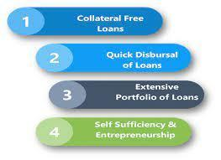
Figure 2: Challenges of microfinance
(Source: Gyimah and Boachie, p. 2)

2.6 Literature Gap
The underlying problem that this particular research has undertaken is the impact of the use of microfinance on the small and medium-sized businesses of the UK. This research will contribute to an understanding of the areas where and how the two variables of this research operate. The problem that the research deals with are the matter of SMEs in the UK and how they are positively influenced by microfinance.
Research gap is a matter that has not been dealt with before and is therefore absent from the available studies or research within the arena of study. The gap fulfilled by this study is the understanding of the impact of microfinance on the small as well as medium-sized businesses of the UK. This study will help ascertain the extent to which such impacts are significant. This study will also assist in analysing the difficulties faced and levels of growth ensured. Although there are many works on microfinance, there is not much work available on its application by UK SMEs, and so is the focus of this research. There is more scope for developing studies with such research.

2.7 Conceptual framework
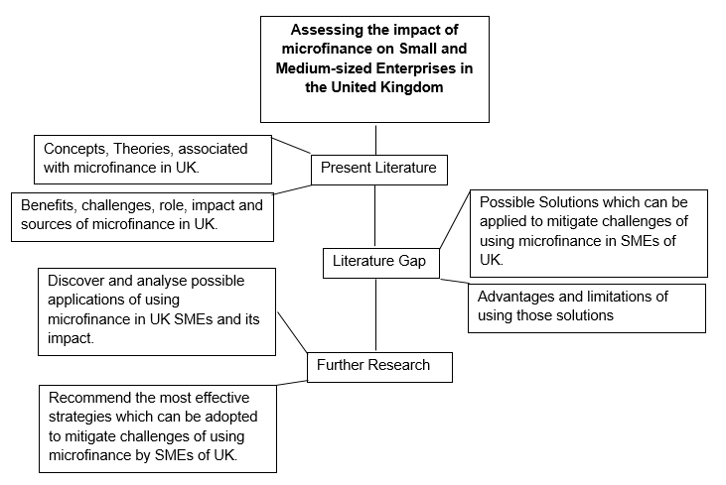
Figure 3: Conceptual Framework
(Source: Developed by the author)

Chapter 3: Methodology

3.1 Introduction
The methodology which will be used for this research is a comprehensive review of the existing scholarly articles and a critical evaluation of the existing literature. The overall scenario of the effect of micro finances on the SMEs of the UK will be analysed. This will help in understanding the growth brought about by microfinance in SMEs in the UK (Brown and Lee, 2019).
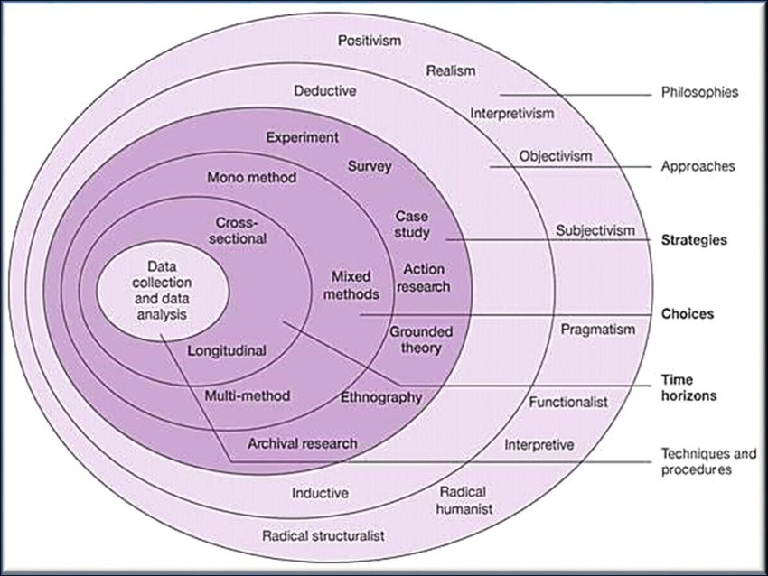
Figure 4: Research Onion
(Source: Snyder, 2019, p. 333)

3.2 Research philosophy
Research philosophy is a belief that the process of data should be gathered, used and analysed. Ontology and epistemology tend to shape research philosophy where ontology presents various knowledge and comprehending. On the other hand, epistemology is defined as the requirement for reliable information to conduct the research. Ontology and epistemology shape research philosophy and research are dependent on these two factors. To first comprehend the principles of ontology, it is necessary to comprehend that the purpose of an ontology is to answer the question of what reality and what shapes reality by is discussing current knowledge. Regardless of the scenario or issue, ontology tends to generate potential solutions. What is reality/knowledge, what influences reality/knowledge, and what is the relationship between each component that melds reality or creates the knowledge provided by ontology? Ontology describes what constitutes reality. There are several beliefs available in ontology, but this study focuses on the three most important ones. The initial objective is to determine whether there is just one reality, one universal truth, or a solution to any problem, often known as the concept of singularity. The second notion examines if there is more than one reality or numerous truths. Although the existence of various realities or truths is independent of the perceiver, perception plays a significant role in shaping reality or truth. The third belief is that one or more realities can exist. In addition, epistemology is described as the process of acquiring knowledge and the notion of reality. It represents the procedures of acquiring or gathering information. Similar to ontology, epistemology has a variety of beliefs, but for the sake of clarity, this study will focus on the three most important ones. The first belief demonstrates that knowledge may be measured using scientific norms and dependable instruments and designs. The second notion is that knowledge is interpretive in nature, and hence researcher must interpret or explain any reality or truth. The third belief is that truth can be measured or that knowledge may be measured and understood simultaneously. In research philosophy, there are three types of research philosophy used: positivism, interpretivism and pragmatism. Positivism research philosophy considers that there is only one belief existing and collects information via trustworthy instruments and designs. Interpretivism philosophy believes in different realities and considers measuring information by interpreting it. Pragmatism considers there can be different realities or one reality which either can be measured or interpreted.
Moreover, for this research interpretivism research philosophy is more suitable while conducting the research. As it will help in unfolding various strategies which can be followed by UK SME to make use of microfinance and further unfold the multiple benefits and limitations of applying those strategies.

3.3 Research Approach
Research approach is plans and procedures which are analysed based on the detailed assumptions of data collection, analysis and interpretation. There are two types of research approach: Inductive and deductive research approach. Deductive research approach means quantitative analysis where researcher build theory then hypotheses then collect data and observe based on that develop hypothesis and confirm the theory. Inductive research is primarily based on qualitative data which starts observing a specific issue or reason and develops a new theory out of the developed patterns. Inductive approach is mainly focused on data observation and collecting reliable data to meet research objectives.
For this research, an inductive research approach is suitable as the data and information would be collected from secondary sources and qualitative data is collected.

3.4 Research strategy
The third layer of the research onion structure consists of research strategies, which define the research conduct processes. Research strategy gives general direction, including techniques that tend to be utilized to do research (Snyder, 2019, p. 333). There are seven primary research philosophies employed in research strategy. Based on previously established concepts, parameters, lab conditions, or construction, experimental research is undertaken to examine the changes in a single variable. The second is a survey conducted by researcher through any survey, questionnaire, or interview directly or indirectly involving respondents. To communicate directly with respondents, researcher typically use semi-structured or open questionnaires when conducting surveys. The next step is a case study in which academics examine contemporary difficulties that mankind or society faces. The majority of a company's problems are management-related, and resolving the case study presents several difficulties. Another type of research is action research, in which researcher actively collect data and information. In a case study, the researcher is merely an observer, however, in action research, the researcher actively participates in the research to collect information and evidence. In action research, it may take time to collect information and data, and researcher may serve as decision-making participants, influencers, or contributors. Finally, grounded theory is a type of qualitative research that may be used for both information gathering and theory development. Like the inductive research method, the grounded theory begins with observation and concludes with theoretical features and collects data through interviews or other means for creating theory. Ethnography is a type of research in which researcher focus on gathering knowledge about different cultures or researching specific characteristics of a society. In these sorts of research, researcher must spend time with the cultural society for an in-depth examination of concepts and differences (Zangirolami-Raimundo et al., 2018, p. 360). In archive research, researcher utilize previously published resources and information to articulate any subject or problem. In this study, researcher typically utilize online publication tools such as journals, papers, and websites.
An archival research strategy would be a more appropriate method for performing this research and drawing conclusions as it will help in drawing patterns towards which alternatives sources of finance can be much more suitable for UK SMEs.

3.5 Research choices
The fourth layer of the research onion is research options, which specify the types of methodologies that will be employed to conduct the study (Al-Ababneh, 2020, p. 75). The success and overall quality of a research study are significantly influenced by the research approach chosen. The three most common sorts of methods are the mono method, the mixed method, and the multi-method. The mono method refers to researcher who are capable of utilizing either qualitative or quantitative methodologies. The mixed method combines qualitative and quantitative approaches. Rarely employ multiple approaches where qualitative and quantitative then quantitative and qualitative processes occur together (Dodds and Hess, 2020, p. 203). This research would employ a mono method since it employs a qualitative research approach.

3.6 Time Horizons
The fifth layer of the research onion determines whether the research has cross-sectional or longitudinal time frames. Whether through questionnaires or the development of a theory, researcher collect data and information only once in cross-sectional processes. In some studies, researcher need longer time to collect information to ensure the accuracy and trustworthiness of their findings. In the longitudinal study, researcher must gather data multiple times and employ numerous investigative techniques Moreover, in longitudinal research methods, researcher must focus on several observations and collect data through observation. As research tends to collect information only once, cross-sectional research would be much more appropriate for this study.

3.7 Data Collection Method
The data gathering method is one of the most significant components of the research methodology section and the onion's core. Considered for research design, this aspect specifies whether data will be collected via interviews or questionnaires. The process of data collecting primarily enables researcher to end the study by resolving pertinent questions. For this research, secondary sources will be used. Secondary data provides access to the most relevant research made on the topic.
Secondary qualitative data such as peer-reviewed articles, journals, companies as is available on various scholarly sites, like Google Scholar, Scopus, EBSCO and other relevant information about the impact of micro finances on the SMEs of the UK will be included to deliver the required data. The time period for which the data shall be collected will be from the year 2019-2022. The research shall focus on data collection in these years only as it will help in maintaining the credibility of solutions and relevance of information provided in the current scenario. As post pandemic the conducting a business has evolved and not the same as it was before pandemic. The world is digitising so shall the UK SMEs have to do in order to capture the targeted market.
As mentioned earlier, the collected data shall comprise annual company reports and information from various sites, therefore the researcher shall aim at conducting a thematic analysis further as it will help in drawing the patterns of results drawn by using microfinance which will thus help the UK SMEs further. The key words chosen for research will be “different sources of financing in UK”, “advantages and disadvantages of particular source of finance” etc.

3.8 Data analysis
Researchers utilize research data analysis to reduce data and evaluate insights gained from the data. Data analysis is the process of reducing a large quantity of data into smaller bits (Abutabenjeh and Jaradat, 2018, p. 237). Content analysis, discourse analysis, narrative analysis, and grounded theory are among the approaches utilized in qualitative research for data analysis. In research methodology, content analysis is a commonly used and often adopted tool for data analysis. This method is mostly employed for analyzing recorded data such as photos, text, and other physical objects. Based on the research questions, this study indicates when and when this strategy should be utilized. Narrative analysis is used to analyze content acquired from a variety of sources, including field observation, surveys, and interviews. The information gathered from participants focuses mostly on achieving study objectives. Similar to story analysis, discourse analysis focuses on analyzing people's interactions. For insightful study findings, discourse analysis focuses mostly on lifestyle and daily surroundings. Finally, a grounded theory explaining a specific phenomenon emerged (Greening, 2019, p. 88). Primarily, grounded theory is employed to examine data regarding similar host cases occurring in various settings. To complete study issues, this analysis must be utilized to modify or provide new explanations. Since secondary data gathering methods are employed in this study, content analysis would be utilized. Since researcher typically study material from secondary sources.

3.9 Limitations of the study
Research and studies will inevitably face some limitations in studying and meeting the research objectives. The expected limitations of this research while it is being conducted are as follows:
a. The research is completely based on secondary data. As a result, research analysis may not be able to be accurate because of the absence of updated data if it is inaccessible.
b. As the chosen topic is not very common and research that has been conducted in the arena is few, there is less information to comprehend the relation between the two and find how the UK SMEs can specifically be benefited with the help of Microfinance.
c. The researcher will not be able to conduct the primary research, as the topic demands analysis of various data available to draw the patterns of best use of microfinance in the UK. However, the primary data would have been much more reliable which thus reflects the limitation of this study.
d. The conducted study has not been done on a particular company, however as the researcher understands the various aspects of microfinance, it would have been better to study one company as a case study on how this company can apply the developed strategies, thus this acts as a limitation of this research.
e. There are several other channels which can be used for financing UK SMEs, however, to maintain the focus of the research, the same has not been considered which acts as a limitation of this study.

3.10 Ethical consideration
Ethical considerations are the methods for establishing research design and practice-guiding concepts. Researcher are obligated to adhere to a code of conduct for data gathering techniques when doing research. The objective is to comprehend real-world events, explore behaviors, discover effective theories, and enhance research outcomes. It is essential to preserve individual data and avoid collecting incorrect information when doing research.

3.11 Timescale

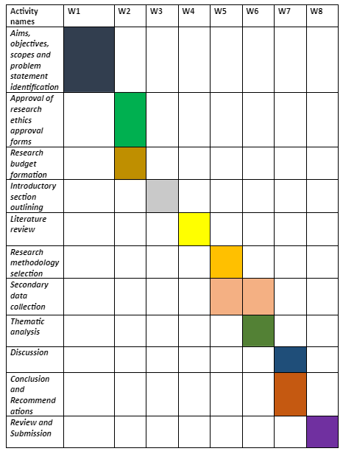
Figure 5: Gantt chart
(Source: Developed by the author)

Chapter 4: Findings and Discussion

Findings

4.1 Role of microfinance in the present economic scenario of the UK
As contradicted by Bateman, (2018, p. 42), Microfinance's brief existence in the 1970s aroused widespread interest from policymakers, firms, academics, and financial institutions worldwide. Microfinance includes a variety of services, such as microcredit, micro-savings, micro remittances, microbanks, money transfers, and microinsurance. By providing essential financial services, information and communications technology are a category of financial services that have the potential to reduce global poverty. Microfinance is seen differently by governments in different nations. In the United Kingdom, microfinance refers to the provision of small amounts of savings, credit, and other financial services to urban, semi-urban, and rural communities to enhance their income and improve their living conditions (Asad et al., 2020, p. 223). Microfinance's purpose in the financial system is to provide financial services and a considerable flow of capital to economically disadvantaged people whom the official financial sector has neglected. The review of microfinance for developing economies demonstrates that individuals who are excluded from conventional financial institutions can access alternate ways to save or borrow, rather than relying on family and friends. In both developed and developing economies, microfinance provides alternatives to conventional financial services and plays a crucial role in promoting the financial inclusion of disadvantaged groups. While functioning as a source of financial services, MFIs frequently face obstacles such as unpredictable revenue sources, unemployment, lack of asset collateral, and limited credit history, as well as moral hazard concerns and adverse selection. Nonetheless, MFI continues to expand with a mandate to support entrepreneurial ventures to build endogenous growth and eliminate poverty in comparison to prevalent techniques such as government-run programs and foreign aid. Offering financial services, assists disadvantaged individuals to remain economically active. Microfinance is regarded as one of the most significant policy developments in the industrialized world (Nautwima and Asa, 2021, p. 12).
Financial inclusion highlights the eradication of poverty and inequality, as well as economic prosperity. Microfinance has been identified as one of the most effective tools for reducing poverty by global organizations. Common MFI social goals include poverty reduction, female empowerment, job creation, economic growth, social inclusion, and social development. In industrialized nations, microfinance can enhance self-employment and foster the growth of small and medium-sized enterprises (SMEs). Due to microfinance, households can extend options, such as income accumulation, and provide financial assistance to family members (Omondi and Jagongo, 2018, p. 24).
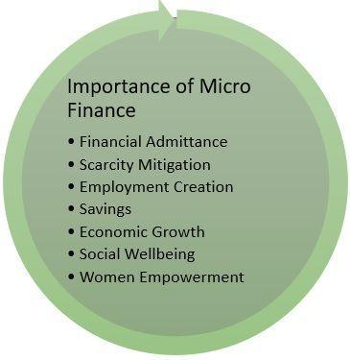
Figure 6: Impact of Microfinance
(Source: Omondi and Jagongo, 2018, p. 24)

4.2 Growing importance of Micro finance for small and medium enterprises
Over the decades the UK economy has had remarkable transformations and in 1980 only 24 million people were employed which has increased to 30 million. Nearly 95.5% of the private sectors are micro firms in the UK (Nautwima and Asa, 2021, p. 12). On the other side, micro-businesses accounted for 32% private employment and 20% private sector turnover. In recent years the contribution of micro business has increased and the growth of business populations driven by micro firms will increase 40% in 2020. The World Bank's MSME portfolio includes US$3.5 billion for active lending with lending projects in 47 countries. Formal SMEs contribute 40% national income (GDP) and it is estimated 600 million jobs will be required by 2030 due to increasing global workforce.
Microfinance companies benefit from people with low incomes and people who don't have much. From rural and urban areas, microlending can give out between 50,000 and 150,000 loans. The main goal of microfinance companies is to make it easier for people with low incomes to get credit. In the UK, there are many loans that help small and medium-sized businesses (SMEs) and entrepreneurs grow their businesses. Small businesses usually borrow between £500 and £25,000, and the interest rate is fixed at 6%. These loans also come with free support and a mentor for the business owner after the loan is paid off. Small and medium-sized businesses (SMEs) that want to grow can get loans from the Coventry and Warwickshire Reinvestment Trust (CWRT), the Business Enterprise Fund (BEF), and the Southwest Investment Group (SWIG). CWRT also tends to offer small and medium-sized businesses in Warwickshire Small Business Loans. During the Covid-19 crisis, the British Business Bank created a new programme called the Bounce Back Loan to help small and medium-sized businesses grow in the current market. The Coronavirus Business Interruption Loan Scheme gives £5 million in term loans, invoice finance, overdrafts, and asset finance to SMEs with sales of less than £45 million (CBILS). This business plan tends to help businesses get through tough times (Aladejebi, 2019, p. 261).
Small and medium-sized businesses (SMEs) needed more help to reach their goals and deal with all the challenges in the business world. During the Covid pandemic, 30% of businesses closed, and the number of people without jobs went up. Small business resources tend to group together for different entrepreneurs, but microenterprises need different kinds to support innovation. It is necessary for SME owners to grow and meet their customers' specific needs. For reducing poverty, getting more people jobs is important for a stable economy. Due to the high risk of default, microfinancing misses the mark. Microfinance is an important and powerful tool that helps small businesses and entrepreneurs grow their businesses in the current market. Microfinancing is seen as a long-term way for the owners of SMEs to break the cycle of poverty for their children and grandchildren. Small and medium-sized businesses can talk to lenders directly about their financial needs. the processes that take a lot of time and where business owners can run into urgent needs that might not be met. The UK National Audit Office said that the government could lose anywhere from £15 billion to £26 billion. The loss means that there are less funds available for small and medium-sized businesses that really needed them (Omondi and Jagongo, 2018, p. 24).
Small and medium-sized businesses are hurt a lot by the uncertain spread of Covid-19, which affects their cash flow in a big way. Most of the time, microfinance helps women who are able to get out of poverty and can take out small loans of $60. Women from Paraguay, for example, take out small loans for $60 to start an empanada and snack stand. By getting loans, you can help the women grow their businesses and pay back the loans. After that, they were able to take out a bigger loan to build their own businesses with equipment like refrigerators and homes that are attached. In 2019, there is evidence that 65% of borrowers are from rural areas (Tasha et al., 2018, p. 97).

4.3 Alternatives of microfinance for SMEs in the UK
In the UK economy, small and medium-sized businesses, which include informal businesses and provide 90% of jobs, are responsible for 33% of GDP in South Asia and Africa. SMEs usually serve customers in poorer urban areas and rural areas that don't have the infrastructure for big businesses or government work (Gakpo et al., 2021, p. 28). Getting money for growth is one of the hardest things to do. Commercial banks tend to focus on big business deals, so SMEs often have to deal with high-risk and expensive services to meet their different financial needs. Microfinance can be replaced by Business Lines of Credit, Merchant Cash Advances, Working Capital Loans, Equipment Loans, and many other types of loans. Bank loans are a common way for small and medium-sized businesses to get money for their projects. Large business loans from banks are hard to come by for small businesses. Businesses often need alternative financing from reputable lenders, but most small and medium-sized enterprises (SMEs) rely on banking services because they are a safe way to get financing. Small and medium-sized businesses (SMEs) don't have to get loans from banks alone.

4.4 Solutions that can be used to mitigate the challenges of using microfinance in UK SMEs
When starting a business, it's important to put money into the things you need, whether that's getting cash or buying assets. This tends to show that bankers and investors are willing to stick with projects for a long time and are willing to take risks. Venture capitalists often have stakes in companies that don't take on high-risk, but potentially profitable, projects. Most of the time, this means giving third-party ownership or equity in the business. When a business starts selling shares to the public, venture capitalists often invest in healthy returns. For future financing decisions, a business can adapt to changes in the economy. Taking on too much debt can force you to use equity financing when the equity market isn't very good. There aren't any good choices, no matter what the situation is. Companies may need to borrow more money at a very high-interest rate, which means there will be more demand for lenders. Too much equity tends to make similar problems worse, while companies want to run in more than one way. For loans between £50 and £15,000, you must give detailed information to get a good offer (Sani et al., 2018, p. 756). After the application and terms have been approved, offers are made based on the applicant's current financial situation. If a borrower misses a payment date or pays late, it can hurt their credit history and cause their payment limits to go up.
Compared to commercial loans, microloans are not enough because they tend to bring a lot of problems and problems. SME owners need to take out loans so they can invest in their businesses and set clear goals. Agents would be more efficient and reach more customers if they didn't have to talk to branches. In the 21st century, it's enough for borrowers to keep track of and update the small amounts they need to pay back. Modern, high-tech digital tools tend to remind borrowers when their payments are due, so they don't miss any date. Since missing a payment deadline can hurt your banking history and cause problems in the future. Agents tend to work more effectively and reach out to more customers. According to the International Finance Corporation, the cost of doing business with agents is 25% less than with branches (Sussan and Obamuyi, 2018, p. 51). When consulting with agents, you can find out about new risks, operational risks, and other things you need to know to move toward agent banking. It is thought that many microfinance organizations still use paper records, which may be useful but take a lot of time. Using today's advanced technology can be helpful, but it can also lead to a lot of fights. MFI needs to put collecting data as a top priority when it comes to data management systems. It would be helpful to deal with structural data and find digital ways to collect data that are quick and accurate.
Short payback means that an investment will be paid back in a short amount of time. The minimum interest rate and amount to pay each month is thought to be a long payback period. Long periods can give inventors time to reach the point where they start making money. Longer payback periods can be less desirable than investments with shorter payback periods (Onyeiwu and Abayomi, 2020, p. 2). For SME businesses, it can take a while to reach the point where they break even. If the payback period is short, the owners of SMEs have to pay back, which slows down the time they can invest. The longer the money is tied down, the fewer chances it will give the company. Most SMEs and entrepreneurs have trouble getting enough money and keeping it coming in. In case the economy goes down, it is important to look at the business sector and industry. If the assessment shows sectors that aren't affected by a recession, it tends to be bad, but it gives people time to be creative. By keeping track of cash flow and separating profit margins, a business is more likely to do well. But it can be hard for business owners who don't know what the future holds for their business. Reviewing and changing your product lines can lead to success and help you save money on overhead costs, staff, and other extra costs (Onyeiwu et al., 2021, p. 4).
When payback lengths change often, it puts pressure on and challenges the owners of SMEs. A better investment is one with a shorter payback time. Investing is often one of the most important things for the owners of SMEs. When interest rates and inflation are high, business owners tend to think twice about investing, and getting their money back can take a long time. The period doesn't take into account what happens after payback, and it tends to ignore the overall profits of an investment. For example, if you invest $1 million and expect to get $250,000 each year, you are taking a risk (OKAFOR, 2020, p. 3). To get this kind of profit margin, you have to put money into it for four years, and the frequent paybacks cause problems.
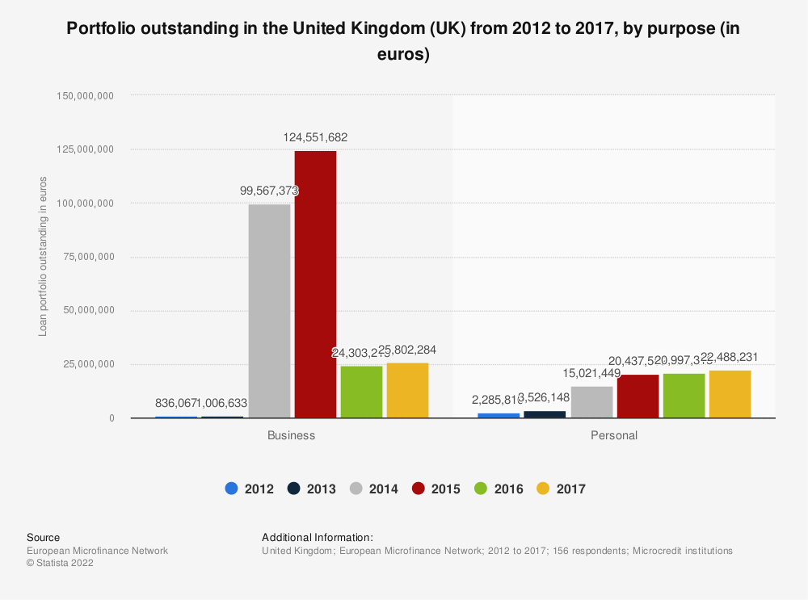
Figure 7: Impact of microfinance in SMEs
(Source: Khan et al., 2019, p. 125)

4.5 Advantages and limitations of applying the solutions by UK SMEs
In recent years, microfinance has become one of the advantageous factors that also serves as an essential resource for establishing businesses. In the British Isles Small- to medium-sized business owners or entrepreneurs with no collateral can obtain up to $50,000 in loans, which encourages them to launch a firm. In 2018, microfinance organizations served 139.9 million borrowers, a significant increase from 2017 (Khan et al., 2019, p. 125). Microfinance can break down barriers and assist rural and urban residents in maintaining a steady income flow.
Supporting MFI to ensuring low-income or rural individuals have access to credit and a stable economy. MFI struggled to obtain commercial capital to deliver it to borrowers. As a covid-19 alleviation and recovery reaction, the program has increased microfinance help during any challenging situation. Most micro and small- and medium-sized firms benefit women by providing them with greater financial options that can improve their standard of living and income. Microfinance Institutes empower women entrepreneurs with long-term loans to boost the economy. Microfinance services assist rural women in attaining financial independence and empowering them to make sound choices. Nearly 45 percent of the rural population lacks access to credit from commercial banking institutions, particularly women with stable financial connections. On the other hand, MFI grants women access to all types of financing for launching a business. By presenting the proper documentation, having no criminal background, and having a favorable banking history, women can gain access to and borrow loans. Therefore, microfinance institutes in the United Kingdom provide microcredit to rural households, with 121,000 women as their major focus for boosting their literacy and financial planning skills (Ahmed, 2020, p. 45).
Small enterprises in small towns required financial sources for maintaining operations, expanding their firms, and investing in various modern technologies. 60 percent of the population resides in rural and secondary urban areas, where small companies and agricultural livelihoods create employment opportunities to increase income. People banks often provide microfinance services for the development of enterprises in rural areas. Natural resources contribute 20% of the country's gross domestic product, while exports account for 80% of the country's income. However, SMEs are responsible for 90% of employment creation and business registration (Chege and Wang, 2020, p. 256). Supporting efforts to construct a stable economy, more financial aid eventually generates business growth opportunities and an increase in new job positions. According to research, the availability of microfinance has the potential to benefit businesses and people's livelihoods.
The basic purpose of microfinance concepts is financial inclusion for impoverished and disadvantaged groups. Access to microfinance has helped women achieve financial independence and boosted the number of female entrepreneurs. According to studies, there are now 145,200 women who own their businesses, up to 56,200 in 2018 (Eldridge et al., 2021, p. 105). However, there are several restrictions on MFI loan borrowing that are outlined below.
The Microfinance sector deals with marginalized sections for improving the living standard of rural area people and over-indebtedness is one of the biggest challenges. In the lack of legitimate functioning protocols and compliance, microfinance employs a stringent repayment strategy. Thus, many SME owners do not borrow it the following time around. As microfinance companies have to follow strict compliances therefore often manipulate customers to repay unethically which is not sufficient and damages the image. Microfinance companies provide small amounts of loans and do not even ask borrowers the amount they need to start the businesses. Since the bank does not ask for collateral for credits and large loan disbursement can be impossible. For instance, if an entrepreneur requires a huge amount of loan to purchase equipment and invest in a business. This is one of the reasons that create challenges for entrepreneurs to operate their business operation seamlessly. Another limitation of applying Microfinance in SMEs is that companies are unable to render low-interest loans. Microfinance follows different aspects and does not follow traditional banks' footprint where the accumulation of funds is easy. Along with that, it becomes easier for SME business owners to borrow money from these banks to execute appropriate and maintain risk management. It has been estimated that MFI operation cost is high compared to a high volume of transactions for each day. Investment valuation is one of the important capabilities for the seamless functions of MFI. The current developing nature of MFIs in the market often has limited activity. Therefore, it has become difficult for MFI to increase access to market data for valuation purposes. It is difficult for MFI management teams to accomplish a high level of quality information due to a lack of consistency and reliable valuation procedures which might be required for making investment decisions. Lack of adequate knowledge is one of the significant factors that help rural populations to access MFI easy credit to reach financial requirements (Pervin et al., 2020, p. 1465).

Discussion
Understanding Microfinance and how it helps small and medium-sized entrepreneurs start new firms and achieve financial independence was the major objective of this study. Instead of turning to payday lenders or taking out enormous loans, microfinance tends to help entrepreneurs flourish financially. The major objective of this study was to determine the impact of microfinance on UK SMEs. This study established research objectives to preserve research efficacy. The primary purpose of this study is to determine the function of microfinance by examining the current state of the British economy. In the first theme of the findings section, the first objective was explored. Before conducting in-depth research and gathering data, it is essential to establish a foundational understanding of microfinance. Microfinance provides numerous services, including microwaving, microcredit, money transfers, and microinsurance, according to studies. The facilities, policies, and procedures of microfinance services differ from those of government banking services. Microfinance provides alternatives to conventional financial services for SME owners and is seen as an essential source of financial support for rural and urban residents. Due to the unpredictability of revenue sources, lack of collateral assets, unemployment, and low credit history, MFI frequently faces several obstacles. MFI has a reputation for assisting entrepreneurs and SME owners in expanding their businesses while eliminating poverty (Khan, 2020, p. 115).
The second purpose of this study was to investigate the impact and significance of microfinance among UK SMEs. The second theme of the findings section focuses on the increasing significance of microfinance in small and medium-sized businesses. In the United Kingdom, microfinance firms receive benefits from small and medium-sized enterprises (SMEs) since it aids in business expansion and loan repayment at a fixed interest rate. SME owners require assistance to overcome any obstacles and achieve commercial success. Microfinance not only helps small and medium-sized businesses or entrepreneurs expand their businesses, but they also eliminate poverty and unemployment. During covid-19, the majority of start-up firm owners must close due to the financial crisis. During this period, microfinance aided entrepreneurs financially and became one of the most effective tools for expanding and running a firm efficiently. Accessibility to microfinance has primarily benefited rural and urban residents, with 65 percent of borrowers residing in rural areas (Khan et al., 2019, p. 125)
The third issue in the findings section addressed the availability of alternatives for SMEs in the United Kingdom. As banks supply enormous sums of loans, it is quite difficult for SMBs to obtain commercial loans. For entrepreneurs to launch a business, a limited quantity of loans is sufficient. To minimize disagreements and pressure, the majority of entrepreneurs prefer to borrow small sums of money. SMEs (Small and medium-sized firms) who use microfinance services to obtain loans are more capable.
In the fourth theme of the section on findings, the solutions to microfinance difficulties faced by UK SME owners are discussed. For beginning a firm, entrepreneurs typically invest capital to generate sufficient profit. Moreover, business endeavours frequently lack sufficient capital and prefer to obtain loans. Due to stringent rules and restrictions in commercial banks, it is challenging for SME owners to obtain loans. Taking on excessive debt tends to necessitate the use of equity financing, which is ineffective. For large projects, businesses may be required to borrow money at a high rate of interest, which defines the need for lenders. While business owners desire a fluid business operation, an excessive amount of equity tends to create difficulties. It has been determined that when applying for microfinance, SMEs frequently face several obstacles. Agents can be consulted by SME owners instead of banks for precise information. Since Agents are more customer-friendly to address all questions and concerns. SME owners are now better able to track financial transactions with the use of modern digital technology. To prevent late payments or penalties, modern high-tech gadgets serve as a reminder of the payment deadline. In microfinance institutions, skipping a due date frequently creates complications in which borrowers may be required to pay additional fees. MFIs offer short-term loans with high-interest rates, which generates problems for SME proprietors. Instead, the MFI must provide a lengthy amount of time that allows the borrower to reach the point of breaking even (Ghak and Zarrouk, 2022, p. 311).
The third objective of this research is associated with the benefits and challenges of microfinance for SMEs in the UK. This has been in the fifth theme of finding sections where it has been discussed about the advantages and limitations of accessing microfinance solutions by SMEs in the UK. In a few years microfinance has become one of the important services which encourage borrowers to take loans for starting or investing in businesses. The sixth theme of this research examines how utilizing MFI benefits rural residents. It has been analyzing Microfinance tends to influence women to become financially independent and empowered with stable income sources. Within that, it also increases financial planning skills and literacy for women to gain knowledge about finances and arrange the business. The MFIs tend to increase rural areas and agricultural people to increase livelihood standards.
Meanwhile, it has also been addressed that using MFIs brings limitations such as limited borrowing amounts, high-interest rates, and other challenges. MFIs need to follow strict compliance and often try to manipulate customers for unethical repayment. In MFIs the amounts provided for borrowing are limited which has created conflicts for SME owners. As it has been addressed starting or investing in business entrepreneurs might require huge amounts instead of providing limited amounts MFIs can allow SME owners to choose the most preferable amounts. Since Microfinance does not follow traditional banking services processes, borrowing money is easy for SME owners. However, the operation cost of high-volume transactions is high. MFIs have limited activity and it has become difficult to access market data with the purpose of valuation. However, due to a lack of consistency and reliable valuation processes, it is difficult for MFI to accomplish high-level quality information (Al-Naimi, 2021, p. 5111).

Chapter 5: Conclusion and recommendation

5.1 Conclusion
The above study concludes by stating the concepts associated with microfinance in the UK economy, further it also shares the significance of it for UK SMEs. The study also discussed the benefits and challenges of using microfinance for business and the sources which can help these businesses to use microfinance services. Post which in the discussion section the study represented the role of it in the UK economy and how it can be used.
Microfinance usually gives business owners access to financial services that help them grow their businesses. Research has shown that microfinance is now the main source of financial help that leads to ethical lending practices. Due to strict documentation requirements and the need to have a good banking history, it can be hard for the owners of SMEs to get loans from commercial banks. People in both rural and urban areas can get small loans from microfinance institutions. Small and medium-sized businesses (SMEs) could use the money to invest, save, or buy insurance. This would help them save, make, and grow their businesses. The main goal of this study was to find out how microfinance affects SMEs. Most rural and urban people can start new businesses because of microfinance. In the last two years, the number of people who own SMEs has grown by 37%. This is because it encourages women and other people to start their businesses. Accessing Microfinance institutions has been looked at and found to have both benefits and challenges for SMEs. With the help of microfinance, it is not only possible to grow the economy, but also to improve the quality of life. Microfinance has caused more women to start their businesses because it helps them become financially independent and boosts the economy (Adhariani, 2022, p. 366).

5.2 Linking with objectives
This study aimed to examine the impact of microfinance on small and medium-sized enterprises (SMEs) in the United Kingdom. Taking into account research aims, the first objective is to discuss the function of microfinance in the current economic climate of the United Kingdom. Before conducting an in-depth study and gathering data on microfinance and its influence on SMEs. It is essential to comprehend microfinance's contribution to the British economy. Under the first category of the literature review, the notion of Microfinance is discussed. Microfinance and its implementation processes are defined in the first heading. This information's summary helps to continue the investigation.
The second purpose of this study is to examine the impact and significance of microfinance on SMBs in the United Kingdom. The second section of the literature defines the relevance and impact. According to the research, microfinance might increase income while highlighting the vulnerability of the individuals. Due to a lack of financial stability, poverty, and unemployment plague most nations. In addition, microfinance tends to encourage economic stability and business expansion. Microfinance is one of the most important concepts for SME productivity enhancement and financial support. MFI has enabled someone with an unknown past to compete with others. Microfinance has become one of the most effective long-term tools for combating poverty over time.
The third objective of this research is benefits and challenges associated with microfinance in UK SMEs. There is no doubt that Microfinance has brought several benefits for SMEs and start-up owners to build a business with a stable economy. Microfinance loans are easy to access as the borrower does not need to have a strong banking presence or credit history. For first-time borrowers Microfinance is very useful by providing the necessary documents to get access to the loan. However, it is also acknowledged that microloans may not be sufficient, and more funds may be necessary.

5.3 Recommendation
Consultations and supervision by the financial institution towards the SME units to ensure effective utilization of investment- The most common challenge faced by SME organizations is not due to the inability to acquire funds but to invest those funds to make strategic improvements in business and attain growth. The financial institute offers several microfinance products to SMEs but at the same time is also concerned about the recovery and revenue generated with the help of allotted funds to SMEs (Dewick, et al., 2020 p.1195). The increasing indulging of a financial institution in the business operations of SMEs will be beneficial for organizations and provide consultations and guidance to the SMEs for making efficient use of funds, and investing in profitable ventures, that will not only benefit the business enterprise but this will be beneficial for banks offering guidance, consultations, and micro-financing products, as they would be able the recover invested the amounts and get interested from the investments in SMEs.
Improvements in financial planning viability in small and medium-scale enterprises in the UK- another significant factor that increases the challenges for both banks and business organizations is due to ineffective planning and managerial tactics to manage the financial viability and stability of the organization. The root cause of several problems and challenges arises due to ineffective planning and using different managerial tools to improve the financial viability of the organization (Dominic, et al., 2022 p.832). Starting an SME with an effective business idea is not sufficient until that is not supported by strategic planning. SME owners and managers but be specific and oriented toward the procurement, investment, and cost structure of the organization. Microfinancing seems to be convenient for small and medium-scale organizations, but an effective planning process will increase the possibility to utilize those funds constructively and that leads to saving the interest of both banking and SME business organizations. Increasing efforts for beneficial strategic planning for maintaining financial stability and increasing the revenue generation capacity of the organization will lead to the overall cultural adoption of sound planning procedures to manage funds and the profitability of the organization.
Increasing focus on the revenue stream and structure of the SME organizations- generating revenue is the only source that can benefit the management to maintain its stability and profitability. The concern about the challenges and issues faced while microfinancing small and medium-scale business organizations can be solved by proper implementations of tactics to increase revenue generation capacity (Hock, et al., 2021 p.691). Management of the organization must be focused on the revenue stream and include all the efforts in terms of marketing implementation, advertisement, promotion, and effective human resource management to increase the revenue stream and it must be decided in advance. What would be the beneficial ways and strategies to increase the revenue, and how would overall operational and other costs be reduced to increase the margin of profit? Answering these questions will be helpful to increase the financial stability of the organization and more institutions will be willing to provide finance for that business organization. Stability and consistency must be focused on by the management of SME organization rather than taking infrequent and premature steps which impact the profitability and sustainability of the business organization and also impacts the revenue structure of financial institutions.
Microfinance institutions to which the majority of SMBs have access. Bank advances and credit enhancements are still regarded as sources of external finance for small and medium-sized enterprises. Short- and long-term financing options for small and medium-sized enterprises (SME) borrowers have been modified drastically by the increased affectability of external shocks. It has been determined through study that SME owners prefer MFIs since credit quantities are readily accessible. It is proposed, therefore, to boost the capital efficiency of MFIs and affect the financial performance of SMEs. Frequently, microfinance agents influence borrowers to pay more fees in an unethical manner. Therefore, micro-credit services must develop strong partnerships with one another. As a result, it entails an expansion of microcredit services along with financial change (Chege and Wang, 2020, p. 256). The MFI can approve; however it may take some time for the funds to be deposited into the borrower's bank account. Commercial banking services give instantaneous loans. In emergency cases, waiting for one or two days can result in a confrontation. Since the MFI does not wish to wait two days for repayment, it is also recommended that the MFI provide the loan amount quickly.
Having extensive knowledge of MFIs-Knowledge of finance processes would enable SME owners to assume responsibility, make strategic decisions, assume risks, and learn from their successes and failures. Increasing business productivity and training has a positive effect on the work efficiency of businesses. Knowledge of the micro-level will stimulate economic expansion. While acquiring loans from MFI owners, gather pertinent data for improving the performance of small and medium-sized enterprises. A comprehensive understanding of MFI would provide information regarding the external and internal business settings. Additionally, it helps improve performance and boost productivity by minimizing risk factors. In addition, possessing financial understanding would enable SME owners to avoid making unethical extra payments.
Facilitating business growth, one of the primary responsibilities of microfinance is to offer blueprints for company expansion and agents to expand the operating footprint of traditional strongholds to small and medium-sized enterprises (SMEs).
Small- and medium-sized enterprises tend to increase the number of access points to undiscovered markets and become formidable competitors. Group of individuals who share a common interest and can assist with microfinance credit facilities. There are numerous opportunities for distributions to be shared and shouldered by other groups (Worokinasih and Potipiroon, 2019, p. 28). Microfinance finds it simpler to collect loans that result in subsequent borrowing. SMEs have the propensity to invest in productivity and profit procedures.
Improved credibility, the cooperative nature of microfinance aids small and medium-sized enterprises that have the propensity to foster borrower trust. Small- and medium-sized enterprise (SME) owners prefer microfinance organizations to commercial banks when seeking financing. Microfinance can provide personalized financial services that also meet the needs of SMBs and the kind of business, according to a study. It has classified MFIs that invest in enhancing procedures and decreasing cost-effectiveness. Cost leadership has a favorable effect on operating microfinance institutions, which has a positive effect on their performance.

5.4 Future scope
The primary objective of this study was to define the impact of microfinance on UK SMEs. The future scope of this research topic can be to demonstrate the application and solutions for overcoming the obstacles encountered by SMEs while using other sources of finance suggested above. While obtaining loans, SMEs frequently face several obstacles due to a lack of pertinent information. In addition, future research can likely be to concentrate on SME owner-applicable microfinance service models and increase their information further on it.

References:
Adhariani, D., 2022. Microfinance and the role of accounting in supporting family-resilience-based women's empowerment. The Qualitative Report, 27(2), pp.366-384.
Ahmed, B., 2020. The Impact of Small and Medium Enterprises (SMEs) on Economic Growth and Job Creation in Somalia. Journal of Economic Policy Research, 8(1), pp.45-56.
Akingunola, R.O., Olowofela, E.O. and Yunusa, L., 2018. Impact of microfinance banks on micro and small enterprises in Ogun State, Nigeria. Binus Business Review, 9(2), pp.163-169.
Aladejebi, O., 2019. The impact of microfinance banks on the growth of small and medium enterprises in Lagos Metropolis. European Journal of Sustainable Development, 8(3), pp.261-261.
Al-Naimi, A.A., 2021. The role of Jordanian financial institutions’ in supporting entrepreneurial success and cope up the challenges. Turkish Journal of Computer and Mathematics Education (TURCOMAT), 12(11), pp.5111-5119.
Asad, A., Hameed, W.U., Irfan, M., Jiang, J. and Naveed, R.T., 2020. The Contribution of Microfinance Institutes in Women-Empowerment and role of Vulnerability. Rev. Argent. Clín. Psicol, pp.223-238.
Bateman, M., 2018. Impacts of the microcredit model: Does theory reflect actual practice?. In The Rise and Fall of Global Microcredit (pp. 42-68). Routledge.
Belhadi, A., Sha’ri, Y.B.M., Touriki, F.E. and El Fezazi, S., 2018. Lean production in SMEs: literature review and reflection on future challenges. Journal of Industrial and Production Engineering, 35(6), pp.368-382.
Briones, D.D., 2020. Development Model for High Potential Leaders Based on Personal Values and Emotional Intelligence of Officers in CARD MRI Microfinance in the Philippines. Review of Integrative Business and Economics Research, 9, pp.88-100.
Chege, S.M. and Wang, D., 2020. Information technology innovation and its impact on job creation by SMEs in developing countries: an analysis of the literature review. Technology Analysis & Strategic Management, 32(3), pp.256-271.
Chege, S.M. and Wang, D., 2020. Information technology innovation and its impact on job creation by SMEs in developing countries: an analysis of the literature review. Technology Analysis & Strategic Management, 32(3), pp.256-271.
Chikwira, C., Vengesai, E. and Mandude, P., 2022. The impact of microfinance institutions on poverty alleviation. Journal of Risk and Financial Management, 15(9), p.393.
Dahal, M. and Fiala, N., 2020. What do we know about the impact of microfinance? The problems of statistical power and precision. World Development, 128, p.104773.
Dewick, P., Bengtsson, M., Cohen, M.J., Sarkis, J. and Schröder, P., 2020. Circular economy finance: Clear winner or risky proposition? Journal of industrial Ecology, 24(6), pp.1192-1200.
Dominic, O.B., Atianashie, M. and Adaobi, C.C., 2022. Financial Management Practices among Small and Medium Scale Enterprises in the Sunyani Municipality: Financial Management Practices among Small and Medium Scale Enterprises. Scholars Journal of Science and Technology, 3(4), pp.828-840.
Eggers, F., 2020. Masters of disasters? Challenges and opportunities for SMEs in times of crisis. Journal of Business Research, 116, pp.199-208.
Ekwueme, W.C., 2020. Small and Medium Enterprises Awareness of Alternative Microfinancing: A Qualitative Case Study. Doctoral dissertation, University of Phoenix.
Eldridge, D., Nisar, T.M. and Torchia, M., 2021. What impact does equity crowdfunding have on SME innovation and growth? An empirical study. Small Business Economics, 56(1), pp.105-120.
Farghly, B., Saleh, A., Youssef, A. and Bary, A.A., 2018. The impact of microfinance on sustainable growth of micro, small and medium enterprises (msmes)-An empirical study on Egypt. The Business & Management Review, 9(4), pp.420-430.
Félix, E.G.S. and Belo, T.F., 2019. The impact of microcredit on poverty reduction in eleven developing countries in south-east Asia. Journal of Multinational Financial Management, 52, p.100590.
Gakpo, M.D.Y., Wujangi, M., Kwakye, M. and Asante, V.G., 2021. THE IMPACT OF MICROFINANCING ON POVERTY ALLEVIATION AND SMALL BUSINESSES IN GHANA. The International Journal of Social Sciences and Humanity Studies, 13(1), pp.1-28.
Ghak, T.E. and Zarrouk, H., 2022. Opportunities and Challenges Facing SMEs’ Access to Financing in the UAE: An Analytical Study. Contemporary Research in Accounting and Finance, pp.311-328.
Grimpe, B., 2019. Attending to the importance of context: Trust as a process in global microfinance. Journal of Trust Research, 9(1), pp.87-109.
Gyimah, P. and Boachie, W.K., 2018. Effect of microfinance products on small business growth: Emerging economy perspective. Journal of Entrepreneurship and Business Innovation, 5(1), pp.59-71.
Hock-Doepgen, M., Clauss, T., Kraus, S. and Cheng, C.F., 2021. Knowledge management capabilities and organizational risk-taking for business model innovation in SMEs. Journal of Business Research, 130, pp.683-697.
Islam, S., 2021. EXTERNAL SOURCES OF FUND OF MICROFINANCE INSTITUTIONS (MFI) IN BANGLADESH: DO INSTITUTIONAL CHARACTERISTICS MATTER? Indian Journal of Finance and Banking, 7(1), pp.13-30.
Khan, A., Inayat, D. and Kiran, S., 2019. The Role of Microfinance in the Development of Small and Medium Enterprises (SMEs). Journal of Business & Tourism, 5(2), pp.125-145.
Khan, B., 2020. Microfinance banks and its impacts on small and medium scale enterprises in Nigeria. World Scientific News, 141, pp.115-131.
Mia, M.A., 2022. Commercialization in Microfinance: Concepts, Definitions and Features. In Social Purpose, Commercialization, and Innovations in Microfinance (pp. 47-68). Springer, Singapore.
Nautwima, J.P. and Asa, A.R., 2021. The Impact of Microfinance Support on the Development of Manufacturing SMEs Operating in Windhoek-Namibia. Archives of Business Research, 9(12).
OKAFOR, C.O., 2020. Microfinance Banks and Performance of Small and Medium Scale Enterprises in Nigeria. Journal of Applied Economic Sciences, 15(3).
Omondi, R.I. and Jagongo, A., 2018. Microfinance services and financial performance of small and medium enterprises of youth SMEs in Kisumu County, Kenya. International academic journal of economics and finance, 3(1), pp.24-43.
Onyeiwu Ph D, C., Muoneke, O.B. and Abayomi, A.M., 2021. Effects of Microfinance Bank Credit on Small and Medium Scale Businesses: Evidence from Alimosho LGA, Lagos State. The Journal of Entrepreneurial Finance, 22(2), p.4.
Pervin, M.T., Sarker, B.K. and Begum, R., 2020. Challenges and benefits of SMEs in Bangladesh to adopt open innovation: a quantitative study. GSJ, 8(4), pp.1465-1477.
Sani, H., Nohd-Khan, S.J. and Zamzuri Noor, M.S., 2018. Microfinance training and the number of loans received by SMEs. An empirical evidence from emerging economy. Business and Economic Horizons (BEH), 14(1232-2019-756), pp.326-341.
Sunitha, B.K., Aggarwal, A., Keerthi, M. and Kedia, S., 2019. Microfinance and women empowerment in India. International Journal of Creative and Innovative Research in All Studies, 2(5), pp.94-99.
Sussan, M.U. and Obamuyi, T., 2018. The impact of microfinance bank on entrepreneurship development in Nigeria. Journal of Business and Economic Development, 3(2), pp.51-61.
Tanima, F.A., Brown, J., Wright, J. and Mackie, V., 2021. Taking critical dialogic accountability into the field: Engaging contestation around microfinance and women’s empowerment. Critical Perspectives on Accounting, p.102383.
Tasha, N., Vardari, L. and Arapi, D., 2018. The Impact of Microfinance Institutions (MFI) on Small and Medium Enterprises (SME) in Kosovo. International Journal of Social and Humanities Sciences, 2(2), pp.97-104.
TORIOLA, A., 2021. MICRO-FINANCING AND PERFORMANCE OF SMALL AND MEDIUM SCALE ENTERPRISES IN NIGERIA LATEEF ABIODUN SALAMI PhD. EDITORIAL BOARD, p.102.
Upravitelev, A.A., 2022. Bounded Rationality of Decision-Making by Online Microfinance Organizations´ Consumers. Finansovyj žhurnal—Financial Journal, (4), pp.134-147.
Worokinasih, S. and Potipiroon, W., 2019. Microfinance repayment performance of SMEs in Indonesia: Examining the roles of social capital and loan credit terms. The Journal of Behavioral Science, 14(1), pp.28-45.
Yusufu, O.S., Suleiman, O. and Saliu, H.T., 2020. Effect of micro finance bank on the growth of Small and Medium Enterprises in Nigeria. KIU Interdisciplinary Journal of Humanities and Social Sciences, 1(2), pp.127-142.
ZEB, N., JALAL, R.N.U.D., FAYYAZ, U.E. and ZAHEER, M.A., 2021. Micro Finance and Economic Development: The Role of Microfinance Institutions Outreach in Pakistan. The Journal of Asian Finance, Economics and Business, 8(5), pp.117-126.
Zhong, X. and Zhou, S., 2020. Risk analysis method of bank microfinance based on multiple genetic artificial neural networks. Neural Computing and Applications, 32(10), pp.5367-5377.

Appendices
Appendix 1
Concepts of microfinance
Appendix 2
Challenges of microfinance
Appendix 3
Conceptual Framework
Appendix 4
Research Onion
Appendix 5
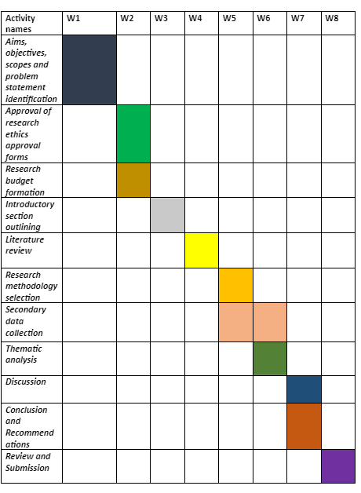
Appendix 6
Impact of Microfinance
Appendix 7
Impact of microfinance in SMEs

