Hotel Administration and Front Office Operations
BMIH4004
Assignment 3
Portfolio – 4 elements

Student Name : Jozef Kotlar
Student ID : 2207347
Lecturer Name : Natalie Brailsford

Table of Contents
Introduction 3
Element 1- Pre-arrival Stage 4
Element 2- Arrival 5
Element 3- Duration of Stay 6
Element 4- Departure 7
Conclusion 8
References 9

Introduction
The hotel guest cycle includes the stages or phases that a guest experiences while staying in a hotel. There are main four stages including the Pre-arrival stage, Arrival stage, the Duration of stay and the Departure stage. Each stage has some key elements or features that are required by the hotel management to provide an excellent guest experience. The key elements of each stage and their real industry examples are described (Zarezadeh et al., 2022).

Element 1- Pre-arrival Stage
The pre-arrival stage starts when a guest considers a booking at the hotel. This stage includes pre-arrival research, and decision-making and extends up to the physical arrival of the guest at the hotel. The key elements of the pre-arrival stage are:
Reservation management: The reservation system must be handled efficiently to provide the guests with a seamless booking experience. For this, utilizing modern reservation tools and technology such as online booking systems or physical booths is crucial to ensure a reliable reservation management system (Buehring, 2019).
Communication: This includes sending necessary information to the customer such as check-in time, and contact details and addressing a personal request of preferences regarding the rooms or other services (Lee ET AL., 2019).
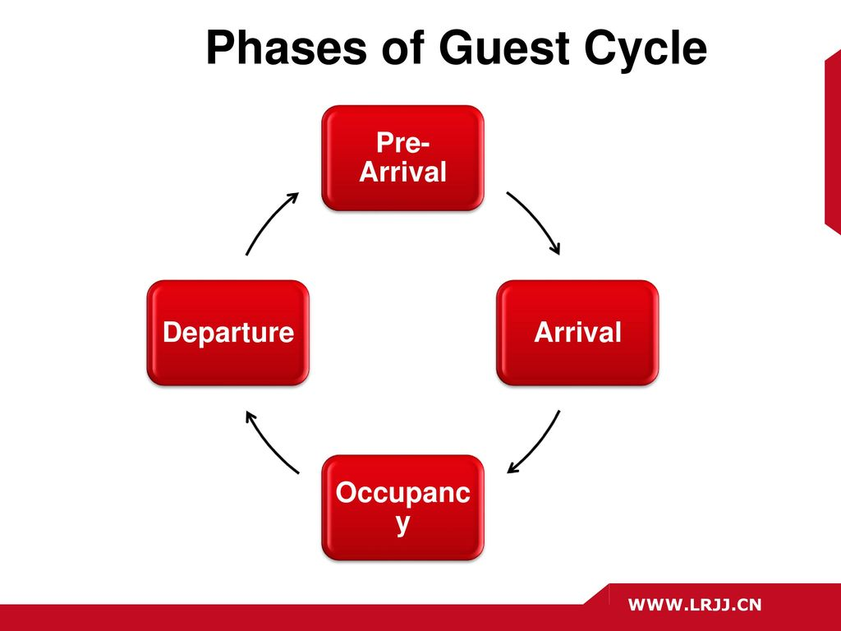
Figure: Phases of guest cycle (Sann, 2020).
Personalized services: Hotels should provide personalized services such as welcome messages and room preferences at the pre-arrival stage. Also, other special services such as meal packages, entertainment activities etc. can be arranged as per guest’s requirements.
For example, the Ritz-Carlton Hotel is known for its excellent hotel reservation system with online websites and mobile applications. Guests are sent pre-arrival greetings and essential information through emails. Also, their personal preferences are highly maintained such as room temperature, meal package, spa services etc. that ensures a comfortable stay experience for the guests (Maglovska, 2020).

Element 2- Arrival
The arrival stage usually starts when guests arrive at the hotel and start physical contact with the hotel reception. This is a shorter phase and stays until the guests check in to their rooms. Communication involves giving the client the relevant facts, such as the check-in time, the contact information, and responding to a customized request for preferences on the rooms or other services (Lee ET AL., 2019). The key elements are:
Check-in procedures: The check-in process should be efficient and seamless for the guests. Also, there should be minimal waiting times and hassle-free experiences. For this, the hotel staff should prepare necessary documentation and room keys or keycards in advance (Kim ET AL., 2021).
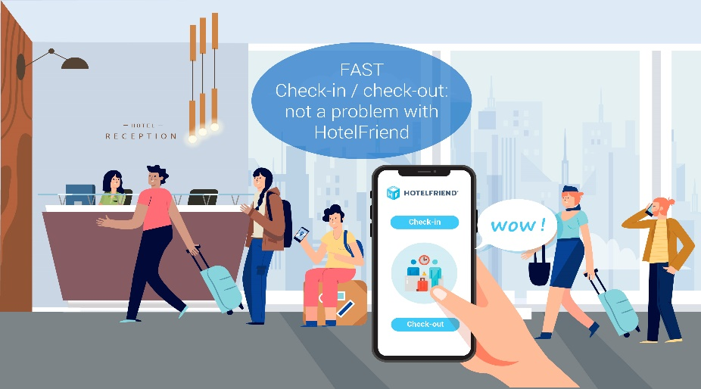
Figure: Modern check in procedure (Wu, 2023).
Front desk services: The front desk should have staff who are friendly and knowledgeable. They should assist the guests with necessary registrations, and documentations and provide relevant information such as brochures, maps etc. to address any concerns.
Guest orientation: The hotel staff should inform the guests about different hotel facilities and services, local events etc. That they can enjoy while staying at the hotel. Besides, the guests should be explained about security procedures and emergency concerns (Sann, 2020).
For example, Marriot International Hotel offers mobile-based digital check-in procedures where guests are sent necessary information through notification and can have keyless entry to their rooms using mobile devices. Besides, they have excellent front desk staff who provide a seamless arrival experience to the guests (Marković, 2020).

Element 3- Duration of Stay
The duration stage is the entire time the guests stay at the hotel from their check-in time. This is the most important stage of the hotel guest cycle and hotels must provide excellent services during this phase. The key elements are:
Guest service: The staff should be trained properly to provide responsive and attentive service to the guests. They should be courteous and respectful while interacting with the guests. Any concerns or issues reported by guests should be handled professionally and in an efficient manner (Wu, 2023).
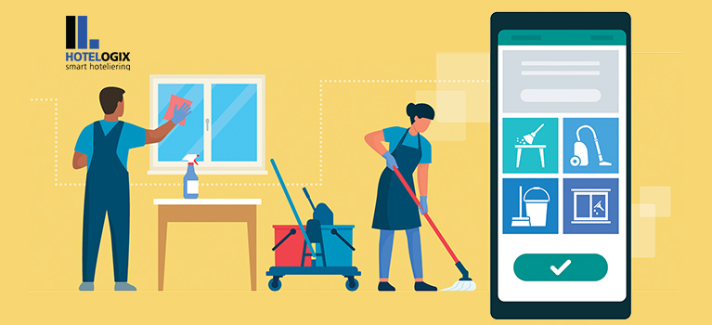
Figure: Housekeeping (Marković, 2020).
Housekeeping: The hotel should ensure clean and comfortable rooms so that guests can have a satisfactory staying experience. The housekeeping staff should clean the rooms regularly. Also, staffs must maintain the privacy of guests while housekeeping.
Personalization: Hotel management should address guest’s personal preferences while providing hotel services such as dining, hotel amenities, entertainment activities, or other hotel services according to the guest’s requirements.
For example, Hilton is known to always focus on providing personalized hotel experiences for their customers. They highly prioritize guest’s preferences and requirements while providing any services. They are very concerned about the cleanliness and well-being of the guests. They have different dining options to cater to guests’ individual choices (Buehring, 2019).

Element 4- Departure
The departure stage starts when guests decide to check out from the hotel. The key elements of the departure stage are:
Check-out procedure: The check-out procedure should be express and prompt to offer synonymous departure of the guests. It includes settling outstanding bills and retrieving room keys. It also includes assistance with luggage carrying and transportation (Zarezadeh et al., 2022).
Feedback collection: Hotels can request feedback from the guests by filling up a survey or having in-person conversations about their experiences and thoughts about the hotel services. This will help the hotel identify any improvement areas and enhance its services.
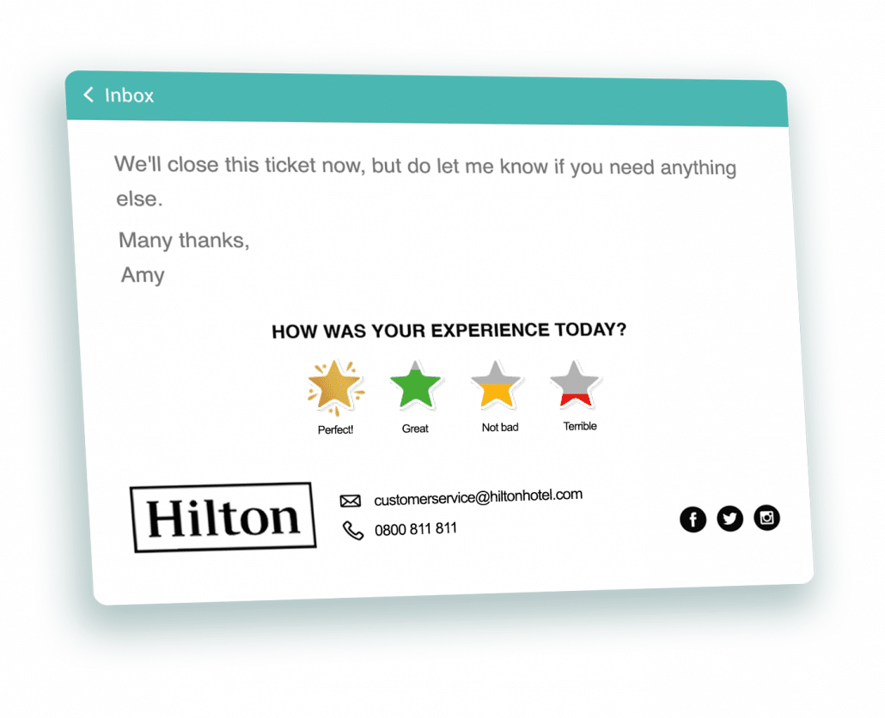
Figure: Customer feedback (Buehring, 2019).
For example, Airbnb offers an online check-out option for their guests who can check out and pay any bills through a mobile app and online website digitally which saves them time and provides a hassle-free experience. Airbnb also encourages guests to leave ratings and their feedback on the website which provides insights about its services and improvement concerns (Marković, 2020).

Conclusion
Thus, to provide visitors a flawless booking experience, the reservation system must be managed effectively. The phases or stages that a visitor goes through while staying at a hotel are included in the hotel guest cycle. The Pre-arrival stage, Arrival stage, Duration of stay stage, and Departure stage are the four primary stages. For the hotel management to provide a superior guest experience, each stage contains a few essential components or qualities that must be present. In order to do this, it is essential to use contemporary reservation tools and technology, such as online booking platforms or physical booths (Buehring, 2019).

References
Buehring, J. and O’Mahony, B., (2019). Designing memorable guest experiences: development of constructs and value generating factors in luxury hotels. Journal of Hospitality and Tourism Insights, 2(4), pp.358-376.
Kim, H., Huh, C., Song, C. and Lee, M.J., (2021). How can hotel smartphone apps enhance hotel guest experiences? An integrated model of experiential value. Journal of Hospitality and Tourism Technology, 12(4), pp.791-815.
Lee, M., Lee, S. and Koh, Y., (2019). Multisensory experience for enhancing hotel guest experience: Empirical evidence from big data analytics. International Journal of Contemporary Hospitality Management, 31(11), pp.4313-4337.
Maglovska, C.R., (2020). What do hotel guests really want? An analysis of online reviews using text mining. Менаџмент у хотелијерству и туризму, 8(1), pp.37-48. Rabby
Marković, S. and Gjurašić, M., (2020), October. Creating Personalized Guest Experience Journey in Leisure Hotel. In Fourth International Scientific Conference on Recent Advances in Information Technology, Tourism, Economics, Management and Agriculture (p. 31).
Sann, R. and Lai, P.C., (2020). Understanding homophily of service failure within the hotel guest cycle: Applying NLP-aspect-based sentiment analysis to the hospitality industry. International Journal of Hospitality Management, 91, p.102678.
Wu, C.H.J. and Liang, R.D., (2023). Effect of experiential value on customer satisfaction with service encounters in luxury-hotel restaurants. International Journal of Hospitality Management, 28(4), pp.586-593.
Zarezadeh, Z.Z., Rastegar, R. and Xiang, Z., (2022). Big data analytics and hotel guest experience: a critical analysis of the literature. International Journal of Contemporary Hospitality Management, 34(6), pp.2320-2336.

