How to Create a Chart in a Word Document
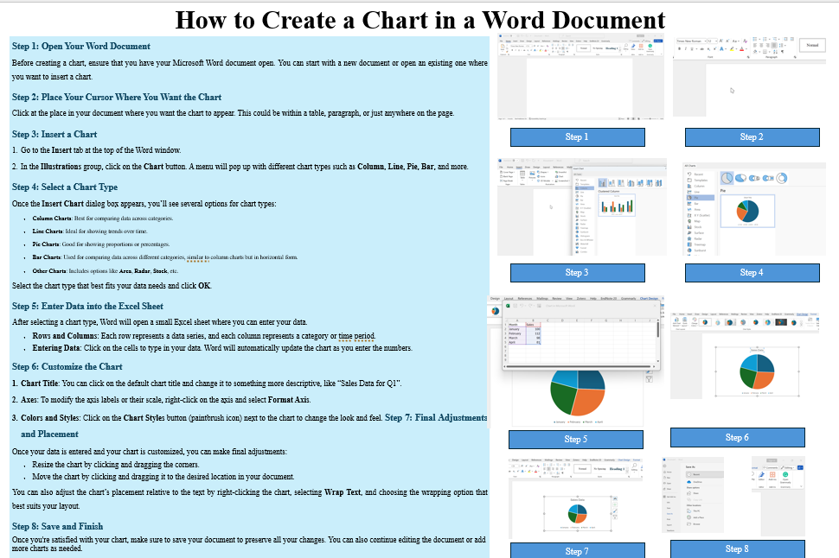

Step 1: Open Your Word Document
Before creating a chart, ensure that you have your Microsoft Word document open. You can start with a new document or open an existing one where you want to insert a chart.

Step 2: Place Your Cursor Where You Want the Chart
Click at the place in your document where you want the chart to appear. This could be within a table, paragraph, or just anywhere on the page.

Step 3: Insert a Chart
- Go to the Insert tab at the top of the Word window.
- In the Illustrations group, click on the Chart button. A menu will pop up with different chart types such as Column, Line, Pie, Bar, and more.

Step 4: Select a Chart Type
Once the Insert Chart dialog box appears, you’ll see several options for chart types:
- Column Charts: Best for comparing data across categories.
- Line Charts: Ideal for showing trends over time.
- Pie Charts: Good for showing proportions or percentages.
- Bar Charts: Used for comparing data across different categories, similar to column charts but in horizontal form.
- Other Charts: Includes options like Area, Radar, Stock, etc.
Select the chart type that best fits your data needs and click OK.

Step 5: Enter Data into the Excel Sheet
After selecting a chart type, Word will open a small Excel sheet where you can enter your data.
- Rows and Columns: Each row represents a data series, and each column represents a category or time period.
- Entering Data: Click on the cells to type in your data. Word will automatically update the chart as you enter the numbers.

Step 6: Customize the Chart
- Chart Title: You can click on the default chart title and change it to something more descriptive, like “Sales Data for Q1”.
- Legend: You can choose to show or hide the legend by selecting the Chart Elements button (the plus sign next to the chart) and checking or unchecking the Legend box.
- Axes: To modify the axis labels or their scale, right-click on the axis and select Format Axis.
- Colors and Styles: Click on the Chart Styles button (paintbrush icon) next to the chart to change the look and feel. You can choose from a range of pre-set styles and color schemes.

Step 7: Final Adjustments and Placement
Once your data is entered and your chart is customized, you can make final adjustments:
- Resize the chart by clicking and dragging the corners.
- Move the chart by clicking and dragging it to the desired location in your document.
You can also adjust the chart’s placement relative to the text by right-clicking the chart, selecting Wrap Text, and choosing the wrapping option that best suits your layout.

Step 8: Save and Finish
Once you're satisfied with your chart, make sure to save your document to preserve all your changes. You can also continue editing the document or add more charts as needed.

Tips for Effective Chart Creation
- Keep it simple: Don't overcrowd your chart with too much data.
- Use colors effectively: Ensure that the colors in your chart are distinguishable and meaningful.
- Provide a title: Always label your chart with a clear and concise title.
- Review your data: Make sure the data entered is accurate and relevant to the chart type.

