Enterprise & Innovation Group Project

Contribution Report

Electronics Engineering Course @ UWTSD
By Krzysztof Matela
Student ID: 1804424

Page Index:
Page 3 …………………………………………………………………………………………………………. Ideation
Page 3 ……………………………………………………………………………………………………… Illustration
Page 4 ………………………………………………………………………………………………………….…. Design
Page 4 ……………………………………………………………………………………………………………….. MVP
Page 4 ………………………………………………………………………………………………………. Resources
Page 5 ……………………………………………………………………………………………………………….. USP
Page 5 …………………………………………………………………………………………………. Development
Page 8 ……………………………………………………………………………….. Where it all went wrong?
Page 8 …………………………………………………………………………………………………………. Finances
Page 8 ………………………………………………………………………………….. References & Appendix

- Ideation:
The Smart Brain group has come out with innovative idea to develop a custom hearing aid which, combined with latest technology, is meant to support a person suffering from a dementia with carrying out everyday tasks completely independently. This is achievable by adding few electronic modules to a typical circuit design of a hearing aid and by doing so, expanding its features and applications.
Illustration:
Dementia – a decline in cognitive functions, which in the simplest terms means that brain does not operate the way it should and as a result, a person that suffers from Dementia can have problems with, but not limited to:
- Struggling to remember recent events
- Difficulty with finding the right words
- Loss of sense of direction
- Sudden changes in mood
- Trouble completing everyday tasks
- Adapting to lifestyle changes
This has a huge impact on the quality of life of such a person and its loved ones, even in the early stage the symptoms are quite problematic and being under supervision of a family member or caregiver is not always an option.
The reason for hearing aid being the “core” device for this project was based on a fact that this kind of mental impairment affects elderly and is connected to their age and so is the partial hearing loss. “Partial hearing loss forces brain to use up more resources to process auditory information which can promote cognitive decline ⁽¹⁾”. Although providing a person with hearing aid can only slow down the decline process and so the everyday struggles will continue on and therefore, our hearing aid must do more than just amplify surrounding noise.
Smart Brain aims to upgrade hearing aid with sensors that can monitor users’ basic health condition (body temperature, heart rate, etc.) and provide mobile app that would could communicate with the ear piece. Outcome set could easily work as a personal assistant that would help user with daily tasks like: regularly take medicine or go do grocery; maybe even call for an ambulance in case of an emergency.
The software application is limitless but each of the patients are going to have their own unique needs and daily routines that app will have to adapt for and so it must be flexible and generally easy to use, especially for the elderly – who are not so confident with technology.

Design:
Ideally, the custom hearing aid should be small and light but with each new functionality team is going to add, the device itself will grow larger and heavier – resulting “bulk” might be uncomfortable to use. Additionally, this device must be able to connect to a mobile phone, preferably via Bluetooth as the mobile’s phones Wi-Fi should remain available for internet connection.
As for the app, the targeted audience are mostly people of age and those might struggle to use the app and so it would be in their interest to make it as automated as possible while maintaining flexibility for people to plan their day out with ease.
Lastly, since each customer will have to input his/her details, and company requires a database on which to store all the data coming from users. Naturally, it has to be properly secured from any threads.
MVP:
At minimum, the Smart Brain Group hopes to provide an affordable option for hearing aid with assistant app to help throughout the day, not just for people suffering from dementia but for everyone who could benefit from it. Operating without target audience will cause further development to be much more difficult due to much larger variety of customers and their needs. Keeping vital monitors could benefit those people which are trying to be more active and healthier by providing proper scan of their condition in real-time.
Resources:
Each team member requires software and/ or hardware to do their job effectively which is listed below:
Name | Software | Hardware | Task
Matthew Howells | AutoCAD | 3D Printer | 3D Printing
Matthew Howells | UWTSD Cloud | UWTSD Cloud | Database
Matthew Howells | MS Office | - | Team Management
Ryan Williams | Visual Studio | - | App Production
Ryan Williams | - | - | -
Krzysztof Matela | Proteus, Easy-PC | - | Hearing Aid Simulation
Krzysztof Matela | MPLAB / Visual Studio / Arduino IDE | Workstation, IC components | Hearing Aid Prototype

USP:
Vital differentiating factor for the complete set from these available on the market is the affordability. Most of the hearing aids can cost over £100 and that’s only for the earpiece itself and not a complete earpiece with body sensors and assistant app.
Big advantage for Brain Smart, especially for start, are the target customers because Dementia problem continues to grow around UK with the government unable to cope. Our group hopes to have minimal costs and keep the profits at a level that would allow stable growth without overpricing our products.
Side fact worth mentioning, the giants in hearings aids (such as ReSound) often advertise their apps with their products which allows user to modulate some of the hearing aids’ features such as volume level, noise level filtering etc. perhaps it is worth including in the assistance app.
- Development:
Electronics Engineer – Report
There are two ways to develop functioning prototype of a hearing aid for the Smart Brain Group:
- Analog – this is a time consuming and yet very neat and effective method to develop a prototype however, it requires in-depth knowledge of available PIC’s and transducers and even more math skills.
- Digital – Digital prototype requires less time because it will be composed out of smaller modules which are already pre-soldered and universally compatible. Although, it will require a fair amount of programming skills.
With deadline coming closer and time running thin, decision was made to go with the digital prototype for the demonstration. It will have sloppy and large appearance but it should save a lot of time on development.
The requirements are:
- Actual hearing aid functionality (microphone + speaker)
- Temperature sensor (such digital sensors are made mainly for measuring surrounding temperatures but it should fit for the demonstration purposes)
- Accelerometer (can measure horizontal or vertical positioning using earth’s gravity for reference when in stand-still)
- Bluetooth module (a way to be able to connect to users mobile)
- (Optional) LCD display (a way to visibly display data coming from other modules of the prototype)
Components chosen are (whole set costs around £40-£50):
- ESP32 Dev board (development board similar to Arduino with embedded wireless technology, Wi-Fi + BT)
- GY-521 module (accelerometer)
- DHT11 (temperature & humidity sensor)
- ISD1820 (voice recording and playback module)
- OLED SSD1306 (graphic display)
- Arduino Nano (backup scenario in case of need for extra features or more I/O ports)
- Breadboard Power Supply Module (whole thing requires power source)
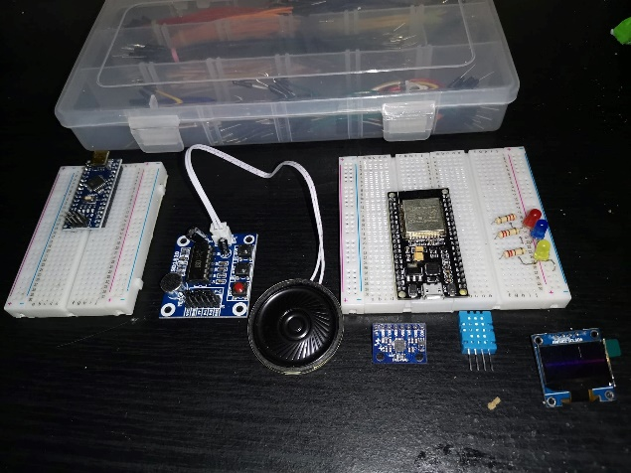
After shopping for chosen components, it is time to get familiar with them – starting from ESP32 Dev Board. ESP32 is a development board similar to Arduino and relies on the very same principle of operations. Main difference is that it has integrated wireless module for both Bluetooth and Wi-Fi technology.
Pin layout:
Very simple task – relied on looking up images of different types of pin layouts and match them to existing one. This also gave an info that it is the rev.4 version of ESP32 that will be used.
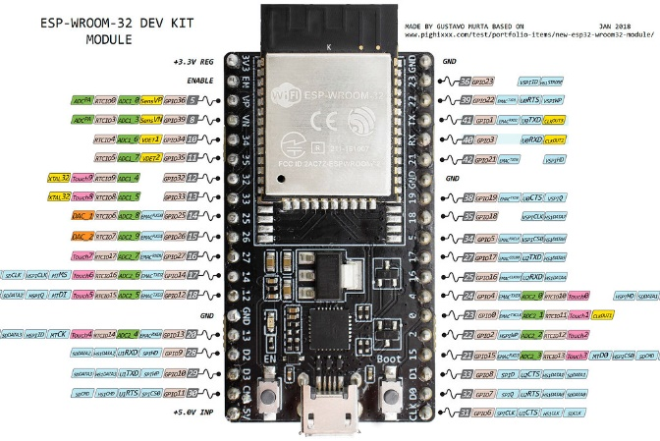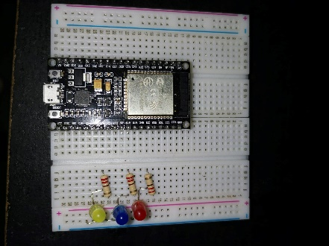

First program:
First program will simply turn few LED lights on and off. This gave an insight into how different “boards managers” can be used with different devices as well as confirming that pin layout found earlier is correct and usable.
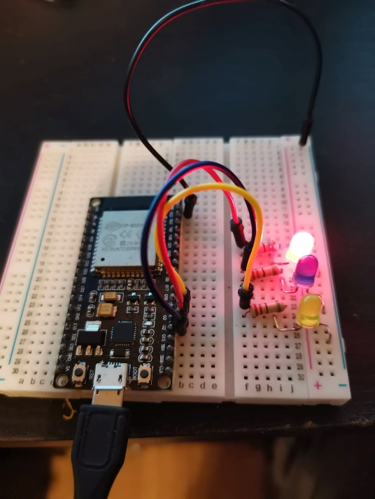 ` 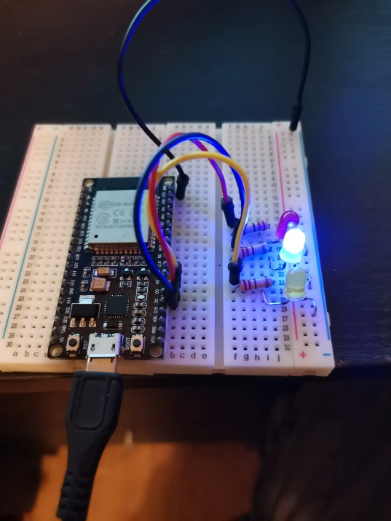

Accelerometer (GY-521):
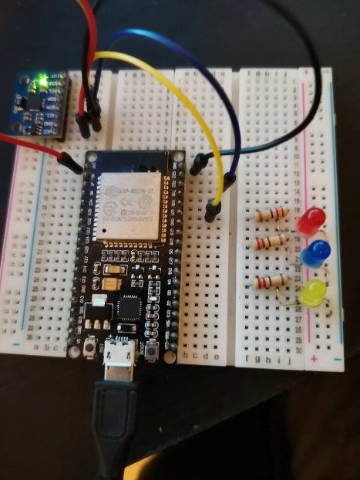
The module itself comes from Arduino Mega 2560 starter kit and therefore, the example code was provided. This exercise only gave an insight into I2C devices and what ports they use. Code example was functional but poorly explained. Nevertheless, it worked – using Serial Monitor, ESP32 has displayed the required data.

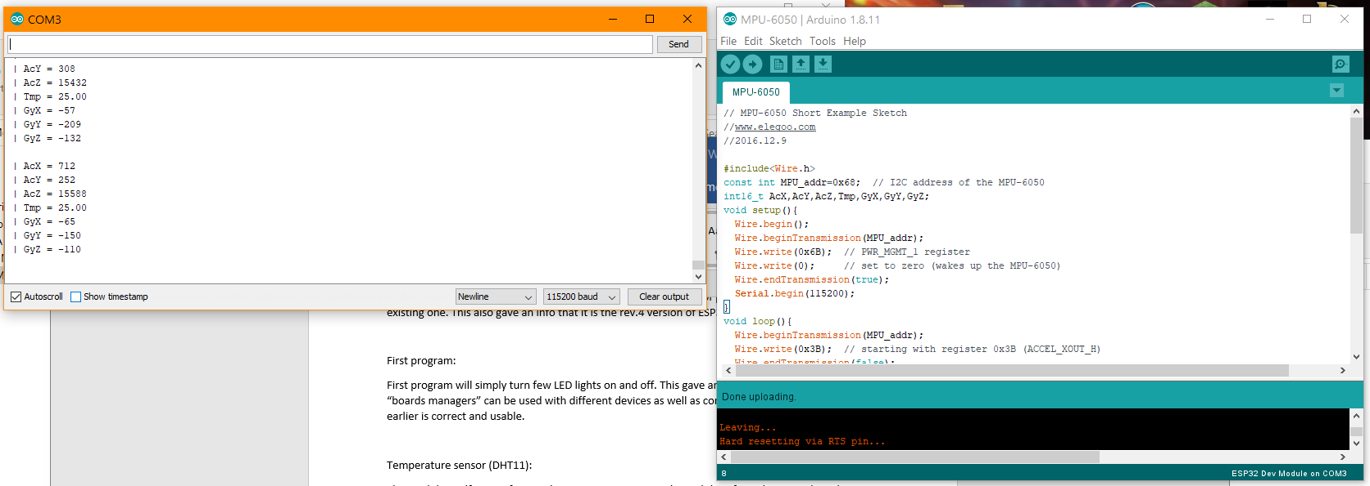
Temperature sensor (DHT11):
Temperature sensor in individual module is now expendable because Accelerometer module can do it as well. Not used.

Voice recording and playback module (ISD1820):
All this module needed to run was power source and it has embedded feature that allows recording and playback. According to online description, it also has the ability to playback in real time. It also required a bit of soldering as it came partially assembled.
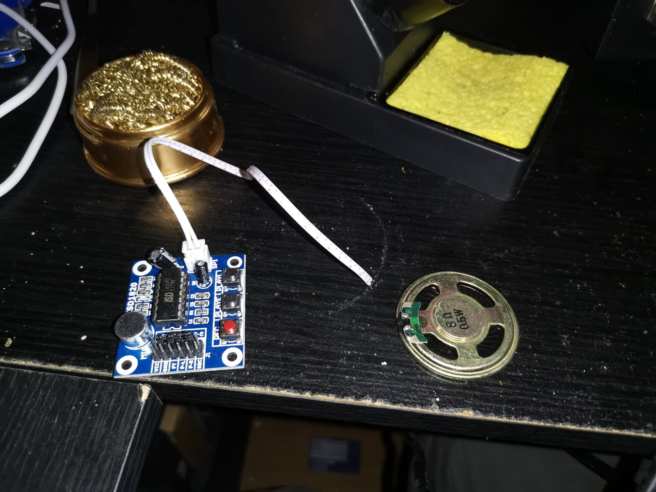
Graphic Display (OLED SSD1306):
Not needed – not used.
Where it all went wrong:
To achieve actual functionality, the ESP32 module must connect to another device via Bluetooth and other modules must operate as one.
Problem is that each tutorial read only shown how to operate with a single device. Each individual functionality appears to be using the exact same type of communication method (wire.h) and no information about how to use different digital pins for same functions were found.
Fact is, the entire development was done using incomplete information and it will require a lot more research and experiments in order to complete whole functionality.
As a result – the project is now frozen.
Finance:
At the start of the project every member of the group agreed to make Smart Brain Group a Community Interest Company. The entire investment comes from the pockets of team members with a genuine belief we’re doing what’s right. Unfortunately, without money management, this enterprise will quickly fail. Goal is to maintain a gentle profit, right above breakeven line so the team will continue to operate as usual without putting their own financial stability at risk.
Costs
Prototype: £50 - per device (est. 4 for start - £200 total)
Rent: £70 - weekly
Bills: £30 - weekly
Office equip: £5 - weekly
Weekly Total: £105 = Monthly: £420
Prototypes: £50 = 4 prototypes: £200
Total: £620
Profiting
It comes from sales of entire package:
£10 per sale per month
Breakeven
Fallowing that logic:
Smart Brain Group must sell 62 packages within first month to achieve breakeven.

References:
- https://www.alzdiscovery.org/cognitive-vitality/blog/can-hearing-aids-help-prevent-dementia - 3rd paragraph from section: “What the evidence says”
Appendix:

